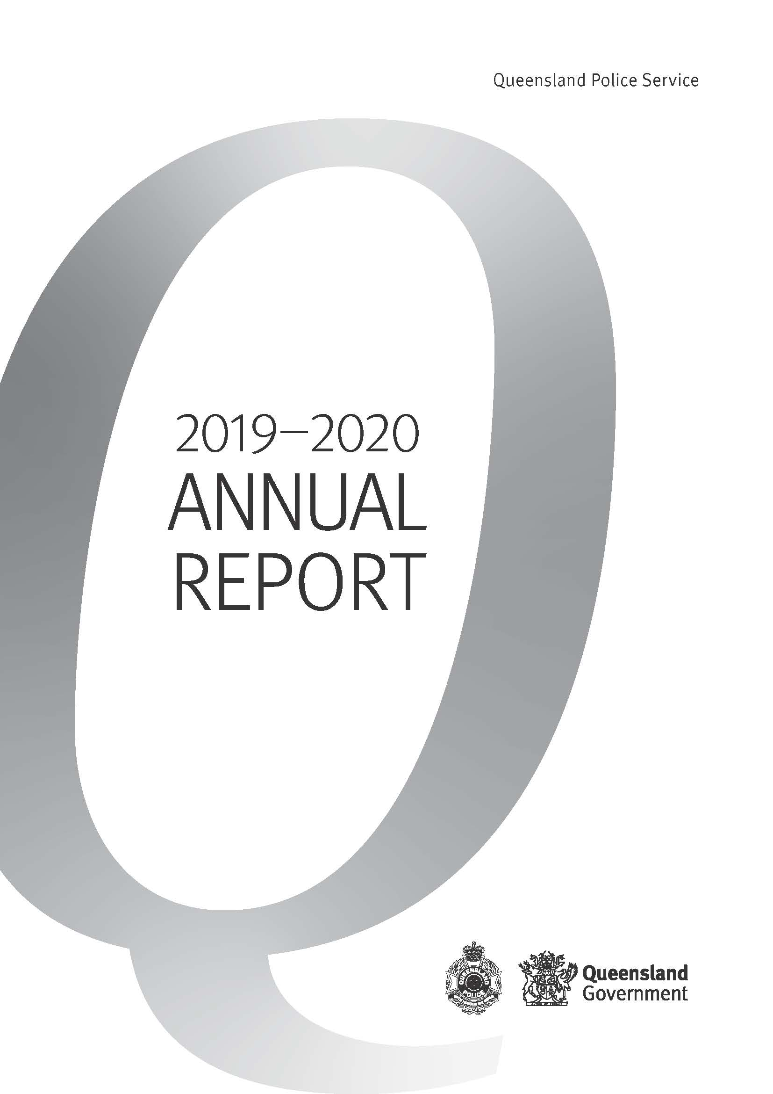

This annual report provides information about the Queensland Police Services’ financial and non-financial performance information for 2019-20. It has been prepared in accordance with the Financial Accountability Act 2009, the Financial and Performance Management Standard 2019 and the Annual report requirements for Queensland Government agencies.
Enquiries and further information
Telephone: (07) 3364 3616
Visit: www.police.qld.gov.au
Email: QPS.Reporting@police.qld.gov.au
This annual report can be obtained in paper form by calling 13 QGOV (13 7468) or online at www.police.qld.gov.au/corporatedocs/reportsPublications/annualReport/default.htm.
Feedback
Feedback on the annual report can be provided through the Get Involved website:
https://www.getinvolved.qld.gov.au/gi/consultation/7550/view.html
Other languages and formats
The Queensland Government is committed to providing accessible services to Queenslanders from all cultural and linguistic backgrounds. If you have difficulty understanding this publication and need a translator, please call the Translating and Interpreting Service (TIS National) on telephone number 131 450 and an interpreter will be arranged to communicate the report to you.

Queensland Police Service (www.police.qld.gov.au)
 | www.mypolice.qld.gov.au |  | www.youtube.com/QueenslandPolice
 | www.facebook.com.au/QueenslandPolice |  | www.instagram.com/qldpolice
 | www.twitter.com/QldPolice
Copyright
© The State of Queensland, Queensland Police Service 2020
Licence
This annual report is licensed by the State of Queensland, Queensland Police Service under a Create Commons Attribution (CC BY) 4.0 Australian licence.
CC BY Licence Summary Statement
In essence, you are free to copy, communicate and adapt this annual report, as long as you attribute the work to the State of Queensland, Queensland Police Service. To view a copy of this licence, visit: www.creativecommons.org/licenses/by/3.0/au/deed.en
Attribution
Content from this annual report should be attributed as: The State of Queensland, Queensland Police Service Annual Report 2019-2020.
ISSN:
Online: 1837-235X
Print: 1837-2341

Letter of compliance

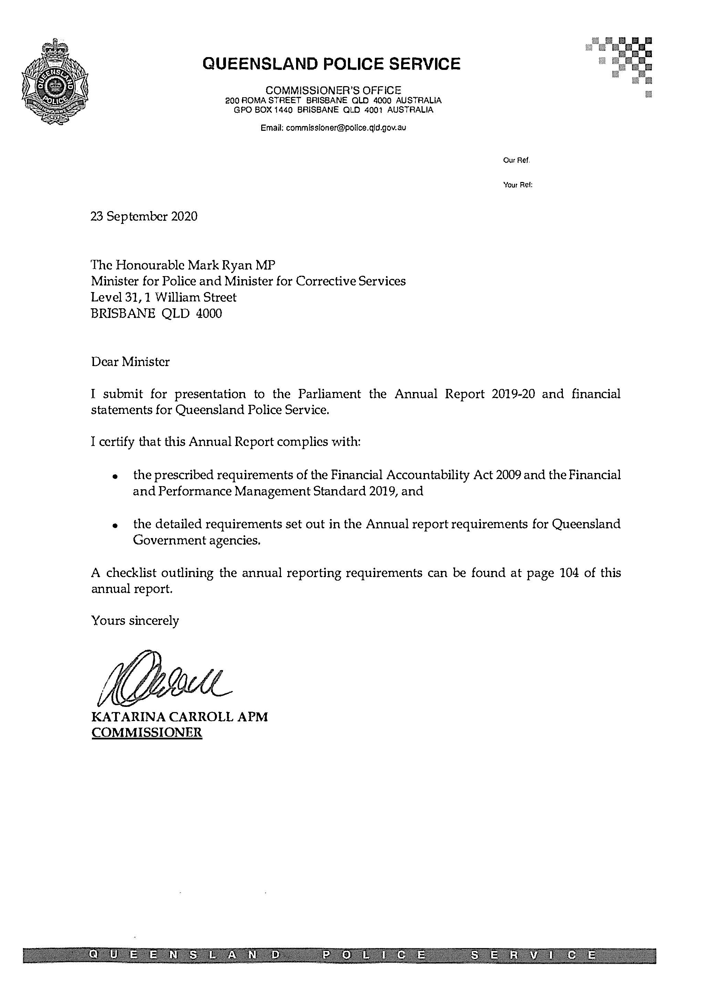

Table of contents

Letter of compliance 2
Table of contents 3
Commissioner’s message 7
About Us 7
Legislation administered by the QPS 14
Organisational structure 17
Service Alignment Program 18
QPS Regional Map 20
QPS response to COVID-19 22
Financial Summary 24
Summary of financial performance 24
Summary of financial position 26
Performance 28
Key performance measures 28
2019-20 Highlights 34
Governance 42
Executive management 42
Boards and committees 45
Government bodies 51
Ethics and code of conduct 51
Risk management and accountability 53
Human resources 57
Financial Statements 62
Appendices 97
Government bodies 97
Acronyms 102
Compliance checklist 104
Contacts and key locations 106

Information about consultancies, overseas travel and the Queensland Language Services Policy is available on the Queensland Government Open Data website (www.data.qld.gov.au).

Commissioner’s message
In my first year as Queensland’s Police Commissioner, I feel immensely proud of how the QPS has responded to a constantly evolving policing environment.
In 2019-20, the QPS faced many challenges, including the impact of the COVID-19 health pandemic which saw the QPS significantly refocus its services in the second half of the 2019-20 year. The QPS played a critical role in responding to this pandemic and to flattening the curve here in Queensland. This involved:
- closing the Queensland borders for the first time in 100 years in the interests of safety which resulted in state border controls at airports and state roads and enforcing entry restrictions;
- standing up the State Police Operations Centre (SPOC) and activation of the State Disaster Coordination Centre (SDCC) to prepare, plan and coordinate the QPS’s and whole-of-Government response to COVID-19;
- conducting border patrols and vehicle checkpoints, quarantine compliance visits, social distancing enforcement and deployment of officers and staff members to the SPOC and SDCC, while maintaining business as usual policing activities;
- conducting various policing operations and changing how we deliver frontline policing services to reduce the potential transmission of COVID-19.
Despite these challenges, the QPS continued to deliver outstanding frontline policing services and accomplished significant achievements that showcased the exceptional work and dedication of our members. Achievements for 2019-20 included:
- the commencement of the Service Alignment Program to improve how we deliver frontline services. Business improvements delivered during the reporting period include the:
- service delivery re-design trial in Moreton District, which is aimed at establishing connectivity between different teams and functions across the district. The new service delivery model will align functionality and create further efficiencies in our business processes and practices;
- transition to a four Deputy Commissioner model, with the creation of a new Regional Queensland Deputy Commissioner (located in Townsville) to oversee the policing operations across the central and northern police regions. The Southern Queensland Deputy Commissioner oversees the policing operations across the Southern, South Eastern and Brisbane Regions. The introduction of the Southern and Regional Deputy Commissioners assists the Service in strengthening important partnerships with government agencies, non-government organisations and community groups, to maximise opportunities and ultimately prevent crime and enhance community safety. It also provides greater support and better understanding of our frontline service delivery;
- introduction of Workplace – a dedicated and secure internal communications platform.
- the commencement of the Human Rights Act 2019 in January 2020 and the QPS’s commitment to respect, protect and promote human rights in our decision-making and actions;
- the implementation of the Youth Justice Five-Point Action Plan to ensure that youth offenders are both held liable for their actions but also can be appropriately diverted to support services to curb future recidivist behaviour;
- contributing to the Domestic and Family Violence Third Action Plan 2019-20 to 2021-22;
- conducting various road policing operations to reduce the road toll and curb negative road user behaviour;
- the QPS acknowledged the 30-year anniversary of the Fitzgerald Inquiry which provided an unprecedented platform for long lasting reform. The legacy of this reform is still felt in the QPS 30 years later;
- advancements in investigative techniques, including solving one of the oldest cold case murder investigations dating back 55 years;
- leveraging technological advancements to improve the way we deliver policing services including remote piloted aircraft to reduce delays on main roads and freeways caused by major traffic accidents and a new evidence management facility in Brisbane;
- continuing to improve communications with the community through various social media platforms;
- development of a new Safety and Wellbeing Strategy and commencement of an external review of our current injury management processes which will guide the Service as we create a healthy, connected and supported workforce.
We also farewelled former Assistant Commissioners Tony Wright, Alan McCarthy and Alistair Dawson in 2019-20. They had long-standing careers with the QPS spanning over 30 years each. They collectively delivered invaluable services to the community of Queensland and I wish them well in their future endeavours.
I am incredibly passionate about providing the best possible service to the community of Queensland with the new values I released in January 2020, including integrity, professionalism, community, fairness and respect which represent who we are at the core of ourselves, our organisation and our community. These new values will position the service to achieve greater outcomes for our organisation and our communities as we continue to move towards a policing model that is focused on prevention, disruption, investigation and response.
I am honoured to have led the QPS in my first year as Commissioner and I would like to thank the QPS Executive Leadership Team and our 15,000 members, police and staff alike, for their exceptional service, extraordinary dedication and commitment to keeping our community safe and making Queensland the safest State.


Katarina Carroll APM
Commissioner
About Us
The QPS is the primary law enforcement agency for Queensland. It fulfils this role throughout the state, 24 hours a day, seven days a week, upholding the law and providing assistance to the community particularly in times of emergency, disaster and crisis.
The Queensland Government supported the QPS 2019-20 budget which totalled more than
$2.6 billion, made up of $2.428 billion for operating expenses and $178.3 million for capital programs, including QPS programs delivered through the Public Safety Business Agency.
Our Vision: Delivering safe and secure communities through collaboration, innovation and best practice.
Our Purpose: In collaboration with community, government and non-government partners, provide effective, high quality and responsive policing services to make Queensland safer.
Our Accountabilities
Under the Police Service Administration Act 1990, the QPS is responsible for:
- preserving peace and good order in all areas of Queensland
- protecting and supporting the Queensland community
- preventing and detecting crime
- upholding the law
- administering the law fairly and efficiently
- bringing offenders to justice.
Our values
Consistent with the QPS Strategic Plan 2019-2023, QPS members value:
- Courage: by always doing the right thing
- Fairness: in making objective, evidence-based consistent decisions and by treating people with respect
- Pride: in themselves, the QPS, the work they do and the community they serve.
In January 2020, the Commissioner released new values to support her vision for the QPS moving forward which include:
- Integrity: is in everything we do. We are honest, trustworthy and hold each of to a high standard
- Professionalism: times are challenging but if we are professional in everything we do, our communities will continue to support us
- Community: we support each other and lend a hand to ensure we can respond to community needs as well as the needs of our policing community
- Fairness and Respect: we treat each other and our communities as we would like to be treated ourselves – with fairness, dignity and respect.
The QPS shares the Queensland Public Service Vales of:
 | Customers first  - Know your customers  - Deliver what matters  - Make decisions with empathy
 | Ideas into action  - Challenge the norm and suggest solutions  - Encourage and embrace new ideas  - Work across boundaries
 | Unleash potential  - Expect greatness  - Lead and set clear expectations  - Seek, provide and act on feedback
 | Be courageous  - Own your actions, successes and mistakes  - Take calculated risks  - Act with transparency
 | Empower people  - Lead, empower and trust  - Play to everyone’s strengths  - Develop yourself and those around you

Our objectives
The QPS contributed to the government’s objectives for the community by delivering quality frontline services and supporting safe, caring and connected communities. The QPS did this through our focus on:
- Stopping crime
- Making the community safer
- Strengthening relationships with the community
- Equipping our workforce for the future so we can meet the challenges of policing as we move forward.

Strategies
The QPS achieves its objectives through a range of strategies:
To stop crime, the QPS:
- developed sustainable, effective, innovative and efficient approaches to prevent, disrupt and investigate crime
- addressed the threat of serious and organised crime, terrorism and radicalisation through strong collaborative partnerships with the community and other law enforcement agencies.
To make the community safer, the QPS:
- provided timely and professional responses to calls for service to maintain community confidence through a community-centred, victim-focussed approach to policing
- worked to improve policing responses to people who are over-represented in the criminal justice system as either victims or offenders, including vulnerable persons and victims of domestic and family violence.

To strengthen relationships with the community, the QPS:
- fostered collaborative partnerships with government agencies, non-government organisations and community groups to maximise opportunities to prevent crime and enhance community safety
- worked to preserve the legitimacy of policing through fair and ethical service delivery
- strengthened positive online user and social media experiences to expand options for engagement with police.
To equip the workforce for the future, the QPS:
- invested in our people to meet current and future challenges through capability planning and development to position the QPS as a learning organisation
- worked to deliver world-leading equipment, technology and facilities to support our frontline staff
- supported healthy, safe and inclusive workplaces and promoted a diverse workforce that reflects the community we serve.
The QPS also contributed to a range of local, state and national strategies on matters including youth justice, drugs and alcohol, domestic and family violence and vulnerable persons, mental health, child protection, counter-terrorism and road safety.
Queensland Government objectives
The Queensland Government remains committed to meeting the challenges facing Queensland communities, particularly around job-creation and a stronger economy, education, health and community safety.
Our Future State
Our Future State: Advancing Queensland’s Priorities are the government’s objectives for the community. They are designed to confront and tackle the major challenges facing Queensland.
Advancing Queensland’s Priorities is part of the Government’s long term plan for the future of our state, guided by the Queensland Plan. More information about the plan is available online at www.queenslandplan.qld.gov.au
Community safety is a shared responsibility and the QPS works with other government departments, agencies, community groups and members of the community to support the safety and security of all Queenslanders.
Information about QPS policies, programs and services aimed at keeping our communities safe can be found in 2019-20 Highlights (refer page 34).
Keep Communities Safe
As part of the Our Future State: Advancing Queensland’s Priorities, the government has identified six priority outcomes for Queensland now and into the future.
The Keep Communities Safe outcome will focus on reducing victimisation and youth crime and youth reoffending and will build the government’s recent effort in key areas such as tackling Ice, domestic and family violence, and toughening its serious and organised crime legislation.
The Queensland Government will work to deliver the two key targets of the Keeping Communities Safe outcome:
- a 10% reduction in the rate of crime victims over 10 years
- more can be done to reduce the number of crime victims—particularly victims of personal and property crime. This means reducing the number of people physically and sexually assaulted, and those affected by domestic and family violence, as well as reducing break and enters, vehicle thefts and property damage.
- a 5% reduction (by 2020-21) in the rate of youth reoffending over five years (from 2015-16)
- early intervention activities such as diversionary programs, along with engagement in education, training, employment and sport can have a positive impact on young people before they become ingrained in the criminal justice system.
In 2019-20, the QPS has undertaken the following activities to reduce victims of crime:
- commenced bodies of work to implement the QPS Crime Prevention Framework to deliver a three-pillared victimology, engagement and evidence-based intervention approach to support prevention, planning and collaboration focussing on preventing property and personal crime victimisation, including domestic and family violence;
- refreshing the Crime Prevention Through Environmental Design (CPTED) guidelines for Queensland, as well as, free CPTED training for local community groups, schools and local councils;
- developing training packages to deliver free presentations and resources for members of the community on personal safety, cybercrime and fraud prevention.
More information about Keeping Communities Safe is available online at https://www.ourfuture.qld.gov.au/safe-communities.aspx.
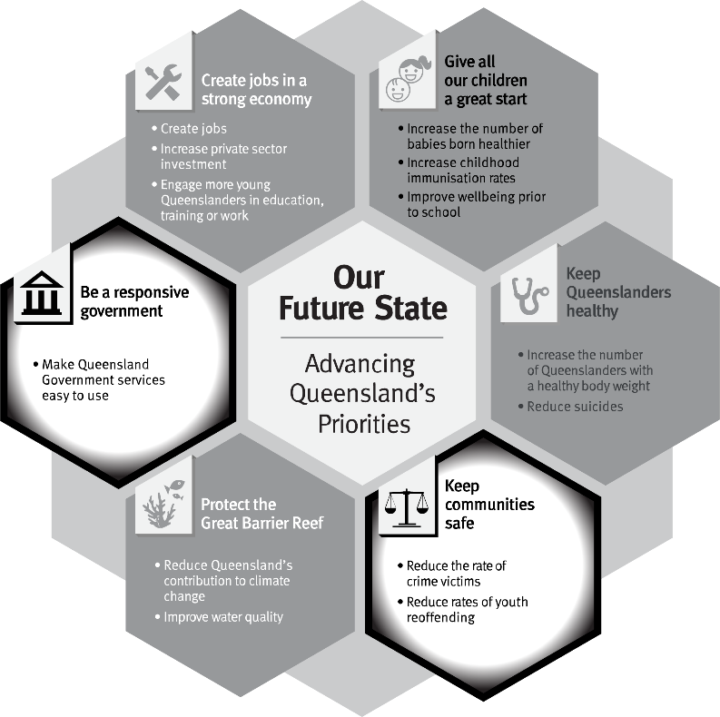
The QPS will also contribute to other priority outcomes as part of the Our Future State: Advancing Queensland’s Priorities.

Human Rights Act 2019
On 1 January 2020, the Human Rights Act 2019 (the Act) came into effect, creating obligations for public entities to act and make decisions in a way that is compatible with human rights, and to give proper consideration to human rights when making a decision. The QPS has made a commitment to respect, protect and promote human rights in our decision-making and actions.
The QPS works tirelessly to ensure Queensland is the safest state which includes exercising police powers embedded in legislation in a way that least impacts on people’s rights while protecting the liberty and security of the Queensland community.
As part of this commitment, the QPS has taken steps to further the objectives of the Act including:
- creating a network of human rights champions in each region, district and command across the QPS to serve as a key point of contact and to foster a culture of human rights within their respective areas;
- development of the Human Rights Training Strategy 2019-20 which aimed to equip employees with the requisite knowledge to consistently and competently apply human rights considerations in the performance of their duties;
- reviewing all legislation administered by the QPS, however, no legislative amendments were deemed necessary;
- reviewing existing local policies and procedures which resulted in over 2,000 documents being assessed and amended to support compatibility with the Act;
- over 40 human rights awareness sessions were delivered to over 800 members across the Service on how best to integrate human rights in their day-to-day business (pre-COVID-19);
- delivery of the Human Rights Communication Strategy 2019;
- publishing a series of articles in the QPS Police Bulletins, which is a “newsletter” style publication;
- embedding human rights in our internal and external reporting requirements;
- developing a human rights online learning product that was compulsory for all QPS members as well as a 5 Minute Intensive Learning Experience (5MILE);
- amending Service-wide policies and procedures to incorporate human rights.
Human Rights complaints
Since the commencement of the Act, the QPS has updated its complaints and grievance policies, procedures and mechanisms to ensure human rights complaints can be recorded, assessed and responded to appropriately.
Since the commencement of the Act on 1 January 2020 to 30 June 2020, there were 244 complaints where one or more human rights were alleged to have been unreasonably limited. All complaints are assessed to determine the validity of the allegations raised, and as at 30 June 2020:
- 99 of the 244 complaints had been finalised;
- 14 (of the 99) complaints were considered to be minor and resulted in management action as a human right was assessed as infringed. The officer/s involved received additional training and guidance;
- 85 finalised complaints were unfounded or had no adverse human rights implications;
- 145 of the 244 complaints are yet to be finalised.

Total number of complaints where one or more Human Rights were allegedly unreasonably limited  (as at 30 June 2020) | Further Action  (as at 30 June 2020)
244 | 14

Notes:
- A human rights complaint is a complaint about an alleged contravention of Section 58(1) of the Act by a public entity in relation to an act or decision of the public entity (i.e. that an act or decision is not compatible with human rights and/or that a decision did not properly consider relevant human rights).
- It is expected that sometimes a complainant will not identify human rights matters within a complaint they make to the QPS. Where the QPS identifies that the complaint may include a contravention of Section 58 of the Act the QPS is expected to record this and respond appropriately.
- The total number of human rights complaints includes all those identified by a complainant and the QPS. A human rights complaint is counted as one regardless of the number of alleged acts, decisions or human rights limited within a complaint made to the QPS.
- The total number of complaints where one or more HR were allegedly unreasonably limited (244) is already included in the total number of complaints against police (refer page 51).
Key QPS actions that engaged human rights during COVID-19
During 2019-20, the COVID-19 health pandemic emerged at a significant issue for the QPS and Queenslanders. The QPS continues to play a central role in the whole-of-government response to ensure compliance with public health directions to reduce potential transmission, while still delivering key frontline services to the Queensland community.
The QPS acknowledges its involvement in the whole-of-government response to COVID-19 restricted some human rights such as freedom of movement and peaceful assembly and freedom of association. However, the temporary limitations of these rights were lawful, necessary and proportionate to prevent transmission of the virus and loss of life. The public health measures implemented in response to the COVID-19 pandemic and the associated compliance activities including self-isolation and social distancing were balanced against the critical need to promote and protect the right to life.

Our environment
The policing environment in Queensland has changed and traditional policing services are adapting to meet the demands of policing now and into the future. Shifting community expectations and rapid technological innovation are impacting on traditional approaches to policing and service delivery more broadly. Rapid advances in technology are changing the way people interact with each other. Queensland also remains at risk from natural disasters, the COVID-19 health pandemic and severe weather events, which present threats to public safety.
In response, the QPS will:
- continue to deliver business improvements resulting from the Service Alignment Program;
- continue to commit to respect, protect and promote human rights in our decision-making and actions;
- continue to address the COVID-19 pandemic to reduce potential transmission, conduct border patrols and ensure the health and safety of our workforce and the Queensland community;
- continue to deliver key initiatives of the Government’s Keep Communities Safe and Tackling Alcohol Fuelled Violence policies;
- continue to support the implementation of the Domestic and Family Violence Prevention Strategy 2016-2026 and the Government response to the report from the Special Taskforce on Domestic and Family Violence in Queensland;
- work with other relevant agencies to increase the proportion of offenders, particularly young people, diverted from the criminal justice system;
- utilise new and emerging technologies to benefit police, by improving interoperability between public safety agencies and enhancing operational effectiveness;
- continue to work collaboratively with police agencies in other jurisdictions to address serious criminal activity.

Our challenges and opportunities in 2019-20
The QPS acknowledges the importance of addressing a range of potential strategic challenges to ensure we keep Queenslanders safe. The Service identified these challenges along with opportunities over the next 12 months, linking them to the four strategic objectives and supporting the delivery of safe and secure communities.
Key challenges for the QPS during 2019-20 included:
- adapting to economic conditions to ensure the delivery of high quality and efficient policing services;
- strengthening the ethical behaviour of police to address the community’s changing expectations;
- maintaining community satisfaction and confidence in police in an environment of changing expectations;
- adapting to the proportion of demand on police containing digital elements, with the knowledge and skills to understand criminal uses of emerging technologies being crucial for law enforcement.
To address these challenges, the QPS identified the following opportunities to best position the QPS to make Queensland a safer place for all:
- maintaining strong leadership of the QPS service delivery model during growing and changing demands to improve the future direction of the organisation;
- championing networks and partnerships across the public and private sectors and the community to create opportunities to improve responses and enhance social cohesion;
- promoting a workforce which is flexible, inclusive and diverse to enhance engagement and performance in delivering services to the Queensland community;
- empowering the workforce by investing in their safety and wellbeing and organisational capabilities to improve responses to future challenges;
- championing collaborative approaches through information sharing and coordinated case management with partnering stakeholders to benefit Queensland’s youth.
2020-21 Outlook
The greatest strategic challenges for the QPS in 2020-21 will be:
- maintaining an agile disaster management capability to plan for and respond to an increase in the frequency and/or severity of extreme weather events, natural disasters and severe community health challenges including the ongoing COVID-19 pandemic;
- adapting to economic conditions to ensure high quality and efficient policing services are met and maintained;
- strengthening the integrity and professionalism of police to enhance community satisfaction, trust and confident in the QPS, in an environment of evolving community expectations;
- adapt to keep pace with the challenges of a dynamic environment with new and emerging technologies.

To address these challenges in 2020-21, the QPS identified the following opportunities including:
- leading the QPS service delivery model during growing and changing demands influenced by numerous factors including population growth, the aging population and cultural diversity;
- championing networks and partnerships across the public and private sectors and the community to create opportunities to improve responses and enhance social cohesion and community safety;
- promoting a workforce which is flexible, fair, inclusive and diverse to enhance engagement and performance in delivering services to the Queensland community;
- empowering the workforce by investing in their safety, mental health and wellbeing and organisational capabilities to support future challenges;
- championing collaborative approaches to improve understanding and positive outcomes for vulnerable and high-risk groups in Queensland.

Legislation administered by the QPS

In accordance with Administrative Arrangements Order (No. 1) 2020, the QPS administered the following legislation during 2019-20:
- Australian Crime Commission (Queensland) Act 2003
- Child Protection (Offender Reporting and Offender Prohibition Order) Act 2004
- Police Powers and Responsibilities Act 2000
- Police Service Administration Act 1990
- Prostitution Act 1999
- Public Safety Preservation Act 1986
- State Buildings Protective Security Act 1983
- Summary Offences Act 2005
- Terrorism (Preventative Detention) Act 2005
- Weapons Act 1990

Our partners
The QPS continued to foster strong relationships with its partners in the community, including the Queensland Police-Citizen Youth Welfare Association, Neighbourhood Watch Queensland and Crime Stoppers Queensland.
- Queensland Police-Citizens Youth Welfare Association (QPCYWA)
The QPCYWA, commonly known as Police-Citizens Youth Club (PCYC), is a non-government, not-for-profit organisation that provides appropriate, affordable and accessible youth development programs and services to support young people in making positive life choices.
Every PCYC is managed by a QPS Sergeant as its Branch Manager. This encourages positive relationships in the community and fosters unique interactions and experiences between QPS officers and young Queenslanders. The PCYC was first established in 1948 and there are 55 PCYC locations with 77 staff, comprising 73 sworn and 4 unsworn members working to manage and coordinate their operations across the state.
For more information or to find a club near you, visit the PCYC website at www.pcyc.org.au.
- Neighbourhood Watch Queensland (NHWQ)
NHWQ is a joint partnership between the QPS and the Queensland community to enhance community safety. It encourages communities to join together in small informal groups to improve the safety of their families and other people who live, visit and do business in their neighbourhood. NHWQ is focused on enhancing home security, reducing the fear of crime and reporting suspicious activity to police. There are approximately 390 NHWQ groups located throughout Queensland.
The NHWQ blog provides daily NHWQ information from around the state.
For more information or to find your local NHW group, visit the NHWQ website at www.nhwq.org.
- Crime Stoppers Queensland
Crime Stoppers Queensland is a community volunteer organisation that encourages the community to help make a difference in solving and preventing crime. It provides an avenue for the community to assist police to solve crimes.
Crime Stoppers Queensland provides a telephone hotline and website for members of the community to provide anonymous information about criminal activity. This information is sent electronically to the relevant police establishment for investigation in the area where the crime is occurring.
The QPS assists Crime Stoppers Queensland through the following mechanisms:
- the Assistant Commissioner, State Crime Command is on the Board of Directors as the Commissioner’s representative
- a dedicated police unit manages the partnership deliverables, administers intelligence reports, handles investigator inquiries and assists Crime Stoppers State Office personnel with promotional displays and presentations as required
- police officers act as partnership representatives on each of the 31 Volunteer Area Committees spread throughout the state.
During 2019-20, the QPS Crime Stoppers Unit, in partnership with Crime Stoppers Queensland, continued to receive information from the public on criminal activity which resulted in:
- over 68,000 contacts from members of the public
- the apprehension of 1,713 people
- more 6,700 charges being laid
- the confiscation of more than $3,421,000 worth of drugs
- the seizure of approximately $1,662,000 in proceeds of crime.
For more detailed information, visit the Crime Stoppers Queensland website at www.qld.crimestoppers.com.au.
- Volunteers in Policing
The aim of the Volunteers in Policing (ViP) program is to recruit and train local community members to carry out a range of voluntary tasks that complement but do not compete with the established responsibilities of police officers and other paid staff members. In general, these tasks assist police to deliver a range of services designed to enhance community safety. ViPs are based in local police establishments where they work with police to address customer service, community safety and crime prevention needs in the community. ViPs also support victims of crime, often attending with police to speak with and provide support to people who have gone through difficult and traumatic experiences. ViPs also assist Police Recruiting with the overall recruiting process. There are approximately 350 ViPs throughout the state.
For more information or to become a ViP, visit the QPS website www.police.qld.gov.au/join/vip/default.htm.

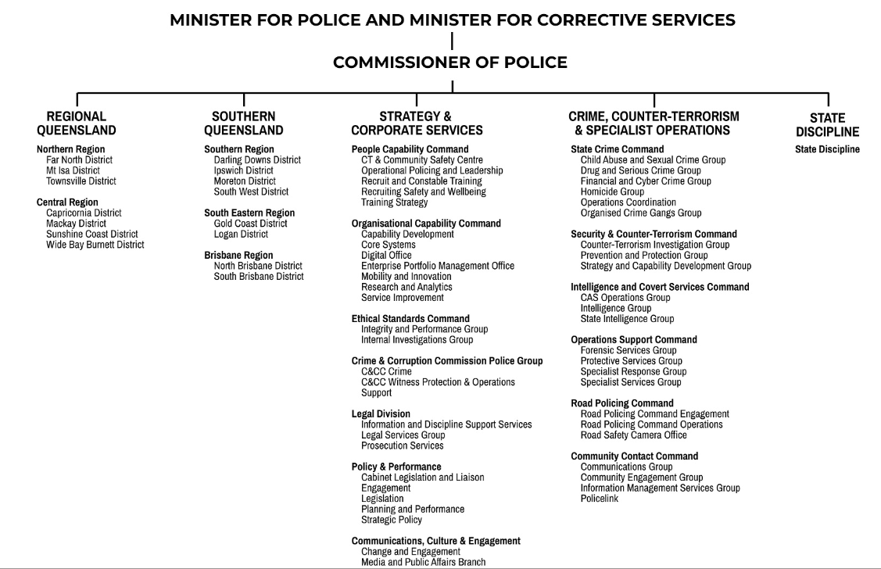
Organisational structure
(as at 30 June 2020)
17

Regional Queensland is responsible for and overviews the policing operations throughout Central and Northern Regions.

Southern Queensland is responsible for and overviews the policing operations across Brisbane, South Eastern and Southern Regions.
- As part of the QPS’s response to COVID-19, Deputy Commissioner Southern Queensland, Steve Gollschewski, as the State Disaster Coordinator, was deployed as the Commander of Taskforce Sierra Linnet within the State Police Operations Centre. During this time, Deputy Commissioner Regional Queensland oversaw the responsibilities for Southern and Regional Queensland.

Strategy and Corporate Services is responsible for continuous improvement and review, organisational efficiencies and better service provision to our community. The portfolio is responsible for Organisational Capability Command, People Capability Command, Policy and Performance Division, Legal Division, Ethical Standards Command, Communications, Culture and Engagement Division and the Crime and Corruption Commission (Police Group).

Crime, Counter-Terrorism and Specialist Operations is responsible for the provision of specialist police services through Community Contact Command, Security and Counter-Terrorism Command, Intelligence and Covert Services Command, Operations Support Command, Road Policing Command and State Crime Command.

State Discipline is responsible for the effective management of the discipline process across the QPS, by providing consistency with government policy directions and the Service’s strategic plan.

Service Alignment Program
In late 2019, the Commissioner sought a detailed, independent assessment of strategic challenges and opportunities for the organisation which came to be known as the QPS Strategic Review. The Review concluded in December 2019 with 22 recommendations made across seven themes:
- People, culture, health and wellbeing – supporting an engaged workforce
- Service delivery optimisation – an integrated service delivery model that respects local requirements
- Balancing resources and demand – mechanisms intended to ensure resources are allocated equitably across the Service
- Organisational performance management – implementing an approach that connects the organisation and unifies effort
- Governance – supporting effective prioritisation and decision making
- Importance of implementation – an improved, outcomes focussed orientation in delivering initiatives
- Public Safety Business Agency (PSBA) – a customer-oriented delivery model better attuned to the needs of the QPS.
The Service Alignment Program was established in January 2020 to implement the recommendations. The objectives of the program are threefold:
- delivering effective, efficient and responsive policing services
- a balanced focus on prevention, disruption, response and investigation
- a connected and engaged workforce aligned to the QPS values.
One of the foundational initiatives for the program is the Service Delivery Redesign Project which began in early 2020 and will drive service delivery reform throughout the state. The new service delivery model will be piloted in Moreton District in late 2020 with a broader rollout anticipated for 2020-21.
The SAP also facilitated the following organisational business improvements between program inception and 30 June 2020:
- the transition to a four Deputy Commissioner model with the creation of a new Regional Queensland Deputy Commissioner (located in Townsville) to oversee the policing operations across the central and northern police regions. The Southern Queensland Deputy Commissioner oversees policing operations across the Southern, South Eastern and Brisbane Regions. The introduction of the Southern and Regional Deputy Commissioners will assist the service in strengthening important partnerships with government agencies, non-government organisations and community groups to maximise opportunities and ultimately enhance community safety. It also provides greater support and better understanding of our frontline service delivery;
- Axon Citizen – a new functionality which simplifies the process for collecting evidence from members of the public. An intuitive interface allows critical evidence to be securely submitted into Evidence.com where items can be viewed, catalogued and stored. This new functionality will save officer time by removing the need to drive out to collect evidence on USBs or other storage devices or to obtain software to view footage that has been obtained;
- introduction of Workplace – a dedicated and secure internal communications platform to better connect and engage with our workforce.
In addition, the QPS also implemented changes to the organisational structure, including:
- transition of the QPS Armoury from PSBA to QPS as part of the realignment of PSBA and QPS functions;
- creation of the Communications, Culture and Engagement Division.

QPS Regional Map
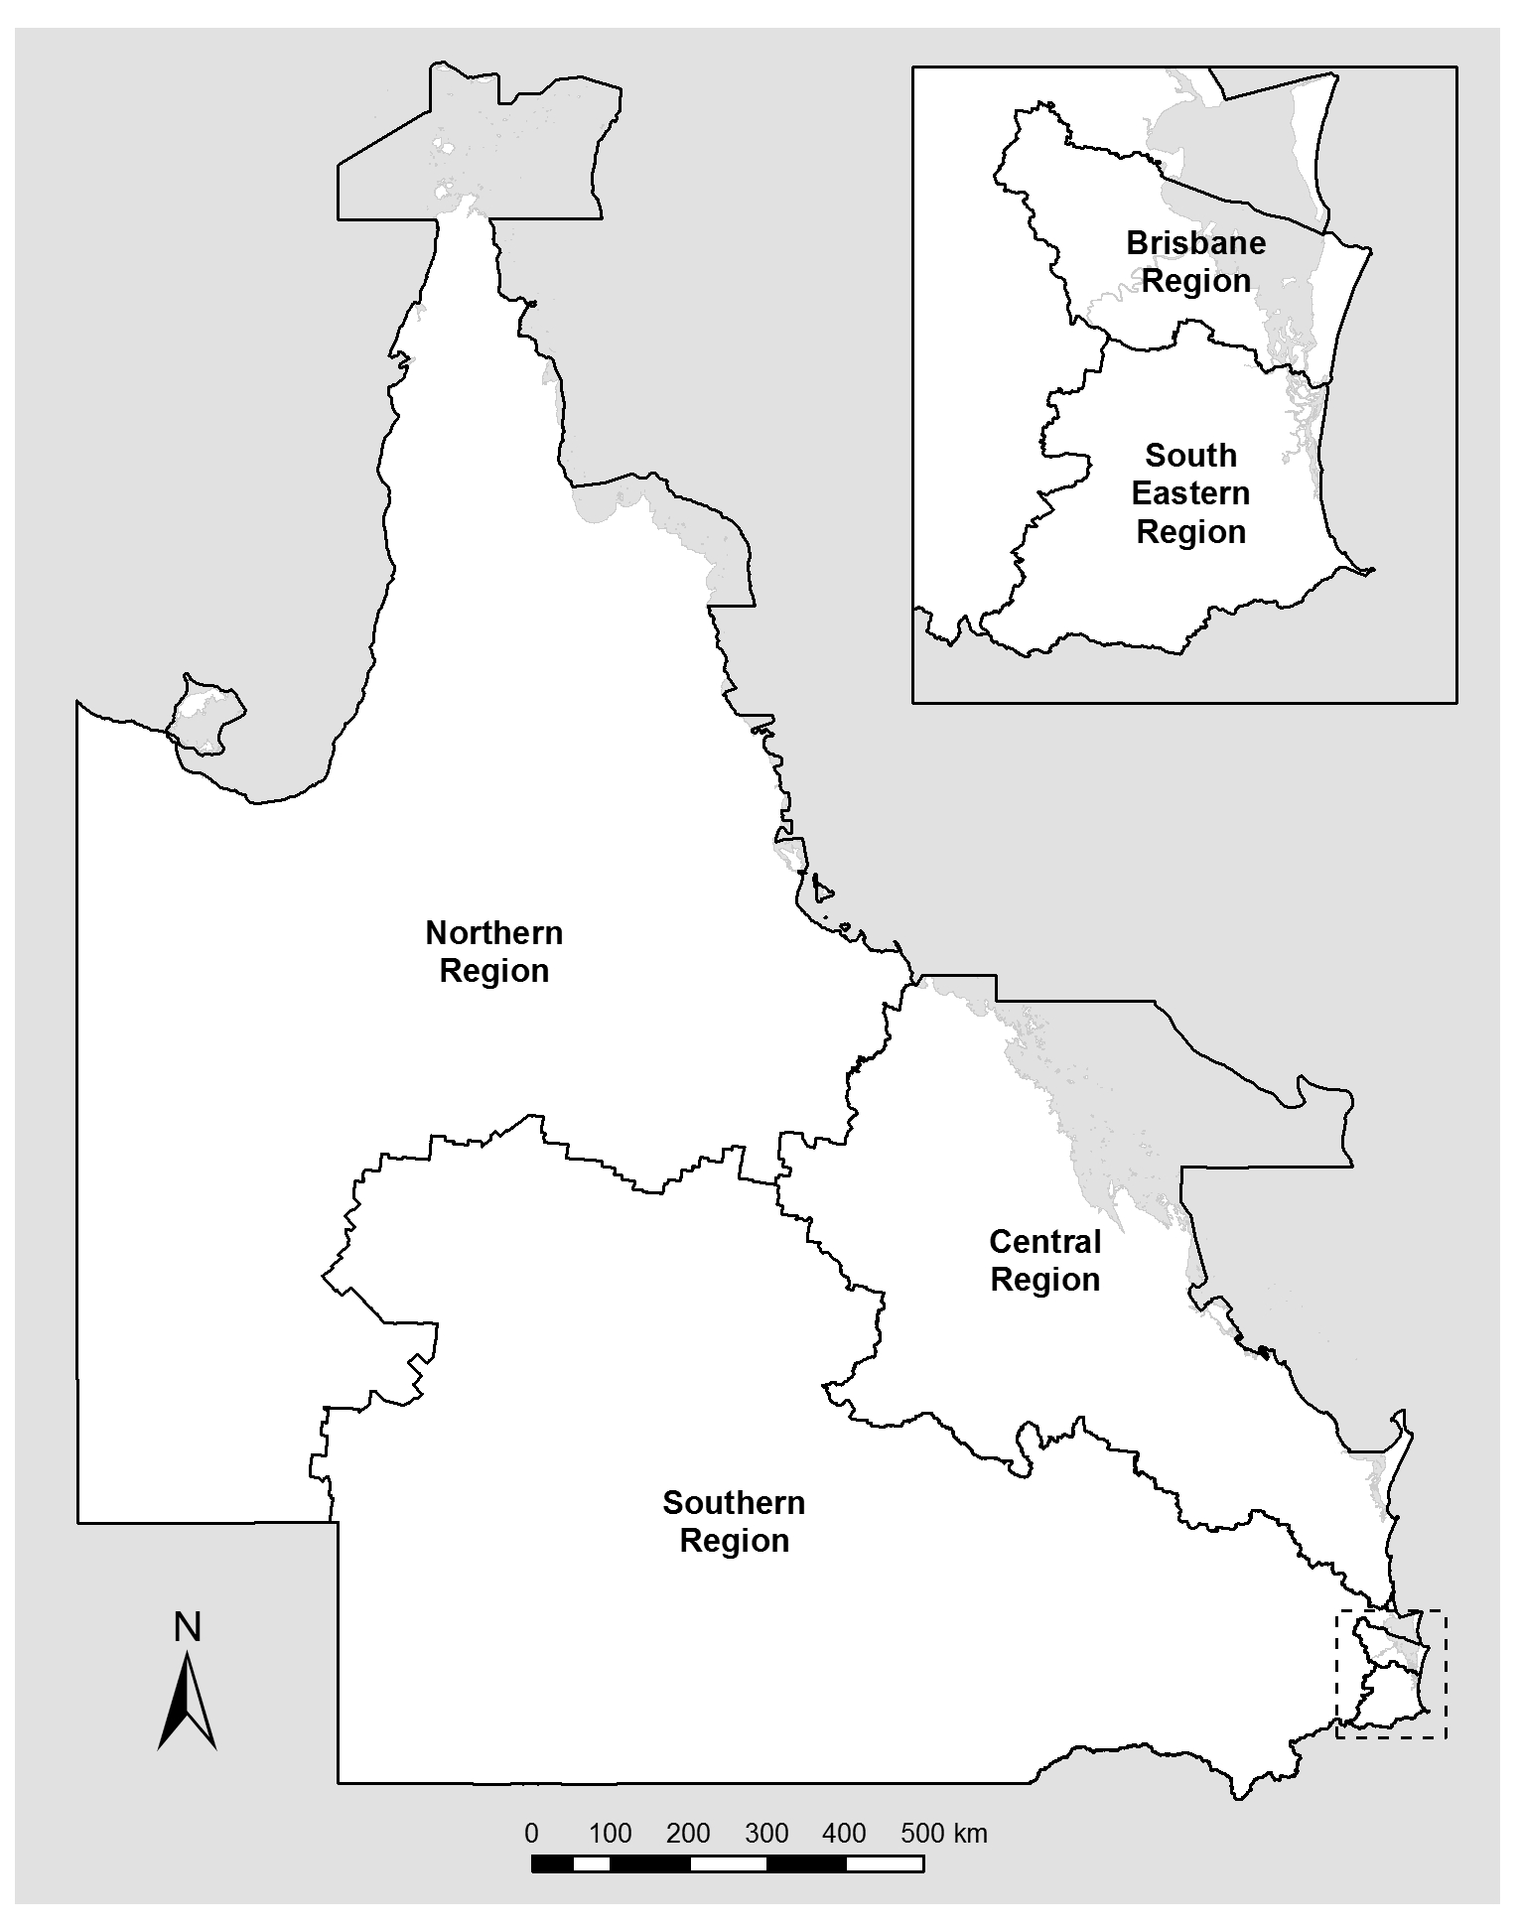
(as at 30 June 2020)
Locations

QPS delivers its services from various locations throughout the state including:

- Police stations | 339
- Police watchhouses | 58
- Police neighbourhood beats and shopfronts | 83
- District offices | 15
- Headquarters and regional offices | 6
- Communication centres | 14
- Police academies located in Oxley and Townsville | 2
- Policelink located in Brisbane (Zillmere) | 1
- Rapid Action and Patrols (RAPS) located at Gold Coast and Townsville | 2

In addition, each police district is supported by a range of specialist areas which may include the Child Protection and Investigation Unit, Criminal Investigation Branch, Intelligence Unit, Scenes of Crime and Scientific Units, Dog Squad Unit, Forensic Crash Unit, Road Policing Unit, Prosecutions Corp and Water Police Unit. There are also purpose-build investigation centres to respond to major incidents located at various stations and district offices throughout the state. A list of contacts and key locations for QPS is included in the appendices of this report.

The Public Safety Business Agency, in consultation with QPS, is responsible for delivering minor and medium capital works and major capital investment projects on behalf of the QPS. In 2019-20, the QPS, in partnership with PSBA, delivered:
- the new state-of-the-art Arundel Police Facility in Gold Coast District, which includes a dayroom with 104 workstations, a purpose-built Dog Squad facility and the Gold Coast Rapid Action Patrol Group;
- upgrade of the Logan Village Police Beat to the Logan Village Yarrabilba Police Facility;
- the new Newtown Police Facility, which will house various policing units and is a key hub for the local community to engage with police.

For more information on capital works activities, refer to the PSBA Annual Report 2019-20 which is available at www.psba.qld.gov.au.

QPS response to COVID-19
During 2019-20, the COVID-19 health pandemic has emerged as a significant issue for the Queensland community. The QPS continues to play a critical role in the whole-of-government response by ensuring compliance with public health directions, while maintaining business as usual policing activities. Since the declaration of the public health emergency on 29 January 2020 under the Public Health Act 2005, the QPS has performed a pivotal role in the whole-of-government response to protect the community from the spread of COVID-19 in Queensland. The highly effective compliance activities performed by QPS to give effect to and enforce the public health measures are fundamental to Queensland’s success in flattening the curve and keeping case numbers low. The extensive and ongoing QPS contribution to the Queensland Government’s COVID-19 response has comprised the following (to 30 June 2020):
- establishing Taskforce Sierra Linnet within the State Police Operations Centre (SPOC) to prepare, plan and coordinate the QPS’s contribution to the whole-of-government COVID-19 response. The operation of the SPOC and other various functions associated with the COVID-19 response has required the allocation of a significant number of police officers and staff members at short notice to duties dedicated to the COVID-19 response;
- standing up the State Disaster Coordination Centre at the Kedron Emergency Services Complex in Kedron, District Disaster Coordination Centres and Local Disaster Management Groups;
- leading the whole-of-government planning groups across a broad range of disaster management issues through its legislative responsibilities under the Disaster Management Act 2003 and Queensland’s disaster management arrangements which included the temporary appointments of the State Disaster Coordinator, District Disaster Coordinators, State Disaster Coordination Centre Commander and Chair of the State Coordination Group. The disaster management arrangements have been used to activate support from the Australian Defence Force who have provided significant commitments to the operationalisation of border plans;
- effectively implementing state border controls at international and domestic airports, state roads, and establishing vehicle check points and restricting access to remote communities prescribed as ‘designated areas’ under, initially, Commonwealth biosecurity legislation and later, a public health direction of the Queensland Chief Health Officer;
- appointing approximately 12,000 police officers as emergency officers (general) under the Public Health Act 2005 which enables police officers to assume delivery of emergency officer (general) roles, including the service of quarantine notices at Queensland’s state and international borders;
- providing a security overlay for quarantine arrangements at hotels and accommodation facilities for international and domestic arrivals to Queensland;
- conducting residential quarantine and business compliance visitations, including targeted operations and ongoing monitoring;
- establishing dedicated intelligence and investigative functions to detect and address offending that endangers public health;
- delivering various policing operations, including dedicated high visibility operations to enforce social distancing requirements in public places, including shopping centres, markets, parks, picnic areas, waterfronts, beaches etc;
- conducting proactive patrols, general compliance and community education about public health restrictions;
- maintaining business as usual policing functions; and
- enforcing social distancing.

The QPS has maintained business as usual policing operations with some adjustments to certain activities to reduce the risk of potential transmission of COVID-19. To prioritise the allocation of frontline resources to the COVID-19 response, the QPS deferred police attendance for some standard operational duties including:
- static breath testing and drug testing operations (random breath and drug testing continued through vehicle interceptions);
- practical driver testing in regional and remote areas;
- mobile operations component of the Camera Detected Offences Program (to re-allocate police officers normally staffing mobile speed camera vans to COVID-19 related tasks);
- diverting support staff from non-essential duties to support COVID-19 related tasks.
The guiding principle for QPS’s contribution to the COVID-19 emergency has been to support the public health response through an organisational enforcement posture of ‘compassion, communication and compliance’. The QPS has issued warnings, penalty infringement notices or commenced prosecution for blatant and serious breaches of relevant Public Health Act 2005 offences. Maintaining community confidence and cooperation is crucial to achieving the public health objectives, however, behavior that recklessly or deliberately endangers public health has been the subject of appropriate enforcement action.
The rapid and frequent changes to public health measures in Queensland have required unprecedented levels of responsivity and scalability from QPS, including legal resources to interpret and apply the measures in an operational context and communication to, and training of, frontline police to ensure the changes are understood and applied correctly. Large-scale planning activities undertaken in the preliminary stages of the QPS response enabled the operationalisation of these functions and continue to inform and be adapted for later stages of the COVID-19 response.
The QPS has taken a proactive approach in ensuring the safety and wellbeing of its employees throughout the COVID-19 pandemic. Risk mitigation measures have been implemented including:
- adjustments to operational procedures to minimise physical contract;
- supply of personal protective equipment to ensure the ongoing delivery of effective policing services to Queensland communities while safeguarding the wellbeing of QPS members;
- development of safe operating procedures to minimise risk of potential exposure to COVID-19 during routine policing functions. This includes procedures for general interactions with members of the public and specific instructions for conducting finger printing, roadside breath testing and drug testing, DNA sampling, and prisoner transportation;
- development of the COVID-19 Safe Strategy and Planning Framework, which sets out enablers for safe, healthy and sustainable workplaces; monitoring and responding to potential outbreaks of COVID-19; and delivering a protected and resilient workforce that is capable of sustaining business operations within the COVID-19 environment.
The Service continues to review and adapt its operational capabilities and priorities based on the risk profile of COVID-19 in the community. The QPS acknowledges the COVID-19 pandemic presents a significant public health and safety issue which is likely to continue into the future, at least in the short term and policing in Queensland will continue to reflect the risks to the community and QPS employees. The QPS remains committed to supporting the public health response to the declared disaster situation and public health emergency for COVID-19 through its law enforcement functions and public safety capabilities to ensure the safety of all Queenslanders.
Financial Summary

Summary of financial performance
The following table summarises the operating result and financial position for QPS 2019-20 and the previous financial year.
Statement of comprehensive income | 2019-20  $’000 | 2018-19  $’000
Total income from continuing operations | 2,468,540 | 2,397,039
Total expenses from continuing operations | 2,483,421 | 2,393,656
Total other comprehensive income | 106 | (1)
Total comprehensive income | (14,775) | 3,383
Statement of financial position | 2019-20  $’000 | 2018-19  $’000
Total assets | 249,565 | 290,481
Total liabilities | 133,984 | 164,521
Net assets/equity | 115,581 | 125,960

Income and expenses from continuing operations
QPS is funded to deliver timely, high quality and efficient policing services, in collaboration with community, government and non-government partners, to make Queensland safer. Funding for these services is received principally through parliamentary appropriations.
QPS also receives income from other sources, including user charges and fees comprising special services, the sale of goods and services, corporate services provided by the PSBA at below fair value and government grants and contributions.
QPS aims to deliver safe and secure communities through innovation, collaboration and best practice. The expenses incurred in the delivery of these services are summarised below.
For 2019-20, QPS received income from continuing operations totalling $2,468.54 million and incurred total expenditure from continuing operations of $2,483.42 million. This was comprised of:

Income

Expenses

Summary of financial position
QPS was in a positive financial position at the end of the financial year. The total equity (assets less liabilities) of QPS at the end of 2019-20 was $115.58 million. This was comprised predominantly of:
Assets

Liabilities

The Public Safety Business Agency Act 2014 (section 7) requires the PSBA to hold and maintain infrastructure, fleet and communication technology assets for the public safety entities and the majority of these assets are recognised and reported in the financial statements of the PSBA. As a result of a shift in assets, accounting management and policy for the department, which was endorsed by the Queensland Treasurer, QPS operational assets will transfer from PSBA to QPS in 2020-21. The net book value of these assets as at 30 June 2020 are as follows:
- land $461.8 million
- buildings and infrastructure $970.8 million
- plant and equipment $151.5 million
- software $0.04 million
- heritage and cultural assets $24.2 million
- work in progress $72.6 million.
There were no significant events after balance date that could be expected to impact the reported operating result for QPS for the year ended 30 June 2020.

Performance
Key performance measures
The services provided by the QPS focus on reducing and preventing the incidence of crime, public disorder, and road trauma to build safe, caring, and connected communities. These are delivered through two service areas – Crime and Public Order, and Road Safety.
The objective of Crime and Public Order is to uphold the law by working with the community to stop crime and make Queensland safer. A range of services is provided by the QPS to support this and includes:
      - protecting personal safety and preventing and detecting related offences including homicide, assault, sexual assault and robbery
      - protecting property and preventing and detecting related offences, including unlawful entry, other property damage, motor vehicle theft, and other theft
      - maintaining public order and safety, including during major events and disasters; addressing public space enjoyment, street and nuisance offences; liquor licensing issues; and environmental design to reduce crime including alcohol-fuelled violence.
The objective of Road Safety is to contribute to stopping crime and keeping communities safe through road safety relationships, reducing road trauma and evidence-based enforcement anywhere, anytime. This includes targeting the prevention and detection of speeding; red light offences; driving while distracted; driving under the influence of alcohol or drugs; driving while fatigued; and not wearing seatbelts.
The delivery of Crime and Public Order and Road Safety policing services to Queenslanders is supported by a range of activities designed to promote ethical behaviour, discipline and professional practice.
The impact of the COVID-19 health pandemic had a significant impact on Queenslanders and the delivery of some policing services. At least part of the variance between the 2019-20 target/estimate and the 2019-20 actual result may be attributed to the impact of, and QPS’s response to, the COVID-19 health pandemic, including the allocation of resources to the SPOC, SDCC and increased patrols at Queensland’s border, domestic and international airports and other identified COVID hotspots.
The following tables provide an overview of the key performance measures for the QPS for 2019-20. Data for 2018-19 is sourced from the Queensland Police Service 2018-19 Annual Report unless otherwise stated in the Notes.
Service Area: Crime and Public Order
Performance measures | Notes | Strategic Plan | 2019--20 SDS | RoGS | 2018-19 Actual | 2019-20 Target  /Estimate | 2019-20 Actual
Percentage of personal safety offences cleared within 30 days: | 1,4 |  | 
- Homicide |  |  |  |  | 78% | 70-83% | 71%
- Assault |  |  |  |  | 55% | 54-63% | 57%
- Sexual assault |  |  |  |  | 48% | 48-57% | 50%
- Robbery |  |  |  |  | 67% | 57-62% | 66%
- Total personal safety |  |  |  |  | 54% | 54-61% | 55%

Service Area: Crime and Public Order (cont’d)
Performance measures | Notes | Strategic Plan | 2019-20 SDS | RoGS | 2018-19 Actual | 2019-20 Target  /Estimate | 2019-20 Actual
Percentage of property security offences cleared within 30 days: | 2, 4 |  | 
- Unlawful entry |  |  |  |  | 20% | 18-21% | 22%
- Other property damage |  |  |  |  | 25% | 25-27% | 27%
- Motor vehicle theft |  |  |  |  | 37% | 36-39% | 43%
- Other theft (excluding unlawful entry) |  |  |  |  | 26% | 26-28% | 29%
- Total property security |  |  |  |  | 28% | 28-30% | 30%
Percentage of good order offences cleared within 30 days | 3, 4 |  |  |  | 81% | 80-85% | 78%
Rate of complaints against police per 100 sworn (operational) staff | 5 |  |  |  | 9.5 | <9.8 | 9.4
Public perception of police integrity | 6
- Police perform their job professionally |  |  |  |  | 87.1% | ≥85% | 86.0%
- Police treat people fairly and equally |  |  |  |  | 74.4% | ≥75% | 71.8%
- Police are honest |  |  |  |  | 73.9% | ≥75% | 73.0%
- I do have confidence in the police |  |  |  |  | 84.8% | ≥85% | 83.9%
Satisfaction of members of the public who had contact with police in the last twelve months | 6 |  |  |  | 84.5% | ≥85% | 81.7%
Public satisfaction with police dealing with public order problems | 6 |  |  |  | 73.8% | ≥70% | 72.0%
Public satisfaction with police dealing with emergencies and disasters | 6 |  |  |  | 83.5% | ≥85% | 85.5%
Percentage of code 1 and code 2 incidents attended within 12 minutes | 7 |  |  |  | 86% | >80% | 87%
Youth diversions as a proportion of all youth offenders proceeded against by police | 8 |  |  |  | 57.3% | >60% | 62.5%
Service Area: Crime and Public Order (cont’d)
Performance measures | Notes | Strategic Plan | 2019-20 SDS | RoGS | 2018-19 Actual | 2019-20 Target  /Estimate | 2019-20 Actual
Cost of crime and public order per person | 9 |  |  |  | $380 | $389 | $392
Rate of victimisation | 10, 11 | 
- Offences against the person |  |  |  |  | 6.8 | <6.5 | 7.0
- Offences against property |  |  |  |  | 47.5 | <43.3 | 49.7
Youth reoffending | 12, 13, 14 |  |  |  | 73% | 73.6% | 71%
Offender Diversions as a proportion of all offenders proceeded against by police | 15 |  |  |  | N/A | >10% | 10.7%
Public perception of safety | 6, 16, 17 |  |  | 
- Feelings of safety walking alone in neighbourhood during the night |  |  |  |  | 53.4% | >50% | 52.6%
- Feelings of safety travelling alone on public transport during the night |  |  |  |  | 32.3% | >25% | 33.0%
Agency engagement | 18, 19 |  |  |  | 53% | >53% | 53%
Workforce diversity | 20, 21, 22 | 
- Women in SO, SES and above |  |  |  |  | 13.8% | 16.7% | 14.0%
- Aboriginal and Torres Strait Islander peoples |  |  |  |  | 2.4% | 3.0% | 2.4%
- People with Disability |  |  |  |  | 2.9% | 5.0% | 2.8%
- People from non-English speaking background |  |  |  |  | 7.0% | 9.0% | 6.7%

Notes
- The offence categories reported separately are those classified as ‘violent’ crimes and are the most significant personal safety offence categories in terms of their impact on the community. The ‘total personal safety’ offences figure also includes the offence categories of extortion, kidnapping, abduction and deprivation of liberty and other offences against the person. Homicide includes the offence categories of murder, attempted murder and conspiracy to murder.
- The offence categories reported separately are considered high volume property security offences. The total property security offences figure also includes arson, fraud and handling stolen goods.
- Good order offences include offences relating to public nuisance, obstructing police and other offences against good order. An increase in good order offences generally indicates an increase in policing activity around public spaces and major events, and a range of related proactive policing strategies often focusing on liquor-related enforcement.
- Performance is reported against a range rather than a single figure. The target ranges for 2019-20 consider recent results and any known factors that are likely to have an impact in the reporting period. Upper and lower values account for past variation from the recent historical average.
- ‘Complaints’ are defined as statements by members of the public regarding police conduct, including officers on, off or unknown duty, when a person was in police custody or had voluntary dealings with the police. Sworn (operational) staff refers to a police officer employed by the QPS who has sworn the Oath of Office under the Police Service Administration Act 1990, delivering a police or police-related service to an external customer.
- Public satisfaction with police and perceptions of police are sourced from the results of the National Survey of Community Satisfaction with Policing. The National Survey of Community Satisfaction with Policing is a general community survey. Respondents to these questions may or may not have had contact with police in the last 12 months.
- Code 1 and 2 incidents include very urgent matters when danger to human life is imminent and urgent matters involving injury or present threat of injury to person or property. The benchmark of 12 minutes was chosen for comparability with New South Wales police who use similar methodology, business rules and systems.
- The wording of the measure has been amended to refer to ‘young offenders’ in place of the term ‘juvenile’, reflecting the current Queensland Youth Justice Strategy and the nationally agreed terminology for the RoGS measure. The existing data definition (current as at 1 July 2019 and on the basis of which the 2019-20 target was set) is to be amended for the 2021 edition of the RoGS. It has been determined by agreement of all Australian policing jurisdictions that the revised definition will apply to 2019-20 figures. The 2021 RoGS will re-publish figures for youth diversions using the revised data definition for the 10 years to 2019-20. Therefore, the above-quoted figure will differ from that reported in the 2021 RoGS and will be revised for the 2020-21 QPS Annual Report.
- Cost of crime and public order per person is the total cost of delivering crime and public order-related policing activities divided by the estimated population of Queensland. This measure is reported in line with RoGS methodology. Total cost is calculated based on the estimated percentage of police activity applied to crime and public order related activities. This includes operating expenditure plus a calculated user cost of capital for property, plant and equipment assets excluding land assets. This measure is acknowledged as a high-level estimate only owing to current limitations of aligning budget allocation to specific service areas.
- The measure counts the number of people or addresses classed as a ‘victim’ of a personal or property offence in the preceding 12-month period and represents this as a rate per 1000 population. The measure is used as a headline measure for the Queensland Government’s Keep Communities Safe objective in Our Future State: Advancing Queensland’s Priorities and employs the same definition and methodology. The figure is separate and distinct from the rates of offending. It is possible to have a reduction of the number of victims without a reduction in offences.
- The Queensland Government has set a target that the rate of victimisation should reduce by 10% over 10 years to 2028, based on baseline figures for 2017-18. The 2019-20 target is calculated on that basis.
- Also known as ‘Proportion of young offenders with another charged offence within 12 months of initial finalisation for a proven offence’, the measure is currently used as a headline measure for the Keep Communities Safe objective in Our Future State: Advancing Queensland’s Priorities.
- As part of the ‘Keep Communities Safe’ Advancing Queensland Priority the Queensland Government has set a target for a 5% reduction (against a 2015-16 baseline) by 2020/21.
- Measuring recidivism is complex due to the varying nature, detection and processing of offending and offenders, and the variety of ways to measure re-offending. This measure reflects the offending of all young people in Queensland who have had a proven charge, regardless of whether they had prior contact with the youth justice system or had received youth justice services.
- Offender Diversions refers to the number of all offenders who are diverted as a proportion of all offenders proceeded against by police. The term ‘diverted’ includes diversions of offenders away from the courts by way of: community conference, cautioning by police, intoxication diversion, drug diversion or graffiti diversion and infringement notices (excluding traffic infringement notices).
- The figure refers to the percentage of Queensland survey respondents who selected “very safe” or “safe” for each of the following activities:
- Walking alone in your neighbourhood during the night
- Travelling alone on public transport during the night.
- The measures for feelings of safety on public transport are based on the entire survey population and includes those participants who have not used public transport. The figure is reported to match the existing RoGS standard.
- Data for this measure is taken from responses of QPS employees to the whole-of-Government Working for Queensland survey, conducted annually. The measure describes employees’ level of engagement with the organisation in relation to motivation, inspiration and pride.
- The target is based on continual improvement from the baseline figure of 2016 (53%) or the most recent figure (whichever is the higher).
- In early 2016, the Leadership Board of Directors-General introduced and committed to sector-wide diversity targets, working from the principle that our workforce should closely represent the community we serve.
- Data is based on substantive placements and includes paid and unpaid employees, excluding staff members engaged on a casual relief basis. Figures are based on self-reported data that is not mandatory which may result in under-reporting on at least some of the diversity categories included. QPS has an operational workforce with 96.5% of police officers employed in operational roles. Due to the operational requirements of police, the “People with disability” target is based on non-operational staff members only.
- The targets listed for each group represent the target percentage representation for the year 2022. It is not considered appropriate to set an annual target in the context of police officers. The QPS workforce generally changes at a slower rate compared to other agencies as it has a lower attrition rate, and regarding police officers, generally fills positions internally only. Consequently, it is challenging to achieve changes to the workforce except over an extended period.

Key
RoGS – Report on Government Services
SDS – Service Delivery Statement
Strategic Plan – Queensland Police Service Strategic Plan 2019-2023

Service Area: Road Safety
Performance measures | Notes | Strategic Plan | 2018-19 SDS | RoGS | 2018-19 Actual | 2019-20 Target  /Estimate | 2019-20 Actual
Rate (per 100,000 people) of road crash fatalities | 1, 2, 3 |  |  |  | 4.47 | 4.4 | 4.64
Rate (per 100,000 people) of people hospitalised following a road crash | 1, 2, 3 |  |  |  | 134.0 | 110 | TBC
Cost of Road Safety per person | 4 |  |  |  | $88 | $90 | $90

Notes:
- Road safety in Queensland is a collaborative approach and enforcement strategies are one aspect of overall road safety efforts. The QPS collaborates with key industry and community organisations, research institutions, government agencies and peak bodies representing road user groups.
- The 2019-20 Target/Estimate is consistent with the targets outlined in Safer Roads, Safer Queensland: Queensland's Road Safety Strategy 2015-21 (the Road Safety Strategy) as well as taking into account historic trends and the economic outlook. The 2019-20 Target/Estimates have been amended to be consistent with targets set by the Department of Transport and Main Roads (DTMR).
- Population data is sourced from Australian Bureau of Statistics Australian Demographic Statistics Catalogue No. 3101.0.
- Cost of road safety per person is the total cost of delivering traffic-related policing activities divided by the estimated population of Queensland. This measure is reported in line with Report on Government Services methodology. Total cost is calculated based on the estimated percentage of police activity applied to road safety related activities. This includes operating expenditure plus a calculated user cost of capital for property, plant and equipment assets excluding land assets. This measure is acknowledged as a high-level estimate only.

Key
RoGS – Report on Government Services
SDS – Service Delivery Statement
Strategic Plan – Queensland Police Service Strategic Plan 2019-2023

2019-20 Highlights

This section reports on the objectives of the QPS Strategic Plan 2019-2023. To drive delivery of its objectives, the QPS focuses on four main strategies:
- Stop crime: the QPS is committed to preventing, investigating and disrupting crime to ensure the safety of all Queenslanders
- Make the community safer: the QPS is committed to the safety of all Queenslanders and delivers this through policing operations conducted on the road, in the sky and on the water
- Strengthen relationships with the community: the QPS values the assistance provided by the public in reporting crimes, sharing social media posts to help locate missing persons and locate offenders, and participating in QPS-led events
- Equip our workforce for the future: the QPS is committed to ensuring its officers are equipped to deal with emerging issues and trends, now and into the future.
This is just a snapshot of the performance highlights from 2019-20 and is not representative of all work undertaken during the reporting period.

YOUNG PEOPLE – YOUTH JUSTICE STRATEGY
The QPS continues to work collaboratively across the state to implement the Queensland Government Youth Justice Strategy – Working Together Changing the Story 2019-2023 Action Plan. The QPS is the lead agency for two ongoing actions in the Action Plan:
Increasing Police Diversions
The QPS continues to enhance policing practices for dealing with young offenders with an emphasis on building more robust processes to divert young people away from the youth justice system in appropriate circumstances. During 2019-20, the QPS continued to work with the Department of Youth Justice (DYJ) and Department of Child Safety, Youth and Women (DCSYW) to facilitate, where appropriate, the diversion of young offenders, who commit relatively minor offences, from the criminal justice system to a range of support services where they can address factors that may be contributing to their offending behaviour and to curb future recidivist behaviour. As at 30 June 2020, the QPS dealt with 11,113 unique young offenders and achieved a diversion rate of 62.5% or 6,943 unique young offenders were diverted from the court system.
On 5 July 2019, the QPS developed the protected admissions scheme which addressed legal limitations requiring a young person to make an admission to the offence to police, prior to diverting the young offender to appropriate support services. As at 30 June 2020, 211 youths accepted protected admissions and were cautioned.
Framing the Future
Following the success of Project Booyah, the QPS initiated Framing the Future (FtF) – a dedicated mentoring and support program for graduates of Project Booyah and the new Booyah Respect program. The aim of FtF is to maintain a relationship with the graduates to prevent regression into anti-social and criminal behaviour by facilitating their continued engagement with education and/or employment and implementing tailored interventions for those that do regress.
During 2019-20 as part of Project Booyah, the FtF program continued to operate across nine areas in Queensland including Cairns, Townsville, Rockhampton, Pine Rivers, Redlands, Logan, Ipswich, Sunshine Coast and Gold Coast. As at 30 June 2020, 309 young people were being supported through the Project Booyah FtF across these nine locations, including participants from both the Booyah and Respect programs.

Co-Responder approach to Youth Justice
In December 2019, the Logan District Child Protection and Investigation Unit (CPIU) commenced trialling a joint initiative with the Department of Youth Justice (DYJ) called the Community Youth Response (CYR).
The CYR is a co-responder model designed to provide support to frontline police in matters involving young people. The model aims to support police and young people by creating links to stakeholder services, explore opportunities for diversion and assist with alternatives to remanding youth in custody, where appropriate. Police and Youth Justice employees are currently staffing the program three nights a week. The primary aim of the trial is to reduce recidivism and the number of youths in custody.
Youth Justice Five-Point Action Plan
On 10 March 2020, the Queensland Government released the new Five-Point Action Plan to reinforce and strengthen the existing strategies and initiatives already in place to address youth crime. The QPS is committed to stopping crime and making the community safer and will continue to work collaboratively with the DYJ and other key stakeholders to implement the actions in the Five-Point Action Plan.
The Five-Point Action Plan includes:
- Tougher action on bail. Offenders posing a risk to the community should not get bail;
- Police blitz on bail, appealing children’s court decisions where appropriate;
- 24/7 Co-responder Team, a police/youth justice worker partnership targeting high-risk offenders;
- Culture-based rehabilitation for indigenous offenders through new On Country initiatives;
- Empowering local communities in the war on crime with $2 million for community-based organisations for local community-based solutions.
As part of the Five-Point Action Plan, the QPS and DYJ have established co-responder teams in five locations across Queensland (North Brisbane, Rockhampton, Townsville, Cairns and Logan) to increase community safety and engage at-risk young people to reduce youth offending.
Blitz on Bail
Since the announcement of the Five-Point Action Plan, the QPS Youth Justice Prosecution Team have been carrying out the “Blitz on Bail” by reviewing bail decisions made by both police and the Court. Matters where it is believed that the young person would pose an unacceptable risk to community safety are identified, and if bail is granted by the Courts, appropriate steps are being taken to seek review of those decisions in the Supreme Court. Since March 2020 to 30 June 2020, the QPS achieved a 100% success rate in appeals that resulted in bail being revoked, which highlights our commitment to making the community safer.
The achievements of the QPS with respect to youth justice represents our commitment to stopping crime, making the community safer and strengthening relationships with the community as well as our partner agencies. The QPS will continue to work with other government agencies and the community to address youth crime and, where possible, divert youths from the criminal justice system to support services.

WHAT’S BEEN HAPPENING ACROSS THE SERVICE
The QPS has five regions and various specialist policing commands that are dedicated to serving and protecting the Queensland community.
Refer to the pages 17-20 for more information on the QPS’s Organisational Structure and map of the QPS regions.
Road Policing and the Fatal Five
The Queensland road toll for the 2019-20 financial year was 238 road fatalities, which equates to 4.64 fatalities per 100,000 population. This represents 10 more fatalities than the previous financial year, when 228 fatalities were recorded (4.51 fatalities per 100,000 population).
Many road crashes involve at least one of the ‘Fatal Five’ high-risk road user behaviours which include speeding, drink and drug driving, not wearing a seat belt, driving while fatigued, and driver distraction and inattention. The QPS is committed to making the community safer by conducting multiple statewide road policing enforcement campaigns to influence driver behaviour and target criminal offending on Queensland roads. In 2019-20, the QPS delivered various high visibility road safety operations to target the Fatal Five high-risk road user behaviours and reduce lives lost on the roads which resulted in:
- more than 146,000 speeding infringement notices issued (excluding camera detected offences)
- approximately 7,940 infringement notices issued for not wearing seat belts
- more than 8,700 infringement notices issued for using mobile phones
- over 2.03 million random breath tests which detected approximately 15,190 drink driving offences.
Remote Piloted Aircraft to ease delays caused by major traffic accidents
The QPS is utilising the latest drone technology to reduce the impact of road closures and traffic congestion on main roads and freeways caused by major traffic accidents, cutting crash scene mapping times in half and improving the quality and accuracy of evidence captured at the scene. As we move into a digital era, the QPS looks to technology for opportunities to better equip our workforce for the future and to provide better outcomes for the community. The implementation of this innovative drone technology demonstrates QPS’s commitment to achieving these objectives.
Never too old to be solved
The Homicide Cold Case Investigation Team is committed to stopping crime and making the community safer by examining unsolved homicide and suspicious long-term missing persons investigations utilising advancements in technology and forensic and criminal investigation techniques.
In August 2019, the team solved one of the oldest cold case murder investigations that dated back 55 years ago to April 1964 and resulted in an offender being charged with murder. Further investigations by the team revealed the offender was also responsible for a triple homicide that occurred in 1974.
The dedication and commitment of the Homicide Cold Case Investigation Team demonstrates QPS’s ongoing commitment to stopping crime, holding offenders accountable and providing some closure for the families and friends of the victims of these crimes.
Cracking down on Outlaw Motorcycle Gangs
The Organised Crime Gangs Group (OCGG) works in partnership with police districts and various government departments to target crime linked to organised crime gangs including Outlaw Motorcycle Gangs to stop crime and make the community safer.
During 2019-20, the OCGG worked in partnership with the National Anti-Gang Squad Strike Team, Australian Federal Police and Australian Taxation Office to prevent, disrupt and investigate cross-jurisdictional gang related crime which resulted in:
- 302 OMCG participants arrested on 1,218 charges
- 319 official consorting notices issued, deterring recognised offenders from establishing, maintaining and expanding criminal networks
- 40 persons charged with wearing gang related prohibited items
- since 2013, in partnership with the Crime and Corruption Commission, 59 restraining orders have been obtained over property to the value of $16.7 million, in addition to various ATO tax assessments being levied from operations identifying unexplained income.
Keeping our Queensland waterways safe
The QPS is dedicated to keeping the Queensland community safe, not only on our roads and in the sky, but also on our waterways too. The Queensland Water Police provides specialist support focussing on maritime incidents and operations including:
- maritime safety and enforcement activity on our coastal and inland waterways to a distance of 200 nautical miles offshore;
- drug and alcohol enforcement activity and intelligence gathering;
- search and rescue with approximately 750 operations undertaken annually;
- a statewide Dive Unit response with approximately 150 deployments each year.
The Water Police operates from 11 main water police bases across Queensland 24/7 and has a fleet of 65 vessels to ensure the safety of the marine community.
In March 2020, a commissioning ceremony was held for two new Queensland Police Vessels (QPV) for Sunshine Coast and Hervey Bay. The vessels are named after two police officers who sadly lost their lives in the line of duty. QPV Norm Watt is named after Senior Constable Norm Watt who died while responding to an incident near Rockhampton on 21 July 2000, and QPV Shayne Gill is named after Constable Shayne Gill who died instantly when he was struck by a passing truck while writing a traffic ticket on the Bruce Highway on 21 May 1996. These vessels honour the memory of these two officers and their efforts to serve Queensland.
In delivering on our commitment to equipping the workforce for the future, the Gold Coast Water Police Unit received a new purpose-built 12 metre monohull speed patrol boat with enhanced operational capability in May 2020. This new vessel, which is yet to be commissioned, will complement the two rigid-hull inflatable boats and two jet skis currently utilised by the Gold Coast Water Police.
Bail Application
The Mobile Capability Centre has produced a new and innovative Bail Application across the QPS desktop and Apple Ipad QLiTE devices. The application digitises bail reporting, automated several manual processes and provided a standardised reporting and search solution for all persons reporting on bail across Queensland. This application is another example of QPS utilising technological advancements to make the community safer and better equip the workforce for the future.
The Bail Application has been integrated into the Queensland Police Records Information Management Exchange (QPRIME) database which enables the timely addition of warnings and flags, thereby increasing the safety of officers and Station Client Service Officers. The Application also facilitates easy auditing of bailee activity and efficient use of information to report breaches of bail.
The Bail Application has improved efficiency and saved officer time in bail administration and auditing for the over 4,200 bailees actively managed by the QPS, at any one time. Further developments to the Bail Application enable frontline officers to conduct field recording of bail compliance and curfew checks for adult and youth offenders which also supports the Queensland Government’s Five-Point Action Plan to reduce youth crime.

New Evidence Management Facility in Brisbane
In February 2020, the QPS opened the new purpose-designed evidence management facility in Brisbane to ensure our police officers are equipped to respond to the challenges of the future. The size of the new facility can house over 37,000 exhibits, 50 motor vehicles, 600 pallets of interview tapes and the police armoury.
The new state-of-the-art facility contains specialised examination spaces, a vehicle examination garage, climate-controlled storage for cold case evidence and delivers a significant increase in the capacity for the storage of general exhibits. It also incorporates the latest technology and security features and gives officers access to the latest forensic methods.
Counter-Terrorism
The new world-class use of force, weapons and counter-terrorism training facility currently under construction at Wacol is just one example of QPS’s commitment to ensuring its officers are equipped with the state-of-the-art equipment and technology now and into the future. The facility will include two indoor firearms ranges, a scenario village and specialist training areas to increase capability in managing terrorism and critical incidents.
Authorisations made relating to a terrorist act or threat
In terms of the Police Service Administration Act 1990 section 5.17(15) Authorisation of non-State police officers, no authorisations were made relating to a terrorist act or threat during 2019-20.
Amber Alert
The QPS values the information and assistance received from members of the public and strives to strengthen relationships with the community to generate better outcomes for police and the people of Queensland. Amber Alerts are issued by police when they need urgent public assistance from the Queensland community to help locate abducted or high-risk missing children who are at imminent risk of death or serious harm. The alerts are broadcast to the public through secondary alerting partners including the media, commercial billboard companies, community groups and other government agency shared messaging, public transport messaging systems, a national emergency alerting company and on various social media platforms. The Amber Alert branding is now widely recognised by the community as an urgent ‘call to action’.
In 2019-20, seven Amber Alerts were issued with all children safely located, with evidence showing the Amber Alerts played a significant role in the safe recovery of these children.
QPS’s eye in the sky
The two POLAIR helicopters, based in Brisbane and Gold Coast, provide tactical aerial support to police operations to help stop crime and improve officer and community safety and situational awareness of major events and critical incidents. From tracking offenders, to search and rescue, and providing real time situational awareness of major incidents, police helicopters help keep the community safe by providing quality support to frontline police. During 2019-20, the two helicopters:
- were the first police resource on scene for 922 reported incidents;
- proactively identified 400 traffic-related matters with its contemporary equipment;
- located 86 missing persons with its state-of-the-art night vision and infra-red technology;
- located 1,141 offenders;
- participated in 182 counter terrorism and covert surveillance operations.

Fitzgerald Inquiry 30-year anniversary
In July 2019, the QPS acknowledged the 30-year anniversary of the Fitzgerald Inquiry into policing in Queensland which provided an unprecedented platform for lasting reform. The inquiry presented an opportunity for the QPS to embark on a journey of transparency and accountability and 30 years on, the QPS is recognised as one of the most professional and world-class law enforcement agencies.
Over the years, the QPS had implemented several initiatives/reforms which continue the Fitzgerald legacy including:
- the continued rollout of body worn cameras which provides a new level of accountability during interactions between police and the public;
- a new police discipline system to streamline disciplinary investigations, delivering faster and more consistent outcomes and modernised sanctions with oversight from the Crime and Corruption Commission;
- informing the public when an officer faces serious allegations of misconduct through the MyPolice Blog and publishing deidentified disciplinary outcomes in the QPS Police Bulletin to increase transparency and accountability;
- establishment of the Inclusion and Diversity Restorative Engagement and Cultural Reform Program, known as Juniper – a program that gives current and former QPS employees the confidence and confidentiality to report issues of workplace bullying, unlawful discrimination and sexual harassment.
NAIDOC Week 2019
The National Aboriginal and Islander Day Observance Committee (NAIDOC) Week 2019 was held nationally in July to celebrate the history, culture and achievements of Aboriginal peoples and Torres Strait Islander peoples. The national theme for 2019 was Voice, Treaty, Truth.
The QPS acknowledged this important occasion with flag raising ceremonies at police establishments throughout Queensland followed by a breakfast hosted by the Commissioner. This ceremony, which has been an annual event since 2011 and is attended by over 100 members, strengthens our relationship with the community, and brings together representatives across government and Aboriginal and Torres Strait Islander communities and QPS senior executives.
Improving communications with the community
The QPS is committed to working with and strengthening relationships with the community using social media as a community engagement strategy and platform to share critical information during crisis situations (including disaster management), to help locate missing persons and issue Amber Alerts and to provide property and personal safety tips.
The QPS Media Unit continues to provide operational support and advice 24/7. During the reporting period, the unit:
- launched or managed various media and social media campaigns including Queensland Road Safety Week 2019, rollout of the regional Facebook pages and Operation ‘Wake Up’ road safety campaign in South Brisbane
- received more than 57,900 calls
- issued more than 2,500 media releases
- issued approximately 650 written media responses
- held more than 440 press conferences.

PROTECTING OUR VULNERABLE PEOPLE IN THE COMMUNITY
The QPS is committed to protecting the most vulnerable in our community including those affected by domestic and family violence, older people, children, people with disability, and those struggling with mental health. The QPS has delivered significant bodies of work to stop crime and make the community safer for our most vulnerable and their families.
The QPS has a dedicated State Domestic, Family Violence and Vulnerable Persons Unit (SDFV&VPU) which provides strategic direction and operational advice, as well as delivering statewide reforms to enhance the policing response to vulnerable persons. During the reporting period, the SDFV&VPU with the support of our frontline police has:
- enhanced the Vulnerable Persons Framework
- contributed to the Queensland Government’s Domestic and Family Violence Third Action Plan 2019-20 to 2021-22 which included:
- delivery of the inaugural coaching program to selected Culture Change Champions. The Champions will now lead a state-wide rollout of the program to highlight the influence police have in their everyday roles in responding to domestic and family violence;
- progressing the Domestic and Family Violence Process Improvement Initiative in consultation with partner agencies. The initiative seeks to enhance the Service’s effectiveness in responding to domestic and family violence through the refinement of processes, policies, and legislation that maintain the focus on victim safety and perpetrator accountability;
- the continued rollout of specialist Domestic and Family Violence Coordinators;
- creation of two new High-Risk Teams at Mackay and Moreton which brings the total number of high-risk teams across the state to eight;
- participating in the State Domestic and Family Violence COVID-19 Summit in May 2020. The summit focussed on the impact of the coronavirus pandemic on the domestic and family violence service system.
Elder Abuse
The QPS is committed to working with older people and the community to reduce elder abuse. Elder abuse takes many forms including assault, financial exploitation, intimidation, isolation and neglect. During the reporting period, the SDFV&VPU developed elder abuse prevention and education resources including the release of the Reportable Assaults in Aged Care Facilities Investigation Guidelines and supporting material; Elder Abuse Investigation Aide-Memoire to assist officers investigating incidents of elder abuse; and revised the elder abuse community presentation designed to help educate the community about the signs of elder abuse and the policing response.
Police Referrals Program
The Police Referrals Program allows officers to connect at-risk vulnerable Queenslanders directly to over 510 service providers, covering 67 different issues which are broadly grouped into 22 referral categories. In 2019-20, the referral program resulted in more than 116,530 referrals, of which:
- approximately 8,620 referrals were for people over 18 years;
- more than 29,490 domestic violence aggrieved referrals;
- more than 14,720 respondent referrals.
The QPS worked with these service providers to enhance support to people experiencing homelessness during the COVID-19 pandemic.
QPS the Big Issue Challenge
In July 2019, the SDFV&VPU took to the streets and participated in The Big Issue Challenge to get a realistic understanding of homelessness and the struggles individuals face on a daily basis as a key vulnerable group. The Big Issue is a not-for-profit work opportunity for homeless, marginalised and disadvantaged people, and supports the sale of about 3,000 issues per fortnight. A portion of the sale from each magazine goes back to the vendor, which in some cases, is their only source of income.
The Big Issue Challenge saw officers wear bright vests and stand on corners alongside ‘Big Issue’ vendors to sell the magazines. The challenge tested unconscious bias, educated officers about marginalisation and strengthened the relationship between police and homeless and marginalised community members.
The outcomes from this challenge will assist the SDFV&VPU develop strategies and initiatives to assist the homeless and marginalised community as vulnerable persons.
Helping people with disability
As part of QPS’s commitment to strengthening relationships with the community, the QPS continued to improve the response to people with a disability. In 2019-20, the QPS enhanced the Police Referrals system to improve the identification and provision of support to people with disability (impacted by domestic and family violence) and developed a new online education product to help officers improve their engagement with people with a disability.
Improving responses to people with mental health issues
The QPS continued to improve how police interact with people living with mental health illness. During the reporting period, the QPS:
- completed the Mental Health Intervention Program (MHIP) Review. The Outcomes Report and proposed recommendations were considered by the Tri-Agency Mental Health Steering Committee in early 2020, with work planned to commence in 2020-21 on how best to operationalise the MHIP Review report recommendations;
- commenced monitoring the impact of COVID-19 on mental health in Queensland to help guide our policing response;
- contributed to the development of a Queensland response to the Federal Government’s Fifth National Mental Health and Suicide Prevention Plan;
- trialled a Mental Health Co-Responder Model in South Brisbane District in partnership with the Metro South Addiction and Mental Health Service. This initiative facilitates a safer and more cost-effective response to the management and resolution of mental health crises in the community. It also helps to reduce the risk of behavioral escalation in the community and ensures timelier mental health assessments and early intervention.
Protecting our children
The Argos Unit is principally responsible for the investigation of organised child exploitation, including computer-facilitated offences to stop crime, make the community safer and to keep children safe and free from harm. Investigators proactively and reactively target a broad range of websites and mobile applications used by child sex offenders to prey on children. Argos staff also identify and implement new strategies to combat computer-facilitated crimes against children.
During the reporting period, Argos investigators:
- contributed to the identification of 250 children in circumstances of sexual harm nationally and internationally
- arrested 103 child sex offenders on 674 criminal charges
- referred 1,085 cases to law enforcement agencies nationally and internationally.
The QPS has, and will continue to, foster collaborative partnerships with national and international police jurisdictions to develop innovative and efficient approaches to preventing, disrupting and investigating crime.
Governance

Executive management

Board of Management profiles (as at 30 June 2020)

Katarina Carroll APM
Commissioner
The Commissioner is responsible for the efficient and proper administration, management and functioning of the QPS.
The Commissioner provides the business direction and represents the organisation at local, community, state, national and international forums as well as ceremonial functions.
The Commissioner is a Chairperson, Council Member and Board Member on numerous national boards, committees and professional organisations. She also performs the role of Patron and Ambassador for a number of police and community groups.
Tracy Linford APM
Deputy Commissioner, Crime, Counter-Terrorism and Specialist Operations
The Deputy Commissioner, Crime, Counter-Terrorism and Specialist Operations is responsible for the provision of specialist police services including Community Contact, Security and
Counter-Terrorism, Intelligence and Covert Services, Operations Support, Road Policing and State Crime Commands.
Nationally, the Deputy Commissioner is the QPS representative on the Australia-New Zealand Counter-Terrorism Committee (ANZCTC) and Chairs the Public Information Sub-Committee of ANZCTC.
Deputy Commissioner Linford is a member of, and represents the QPS at, the Australia and New Zealand Society of Evidence Based Policing, Australian Centre to Counter Child Exploitation, Australian Transnational, Serious and Organised Crime Committee, National Crime Intelligence System Steering Committee and the Major Events Executive Committee. Deputy Commissioner Linford also represents the QPS on several intergovernmental and internal committees.
Steve Gollschewski APM
Deputy Commissioner, Southern Queensland
The Deputy Commissioner, Southern Queensland is responsible for supporting service delivery throughout Southern Queensland across the Brisbane, South Eastern and Southern police regions. The Deputy Commissioner provides leadership to Regional Assistant Commissioners of these regions to facilitate the effective management of their areas of responsibility including promotion and maintenance of an ethical and professional organisational climate.
Deputy Commissioner Gollschewski is the State Disaster Coordinator for Queensland. He is also undertaking the position of Overall Commander, Taskforce Sierra Linnet which is the QPS response to COVID-19. The Deputy Commissioner performs key governance roles within the QPS and is the Domestic and Family Violence Champion for the QPS and on the Queensland Domestic and Family Violence Prevention Council. Additionally, he is the QPS champion for Inclusion and Diversity.
Paul Taylor APM
Deputy Commissioner, Regional Queensland
The Deputy Commissioner, Regional Queensland is responsible for ensuring leadership to a dedicated team of over 4,000 employees, delivering professional and ethical policing whilst addressing contemporary and emerging local issues. Many of these issues are unique to the Northern and Central Regions, where distance and remoteness can provide considerable policing challenges.
Committed to upholding the values of the organisation, Deputy Commissioner Taylor promotes an inclusive workplace, fostering integrity, professionalism, community, respect and fairness – strengthening workforce capabilities to ensure that the ever-evolving needs of Regional Queensland are met.
Deputy Commissioner Taylor, a graduate of LinCT, has significant national experience in developing counter-terrorism capability. His command experience includes serving as Deputy Commander for the G20 Brisbane and Commander for both the G20 Finance Minister’s Meeting and the Pacific Islands Forum. Deputy Commissioner Taylor currently serves as a Director on the Board of the QPCYWA.
Doug Smith APM
Deputy Commissioner, Strategy and Corporate Services
The Deputy Commissioner, Strategy and Corporate Services is responsible for continuous improvement and review, organisational efficiencies and better service provision to our community. The Strategy and Corporate Services portfolio has direct responsibility for Crime and Corruption Commission (Police Group), Ethical Standards Command, Organisational Capability Command, People Capability Command, Policy and Performance Division, Legal Division and Communications Culture and Engagement Division.
The Deputy Commissioner performs key governance roles on Boards and Committees including Board of Management, QPS Audit and Risk and chairs the Demand and Resource Committee. The Deputy Commissioner also chairs the Prevention Committee Meeting, State Honours and Awards Committee and the COVID-19 Public Safety and Security Functional Recovery Group and he is also the QPS representative on the National Police Memorial Coordination Committee. Deputy Commissioner Smith also represents the QPS on several state and national inter-governmental committees.
Jenny Walker
Independent external member
Jenny has held various positions on boards and committees of a number of community, non-profit and private organisations and companies, including Personalised Plates Queensland and Sisters of St Joseph Aged Care Services (Queensland). Jenny is also a Member of the Veterans’ Review Board and is Chair of the QPS Audit and Risk Committee. She is also the Chair of the Strategic Governance Board, Advocacy Training and Development Program, a partnership between the Department of Veterans’ Affairs, ex-service organisations and the Department of Defence to provide advocacy services to veterans.
Jenny has been the Chief Executive Officer of Legacy Australia, and United Synergies. She is Principal Consultant with Directors Australia and has had 40 years’ organisational experience in public and private sector and not for profit organisations. She is a graduate of the Australian Institute of Company Directors and has tertiary qualifications in Business (Marketing, Human Resources and Government), Market Research and a background in land and engineering survey drafting and cartography. Her public sector experience includes Commonwealth, State and Local Government agencies. She has had over 25 years’ management experience in line management and project management roles and has consulted widely to Queensland Government Departments and agencies, being involved in numerous reviews and investigations. These include specific involvement in disaster management arrangements in Queensland.
She served for 16 years in the Australian Intelligence Corps of the Active Army Reserve. Major Walker received the Reserve Force Medal and the Australian Defence Medal.
Sandra Slater
Independent external member
As Chief Information Officer for the Department of Transport and Main Roads (TMR), Sandra leads a team of more than 400 staff and contractors. She is responsible for delivering a significant Information and Communication Technology (ICT) program to improve customer experience and deliver better digital business outcomes for the department.
Sandra has proudly dedicated her 30-year career to TMR, working predominantly in ICT roles. She has led the development of ICT strategies and solutions and led teams to deliver many large-scale business and ICT change projects. Sandra is an experienced ICT executive across all elements of ICT planning, delivery, operations and governance, maintaining strong engagements with customers, stakeholders, vendors and industry.
She is passionate about leading Information Technology Branch to become an agile organisation with a strong customer focus, delivering innovative ICT and digital solutions and driving outstanding performance in partnership with key TMR stakeholders and external vendors.
Having initially entered TMR as an engineer, Sandra is a proud champion of gender diversity in technical professions and regularly lends her time to mentoring programs and creating opportunities for women in the workplace. In 2018, Sandra was the recipient of Women in Technology’s 2018 ICT Outstanding Achievement Award and is also a recent graduate of Australian Institute of Company Directors.
David Evans
Independent external member
Mr Evans is a management consultant with extensive banking and finance experience in the Asia-Pacific Region. He specialises in strategy and risk management as well as board governance and is an accredited facilitator for the Australian Institute of Company Directors. David is a graduate of the University of Queensland, University of Tasmania and National University of Singapore/Stanford University.
Mr Evans is a Fellow CPA Australia, Fellow Financial Services Institute of Australasia and Fellow of the Australian Institute of Company Directors. In 2003, he was awarded a Centenary Medal by the Australian Government for his services to the health industry through the National Heart Foundation.
Mr Evans holds directorships in the private, public and not for profit sectors in both Australia and overseas. He is also a Non-Executive Director and Deputy Chair of the Commonwealth owned Aboriginal Hostels Limited.

Boards and committees

The QPS Governance Framework (as at 30 June 2020) is as follows:

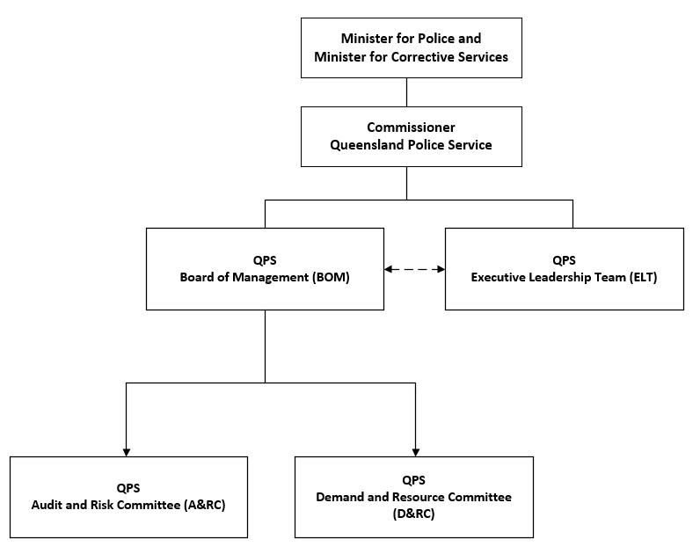

QPS Board of Management (BoM)
The BoM supports and advises the Commissioner on strategy, direction and setting the tone of the Service. The BoM supports the Commissioner as the sole decision-making authority pursuant to the Police Service Administration Act 1990 and the Financial Accountability Act 2009.
The QPS BoM provides support and expert advice to the Commissioner in making key decisions that deliver a strategic or Service-wide impact. The Board meetings are chaired by the QPS Commissioner.
The BoM meets quarterly or as determined by the Chair. In 2019-20, the BoM met on five occasions and considered 17 matters out-of-session.
The independent external members collectively received $5,000 in remuneration. There were no other on costs.
Board Members
- Commissioner Katarina Carroll (Chair)
- Deputy Commissioner Steve Gollschewski, Southern Queensland
- Deputy Commissioner Tracy Linford, Crime, Counter Terrorism and Specialise Operations
- Deputy Commissioner Paul Taylor, Regional Queensland
- Deputy Commissioner Doug Smith, Strategy and Corporate Services
- Jenny Walker (external member)
- Sandra Smith (external member)
Achievements
During 2019-20, the BoM approved a number of significant matters including the:
- QPS Strategic Plan 2019-23 and QPS Operational Plan 2019-20;
- 2019-20 budget allocations and adjustments during the financial year;
- QPS ICT Investment Program 2019-20;
- QPS 2019-20 Total Asset Management Plan;
- QPS 2019-20 Strategic Asset Management Plan;
- 2020 QPS Environmental Scan;
- updated Board handbook, Demand and Resource Committee Terms of Reference, Audit and Risk Committee Terms of Reference;
- 2020-21 Board and Committee Calendar and Annual Planner; and
- establishment management matters including the transition of the PSBA Armoury to the QPS.
The BoM had in depth strategic discussions on the following topics:
- mental health;
- QPS Healthy Minds and Wellbeing Strategy;
- QPS Review and Service Alignment Program; and
- performance measuring tools.
The BoM also overviewed and discussed strategic matters relating to financial reporting, human resources reporting, information, communication & technology reporting, performance and capability reporting, risk reporting and project reporting.

QPS Demand and Resource Committee (D&RC)
The Demand and Resource Committee supports the Commissioner and QPS BoM in delivering the organisational prioritisation of resources. The committee assists by ensuring effective processes are used relating to direction and control of finances, people, assets and ICT. This includes oversight of policies, plans and practices relating to demand management and resource management.
The Chair of the Committee is rotated among the Deputy Commissioners on an annual basis.
The committee meets monthly or as determined by the Chair.
During 2019-20, the committee met on ten occasions and considered 15 urgent matters
out-of-session.
Committee Members
- Deputy Commissioner Steve Gollschewski, Southern Queensland
- Deputy Commissioner Tracy Linford, Crime, Counter Terrorism and Specialist Operations
- Deputy Commissioner Paul Taylor, Regional Queensland
- Deputy Commissioner Doug Smith, Strategy and Corporate Services
Achievements
During 2019-20, the committee considered a number of significant matters including:
- establishment management matters including the creation and allocation of permanent positions and reclassification (upgrades) of positions across the service;
- overviewing and supporting initial 2019-20 budget allocations and budget reviews and determining adjustments for numerous organisational priorities;
- monitoring performance measures and service delivery standards;
- monitoring the QPS Program including considering exception reporting
- approving the formalisation of Vulnerable Persons Units in multiple districts;
- approving the strategic review of the Cairns accommodation requirements;
- approving the establishment of a permanent Project Booyah model;
- approving the permanent establishment of the Remotely Piloted Aircraft System Unit within POLAIR Queensland, Specialist Services Group, Operations Support Command as an organisational entity;
- approving the establishment of the Resource Allocation Committee and Service Alignment Program Board Terms of Reference;
- approving a checklist to assist in the development of operating cost estimates for capital works builds.

QPS Audit and Risk Committee (A&RC)
The QPS A&RC was established to assist the Commissioner and QPS BoM in scrutinising, challenging and delivering oversight of the management responsibilities imposed on the Commissioner. This includes management responsibilities imposed on the Commissioner under the Police Service Administration Act 1990, the Financial Accountability Act 2009 and the Financial and Performance Management Standard 2019.
The committee assists the BoM through review and monitoring of financial management and reporting processes, and review and oversight of risk management, internal control and compliance systems.
The committee additionally provides oversight to processes which effectively:
- identify and manage significant business risks/business continuity
- implement appropriate/adequate control, monitoring and reporting mechanisms
- monitor emerging compliance issues
- monitor and assess the performance of internal and external auditors.
The committee meets quarterly or as determined by the Chair. During 2019-20, the committee met on three occasions.
The two independent external members collectively received $6,960 in remuneration. There were no other on-costs.
Mr David Evans ceased his role an independent external member for the A&RC on 30 June 2020.
Committee Members
- Jenny Walker (External Member – Chair)
- David Evans (External Member)
- Deputy Commissioner Doug Smith, Strategy & Corporate Services
- Assistant Commissioner Cameron Harsley, Organisational Capability Command
- Assistant Commissioner Sharon Cowden, Ethical Standards Command
Achievements
During 2019-20, the committee provided strategic advice and support to the BoM by considering matters of risk management, internal control and compliance, financial compliance and audit reporting including:
- QPS Strategic Risk Report
- QPS Risk Appetite Statement
- Compliance and Inspections Program Findings
- Annual Financial Statements
- Cyber Security Risk Register

QPS Executive Leadership Team (ELT)
The ELT is a ‘think tank’ assisting the Commissioner through support and advice in operational execution of decisions. The QPS BoM also requests and relies on ELT recommendations and advice.
The ELT assists the Commissioner, the BoM and entire governance structure through delivering a collaborative environment for:
- provision of advice on the strategic direction of the QPS operationalising strategy
- leading change management and promotion of the Commissioner’s intent
- acting as a consultative forum on opportunities and risks arising from key changes to strategy, policy and operations within and outside the QPS
- identifying opportunities for creating efficiencies
- uncovering opportunities to improve the quality of service delivery and for fostering an environment for innovation
- identifying new or emerging opportunities, technologies, better practice and risks for the QPS.
The ELT meets via video conference each week and in person on a monthly basis, or as determined by the Chair. The ELT also met via Microsoft Teams on a regular basis due to
COVID-19 implications.
During 2019-20, the ELT met on 10 occasions (in-person) including meetings at RNA Show Grounds (Brisbane Region), Gold Coast (South Eastern Region) and Emerald (Central Region).
The independent external members of the QPS BoM and A&RC attended one ELT meeting as guests in 2019-20. The independent external members collectively received $2,000 in remuneration. There were no other on-costs.
ELT Members
- Commissioner Katarina Carroll (Chair)
- Deputy Commissioner Stephen Gollschewski, Southern Queensland
- Deputy Commissioner Tracy Linford, Crime, Counter-Terrorism and Specialist Operations
- Deputy Commissioner Paul Taylor, Regional Queensland
- Deputy Commissioner Doug Smith, Strategy & Corporate Services
- Assistant Commissioner Maurice Carless, State Discipline
- Assistant Commissioner Shane Chelepy, Operations Support Command
- Assistant Commissioner Brian Codd, Brisbane Region
- Assistant Commissioner Mike Condon, Southern Region
- Assistant Commissioner Sharon Cowden, Ethical Standards Command
- Assistant Commissioner Peter Fleming, State Crime Command
- Assistant Commissioner Kevin Guteridge, Central Region
- Assistant Commissioner Cameron Harsley, Organisational Capability Command
- Assistant Commissioner Mike Keating, Road Policing Command
- Assistant Commissioner Ben Marcus, Community Contact Command
- Assistant Commissioner Charysse Pond, People Capability Command
- Assistant Commissioner Cheryl Scanlon, Security and Counter-Terrorism Command
- Assistant Commissioner Brett Schafferius, Northern Region
- Assistant Commissioner Brian Wilkins, South Eastern Region
- Michelle Tayler, Acting Executive Director, Communications, Culture and Engagement Division
- Paul Friedman, Acting Executive Director, Policy and Performance Division
- Carolyn Harrison, Executive Director, Legal Division
- Chief Superintendent Daryl Johnson, Crime and Corruption Commission – Police Group
Standing Invited Attendees
- Simon Kelly, Director, Media and Public Affairs Group
- Superintendent Marcus Hill, Commissioner’s Office
Achievements
During 2019-20, the ELT considered significant matters including:
- COVID-19 – planning, challenges and opportunities, living with COVID-19
- QPS Review and Service Realignment Program (SAP)
- 2019-20 internal QPS budget matters
- capital works program build
- complaints reform project and human rights
- discipline system
- QPS Strategic Plan
- Working for Queensland survey results
- internal communications platform
- human resources and the safety and wellbeing of members
- leadership training
- Transfer Advisory Committee and promotion process
- QPS values and culture
- regional and district performance
- crime statistics and performance
- operational environments
- domestic and family violence process enhancement
- Criminal Justice System Reform Framework and development of demand model
- reduction of red tape
- crime prevention
- internal audit matters
- governance framework

Government bodies
- Commissioner for Police Service Reviews
- Controlled Operations Committee
- Public Interest Monitor
For further information about the Government Bodies refer to page 97 within the appendices.
Ethics and code of conduct
The delivery of professional policing services must be underpinned by ethical decisions and actions. These ethical decisions and actions provide the QPS with its most valuable asset, namely its reputation and the confidence and trust that such a reputation inspires in the community. The QPS has a broad range of programs, policies and initiatives that support professional and ethical practice including a robust internal complaints system, policies on declarable associations, gifts and benefits as well as discipline and ethical awareness training. The QPS Values, Standard of Practice and Procedural Guidelines for Professional Conduct supplement the Queensland Government values and the Code of Conduct for the Queensland Public Service and outline appropriate behaviour expected of all QPS employees.
Members of the QPS continue to operate under the organisation’s Integrity Framework. This framework approach allows specific issues to be brought into focus more clearly by highlighting the principles that drive integrity and ethics management in the Service. The framework seeks to promote an actionable process of thinking about integrity and then integrating that thinking into all planning, implementation, monitoring and evaluation processes across the QPS.
During 2019-20, Ethical Standards Command (ESC) continued to promote, monitor and enforce ethical behaviour, discipline and professional practice through education, deterrence and systems improvements. ESC is the principal work unit for communication between QPS and oversight bodies such as the Crime and Corruption Commission.
Reported complaints are continually monitored and reviewed by the QPS to identify primary contributing factors and/or trends which may arise from complaint types and/or the complaint data more generally. All complaints are considered, actioned and investigated as required. In 2019-20, the QPS received 1,072 complaints by members of the public against officers on or off duty. This figure counts the number of distinct individuals who have either lodged a complaint or lodged a complaint on behalf of another person even if it relates to the same incident. When applying relevant context to this figure, the QPS undertakes millions of interactions with people in the community each day and moreover, each year. Comparatively, very few of those interactions result in complaints relating to the conduct of police.
The Police Service Administration (Discipline Reform) and Other Legislation Amendment Bill 2019 (the legislation) passed through parliament on 17 October 2019 and received assent on
30 October 2019. To support the legislation, ESC developed (in consultation with key stakeholders) new complaint resolution guidelines, discipline policy and supporting forms. The legislation has introduced a broader and fairer range of sanctions which will be used in conjunction with professional development strategies to provide a holistic response to allegations of misconduct. Statutory timeframes to commence a disciplinary proceeding are now in effect for all complaint matters ensuring the process is more fair, timely and consistent across the Service.
As part of its monitoring role, ESC undertakes a range of inspections and evaluations of operational establishments, including their functions and duties. During 2019-20, ESC performed 64 watchhouse inspections involved in the “Operation Protocol to the Convention against Torture” (OPCAT) and conducted compliance inspections of 15 stations and establishments. ESC also undertook quality assurance on all audits conducted independently by regions and commands.
Education and training
The Professional Standards Training Continuum provides an ethics and integrity-based approach to all members of the QPS. All employees are required to undertake compulsory online and face-to-face training on the Queensland Public Service Code of Conduct, ethical decision making and the Public Service Act 2008. ESC also provides an Ethics and Ethical Decision-Making online learning product (OLP). While this OLP is not mandatory all employees are strongly encouraged to undertake this training within six months of commencing with the QPS.
The QPS also publishes deidentified disciplinary outcomes in the monthly QPS Bulletin to provide members with increased visibility and confidence in our internal discipline system. The intention is to proactively encourage organisational and individual behavioural change through heightened awareness of the issues that impact us all. The QPS relies on its high levels of integrity and is committed to maintaining a culture of the highest professional standards.

Risk management and accountability

Risk management
The QPS has adopted an Enterprise Risk Management approach, where risk is fully integrated into the management processes of the organisation. The Commissioner and Senior Executive are committed to the management of risk. The QPS has an Enterprise Risk Management Framework in compliance with Queensland Government standards, which provides a process for managing risk in the QPS.
The QPS produces a yearly Risk Appetite Statement which outlines the key risk categories and the QPS risk approach to those risks. The QPS embeds risk management into all planning processes and activities. Risk management planning and processes are aligned to the QPS Strategic Plan and Operational Plan, linking organisational objectives with identified strategic risks and challenges.
Risk management in the QPS is overviewed by the QPS Audit and Risk Committee (for further information regarding the committee refer to page 53). The Chief Risk Officer, promotes best practice, identifies whole-of-state risk issues, scans for emerging risk and provides advice and support on risk management practices. International Standard ISO 31000:2018 Risk management – Guidelines has been applied to the QPS risk management framework and elements of the policy are drawn from this standard.
External Scrutiny
This section provides information about external agencies and processes which examined the operations of QPS or other agencies with findings/issues requiring consideration by, or impacting on, QPS:
Crime and Corruption Commission
The Crime and Corruption Commission (CCC) is a statutory body established to combat and reduce the incidence of major crime and corruption in the public sector in Queensland. Its functions and powers are set out in the Crime and Corruption Act 2001. The Commission investigates both crime and corruption, has oversight of both the police and the public sector, and protects witnesses.
Crime and Corruption Commission reports are available online at http://www.ccc.qld.gov.au/research-and-publications.
Operation Impala – A report on misuse of confidential information in the Queensland public sector
Operation Impala was a Queensland CCC investigation authorised by virtue of sections 176 and 177(2)(c)(ii) of the Crime and Corruption Act 2001 {Qld} to examine the practices of a representative group of Queensland Public Sector agencies regarding their management of confidential information.
During nine days of public hearings in November 2019, the CCC examined:
- factors which facilitate misuse of information within the Queensland public sector, by examination of the technical, people, and systems components of information management within identified agencies; including the QPS;
- features of the legislative, policy and operational environment within each agency that may enable corrupt conduct to occur or are vulnerable to corrupt conduct; and
- reforms to better prevent, detect and deal with corrupt conduct relating to misuse of information within the identified agencies, and lessons that can be extrapolated to the broader Queensland public sector.
In February 2020, the CCC published its report on Operation Impala and made 18 recommendations to assist Queensland Government agencies strengthen their individual practices as well as improve consistency across the wider public sector. Of the total 18 recommendations, 13 have applicability for the QPS. The QPS fully supports the recommendations and the importance of information privacy.
Several recommendations required the strengthening of internal policies and a broader range of prevention strategies to be considered and adopted. The QPS has commenced the implementation process and this is being coordinated by ESC.
Queensland Ombudsman
The Queensland Ombudsman investigates complaints about the actions and decisions of state government departments and agencies, local councils and public universities. Their role is to improve the quality of decision making and administrative practice in public organisations through identifying, investigating and publicly reporting serious systematic issues and making recommendations to improve decisions making practices.
Investigative reports prepared by the Queensland Ombudsman are available at https://www.ombudsman.qld.gov.au/improve-public-administration/reports-and-case-studies/investigative-reports.
The Forensic Disability Service report: An investigation into the detention of people at the Forensic Disability Service
In August 2019, the Ombudsman released their findings into an investigation relating to the treatment of people detained at the Forensic Disability Service (FDS) which is a medium security 10-bed facility at Wacol, in Brisbane. The FDS is for the involuntary detention of people found unfit for trial as a result on an intellectual or cognitive disability and require secure care. The facility is operated by the Department of Communities, Disability Services and Seniors (DCDSS) with oversight from the Director of Forensic Disability (the Director).
The report made 15 recommendations which were directed to DCDSS or the Director. One recommendation referred to the QPS and the manner in which police respond to an incident at the FDS. The QPS has a strong working relationship with the Wacol Forensic Disability Services facility and continues to work with the Office of the Director to improve policing responses to vulnerable persons at the facility.
Queensland Coroner
During 2019-20, four recommendations arising from four coronial inquests were directed to QPS. The Findings of Inquest and the Government’s responses are available at www.courts.qld.gov.au/courts/coroners-court/findings.
Queensland Audit Office (QAO)
The QAO supports the role of the Auditor-General of Queensland in providing the Parliament with an independent assessment of the financial management and performance activities of public sector entities. The QAO provides an independent audit service and reports to the Parliament to enhance public sector accountability. QAO reports are available online at https://www.qao.qld.gov.au/reports-resources/parliament.
Report to Parliament 8: Queensland state government entities: 2018-19 results of financial audits
The Queensland State Government delivers services and goods to benefit the public. To demonstrate their accountability in managing public money on behalf of the Queensland community, all government departments must report on their finances and have them audited. The Auditor-General of Queensland, supported by the QAO, is responsible for providing Parliament with an independent assessment of the financial management of government departments.
The audit assesses the position, performance and financial stability of the state government based on the assessment of financial statements. The QAO issues comments on the timeliness and quality of financial reporting and explains how QAO assessed the key audit matters disclosed by Queensland Government Departments.
The report refers to the QPS as meeting the statutory date and reporting requirements for certification of the 2018-19 financial statements and acknowledges that no adjustments were required.
Internal audit
The PSBA Internal Audit Unit provides advice across a wide range of disciplines including risk, assurance, information technology, finance, compliance and general consulting activities for the QPS, Office of the Inspector-General Emergency Management (IGEM), the PSBA and Queensland Fire and Emergency Services (QFES). The Head of Internal Audit, PSBA is also the nominated Head of Internal Audit for the QPS, Office of the IGEM and QFES in accordance with the Financial Accountability Act 2009.
The work of the Internal Audit Unit is undertaken in accordance with the Institute of Internal Auditors’ standards and under an approved charter consistent with relevant audit and ethical standards.
In accordance with the Financial and Performance Management Standard 2019, an annual internal audit plan and three-year strategic audit plan sets the direction of the unit. A detailed audit planning and risk assessment process was completed in devising this plan. The Public Safety Business Agency Annual Internal Audit Plan 2019–2020 and Strategic Internal Audit Plan 2020-23 was endorsed by the QPS Audit and Risk Committee and approved by the Chair of the PSBA Board of Management on 4 June 2019. The PSBA Internal Audit Unit reports regularly to the QPS Audit and Risk Committee which reviews the work of the internal audit function. The relationship with the committee is based on Queensland Treasury’s Audit Committee Guidelines.
Under its approved charter, the unit reviews compliance (effectiveness), performance (efficiency), financial management and information technology to identify areas of risk and to improve outcomes for the Service. The unit has systems in place to ensure the effective, efficient and economic operation of the audit function.
In 2019-20, the unit delivered the activities in the approved Annual Internal Audit Plan 2019-2020 using in-house and soured delivery methods, including the engagement of Ernst and Young. All fieldwork was completed as at 30 June 2020. It is expected the final reports will be delivered by 30 September 2020.
Achievements specific to QPS for 2019-20 include:
- delivery of the approved annual internal audit plan with specific QPS audit coverage including:
  - an incident response risk assessment
  - a forensic computing review
  - the Vic Roads Information Protection Agreement
  - delivery of the Trusted Advisor Series of work.
- the following public safety agencies’ corporate activities also had a direct impact on QPS operations:
- system access controls
- third party contract management
- fraud and corruption
- security awareness review
- CFO assurance Statement
- risk management framework assessment
- ICT project governance, reporting and benefits realisation.

Information systems and recordkeeping
The PSBA, as the provider of corporate services to Queensland’s public safety portfolio agencies including QPS, is responsible for recordkeeping and information systems across the Public Safety Agencies. PSBA has a dedicated records management team, Information Management Unit (IMU), which provided advice and assistance to QPS during the reporting period resulting in improved efficiencies which included:
- providing advice relating to recordkeeping and training in use of the Objective electronic document and records management system (eDRMS) and ensured new users were made aware of, and understood, their broader recordkeeping responsibilities;
- restrictions imposed via the COVID-19 (remote) operating environment accelerated the shift towards more business units accessing content digitally and utilising electronic approval processes;
- working with QPS business units to identify opportunities to reduce duplication of records and minimise reliance on hardcopy documents. IMU provided detailed advice on scenarios and circumstances where digital signatures and electronic approval processes can be compliantly implemented, resulting in enhanced operational efficiency;
- the police recruitment process transitioning from hard copy paper to Objective eDRMS which resulted in 9,930 complex workflows being actioned to support this transition. The delivery timeframes and capacity of QPS personnel responsible for managing these records have not been impacted by COVID-19. Functions can be supported remotely via staff securely accessing electronic content managed in the eDRMS and other systems used to support the recruiting process.
- the eDRMS supported the creation of over 250,000 files associated with Weapons Licensing Branch functions and more than 22,000 administrative files for general use within QPS business units;
- PSBA supporting development of an Objective eDRMS workflow that underpins the Police Officer Confirmation of Appointment process. It is expected this new workflow will be deployed in 2020-21 and will become the primary mechanism for supporting management of records associated with the confirmation process;
- new procedures allowing hard copy receipts and invoices for corporate card transactions to be fully digitised which will significantly reduce off-site physical storage costs and overall time spent supporting the corporate card process.
A consultation draft of a revised QPS Retention & Disposal Schedule (R&DS) was submitted to Queensland State Archives (QSA) during the reporting period. A reformatted version of this document, provided by QSA following review, incorporates significant structural changes set to be progressively incorporated into whole-of-Government and agency specific schedules. Following QPS endorsement, a finalised version of the Schedule will be submitted to QSA for approval. Aligning the format of this document to the whole-of-Government standard will improve ease of use for end users and enable subsequent updates of the schedule to be made within shorter timeframes.
A small volume of Permanent Records was transferred to QSA in the reporting period.

Human resources

Strategic workforce planning and performance

Workforce profile
The total number of full-time equivalent (FTE) staff in QPS was 15,579.9 as at 30 June 2020. The FTE figure is calculated using the Minimum Obligatory Human Resource Information (MOHRI) aligned information.
Between 1 July 2019 and 30 June 2020, the QPS permanent separation rate was 2.7% for police officers and 6.1% for permanent staff members (excluding temporary and casual employees).
The QPS has various policies and processes in place that promote flexible working arrangements and a healthy work-life balance for all QPS employees. These policies are periodically reviewed to ensure they meet the needs of the service and its employees.
The QPS also has a dedicated Leadership Centre that facilitates and encourages learning and development of police officers and staff members at all levels of the organisation (see page 59 for more information).
Our People Matter Strategy
The QPS is committed to ensuring the safety and wellbeing of all employees, as well as their families. The Our People Matter Strategy which was launched in 2018 sets the direction for the QPS executive and workforce in creating working environments that improve support to police employees and their families.
The QPS continued to implement the strategy in partnership with the Queensland Police Union of Employees, the Queensland Police Commissioned Officers Union of Employees and the Together Union. Activities undertaken in 2019-20 that support the four priority areas (fair and positive workplaces, safer workplaces, healthy minds and healthy bodies) include:
- development of an OLP for psychological health and fitness that provides information and tools needed to help build and maintain personal wellbeing and that of our colleagues and families. This OLP has been made compulsory for all members up to the rank of Chief Superintendent and Executive Director;
- the launch of external mental health, wellbeing and support material, including support services, available on the external Our People Matter website and accessible by current and former QPS members and their families;
- commencement of a comprehensive review of our current injury management process which is expected to be finalised in September 2020.
These initiatives are intended to enhance awareness, connection and conversation; reduce stigma; ensure all employees and their families have access to support services and resources; and ensure the QPS has in place the best possible processes and systems for members who experience an injury or illness.
Supporting our workforce during COVID-19
The QPS played an instrumental role in the whole-of-Government COVID-19 pandemic response, led by Queensland Health, to keep Queenslanders safe.
Taskforce Sierra Linnet was established to lead the QPS response and operated with the following priorities:
- the maintenance of community safety and reassurance
- a sustained and supported workforce
- a connected and engaged response within QPS and across government.
For more information about Taskforce Sierra Linnet and the activation of the SDCC please refer to pages 22-23.
A representative of the Queensland Police Union of Employees was invited to join the taskforce to maintain open lines of communication and ensure adequate support was made available to the frontline. Other support made available to all members of the QPS during this time of uncertainty was communicated and made available via a dedicated SharePoint site and a specific Workplace page with FAQs and an Artificial Intelligence (AI) assistant, Cornelia, to help guide and direct members to access the required COVID-19 relevant information in a short timeframe.
Information created and provided to the workforce via the SharePoint site included:
- the correct fit, removal and disposal of PPE
- safe operating procedures for a variety of high-frequency policing activities
- health and safety alerts
- messaging around flexible working arrangements/alternative workplaces and COVID-19 pandemic employment conditions
- start, middle and end of shift cleaning and hygiene procedures for desks, vehicles, stations and establishments
- expanded external support, health and information services
- self-care in uncertain times
- managing others in uncertain times
- COVID-19 specific podcast focussing on the uncertainty and risks associated with policing at this time.
Inclusion and Diversity
The QPS is committed to building an inclusive and diverse workplace in which all employees feel valued, included and welcome and have equal access to opportunities. To ensure the QPS remains focussed on inclusion and diversity, the QPS established the Inclusion and Diversity Restorative Engagement and Cultural Reform Program, known as Juniper. Three teams have been established within Juniper, including the Restorative Engagement Team, Investigations Team and Cultural Reform Team.
During the reporting period, Juniper:
- continued to support the ‘Speak Safe’ initiative which provides an independent, external therapeutic support option for current and former employees affected by workplace bullying, unlawful discrimination and sexual harassment
- continued to organise external mediation and conflict coaching courses to enhance existing
non-investigative intervention capability across the QPS. The network of trained mediators and conflict coaches has more than tripled and will also provide preventative and reactive support to issues at the local level. This enhanced capability has been extended to Queensland Fire and Emergency Services
- continued to develop training, marketing and general information products to support cultural reform within the QPS and have conducted over 100 awareness presentations and workshops.
- commenced the START (Support, Triage, Advice, Referral and Targeted) Program, a targeted and structured intervention for workplaces experiencing issues that impede on optimal occupational functioning.
Working for Queensland
The Working for Queensland survey (WFQ survey) is an annual survey that measures employee perceptions of their work, manager, team and the QPS. The survey is administered by the Public Service Commission and it explores our people’s perceptions of their workplace climate in key areas.
Results from the WFQ survey drive workplace changes across the Service and helps the QPS measure how the Service is progressing towards the QPS’ strategic objective to Equip Our People for the Future.
During 2019-20, the QPS focussed on helping leaders engage with the WFQ results and develop people-focussed strategies to support members through changes associated with strategic programs and the COVID-19 response. To support these strategies, the QPS focussed on leadership development including change management and effective communication, ensuring a human centric approach was undertaken to improve how our people experienced work. We utilised our new internal communications platform to facilitate two-way communication across the state and increase transparency of information ensuring our leadership were active and visible to all ranks. We embraced new technology on the platform including live feeds and automated chatbot to keep our staff fully informed of changes emerging in our response to COVID-19.
In 2019, the Working for Queensland Strategic Objectives results were:
- Agency engagement 53%
- Organisational leadership 40%
- Innovation 48%
The full 2019 Working for Queensland survey results are available to view at https://www.forgov.qld.gov.au/working-queensland-survey.
The 2020 Working for Queensland survey will be conducted across Queensland Government agencies in September 2020.
Leadership and professional development opportunities
People Capability Command continued to focus on the development of current and future leaders across all police ranks and civilian levels.
Facilitation of professional and personal development was conducted to enhance individual growth and improved performance through coaching capability. A mentoring framework has also been established and reflective practices such as 360 feedback and individual development plans have been offered as development strategies. Enhanced leadership for women was delivered through
Q-Balance.
During the reporting period, the QPS offered a range of opportunities and pathways to accessing professional development to police and civilian employees including:
- Management Development Program (MDP) to develop leadership abilities of members from frontline to senior leadership.
- Senior Women’s Collective
- various programs to develop the behaviours, skills and knowledge required for critical operational roles including the Detective Training Program, intelligence practice and intelligence operations course, child protection and investigation unit course and investigative interviewing.
- collaborations with partner organisations including the Australian Institute of Police Management, Australian Institute of Management and the University of Queensland to offer educational programs.
- the Leadership Centre which administers scholarship programs provided by RACQ, Suncorp, Public Sector Management Program through Queensland University of Technology, and the University of Southern Queensland
Safety, injury management and wellbeing services
The QPS has a comprehensive management system for the identification and management of risks and hazards. This includes a strong consultative framework for health and safety, which includes the QPS Safety and Wellbeing Coordinating Committee, and over 30 Health and Safety Committees across the state representing all workers within groups, districts, regions and commands. There are also 94 elected Health & Safety Representatives who provide representation for all workers within their group on health and safety matters. These committees and representatives are complemented by 294 Trained Safety Advisors who provide advice and assistance to management in fulfilling health and safety obligations.
The QPS continues to focus on de-stigmatising mental health issues and promoting and encouraging members to seek help and counselling services either internally or externally from the Service. The number of police accessing free counselling services through external providers increased from 676 in 2018-19 to 863 in 2019-20 which is a positive trend supporting QPS efforts to de-stigmatise mental health and encourage people to seek help. A further 129 public servants and recruits also accessed these external counselling services during the same period. The utilisation rate for internal counselling services via QPS psychologists and social workers for 2019-20 remains relatively stable at 12%.
The Employee Assistance Service helps prevent and manage mental health issues for employees across the public safety portfolio by providing advice, counselling and referral to external services for a full range of organisational and personal issues.
The Psychological Assessment Unit (PAU) provides psychological assessment services to the QPS and undertakes psychological assessments for police recruits and specialist work units. It has expanded its scope to implement and review members self-psychological screening services through the Psych Health Screen (PHS) platform. PHS, an early-intervention and referral service, was approved for implementation across the Service in April 2020. The PHS process comprises an internet-based mental health screen followed by an interview with an Occupational Psychologist. In 2019-20, 1,245 members completed the new initiative (8% utilisation rate) with 285 members referred for further support.
For the same period, PAU conducted 1,547 psychological assessments of persons applying to become police recruits and a further 495 assessments were conducted on persons applying for identified ‘high risk roles’ in the QPS.
PAU has developed and released six episodes of the Not Your Therapist podcast for members and their families in 2019-20 and conducted workshops regarding personality and mental health as part of leadership development and specialist training courses.
1800 ASSIST, established for QPS members and their partners in 2014, is a free, 24 hours a day, seven days a week, confidential, short-term counselling service, provided by independent, qualified, experienced professionals.
In 2019-20, a dedicated project team was formed to further define and develop the QPS Wellbeing Strategy with the purpose of increasing awareness, reducing stigma and fostering a supportive culture where mental health and wellbeing is an organisational priority. This has resulted in the formation of a Wellbeing Steering Committee to replace the previous Psychological Wellbeing Steering Committee, comprising joint Union and QPS Executive and broader workforce representation to guide the implementation of sub-programs of work. These include progressing the establishment of an external ‘Self Refer’ anonymous counselling service, commencing reviews of injury management and the peer support officer program, progressing the mental health training framework and delivering digital wellbeing solutions to the workforce.
Internal confidential support services
The QPS has various internal confidential support services available for its members which include Senior Psychologists/Senior Social Workers, Peer Support Officers and Chaplains.
These services are available free of charge to all QPS members including sworn officers and civilians. QPS members are able to seek these services for work and/or personal issues.
Senior Psychologists/Senior Social Works, formerly known as Human Services Officers, enhance employee wellbeing and reduce the risk of psychological harm in the workplace.
Peer Support Officers are sworn and unsworn members of the QPS who volunteer their time to assist and support colleagues experiencing personal and/or work-related difficulties.
QPS Chaplains provide a ‘safe place’ for all current and former QPS members and their immediate families to seek support for either personal or workplace matters. Police Chaplains regularly visit police establishments, offering face-to-face support for any issues that may be impacting QPS employees.

Enterprise Bargaining Agreement
The QPS negotiated with the Together Union, Queensland Police Union of Employees and Queensland Police Commissioned Officers Union to establish updated certified agreements for all relevant sworn and unsworn staff during 2019-20, which delivered the Government’s core commitments in accordance with the wages policy.
Early retirement, redundancy and retrenchment
No early retirement, redundancy or retrenchment packages were paid to QPS employees during 2019-20.

Financial statements

Table of contents

Statement of comprehensive income 63
Statement of financial position 64
Statement of changes in equity 65
Statement of cash flows 66
Notes of the statement of cash flows 67
Statement of comprehensive income by major departmental services 68
Statement of assets and liabilities by major departmental services 69
Notes to the financial statements 70
Management Certificate 93
Independent Auditors Report 94

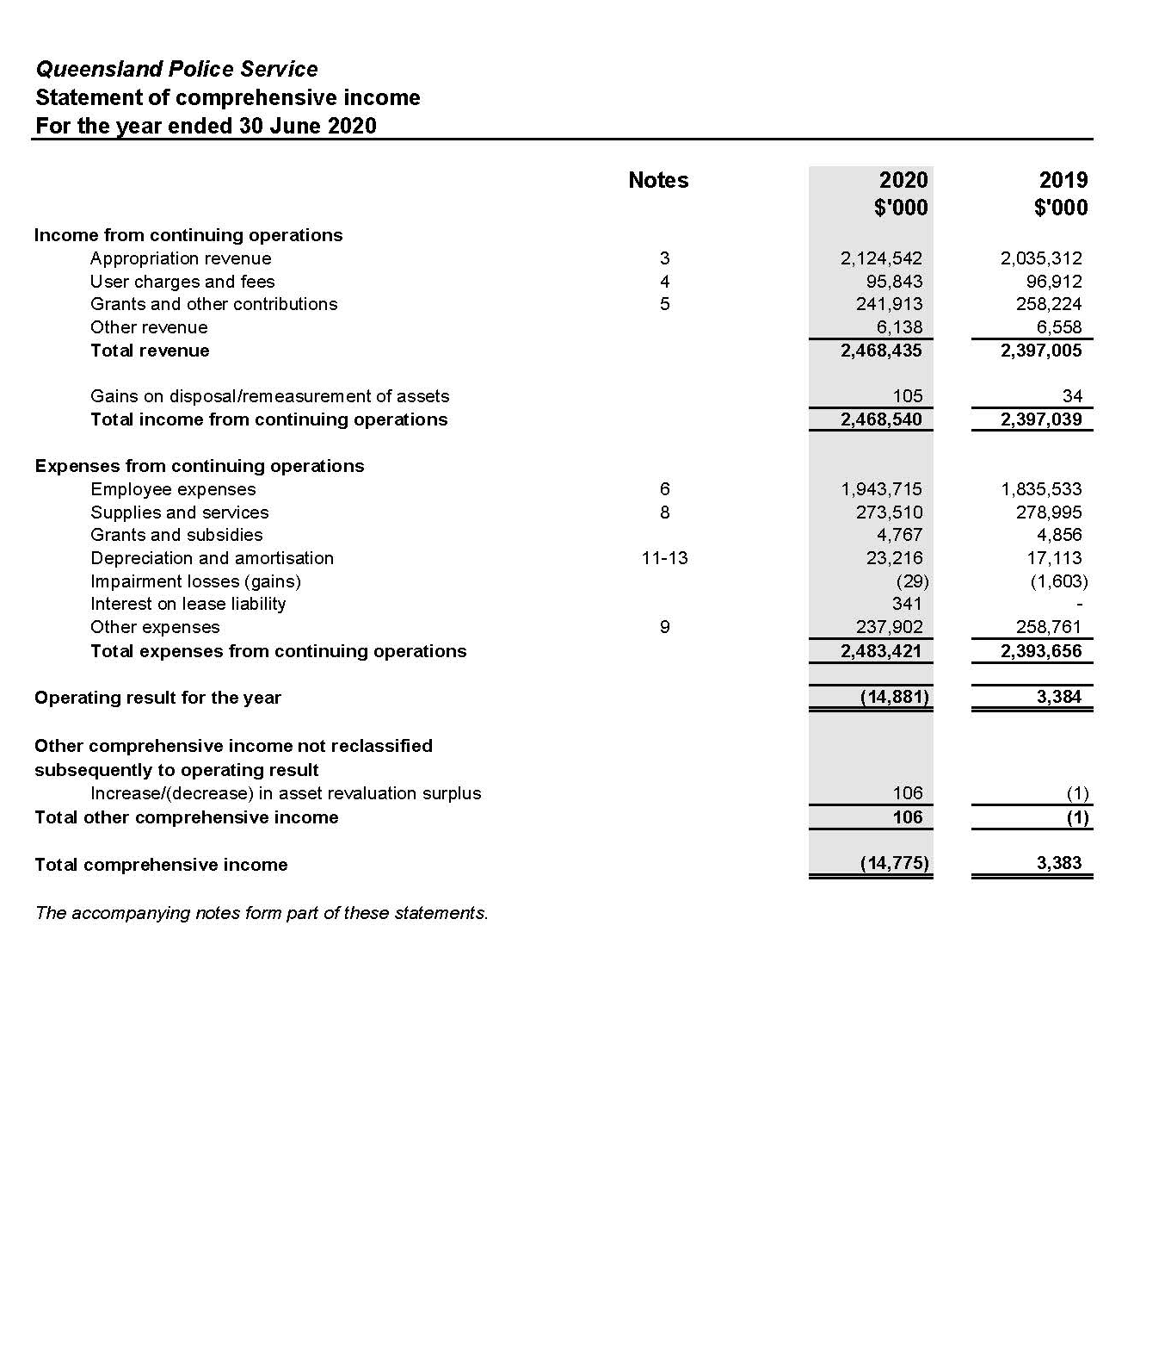

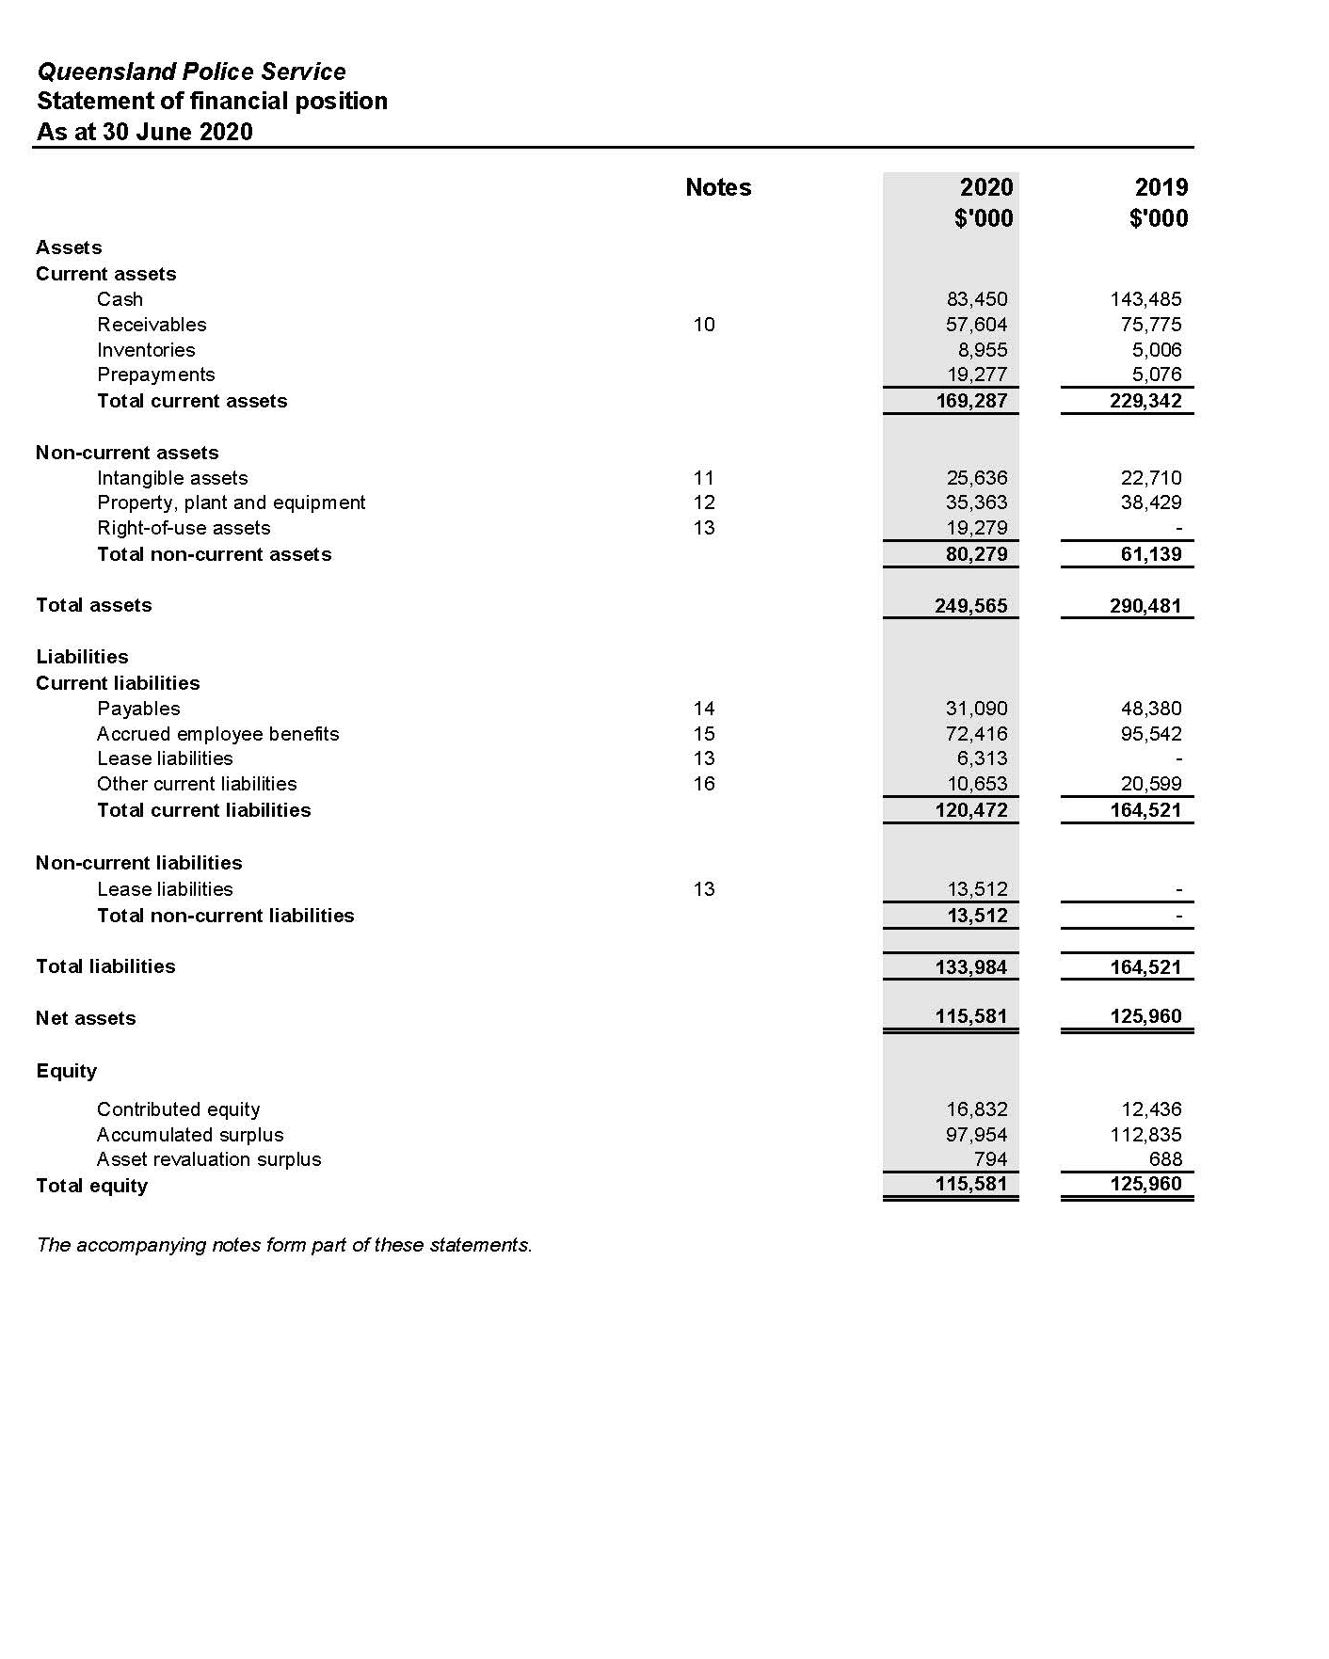

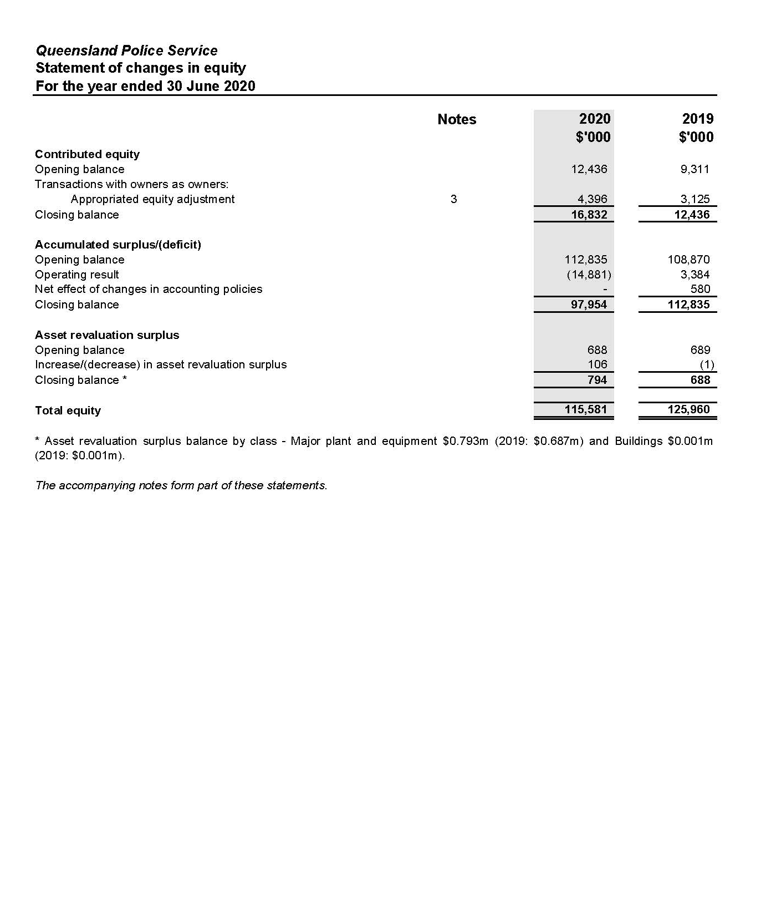

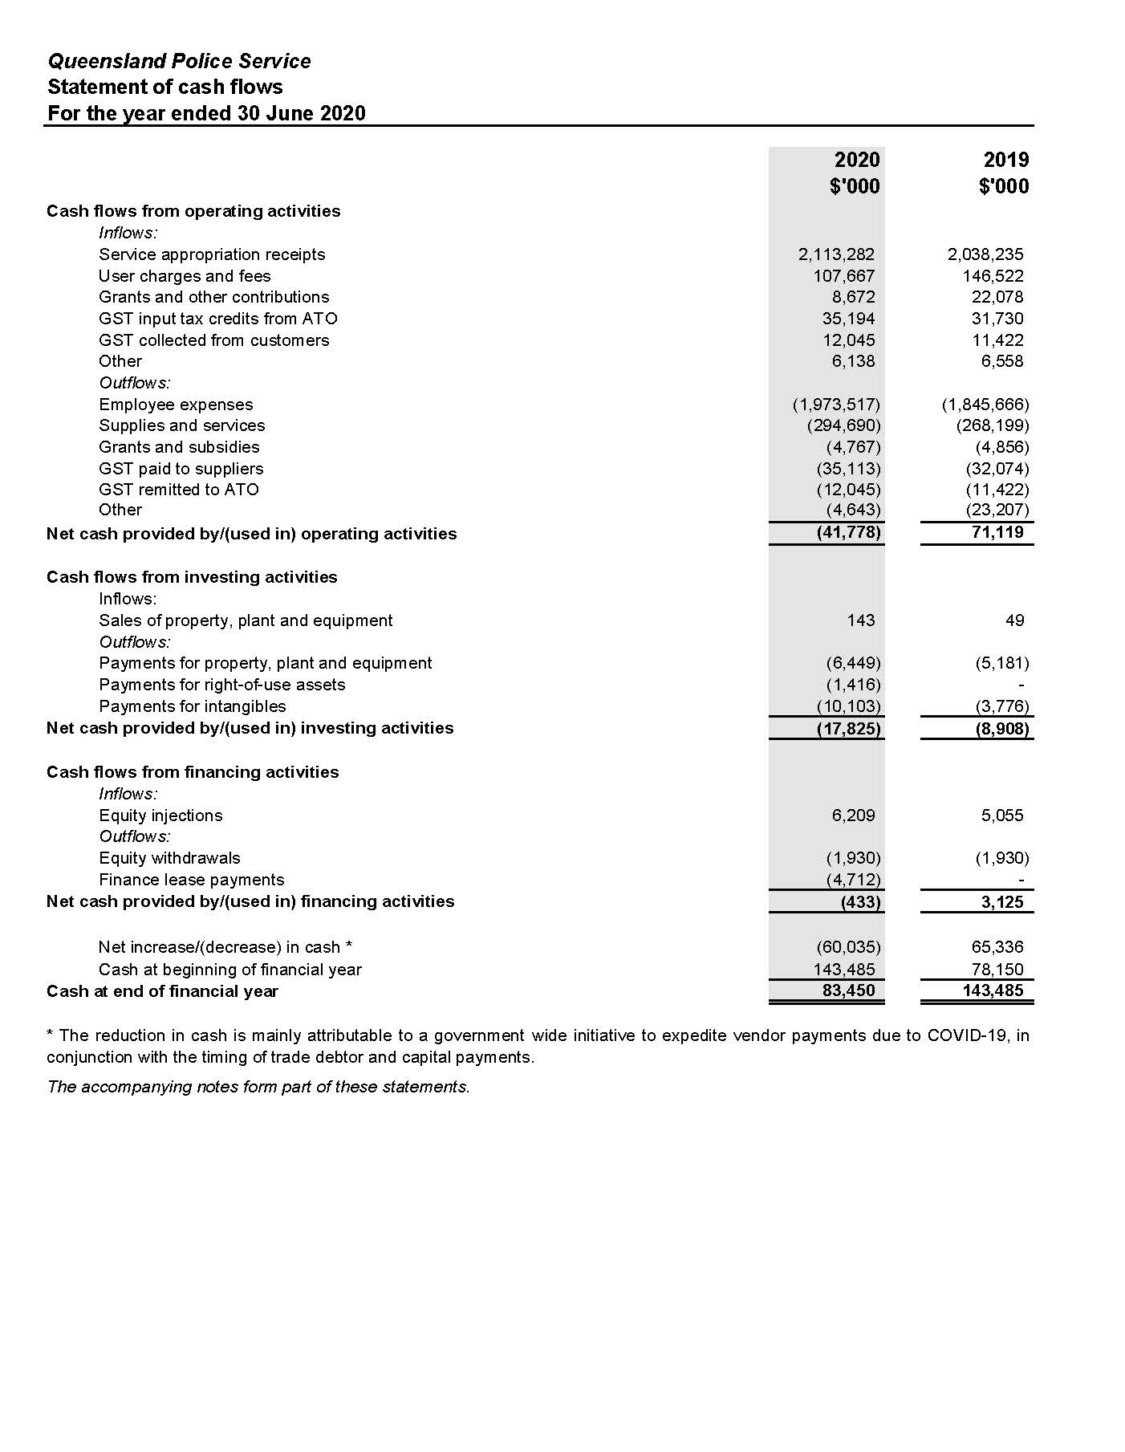

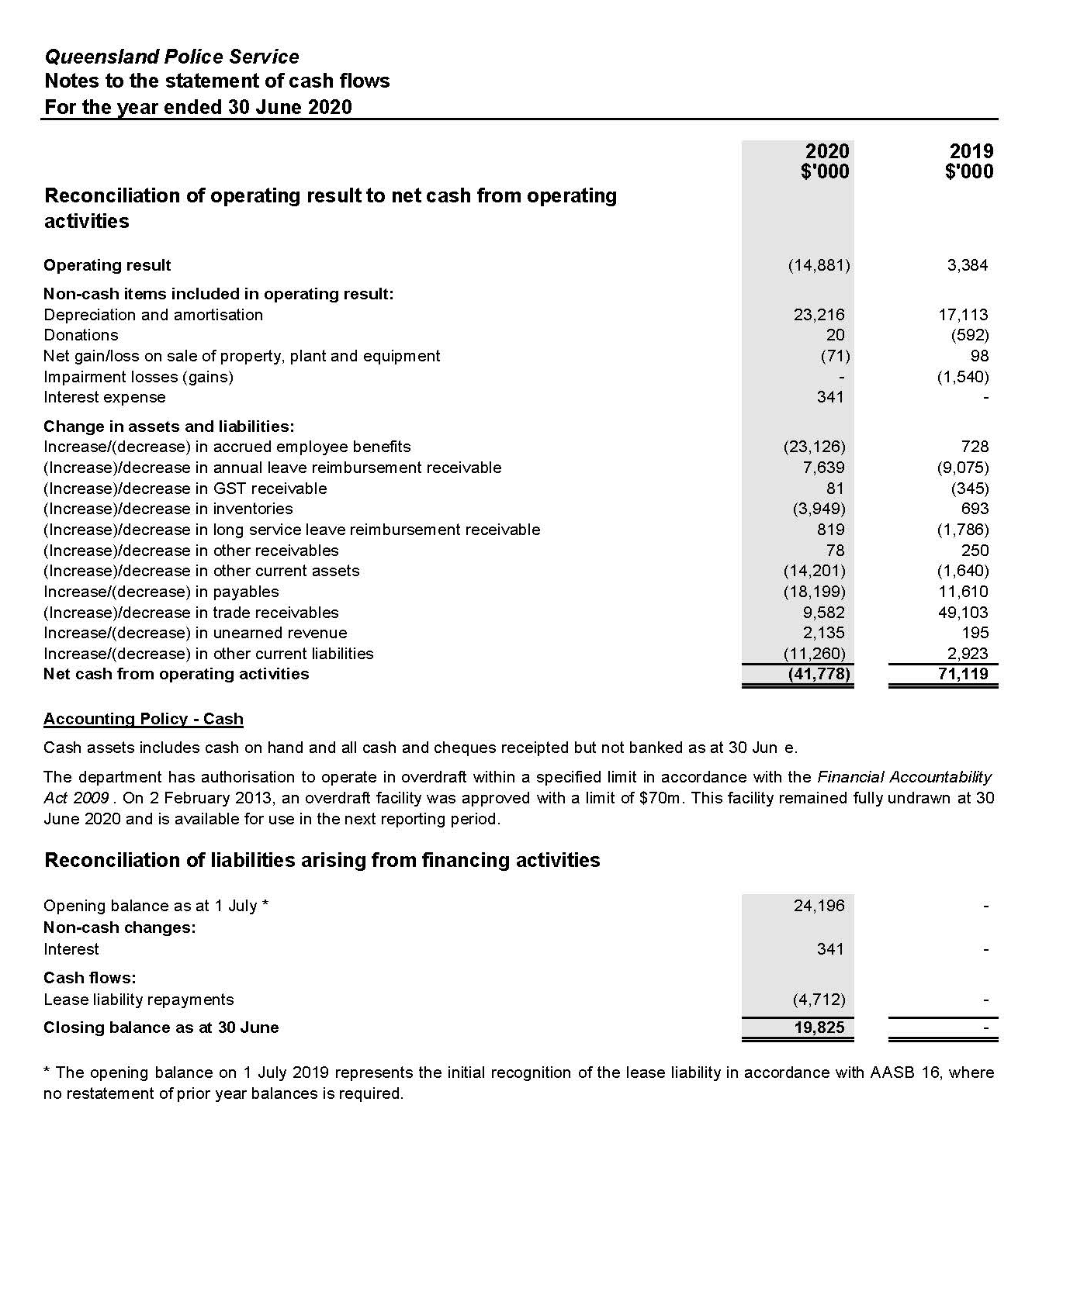

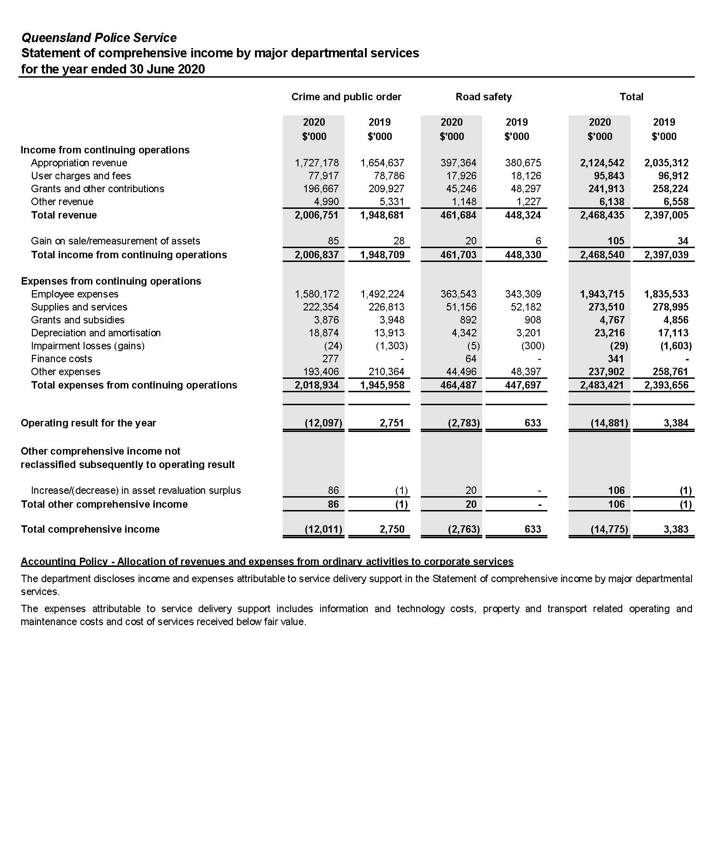

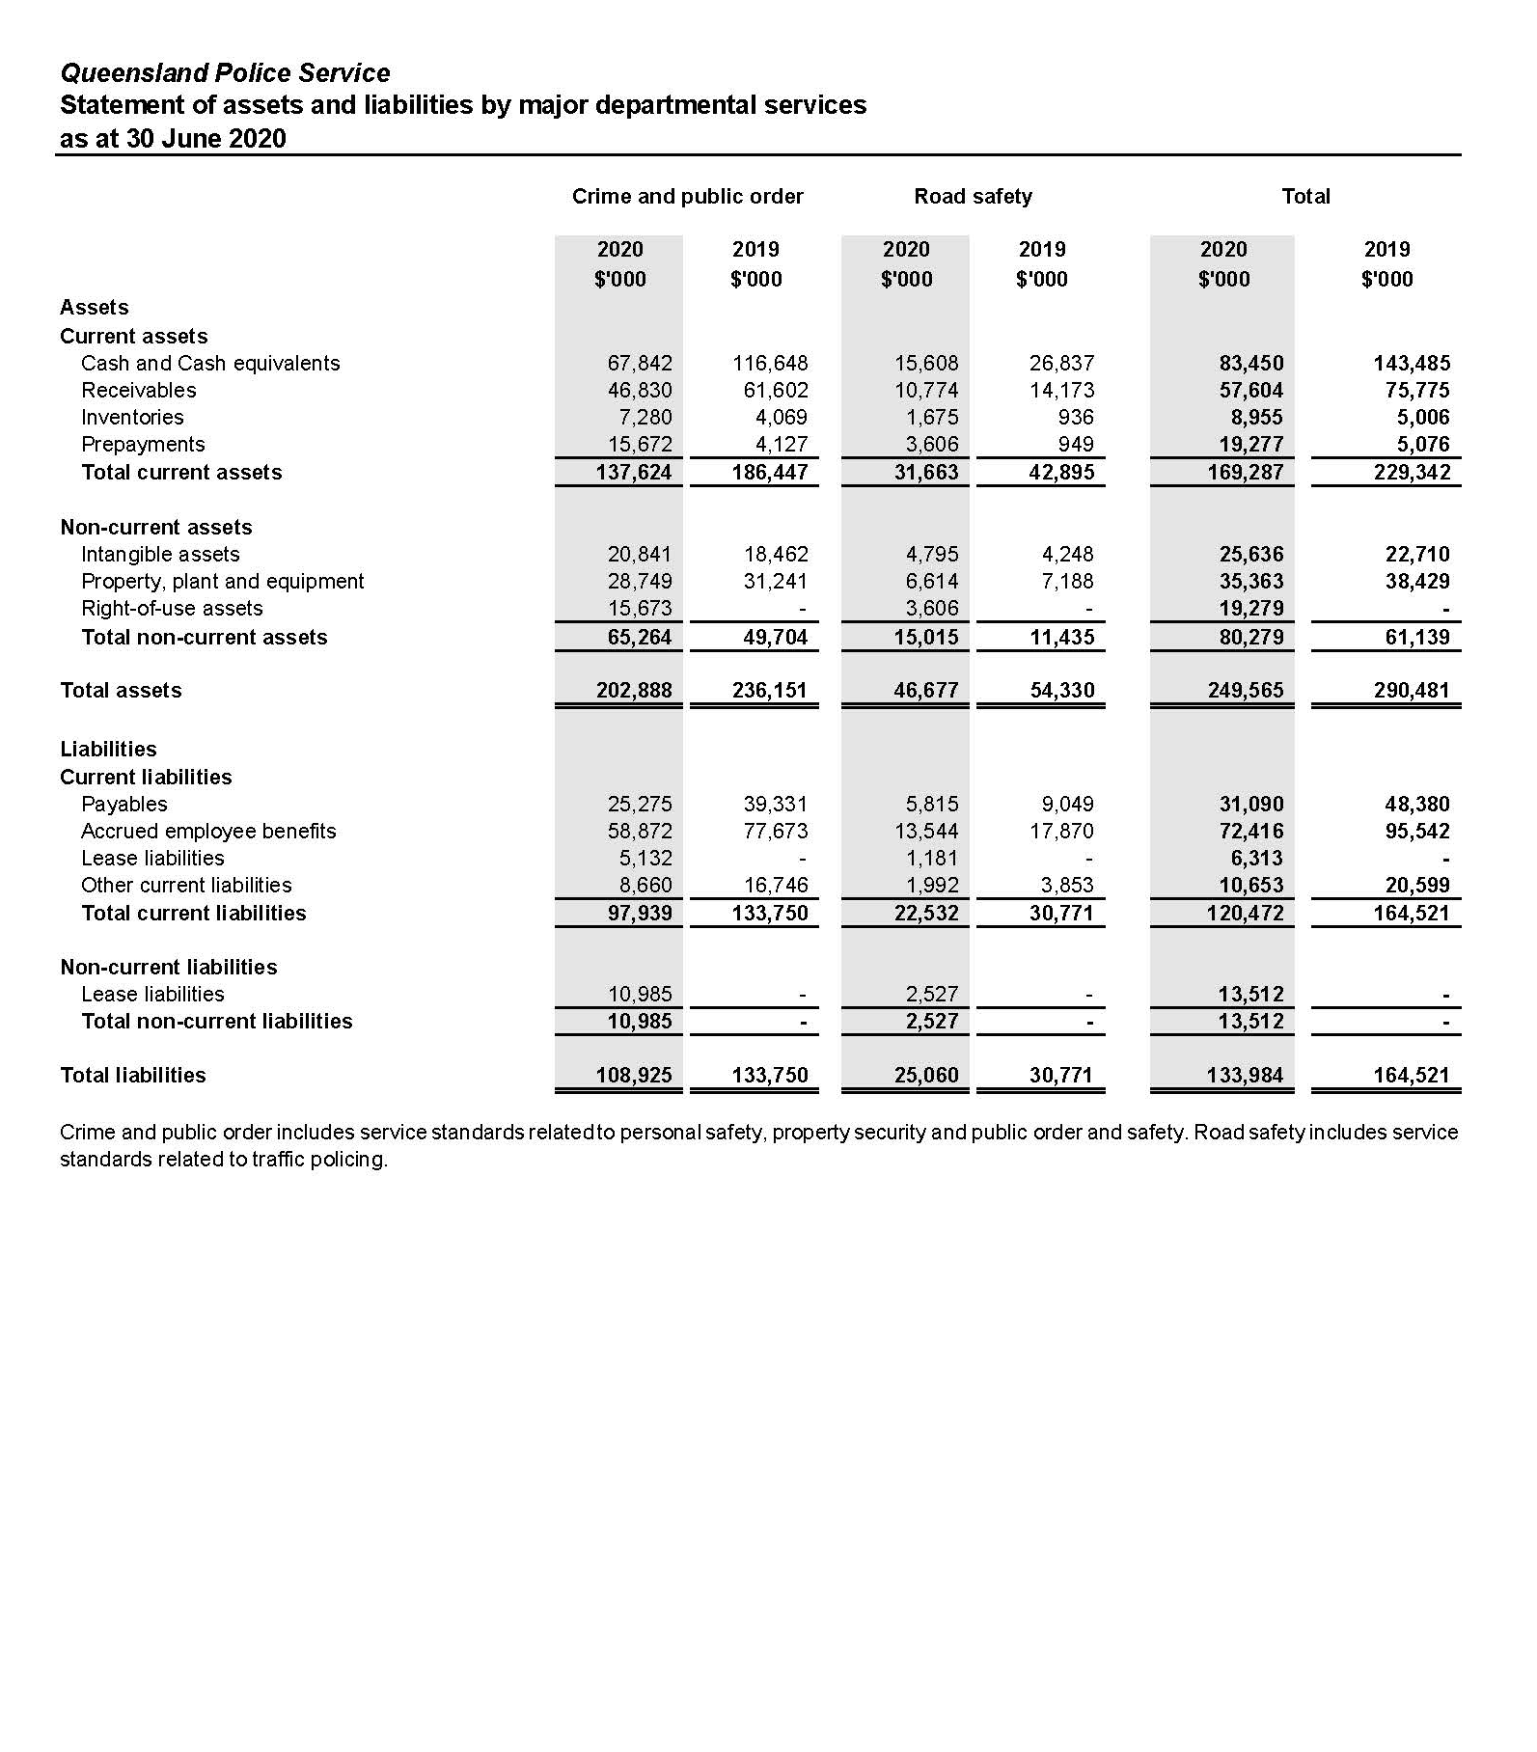

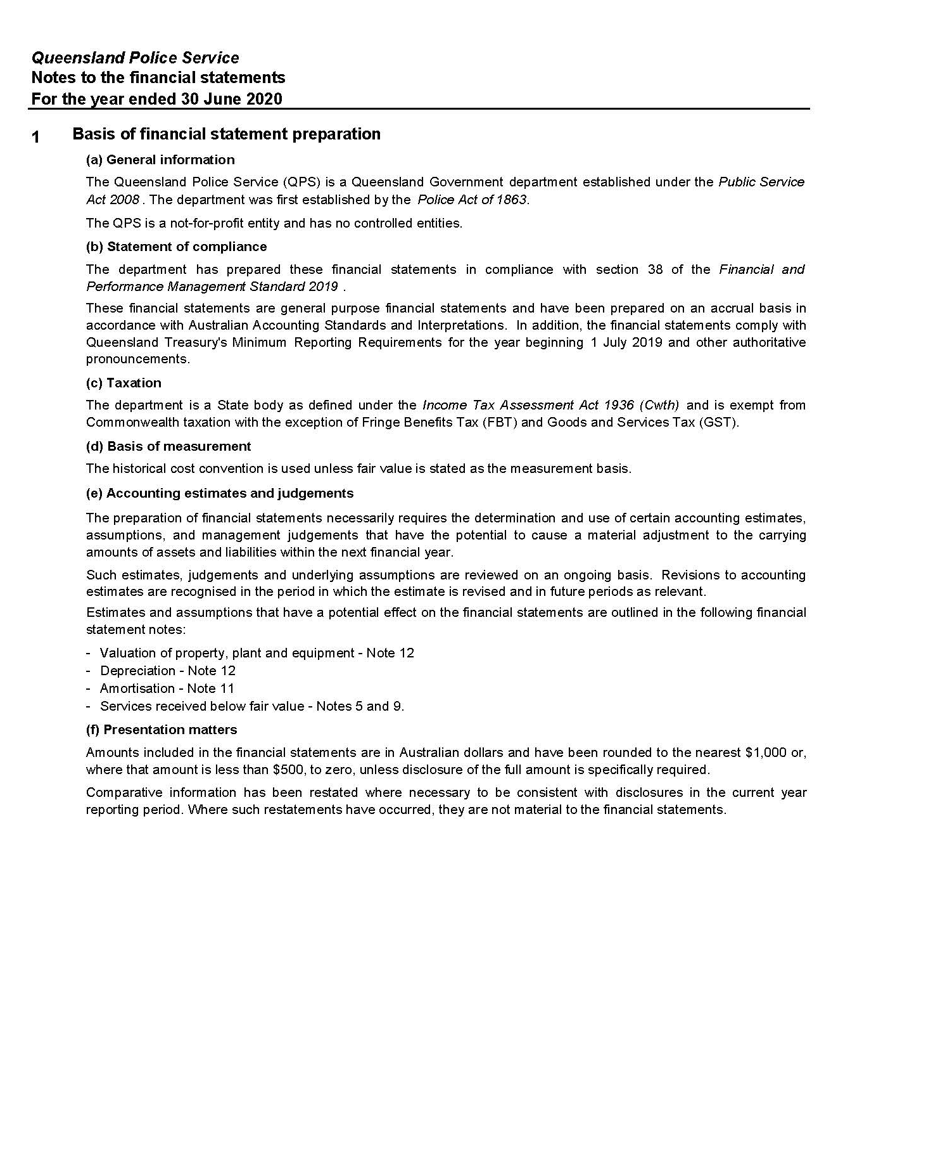

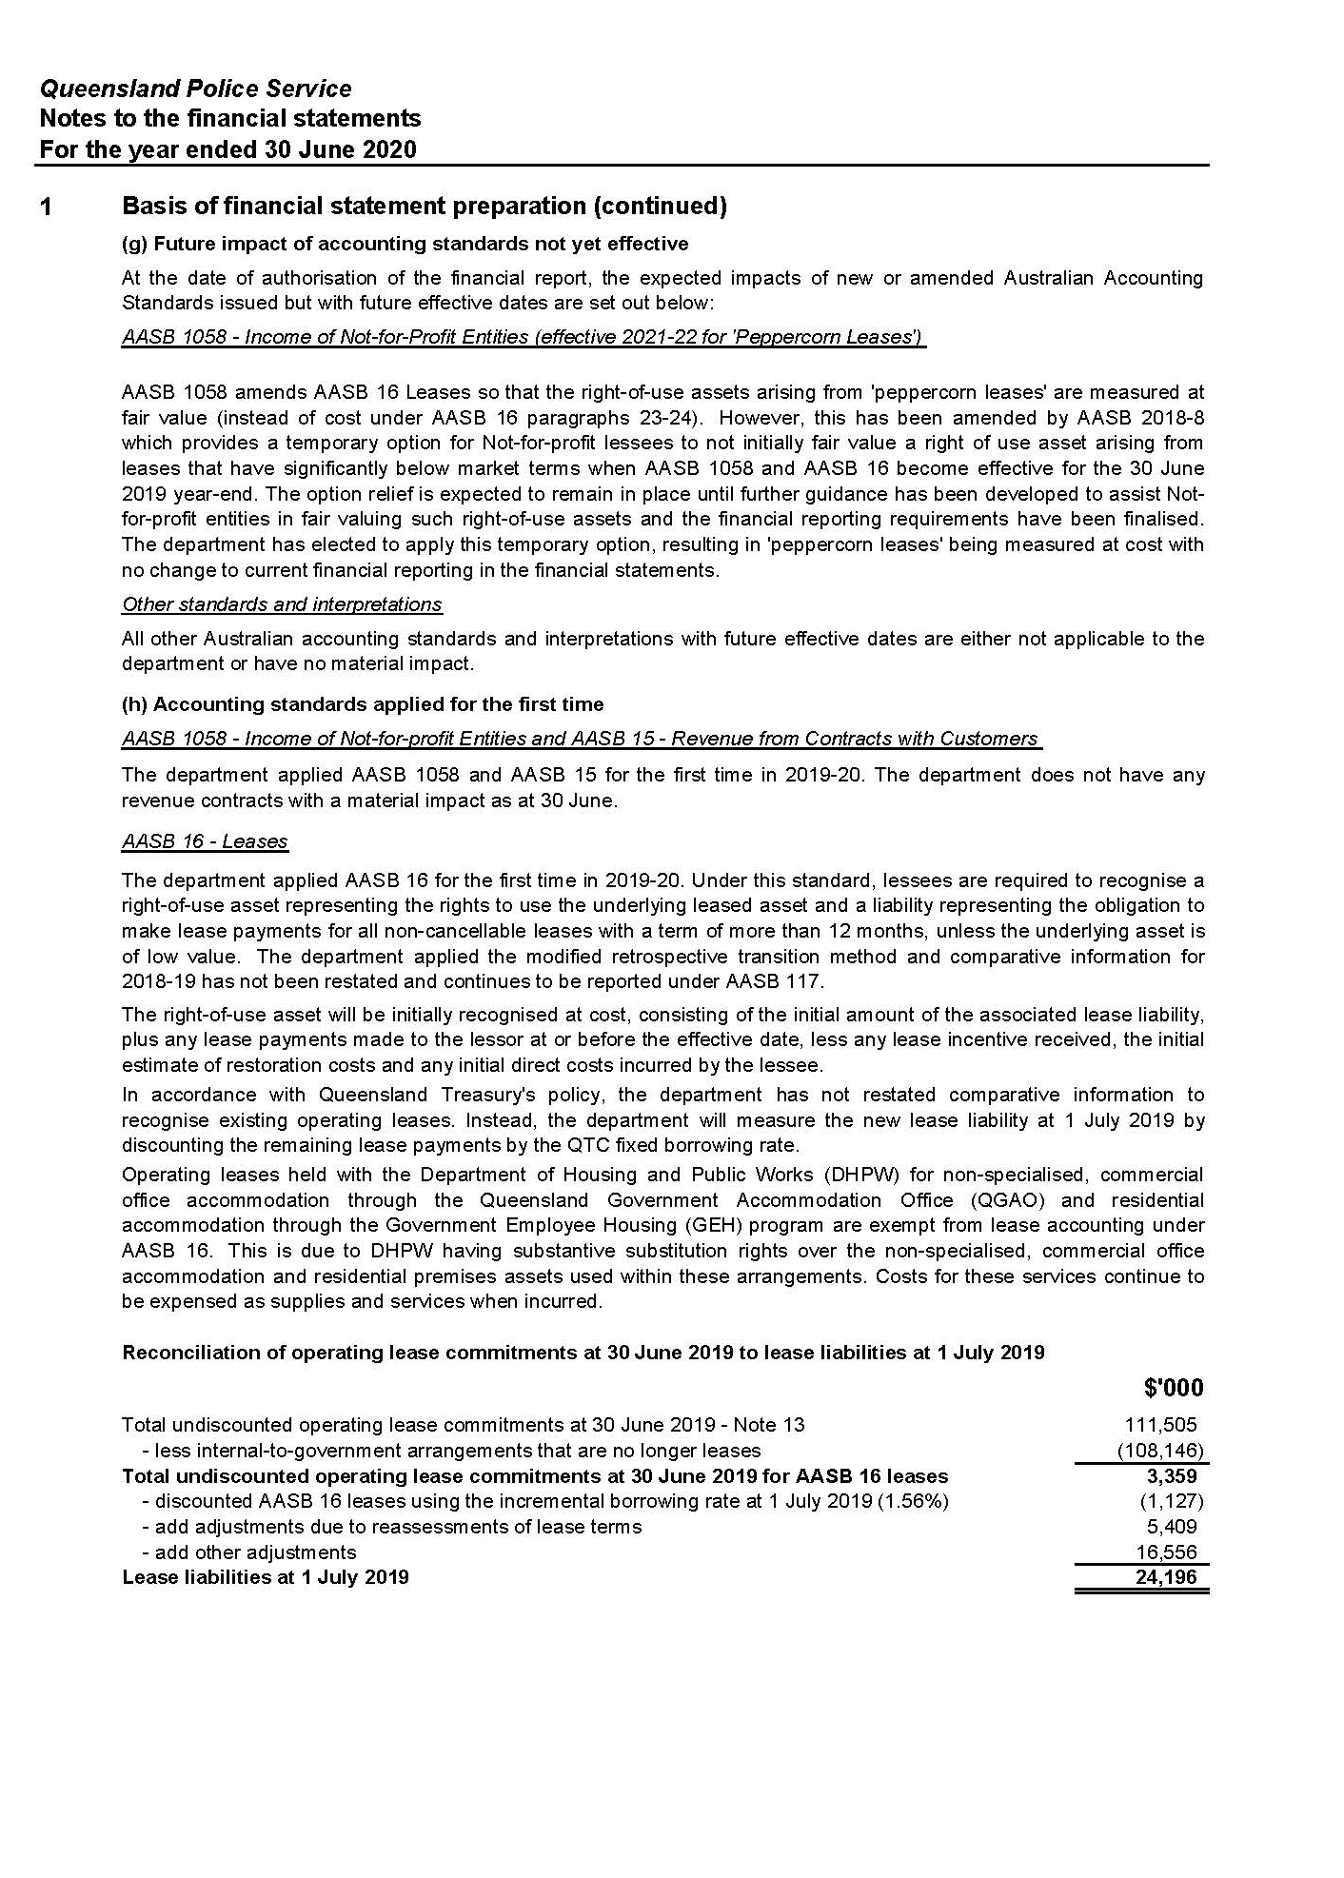

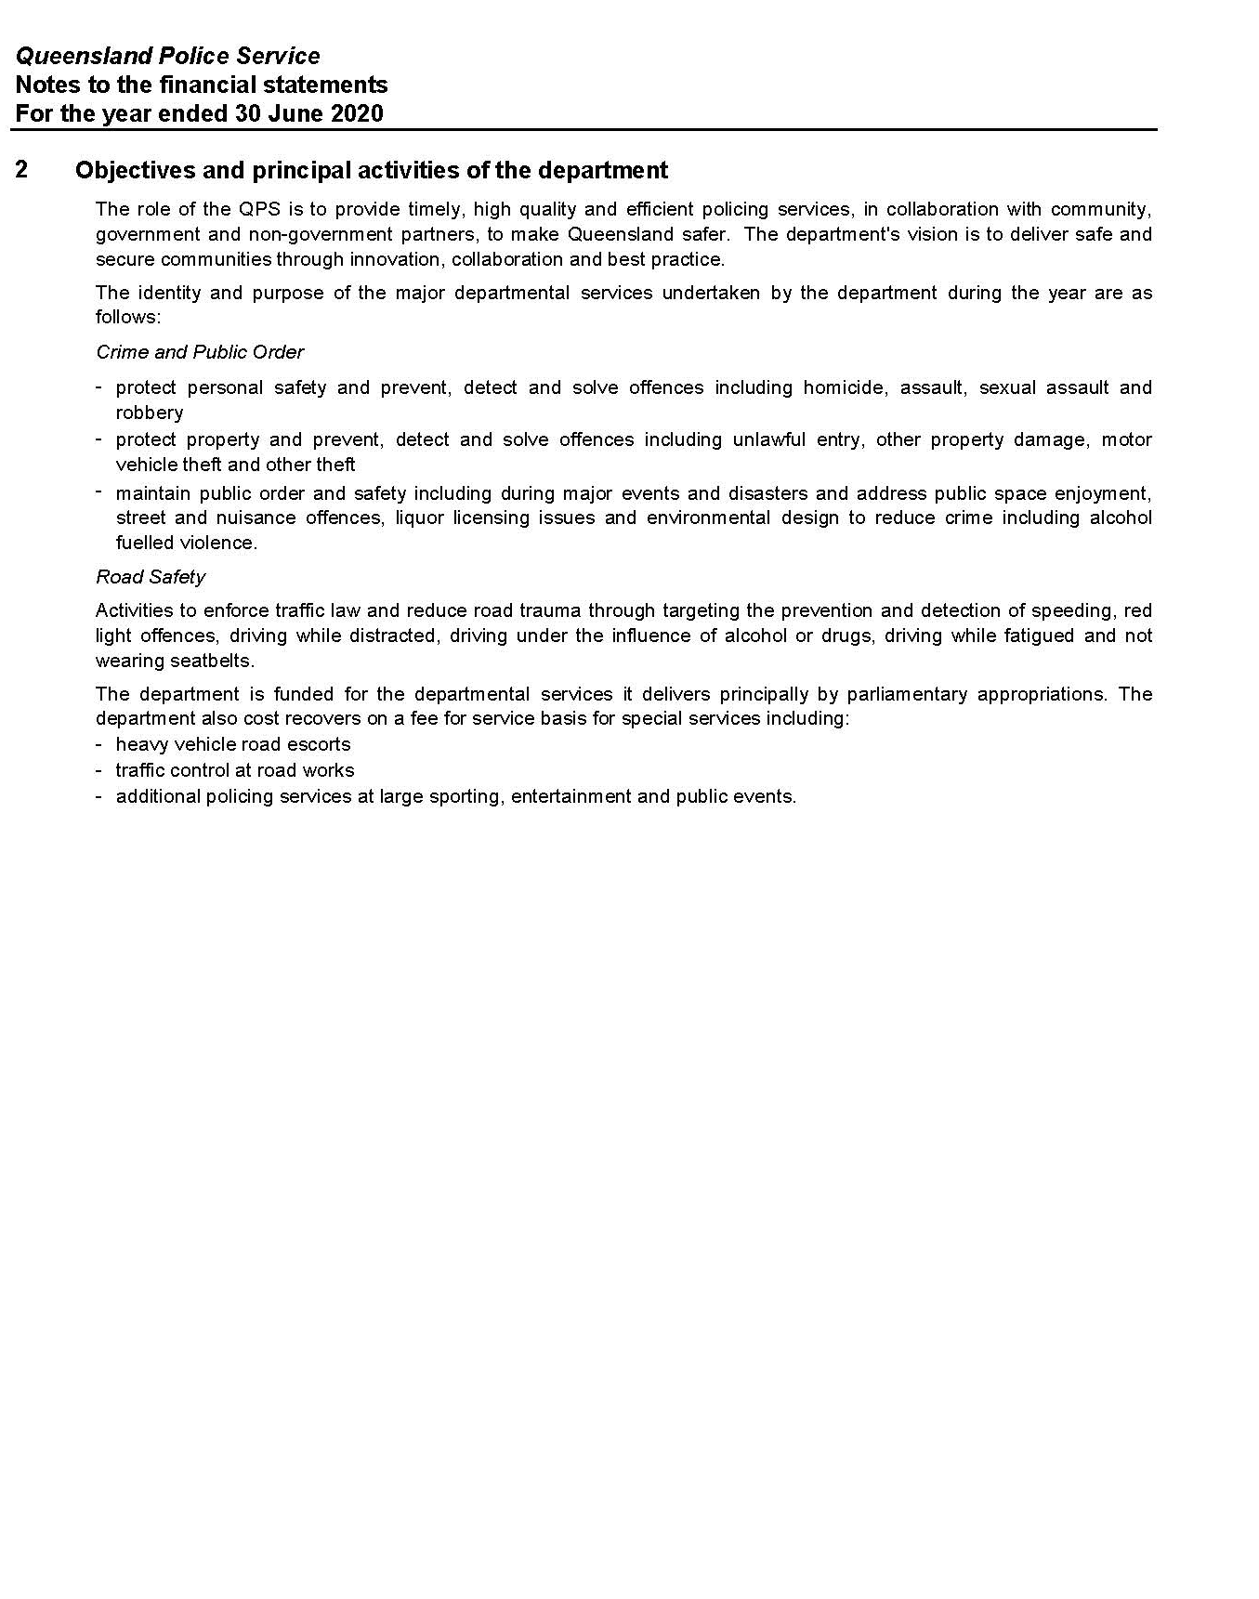

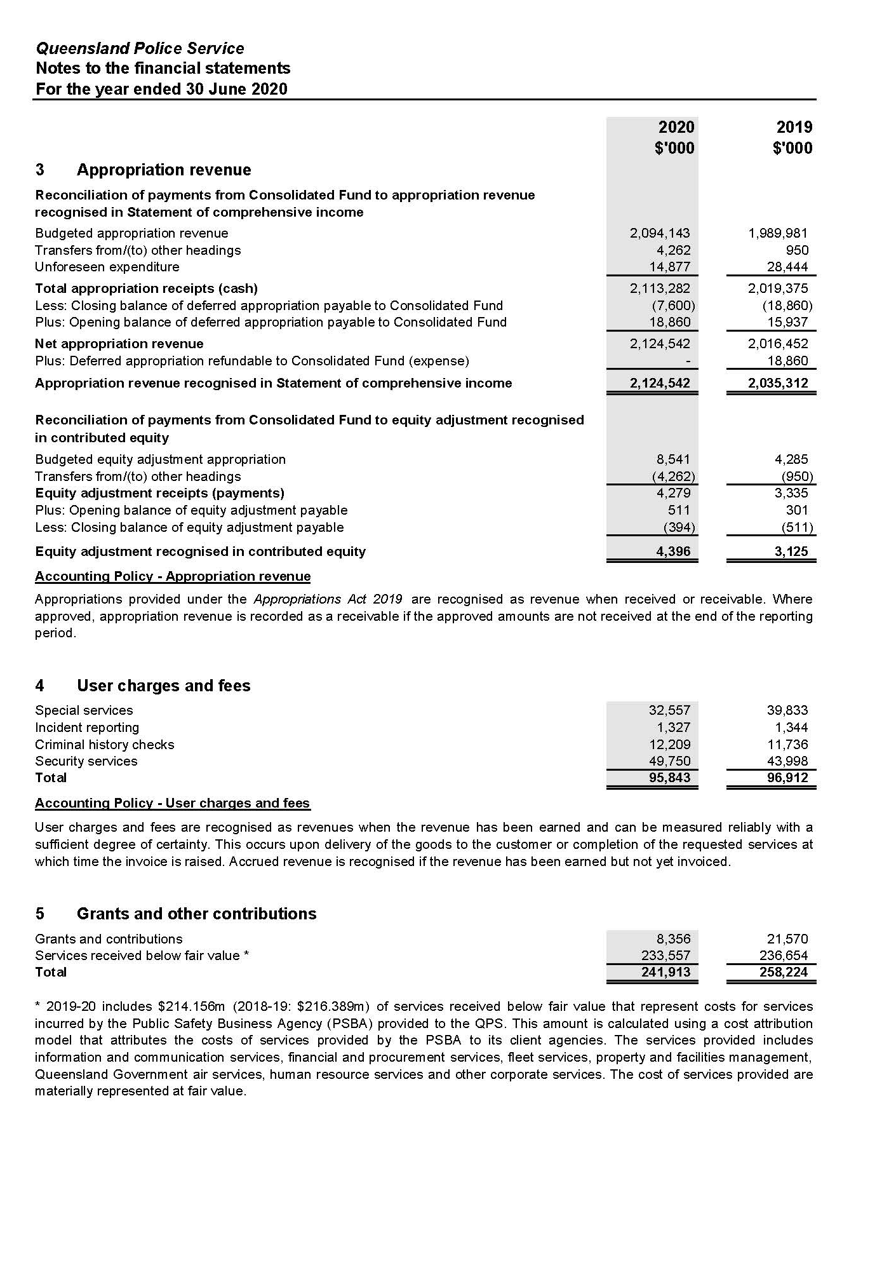

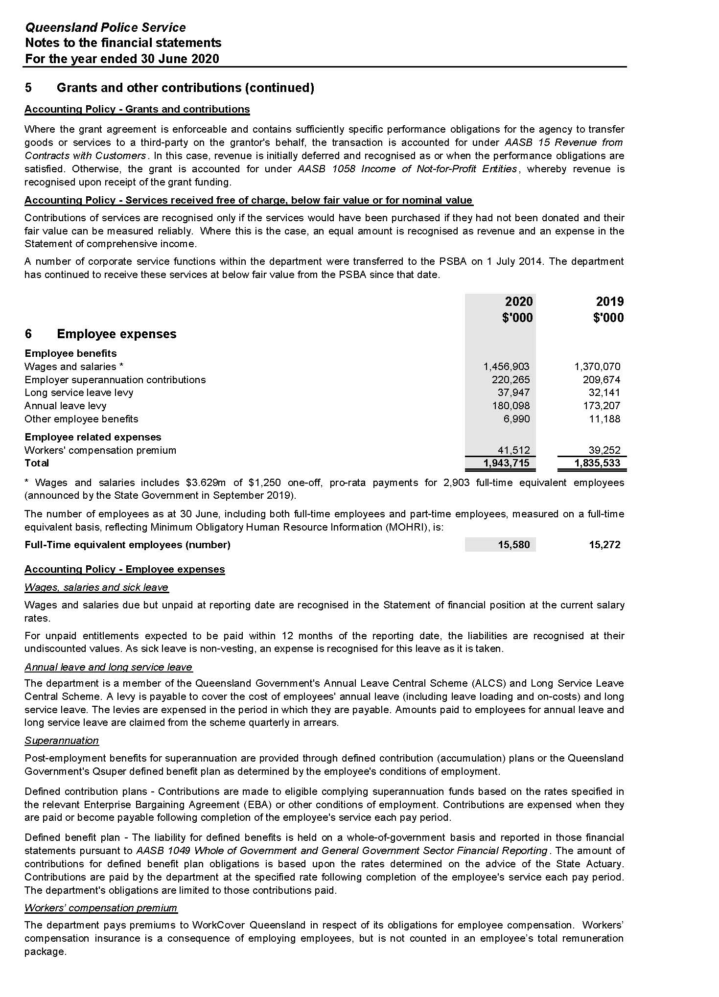
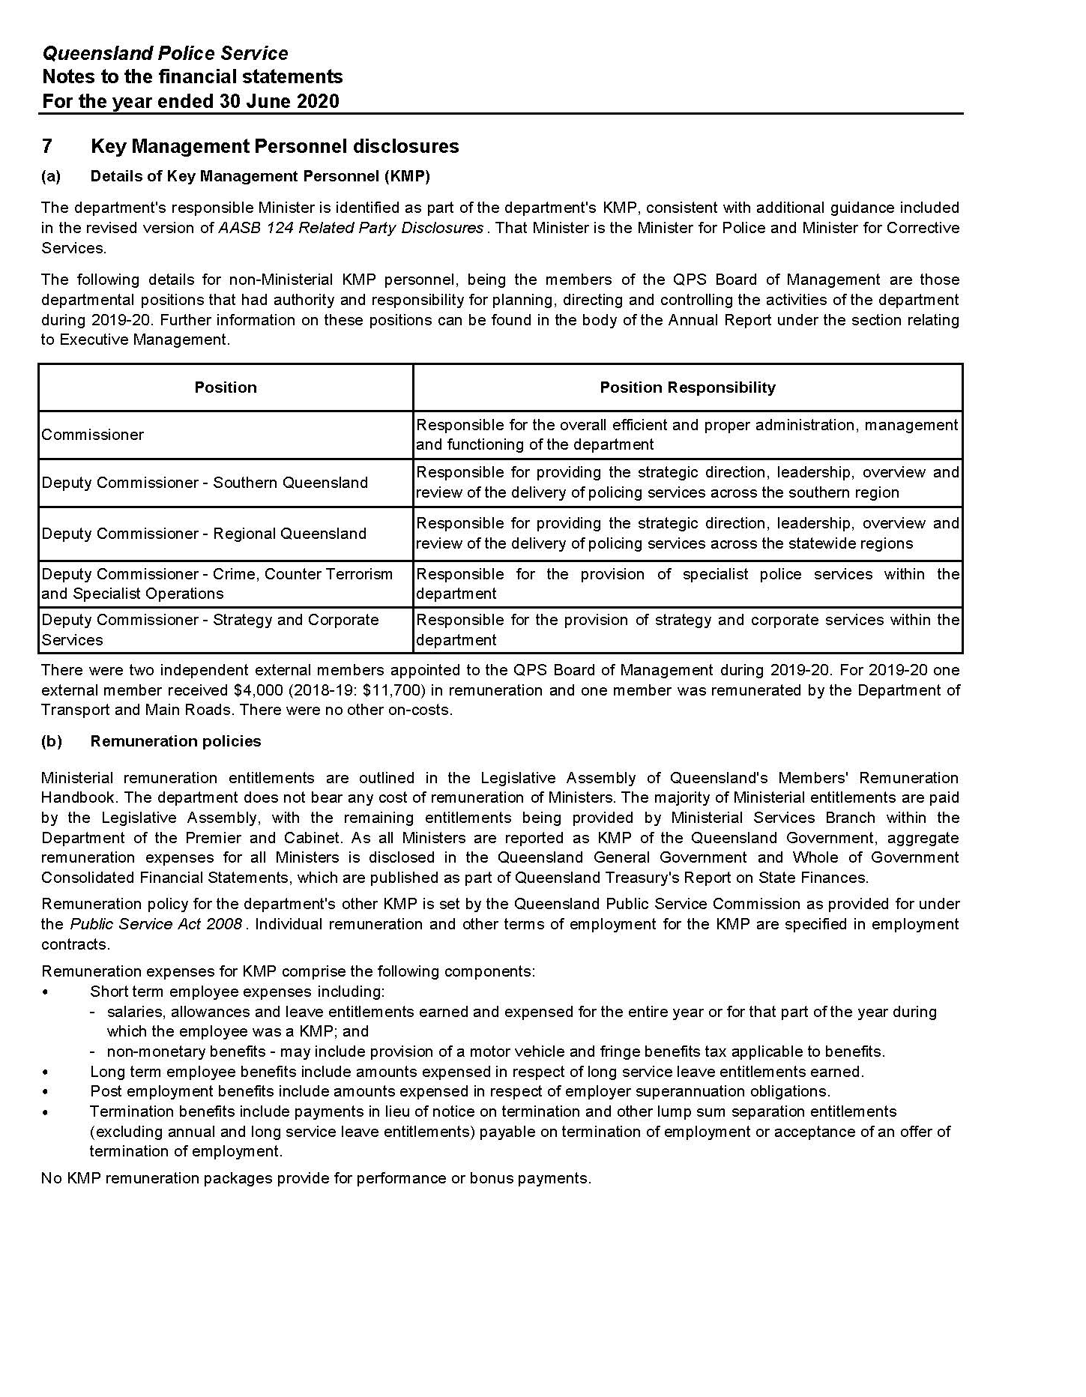

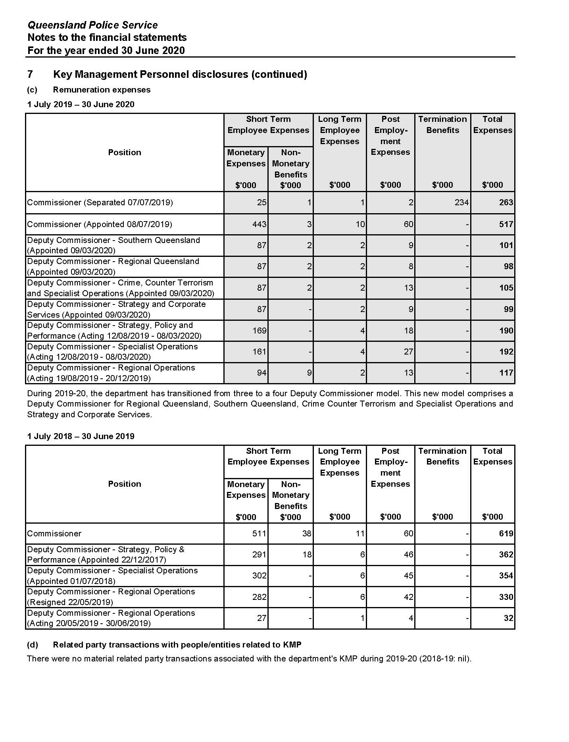

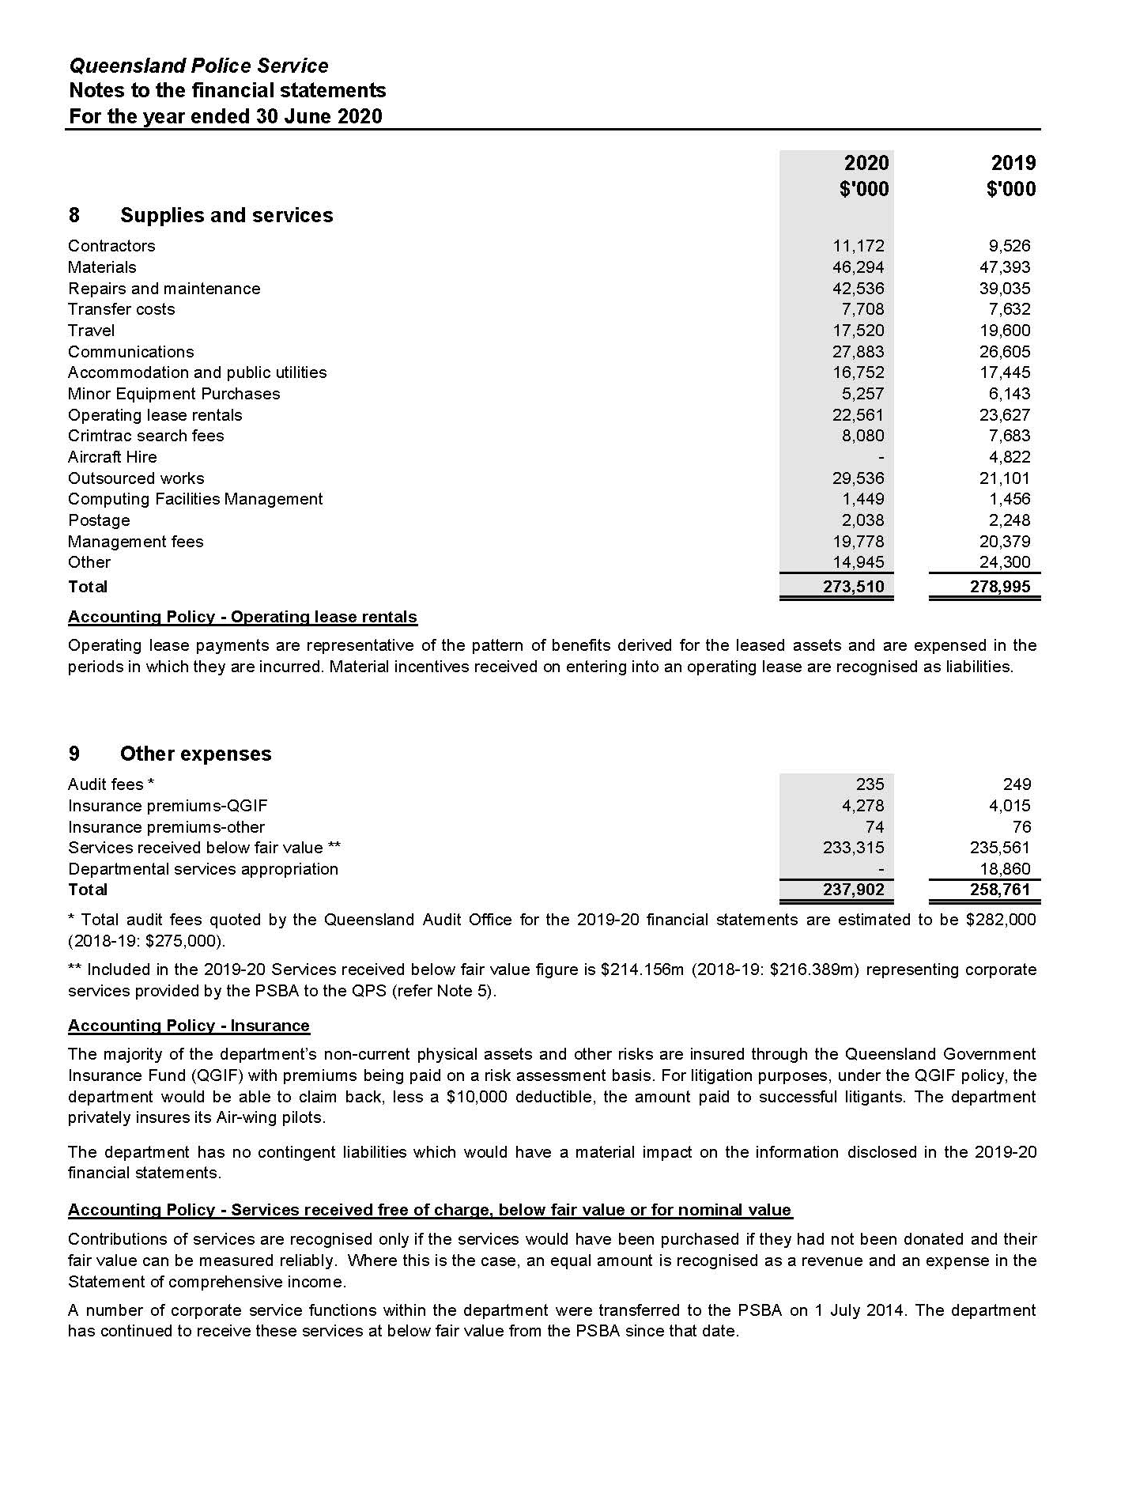

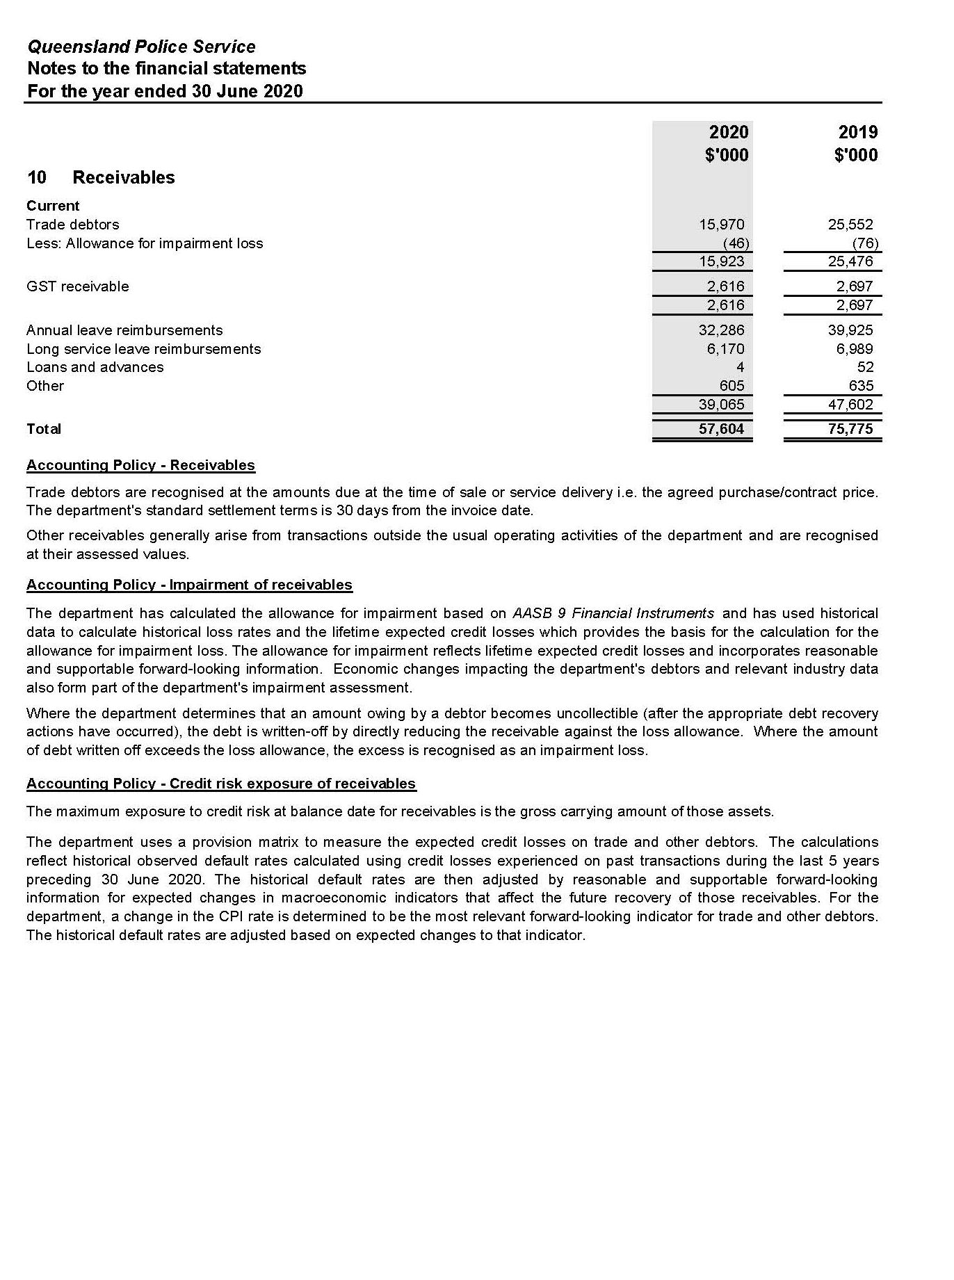

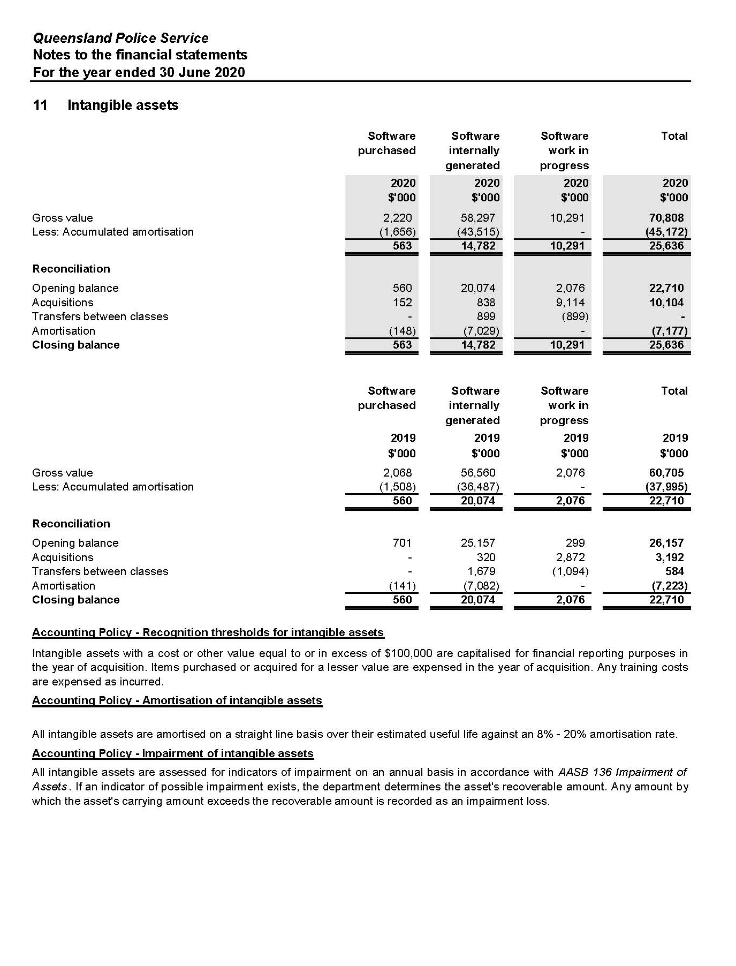

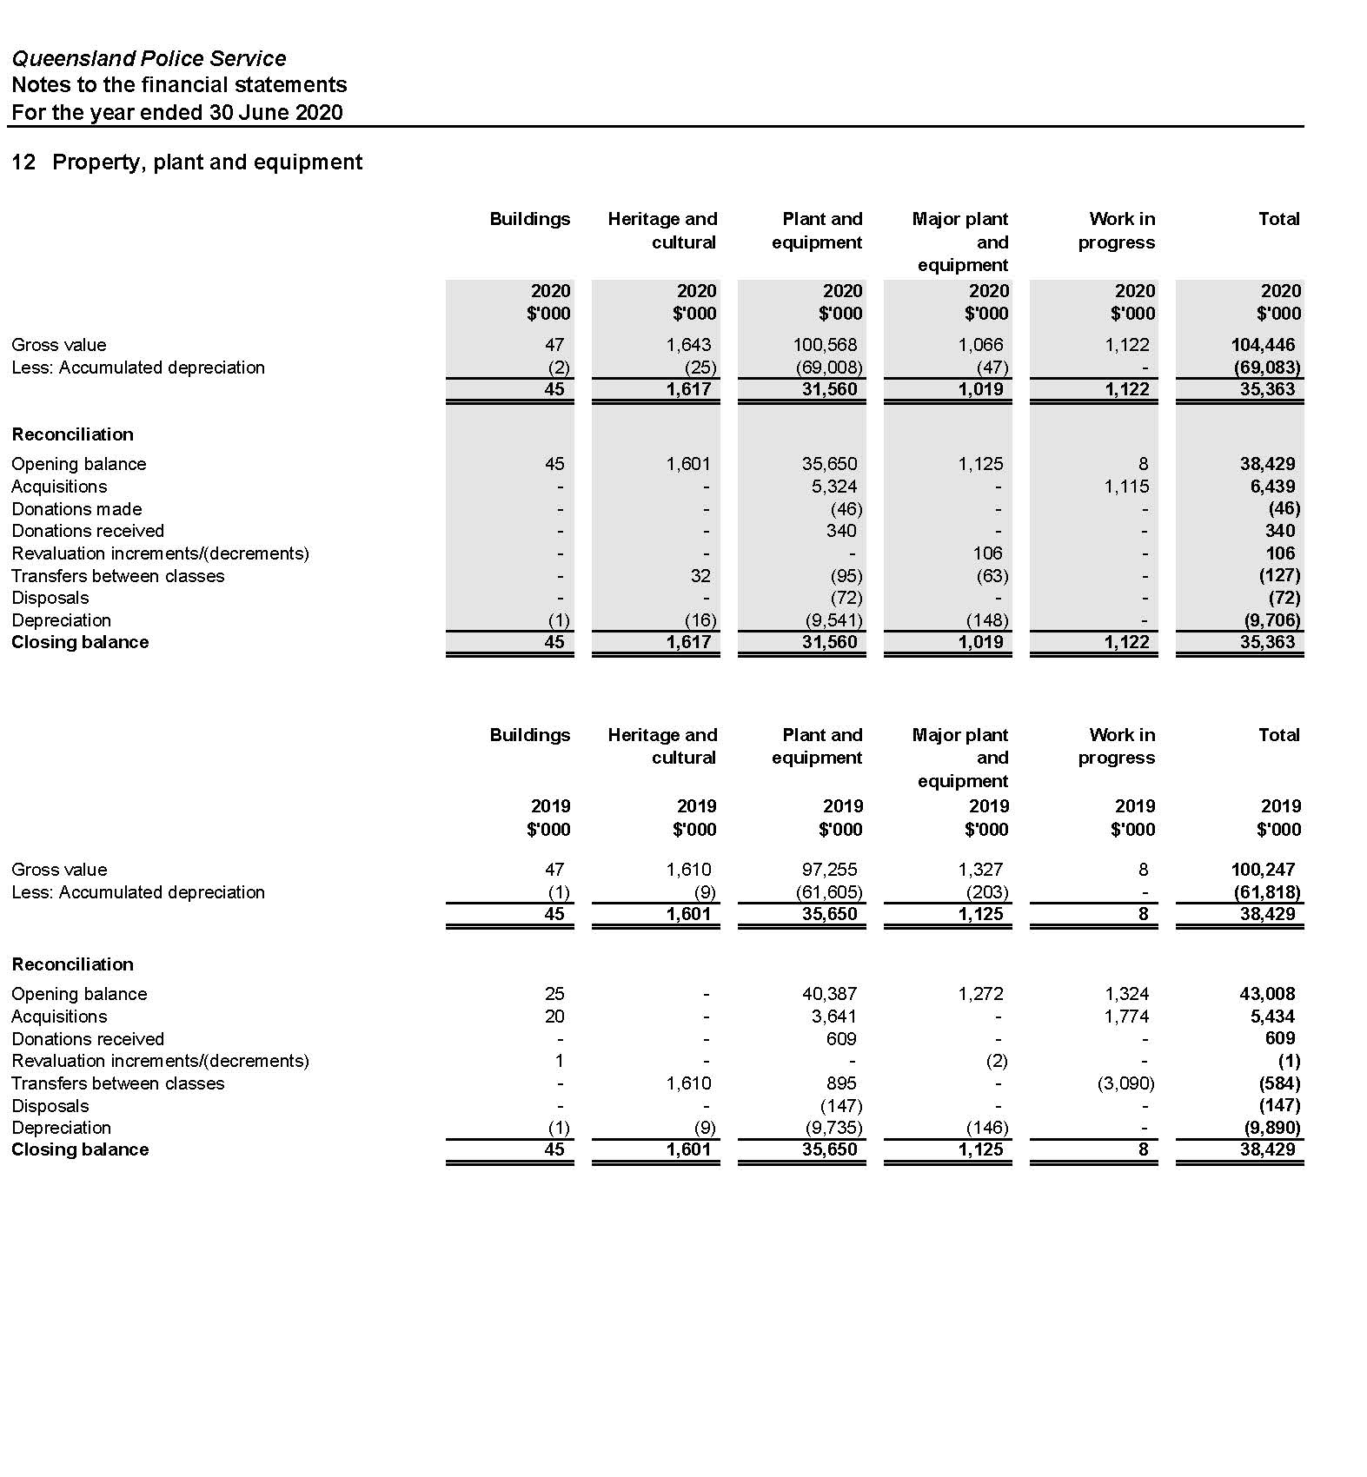

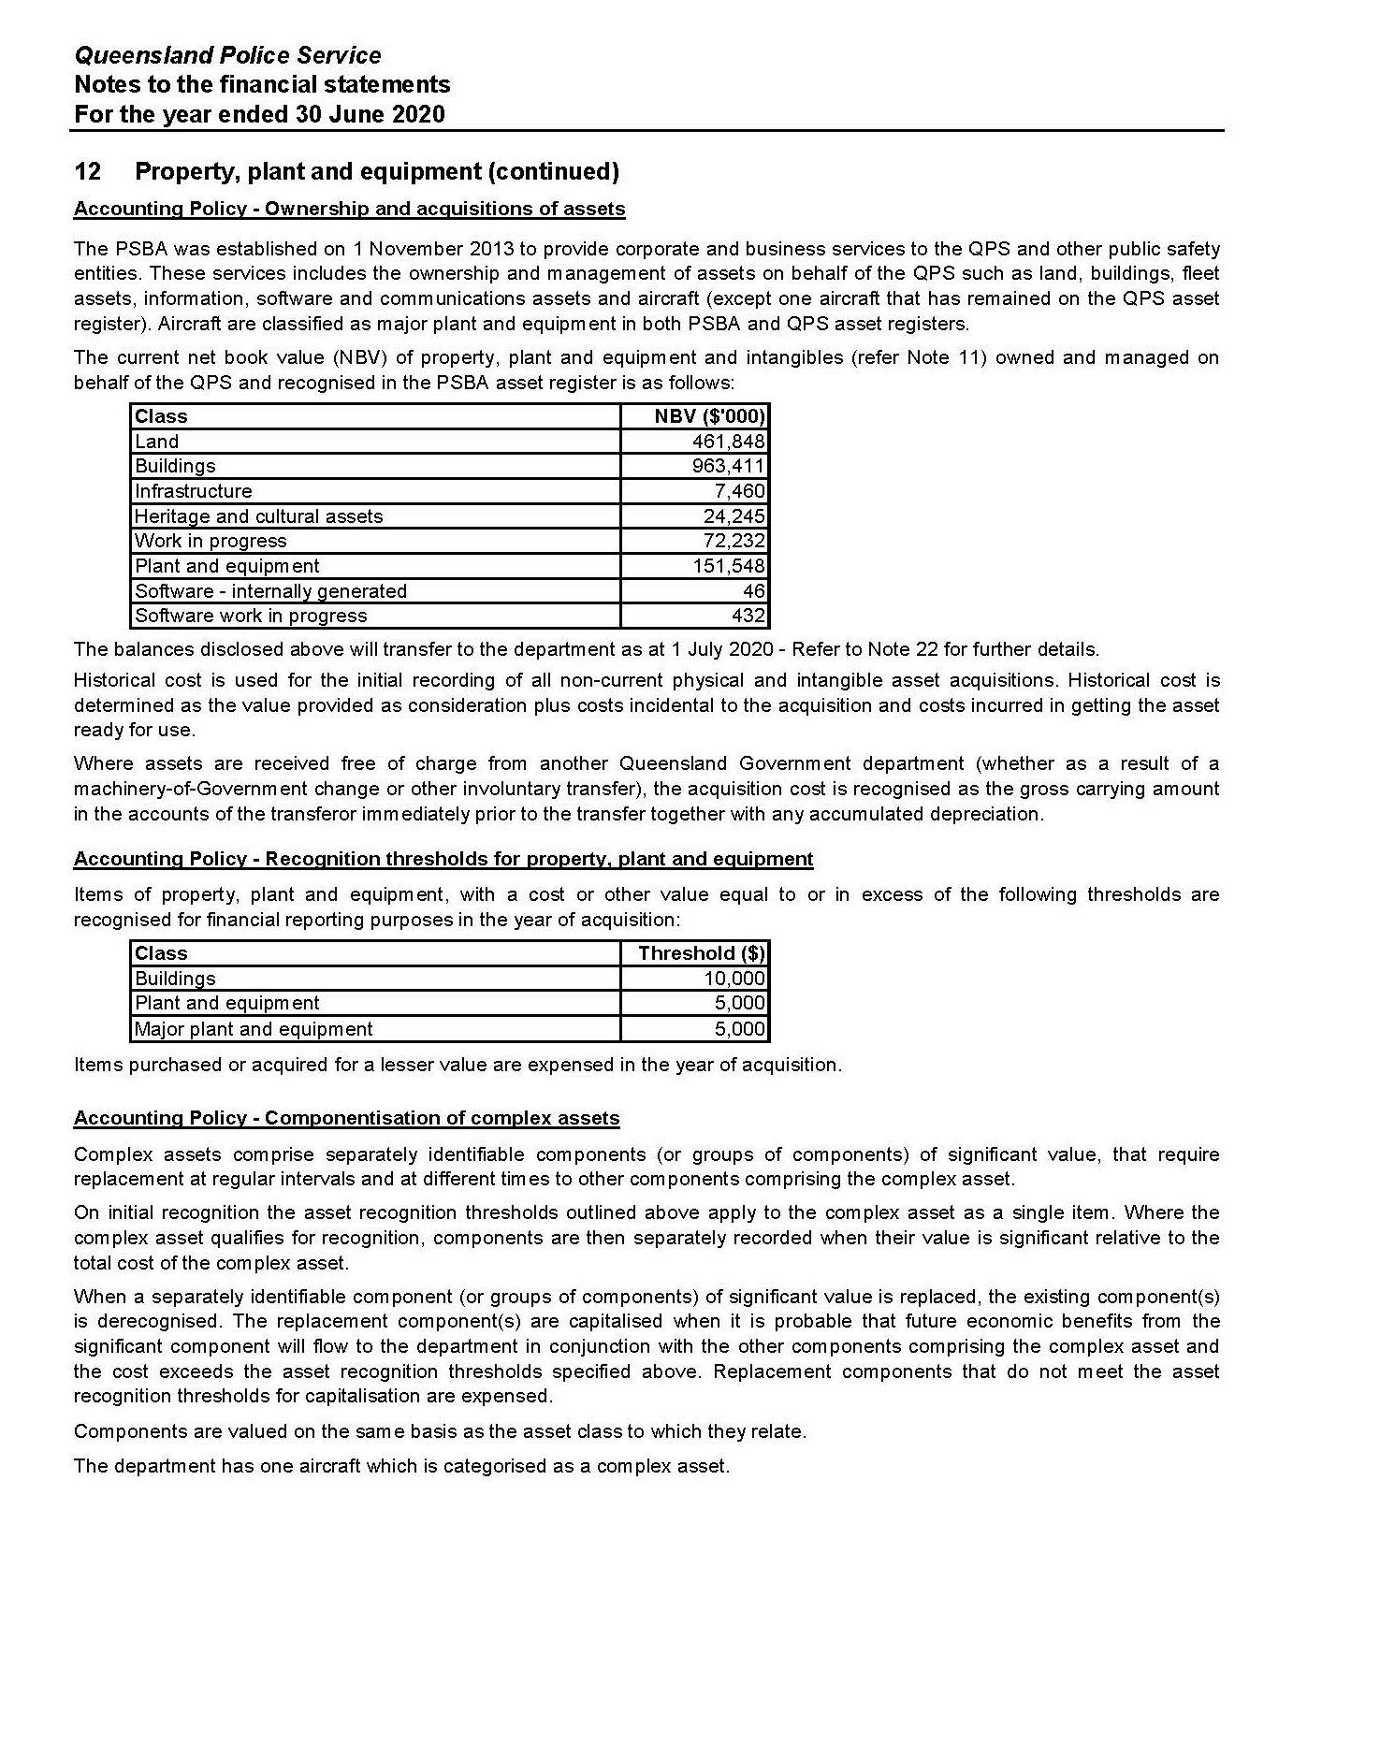

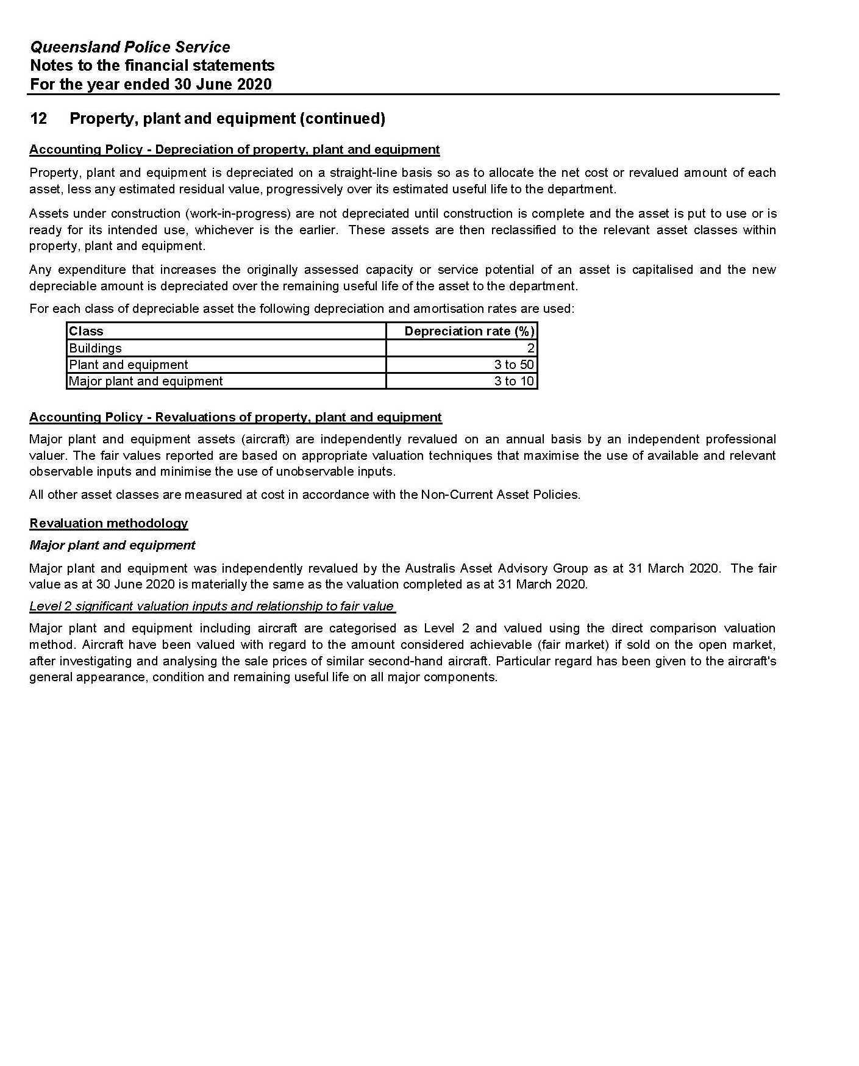

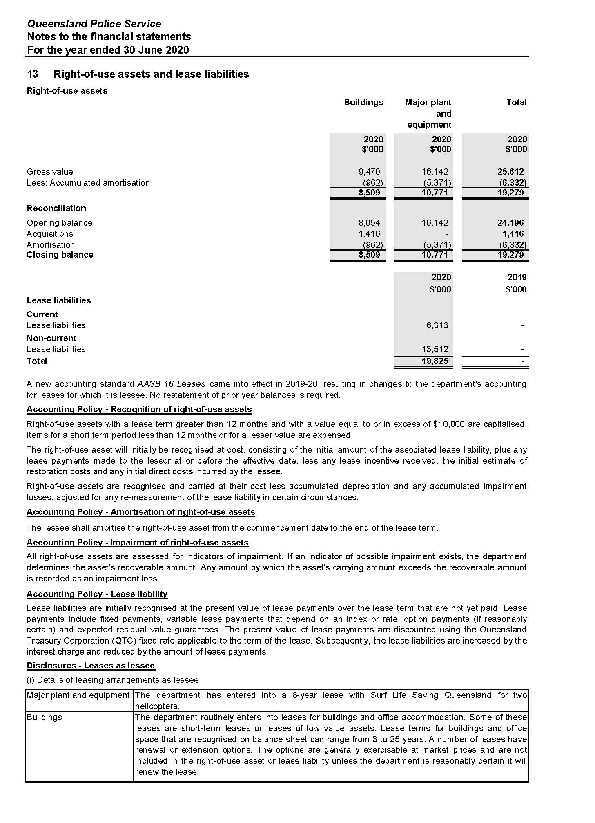

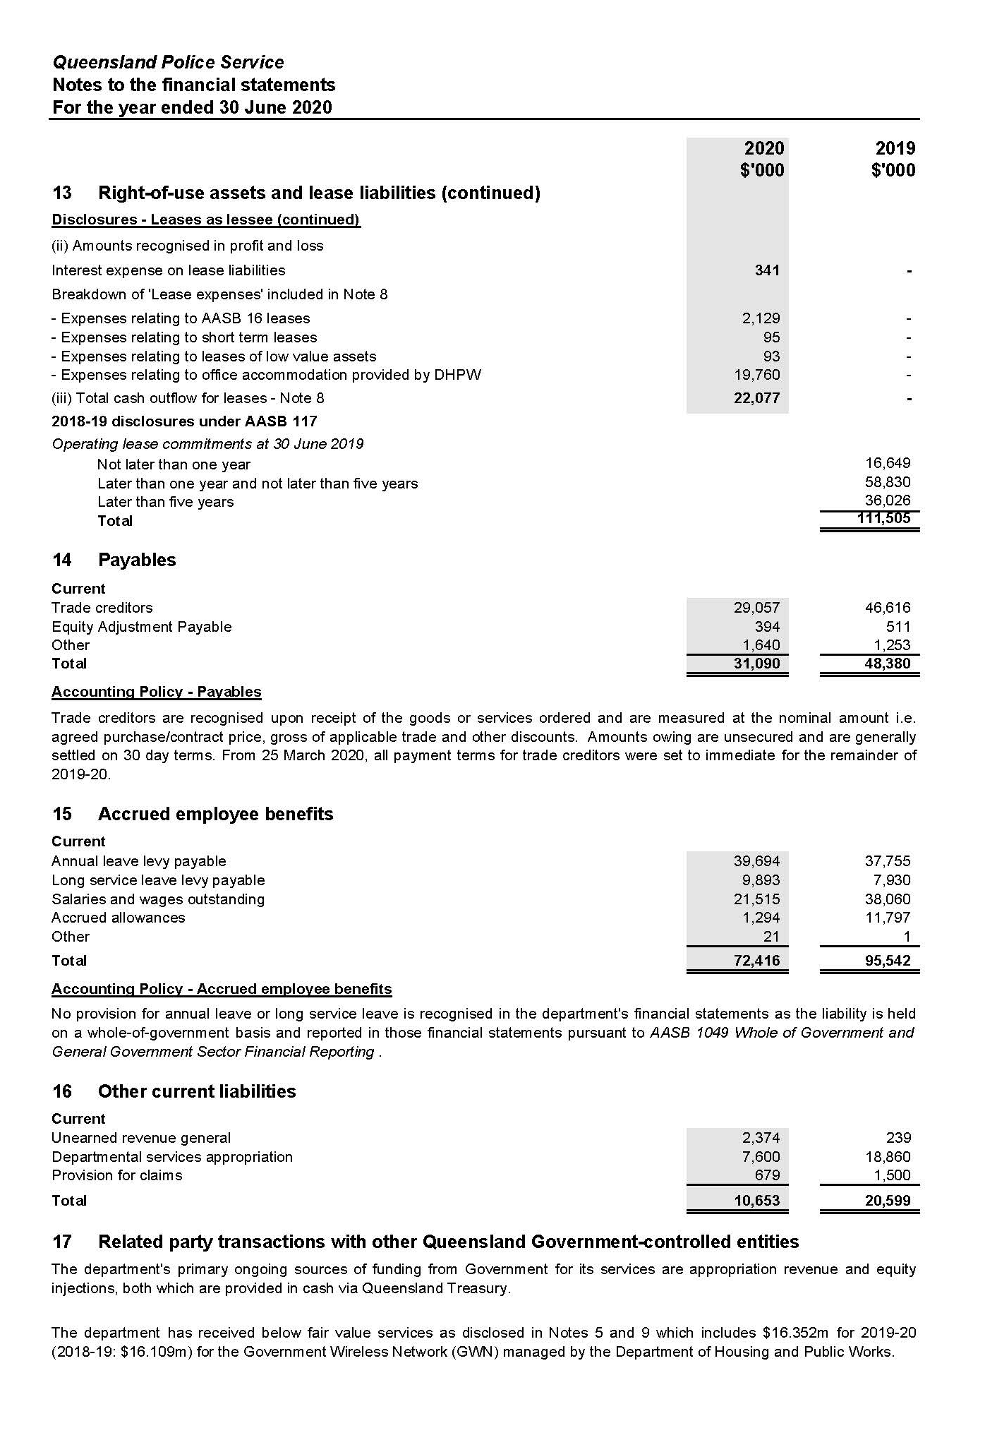
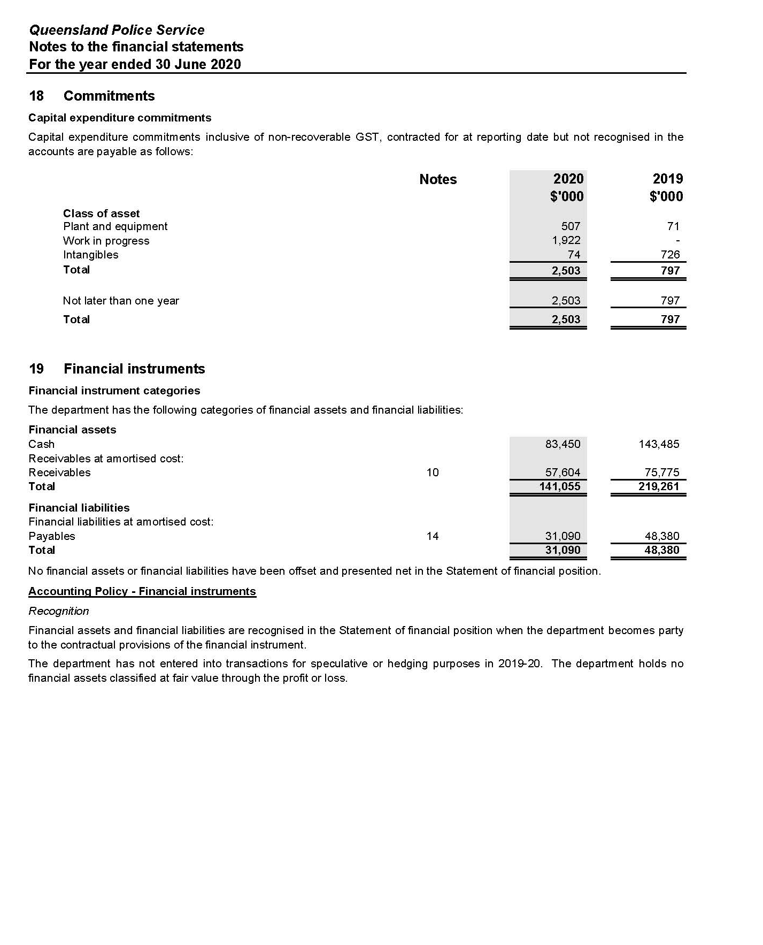

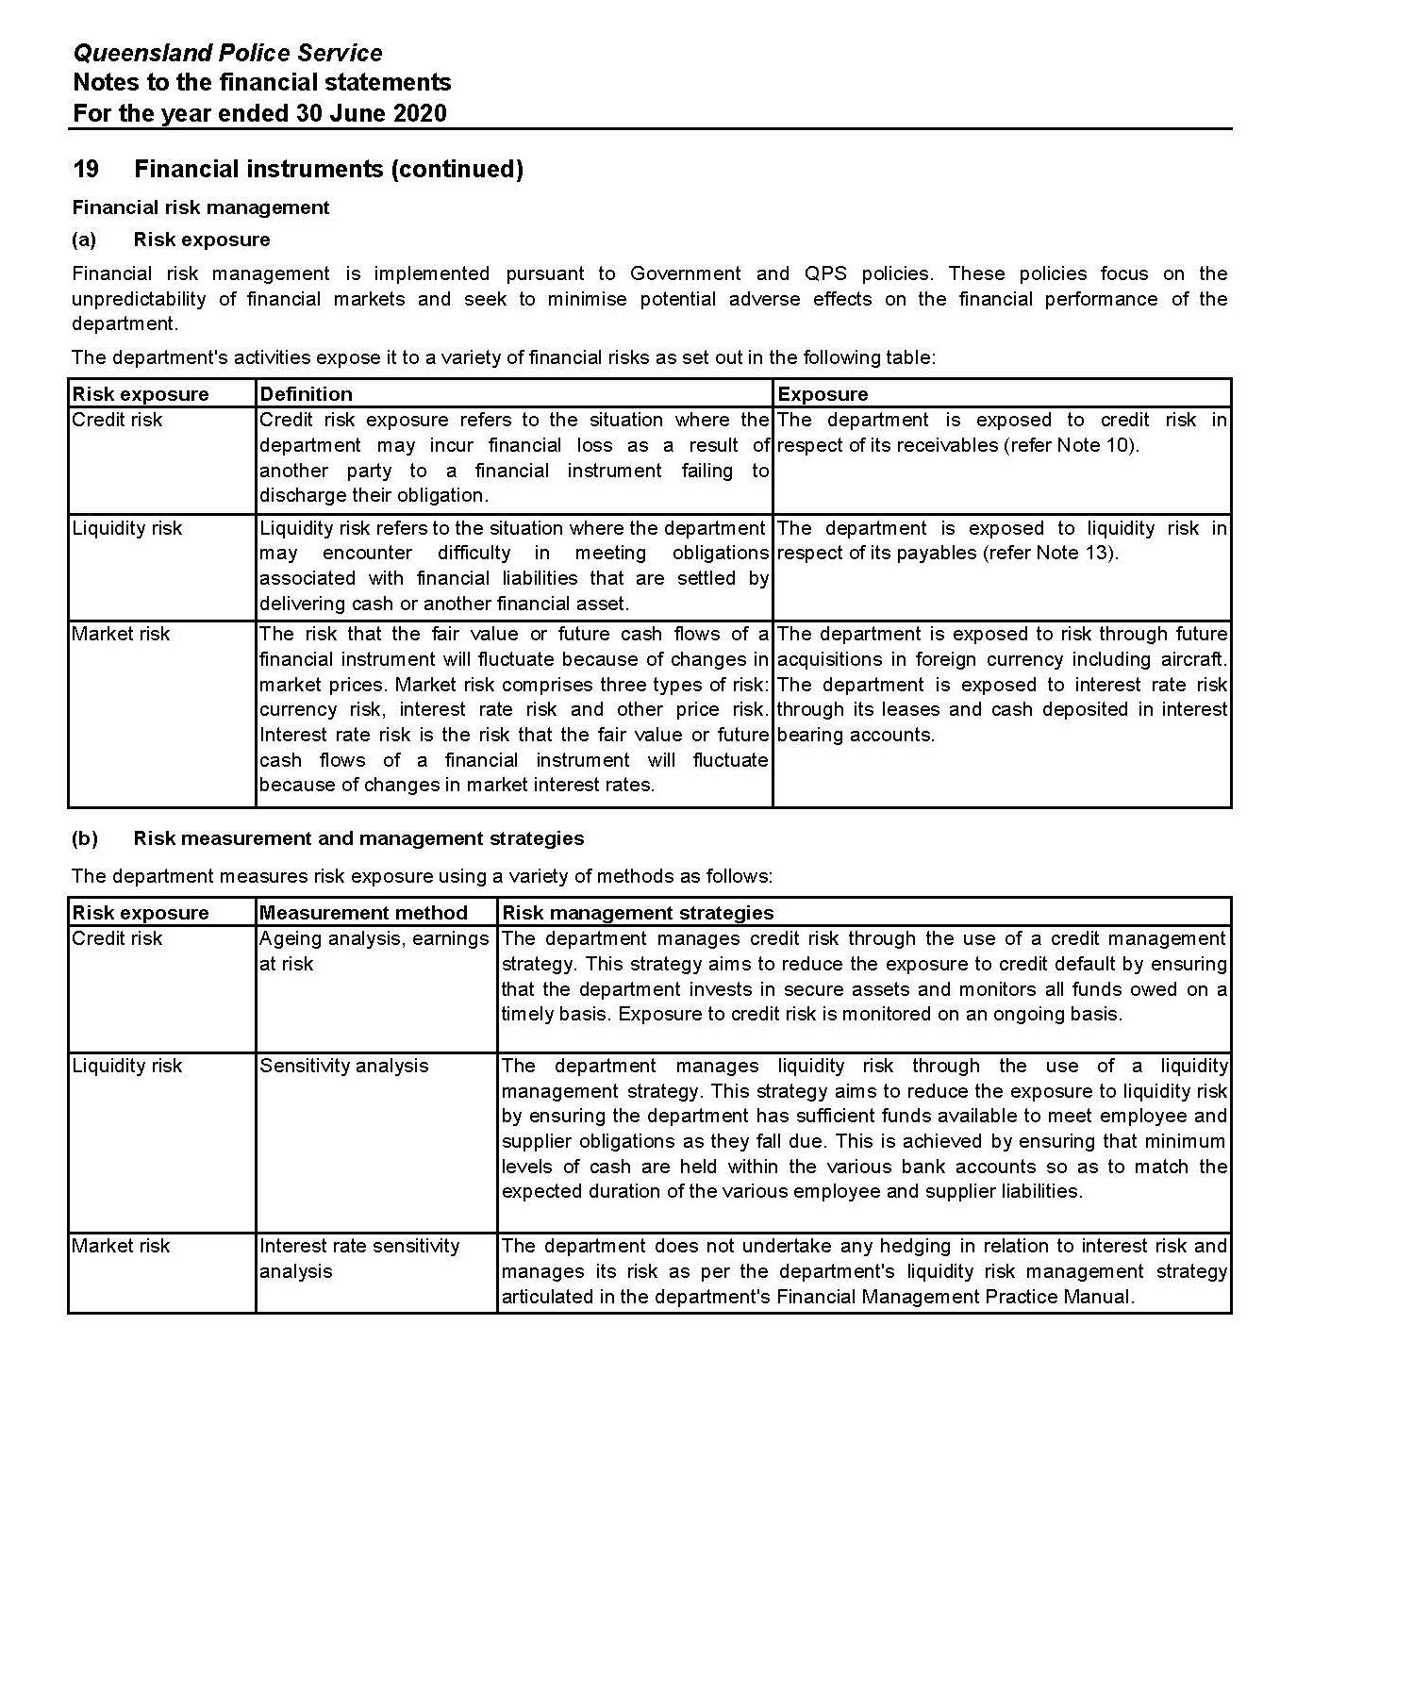

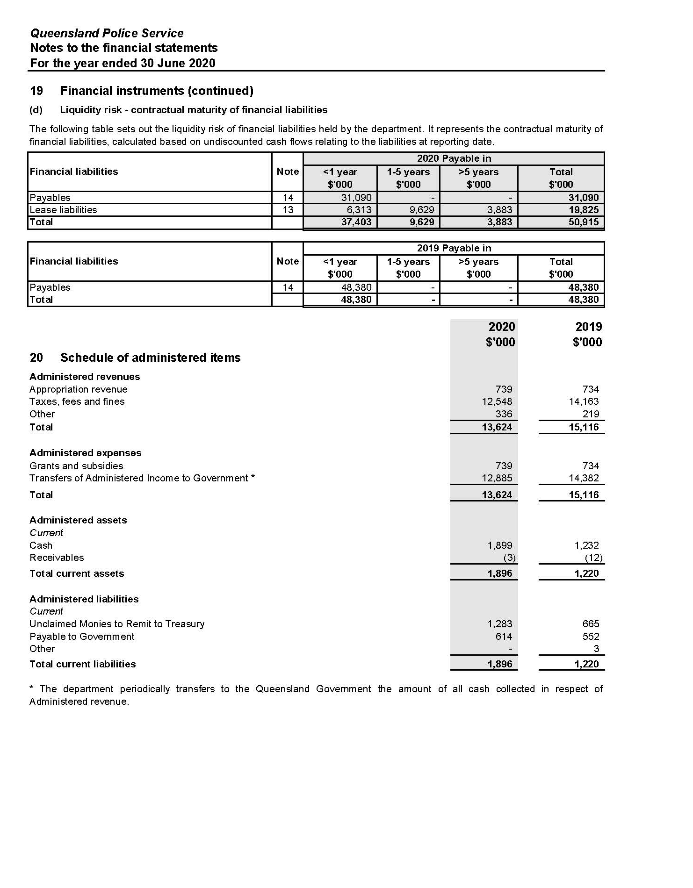

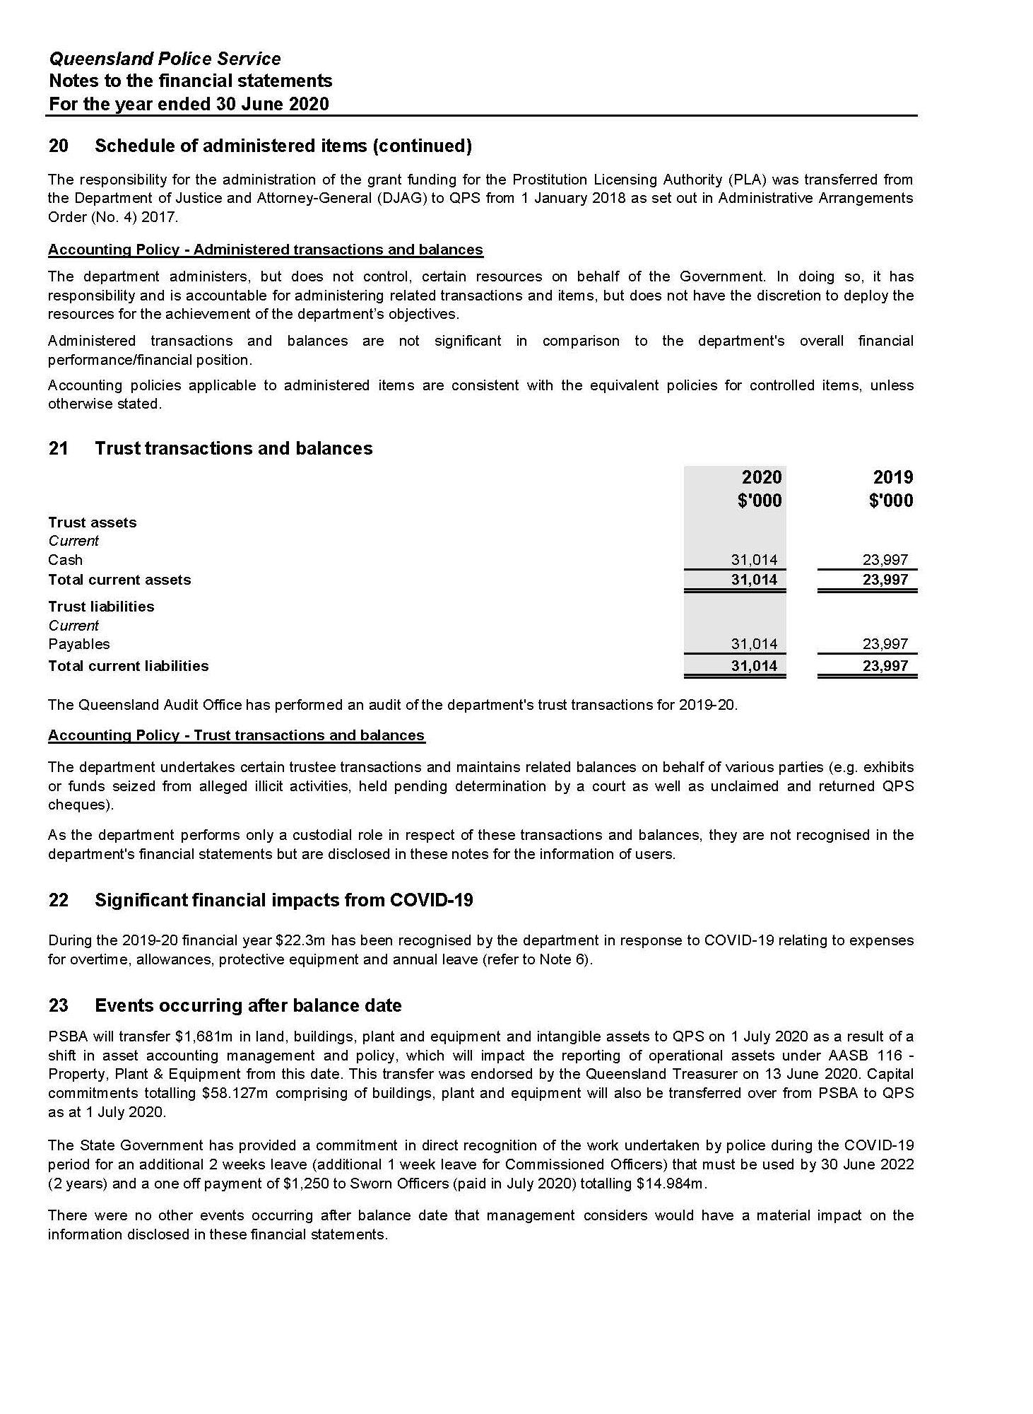

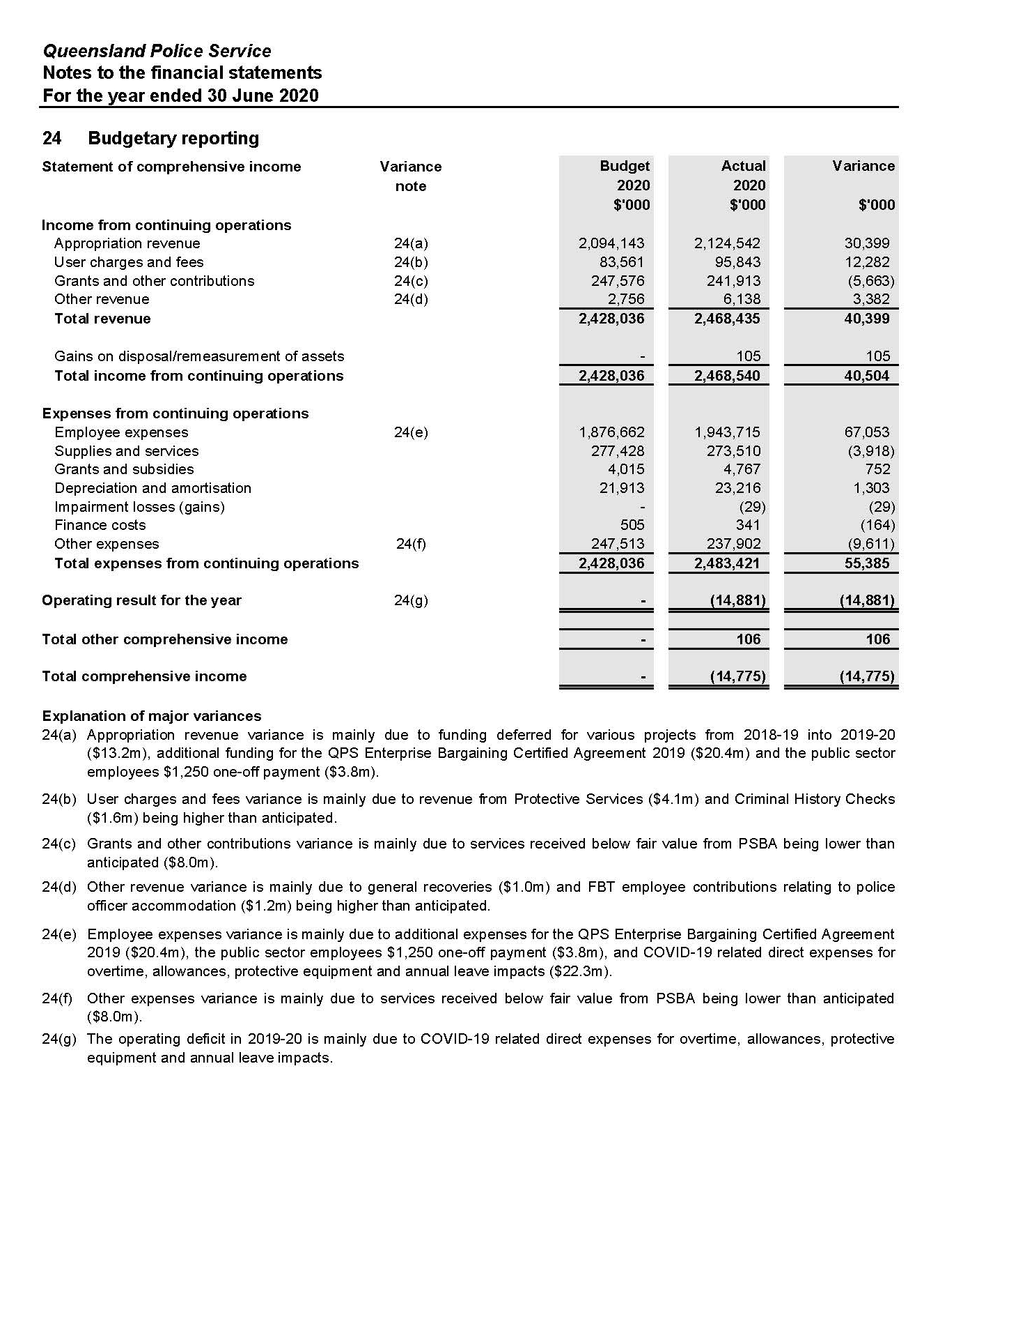

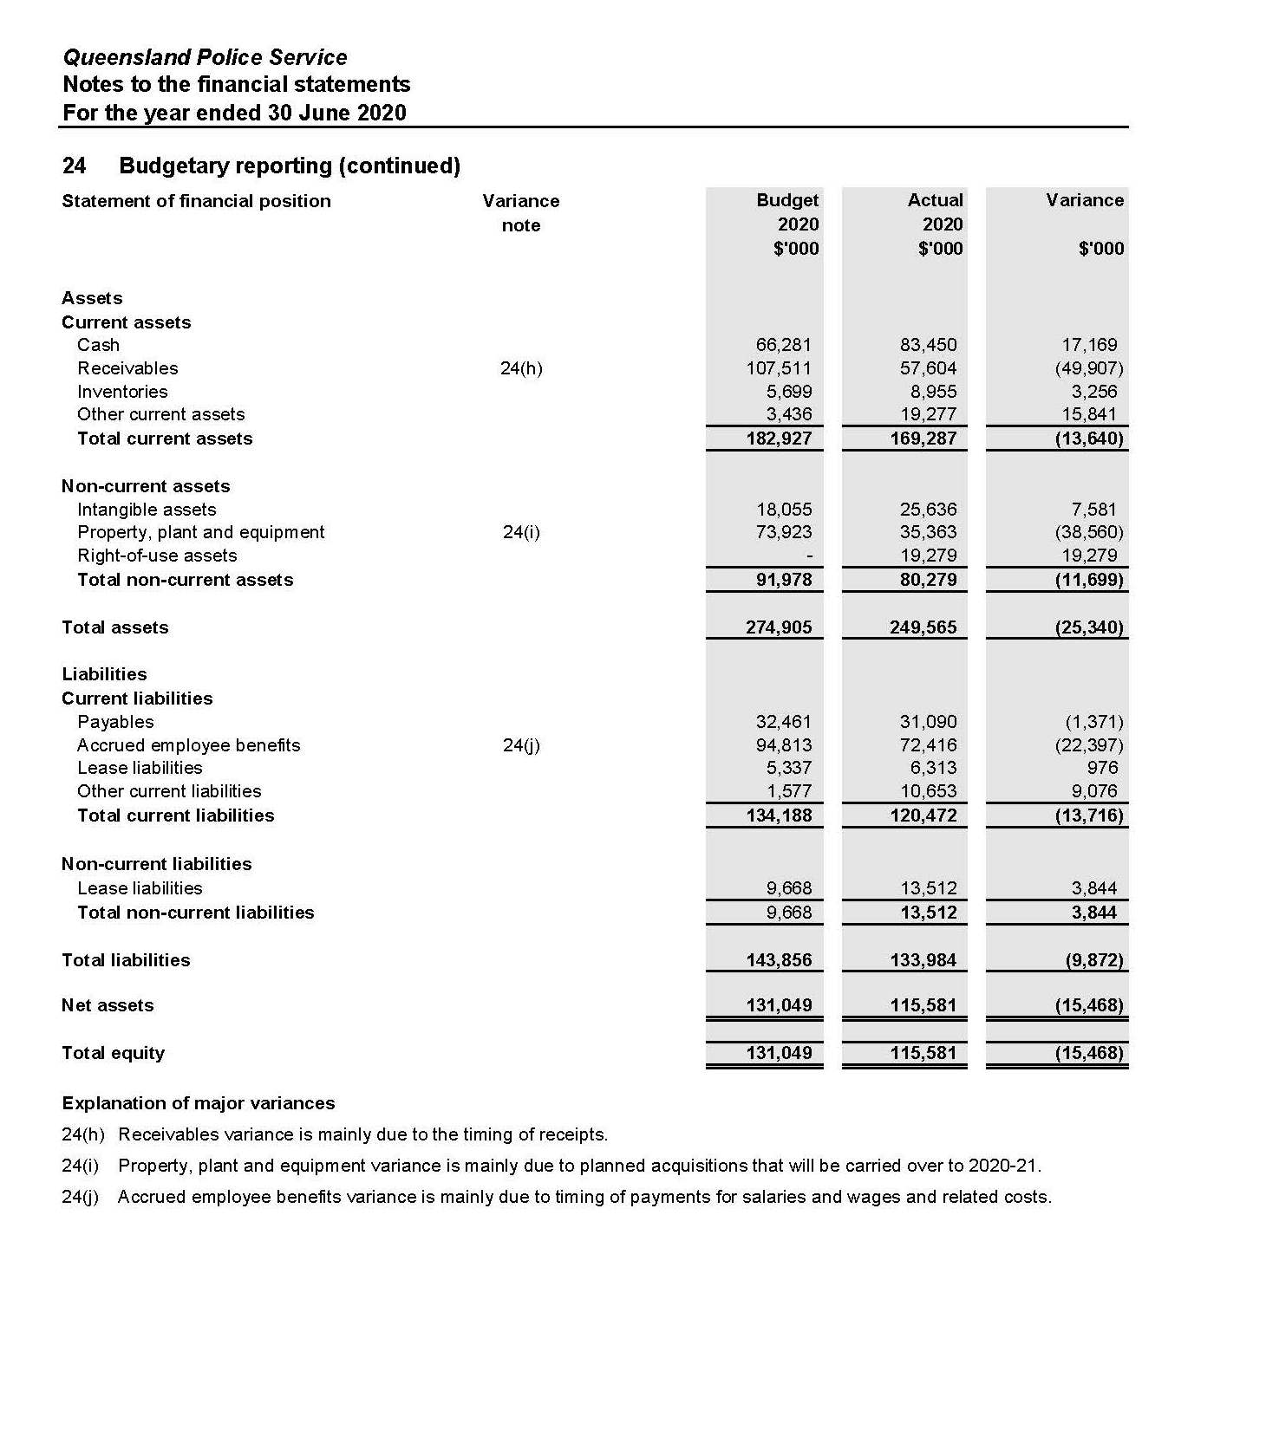

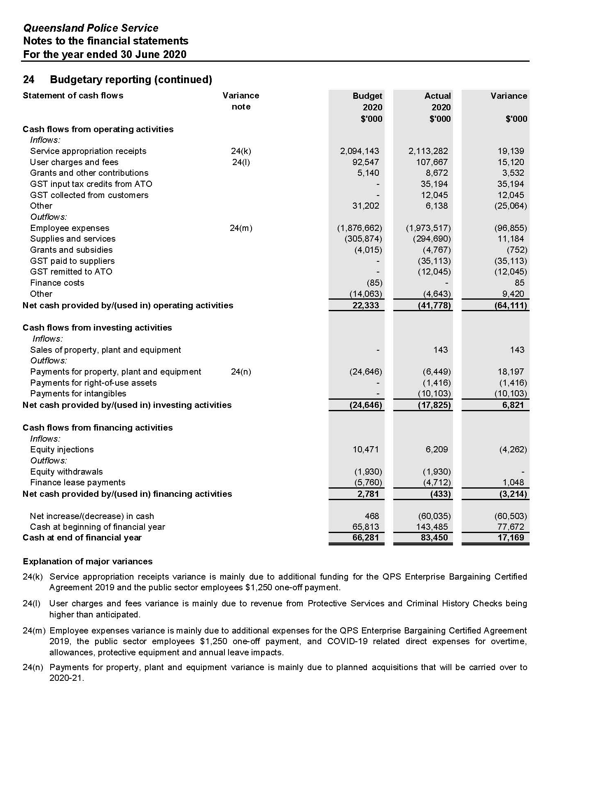

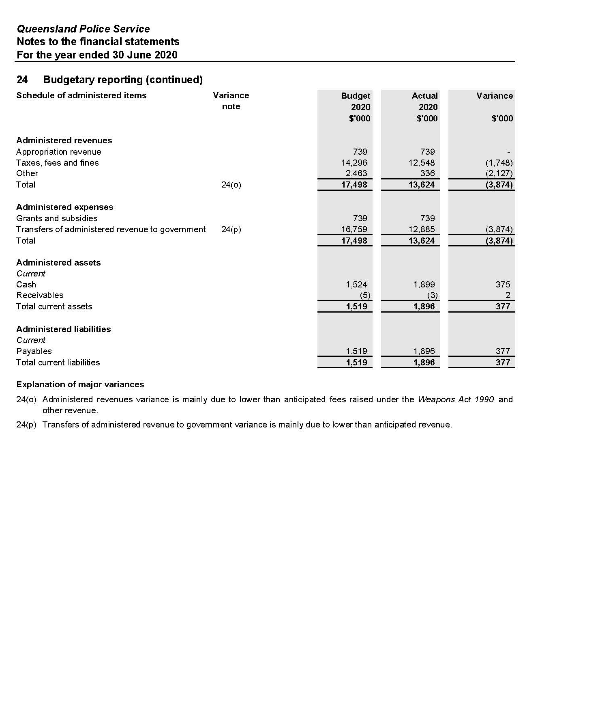

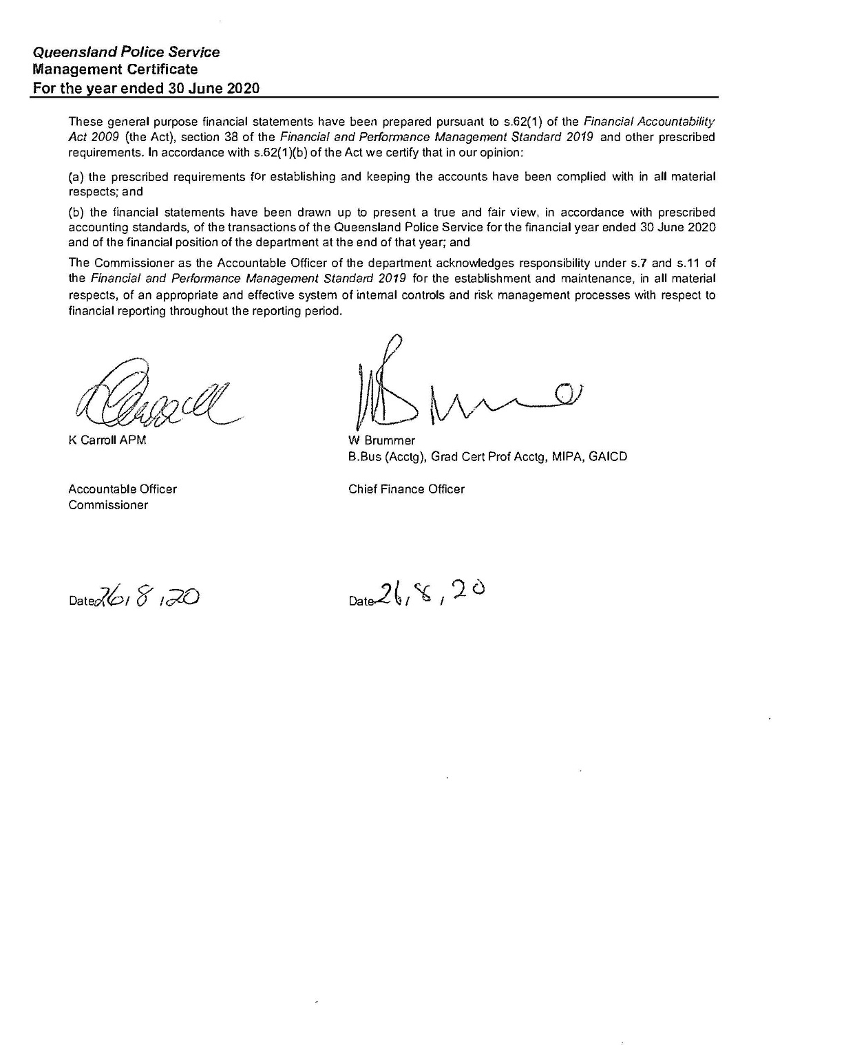

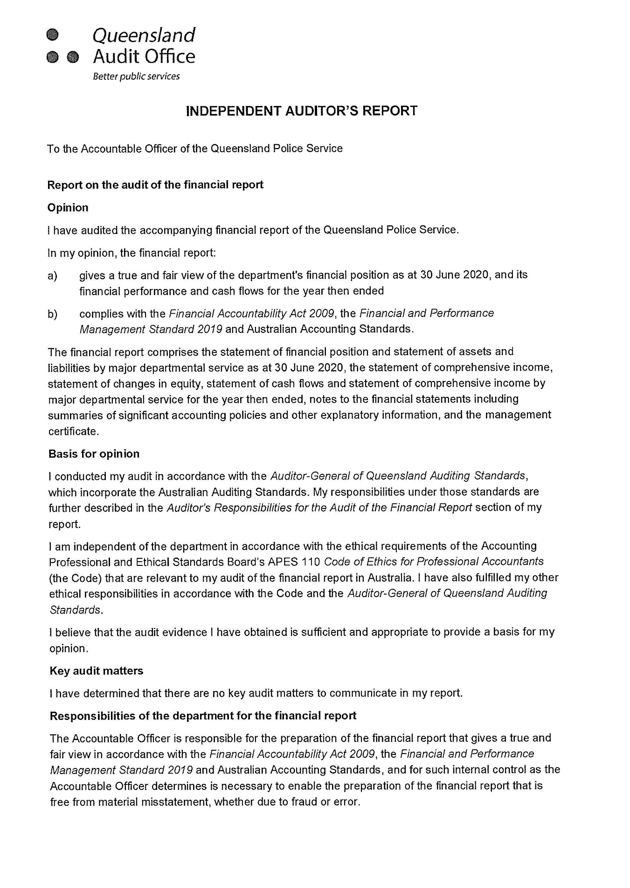

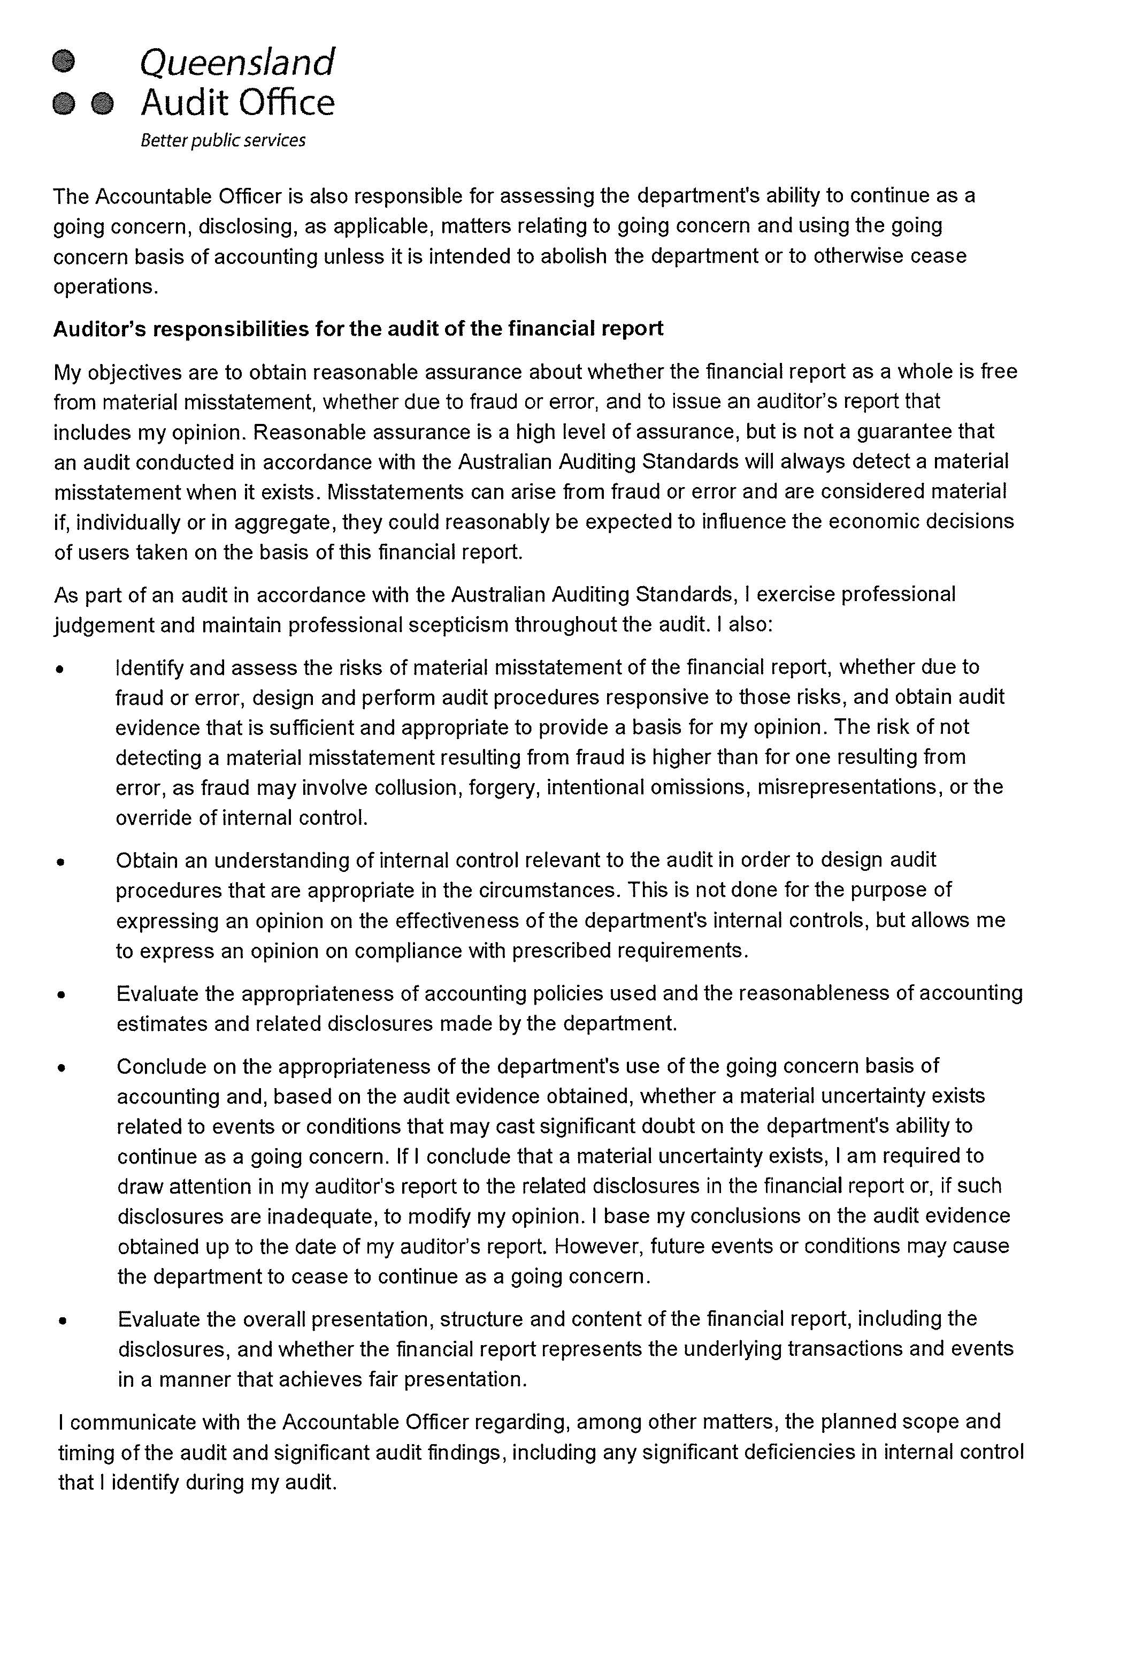
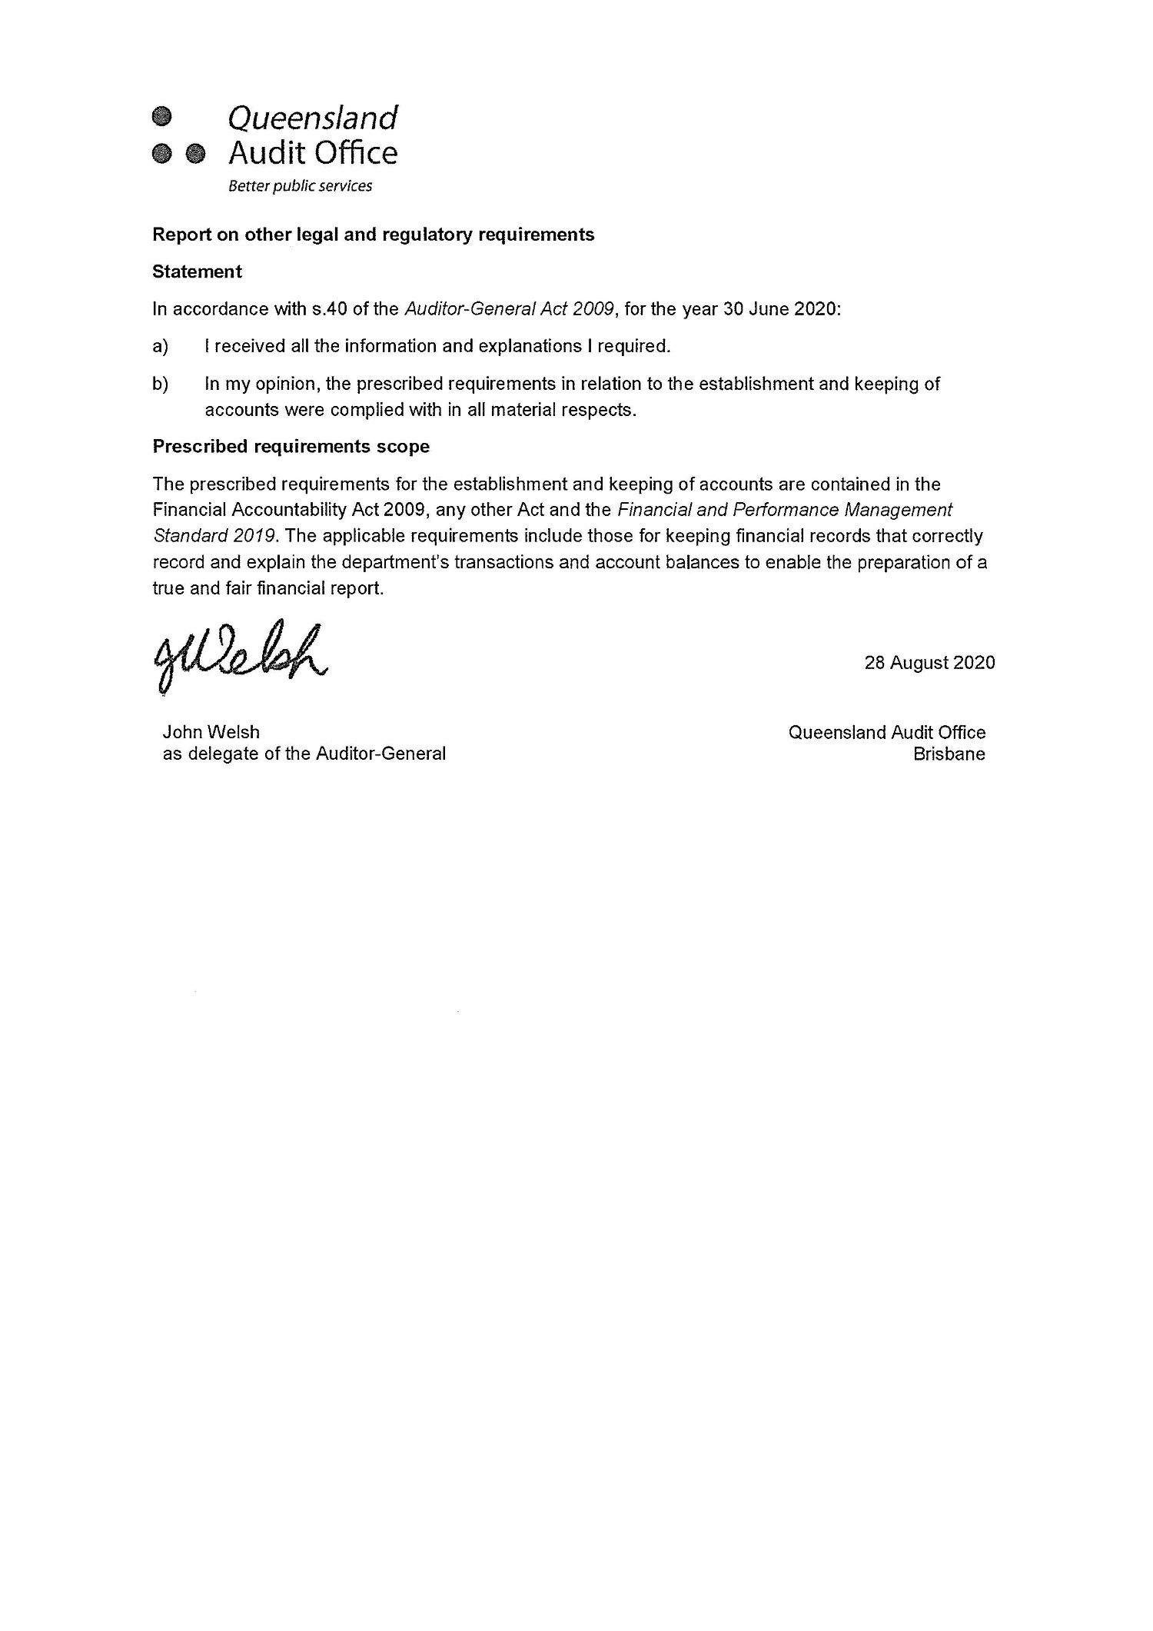

Appendices

Government bodies

Commissioner for Police Service Reviews
Act/instrument | The Commissioner for Police Service Reviews is established under the Police Service Administration Act 1990 and Police Service Administration (Review of Decisions) Regulation 1990.
Functions | The Review Commissioner is responsible for hearing grievances from police officers relating to appointments, promotions, transfers or disciplinary actions made under the Act.  Appeals are heard before a Review Commissioner nominated by the Crime and Corruption Commission yet otherwise independent of the Crime and Corruption Commission and the QPS. Where a matter progresses to a hearing, the Review Commissioner will consider the material presented and prepare written recommendations for the Police Commissioner who will make the final decision. Where the Police Commissioner does not accept the recommendation, reasons must be provided to the Review Commissioner.  The Crime and Corruption Commission provides a secretariat to support the review function.
Further information about the Commissioner for Police Service Reviews is available at www.ccc.qld.gov.au/.
Controlled Operations Committee
Act | The Controlled Operations Committee is established under the Police Powers and Responsibilities Act 2000.
Functions | The Controlled Operations Committee is responsible for considering and making recommendations about applications for an authority, or variation to an authority, to conduct a controlled operation under Chapter 11 of the Police Powers and Responsibilities Act 2000.
Achievements | The committee provides its own annual report after 30 June each year, detailing the work and activities of the QPS under Chapter 11 Controlled operations of the Act for the preceding 12 months.  The committee’s annual report is available online at www.parliament.qld.gov.au/work-of-assembly/tabled-papers.
Financial reporting | Records are inspected by the Chairperson of the Controlled Operations Committee. Transactions of the entity are accounted for in the QPS financial statements which are certified by the Auditor-General of Queensland.

Controlled Operations Committee (cont’d)
Remuneration
Position | Name | Meetings | Approved fee | Approved sub-committee fees | Actual fees received
Independent Member | Judge John Jerrard | 137 | $167 | - | $2,171
Independent Member | Judge Manus Boyce | 3 | $167 | - | $501
Chairperson (QPS) | Detective Chief Superintendent Katherine Innes | 5 | - | - | -
Acting Chairperson (QPS) | Detective Chief Superintendent Denzil Clark | 5 | - | - | -
Acting Chairperson (QPS) | Detective Chief Superintendent Terry Lawrence | 2 | - | - | -
Acting Chairperson (QPS) | Detective Chief Superintendent Chris Hodgman | 2 | - | - | -
Acting Chairperson (QPS) | Detective Superintendent Roger Lowe | 1 | - | - | -
Acting Chairperson (QPS) | Detective Superintendent Troy Pukallus | 1 | - | - | -
Member (CCC) | Allan MacSporran | 15 | - | - | -
Acting Member (CCC) | Marshall Irwin | 1 | - | - | -
No. of scheduled meetings | 17 (this figure includes annual inspection)
Total out of pocket expenses | n/a

Public Interest Monitor
Act | The Public Interest Monitor is appointed under the Police Powers and Responsibilities Act 2000 and the Crime and Misconduct Act 2001.
Functions | The Public Interest Monitor has the following functions for surveillance device warrants, retrieval warrants, approvals of the use of surveillance devices under emergency authorisations, and covert search warrants:  - to monitor compliance by police officers with chapter 9 of the Police Powers and Responsibilities Act 2000 (the Act) in relation to matters concerning applications for covert search warrants  - to monitor compliance by law enforcement officers with chapter 13 of the Act in relation to matters concerning applications for surveillance device warrants, retrieval warrants and approvals of the use of surveillance devices under emergency authorisations  - to appear at any hearing of an application to a Supreme Court judge for a warrant or approval mentioned in paragraph a) or b), or to a magistrate for a warrant mentioned in paragraph b), to test the validity of the application, and for that purpose at the hearing, to –  - present questions for the applicant to answer and examine or cross-examine any witness  - make submissions on the appropriateness of granting the application to appear at a consideration of a report made to a Supreme Court judge or a magistrate or given to the monitor and referred to a judge or magistrate under section 357 of the Act  - to appear at a consideration of a report made to a Supreme Court judge or a magistrate or given to the monitor and referred to a judge or magistrate under section 357 of the Act  - to gather statistical information about the use and effectiveness of covert search warrants and surveillance device warrants  - to report as required by this Act on any matter about which this Act expressly requires the Public Interest Monitor to report  - whenever the public interest monitor considers it appropriate  - to give to the Commissioner a report on noncompliance by police officers with chapter 9 of the Act; or  - to give to the chief executive officer of a law enforcement agency a report on noncompliance by law enforcement officers of the law enforcement agency with chapter 13 of the Act.  The Public Interest Monitor also has the following functions:  - under the Criminal Code of the Commonwealth, to exercise the power conferred on the monitor under the following sections –  - section 104.12 (Service, explanation and notification of an interim control order)  - section 104.12A (Election to confirm control order)  - section 104.14 (Confirming an interim control order)  - section 104.18 (Application by the person for a revocation or variation of a control order)  - section 104.17 (Service of a declaration, or a revocation, variation or confirmation of a control order)  - section 104.19 (Application by the Australian Federal Police Commissioner for a revocation or variation of a control order)  - section 104.23 (Application by the Australian Federal Police Commissioner for addition of obligations, prohibitions or restrictions)  - under the Terrorism (Preventative Detention) Act 2005, to exercise the power conferred on the monitor under the following sections –  - section 14 (General provisions that apply if the Public Interest Monitor must be notified about an application to the issuing authority)  - section 73 (Supreme Court hearing and decision)
Public Interest Monitor (cont’d)
Functions (cont’d) | - to gather statistical information about the use and effectiveness of control orders and preventative detention orders under the Acts mentioned in paragraphs a) and b)  - whenever the Public Interest Monitor considers it appropriate – to give to the Commissioner a report on noncompliance by police officers with the Terrorism (Preventative Detention) Act 2005.  The Public Interest Monitor is responsible for the recording, reporting and inspection regime for telecommunications interception in accordance with the Telecommunications Interception Act 2009 which enables the use by the QPS and the Crime and Corruption Commission of Commonwealth telecommunications interception powers as a tool for the investigation of serious offences.  The Public Interest Monitor is entitled to appear at the hearing of the application for a telecommunications interception warrant to test the validity of the application and, for that purpose at the hearing, to –  - ask questions of any person giving information to the eligible Judge or nominated Administrative Appeals Tribunal member; and  - make submissions to the eligible Judge or nominated Administrative Appeals Tribunal member about the following maters –  - in relation to an application for a warrant in relation to a telecommunications service  - in relation to an application for a warrant in relation to a person.  In addition, the Public Interest Monitor has record-keeping oversight to ensure eligible authorities keep documents connected with the issue of warrants in accordance with the Telecommunications Interception Act 2009.  As the inspecting entity for the QPS, the Public Interest Monitor:  - must inspect the eligible authority’s records as required under section 23 of the legislation to ascertain the extent of compliance by the authority’s officers  - must report in writing to the Minister about the results of the inspections  may do anything necessary or convenient for the performance of the functions mentioned in (a) and (b).
Achievements | The annual report of the Public Interest Monitor is available at www.parliament.qld.gov.au/work-of-assembly/tabled-papers.
Financial reporting | Financial transactions made with the Public Interest Monitor are accounted for in the QPS financial statements which are certified by the Auditor-General of Queensland.  The actual fees received is based on the total amounts invoiced for work performed during the 2019-20 financial year.
Remuneration
Position |  | Meetings | Approved fee | Approved sub-committee fees | Actual fees received
Public Interest Monitor |  | 124 | A service fee of $450.00 per hour to a maximum of $2,250.00 per day | n/a | $113,316
Deputy Public Interest Monitor |  | 112 | A service fee of $450.00 per hour to a maximum of $2,250.00 per day | n/a | $179,528
Public Interest Monitor (cont’d)
Deputy Public Interest Monitor |  | 78 | A service fee of $450.00 per hour to a maximum of $2,250.00 per day | n/a | $51,555
No. of scheduled meetings |  | 314
Total out of pocket expenses |  | n/a

Acronyms

AI | Artificial Intelligence |  | NAIDOC | National Aboriginal and Islander Day Observation Committee
A&RC | Audit and Risk Committee |  | NHWQ | Neighbourhood Watch Queensland
ANZCTC | Australian-New Zealand Counter-Terrorism Committee |  | OLP | Online Learning Product
BOM | Board of Management |  | OCGG | Organised Crime Gangs Group
CPIU | Child Protection and Investigation Unit |  | PPE | Personal protective equipment
CYR | Community Youth Response |  | PCYC | Police Citizens Youth Club
CCC | Crime and Corruption Commission |  | PHS | Psych Health Screen
CPTED | Crime Prevention Through Environmental Design |  | PAU | Psychological Assessment Unit
D&RC | Demand and Resource Committee |  | PSA | Public Safety Agencies
DCSYW | Department of Child Safety, Youth and Women |  | PSBA | Public Safety Business Agency
DCDSS | Department of Communities, Disability Services and Seniors |  | QAO | Queensland Audit Office
DTMR | Department of Transport and Main Roads |  | QFES | Queensland Fire and Emergency Services
DYJ | Department of Youth Justice |  | QPRIME | Queensland Police Records Information Management Exchange
EDRMS | Electronic document and records management system |  | QPS | Queensland Police Service
ESC | Ethical Standards Command |  | QPV | Queensland Police Vessel
ELT | Executive Leadership Team |  | QPCYWA | Queensland Police-Citizens Youth Welfare Association
FDS | Forensic Disability Service |  | QSA | Queensland State Archives
FtF | Framing the Future |  | ROGS | Report on Government Services
FTE | Full-time equivalent |  | R&DS | Retention and Disposal Schedule
HR | Human Rights |  | SDS | Service Delivery Statement
ICT | Information and Communications Technology |  | SDCC | State Disaster Coordination Centre
IMU | Information Management Unit |  | SDFV&VPU | State Domestic and Family Violence and Vulnerable Persons Unit
IGEM | Inspector-General Emergency Management |  | SPOC | State Police Operations Centre
MDP | Management Development Program |  | START | Support, Triage, Advice, Referral and Targeted Program
MHIP | Mental Health Intervention Program |  | TAS | Trusted Advisor Series
MOHRI | Minimum Obligatory Human Resource Information |  | VIP | Volunteers in Policing
5MILE | 5 Minute Intensive Learning Experience |  | WFQ | Working for Queensland

Compliance checklist

Summary of requirement |  | Basis for requirement | Annual report reference
Letter of compliance | - A letter of compliance from the accountable officer or statutory body to the relevant Minister/s | ARRs – section 7 | 2
Accessibility | - Table of contents  - Glossary | ARRs – section 9.1 | 3, 102-103
Accessibility | - Public availability | ARRs – section 9.2 | 1
Accessibility | - Interpreter service statement | Queensland Government Language Services Policy  ARRs – section 9.3 | 1
Accessibility | - Copyright notice | Copyright Act 1968  ARRs – section 9.4 | 1
Accessibility | - Information Licensing | QGEA – Information Licensing  ARRs – section 9.5 | 1
General information | - Introductory Information | ARRs – section 10.1 | 6-9
General information | - Machinery of Government changes | ARRs – section 10.2, 31 and 32 | (not applicable)
General information | - Agency role and main functions | ARRs – section 10.2 | 6-8
General information | - Operating environment | ARRs – section 10.3 | 12
Non-financial performance | - Government’s objectives for the community | ARRs – section 11.1 | 6-9
Non-financial performance | - Other whole-of-government plans / specific initiatives | ARRs – section 11.2 | 8, 34-41
Non-financial performance | - Agency objectives and performance indicators | ARRs – section 11.3 | 28-33
Non-financial performance | - Agency service areas and service standards | ARRs – section 11.4 | 28-33
Financial performance | - Summary of financial performance | ARRs – section 12.1 | 24-27
Governance – management and structure | - Organisational structure | ARRs – section 13.1 | 17
Governance – management and structure | - Executive management | ARRs – section 13.2 | 42-43
Governance – management and structure | - Government bodies (statutory bodies and other entities) | ARRs – section 13.3 | 97-101
Governance – management and structure | - Public Sector Ethics | Public Sector Ethics Act 1994  ARRs – section 13.4 | 51-52
Governance – management and structure | - Human Rights | Human Rights Act 2019  ARRs – section 13.5 | 10-11
Governance – management and structure | - Queensland public service values | ARRs – section 13.6 | 6-7
Governance – risk management and accountability | - Risk management | ARRs – section 14.1 | 53
Governance – risk management and accountability | - Audit committee | ARRs – section 14.2 | 48
Governance – risk management and accountability | - Internal audit | ARRs – section 14.3 | 55
Governance – risk management and accountability | - External scrutiny | ARRs – section 14.4 | 53-54
Governance – risk management and accountability | - Information systems and recordkeeping | ARRs – section 14.5 | 56
Governance – human resources | - Strategic workforce planning and performance | ARRs – section 15.1 | 57-61
Governance – human resources | - Early retirement, redundancy and retrenchment | Directive No.04/18 Early Retirement, Redundancy and Retrenchment  ARRs – section 15.2 | 61
Open Data | - Statement advising publication of information | ARRs – section 16 | 1
Open Data | - Consultancies | ARRs – section 33.1 | https://data.qld.gov.au
Open Data | - Overseas travel | ARRs – section 33.2 | https://data.qld.gov.au
Open Data | - Queensland Language Services Policy | ARRs – section 33.3 | https://data.qld.gov.au
Financial statements | - Certification of financial statements | FAA – section 62  FPMS – sections 38, 39 and 46  ARRs – section 17.1 | 93
Financial statements | - Independent Auditor’s Report | FAA – section 62  FPMS – section 46  ARRs – section 17.2 | 94-96

FAA Financial Accountability Act 2009
FPMS Financial and Performance Management Standard 2019
ARRs Annual report requirements for Queensland Government agencies

Contacts and key locations

Queensland Police Headquarters | 200 Roma Street  Brisbane Qld 4000 | GPO Box 1440  Brisbane Qld 4001 | (07) 3364 6464
Central Region | Rockhampton Police Complex  161 Bolsover Street  Rockhampton Qld 4700 | PO Box 221  Rockhampton Qld 4700 | (07) 4932 3400
Brisbane Region | 20 Pickering Street  Alderley Qld 4051 | GPO Box 1440  Brisbane Qld 4001 | (07) 3354 5005
Northern Region | Mundingburra Police Complex  244-246 Charters Towers Road  Hermit Park  Townsville Qld 4812 | PO Box 3737  Hermit Park Qld 4812 | (07) 4726 8777
South Eastern Region | Surfers Paradise Police Complex  68 Ferny Avenue  Surfers Paradise Qld 4217 | PO Box 561  Surfers Paradise Qld 4217 | (07) 5570 7924
Southern Region | 52 Neil Street  Toowoomba Qld 4350 | PO Box 144  Toowoomba Qld 4350 | (07) 4631 6501
QPS stations are located throughout Queensland. You can locate or contact your nearest station by calling the regional office or 13 QGOV (13 74 68). Alternatively refer to the online station locator accessible at www.police.qld.gov.au/apps/stationlocator/.



