MISSING - SUSPECTED MURDER OF
ANTHONY JOHN JONES
$500,000 REWARD
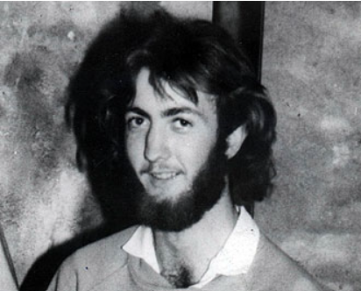
REWARD: The Minister for Police and Corrective Services and Minister for Fire and Emergency Services has approved a reward of $500,000 offered for information leading to the apprehension and conviction of the person or persons responsible for the disappearance and suspected murder of Anthony John JONES on or about 12 November 1982.

INDEMNITY FROM PROSECUTION: In addition, an appropriate indemnity from prosecution will be recommended for any accomplice, not being the person who actually committed the crime, who first gives such information.

The allocation of the $500,000 reward will be at the sole discretion of the Commissioner of the Police Service.

CIRCUMSTANCES: Anthony John JONES of Perth, Western Australia, had been travelling in Queensland since September 1982. Anthony hitchhiked from place-to-place meeting his brother from time to time in pre-arranged locations. After visiting Brisbane, Mackay and Airlie Beach, Anthony left Townsville on 28 October 1982 to travel to Cairns with arrangements in place to meet his brother in Mt Isa a week later. Anthony was known to be in Townsville on the 3rd of November 1982 when he telephoned his home in Perth and indicated he was travelling to Mt Isa to meet his brother. On or about the 12th of November 1982 witnesses place Anthony in Hughenden. Anthony has not been seen or heard from since that time, and it is suspected that he has been murdered.

Any member of the public with information which could assist Police is asked to contact
- Townsville Criminal Investigation Branch; Phone (07) 4759 9711
- The Homicide Investigation Group, Brisbane; Phone (07) 3364 6122
- Any Police Station; or
- Crime Stoppers, Phone 1800 333 000
Commissioner’s Office  BRISBANE | KATARINA CARROLL APM COMMISSIONER

