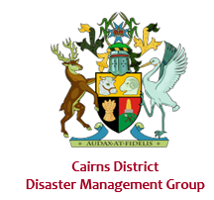

Cairns District Disaster Management Plan
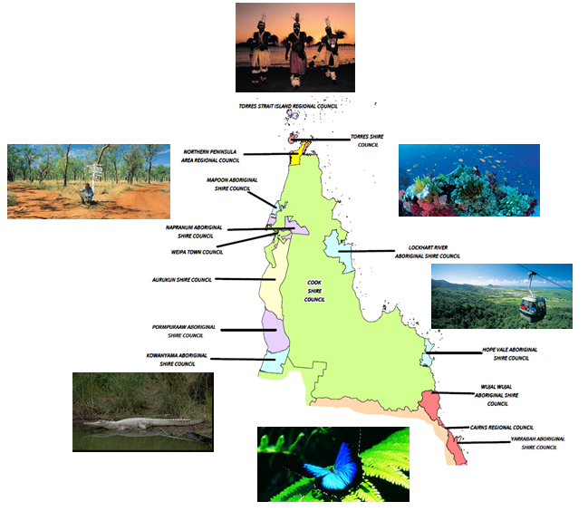

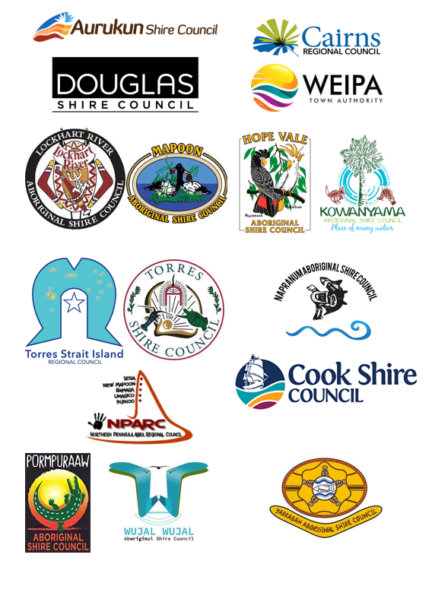

BUSINESS

Foreword

“Natural disasters have a significant economic, social, environmental, and political impact on the community. While some of the impacts of natural disasters can be mitigated, the risk cannot be completely eliminated. Therefore, decisions regarding what risks are acceptable need to be made by those involved in managing natural hazard impacts.

Tropical cyclones, floods, severe storms and bushfires and the phenomena that they produce have had by far the greatest impact historically in Australia. However, a single event, such as a moderate earthquake in Sydney, could change the historical picture of natural hazards. It is for this reason that modelling potential impacts for a full range of small through to extreme events, and considering the potential impacts of climate change, is important. The study of prehistoric impacts of natural hazards can be useful in extending the knowledge provided by historical records.

The socioeconomic cost and natural disaster policy, as much as the spatial and temporal distribution of both hazards and communities, need to be considered when managing the impact of natural disasters. A hazard develops into a disaster when it has a widespread or concentrated negative impact on people. While Australia’s growing economy and technological advances may assist in managing disasters, they also make communities more vulnerable to the potential impact of hazards. This occurs through the increase and concentration of the population and the built environment, and a greater reliance on infrastructure such as power and water supplies.

The difficulty of measuring the actual impact of a natural disaster on the community continues to be a major challenge because of the complexities in assessing loss. Intangible losses, such as destruction of personal memorabilia and the effects of post-disaster stress, are particularly difficult to measure. Though insured losses are the most easily captured, they are only a small proportion of total losses.

These challenges need to be kept in mind when measuring and communicating ‘impact’. A key to reducing the overall risk is for those who play a role in the management of natural hazards to work closely with the wider community, as well as with each other.”

The philosophy underpinning ‘Disaster Management’ planning in Queensland is based on the nationally recognised ‘Comprehensive approach’ principles of ‘Prevention, Preparedness, Response and Recovery’. These principles are referred to in the Disaster Management Act (QLD) 2003- Reprinted as in force on 1 November 2010. These principles are referred to as Part 3 of the Disaster Management Act (QLD) 2003.

Endorsement

The preparation of this District Disaster Management Plan has been undertaken in accordance with the Disaster Management Act 2003 (DM Act), to provide for effective disaster management in the Cairns Disaster District.

The plan is endorsed for distribution by the District Disaster Management Group.

……………………………………………

Glenn Morris
Chief Superintendent
District Disaster Coordinator
Cairns District Disaster Management Group

Contents
BUSINESS
Foreword 3
Endorsement 4
Contents 5-6
Document Control 7
Amendment Control 7
Amendment Register 7
Distribution 7
Definitions 8-11
Abbreviations and Acronyms 12-13
Governance 14
Authority to Plan 14
Purpose 14
Objectives 14
Strategic Policy Framework 14
Scope 15
Disaster Management Priorities 16
Cairns District Disaster Management Group 16
Establishment 16
Role 16
Functions 16
Membership 16-17
Functional and Supporting Roles 17-19
Roles and Responsibilities 20
Meetings 20
Capacity Building 22
Training 22-23
Exercise Evaluation 23
Post Disaster Assessment 23
Disaster Risk Management 23
Community Context 23

OPERATIONS
District Appreciation
Geography 24
Climate and Weather 24
Topography 25
Rivers and Dams 25-26
Referrable Dams 26
Agriculture Industries 27
Aquaculture, Mining and Tourism 27
Demography 27

Critical Infrastructure 28-31
Essential Services 31-33
Hazards 33-35

Response Strategy 36
Concept of Operations for Response/Activation and Triggers 36
District Disaster Coordination Centre 38 - 39
Operational Reporting 39
Disaster Declaration 39
Request for Assistance 39
Resupply 39
Emergency Supply 40
Request for Air Support 40
Financial Management 40
Warning Notification and Dissemination 41-42
Emergency Alerts and SEWS 42-43
Functional Plans 43-45
Hazard Specific Arrangements 45-46
Post Event Assessment 46

Recovery Strategy 47
Immediate/Short Term 47
Medium/Long Term 47
Recovery Functions and Lead Agencies 47-48

REVIEW AND ASSURANCE
Review and Renew Plan 48
External Assessment 48
Review of Local Disaster Management Arrangements 48
Post Disaster Assessment 48-49

Annexures Index 49

Document Control

Amendment Control
This District plan is a controlled document. The controller of the document is the Cairns District Disaster Coordinator (DDC). Any proposed amendments to this plan should be forwarded in writing to:
The Executive Officer
Cairns District Disaster Management Group
PO Box 7419
Cairns Qld 4000

The DDC may approve inconsequential amendments to this document. Any changes to the intent of the document must be endorsed by the District Disaster Management Group (DDMG).

A copy of each amendment is to be forwarded to those identified in the distribution list. On receipt, the amendment is to be inserted into the document and the Amendment Register updated and signed.

Amendment Register

No / Ref | Issue Date | Comment | Inserted by | Purpose
01 | 25 11 22 | Rewrite | XO Cairns DDMG | New DDMP
02 | 10 07 23 | Meeting dates updated | XO Cairns DDMG | Annual review & assessment

Distribution
This plan is available to all Cairns DDMG including core members and advisors via the QPS website.

Definitions

Advisor | A person invited to participate in the business of the DDMG in an advisory capacity on an as-needed basis.
Chair | The person appointed by Governor in Council as the Chairperson of the DDMG. The Chair of the group is the District Disaster Coordinator.
Coordination | The bringing together of organisations to ensure effective disaster management before, during and after an event. It is primarily concerned with systematic acquisition and application of resources (people, material, equipment, etc) in accordance with priorities set by disaster management groups. Coordination operations horizontally across organisations and agencies.
Deputy Chair | The person appointed by Governor in Council as the Deputy Chairperson of the DDMG.
Disaster | A serious disruption to the community, caused by the impact of an event, that requires a significant coordinated response by the state and other entities to help the community recover from the disruption (Disaster Management Act 2003).
Disaster District | Part of the state prescribed under a regulation as a disaster district.
Disaster Management (DM) | Arrangements about managing the potential adverse effect of an event, including, for example, arrangements for mitigating, preventing, preparing for, responding to, and recovering from a disaster (Disaster Management Act 2003).
Disaster Management Group | One of or a number of any of the following: the QDMC, DDMGs or LDMGs.
Disaster Management Strategic Policy Framework | A strategic tool which identifies principles that guide the development and implementation of policy and initiatives to achieve disaster management priorities.
Disaster mitigation | The taking of preventative measures to reduce the likelihood of an event occurring or, if an event occurs, to reduce the severity of the event. (Disaster Management Act 2003)
Disaster operations | Activities undertaken before, during or after an event happens to help reduce loss of human life, illness or injury to humans, property loss or damage, or damage to the environment, including, for example, activities to mitigate the adverse effects of the event (s. 15, DM Act).
Disaster response | The taking of appropriate measures to respond to an event, including action taken and measures planned in anticipation of, during, and immediately after an event to ensure that its effects are minimised and that persons affected by the event are given immediate relief and support. (Disaster Management Act 2003)
Disaster response operations | The phase of disaster operations that relates to responding to a disaster. (Disaster Management Act 2003)
Disaster recovery operations | The phase of disaster operations that relates to recovering from a disaster. (Disaster Management Act 2003)
Disaster risk assessment | The process used to determine risk management priorities by evaluating and comparing the level of risk against predetermined standards, target risk levels or other criteria. (COAG, Natural Disasters in Australia: Reforming mitigation, relief and recovery arrangements: 2002)
Disaster District Coordinator | A person appointed under the Disaster Management Act 2003 who is responsible for the coordination of disaster operations in the disaster district for the District Disaster Management Group.
District Disaster Management Group (DDMG) | The group established in accordance with s. 22 of the DM Act to provide coordinated State Government support and resources to LDMGs on behalf of local governments.
District Disaster Management Plan | A plan prepared in accordance with s53 of the Act, that documents planning and resource management to counter the effects of a disaster within the disaster district.
Emergency Management Assurance Framework  (EMAF) | The EMAF provides the foundation for guiding and supporting the continuous improvement of entities, disaster management programs across all phases of disaster management. The framework also provides the structure and mechanism for reviewing and assessing the effectiveness of Queensland disaster management arrangements.
Event | (1) Any of the following:  - a cyclone, earthquake, flood, storm, storm tide, tornado, tsunami, volcanic eruption or other natural happening  - an explosion or fire, a chemical, fuel or oil spill, or a gas leak  - an infestation, plague, or epidemic (example of an epidemic – a prevalence of foot-and-mouth disease)  - a failure of, or disruption to, an essential service or infrastructure  - an attack against the state  - another event similar to an event mentioned in (a) to (e).  (2) An event may be natural or caused by human acts or omissions. (Disaster Management Act 2003)
Executive Officer (XO)  DDMG | The person appointed by the Commissioner, Queensland Police Service as the XO of the DDMG.
Executive Team | The Chairperson, Deputy Chairperson and Executive Officer.
Extraordinary Meeting | A meeting convened by the Chairperson in response to an operational event both inside and outside the disaster district.
Functional Lead Agency | An agency allocated responsibility to prepare for and provide a disaster management function and lead relevant organisations that provide a supporting role.
Guidelines | Guidelines are developed under s63 of the Act to inform the, DDMGs and LDMGs about the preparation of disaster management plans, matters to be included in disaster management plans and other appropriate matters about the operation of a DDMG or LDMG.
Hazard | A source of potential harm, or a situation with a potential to cause loss. (Emergency Management Australia, 2004)
Local Disaster Coordinator | A person appointed under the Act who is responsible for the coordination of disaster operations for the LDMG.
Local Disaster Management Group (LDMG) | The group established in accordance with s. 29 of the DM Act to support the disaster management and operational activities of local governments. The specific functions of the LDMG are outlined in s. 30 of the DM Act.
Local Disaster Management Plan | A plan that documents agreed arrangements that are in place to deal with disaster events within its area of responsibilities.
Member | A person officially appointed as a member of the DDMG. Members have voting rights to validate the business of the group.
Minister | Minister for Police, Corrective Services and Emergency Services.
Ordinary Meeting | A DDMG meeting which is scheduled and convened on a regular basis at an agreed time (set by the Chairperson) to discuss routine business of the group.
Post-disaster Assessment | Addresses performance during and the risks revealed by a disaster event in order to improve future development of mitigation measures. Post-disaster assessment forms part of continuous improvement of the whole system. (Adapted from COAG, Natural Disasters in Australia: Reforming mitigation, relief and recovery arrangements: 2002)
Primary Agency | An agency allocated responsibility to prepare for and respond to a specific hazard based on their legislated and/or technical capability and authority.
Queensland disaster management arrangements | Whole-of-Government arrangements to ensure the collaborative and effective coordination of planning, services, information and resources for comprehensive disaster management
Queensland Disaster Management Committee (QDMC) | The group established in accordance with s. 17 of the DM Act who is responsible for disaster management and operational arrangements  for the state of Queensland. The specific functions of the QDMC are outlined in s. 18 of the DM Act.
Quorum | The minimum number of DDMG members required to validate the business of the group.
Recovery | The taking of preventative measures to recover from an event, including action taken to support disaster-affected communities in the reconstruction of infrastructure, the restoration of emotional, social, economic and physical wellbeing, and the restoration of the environment. (Disaster Management Act 2003)
Relief | The provision of immediate shelter, life support and human needs of persons affected by, or responding to, an emergency.
Residual Risk | The risk remaining after risk treatment. Residual risk can contain unidentified risk. Residual risk can also be known as ‘retained risk’. (ISO Guide 73:2009 Risk management – Vocabulary)
Risk | The effect of uncertainty on objectives. (ISO Guide 73:2009 Risk management – Vocabulary)
Risk Management | Coordinated activities to direct and control a community or organisation with regard to risk. (Adapted from ISO Guide 73:2009 Risk management – Vocabulary)
Risk Register | A listing of risk statements describing sources of risk and elements at risk with assigned consequences, likelihoods and levels of risk.
Risk Treatment | Process of selection and implementation of measures to modify risk. (National Emergency Risk Assessment Guidelines)
Serious Disruption | Serious disruption means:  - loss of human life, or illness or injury to humans; or  - widespread or severe property loss or damage; or  - widespread or severe damage to the environment.  (Disaster Management Act 2003)
State Disaster Coordinator | A person appointed under the Act who is responsible for the coordination of disaster response operations for the SDMG.
State Recovery Coordinator | A person appointed under the Disaster Management Act 2003 who is responsible for the coordination of disaster recovery operations for the State Disaster Management Group.
State Disaster Management Plan | A planning tool for disaster managers which provides an overview of Queensland’s all-hazards disaster management arrangements, including agency roles and responsibilities at each tier of the arrangements.
State Recovery Coordinator | A person appointed under the Act who is responsible for the coordination of disaster recovery operations for the QDMC.
Temporary District Disaster Management Group | A DDMG established under the Act by the QDMC Chair, in consultation with the Commissioner, Queensland Police Service, as a temporary district group to manage a disaster across two or more affected disaster districts.

Abbreviations and Acronyms
ADF Australian Defence Force
AUSVETPLAN Australian Veterinary Plan
BoM Bureau of Meteorology
DACC Defence Aid to the Civil Community
DAFF Department of Agriculture, Fisheries and Forestry
DDC District Disaster Coordinator
DDCC District Disaster Coordination Centre
DDMG District Disaster Management Group
DDMP District Disaster Management Plan
DEHP Department of Environment and Heritage Protection
DHPW Department of Housing and Public Works
DM Act Disaster Management Act 2003 (Qld)
DOC Department of Communities, Child Safety and Disability Services
DRAT District Risk Assessment Team
DRFA Disaster Relief Funding Arrangements
DRC District Recovery Coordinator
DRG District Recovery Group
DSDIP Department of State Development, Infrastructure and Planning
DSITIA Department of Science, Information Technology, Innovation, and planning
DTMR Department of Transport and Main Roads
EAP Emergency Action Plan
ECC Earthquake Coordination Committee (Queensland)
EMA Emergency Management Australia
EMAF Emergency Management Assurance Framework
EOC Emergency Operations Centre
EPA Environmental Protection Agency
FMD Foot and Mouth Disease
LDC Local Disaster Coordinator
LDCC Local Disaster Coordination Centre
LDMG Local Disaster Management Group
LDMP Local Disaster Management Plan
NDRRA Natural Disaster Relief and Recovery Arrangements
NGO Non-Government Organisation
OPSO Operations Support Officer Queensland Police Service
QAS Queensland Ambulance Service
QCCAP Queensland Coastal Contingency Action Plan
QDMA Queensland disaster management arrangements
QDMC Queensland Disaster Management Committee
QFES Queensland Fire & Emergency Service
QFRS-RFS QFRS – Rural Fires Service
QLDVETPLAN Queensland Veterinary Emergency Plan
QNPRSR Queensland National Parks, Recreation, Sport, and Racing
QPS Queensland Police Service
QR Queensland Rail
QTCCC Queensland Tropical Cyclone Coordination Committee
RAAF Royal Australian Air Force
SDC State Disaster Coordinator
SDCC State Disaster Coordination Centre
SDCG State Disaster Coordination Group
SDMP State Disaster Management Plan
SDRA State Disaster Relief Arrangements
SEWS Standard Emergency Warning Signal
SES State Emergency Service
SOP Standard Operating Procedure
SPF Queensland Disaster Management - Strategic Policy Framework
the Act Disaster Management Act 2003
the Minister Minister for Police and Community Safety
XO Executive Officer

Governance

Authority to Plan

This District Disaster Management Plan is prepared under the provisions of s 53 of the Disaster Management Act 2003 (including amendments in 2010).

Purpose

This plan details the arrangements within the Cairns Disaster District to provide whole-of-government planning and coordination capability to support local governments in disaster management.

Objectives

The objective of the Cairns District Disaster Management Plan is to facilitate the implementation of effective and efficient disaster management strategies and arrangements including:

- the development, review, and assessment of effective disaster management for the district including arrangements for mitigating, preventing, preparing for, responding to, and recovering from a disaster.

- compliance with the Queensland Disaster Management Committee’s (QDMC) Strategic Policy Framework; the State Disaster Management Plan; the District Disaster Management Guidelines; and any other Guidelines relevant to district level disaster management.

- the development, implementation, and monitoring priorities for disaster management for the district.

Strategic Policy Framework

Disaster management and disaster operations in the Cairns Disaster District are consistent with the QDMC Strategic Policy Framework for disaster management for the State. This is achieved by:

- ensuring a comprehensive, all hazards, all agencies approach by achieving the right balance of prevention, preparedness, response, and recovery.

- supporting the mainstreaming of disaster preparedness and mitigation into relevant areas of activity of government, non-government, small business, and corporations.

- aligning disaster risk reduction, disaster mitigation, disaster resilience and climate change adaptation policy and actions with international and national reforms.

- promoting a transparent, systematic, and consistent approach to disaster risk assessment and management, based on the National Emergency Risk Assessment Guidelines and the Australian/New Zealand Standard AS/NZS ISO 31000:2009 Risk management – Principles and guidelines.

- recognising the commitment of stakeholders and the need for collaboration across all levels of government, community, industry, commerce, government owned corporations, private and volunteer organisations, and local communities in all aspects of disaster management.

- emphasising building and maintaining sincere relationships, trust, teamwork, consultative decision-making, and shared responsibilities among stakeholders; and

- promoting community resilience and economic sustainability through disaster risk reduction.

Scope

This plan details the arrangements necessary to undertake disaster management within the Cairns Disaster District in support of the sixteen Councils. This entails the use of any State and Commonwealth government department and/or agencies and all resources available for the prevention of, preparedness for, response to and recovery from, the effects of disasters or events having a community consequence, whilst utilising an all-hazards approach.
For planning and operational management purposes, Queensland is divided into 23
Disaster Districts based on local government boundaries. The Cairns Disaster
District is a combination of three local government boundaries as identified below:

- Aurukun Shire Council
- Cairns Regional Council
- Cook Shire Council
- Douglas Shire Council
- Hopevale Aboriginal Shire Council
- Kowanyama Aboriginal Shire Council
- Lockhart River Aboriginal Shire Council
- Mapoon Aboriginal Shire Council
- Napranum Aboriginal Shire Council
- Northern Peninsula Area Regional Council
- Pormpuraaw Aboriginal Shire Council
- Weipa Town Authority
- Wujal Wujal Aboriginal Shire Council
- Torres Shire Council
- Torres Strait Island Regional Council
- Yarrabah Shire Council

Disaster Management Priorities

The priorities for the Cairns Disaster Management Group are to
- Response and recovery planning and operations
- Improve community (including business) disaster planning/mitigation and preparation.
- Manage training of DDMG members in line with the Queensland Disaster Management Training Framework.
- Integrate effective disaster risk reduction initiatives into strategic and corporate plans at appropriate levels of government, community organisations, industry, and commerce.
- Monitor and evaluate the disaster management arrangements to:
- streamline arrangements.
- develop clear accountability, including defined roles and responsibilities at all levels of the disaster management arrangements.
- improve the communication flow process; and
- develop whole-of-government, media, and community engagement arrangements.

District Disaster Management Group

Establishment

The Cairns District Disaster Management Group (DDMG) is established in accordance with section 22; ‘Functions’ of the Act which incorporates the sixteen Councils.

Role

The Cairns DDMG role is to provide whole of government planning and coordination capacity to support local governments in disaster operations and disaster management.

Functions

The functions of a DDMG are outlined in section 23 of the Act. See the Disaster Management Act 2003 and Queensland Disaster management guidelines.

Membership

The DDMG is comprised of persons and representatives as nominated in section 24: ‘Membership’ of the Act.

Core membership consists of representatives from:
- Queensland Police Service (QPS) Chairperson/DDC
- QPS Deputy Chairpersons
- QPS Executive Officer (XO)
- Aurukun Shire Council
- Cairns Regional Council
- Cook Shire Council
- Douglas Shire Council
- Hopevale Aboriginal Shire Council
- Kowanyama Aboriginal Shire Council
- Lockhart River Aboriginal Shire Council
- Mapoon Aboriginal Shire Council
- Napranum Aboriginal Shire Council
- Northern Peninsula Area Regional Council
- Pormpuraaw Aboriginal Shire Council
- Weipa Town Authority
- Wujal Wujal Aboriginal Shire Council
- Torres Shire Council
- Torres Strait Island Regional Council
- Yarrabah Shire Council
- Queensland Fire and Emergency Services
- Queensland Ambulance Service
- Queensland Health
- Department of Education
- Department of Environment and Science
- Department of Energy and Public Works
- Department of Transport and Main Roads
- Department of Resources
- Department of Seniors, Disability Services and Aboriginal & Torres Strait Island Partnerships
- Queensland Reconstruction Authority
- Department of Regional Development, Manufacturing and Water

Advisory Membership consists of:
- Telstra
- Ergon Energy
- NBN Co
- Maritime Safety Queensland
- Queensland Rail
- Department of State Development, Infrastructure,
Government and Planning
- Office of Industrial Relations (Asbestos management)
- Queensland Building and Construction Commission
- Department of Agriculture and Fisheries
- Department of Justice and Attorney General
- Department of Employment, Small Business and Training
- Queensland Corrective Services
- Sun Water
- Red Cross
- Primary Health Care Network
- Australian Defence Force (ADF/JOSS)
- ABC Radio Far North
- Australian Government Bureau of Meteorology
- Australian Government Services Australia (Centrelink)
- Australian Government Civil Aviation Safety Authority (CASA)
- Australian Government National Indigenous Australians Agency
- Australian Government Department of Agriculture, Fisheries & Forestry
- Australian Government National Recovery and Resilience Agency
- Australian Government, Department of Health, and Aged Care
- Community Enterprise Queensland
- Island and Cape Stores
- Cairns Airport Pty Ltd
- Tourism Tropical North Queensland (TTNQ)

DDMG Contact list is held by the district XO for confidentiality purposes.

Function and Supporting Role

Function | Lead agency | Roles and Responsibilities
Transport | Department of Transport and Main Roads  (TMR) | As detailed in the State Disaster Management Plan (2018) including arrangements for the provision of transport resources for the transportation modes of road, rail, air and sea, and transport engineering to support disaster response and recovery operations
Community  Recovery | Department of Communities, Child Safety and Disability Services  (DOC) | As detailed in the State Disaster Management Plan (2018) including arrangements for the coordination of community recovery services including:  - Information on the range of recovery services available.  - Information of the physical effects of a disaster.  - Personal support services.  - Financial assistance to eligible applicants under the following schemes:  Disaster Relief Assistance.  Associations Natural Disaster Relief.  Special Benefits.  - Provision of counselling and mental health services.  - Longer term accommodation services; and  - Facilitation of community participation in the redevelopment of social networks and community infrastructure.
Health | Department of Health  (Q-Health) | As detailed in the State Disaster Management Plan (2018) including arrangements for the provision of medical and health resources to support disaster response and recovery operations through:  - Lead agency for Pandemic response  - Primary agency for Biological (human related), Radiological and Heatwaves  - Response functions for Public Health, mental health, and medical services  - Mass casualty management  - Emergency aeromedical services  - Command, control, and coordination of medical resources.  - Public health advice and warnings.  - Transportation of patients.  - Psychological and counselling services; and  - Ongoing medical and health services required during the recovery period.
Building and Engineering Services | Department of Housing and Public Works  (Q-Build) | As detailed in the State Disaster Management Plan (2018) including arrangements for the provision of resources and services pertaining to all engineering disciplines which may be required to assist disaster response and recovery operations.
Emergency Supply | QFES | As detailed in the State Disaster Management Plan (2018) including arrangements for the provision and issue of emergency supplies to support disaster response and recovery operations, including arrangements for the procurement, coordinated delivery and management of emergency supplies and associated services.
Communications | Dept of Science, Information Technology, Innovation & the Arts | As detailed in the State Disaster Management Plan (2018) including arrangements for the re-establishment of electronic communication links either within a disaster affected area or within areas outside the affected area, and the provision of special communication facilities to support State and Disaster District level operations mounted in support of an affected area.

Supporting Roles and Responsibilities

Agency | Roles & Responsibilities
Queensland Ambulance Service | As contained in section 3D: ‘Service’s Functions’ of the Ambulance Service Act 1991 including the provision of ambulance services during rescue and other relates activities, transport of persons requiring attention at medical or health care facilities, participate in counter disaster planning, coordinate volunteer first aid groups.
Queensland Fire and Emergency Service | As contained in section 8B: ‘Functions of the service’ of the Fire and Rescue Services Act 1990 including the protection of persons, property and the environment from fire and hazardous materials, protection and extrication of persons trapped in vehicles, building or elsewhere.
Queensland Police Service | As contained in section 2.3: ‘Functions of the service’ of the Police Service Administration Act 1990 including the preservation of peace and good order, the prevention of crime, upholding the law generally, and rendering help as may be reasonable sought by members of the community.
Threat Specific Hazards
Oil Spill | Department of Transport (Maritime Division) | Detail the strategy and actions to be carried out in the event of an oil spill occurring in waters within the vicinity of the Queensland coastline.
Wildfire | Queensland Fire and Rescue Service (Rural Fires Division) | Under development at State level
Emergency Animal Disease | Department of Agriculture, Fisheries & Forestry | Detail the arrangements to cope with a serious exotic animal disease.

See the State Disaster Management Plan

Roles and Responsibilities

The functions, roles, responsibilities, and networks in disaster management as identified by each agency are detailed in the State Disaster Management Plan.

The Cairns District Disaster Management Group adopts the itemisation of these roles and responsibilities at the district level.

- See the State Disaster Management Plan

Business and Meetings

The Cairns DDMG accordingly to the Act is required to meet up to twice per year not withstanding extraordinary meetings that may be called. The frequency increases before and during the wet season. Unless otherwise advised meeting will be held on the second Tuesday of the month

The chairperson of the DDMG must call a meeting when requested, in writing to do so by the chairperson of the QDMC; or at least one-half of the members of the DDMG.

A quorum of members is required for meeting resolutions to be officiated. Section 40 of the Disaster Management Act 2003 refers to quorum for meetings of disaster management groups and provides that it is a number equal to one-half of its members holding office plus one; or in the case where one-half of its members is not a whole number, the next highest whole number.

Personal attendance at meetings is preferred, however if this cannot be achieved a member may be able to participate by using any technology that reasonably allows members to hear and take part in discussions as they happen (section 42). For example, if teleconferencing facilities are available the member is taken to be present at the meeting.

A record of attendance shall be kept as part of the governance of the Cairns DDMG meetings. Section 43 of the Act provides that the Cairns DDMG must keep minutes of its meetings. Minutes will be distributed to members after any meeting held for verification of accuracy. Minutes will be adopted at subsequent meetings and will be held by the chairperson (DDC) on behalf of the Cairns DDMG.

Action items identified during a meeting must be recorded and must be actioned by the representative identified during the meeting as being the appropriate agency to progress the identified item, issue, or query. Progress or conclusion of action items must be recorded in a subsequent meeting.

Reporting requirements within the Cairns Disaster District shall be consistent with the in accordance with s. 38 of the Disaster Management Act 2003 and Queensland’s Disaster Management Group Guidelines.

The DDMG may conduct its business, including its meetings, in a way it considers appropriate.
- Disaster Management Guidelines
- Disaster Management Act 2003

Scheduled meetings:
14/11/23 | 12/12/23 | 09/01/24
13/02/24 | 12/03/24

Administration
Reporting requirements within the Cairns Disaster District shall be consistent with the requirements of the Disaster Management Act 2003 and Queensland’s District Management Guidelines as follows:
- Guidelines
- Disaster Management Act 2003

Prevention Strategies
Prevention and mitigation measures reduce the likelihood of a disaster event occurring or the severity of an event should it eventuate. The implementation of proactive, targeted prevention and mitigation strategies designed to address likely risk factors, the vulnerability of the population and reduce or eliminate the possible impact of disasters ultimately ensures safer, more resilient, and sustainable communities
.
All agencies within the district have a responsibility to identify risks and consider treatment options to mitigate against disasters. Agencies with specific responsibility to influence mitigation should actively seek to do so with the full support of other agencies. This may include, but is not limited to:
- Infrastructure design and planning
- Road development/ redevelopment
- Land Clearing considerations

In accordance with the Queensland Strategy for Disaster Resilience 2017, resilience, in a disaster management context, can be referred to as, a system or community’s ability to rapidly accommodate and recover from the impacts of hazards, restore essential structure and desired functionality, and adapt to new circumstances.
The Strategy for Disaster Resilience outlines four key objectives in working to make the most disaster resilient state in Australia:
- Queenslanders understand their disaster risk
- Strengthened disaster risk management
- Queenslanders are invested in disaster risk reduction
- Continuous improvement in disaster preparedness

Preparedness
Preparedness is crucial in disaster situations to ensure consequences are as minimal as possible and the response is optimum. Coordinated action from member agencies of the DDMG ensure timely and effective response and an increase in community safety.
All member agencies have a responsibility to undertake preparedness activities both within their agency and as part of the DDMG.

Considerations for disaster management planning include:
- Risk Assessment and hazard management
- Education, training, information sharing (including lessons learned)
- Capability development and interoperability

Capacity Building

Training
Disaster management training has been identified as an essential means through which agencies can develop and maintain their disaster management capabilities and capacity. Training and education can provide the knowledge, skills and attitudes required to address the issues of disaster management through prevention, preparedness, response, and recovery. Furthermore, training is important in ensuring that all agencies can seamlessly integrate their arrangements and contribute to an effective and coordinated disaster management response.

QFES (EM) is responsible for ensuring a coordinated approach to disaster management training within the district, including the maintenance and dissemination of the Queensland Disaster Management Training Framework to DDMG members. See the framework.

Agencies and organisations represented on the DDMG have the responsibility of providing suitable opportunities for DDMG representatives (including deputies) to attend required training.

To enhance knowledge and disaster management capabilities DDMG representatives (including deputies) are encouraged to complete training courses beyond their relevant minimum requirements of the Queensland Disaster Management Training Framework.

Training can be accessed online through the Disaster Management Learning Management System, access can be gained by contacting the QFES Emergency Management Coordinator.

Exercises
Exercises are a key component of disaster management strategies and are conducted with the objective of:
- practicing the coordination procedures during an event including.
(a) activation of Disaster Management Groups.
(b) activation of Disaster Coordination Centres.
(c) information management including dissemination of information in respect to threats and warnings, requests for assistance and providing situation reports
- enhancing the interoperability of agency representatives.
- evaluating emergency plans.
- identifying planning and resource issues.
- promoting awareness.
- developing competence.
- evaluating risk treatment strategies.
- validating training already conducted.
- identifying performance gaps and areas for the potential improvement in the skills of agency representatives involved in disaster management; and
- evaluating equipment, techniques, and processes in general.

The DDMG will conduct at least one exercise annually, to include all core members of the Cairns DDMG. Additionally, on an annual basis, functional committees will exercise their respective sub-plans, independent of the disaster district exercise.

Immediately on completion of exercises, hot debriefs will be conducted to identify issues and areas for improvement. A more detailed ‘After Action Review’ is to be conducted within the next following few days addressing the ‘exercise design and conduct’ and the ‘responses to the scenario. The exercise review should identify recommendations for future action and improvements.

Specific training programs and the method by which they will be monitored and evaluated shall be in accordance with the DDMG Annual Operational Plan. The management of this plan is the responsibility of the Executive Officer. Training conducted will be recorded in the Annual Report.

Exercise Evaluation
The purpose of conducting exercises is to ensure the effectiveness of the relevant plans are being tested. Furthermore, to ensure continuous improvement, each exercise will be evaluated for its effectiveness and relevance to disaster management/operations. The evaluation will take many forms including written or oral feedback but will primarily be based on a hot debrief (conducted immediately after the exercise has concluded), and a formal debrief.

A formal debrief should be held after an exercise to enable participants and observers an opportunity to share their experiences and to assist in providing feedback. The minutes of the feedback are to be maintained by the Executive Officer. Any identified issues are to be actioned and progress regarding their treatment reported to the group at Cairns DDMG meetings.

Post Disaster Assessment

A key outcome of post-disaster assessment is that lessons identified from disaster events and disaster management exercises are embedded into disaster management planning. Such lessons come from an examination of the effectiveness of mitigation measures, an analysis of the state of preparedness in readiness for the impacts of a disaster, of the disaster operations themselves and extend into the effectiveness of recovery.

Post- Disaster Assessment addresses performance during and the risks revealed by a disaster event in order to improve future development of mitigation measures. Post-disaster assessment forms part of the continuous improvement of the districts disaster management whole of government system.

The post-disaster assessment should be conducted through a DDMG debrief which should take place after individual LDMGS have undertaken their debrief meeting. Post-disaster assessments are undertaken and can be documented in a Post-Disaster Analysis Report to provide opportunities for participants to comment on the success and areas for improvement of district disaster operations and arrangements. The DDMG Chair is to ensure the report findings are incorporated into the DDMG Annual Operational Plan and Disaster Management Plan for the monitoring and implementation of recommendations.

Outcomes of post-disaster assessments strengthen the districts disaster management capability.

Disaster Risk Assessment

Community Context
The Cairns Disaster District is quite diverse and comprises of 16 Councils:
- Aurukun Shire Council
- Cairns Regional Council
- Cook Shire Council
- Douglas Shire Council
- Hopevale Aboriginal Shire Council
- Kowanyama Aboriginal Shire Council
- Lockhart River Aboriginal Shire Council
- Mapoon Aboriginal Shire Council
- Napranum Aboriginal Shire Council
- Northern Peninsula Area Regional Council
- Pormpuraaw Aboriginal Shire Council
- Weipa Town Authority
- Wujal Wujal Aboriginal Shire Council
- Torres Shire Council
- Torres Strait Island Regional Council
- Yarrabah Shire Council

It is recognised that in accordance with s.28A of the Disaster Management Act 2003
(Temporary disaster district groups) the Cairns Disaster District could also incorporate other areas outside of its nominated boundaries, or alternatively could form part of another disaster district.

District Appreciation

Geographic overview

The Cairns District is located in the far north of the State of Queensland and comprises the major provincial city of Cairns, rural communities located on the east coast hinterland surrounding Cairns and Cooktown and numerous coastal and inland townships including the township of Babinda. The district is unique in several aspects – it encompasses a total of 15 distinct local government areas and one
town authority including both Aboriginal Councils and Island Councils. The district shares international borders with both Papua New Guinea and Indonesia.

Area:

Cairns District is approximately 211,091 square kilometres in area and encompasses the Gulf country, Cape York Peninsula (11 Deed of Grant in Trust communities) and the Torres Strait Islands. The western perimeter of the district adjoins the Gulf of Carpentaria, the northern area of the district extends into the
Torres Strait and the eastern perimeter adjoins the Pacific Ocean.

Climate and Weather:

The climate and weather for the Cairns Disaster District is diverse in nature. The annual wet season has a strong influence on the district in most areas whereas equally during the annual dry season the western sector of the district is also affected.

Wet Season (01 November – 30 April) Source: BoM
Location | Highest Daily Rainfall/Year | Highest Monthly Rainfall | LDMG
Babinda | 613mm (Mar 02, 1935) | 2656mm (Feb 1977) | Cairns
Bellenden Ker | 780mm (Jan 09, 1998) | 5370mm (Jan 1979) | Cairns
Copperlode Dam | 340mm (Apr 20, 2006) | 1249mm (Mar 2004) | Cairns
Cairns | 403mm (Mar 12, 1967) | 1417mm (Jan 1981) | Cairns
Mossman | 723mm (Mar 31, 1911) | 2188mm (Jan 1979) | Douglas
Port Douglas | 801mm (Apr 01, 1911) | 1673mm (Jan 1979) | Douglas
Daintree | 606mm (Mar 06, 1996) | 1782mm (Jan 1979) | Douglas
Cape Tribulation | 818mm (Jan 11, 1981) | 2430mm (Jan 1981) | Douglas
Cooktown | 305mm (Mar 19, 2004) | 915mm (Mar 2006) | Cook
Laura | 224mm (Mar 07, 1940) | 786mm (Jan 1979) | Cook
Coen | 393mm (Jan 16, 1985) | 927mm (Dec 1992) | Cook
Archer River | 210mm (Jan 20, 2005) | 640mm (Jan 2005) | Cook
Kowanyama | 361mm (Feb 08, 2014) | 1470mm (Feb 2014) | Kowanyama
Southwell Station | 272mm (Jan 23, 1998) | 1117mm (Feb 2014) | Pormpuraaw
Aurukun | 346mm (Feb 03, 1973) | 1156mm (Feb 2014) | Aurukun
Lockhart River | 462mm (Apr 11, 1957) | 1286mm (Mar 1960) | Lockhart River
Weipa | 356mm (Jan 23, 2013) | 986mm (Mar 1996) | Weipa & Napranum
Skardon River | 175mm (Jan 09, 2008) | 995mm (Jan 2008) | Mapoon
Bamaga | 395mm (Apr 10, 1972) | 893mm (Feb 2011) | NPARC
Horn Island | 197mm (Feb 21, 1997) | 879mm (Feb 2004) | Torres
Mulgrave Mill | 320mm (Feb 13, 1927) | 1225mm (Mar 1945) | Closest to Yarrabah
Cape Tribulation Store | 818mm (Jan 11, 1981) | 2430mm (Jan 1981) | Closest to Wujal Wujal
Cooktown Airport | 305mm (Mar 19, 2004) | 915mm (Mar 2006) | Closest to Hopevale

Dry Season/Fire Dry Season (01 May – 30 October) Source: BoM
Location | Mean rainfall (mm) for period | Mean relative humidity (%) 9am | Mean Max  Temperature  (°C) | Mean wind speed (km/h) 9am | Max wind gust speed km/h
Cairns | 46mm | 71% | 27°C | 14km/h | 65km/h
Palmerville | 11mm | 63% | 32°C | 6km/h | 68km/h
Musgrave | 8mm | 72% | 31°C | 9km/h | Not Av.
Coen | 8mm | 71% | 29°C | 11km/h | Not Av.
Kowanyama | 7mm | 65% | 33°C | 11km/h | 71km/h
Moreton T Stn | 11mm | 78% | 31°C | 10km/h | Not Av.
Lockhart River | 47mm | 79% | 28°C | 15 km/h | 73km/h
Weipa | 9mm | 69% | 33°C | 17km/h | 80km/h
Butcher Hill | 7mm | 78% | 19°C | Not Av. | Not Av.
Coconut Island | 26mm | Not Av. | 31°C | 26km/h | 73km/h
Horn Island | 20mm | 74% | 30°C | 24km/h | 70km/h
Cape Flattery | 32mm | Not Av. | 28°C | Not Av. | 74km/h
(Note: table based on data availability on BoM site)

Cyclone categories and wind speeds Source: BoM
Category | Maximum Mean Wind (km/hr) | Typical Strongest Gust (km/hr) | Typical Effects
1 | 63 - 88 | <125 | Damaging winds. Negligible house damage. Damage to some crops, trees, and caravans. Craft may drag moorings.
2 | 89 - 117 | 125 - 164 | Destructive winds. Minor house damage. Significant damage to signs, trees, and caravans. Heavy damage to some crops. Risk of power failure. Small craft may break moorings.
3 | 118 - 159 | 165 – 224 | Very destructive winds. Some roof and structural damage. Power failures likely
4 | 160 – 199 | 225 – 279 | Significant roofing loss and structural damage. Many caravans destroyed and blown away. Dangerous airborne debris. Widespread power failures.
5 | >200 | >279 | Extremely dangerous with widespread destruction

Topography:

Distinctive topographical features of the district include the Great Dividing Range which runs along the coastal fringe adjacent the eastern seaboard. This geographical feature rises in some instances from the eastern seaboard coastline and in other locations from approximately 30 kilometres inland from the coastline. The range averages in height at around 1000 to 1200 and hosts in the main tropical rainforest much of which is ‘world heritage’ listed. Diametrically opposed to the tropical lushness on the eastern seaboard of the district is the savannah landscape on the western ‘Gulf’ of the district. This area is typically sclerophyll forest with ‘dusty’ plains during the ‘dry’ season (May to October) and lush grassland and swamp during the ‘wet’ season.

Rivers & Dams:
Cape Rivers (West) | Cape Rivers (East)
Gilbert | Norman
Herbert | Johnstone
Mulgrave-Russell | Barron
Daintree/Endeavour
http://www.bom.gov.au/qld/flood/brochures/qld/Qld_Basins_map.pdf

Source: QGlobe
Rivers
Mitchell River | Staaten River | Walsh River
Palmer River | Walsh River | McLeod River
Watson River | Archer River | Coen River
Jardine River | Wenlock River | Dulhunty River
Einasleigh River | Gilbert River | Copperfield River
Daintree River | Etheridge River | Mossman River
Annan River | Bloomfield River | Endeavour River
Mulgrave River | Barron River | Clohesy River
Hann River | Wild River | Holroyd River
Laura River | Kendall River | Kennedy River
Normanby River | Pascoe River | Edward River
http://www.bom.gov.au/cgi-bin/wrap_fwo.pl?IDQ60005.html

Referable Dams:

There are four dams currently with potential impacts on the Cairns Disaster District as referrable dams.

These being:

A Referrable Dam is defined within the Water Supply (Safety and Reliability) Act 2008 as.
A dam, or a proposed dam after its construction will be a referable dam if—
a) a failure impact assessment of the dam, or the proposed dam, is required to be carried out under the Act; and
b) the assessment states the dam has, or the proposed dam after its construction will have, a category 1 or category 2 failure impact rating: and
c) the chief executive has, under section 349 of the Act, accepted the assessment.

As referrable dams each of these dams is required to have in place an Emergency Action Plan (EAP) for monitoring the dam during times of extreme rainfall. These plans require the water levels and any other relevant information be provided to the relevant LDMG/DDMG. Subject to any dam failures at each of these sites as referrable dams the owner/operators of these facilities are to notify all relevant downstream stakeholders and provide advice regarding the event. The role of the DDMG is to assist the LDMG in managing the event.

Tinaroo  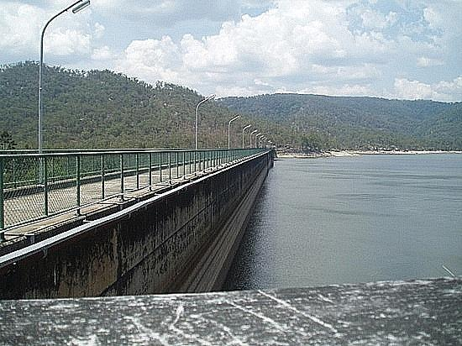 | Copperlode  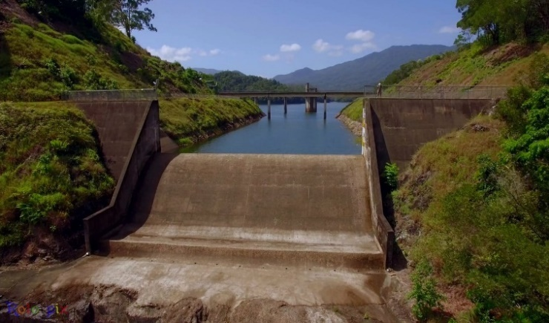
Mc Kinnon Creek Flood Detention Dam
Dam Emergency Action Plans
Moody Creek Detention Basin
http://data.dnrm.qld.gov.au/eap/moody-creek-1-eap.pdf
http://data.dnrm.qld.gov.au/eap/moody-creek-1a-eap.pdf
Tinaroo Dam
http://data.dnrm.qld.gov.au/eap/tinaroo-falls-eap.pdf
Copperlode Dam
http://data.dnrm.qld.gov.au/eap/copperlode-falls-eap.pdf

Agriculture Industries:

Avocado | Bananas | Basil | Beef cattle
Blueberry | Cashews | Citrus | Coffee
Custard apple | Dairy cattle | Flowers | Forestry plantation
Grass seed | Hay | Honey | Legume seed
Longan | Lychee | Macadamia | Maize
Mango | Melons | Mixed fruit | Mixed vegetable
Nursery production | Papaya | Passionfruit | Peanut
Pineapple | Pork | Potatoes | Poultry (eggs)
Poultry (meat) | Pumpkin | Sugar cane | Strawberry
Sweet potato | Table grape | Tea | Tea tree
Turf | Sugar cane | Sorghum

Aquaculture
Barramundi | Prawns

Mining
Bauxite – Weipa | Silica – Cape Flattery

Tourism
Interstate | Intrastate | International

Demography

Population:

The compilation of the Cairns Disaster District population data was compiled from the
Australian Bureau of Statistics (ABS) 2021 Census.

Local Government Area (LGA) | Population | Number of Families
Aurukun | 1,101 | 262
Cairns | 166,943 | 42,472
Cook | 4,511 | 950
Douglas | 12,337 | 3,042
Hopevale | 976 | 227
Kowanyama | 1,079 | 245
Lockhart River | 640 | 134
Mapoon | 432 | 84
Napranum | 883 | 180
NPARC | 2,781 | 602
Pormpuraaw | 611 | 147
Torres | 3,421 | 760
TSIRC | 4,124 | 954
Weipa | 4,100 | 977
Wujal Wujal | 276 | 70
Yarrabah | 2,505 | 567

Critical Infrastructure

Major Arterial Roads
Bruce Highway | Captain Cook Highway
Peninsula Development Road | Gulf Development Road
Burke Development Road | Mossman/Mt Molloy Range Road
Kuranda Range Road | Gillies Range Road
Kennedy Development Road | Mulligan Highway

Rail
North Coastline (to Cairns only) limited western route | Rail station, Cairns

Ports, Jetties and Barges
Ports
Cairns | Weipa
Cape Flattery | Cooktown
Hey point, | Port Douglas (State boat harbor)
Thursday Island
Barge ramps
Aurukun | Pormpuraaw
Lockhart River
Jetty’s
Deeral | Bellenden Ker
Fitzroy Island | Green Island
Palm Cove | Cooktown
Daintree | Thursday Island

Air
International Airport (certified by International Civil Aviation Organisation)
Cairns
Certified Aerodromes (where a terminal instrument flight procedure (TIFP) for the aerodrome and the procedure is not only for use in a specialised helicopter operation)
Cairns | Horn Island
Weipa | Lockhart River
Kowanyama | Pormpuraaw
Cooktown | Coen
Aurukun
Northern Peninsula
Aerodromes
Chillagoe | Yorke Island
Saibai Island

Below are two maps. The first map outlines the airstrips for the Torres Strait and second for the Cape and remaining parts of the Cairns Disaster District.

Torres Strait Airstrips
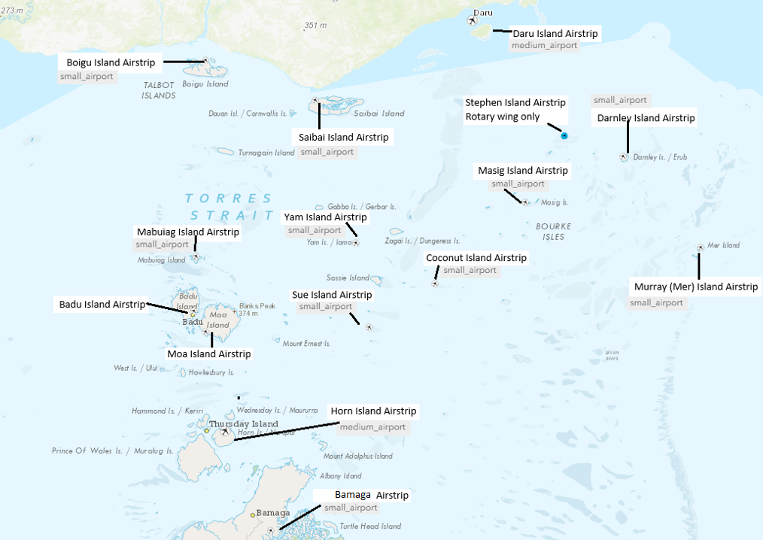
Cape and other disaster district airstrips
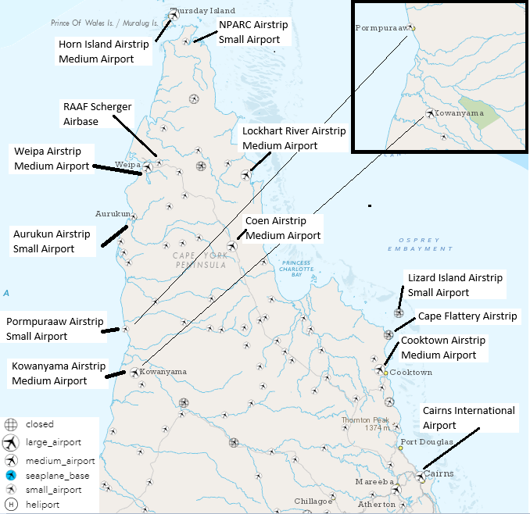

Communications
Mobile Phone Communications Network is spread across the district
Land Line Communications is available across the district and has several providers including Telstra, Optus, and Vodafone-Hutchison Australia
Internet Connectivity is available at varying capability levels across the district including Wi-Fi
Satellite Communications (Sat Comms is in place across the district)
Radio frequency-based communications are in place across the district

Given the extensive phone network across the Cairns Disaster District footprint a separate document has been developed provide an indication of services in remote locations not only within the Torres Strait but also the Cape.

Below is an example:
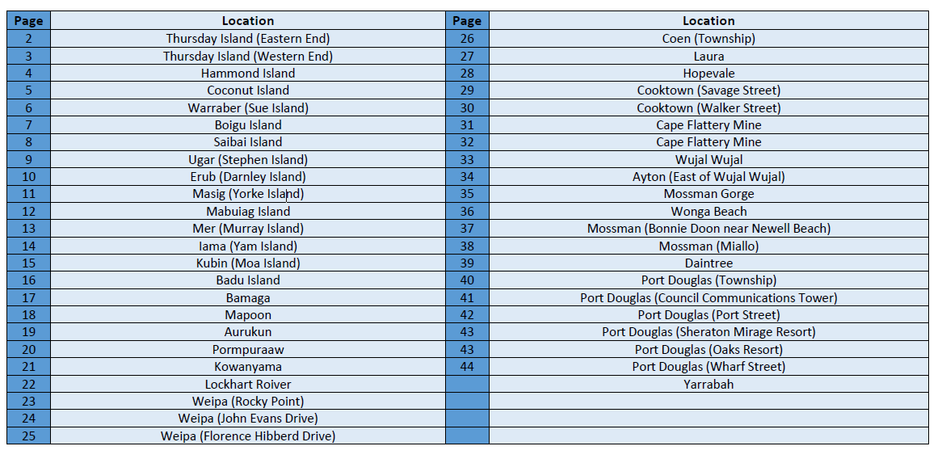
Essential Services Health
Queensland Health have several health clinics which operated across the Cairns Disaster District as per the map below
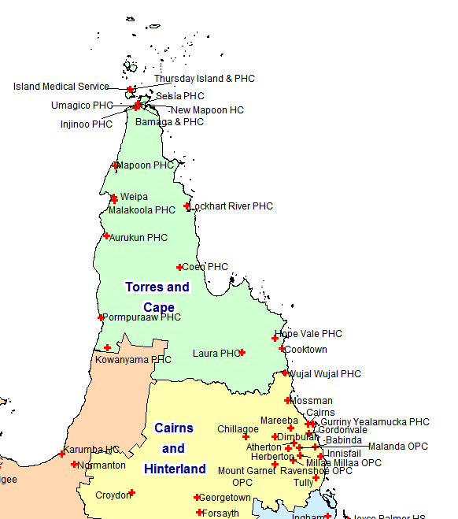

Power Supply
Parts of the district are connected to the Queensland State electricity grid were as in several isolated and remote communities’ electricity is distributed by generators. The following outlines the generational capacity for those remote communities in 2020 for example only.
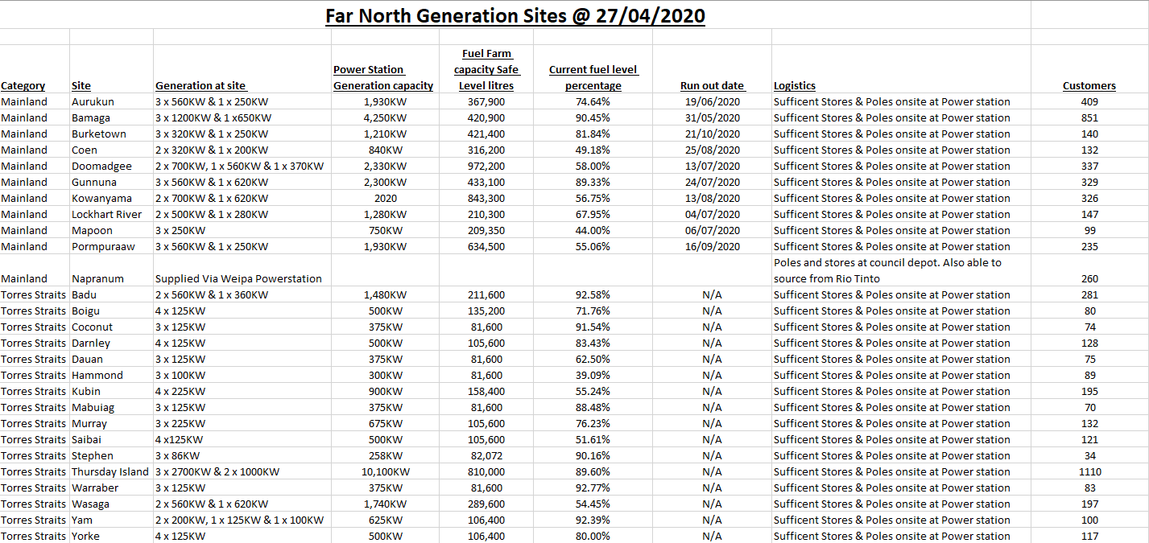

3
Given the Cairns Disaster District footprint a separate document has been developed provide an indication of services in remote locations not only within the Torres Strait but also the Cape. Below is an example:
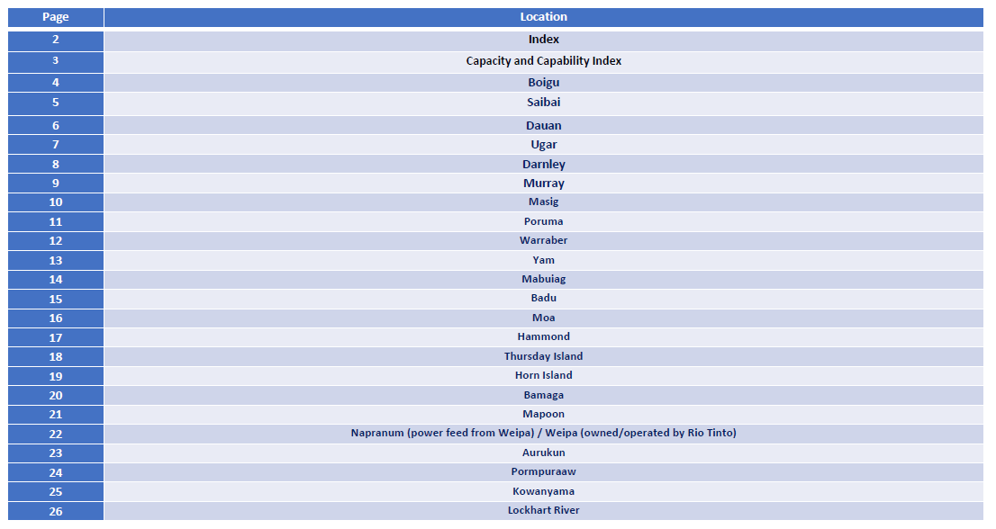

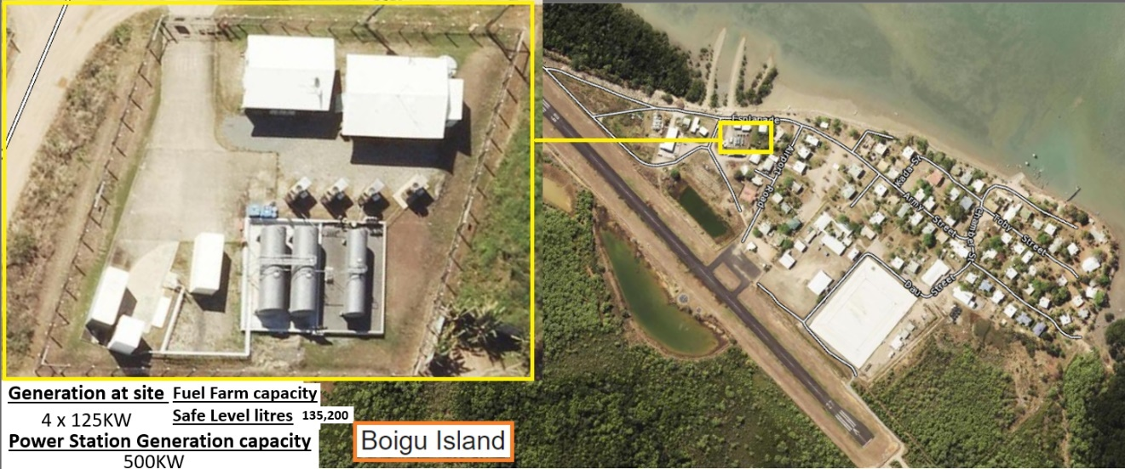

Water Supply and Sewerage treatment and disposal networks

Councils provides water reticulation to the communities and townships across the Cairns Disaster District. To provide ability for readers to comprehend what is in each location all sixteen council web sites are provided below for further research.

- Aurukun Shire Council
- Cairns Regional Council
- Cook Shire Council
- Douglas Shire Council
- Hopevale Aboriginal Shire Council
- Kowanyama Aboriginal Shire Council
- Lockhart River Aboriginal Shire Council
- Mapoon Aboriginal Shire Council
- Napranum Aboriginal Shire Council
- Northern Peninsula Area Regional Council
- Pormpuraaw Aboriginal Shire Council
- Weipa Town Authority
- Wujal Wujal Aboriginal Shire Council
- Torres Shire Council
- Torres Strait Island Regional Council
- Yarrabah Shire Council

Hazards

The hazards to which the district is susceptible, could come from one or more sources of risk including natural, technological, biological, geological, meteorological, social, economic, or political circumstances, or a combination of any.

The hazards analysis conducted in respect to the disaster district identified that the most serious events in terms of probability of occurrence and seriousness of the consequences if they did occur. The list is not to be read as an order of priority or level of risk.

Natural Hazards
Meteorological | Cyclones
 | Storm Surge/Tide
 | Severe weather
 | Floods
 | Bushfire
Geological | Earthquake
 | Tsunami
Biological | Pandemic
 | Exotic animal and plant disease
Non-Natural Hazard
 | Marine Oil Spill

The district may also be impacted by hazards / threats occurring in neighboring local government areas such as:

Failure of critical infrastructure such as power and communications.

- Failure of Critical Infrastructure
- Dam Failure
- Bush Fire
- Major Transport Incident (road, rail, sea, and air)
- Major flooding
- Category 3+ Cyclone (including east coast low)
- Storm tempest (including Tornado)
- Emergency Diseases (human)
- Emergency Diseases (animal)
- Emergency Diseases (plant)
- Landslip
- Terrorist related incident

Risk Assessment

Risk is the concept used to describe the likelihood of harmful consequences arising from the interaction of hazards, communities, and environment. Risks should be assessed through consideration of the likelihood that the event would arise and the consequences of its impact.

The Cairns DDMG shall undertake a district risk assessment based on the
Australian Standard for Risk Management (AS/NZS ISO 31000:2009), and in accordance with the process outlined in the National Emergency Risk Assessment Guidelines. Those risks identified in this risk assessment process are to be recorded in the District Risk Register. This risk register has been developed to incorporate risk identification, risk analysis and risk evaluation.

A review of Local Disaster Management Plans will assist the DRAT in conducting a risk assessment of potential hazards that have the ability to impact across local government boundaries or may significantly impact a single local government.

DRAT identified that risks contained in the District Risk Register should NOT be a duplication of the risks identified by the LDMG’s but only those risks that the DDMG has to manage. As an aid to this risk assessment process LDMG’s have been requested by the DDC to document and notify the DDMG of any risks that require transferring or sharing with the DDMG.

The district risk assessment process, including a review of the District Risk Register, shall be conducted in conjunction with a review of the District Disaster Management Plan.

Risk Assessment

Establish the context

Identify risks

Analyse risks

Risk Treatment

Evaluate risks

Treat Risks
No
Yes
Communicate and Consult
Monitor and Review

The risk management process (AS/NZS ISO 31000:2009)

Risk Treatment

Risks identified in the Risk Register are analyzed by the Cairns District Risk Assessment Team (DRAT) in order to identify strategies for risk treatment. The District Risk Treatment Plan contains preferred treatment options, responsibilities, and timeframes for implementation.

Responsibility for the implementation of risk treatment strategies, monitoring and reporting shall be determined by members of the DRAT under the guidance of the DDC. The District Risk Treatment Plan is to be presented to the Cairns DDMG for endorsement.

To progress any treatment options, the DDMG is to request responsible agencies to incorporate specified risk treatment strategies in their agency corporate planning processes for recognition and implementation.

In instances where the applications of treatment strategies at district level are identified as not being adequate and residual risks remain, the DDMG is to determine whether risk transfer or risk sharing with the SDCG is a treatment option. In these instances, the DDMG is to document and notify the SDCG of these with a view to transferring or sharing the risks. A review of the district risk treatment plan shall be conducted in conjunction with any district risk assessment review process.

Response Strategy

Concept of Operations/Activation and Triggers

The authority to activate the Cairns District Disaster Management Plan is vested in the Chairperson/Disaster District Coordinator, or in that person’s absence the Deputy Chairperson. This should occur following consultation with the following: State Disaster Coordinator (SDC); and the Chair of a LDMG.

The DDC should determine when, and to what extent, the DDMG should activate in support of an event, and may bypass initial levels of activation where appropriate to the event. Activation is scalable and does not necessarily mean the convening of all members of the DDMG or the activation of the DDCC. Activation activities can be as minimal as the provision of information to DDMG members regarding the risks associated with a potential or imminent hazard impact.

The four levels of activation, as defined in the SDMP, are detailed tabled below

Level of Activation | Definition
Alert | A heightened level of vigilance and preparedness due to the possibility of an event in the area of responsibility. Some action may be required, and the situation should be monitored by staff capable of assessing and preparing for the potential threat.
Lean forward | An operational state prior to ‘stand up’ characterised by a heightened level of situational awareness of a disaster event (either current or impending) and a state of operational readiness. Disaster coordination centres are on stand-by; prepared but not activated.
Stand up | The operational state following ‘Lean Forward” whereby resources are mobilised, personnel are activated, and operational activities commenced. Disaster coordination centres are activated.
Stand down | Transition from responding to an event back to normal core business and/or recovery operations. There is no longer a requirement to respond to the event and the threat is no longer present.

The following table outlines the activation states of the Cairns DDCC Triggers

Level | Circumstances | Actions | Communications
Alert | One or more LDMG’s operational  Awareness that threat may be widespread | XO briefs DDC on activation level of LDMG/s  Analysis of threat  Contact LDC/s  Contact Disaster Management (local government) | DDC and XO on mobile remotely
Lean Forward | Potential requirements for DDMG to coordinate disaster operations or provide support because of threat or resource requirements | Maintain contact with LDC/s  Communication procedures established  Planning commenced for support to DDCC, and staff briefed  Advise State regarding status of DDMG  Establish contacts and set up communication systems  Receipt of SITREPS from LDMG/s  Brief DDMG members  Planning for potential support to LDMGs | DDC, XO and DDMG members on mobile and monitoring email remotely  Ad-hoc reporting
Stand Up | Request for support received from LDCC/s  Large threat is imminent  Coordinated support required  Significant state resources committed | Develop situational awareness  Pass on urgent warnings  Commence SITREPs to SDCC  Roster developed for DDCC  DDCC activated with required staff  Forward planning commenced  SDCC advised DDMG stood up  Admin / logistics, operations, planning and intelligence cells in place  Coordination of State support commenced  Advice received from State Disaster Coordinator (if appointed) | DDCC contact through established land lines and generic email addresses  DDC, XO and DDMG members present at DDCC on established land lines and/or mobiles. Monitoring emails
Stand Down | LDMG/s stood down from response  Recovery arrangements functioning | Final check for outstanding requests  Assist LDMG/s to transition to recovery  Debrief of staff in DDCC and DDMG members  Consolidate financial records  Final situation report to SDCC  Hand over to Recovery Coordinator  Return to core business | DDMG members not involved in recovery operations resume standard business and after hours contact arrangements

District Disaster Coordination Centre

The District Disaster Coordination Centre will be activated to coordinate the management of resources as part of the whole-of-government approach in the Cairns Disaster District in the event of a disaster event threatening or impacting upon the area.

The primary District Disaster Coordination Centre (DDCC) is located at:

1st floor
Far North District Office
17-19 Sheridan Street
Cairns City

This venue is fully equipped with computers, fax machine, photocopier, telephones, and welfare facilities. Both buildings are equipped with a generator as an alternate power supply in the event main electricity power supply is disrupted.

Staffing of district co-ordination centre

The Cairns DDCC will contain the following capability framework along with positions and roles and responsibilities. The Cairns DDCC instruction clearly outlines all relevant information and is held by the Cairns DDC and XO.

Areas of capability within the Cairns DDCC may include within a scalable environment may include:

Command Capability
District Disaster Coordinator (DDC) – Chief Superintendent/District Officer
Deputy Chair DDMG to District Disaster Coordinator (D/DDC) – Superintendent or Inspector
Executive Officer (XO) – S/Sergeant
Deputy Executive Officer (DXO) – S/Sergeant/Sergeant mentored by XO to perform role
Situation Board keepers – developing and maintaining up to date situation boards for command cell members and DDCC support staff – will work in conjunction with the Intel Cell

Operations Capability
Preferable Skills Set Senior Sergeant or Sergeant who has experience of operational leadership.

Planning Capability
Preferable Skills Set Senior Sergeant or Sergeant who has experience in the writing of operational orders, action plans and similar

Intelligence Capability
Preferable Skills Set Senior Sergeant or Sergeant or Senior Constables whose substantive organisation position is intel

Administration and Logistics Capability
Preferable Skills Set Senior Sergeant or Sergeant preferable to be experienced in substantive organisational position of district of divisional tactician or similar

Operational Reporting
During operations there is an expectation that Situation Reports (SITREPS) will be forwarded either by FAX or EMAIL to the Executive Officer, Disaster District Management Group in accordance with requirements set by the DDC for an event.

Disaster Declaration
In accordance with section 64 of the Disaster Management Act, the DDC may, with the approval of the Minister, declare a disaster situation for the district, or a part of the district.

In declaring a disaster situation, the DDC is to be satisfied that a disaster has happened, is happening or is likely to happen and it will be necessary or reasonably likely to be necessary to exercise declared disaster powers to prevent or minimise the loss of human life, illness or injury to humans, property loss or damage, or damage to the environment.

The declaration of a disaster situation should ordinarily be made in the approved form however in accordance with section 65(5) of the Act it can be made orally, if necessary, to exercise declared disaster powers before an approved form can be obtained and completed. If the declaration is made orally, it must be recorded in the approved form as soon as is reasonably practicable. (Please note that an oral declaration cannot be made if the DDC is satisfied only that it is reasonably likely to be necessary to exercise disaster powers. The DDC must believe that it is necessary to exercise the powers.)

Before declaring a disaster situation, the DDC is to take reasonable steps to consult with the DDMG and each local government in, or partly in, the proposed declared area. A failure to consult does not affect the validity of the declaration (section 64(3)).

The Minister and the Premier may declare a disaster situation for the State, or a part of the State (Section 69) under the same conditions as those for DDCs under section 64 with the exception that consultation is not required with the DDMG or local government.

Requests for Assistance (RFAs)
When a disaster management group requires logistics support and/or resources to meet operational requirements that are beyond local or district capacity and capability, they must seek assistance through a formal request to the next relevant level (i.e., local to district or district to state). Guidance for following the correct process should be gained from the Request for Assistance - Reference Guide [Click here] or via the Queensland Government Disaster Management website [Click here].

All Requests for Assistance are to be submitted in the prescribed format. Local Disaster Management Groups shall submit their requests for assistance to the District Disaster Coordinator. Requests that cannot be met at District level are to be forwarded to the State Disaster Coordination Centre.

Resupply
Due to the nature of some disasters, there will be occasions where areas within the disaster district become isolated for a lengthy period, requiring the need to resupply provisions to that area.

The Queensland Resupply Guidelines outline in detail the governance and operational process relating to the resupply of essential goods to communities within Queensland and are located at Queensland Resupply Guidelines.

Emergency Supply
During a disaster related event a rapid onset event, the situation may arise whereby members of the community require the supply of essential items and goods to maintain their health and well-being until more permanent arrangements may be made.

As detailed in the Queensland State Disaster Management Plan the arrangements for the provision and issue of emergency supplies to support disaster response and recovery operations, including arrangements for the procurement, coordinated delivery and management of emergency supplies and associated services is the role of QFES.

At the district level, the coordination of emergency supply is the responsibility of the QFES DDMG member to the group of their delegated representative. Emergency supply may be conducted by the QFES representative from within the DDCC or another appropriate location (Incident Operations Centre/Regional Operations Centre/State Operations Centre) as determined necessary in the circumstances.

Request for Air Support – Aviation Capability
Due to the geographical footprint of the Cairns Disaster District the deployment of resources human or otherwise will in most of the case be by aircraft. Ordinarily individual agencies or entities take on the responsibility of booking aircraft however at times the event is such that the need for an aviation capability locally to support district wide operations.

The authority to activate such as a capability lies with the District Disaster Coordinator (DDC). The DDC can form an aviation capability within the DDCC who can work through QGAir for government assets or alternatively the sourcing of air assets from brokering firms.

Financial Management
All agencies, councils and entities have individual responsibilities for financial management.

All processes are performed in accordance with the Queensland Government Financial Management Practice Manual and therefore in compliance with section 46M of the Financial Administration and Audit Act 1977 and other prescribed requirements.

Warning Notification and Dissemination

Public information during the response phase of a disaster management operation provides the community with awareness of hazards and information about events and recommended actions, such as local evacuation arrangements and specific measures available for vulnerable groups (e.g., the elderly, ill and people with a disability).

Traditional media, including radio, television, and print, is used for public information in most events, however local governments and emergency service agencies also use social media, local warning systems, websites, and other channels to provide information to stakeholders and the community.

Predominantly warning products will be issued by the Bureau of Meteorology including, but not limited to, Severe Weather Warnings, Tropical Cyclone Advice, Flood watch or Tsunami Warning Products.

Departments or organisations with specific responsibility for issuing warnings or the management of specific threats, for example, the Bureau of Meteorology for meteorological related information and the Department of Primary Industries for Emergency Diseases in Animals, Queensland Fire and Rescue Service for major fires, shall issue warnings in accordance with their standard operating procedures.

The DDC will receive notification directly from the State Disaster Coordination Centre (SDCC) and internally through Queensland Police Service Communication Centres. The DDC will ensure the dissemination of warnings to vulnerable LDMGs within the district.
DDMG members will receive warning products via several means. Depending on time constraints, DDMG member agencies will normally be notified by e-mail, and depending on the urgency of perhaps a rapid onset event like a tsunami by telephone.

Teleconferencing equipment is available to the Cairns DDMG and the initial e-mail advising of the warning may request an urgent meeting via teleconference. DDMG member agencies may also receive notification from internal agency central offices.

Several agencies will also receive warnings directly from the Bureau of Meteorology.

Details regarding responsibility for notification processes within DDMG member agencies are detailed in respective agency plans. Agency plans will include detailed contact registers to achieve dissemination of warnings.

The Cairns XO plays an important role in ensuring the notification and dissemination of warnings to members of the Cairns DDMG, LDMGs and in some instances, elements of the community that may fall under the responsibility of Cairns DDMG member agencies, such as residents of island communities.

The process for the notification and dissemination of warning products is not a function dependent on the activation of the Cairns DDMG, rather it is an automatic responsibility of Cairns DDMG Executives and members, regardless of the status of activation of the DDMG.

Upon receipt of information that communities located within the Cairns Disaster District are or may be threatened by a particular hazard, the Disaster District Coordinator (DDC) shall ensure that the community and local governments receive appropriate warnings in respect to those threats.

Warnings will be communicated to the vulnerable community by their respective local government in accordance with the relevant provisions of the respective Local Government Disaster Management Plan. These warnings will be conducted in collaboration with the Cairns DDC to ensure uniformity and consistency in the message.

However, where events require a higher level of warning, the DDC may engage the Emergency Alert (EA) system.

Emergency Alert

The Emergency Alert (EA) is a national telephone warning system that provides Australian emergency authorities with an enhanced ability to warn the community in the event of an emergency. The warning system is another tool available for organisations to issue emergency warnings where EA will be issued via landline and mobile telephones.

As the use of EA can be time critical for a community, the process for requesting it does not involve a bureaucratic approval process. EA provides the capability to send warning messages to fixed line telephones based on their physical location and to mobile telephones based on its billing address within a particular area.

The management and administration of Emergency Alert in Queensland is the responsibility of QFES through the Watch desk at SDCC. This includes ongoing maintenance, testing and capture of EA costs including measures for accountability and cost recovery, record-keeping, and reporting

The Queensland Emergency Alert Manual governs the use of EA in Queensland.

District and Local Disaster Management Group should consider the development and preloading of Emergency Alerts for identified hazards within their area of responsibility.

SEWS (Standard Emergency Warning Signal)
The Standard Emergency Warning Signal (SEWS) is a distinctive audio signal that has been adopted to alert the community to the broadcast of an urgent safety message relating to a major emergency/disaster. It is intended for use as an alert signal to be played on public media (such as radio, television, public address systems, mobile sirens), to draw listeners’ attention to a following emergency warning. It is meant to attract listeners’ attention to the fact that they should take notice of the emergency message.

The use of SEWS may be considered outside of the eligible events, in which case the DDC will liaise with the State Disaster Coordination Centre. Further information in relation to ‘SEWS’ can be found in the Guidelines for the Standard Emergency Warning Signal and its use in Queensland.

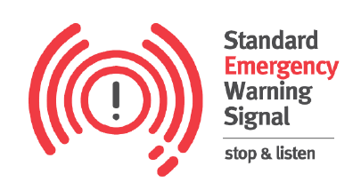

In Queensland, the authority to initiate SEWS warnings is restricted to:
- The Bureau of Meteorology (or nominated delegate) for weather and flood related events only.
- The Commissioner of the Queensland Fire and Rescue Service (QFRS) (or Chief Superintendent or Regional Manager Rural Operations as delegate) for fire and HAZMAT related events only.
• The Commissioner of Queensland Police Service (or Senior Officer of a rank no lower than Assistant Commissioner as delegate), for events not covered by a), b) or c) above.

Functional Plans
A number of agencies have functional plans in support of the Cairns DDMP, and these are available either through the relevant agency or via the Cairns XO.

The following are relevant agency/entity functions and/or functional plans:
AGENCY | FUNCTIONAL PLAN or FUNCTON
Department of Communities, Housing and Digital Economy | Human and Social Recovery Plan  Ready Reservists
Queensland Police Service | Search and Rescue Coordination  Queensland Counter Terrorism Plan  Disaster Victim Identification  Mass Fatality Management (in conjunction with QH)
Department of Transport and Main Roads | Road and Transport Recovery  Maintenance of Traffic and Road Conditions Website 13 19 40  Transport Systems
Department of Environment and Science | Environmental Recovery  Environmental Expert Assessment and Advice  Storm Surge and tidal impact data  Provision of assistance with Satellite Imagery  Water Quality Monitoring  Referable Dams  Reticulated Water Supply Regulation  Energy Infrastructure (electricity, gas, and liquid fuels)  Electricity Supply System Reliability  Dam Safety
Department of State Development, Infrastructure, Local Government and Planning | Economic Recovery Plan  Building our Regions funding program  Land use planning  Initial Economic Impact Assessments  Works for Queensland (Q4Q) Program  Local Government Grants and Subsidies Program  Disaster Mitigation and Resilience Funding  Land Use Planning
Department of Energy and Public Works | DHPW Regional Disaster Management Plan  Temporary Emergency Accommodation Sub-Plan  Building lines of Recovery  Building Codes  Temporary Emergency Accommodation  Telecommunications Industry Engagement  Building and Engineering Services  ICT Infrastructure
Queensland Fire and Emergency Services | Facilitation of Emergency Alerts and  Standard Emergency Warning Signal  Hazard Mapping  Bushfire Mitigation Programs and Readiness Plans  Chemical, Biological & Radiological Incidents  Operation Cool Burn  Emergency Supply  Resupply  Damage Assessments
Queensland Reconstruction Authority | Queensland Recovery Plan  Queensland Strategy for Disaster Resilience  Natural Disaster Resilience Program  Disaster Recovery, Resilience and Mitigation Policy and Planning  Disaster Mitigation and Resilience Funding  Get Ready Queensland Program  Offers of Assistance  State Disaster Relief Arrangements
Department of Agriculture and Fisheries | Animal and Plan Disease Plans
Queensland Health | Biological (human related) Plans  Radiological incident Plans  Heatwave Response Plans  Heatwave Communications Protocol  Pandemic Plans  Public Health, Mental Health, and Medical Services  Mass Casualty Management  Mass Fatality Management  Emergency Aeromedical Retrieval
Maritime Safety Queensland (DTMR) | Ship Sourced Pollution (Queensland Coastal Contingency Action Plans)
Department of Education | School closures  Provision of Departmental building for transition to shelters, places of refuge of evacuation centres
Australian Defence Force | DACC requests
Queensland Ambulance Service | Provide, operation and maintain ambulance services and service delivery during rescue and other related activities  Provide transport for persons requiring medical or health care facilities, to participate with other emergency services during the disaster
Queensland Corrective Services | Deployment and coordination of low-risk prisoners and offenders to assist response and recovery operations
Ergon Energy | Restoration of power supply interruptions  Electricity Restoration Plan
Sun Water | Operate water supply infrastructure and dams according to emergency management protocols  Emergency Action Plans  Provision of notifications and warnings to populations at risk immediately downstream
Telstra. Vodafone & NBN Co | Telecommunications Services  Landline and data communications  Mobile Communications  Backbone data networks  Telecommunications recovery  Satellite Communications on Wheels  Mobile Exchange on Wheels  Wi-Fi Mobile customer office

Hazard Specific Arrangements

Whilst Queensland has adopted an all-hazards approach to the development of disaster management arrangements, it is important to acknowledge that some hazards have characteristics that may require a hazard specific approach.

Other hazard specific plans are developed by associated agencies, which form appendices to and should be read as complementing this plan. The following table outlines the primary agency and associated hazard specific plan.

Hazard | Plan | Primary Agency
Pandemic | - Queensland Whole-of- Government Pandemic Plan  - Queensland Health Pandemic Influenza Plan | Queensland Health
Animal and plant disease | - Australian Veterinary Emergency Plan  - Australian Aquatic Veterinary Emergency Plan  - Australian Emergency Plant Response Plan  - Biosecurity Emergency Operations Manual | Department of Agriculture and Fisheries
Bushfire | - Queensland Bushfire Plan  - A Master Plan for Queensland’s parks and forests | Queensland Fire and Emergency Services  Department of Environment and Science
Ship Sourced Pollution (Oil Spill) | - Queensland Coastal Contingency Action Plan (QCCAP) | Maritime Safety Queensland
Terrorism | - Queensland Counter terrorism Plan | Queensland Police Service
Chemical/Biological (Human)/Radiological | - ChemicalHazMat Plan | Queensland Fire and Emergency Services  Queensland Health
Heatwave | - Queensland Heat Wave Management Sub-Plan | Queensland Health

These plans address specific hazards where government departments and agencies have a primary management responsibility. The primary agency has responsibility to ensure that an effective hazard specific plan is prepared.

All hazard specific plans are to address the hazard actions across all PPRR phases and include information on how the QDMA links with the hazard specific arrangements and provides support to the primary agency in the management of the hazard specific event.
Specific planning is required for these arrangements as their coordination and operational procedures can be different to those of the QDMA.

Coordination centres and the structures within them can be outside the local, district and State coordination centres and the passage of information and resources may be managed using different processes.
Generic hazard specific arrangement’s structure and linkages and communication flow to the broader QDMA is outlined in the State Disaster Management Plan 2018.

Post Disaster Assessment

At the conclusion of any event the DDC may call for an event de-brief to determine lessons learnt to improve the effectiveness of the DDMG for disaster management operations. The de-brief needs to be conducted through the spirit of cooperation and no blame game techniques.

Recovery
Disaster recovery within the district requires a collaborative, coordinated, adaptable and scalable approach from the DDMG. The Queensland Reconstruction Authority (QRA) is the lead agency for disaster recovery including Commonwealth and State Relief and Recovery Arrangements.

QRA has an extensive web site housing information for all members and advisors including the Queensland Recovery Plan which is a sub plan to the State Disaster Management Plan.

Immediate/Short Term Recovery
As disaster response and immediate/short term recovery occurs concurrently, the activation of the strategy will commence with immediate/short term recovery actions undertaken within the response phase. The concept of operations for immediate/short term recovery are in Section 5.3 of the Queensland Recovery Guidelines.

The Immediate to Short‐Term Recovery phase covers immediate community recovery service provision to meet identified individual personal and community needs, and to restore services to the level where Local Government and the normal responsible agencies can manage the continuing recovery process. The immediate/short term recovery phase occurs concurrently to response operations.

Immediate/short term recovery activities of the DDMG will typically include:
- support to LDMGs to ensure the conduct of rapid damage and need assessment.
- support to LDMGs to ensure the provision of immediate community services (e.g., health services, food, clothing and shelter, financial relief).
- support to LDMGs to ensure the restoration of critical utilities and services; and
- support to LDMGs to ensure the provision of temporary housing.

Transition from immediate/short term to medium/long term recovery
The Cairns DDMG will utilise the following as triggers to commence the process of transition from immediate/short term to medium/long term recovery:
- • Emergency is contained.
- • No further hazard or secondary threats are likely in the near future.
- • Response organisations cease their activities.
- • Public safety measures are in place and work effectively.
- • Evacuation centres have closed; or
- • Initial rehabilitation has commenced.

The appointment of the District Recovery Coordinator should take place at the latest during the transition phase and preferably during the response/short term recovery phase of the event.

Medium/Long Term Recovery
The level of district support required in the medium/long term recovery phase will be dependent on the recovery structure advised by the QDMC for each specific event. The concept of operations for medium/long term recovery are in Section 55 and 5.6 of the Queensland Recovery Guidelines.

The level of support required by the DDMG during the medium /long term recovery phase will be dependent on the nature and scale of the disaster. The level of involvement of the DDMG may range from supplementation of a Local Recovery Group to the establishment of a District Recovery Group.

Recovery Functions and Lead Agencies
Function | Lead Agency
Human and Social | Department of Communities, Housing and Digital Economy
Roads and Transport | Department of Transport and Main Roads
Building | Department of Energy and Public Works
Economic | State Development, Infrastructure, Local Government and Planning
Environment | Environment and Science

REVIEW & ASSURANCE

Review and Assessment of Plan
In accordance with section 55 of the Act the District Disaster Management Plan (DDMP) shall be reviewed annually. The review and assessment process for the DDMP will be reflected in amendment register.

External Assessment

The Inspector-General Emergency Management (IGEM) is responsible for providing the Premier, Queensland Government and people of Queensland an assurance of public safety, through the establishment and implementation of an assurance framework to direct, guide and focus work of all agencies, across all tiers of Government to the desired outcomes of the disaster and emergency management arrangements for Queensland. The Office of the Inspector-General Emergency Management supports the IGEM through planning, developing, and conducting a range of review and assessment projects, consulting stakeholders, to enable confidence in Queensland’s disaster and emergency management arrangements.

Review of Local Disaster Management Arrangements
In accordance with section 23 of the Disaster Management Act 2003, it is a function of the DDMG to regularly review and assess the disaster management of local groups in the district.

It will be the responsibility of each Council to annually review their local disaster management arrangements, including their respective Local Disaster Management Plans and submit a review report to the DDC via the XO. The review and assessment process should be in consultation with the XO and QFES EMC.

Post-Disaster Assessment
To aid the development of effective disaster management for the district, the Cairns DDMG may conduct a post-disaster assessment and provide a written report to the QDMC as to the outcomes of this assessment. This assessment report is to be forwarded to the Australian Statistical Geography Standard QDMC within 14 days of the DDMG post-disaster debriefing be held.

A post disaster assessment may be developed through the following process:
- During the operation of the LDCC, the LDC is to brief and request all participants to offer comment on the conduct of the LDCC and provide recommendations to improve best practice.
- As soon as practicable after an LDCC has stood down from operations, the LDC is to conduct a formal debrief of all personnel participating in the LDCC. Matters raised during the operation of the LDCC are to be raised, discussed, and recorded.
- Minutes are to be produced and forwarded to the Executive Officer – DDMG.
- Each LDMG will conduct a formal debrief as soon as practicable after the LDMG is stood down of all personnel participating in the LDMG. Minutes are to be produced and forwarded to the Executive Officer – DDMG.
- During the operation of the DDCC, the DDC is to brief and request all participants to offer comment on the conduct of the DDCC and provide recommendations to improve best practice.
- As soon as practicable after the DDCC has stood down from operations, the DDC will conduct a formal debrief of all personnel participating in the DDCC. Matters raised during the operation of the DDCC are to be raised, discussed, and recorded.
- Minutes are to be produced and forwarded to the Executive Officer – DDMG.
- DDC will then conduct a formal debrief as soon as practicable after the LDCC’s, LDMG’s and the DDCC have stood down. Minutes are to be produced and forwarded to the Executive Officer – DDMG.
- An assessment will be conducted of matters raised to identify appropriate strategies to implement and ensure best practice.
- The assessment will also identify the key partners to be involved in the development of any strategy to resolve the issues raised; and
- Any strategies developed will address the process for the implementation of improvement strategies as a component of the monitoring and review of the DDMP and the district disaster management arrangements.

In line with the District Disaster Management Guidelines the Post-Disaster Assessment Report should be completed in partnership with QFES (EM) to provide an overview of the lessons identified following an event and importantly recommendations for improving disaster management.

Recommendations may include:

- QDMA or State level issues for referral and consideration by the QDMC/SDCG.
- Issues for resolution by the DDMG; and
- Advice for improvements to local disaster management arrangements.

Annexure Index

A Distribution List

B. Risk Register (via the XO)

C. Risk Treatment Plan (via the XO)

D District Levels of Activation for Response Arrangements

District Levels of Activation for Response Arrangements
