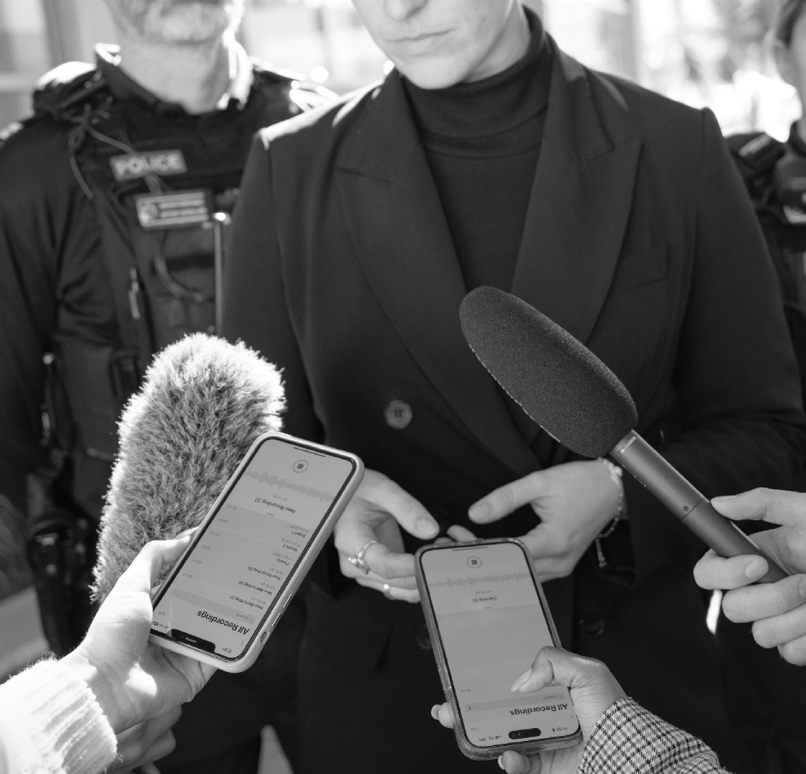


The Queensland Police Service's
MEDIA GUIDE FOR FAMILIES

A guide to help navigate the media when your family have experienced death, injury or serious crime

A QUICK GUIDE:
Things to know

The loss of a loved one, as well as any tragic incident or crime in the family, can be overwhelming and devasting. Navigating interactions with the media during this time can escalate any stress. This Guide will support you through your engagements with the media during these difficult times and offer advice for effectively communicating with journalists.

The Queensland Police Service operates a dedicated Media and Public Affairs Group tasked with providing information to media outlets during critical and unfolding events. The Group is committed to transparency with the public, within defined privacy and ethical boundaries.

The decision to engage with the media rests entirely with you, and it is completely acceptable to choose not to. There are both benefits, and potential risks involved when communicating with the media (see page 6).

If you choose to engage it may be helpful to have a step-by-step process as a guide (see page 8). Planning with your family on these decisions may also ease the process.

Working alongside a police-appointed Family Liaison Officer and the police Media and Public Affairs Group during this challenging time may help you to engage and communicate effectively with journalists. If you find the media becomes too overwhelming or confronting, or if any media reports are inaccurate or incorrect, your Family Liaison Officer can support and guide you through these challenges.

Whether you choose to engage with the media or not, it is important to be
well-informed about the media's right to film in public settings.

2 | MEDIA GUIDE FOR FAMILIES



INTRODUCTION:
The Queensland Police Service is here to support you and your family when unimaginable and devastating events happen. Regardless of whether a person is involved in a traffic incident, experiences a tragic event,
or becomes the victim of a crime, the consequences can be profoundly
devastating and far-reaching. One of the many challenging impacts
of these incidents, is that families and friends are left coping with the loss
of a loved one, dealing with a missing friend or family member, or facing the implications of someone close to you being involved in a serious crime.
Unfortunately, many of these incidents can provoke unwanted media attention. It is the role of a journalist to report on incidents that are considered newsworthy, and journalists are often driven by the urgency to report unfolding situations as they happen.
The Queensland Police Service upholds a commitment to transparency with the public, within defined privacy and ethical boundaries. While media presence may lead to additional stress at an already overwhelming time,
it is important to understand that the media holds a responsibility to report matters of public interest.

QPS MEDIA UNIT, 2025 | 3

Police Media liaise with investigating officers and senior police officers
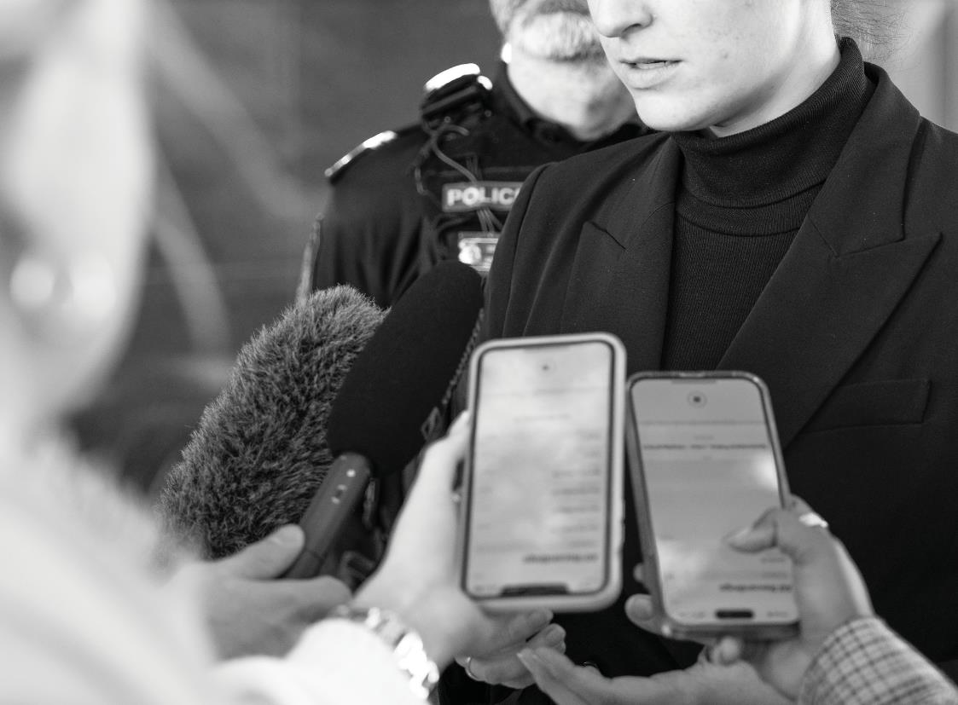
to prioritise victim rights every step of the way.
4 | MEDIA GUIDE FOR FAMILIES

MEDIA INTEREST:
Crime, regardless of its nature, is often considered by the public as ‘newsworthy’. The media’s role in the aftermath of a serious incident involves not only uncovering the facts, but also portraying the emotional side of a story. This process may involve news journalists inquiring into a person’s background, while they are seeking to add depth and context to the story.
This may lead to the media approaching various individuals connected to the incident, such as family members, friends, colleagues, and
neighbours, as well as exploring social media connections. While this may feel intrusive, it enables media to construct a more comprehensive picture of the distressing aftermath of an unexpected death or serious crime.

POLICE MEDIA:
The Queensland Police Service has a dedicated Media & Public Affairs (MPA) Group. MPA is tasked with providing information to media outlets during critical and unfolding events. While upholding transparency, MPA strictly adheres to privacy and human rights laws. For example, MPA does not confirm any personal details such as name/s, contact details or addresses unless explicitly approved by the family. MPA liaises with investigating officers and senior police officers to prioritise victim rights every step of the way.
MPA will also facilitate media engagements on behalf of police and use the media as a valuable tool to assist with investigations, prevent criminal activities, and promote community safety. MPA is comprised of police officers and media professionals and operates 24 hours a day.

QPS MEDIA UNIT, 2025 | 5

QUICK POINTS

You may choose to engage with the media to:
- Appeal to the public for information to aid investigations.
- Pay tribute to a loved one involved in the incident.
- Raise awareness of the incident or community safety concerns.
- Present a more comprehensive picture of the character of the deceased victim.
- Correct inaccuracies or misinformation in existing media reports.

You may choose not to engage with the media to:
- Avoid repetitive and long-lasting media attention.
- Prevent the exposure of children or vulnerable family members to the possibility of ongoing trauma.
- Deny the media from gaining access to your personal contact details. Any contact with the media is suggested via a private number or email address.
- Avoid information being taken out of context.
- Avoid impacting ongoing investigations or court matters.

6 | MEDIA GUIDE FOR FAMILIES



WHAT TO DO WHEN THE MEDIA COMES TO YOU:
It may not feel like it in the moment, but you have a choice when it comes to dealing with the media. Whether or not you choose to engage, having a plan can be helpful. Families are encouraged to determine their involvement with the media collectively, ensuring a unified response when approached by journalists.

If you choose not to engage…
Choosing not to engage with the media is a valid decision. MPA, through your assigned Family Liaison Officer, can assist in conveying the family's desire for privacy by providing a broad notice to the media. However, it is important to be mindful that journalists may still approach you and your extended family or friends to gain as much information as possible. MPA has no authority over media outlets; however, its collective aim is to always respect the wishes of families when asked for privacy.

If you choose to engage…
Opting to engage with the media, even at a minimal level, may allow your family to retain some control over the narrative. As media interest may intensify, it is always recommended to establish restrictions and limitations early in the engagement process. Whether providing a simple photo and written statement or engaging in interviews, clear communication with journalists about boundaries is imperative and your Family Liaison Officer can support you with this.
QPS MEDIA UNIT, 2025 | 7

ENGAGING MEDIA?
For families or individuals choosing to engage with the media, several steps
can guide the process:

Notify your Family Liaison Officer
Before you start talking to journalists, ensure you have advised your Family Liaison Officer of this decision. They may have already had this conversation with you, however it is important they know what your media plan is. There is likely still an active investigation underway into the incident. If this is the case, there may be certain information that
is not appropriate to be shared with the media as it may impact the course of the investigation or the outcome of a court case. For this reason, it is best to keep your Family Liaison Officer in the loop every step of the way. Depending on your media strategy, your Family Liaison Officer can engage MPA to assist you in communicating your message.

Designate a spokesperson
It is recommended to have one spokesperson on behalf of the family to direct media inquiries to. The media may try to reach out through multiple people in the first instance, but if they are referred to the one spokesperson by all other family members and friends, this will help funnel media inquiries through just the one channel.

Decide collectively what you aim to communicate
What are the key messages you want to communicate? Take some time to develop these as dot points or a written statement to ensure your spokesperson adheres to this message. You may wish to involve all members of your immediate family, including children, in the development of this statement. It is important to consider any short or long-term impacts this statement may have. Journalists will often give you an idea of the questions they want answered, or you can request these questions prior to providing a statement or interview. Usually, journalists want to know about the person, how the family is currently feeling, and if there is a general message to the community. Keeping these points simple is best. It is also important to note that the media are often looking to show an emotional response to the public and may ask you questions to provoke this. The aim of this is to prompt a greater audience reach and effective reaction.

8 | MEDIA GUIDE FOR FAMILIES



Have photographs prepared
Select photographs of your loved one promptly to ensure the media does not resort to unsolicited photos from social media. MPA can assist with disseminating these photos to the media, along with a statement on behalf of the family. Choosing not to supply photos is okay, however, it is important to be mindful that the media may source their own photos via
any public social media accounts.

Notify your family
In the event that your family has collectively decided to engage with media, you may wish to consider reaching out to extended family, close friends, and possibly even neighbours to let them know your plan. This will not necessarily prevent them from making their own comments to media, but it can help them work with the media as well.

Consider a press conference
You want to say something, but you only want to say it once? This is completely understandable. MPA can help you facilitate a press conference.
  - Consider having your spokesperson nominate a time and place for media outlets to attend together. Ideally, this is not the family home so as not to give the media your address.
  - Stick to your prepared statement or dot points and take your time. This process may be an overwhelming experience so if you need a breath, take it.
  - Make sure to let journalists know beforehand whether they are approved to ask you questions. Journalists can comprehend what you are going through is emotional and most are very understanding during this time.
  - Remain clear and concise with them:
“No questions please, I’d like to read a statement on behalf of the family.”
Alternatively, if you are open to some questions but there are some areas that are off-limits, clarify this with the media, or through MPA beforehand.

QPS MEDIA UNIT, 2025 | 9

ONGOING ENGAGEMENT:
Members of the media are generally good at staying in contact. If you are open to further interviews later, let them know and they may reach out for more information or follow up questions in the future. Keep in mind, once you give out your contact details, the journalists may share these with other members of their media organisation. If you are happy for them to stay
in contact, consider providing them with an email address or your social media account.

FILMING:
Whether you choose to engage with the media or not, it is important to be well-informed about the media's right to film in public settings. Depending on the level of interest, media may be present in various locations, including court hearings or public spaces. This can include the road outside your home or property which the media may film you on as you come and go.

COURT MATTERS:
During court proceedings, you might find you have regular contact with journalists covering the story. It is critical to maintain a professional relationship. Consider all comments made to the journalist as those comments may impact the investigation or court case. If concerns arise about the media's conduct during this process, your Family Liaison Officer may be able to assist.

ONE-ON-ONE INTERVIEWS AND EXCLUSIVES:
Exclusive interviews may be offered by media outlets, potentially involving financial incentives. Negotiations are a matter for the family or individual. However, it is requested that prior to undertaking the interview, your Family Liaison Officer is notified to ensure this will not impact any ongoing
investigation. If you misspeak, inform the journalist that what you said is not for publication. It is within their interest to work with you.

10 | MEDIA GUIDE FOR FAMILIES



PUBLIC APPEALS:
If the police engage with the media for public appeals, families can choose whether to participate. Detectives, your Family Liaison Officer, and MPA will work with you to ensure you are as comfortable as possible throughout
the process if it is something you choose to do. Public appeals with family members can sometimes benefit an investigation as they allow increased media coverage and ensure members of the public are encouraged to provide information. Family members’ involvement in a public appeal often makes the story more relatable to the public, rather than a police officer asking for assistance.

QPS MEDIA UNIT, 2025 | 11

IF THE MEDIA BECOMES TOO MUCH:
If the media becomes overwhelming, contact your Family Liaison Officer.
MPA is usually able to intervene and request media outlets respect your privacy.

IF THE MEDIA REPORTS ARE WRONG:
If media reports are inaccurate or upsetting, reaching out to your Family Liaison Officer is recommended. MPA can attempt to address the issue with the outlet and assist in drafting a corrective statement.

FUNERALS:
Media may request attendance at funerals, and families have the option to either allow or restrict this. MPA can communicate the family's preference to the media, though this may not prevent their attendance. The media may still attend outside the venue and film from a distance. Providing a copy of the eulogy or establishing a media spokesperson post-event can be considered with the assistance of your Family Liaison Officer and MPA. If you are accepting of having the media attend the funeral and film, you will need to check with the venue, as some religious locations may not allow this. Often, families allow one camera operator closer access to the funeral, so it is not too intrusive, and this vision is shared with other media organisations.

SUPPORT:
Your Family Liaison Officer is there to support you to navigate with the media throughout this challenging period. Every situation is different and how a family wants to engage with media is their choice. There is no perfect way to handle media in this situation however there are various police resources available to assist with this process and you do not have to navigate it alone.

12 | MEDIA GUIDE FOR FAMILIES



If the media becomes overwhelming, or if media reports are inaccurate or upsetting, contact your Family Liaison Officer

QPS MEDIA UNIT, 2025 | 13



IMPORTANT CONTACTS

Queensland Homicide Victim Support Group (QHVSG)
Phone 1800 774 744
QHVSG provides emotional support, advocacy and information for people affected by homicide. They operate 24 hours a day, seven days a week.
Lifeline Phone 13 11 14 Text 0477 131 114
If you are experiencing emotional distress, you can access Lifeline’s
24-hour crisis support and suicide prevention service.
VictimConnect Phone 1300 318 940
VictimConnect provides free and confidential counselling to help you recover from the emotional and psychological impacts of experiencing or witnessing a violent crime.
PACT Phone 1800 449 632
PACT provides free information and support to victims and witnesses going through a court process.

NOTES


Developed by the QPS Media Unit, 2025.

© State of Queensland (Queensland Police Service) 2025 is licenced under CC BY 4.0.
All Queensland Police Service material in this document – except any material protected
by a trademark, and unless otherwise noted – is licensed under http://creativecommons.org/ licenses/by/4.0/legalcode

