Gladstone District
Disaster Management Plan
2025-2026

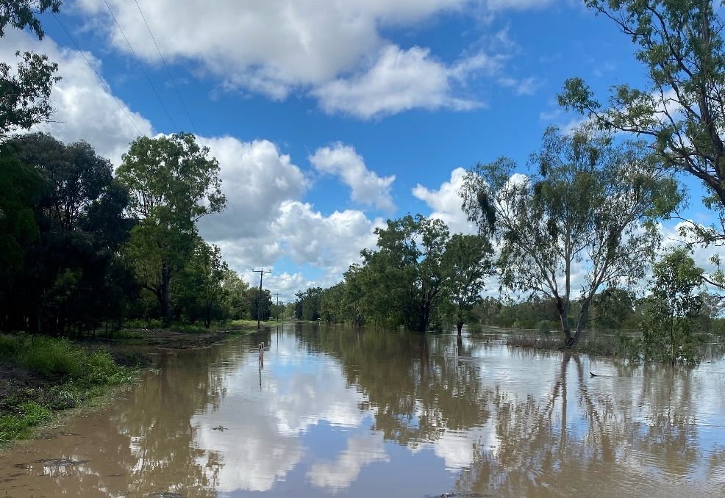

Prepared by the Gladstone District Disaster Management Group

Document Control

Amendments version control
The Gladstone District Disaster Management Plan (DDMP) is a controlled document. The controller of the document is the Chair, Gladstone District Disaster Management Group (DDMG). Any proposed amendments to this plan should be forwarded in writing to:
Post Executive Officer
Gladstone District Disaster Management Group
PO Box 1000
Gladstone QLD 4680
Email DDC.Gladstone@police.qld.gov.au

Minor amendments will be addressed administratively by the Executive Officer, Gladstone DDMG and endorsed by the Chair, Gladstone DDMG. Any changes to the intent of the document must be endorsed by the Gladstone DDMG. A copy of each amendment is to be forwarded to those identified in the distribution list. On receipt, the amendment is to be inserted into the document and the Amendment Register updated and signed.

Amendment Register
The amendments register is documented in Annexure A.

Abbreviation and Acronyms
The Abbreviation and Acronyms register is documented in Annexure B.

Definitions
The definition register is documented in Annexure C.

Distribution
The DDMP has been distributed to all core member and advisory members of the Gladstone DDMG as documented in Annexure D. As the DDMP is a controlled document the plan is not to be distributed outside of member Agencies without the express written permission of the Chair, Gladstone DMDG.
In accordance with the Act, a controlled master copy of the DDMP is available on the Queensland Police Service website.

The DDMP is available for inspection free of charge to members of the public. All applications are to be made to the Executive Officer via post or email.

Post Executive Officer
Gladstone District Disaster Management Group
PO Box 1000
Gladstone QLD 4680
Email DDC.Gladstone@police.qld.gov.au

Foreword

The communities located within the Gladstone Disaster District are susceptible to the impacts from a variety of natural, non-natural and technological hazards.

The Gladstone DDMP has been prepared under the authority of the Disaster Management Act 2003 (the Act) to provide a framework for comprehensive disaster management within the Gladstone District and to ensure that disaster management and disaster operations in the district are consistent with the State group’s Disaster Management Strategic Policy Statement and State Disaster Management Plan.

The DDMP is designed to enhance the District’s disaster management capacity by ensuring the necessary strategies are in place to provide a comprehensive (Prevention/Mitigation, Preparedness, Response and Recovery), all-agency, whole-of-government approach to disaster management through effective disaster management arrangements that may be applied in an all-hazards context.

The DDMP also incorporates hazard specific strategies for disaster management in respect to hazards identified through hazard analysis.

The DDMP will be reviewed periodically and amended as necessary to address the districts most significant risks as identified through hazard analysis and risk assessments and ensure compliance with current best practice procedures in disaster management planning.

Darren Someville
Chair
Gladstone District Disaster Management Group
04/06/2025

Endorsement and Authorisation
The Gladstone DDMP has been prepared in accordance with section 53 of the Disaster Management Act 2003, on behalf of the Gladstone DDMG.
The Gladstone DDMP is endorsed under the authority of the Gladstone DDMG and will be maintained by the Chair, Gladstone DDMG.

Darren Someville
Chair
Gladstone District Disaster Management Group
04/06/2025

Table of Contents
Document Control 2
Amendments version control 2
Amendment Register 2
Abbreviation and Acronyms 2
Definitions 2
Distribution 2
Foreword 3
Endorsement and Authorisation 4
Table of Contents 5
Administration, Governance and Assurance 8
Purpose and Authority to Plan 8
Scope 8
Objectives 8
Disaster Management Priorities 9
Strategic Policy Statement 9
District Priorities 9
Annual Operational Priorities 9
Review and Renew Plan 9
Review of Local Disaster Management Arrangements 10
District Disaster Management Group 12
Establishment 12
Functions of the DDMG 12
Membership 12
Gladstone DDMG Member Responsibilities 13
Hazard Specific Arrangements 13
Functional and Supporting Committees 13
Meetings and Quorum 14
Administrative Reporting 14
Disaster Risk Assessment 16
Community Context 16
Geography 16
Climate and Weather 16
Population 16
Economy / Industry 16
Risk Overview 17
Risk Assessment 17
Risk Treatment 17
Prevention and preparedness 19
Prevention 19
Preparedness 19
Training 19
Exercises 19
Response Strategy 21
Situational Awareness 21
Activation and Triggers for Response 21
Media Management 21
Post Disaster Assessment 21
District Disaster Coordination Centre 21
Disaster Declaration 21
Functional Lead Agencies and Functional Plans 22
Functional Plans 22
Financial Management 22
Recovery Strategy 24
Functions of Recovery 24
Transition from response operations to recovery operations 24
District Recovery Coordinator 24
District Recovery Group 25
District Recovery Group Operational and Action Plans 26
Considerations for Recovery Operational and Action Plans 26
Reporting 26
Annexure Index 27
Annexure A – Amendments Register 28
Annexure B - Abbreviations and acronyms 29
Annexure C – Definitions 30
Annexure D - Distribution List 31
Annexure E – Gladstone DDMG Map 34
Annexure F – DDMG Membership list 35
Annexure G – Functional and Supporting Committees and subplans 37

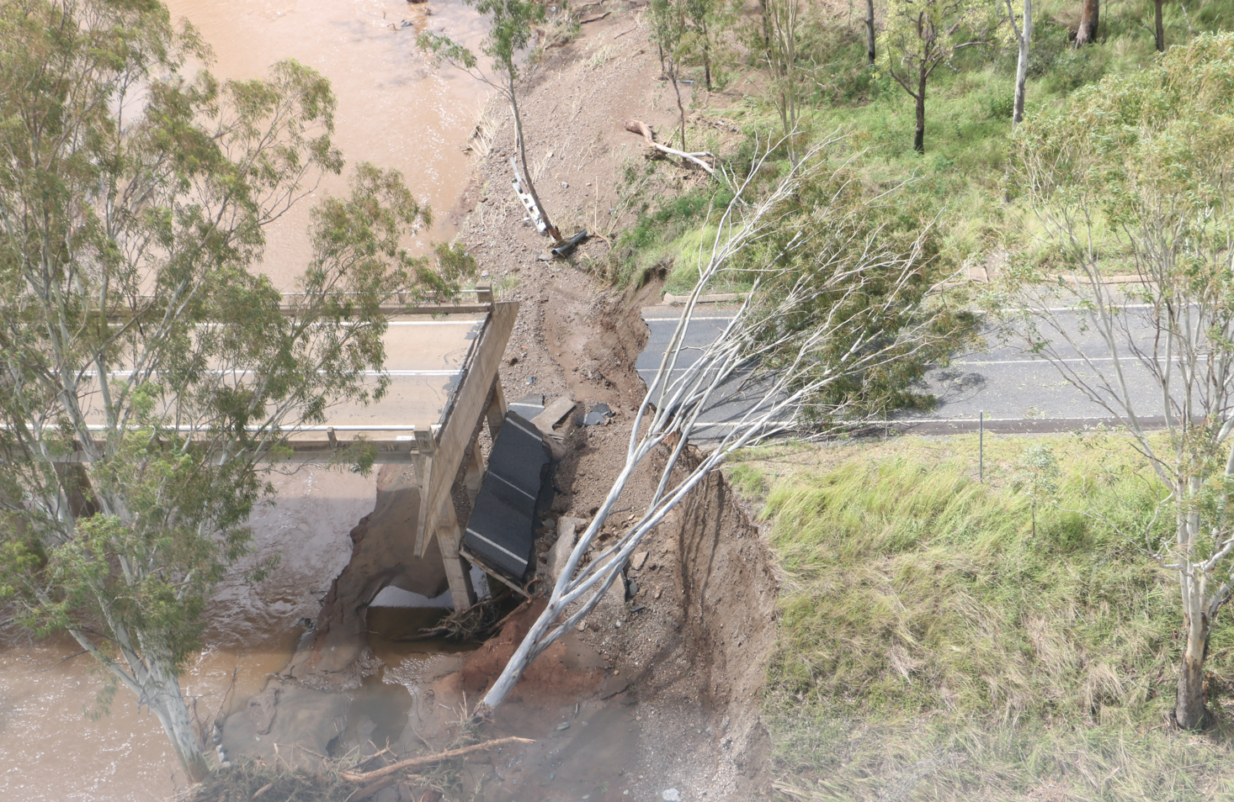

Administration, Governance and Assurance

Administration, Governance and Assurance

Purpose and Authority to Plan
The Gladstone DDMG has a legislative responsibility to prepare a DDMP in accordance with the Act.
The Gladstone DDMP details the arrangements within the Gladstone Disaster District to provide whole-of-government planning and coordination capability to support disaster management arrangements.
The local governments of Banana Shire Council and Gladstone Regional Council should primarily have responsibility for disaster management in their Local Government area. The Gladstone DDMG performs the function of providing coordinated support when required and requested by Banana Shire Council and Gladstone Regional Council through the LDMG’s.

Scope
The DDMP details the arrangements necessary to undertake disaster management within the Gladstone Disaster District in support of the Banana Shire Council and Gladstone Regional Council.
The Gladstone DDMG primarily coordinates the provision of State resources and services in support of local groups in the district. The DDMG is to identify resources that may be used for disaster operations in the district.
The Gladstone DDMP has been developed to comply with and should be read in conjunction with the following documents.
- Disaster Management Act 2003
- Disaster Management Regulation 2014
- The State Disaster Management Plan
- Queensland Emergency Management Assurance Framework
- District Disaster Management Groups Members Responsibilities Manual
- Strategic Policy Statement
- Gladstone DDMG operational Plan and DDCC manual
A map of the Gladstone DDMG boundaries in included in Annexure E.

Objectives
The objective of the Gladstone DDMP is to facilitate the implementation of effective and efficient disaster management strategies and arrangements including:
- Application of strategic policy framework for disaster management.
- To articulate the roles and responsibilities of entities involved in disaster operations and disaster management in the Gladstone Disaster District.
- To coordinate disaster operations and activities relating to disaster management in the Gladstone Disaster District.
- To identify and plan for events that are likely to happen in the Gladstone Disaster District.
- To develop priorities for disaster management in the Gladstone Disaster District.
- The development, review and assessment of effective disaster management for the Gladstone Disaster District including arrangements for mitigating, preventing, preparing for, responding to and recovering from a disaster.
- To ensure disaster management operations and planning adhere to the principles of the Emergency Management Assurance Framework and Standard for Disaster Management in Queensland.

Disaster Management Priorities

Strategic Policy Statement
Disaster management and disaster operations in the Gladstone Disaster District are consistent with the Disaster Management Strategic Policy Statement. This is achieved by:
- Ensuring a comprehensive, all hazards, all agencies approach by achieving the right balance of prevention, preparedness, response and recovery;
- Supporting the mainstreaming of disaster preparedness and mitigation into relevant areas of activity of government, non-government, small business and corporations;
- Aligning disaster risk reduction, disaster mitigation, disaster resilience and climate change adaptation policy and actions with international and national reforms;
- Promoting a transparent, systematic and consistent approach to disaster risk assessment and management, based on the Queensland Emergency Risk Management Framework.
- Recognising the commitment of stakeholders and the need for collaboration across all levels of government, community, industry, commerce, government owned corporations, private and volunteer organisations, and local communities in all aspects of disaster management;
- Emphasising building and maintaining sincere relationships, trust, teamwork, consultative decision-making, and shared responsibilities among stakeholders; and
- Promoting community resilience and economic sustainability through disaster risk reduction.

District Priorities
The priorities for the Gladstone DDMG are to:
- Manage training of DDMG members in line with the Queensland Disaster Management Training Framework;
- Support the integration of effective disaster risk reduction initiatives into strategic and corporate plans at appropriate levels of government, community organisations, industry and commerce;
- Monitor and evaluate the disaster management arrangements to:
  - streamline arrangements ensuring efficiency and effectiveness;
  - develop clear accountability, including defined roles and responsibilities at all levels;
  - improve the communication flow process;
  - support the development of whole-of-government, media and community engagement arrangements; and
  - support the active promotion and encourage continuous improvement and integration of lessons learned.

Annual Operational Priorities
The DDMG Operational Priorities are contained within the DDMG Operational Plan.

Review and Renew Plan
The Gladstone DDMG is required to review or renew the DDMP when the group considers it appropriate or at least once a year. The DDMP review may be triggered by a number of reasons including but not limited to the annual IGEM review, District plan update, an event debrief or independent review.
The District scheduled plan update shall be conducted by members of the DDMG identified by the Chair Gladstone DDMG and shall be conducted as follows:
- April - May - Plan update by DDMG members.
- May - Membership and contact details update.
- June - Draft amendments tabled at the June DDMG meeting for endorsement.
- July - Approved amendments (or new plans, if appropriate) are disseminated to all stakeholders.
Any Sub-plans of the Disaster Districts Functional Committee’s shall be reviewed annually by members identified by the Chair Gladstone DDMG and shall be conducted as follows:
- March – April - Functional Committee reviews sub-plan.
- June - Draft amendments submitted to DDMG for consideration and approval;
- July - Approved amendments (or new sub-plans if appropriate) are disseminated to all stakeholders.

Review of Local Disaster Management Arrangements
The Gladstone DDMG will regularly review and assess the disaster management of local groups in the District as well as Local Disaster Management Plans prepared by local governments in the District.
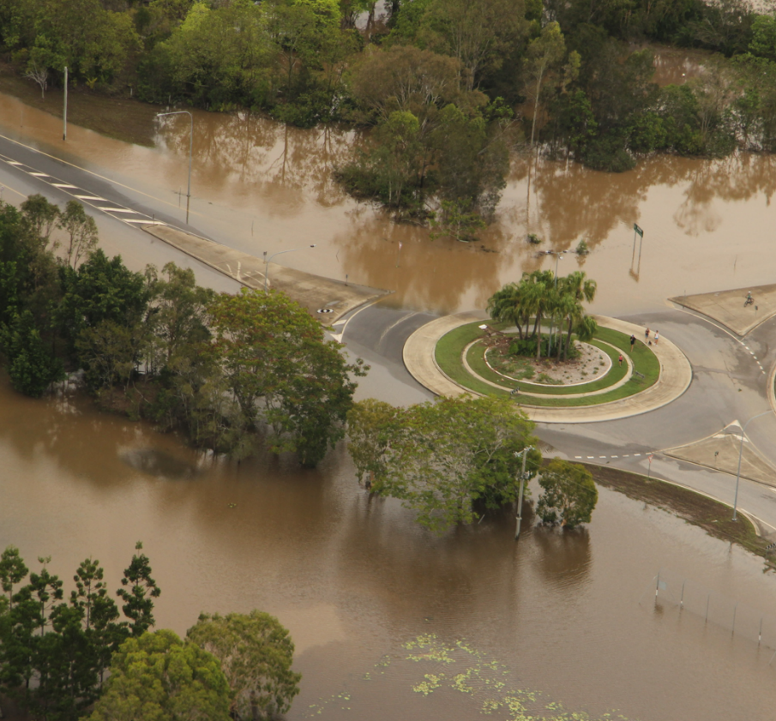

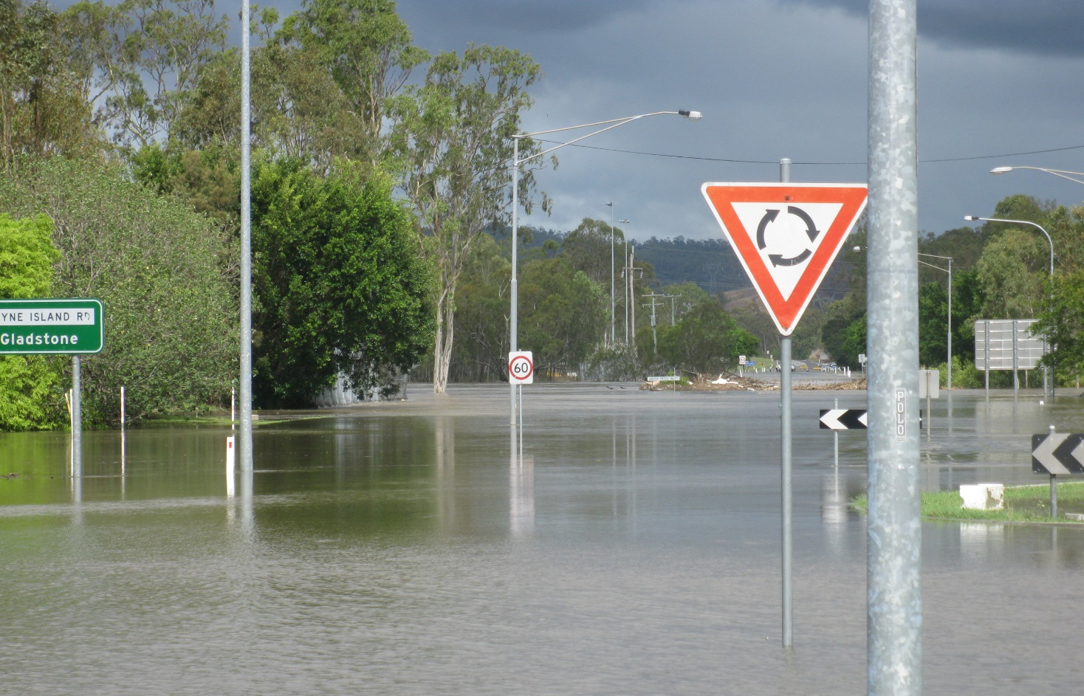
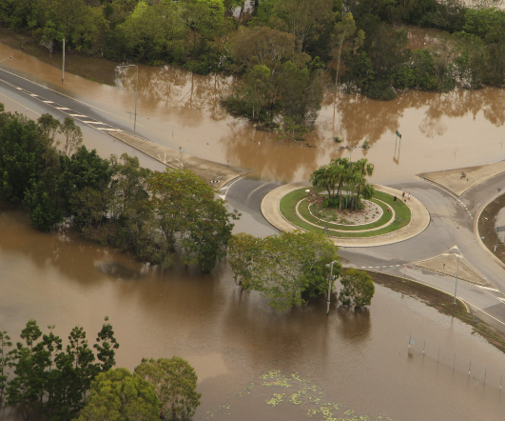

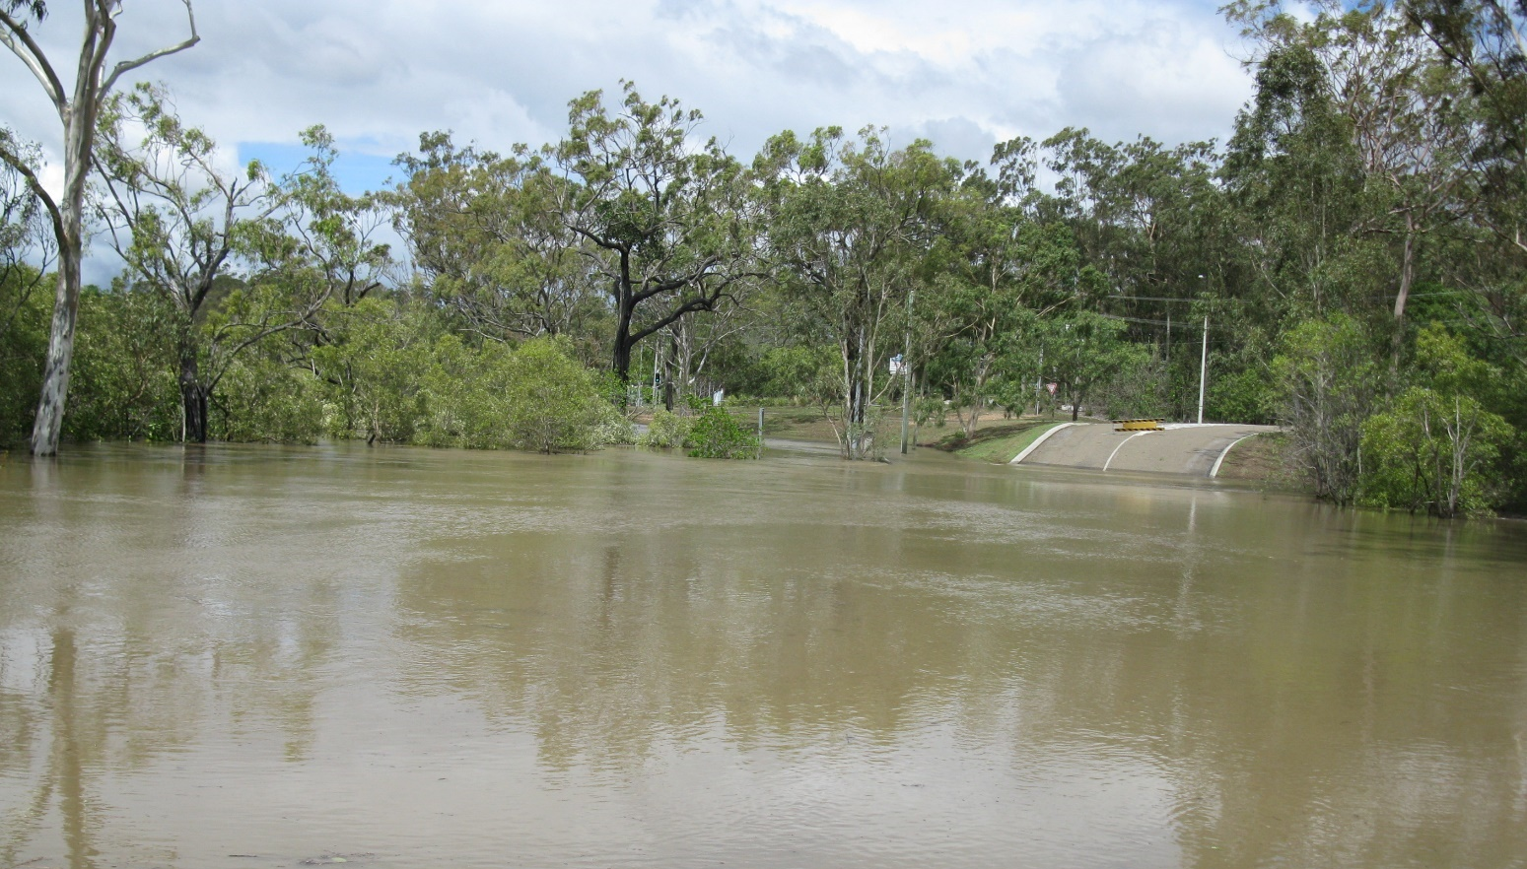
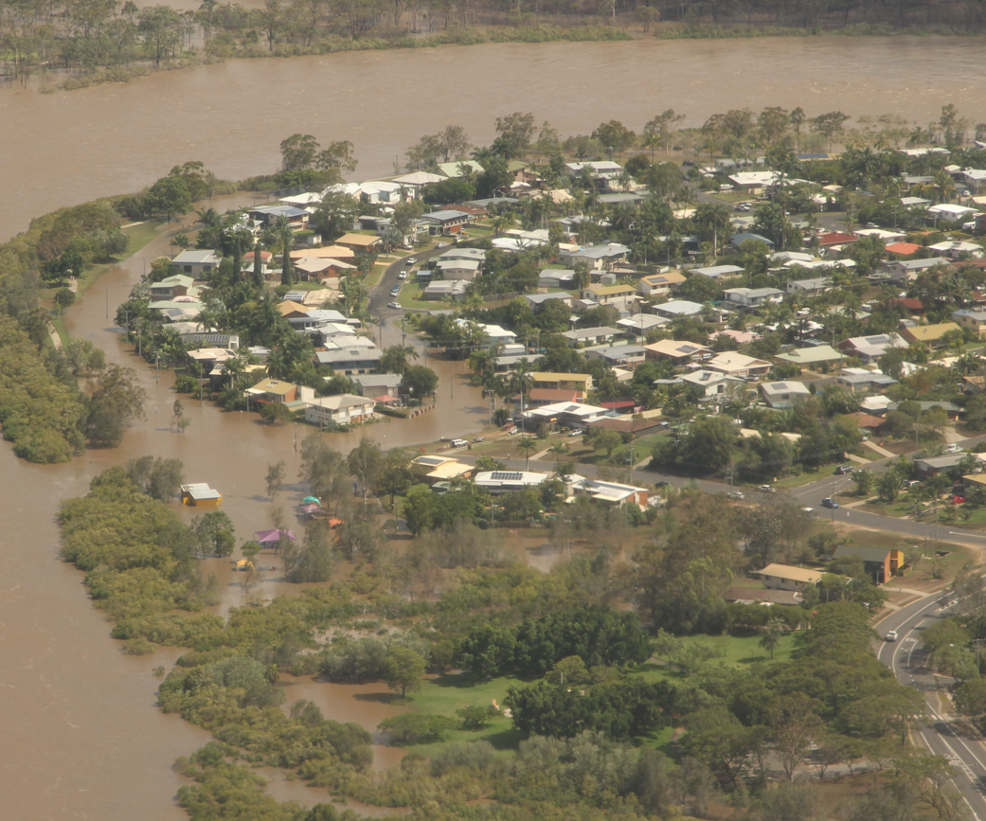
Gladstone District Disaster
Management Group

District Disaster Management Group

Establishment
The Gladstone DDMG is established in accordance with the Act and incorporates the Banana Shire Council and Gladstone Regional Council LGA’s.

Functions of the DDMG
The Gladstone DDMG has the following functions for which it is established:
- to ensure that disaster management and disaster operations in the district are consistent with the State group’s strategic policy framework for disaster management for the State;
- to develop effective disaster management for the district, including a district disaster management plan, and regularly review and assess that disaster management;
- to provide reports and make recommendations to the State group about matters relating to disaster management and disaster operations in the district;
(d) to regularly review and assess—
(i)the disaster management of local groups in the district; and
(ii)local disaster management plans prepared by local governments whose areas are in the district;
(e) to ensure that any relevant decisions and policies made by the State group are incorporated in its disaster management, and the disaster management of local groups in the district;
(f) to ensure the community is aware of ways of mitigating the adverse effects of an event, and preparing for, responding to and recovering from a disaster;
(g) to coordinate the provision of State resources and services provided to support local groups in the district;
(h) to identify resources that may be used for disaster operations in the district;
(i) to make plans for the allocation, and coordination of the use, of resources mentioned in paragraph (h);
(j) to establish and review communications systems in the group, and with and between local groups in the district, for use when a disaster happens;
(k) to ensure information about an event or a disaster in the district is promptly given to the State group and each local group in the district;
(l) to prepare, under section 53, a district disaster management plan;
(m) to perform other functions given to the group under this Act;
(n) to perform a function incidental to a function mentioned in paragraphs (a) to (m).

Membership
The Gladstone DDMG consists of two classes of membership:
- Core members; and
- Advisory members
The Gladstone DDMG core membership consists of the following roles and representatives:
- Chairperson / District Disaster Coordinator
- Deputy Chairperson
- Executive Officer
- A representative of each local government within the district
- Persons representing departments of Hospital and Health Service that the Commissioner of Police considers appropriate to be represented on the group, having regard to effective disaster management for the disaster district
- Any other person appointed by the chief executive of the department that the Commissioner of Police considers appropriate to be a member of the district group, having regard to effective disaster management for the disaster district

The Gladstone Disaster District core and advisory members are documented in annexure F.

Gladstone DDMG Member Responsibilities
A detailed itemisation of the roles and responsibilities of member agencies are outlined within the State Disaster Management Plan and the District Disaster Management Group Member Responsibilities Manual. The Gladstone DDMG adopts the itemisation of these roles and responsibilities at the district level.
In considering appropriate membership to the DDMG, member Agencies should ensure appointed members:
- Attend DDMG activities with a full knowledge of their agency resources and services and the expectations of their agency.
- Are available and appropriately briefed to actively participate in DDMG activities to ensure that planning, projects and operations use the full potential of their agency or function, while recognising any resource or capacity limitations.
- Are appropriately positioned within their agency to be able to commit agency resources.
- Attend meetings and report to the District Group on comprehensive disaster management arrangements.
- Report annually on agency member responsibilities and integration of disaster management activities
- Undertake training in accordance with the Queensland Disaster Management Training Framework (QDMTF).
- Ensure their agency deputy is appropriately trained and has the relevant authority to take on their responsibilities should they be unavailable, and/or to provide additional support during extended operations.
- Participate in risk management activities (including the identification of mitigation strategies and treatment options).
- Plan for disaster management on behalf of the District Group
- Participation in community awareness activities on behalf of the District Group

Core members are required to advise the Gladstone DDMG Chair in writing of any change in title or position within their organisation or change in contact details. The core member is to also advise if they are leaving their position.
The DDMG is to review its membership every May unless a deficiency is identified in the interim.

Hazard Specific Arrangements
Whilst Queensland has adopted an all-hazards approach to the development of disaster management arrangements, it is important to acknowledge that some hazards have characteristics that may require a hazard specific approach. The Gladstone DDMG adopts the itemisation of these hazard specific plans within the SDMP at the district level.

Functional and Supporting Committees
The Gladstone DDMG may establish permanent or temporary Functional and Supporting committees as deemed necessary in response to or recovery from a disaster event. The appointed chairs of each sub-committee are responsible for providing regular updates to the DDMG or as requested by the Chair on the activities of the sub-committee.
The Functional and Supporting sub-committees and associated plans are documented in Annexure G.

Meetings and Quorum
The Gladstone DDMG will schedule up to 4 meetings a year to ensure compliance with legislative requirements of the Act. Extraordinary meetings may be called in response to an event to address operational business as required. Details of the meeting dates are contained in the Gladstone DDMG Operational Plan.
A quorum of members is required for meeting resolutions to be officiated. A quorum is a number equal to one-half of its members holding office plus one; or in the case where one-half of its members is not a whole number, the next highest whole number.
Personal attendance at meetings is preferred, however if this cannot be achieved a member may be able to participate by using any technology that reasonably allows members to hear and take part in discussions as they happen. For example, if teleconferencing facilities are available the member is taken to be present at the meeting.
A record of attendance shall be kept as part of the governance of the Gladstone DDMG meetings and the Gladstone DDMG must keep minutes of its meetings. Minutes will be distributed to members after any meeting held for verification of accuracy. Minutes will be adopted at subsequent meetings and will be held by the Chair on behalf of the Gladstone DDMG.
Action items identified during a meeting must be recorded and must be actioned by the representative identified during the meeting as being the appropriate agency to progress the identified item, issue or query. Progress or conclusion of action items must be recorded in a subsequent meeting.

Administrative Reporting
Member agencies are required to provide a status report at each scheduled meeting. The status report can be submitted either in writing prior to a meeting or verbally during a meeting.
Member agencies are to provide an annual status report to the District at the end of each financial year.

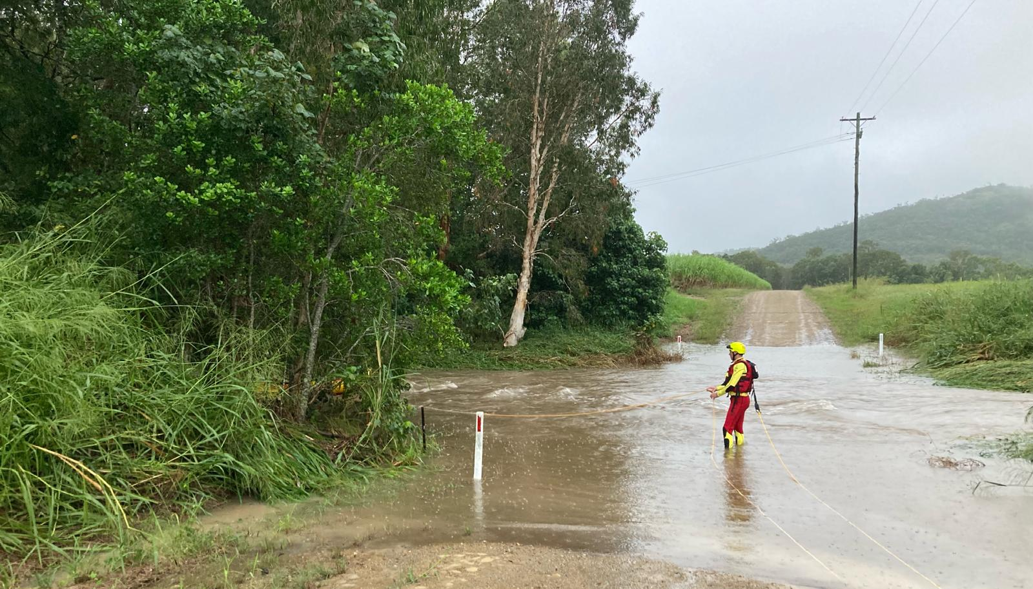
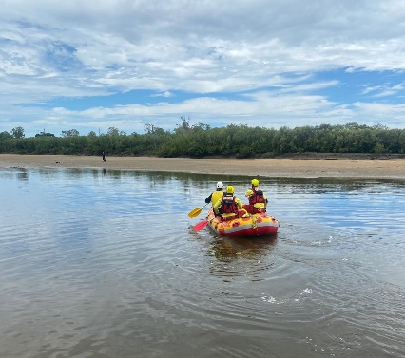

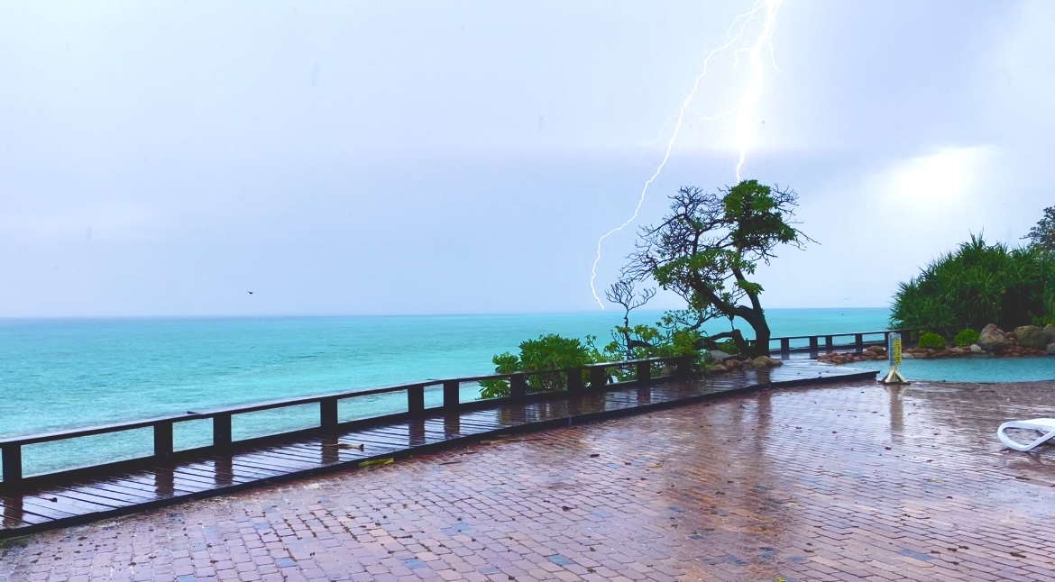

Disaster Risk Assessment

Disaster Risk Assessment

Community Context

Geography
The Gladstone DDMG is located in Central Queensland with an area of approximately 39,034.50 km². The DDMG shares borders with Bundaberg, Rockhampton and Roma DDMG’s.
The DDMG has four (4) major river catchments including Baffle Creek, Boyne River, Dawson River and Calliope River. Each catchment consists of the main river system as well as tributary creeks and floodplains that have historically impacted local communities.
The Gladstone harbour has a natural deep-water harbour that is protected by the low islands of Facing Island and Curtis Island.
The DDMG includes the Capricorn and Bunker group of islands of the southern Great Barrier Reef which are situated between 45 and 75 kilometres from the adjacent departure ports and urban centres of Yeppoon, Gladstone, Town of 1770 and Bundaberg.

Climate and Weather
The climate is a sub-tropical, sub-humid coastal climate, characterised by increased rainfall and hot humid conditions in the summer months (November to March). The average rainfall for Gladstone is approximately 886mm per year which drops further inland to 667mm per year at Biloela.
The average air temperature ranges between 27.8°C to 29.2°C across the DDMG area with a mean maximum temperature in summer of 33.7°C in summer and a mean minimum temperature of 18.3°C in winter with the mean temperatures vary across the DDMG area.

Population
The Gladstone DDMG area consists of the two major population centres of Gladstone and Biloela. As at 30 June 2022 the estimated census population for Gladstone Disaster District was approximately 80,081. Since the previous census date, the region has grown by 0.70%.

Economy / Industry
It is estimated that in excess of 46,000 people work in the Gladstone Disaster District while there is an unemployment rate of 4.3%.
Mining and industrial activity has become the principal bastion of economic prosperity within the Gladstone Disaster District supported by agriculture, tourism, government administration and education.
The district boasts several production industries including the world’s largest alumina refinery and Australia’s largest aluminium smelter.

Risk Overview

Risk Assessment
The Queensland Emergency Risk Management Framework (QERMF) is the methodology for assessing disaster related risk in Queensland. Based upon the QERMF each Local Government has assessed the risks to their area as well as having identified any appropriate mitigation strategies that may be implemented.
The role of the DDMG and DDCC is not to deal with these individual risks but to assist the LDMGs in implementing their respective Local Disaster Management Plans.
The Gladstone DDMG will form a Disaster Risk Management Subgroup which will meet at least annually to review the Gladstone Disaster District Risk Management Plan. This group will comprise of identified stakeholders and be chaired by the Executive Officer of the DDMG. Membership of the Group will also consist of a suitable representative of each local Government Area and the QPS EMC in order to provide input into the risks transferred or shared between the local government areas and the District Disaster Management Group.
The DDMG has developed a district risk register and based upon the identified risks a risk analysis and evaluation has been conducted in accordance with the process outlined in the QERMF.

Risk Treatment
Risks outlined in the District Risk Register are analysed by members of the Gladstone DDMG with a view to identifying strategies for risk treatment. These strategies are documented in the District Risk Treatment Plan. Along with these strategies, the District Risk Treatment Plan contains preferred treatment options, responsibilities and timeframes for implementation.
The allocation of responsibility for the implementation of risk treatment strategies, monitoring and reporting shall be determined by members of the DDMG under the guidance of the DDMG Chair. The District Risk Treatment Plan is to be presented to the Gladstone DDMG for ratification.
To progress any treatment options, the DDMG is to request relevant responsible agencies to incorporate specified risk treatment strategies into their agency corporate planning processes for recognition and implementation.
In instances where the applications of treatment strategies at district level are identified as not being adequate and residual risks remain, the DDMG is to determine whether risk transfer or risk sharing with the QDMC is a treatment option. In those instances, the DDMG is to document and notify the QDMC of these with a view to transferring or sharing the risks.
A review of the district risk treatment plan shall be conducted in conjunction with any district risk assessment review process.

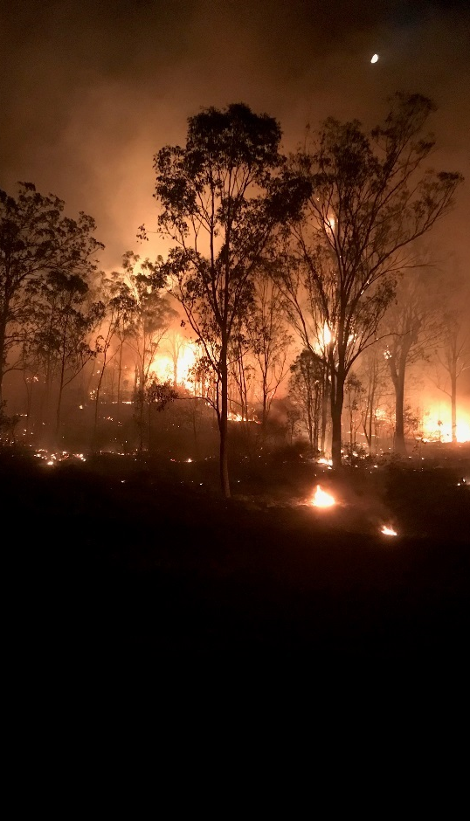
Prevention and preparedness

Prevention and preparedness

Prevention
Prevention and mitigation measures reduce the likelihood of a disaster event occurring or the severity of an event should it eventuate. The DDMG has a responsibility to support all agencies with the implementation of prevention strategies to enhance resilience in the community.

Preparedness
Preparedness is crucial in disaster situations to ensure the response is optimum and the consequences are as minimal as possible. Preparedness activities are to include but not be limited to training, exercises and pre-season and event specific briefings.

Training
Disaster management training has been identified as an essential means through which agencies can develop and maintain their disaster management capabilities and capacity. Training is important in ensuring that all agencies can seamlessly integrate their arrangements and contribute to an effective and coordinated disaster management response.
The Queensland Police Service Emergency Management Coordinator is responsible for delivering disaster management training within the Disaster District and an approved training calendar is documented in Annexure O.

Exercises
The DDMG and functional committees will conduct at least one exercise annually. To ensure continuous improvement, each exercise will be evaluated for its effectiveness and relevance to disaster management. The evaluation can take many forms including written or oral feedback but will primarily be based on a hot debrief and a formal debrief.
An approved exercise calendar is contained in Gladstone District Disaster Management Group Operations Manual.

Response Strategy

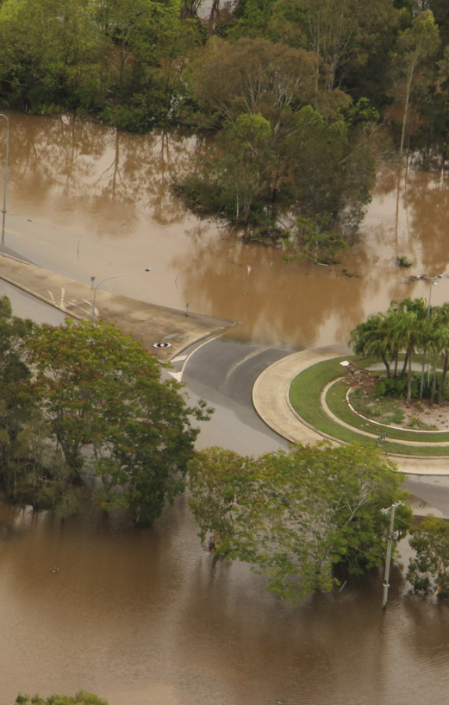

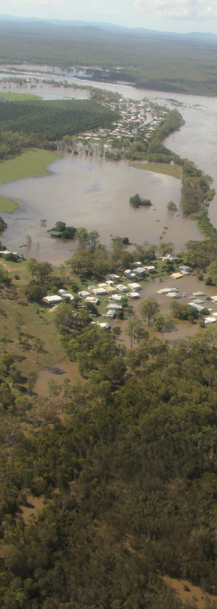

Response Strategy

Situational Awareness
The Gladstone DDMG has a responsibility to ensure event briefings and advice are disseminated to members of the DDMG and QDMC.
The Gladstone DDMG has an established notification and dissemination processes ensuring fit for purpose information and warnings can be shared with members.

Activation and Triggers for Response
The authority to activate the Gladstone DDMP is vested in the Chairperson, or in that person’s absence the Deputy Chairperson.
The Chairperson should determine when, and to what extent, the DDMG should activate in support of an event, and may bypass initial levels of activation where appropriate. Activation is scalable and the DDMG chair is to ensure that advice is provided to the DDMG on the current Group status and briefings schedule.
The activation levels and relevant triggers are detailed in Gladstone DDMG Operational Plan.

Media Management
The Gladstone DDCC operations manual provides advice and guidance in regards to media engagement. Refer to the DDCC operations manual for guidance.

Post Disaster Assessment
The review of operational activities undertaken during a disaster is a key component in ensuring capability development and the continuous improvement of disaster management arrangements.
Post-disaster reviews may be conducted after each event at the discretion of the Chair and ideally should be conducted within four weeks of the DDMG standing down post event.

District Disaster Coordination Centre
The Gladstone DDMG District Disaster Coordination Centre operations manual provides guidance to the establishment and operation of the DDCC. The DDCC operations manual distribution is at the discretion of the Chair, Gladstone DDMG.

Disaster Declaration
Where the DDC considers it is necessary for a disaster declaration within the Gladstone Disaster District, the DDC must take reasonable steps to consult with the DDMG and each local government whose area is in, or partly in, the declared area for the disaster situation. A failure to consult does not affect the validity of the declaration.
The Executive Officer is responsible for preparing relevant documentation on behalf of the DDC for consideration by the Minister for Police. Disaster Declaration templates are available on the Disaster Management website.
If circumstances prevent such processes to be undertaken the DDC will act independently to declare the disaster and subsequently seek verbal approval in accordance with the Act and report the decision subsequently to the DDMG and the LDMG.

Functional Lead Agencies and Functional Plans
A detailed itemisation of the disaster response functions, associated lead agencies and functional plans is outlined within the SDMP. The Gladstone DDMG adopts the itemisation of these functions at the district level.

Functional Plans
The SDMP is supported by functional plans that address the functions of disaster management where government departments and agencies have a functional lead agency role. The Gladstone DDMG adopts the itemisation of these functions at the district level.

Financial Management
Due to the nature of many disaster events, finance operations will often be conducted with compressed time constraints and other pressures. Expenditure may be eligible for cost-recovery if the event and/or expenditure meets eligibility requirements of the Disaster Recovery Funding Arrangements (DRFA).
The DDMG should predetermine event-related financial management arrangements to ensure costs are appropriately endorsed and captured from the onset of operations. The DDC, in consultation with the Executive Officer is responsible for establishing and maintaining financial management procedures for the DDCC as per the DDCC Operations Manual.
Each support agency is responsible for providing their own financial services and support to its response operations relevant to their agency.
All processes are performed in accordance with the Queensland Government Financial Management Practice Manual and therefore in compliance with section 46M of the Financial Administration and Audit Act 1977 and other prescribed requirements.

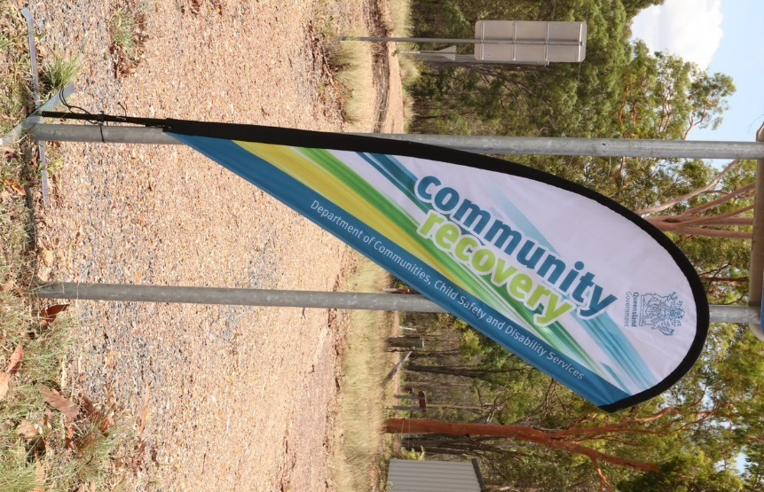
Recovery Strategy

Recovery Strategy

Recovery at the District level will be activated upon direction from the chair/DDC. Recovery provides a framework for the coordination of recovery operations within the district and is supported by the procedures outlined in the Prevention, Preparedness, Response and Recovery Disaster Management Guideline and the Queensland Recovery Plan.

The Queensland Reconstruction Authority (QRA) is responsible for disaster recovery, resilience, and mitigation policy. This principle-based strategy is consistent with the Queensland Recovery Plan and has been developed to be flexible and scalable in support of the recovery efforts being driven locally by the Banana and Gladstone Local Recovery Groups.

Functions of Recovery
The SDMP outlines the functional portfolios and coordination functions for recovery. The Gladstone DDMG adopts the itemisation of these functions at the district level.

Transition from response operations to recovery operations
The Queensland Recovery Plan outlines that transition from response operations to recovery operations will be influenced by the nature of the disaster and therefore requires a degree of flexibility. For example, transition from response to recovery in large scale or geographically dispersed events may be staged, with response and recovery operations being undertaken concurrently.
Transition from response to recovery at the local and district level, and the need to undertake such a process, will be informed by local circumstances and determined by the Chairs of the relevant LDMGs/DDMGs. Transition will be guided by:

- situation reports (SitReps) which evidence the de-escalation of response operations;
- status of response and immediate recovery/relief operations;
- impact and needs assessments;
- response and early recovery situations that may escalate; and
- anticipated recovery issues and risks.

District Recovery Coordinator
The District Recovery Coordinator (DRC) is appointed by the chair. This appointment is made at the time of the event if required. If a DRC is not appointed, the duties will be managed by the chair.

Indicative duties of the DRC include:
- coordinate and chair the district recovery group, reporting to the DDMG.
- liaise with functional lead agency representatives at the local and state levels.
- liaise with the Local Disaster Management Group/s and State Functional Recovery Groups/ State Disaster Coordination Group.
- coordinate the short to medium-term recovery where local resources are exhausted to address the immediate effects of the disaster and develop longer-term measures as appropriate.
- perform the role of conduit between local and state.
- develop and implement effective strategies for district participation and partnership in the recovery process work with identified agencies and Local Recovery Group/s to develop the district event-specific recovery plan.
- ensure the district event-specific recovery plan addresses all relevant functional areas of recovery – human and social, economic, environment, building, and roads and transport.
- undertake post-operations debrief and providing a final report to the DDMG at the conclusion of recovery operations; and
- provide or delegate the responsibility for ongoing recovery reporting on the progress of the district event-specific recovery plan.

District Recovery Group
During recovery operations, the DDMG will provide support to the local level by coordinating individual agency efforts to ensure a timely, efficient, cohesive and cost effective approach is taken to manage recovery. This support may be provided to the local level through joint local and district meetings.
Where appropriate the recovery phase may include the establishment of a District Recovery Group (DRG) with specific membership appointed by the DRC and DDMG Chair. Where a DRG is established, the recovery coordination is transitioned to the Recovery Coordinator who will be the DDC or a person appointed by the DDC. All other times, recovery operations will be managed by the DDMG. If the Group is stood up, the chair of the DRG is the DRC.

The role of the DRG is as follows:
- identify members for the DRG and sub-groups as required.
- ensure recovery operations; planning; logistics and communications are included in overall disaster management activities at the district level.
- support the recovery needs of the local level, including deploying resources to support local activities.
- identify district impact assessment and recovery needs.
- maintain arrangements at district level to achieve their functional responsibilities for recovery.
- facilitates communication and information sharing, including situation reporting, within the District and between local and state FRGs during recovery operations.
- promote council-to-council arrangements where possible to facilitate recovery operations.
- delivery of Outreach Services.
- investigate opportunities for local government collaboration and to build resilience and recovery resource capacity.
- facilitates ‘regional’ leadership discussions to support the State Recovery Coordinator; and
- establish a district event-specific recovery plan, if required.

Membership of the DRG consists of the following roles and representatives:
- DDMG Chairperson or District Recovery Coordinator (if appointed).
- Executive Officer.
- Emergency Management Coordinator.
- Local Recovery Coordinator for each LGA.
- Chair of each District Recovery sub group.
- Queensland Reconstruction Agency.
- Any other member agency nominated by the Chair having regard to the event and requirements within the disaster district.

During recovery operations, the DDMG may be required to facilitate communication and information sharing within the district, and to State Functional Recovery Groups (FRGs), through their FRG lead agency members.
It is recognised that with large disasters, a State Recovery Coordinator (SRC) may be appointed by the chairperson of the QDMC to coordinate recovery operations. The DRG may be used to facilitate ‘regional’ leadership discussions in conjunction with regional organisations to support the SRC where required.

District Recovery Group Operational and Action Plans
When convened for disaster recovery operations, the Gladstone District Community Recovery Committee will develop an Operational Plan to guide its activities. This will be discussed and developed to supplement the local government disaster recovery operational plan. A broad timeframe will be included in this plan.
At the first meeting Action Plans for each recovery function will also be developed. This Action Plan will list the tasks to be performed by the group, agencies/individuals responsible for the tasks and will be developed to supplement the local government disaster recovery action plan.
As the Local Disaster Management Group have a lead role in the disaster recovery process, any District Community Recovery Committee’s operational or action plans will be developed to supplement and support LDMG disaster recovery plan.

Considerations for Recovery Operational and Action Plans
When developing Operational and Action Plans lead functional agencies and recovery committees should consider the following:
- issues identified from information gathered by impact assessments;
- arrangements outlined in existing functional plans;
- how to allocate actions and responsibilities across the five recovery functions to inform the development of action plans;
- arrangements for overall coordination of recovery operations;
- how to develop strategies for recovery with the affected community which detail the vision, goals and project outcomes of the recovery strategy;
- identifying the main short, medium and long-term priorities;
- developing project timeframes, costs, funding priorities and funding strategies;
- advertising and disseminating public information about the Action Plans;
- determining appropriate community engagement and communication strategies;
- transitional and exit strategies; and
- strategies for conducting a debrief and evaluation of recovery operations

Reporting
If stood up, the DRG and sub-groups are to provide regular reports to the DDMG, LDMG and relevant State Functional Recovery groups with the frequency to be determined at the time of the event.

Annexure Index

A | Amendment register
B | Abbreviations and acronyms
C | Definitions
D | Distribution list
E | Gladstone DDMG map
F | DDMG Membership List
G | Functional and Supporting Committees and Sub Plans

Annexure A – Amendments Register

No / Ref | Endorsement Date | Inserted by | Comment
1/20 | 13/05/2020 | - Executive Officer, Gladstone DDMG
1/20 | 13/05/2020 | - Executive Officer, Gladstone DDMG
1/21 | 14/09/2021 | - Executive Officer, Gladstone DDMG | - MoG updates
1/22 | 01/05/2022 | - Executive Officer, Gladstone DDMG | - MoG updates
01/24 | 04/09/2024 | - Executive Officer, Gladstone DDMG  - QPS EMC, Gladstone DDMG | - Operational contents moved to DDMG Operational manual  - Event specific details moved to DDCC manual  - DDMP restructured and creation of annexures to improve governance  - MoG updates completed
01/25 | 04/06/2025 | - Executive Officer, Gladstone DDMG | - MoG updates

Annexure B - Abbreviations and acronyms

DDC | District Disaster Coordinator
DDCC | District Disaster Coordination Centre
DDMG | District Disaster Management Group
DDMP | District Disaster Management Plan
DRC | District Recovery Coordinator
DRG | District Recovery Group
LDMG | Local Disaster Management Group
QDMA | Queensland Disaster Management Arrangements
QDMC | Queensland Disaster Management Committee
SDMP | State Disaster Management Plan
the Act | Disaster Management Act 2003

Annexure C – Definitions

Advisor | A person invited to participate in the business of the DDMG in an advisory capacity on an as-needed basis.
Chair | The person appointed by Governor in Council as the Chairperson of the DDMG. The Chair of the group is the District Disaster Coordinator.
Deputy Chair | The person appointed by Governor in Council as the Deputy Chairperson of the DDMG.
Disaster | A serious disruption to the community, caused by the impact of an event, that requires a significant coordinated response by the state and other entities to help the community recover from the disruption (Disaster Management Act 2003).
Disaster District | Part of the state prescribed under a regulation as a disaster district.
Disaster Management (DM) | Arrangements about managing the potential adverse effect of an event, including, for example, arrangements for mitigating, preventing, preparing for, responding to and recovering from a disaster (Disaster Management Act 2003).
Disaster mitigation | The taking of preventative measures to reduce the likelihood of an event occurring or, if an event occurs, to reduce the severity of the event (Disaster Management Act 2003).
Disaster operations | Activities undertaken before, during or after an event happens to help reduce loss of human life, illness or injury to humans, property loss or damage, or damage to the environment, including, for example, activities to mitigate the adverse effects of the event (s. 15, the Act).
Disaster response | The taking of appropriate measures to respond to an event, including action taken and measures planned in anticipation of, during, and immediately after an event to ensure that its effects are minimised and that persons affected by the event are given immediate relief and support (Disaster Management Act 2003).
Disaster response operations | The phase of disaster operations that relates to responding to a disaster (Disaster Management Act 2003).

Annexure D - Distribution List

Position | Organisation | Hard Copy √ | Electronic Copy √
DDMG Chair | Gladstone DDMG | √ | √
Deputy Chair | Gladstone DDMG | √ | √
Executive Officer | Gladstone DDMG | √ | √
District Disaster Coordination Centre | Gladstone DDMG | √ | √
District Disaster Coordination Centre – Secondary Location | Gladstone DDMG | √ | √
Member and Deputy | Banana Shire Council |  | √
Member and Deputy | Department of Environment, Tourism, Science and Innovation |  | √
Member and Deputy | Department of Housing and Public Works - Public Works |  | √
Member and Deputy | Department of Families, Seniors, Disability Services and Child Safety |  | √
Member and Deputy | Department of Transport and Main Roads - TMR |  | √
Member and Deputy | Department of Transport and Main Roads – MSQ |  | √
Member and Deputy | Gladstone Regional Council |  | √
Member and Deputy | Queensland Ambulance Service |  | √
Member and Deputy | Queensland Fire Department |  | √
Member and Deputy | Queensland Health - CQHHS |  | √
Member and Deputy | Queensland Health – Public Health Unit |  | √
Member and Deputy | Queensland Police Service |  | √
Member and Deputy | Queensland Police Service - Emergency Management Coordinator |  | √
Member and Deputy | State Emergency Service |  | √
Advisor | Australian Defence Force –  Joint Operational Support Staff |  | √
Advisor | Australian Red Cross |  | √
Advisor | Capricorn Helicopter Rescue Service |  | √
Advisor | Country to Coast Qld |  | √
Advisor | Department of Customer Services, Open Data and Small and Family Business |  | √
Advisor | Department of Education |  | √
Advisor | Department of Families, Seniors, Disability Services and Child Safety |  | √
Advisor | Department of Housing and Public Works – Housing |  | v
Advisor | Department of Primary Industries |  | √
Advisor | Department of State Development, Infrastructure and Planning |  | √
Advisor | Department of Trade, Employment and Training |  | √
Advisor | Department of Youth Justice and Victim Support |  | √
Advisor | Ergon |  | √
Advisor | Gladstone Ports Corporation Limited |  | √
Advisor | Marine Rescue Queensland |  | √
Advisor | National Emergency Management Agency |  | √
Advisor | NBN |  | √
Advisor | Office of Industrial Relations - Workplace Health and Safety Queensland |  | √
Advisor | Queensland Building and Construction Commission |  | √
Advisor | Queensland Health (QH) - WBHHS |  | √
Advisor | Queensland Rail |  | √
Advisor | Queensland Reconstruction Authority |  | √
Advisor | Telstra |  | √

Annexure E – Gladstone DDMG Map

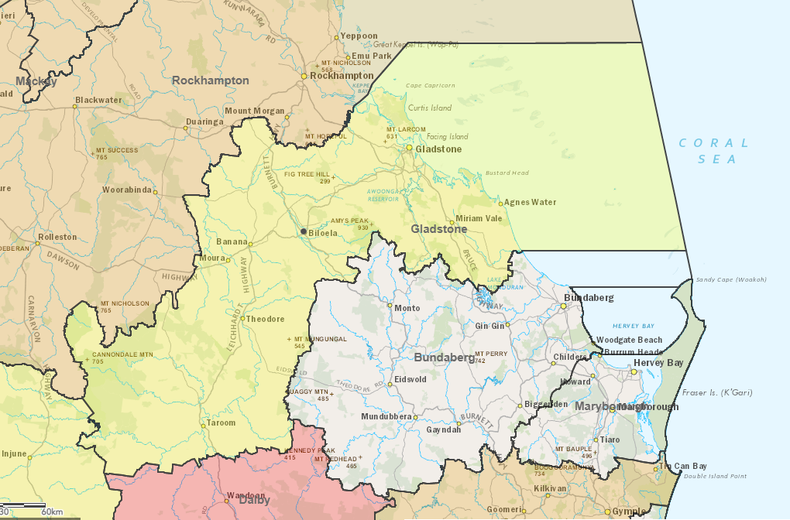

Annexure F – DDMG Membership list

Core members
Core membership of the Gladstone DDMG comprises a representative from each local government and state government departments. Appointments to the DDMG are made in reference to the position held by the representative of their department and not to their name. This allows for the capacity for movement of personnel within their respective organisations without affecting the quorum or membership of the DDMG.

The core membership of the Gladstone DDMG comprises of:
- DDMG Chairperson
- DDMG Deputy Chairperson
- DDMG Executive Officer
- Banana Shire Council
- Department of Environment, Tourism, Science and Innovation
- Department of Housing and Public Works - Public Works
- Department of Families, Seniors, Disability Services and Child Safety
- Department of Transport and Main Roads - TMR
- Department of Transport and Main Roads – MSQ
- Gladstone Regional Council
- Queensland Ambulance Service
- Queensland Fire Department
- Queensland Health - CQHHS
- Queensland Health – Public Health Unit
- Queensland Police Service
- Queensland Police Service - Emergency Management Coordinator
- State Emergency Service

Advisors
Representatives of the following departments / agencies may be invited to attend DDMG meetings and assist in disaster operations in an advisory and cooperative disaster capacity as required:
- Australian Defence Force - Joint Operational Support Staff
- Australian Red Cross
- Capricorn Helicopter Rescue Service
- Country to Coast Qld
- Department of Customer Services, Open Data and Small and Family Business
- Department of Education
- Department of Families, Seniors, Disability Services and Child Safety
- Department of Housing and Public Works – Housing
- Department of Primary Industries
- Department of State Development, Infrastructure and Planning
- Department of Trade, Employment and Training
- Department of Youth Justice and Victim Support
- Ergon
- Gladstone Ports Corporation Limited
- Marine Rescue Queensland
- National Emergency Management Agency
- NBN
- Office of Industrial Relations - Workplace Health and Safety Queensland
- Queensland Building and Construction Commission
- Queensland Health (QH) - WBHHS
- Queensland Rail
- Queensland Reconstruction Authority
- Telstra
- Persons representing departments whom the Executive Officer of the Queensland Disaster Management Committee in consultation with the DDC considers appropriate to be represented on the group as advisors.

Annexure G – Functional and Supporting Committees and subplans

Supporting Committee | Agency | Meetings / Plans
Disaster Management Plan Review Committee | QPS / Local Government representatives / members upon consideration of the Chair | District Disaster Management Plan
District Risk Management Group | QPS / Local Government representatives / members upon consideration of the Chair | District Risk Management Plan
District Human Social Recovery  Committee | Department of Families, Seniors, Disability Services and Child Safety | District Human Social Recovery Sub-plan

Gladstone District Disaster Management Group

Gladstone DDMG
PO Box 1000
Gladstone Qld 4680
DDC.Gladstone@police.qld.gov.au

Climate Data Online
Queensland Regional Profiles
Queensland Regional Profiles
Disaster Management | Queensland Government

