
LGBTQIA+
Support Organisations

HEALTH & WELFARE

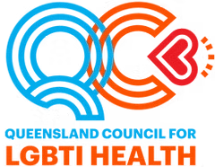
Queensland Council for LGBTI Health
- Sexual Health
- Trans Health & Many Genders, One Voice
- Mental Health
- Alcohol & Other Drugs
- LGBTI Seniors
- 2 Spirits (Promoting Aboriginal & Torres Strait Islander communities)
- Training Facilitation

Diverse Voices
Diverse Voices is a Queensland based non-profit organisation with a focus on the wellbeing of the diverse voices that make up our community. Their focus is on the operation of a peer-to-peer telephone and internet counselling service. They operate in collaboration with our national partners QLife and the National LGBTI Health Alliance
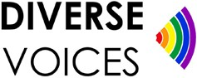
To contact the Diverse Voices/QLife Helpline call 1800 184 527. This service operates between 3pm and Midnight 365 days. For administrative and non- peer support related calls please phone our office during the hours of 9am- 5pm on 0402 109 337
Note: This number is the administration and office line only. At no time will a telephone peer counsellor be available on this number. For the counselling line call 1800 184 527
Alternatively for administration enquiries you can email us at info@diversevoices.org.au
Please note that we do not provide counselling via email. For web chat counselling please visit www.qlife.org.au between 3pm-12 Midnight.

Relationships Australia, Rainbow Services

The Rainbow Program is a collection of RAQ service provisions, striving to support the mental health and wellbeing of people of diverse bodies, genders and sexualities, including lesbian, gay, bisexual, transgender & intersex (LGBTI) people, as well as those questioning their gender identity or
sexual orientation. This includes:
- The Rainbow Counselling Service; and
- The Transcendence Social and Emotional Support Group.
They also support the families, allies and practitioners who, in turn, support those identifying as LGBTQIA+ or questioning.
25-020

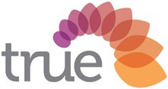
True - Relationships and Reproductive Health
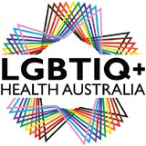
True have clinics throughout Queensland which provide reproductive and sexual health services as well as workforce development through education programs. True’s work includes relationships and sexuality education programs, child-safety programs, and counselling for people who have experienced sexual abuse. They also provide LGBTQIA+ inclusive education to school employees.

LGBTIQ+ Health Australia
LGBTIQ+ Health Australia is the national peak health organisation in Australia for organisations and individuals that provide health-related programs, services and research focused on lesbian, gay, bisexual, transgender, and intersex people and other sexuality, gender, and bodily diverse people and communities.

QLife
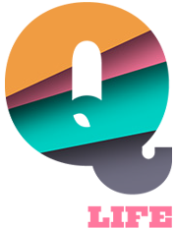
Qlife is a nationally oriented counselling and referral service for people who are lesbian, gay, bisexual, trans, and/or intersex (LGBTI). QLife provides nation- wide, early intervention, peer supported telephone and web-based services
to people of all ages across the full breadth of people’s bodies, genders, relationships, sexualities, and lived experiences.
QLife is contactable on 1800 184 527 between 3pm an 12am everyday.

Holdsworth House Brisbane

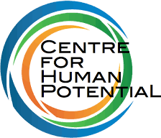
Holdsworth House Medical Brisbane is a comprehensive GP Medical Practice conveniently located in Fortitude Valley. Our practice offers a wide range of services including sexual health and an experienced team of doctors.

The Centre For Human Potential (CFHP)
The Centre For Human Potential is a Brisbane psychologist practice that has been supporting people to reach their potential through effective counselling techniques since 2007. They are specialists in mental health for LGBTQIA+ communities.

Queensland Positive People
QPP is a peer-based advocacy organisation which is committed to peer support, health promotion and treatment information, advocacy, and community HIV education and prevention.

PLFAG+ (Parents and Friends of Lesbian and Gays)
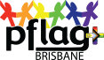
PFLAG+ is a peer support group that assists families and friends understand their lesbian, gay, bisexual and trans (LGBTQIA+) loved ones. PFLAG+ also support LGBTQIA+ youth who are in fear they may be/or have been abandoned by family.

YOUTH

Open Doors Youth Service

Open Doors Youth Service provides support to young people with diverse genders, sex and sexualities. They support young people who identify as Lesbian, Gay, Bisexual, Transgender, Intersex, Queer, Asexual, Pansexual, Sistergirl or Brotherboy (LGBTIQAP+ Sistergirl & Brotherboy) aged 12-24 across Southeast Queensland. If you are located out of Southeast Queensland they can still try to provide support to link you in with safe and inclusive services in your area.
Open Doors Youth Service is Queensland’s leading LGBTIQAP+ youth homelessness service, working with young people who are at risk of/are disengaging with community and are at risk of/are experiencing homelessness.

Queensland Childrens Gender Service

The Queensland Children’s Gender Service (QCGS) sits within the integrated Child & Youth Mental Health Service providing specialist outpatient care at Queensland Children’s Hospital and state wide through telehealth and local partnerships. The aim of the QCGS is to improve the health, wellbeing and function of Queensland children diverse in gender identity through affirmative, family focused, interdisciplinary assessment and specialist care.

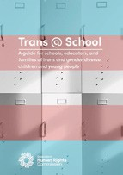
Queensland Human Rights Commission - Trans at School
This resource has been developed in partnership between the LGBTQIA+ Legal Service, Legal Aid Queensland and the Queensland Human Rights Commission, in consultation with the Queensland Children’s Gender Service, young people, parents and educators. This guide is for schools and provides guidance on matters that arise in the school environment.

Student Wellbeing Hub

Student Wellbeing Hub provides information and resources to help the whole school community to create and maintain a safe, supportive and respectful learning environment. Their topics relate to all school students from Foundation through to Year 12.
They also assist Parents to help their child have a safe and positive experience at school and Educators to help create respectful and supportive teaching and learning communities that promote student safety and wellbeing.
INTERSEX

InterAction for Health and Human Rights

InterAction is a national not-for-profit company by and for people born with variations of sex characteristics. They were formerly known as IHRA and OII Australia. They promote human rights, health and bodily autonomy.

Intersex Peer Support Australia

Intersex Peer Support Australia provide peer support between people with any intersex variation throughout Australia.

DOMESTIC AND FAMILY VIOLENCE


DVConnect
DVConnect can assist any LGBTQIA+ people who are experiencing domestic, family or sexual violence

Relationships Australia, Rainbow Services

The Rainbow Program is a collection of RAQ service provisions, striving to support the mental health and wellbeing of people of diverse bodies, genders and sexualities, including lesbian, gay, bisexual, transgender & intersex (LGBTI) people, as well as those questioning their gender identity or sexual orientation. This includes:
- The Rainbow Counselling Service; and
- The Transcendence Social and Emotional Support Group.
They also support the families, allies and practitioners who, in turn, support those identifying as LGBTQIA+ or questioning.

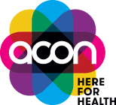
ACON
ACON provide counselling and care coordination support for LGBTQ+ people who have experienced sexual, domestic and/or family violence. For more information or to undertake a brief intake assessment, please contact your nearest ACON office.

Say It Out Loud

Say it Out Loud encourages people from LGBTQIA+ communities to start talking about their relationships.

LGBTQ DV Awareness Foundation
The LGBTQ Domestic Violence Awareness Foundation was established with the purpose of:
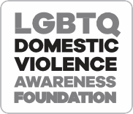


- Helping end domestic, family and intimate partner violence and abuse (DFV) within LGBTQ communities, by increasing visibility through an annual awareness campaign.
- Advocating for and supporting the empowerment of LGBTQ victims and survivors of DFV.
- Collaborating with other organisations to help reduce barriers to reporting violence, accessing support services and creating safe and inclusive experiences for LGBTQ victims and survivors of DFV.
- Providing targeted information and resources to support workplaces, educational institutions and the broader community observe annual LGBTQ Domestic Violence Awareness Day campaigns.

TRANSGENDER AND GENDER DIVERSE PEOPLE
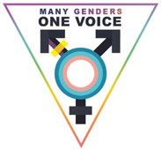
Many Genders One Voice
Many Genders One Voice is a Trans, Gender Diverse, Non-Binary social and support group. The group was founded in 2011 in direct response to the stigma and discrimination Transgender and Gender Diverse people were facing when trying to access gender affirming care. Over time the group has evolved from a health action group to a leadership, social and support group.

QTrans
This not-for-profit non-government organisation (NGO) is run by transgender people to provide a confidential support service with three basic aims:

- Provide consultancy and support for the transgender community, their families and friends
- Provide an education service to the wider community on transgender identity
and issues
- Liaise with government on policy issues and practices affecting the transgender community.
Membership is open to people who have changed their gender role or who intend to change their gender role in the near future and/or are in a recognised gender reassignment.
OLDER PEOPLE

Silver Rainbow
Silver Rainbow provides national coordination and support activities promoting the well-being of LGBTIQ+ elders and the ongoing delivery of the LGBTIQ+ awareness training to the aged care sector

Queensland Council for LGBTI Health
The Seniors Community Visiting Service matches trained volunteer visitors with Lesbian, Gay, Bisexual, Intersex, Queer, Sistergirl and Brotherboy senior clients who feel alone or isolated from their community due to health, mobility or other issues.
The service supports clients to stay connected with others through having regular contact with their visitor for conversation, social connection and/
or outings. It operates alongside but not in place of other in-home care and support services that clients might receive or be looking to access

Uniting
Uniting are passionate about helping people lead happy, healthy lives. Uniting celebrates diversity of ability, age, ethnicity, faith, sexual orientation, intersex variation and/or gender identity and welcomes everyone, exactly as they are.

Uniting was the first faith-based aged care organisation in Australia to be officially recognised as LGBTQIA+ friendly and we received Rainbow Tick Accreditation in 2015. In 2018, Uniting was reaccredited with the Rainbow Tick for over 240 services across:
- Residential aged care
- Home and community care
- Retirement and independent living
- Local Area Coordination of disability services

My Aged Care

- Finding LGBTQIA+ inclusive home care
- Aged care for LGBTQIA+ elders
LEGAL SERVICES

Queensland Human Rights Commission
The Commission provides a complaint resolution service for complaints falling under the Anti-Discrimination Act 1991 and the Human Rights Act 2019. This process is free, and a person does not need a lawyer to make a complaint.

However, many people seek legal advice about making or responding to a complaint. Complaints can be made about the following breaches of the Anti- Discrimination Act:
- Discrimination;
- Sexual harassment;
- Unlawful requests for information;
- Public vilification;
- Victimising another person because they have previously made or been
involved in a complaint about a breach of the Anti-Discrimination Act; or
- Encouraging or requesting someone to breach the Anti-Discrimination Act.

LGBTI Legal Service
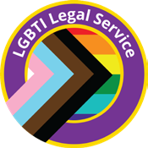
The LGBTI Legal Service offers free and confidential legal advice to Queensland residents who identify as members of the diverse lesbian, gay, bisexual, trans and intersex community.
Consultations are held in-person, via telephone or via videoconference for clients who live outside of Brisbane. To ensure a solicitor who specialises in your type of legal issue is available, please telephone Client Services on (07) 3124 7160 to book an appointment

FIRST NATIONS PEOPLE

Queensland Council for LGBTI Health – Two Spirits Program
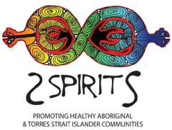
As one of Queensland’s largest health and HIV organisations, we are committed to actively making welcome all people who access our programs and services. It is our responsibility to ensure that every member of our diverse Aboriginal and Torres Strait Islander Lesbian, Gay, Bisexual, Transgender, Intersex, Queer, Sistergirl and Brotherboy Communities feel safe, valued, represented and appropriately supported to co-design, deliver, access, monitor and evaluate our programs and spaces.
We commit to achieving this goal through shared values and principles,
including listening, respect, honesty, transparency and trust.
For more information about our 2Spirits Program:
Postal Address: PO Box 1372 Eagle Farm BC QLD 4009 Phone: 07 3017 1777 or Free call: 1800 177 434
Email: 2Spirits@quac.org.au

Yarns Heal

Yarns heal is a suicide prevention campaign for the Aboriginal and Torres Strait Islander and LGBTQIA+ Sistergirl and Brotherboy community, it’s about sharing stories and reaching out to loved ones and Community Cultural Connectors when times are tough. Yarns Heal aims to strengthen peer support systems so Aboriginal and Torres Strait Islander and LGBTQIA+ Sistergirl and Brotherboy community can access help in culturally safe ways that nurture cultural healing, love and hope.

Gar’ban’djee’lum Network
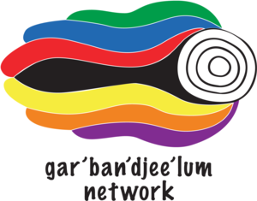
Gar’ban’djee’lum is a Brisbane-based, independent social and support network for Aboriginal & Torres Strait Islander people with diverse genders, bodies, sexualities and relationships. The group was established in 1997 to provide a social avenue for Aboriginal and Torres Strait Islander gay, lesbian, bisexual and transgender (GLBT) people to meet in a supportive, culturally appropriate environment with other GLBT people and their families and friends. Since
its establishment, the group has evolved into a network that provides a safe space of belonging for Aboriginal & Torres Strait Islander people with diverse genders, bodies, sexualities and relationships that is peer based and culturally supportive.

Indigilez
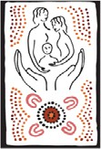
IndigiLez Leadership and Support Group formed in 2008 and has since become one of Queensland’s prominent social support group for Aboriginal and Torres Strait Islander lesbians and same sex attracted women. Founders Rebecca Johnson and Tanya Quakawoot have implemented and developed culturally safe programs for the empowerment of Aboriginal and Torres Strait Islander women.

CULTURALLY AND LINGUISTICALLY DIVERSE PEOPLE

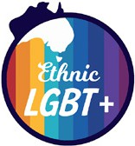
Ethnic LGBT+
This is a space intended to provide ethnic LGBT+ people with the resources to help them navigate the specific challenges they may face in coming out to their families and to provide them with a supportive ethnic LGBT+ network.

Multicultural Australia

We acknowledge the immense trauma members of the LGBTIQ+ community face, having to flee their home countries due to persecution and discrimination. We walk alongside LGBTIQ+ clients to meet their direct needs and ensure their safety in Australia. We are proud to be a Rainbow Tick accredited organisation that provides safe, affirming and inclusive care for LGBTIQ+ staff, clients and the community.

