Annexures

Annexures

Annexure 1 – Timeline of significant reviews and coronial inquests
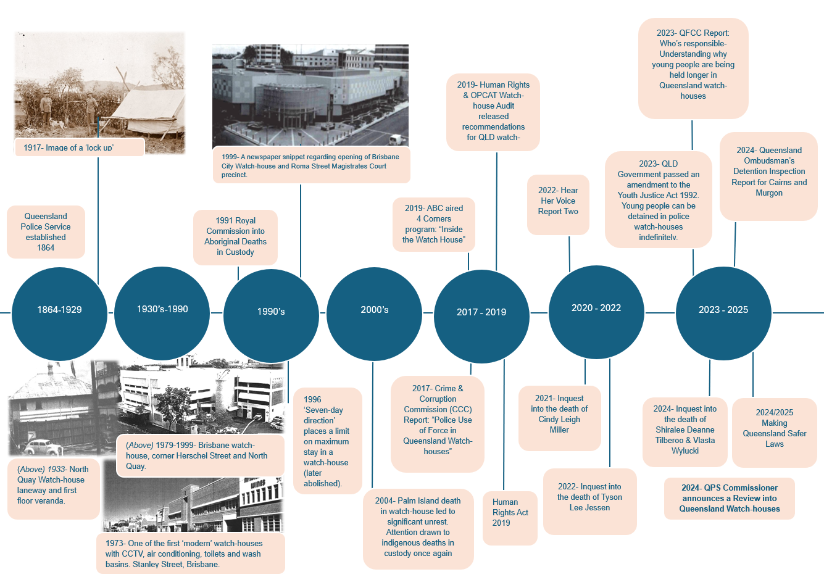

Annexure 2 – Terms of Reference
The Commissioner of Police announced a Watch-house Review (the Review) into how the QPS designs, provisions and operates watch-houses to ensure they are safe and well-managed for people in custody, staff and visitors.
The Review will undertake discovery work across several key areas. Priority will be given to those areas that will achieve the best outcome for people in custody and watch-house personnel, to ensure the custodial activities are managed appropriately.
The review has been split into three main themes:
- People:
  - Ensuring our people are appropriately recruited and trained to care for persons in custody in watch-houses.
  - Ensuring the health and safety of persons in custody.
  - Ensuring the health and safety of our people working in watch-houses.
- Processes:
  - Ensuring our systems and processes are efficient and effective for watchhouse custody operations.
- Places:
  - Examination of our infrastructure and facilities (including technology) to identify opportunities for improvements in the support of our people and processes.
Health and safety matters relating to the above three themes will also inform the review.
There is scope for the Review to include other relevant matters that arise during the review.
Out of scope for the Review includes:
- Policies of Queensland Corrective Services (QCS) and the Department of Youth Justice and Victim Support (DYJVS) that impact the operations of the QPS
- The guarding of detainees in hospitals and medical centres
- Court orderly duties (Proper Officer) and associated movements under section 307-309 of the Corrective Services Act 2006 (CS Act); and
- Court cells (s 310 CS Act).

Annexure 3 – Summary of recommendations

Recommendations relating to watch-house infrastructure
 | Recommendation 1 | Business case for capital works for watch-house facilities
PLACE | The QPS develop business cases for watch-house options including capital works.
PLACE | Recommendation 2 | Reclassification of watch-houses
 | The QPS reclassify current watch-houses, based on facility purpose, locality, structure and operational capabilities. Categorisation is to be informed by WHS assessments and relative controls that can be implemented to reduce overall risk.
PLACE | Recommendation 3 | Watch-house remediation plan
The QPS immediately commence a program of watch-house remediation works to address identified safety issues and privacy concerns (particularly for women and
girls), as funding permits.
PLACE | Recommendation 4 | Body scanner trial
 | The QPS implement a body scanner trial in a large/super watch-house to enhance the safety of staff and prisoners and reduce the need for invasive unclothed searches. An outcome evaluation should be conducted following the trial to consider the potential for further implementation.
PLACE | Recommendation 5 | Watch-house infrastructure improvement plan
 | The QPS update the Building Standards Manual (BSM) to reflect minimum standards for watch-houses, including the reclassification of some watch-houses. Ensure standards reflect findings from Coroners, Ombudsman, Human Rights, and WHS assessment recommendations and undertake inspections to ascertain level of alignment of standards in facilities. Use inspection findings to develop a forward capital assets plan for QPS.
PLACE | Recommendation 6 | Develop QBuild list of preferred contractors
 | The QPS engage with QBuild to develop a list of preferred contractors across the state to ensure the provision of maintenance and remediation works are conducted to the requisite building standards, with the ability to deliver a standard of works that meets the unique requirements of custodial facilities.
  PROCESS | Recommendation 7 | Addressing privacy concerns and segregation of persons in custody
The QPS enhance segregation from male prisoners and privacy for women and girls, by the designation of locations and/or cells for these cohorts.

Work in partnership with DYJVS and QCS to implement strategies that prioritise movement of remanded, particularly girls, and women from watch-house environments (WSJT 2 recommendations 105 and 106).
PROCESS | Recommendation 8 | Baseline all in-cell services (including as meals, clothing, cleaning and laundry)
 | The SCU baseline all watch-house functions including meals, clothing, cleaning and laundry and centralise all procurement and contract management across the state to implement minimum standards and generate fiscal efficiencies. SCU to seek specialist advice on nutritional standards and guidelines for food provision in watch-houses, which guide procurement of appropriate catering contracts that meet minimum standards.

Recommendations relating to prisoner transportation
PROCESS | Recommendation 9 | Length of stay in watch-houses
 | The QPS to prepare a policy position for Government to consider a maximum length of prisoner stay in watch-houses and holding cells relative to the classification of the facility (see re-designation of watch-houses in recommendation two). A 72 hour maximum length of stay is consistent with Coronial recommendations (Tilberoo and Wylucki Inquest), and prioritising safety and expedient transfer of women and girls (Women’s Safety and Justice Taskforce (WSJT) Report 2 recommendations 105 and 106).
PROCESS | Recommendation 10 | Establish a whole-of-system prisoner transport model
 | The QPS to collaborate with other criminal justice agencies to develop a joint whole-of-government business case regarding options for a future prisoner transport model, and performance of hospital guard duties. To support the business case, a consistent and centralised data collection system is required to accurately measure the nature and extent of prisoner transports and hospital guards across the state.

Recommendations relating to building the workforce
  PEOPLE | Recommendation 11 | Enhancing recruitment strategies
 | The SCU to lead enhancement of the recruitment model for watch-house staff (both sworn and civilian), to increase identified First Nations positions and tailor recruitment requirements to boost applicant pools. A dedicated working group, comprising SCU and the PCAP, is to be established to address this.
PEOPLE | Recommendation 12 | Revised training program and onboarding of watch-house staff
 | PCAP to lead curriculum development in collaboration with SCU to overhaul the training model for watch-house staff (both sworn and civilian), to elevate professionalism of watch-house operations (e.g. increase scenario skills, tactical communication, behaviour management, caring for vulnerable groups, and cultural sensitivity). All revisions to training to be evaluated within 12 months of implementation.
PEOPLE | Recommendation 13 | Develop and implement training, culture and professional development
 | The QPS to prioritise development and implementation of training and professional development to influence culture for Watch-house OICs, and ensure compliance prior to undertaking OIC roles, including short-term relieving.
PEOPLE | Recommendation 14 | Mandate OLP compliance
 | The QPS to mandate the completion of OLPs by all staff working in watch-houses, prior to undertaking any watch-house duties. This includes OIC training and professional development. SCU is to monitor and enforce watch-house officers’ compliance with mandatory training.
PEOPLE | Recommendation 15 | Develop mandatory 6-month mentoring package for Assistance Watch-house Officers
 | The QPS to develop a mandatory six-month mentoring package for AWOs by adopting a similar model to the long established First Year Constable program.
PEOPLE | Recommendation 16 | Community of best practice
 | The SCU establish a quarterly forum with watch-house OICs to develop best practice principles to maintain professionalism and integrity within watch-houses and implement the principles across the network.
PEOPLE | Recommendation 17 | Develop a baseline rostering model
 | The QPS to continue to develop a consistent resourcing and rostering model for the effective management of watch-houses regardless of their capacity or location. As a priority, commence a trial of a new demand rostering model for at least three months in two large/super facilities with different layouts (i.e., pod and linear), which considers demand, overtime, staffing ratios, and higher demand prisoners. The outcomes of the trials are to be reported to the Strategic Custody Committee.
PROCESS | Recommendation 18 | State Custody Unit operating model uplift
 | The QPS uplift SCU capability through the creation of specific functions to drive consistency, efficiency, professionalism, and compliance with standards statewide. Functions include SCU to baseline and maintain all relevant information regarding all areas of watch-house operations.
PROCESS | Recommendation 19 | Transfer ownership of watch-houses to SCU
 | The QPS to transfer policy, training and professional development as well as auditing functions to SCU. The operational management and day to day running of watch-house is maintained by the Districts.
PLACE | Recommendation 20 | Risk mitigation to implement WHS controls
 | The QPS to undertake intensive risk mitigation activities to implement WHS controls in watch-houses.
PROCESS | Recommendation 21 | Psychosocial risk audits in watch-houses
 | The QPS Safety Strategy Division in collaboration with SCU to prioritise psychosocial risk audits of watch-houses and develop action plans for implementation of control measures in workplaces.

Recommendations relating to support services

PROCESS | Recommendation 22 | Co-designed delivery of health services to persons in custody
 | The QPS to partner with Queensland Health (QH) to further expand the delivery of co-designed health services (including mental health and medication dispensing and administering), for all watch-houses including utilising VideoLink technology.
PROCESS | Recommendation 23 | Review of intake assessment tools
 | The QPS, in partnership with QH, DYJVS and QCS, develop and implement an appropriate initial intake assessment tool tailored for processing children and adults (including First Nations people) into a watch-house
PROCESS | Recommendation 24 | Delivery of education services for children in watch-houses
 | The QPS partner with DoE to further expand the delivery of co-designed education services for children in watch-houses, including utilising VideoLink technology.

Recommendations relating to policies and procedures
PROCESS | Recommendation 25 | Development of a standalone custody manual
 | The QPS produce a standalone custody manual which provides a holistic reference point for the management and operation of watch-houses. A central custody manual will remove ambiguity regarding standards, compliance, and practices across watch-houses. Chapter 16 of the existing Operational Procedures Manual (OPMs) is to be rewritten prior to inclusion in the custody manual, to remove outdated or superseded procedures. The manual will also stipulate training requirements, baseline local watch-house (station) instruction, watch-house functions and practices, and also include sections regarding granting bail, visitation, nutrition and other operating standards.
PROCESS | Recommendation 26 | Project management responsibilities
 | The QPS Transformation Office to provide project management and governance of watch-house reform program in collaboration with Senior Business Owners (SBOs).
PROCESS | Recommendation 27 | Enhanced awareness of complaints process
 | The QPS ensure all watch-house staff, prisoners and oversight bodies have clear visibility and awareness of the complaints handling process in watch-houses.
PROCESS | Recommendation 28 | Standardised watch-house visitation policy
The QPS to standardise the official watch-house visitor policy to ensure consistency across the state and explore the development of an online appointment system to facilitate equitable access and transparency of functions performed during visits.

The QPS to undertake comprehensive review of third-party service provider access to watch-houses with the objective of taking over the direct management of third-party service provider contracts, including setting of KPIs and service level agreements.

PROCESS | Recommendation 29 | Enhance the existing bail processes for children and adults
 | The QPS explore strategies to enhance bail processing options to minimise the use of watch-houses, supported by the development of a risk-based framework for bail and associated prescribed officer training.

Recommendations relating to digital modernisation
PLACE | Recommendation 30 | Business case to modernise CCTV network
 | The QPS develop a business case to modernise the CCTV network in watch-houses, including a centralised monitoring function and leveraging artificial intelligence (AI) technology to aid prisoner management and reduce risk of adverse health incidents for prisoners.
PROCESS | Recommendation 31 | Increased VideoLink court appearances
 | The QPS engage with DOJ to modernise court processes and optimise timeliness of court appearances for prisoners in watch-house custody (including via VideoLink) to reduce the length of stay.
PROCESS | Recommendation 32 | End-to-end custody management tool
 | The QPS to develop an end-to-end custody information management business case for digital uplift in watch-houses to enhance the performance of operations and functions. This includes capability for information sharing, risk identification and management, and safe prisoner management.
PROCESS | Recommendation 33 | Development of a Mobile Custody Application
 | As a priority, the QPS to develop a Mobile Custody Application which allows watch-house officers to record, in real time, prisoner management activities, and watch-house operations, and deploy QPS Lite Information Technology Exchange (QLiTE) devices to all watch-house officers to operationalise.
PLACE | Recommendation 34 | Expanding support services to be delivered via VideoLink
 | As a priority, the QPS installs VideoLink technology in all watch-houses, to enable better access to health, education, support services, and court appearances.

Annexure 4 – Existing Assistant Watch-house Officer training curriculum and proposed additions
Table 1: Curriculum topics and proposed additions
Current Curriculum | Proposed Additions to Curriculum
Introduction to QPS & the Watch-house Officer role
- Understanding QPS Abbreviations
- Roles & Responsibilities
- Corporate Induction
Ethics, Information Privacy and Security
- Building Strong Foundations – Integrity First
- QPS Building an Ethical Culture
- Accessing QPS Information
- Right to Information
- Public Interest Disclosure
- Declarable Associations
- Cyber Security
- Social Media
- QPS Protective Security Awareness
Legislation, Policy, Procedures relevant to WO role and custody management  - Prescribed Officers | - Transports and Powers whilst on transport  - Prisoner Escorts, movements, prisoner release and transfer
Communication Skills  - De-escalation  - Use of Force & Communication | - 2-day de-escalation course delivered by SMEs
Decision-making, Situational Use of Force (SUOF) options for WO  - Threat Assessment  - Leg Irons  - EMD (Electronic Monitoring Device)  - Body Belt  - Violent Detention Cells  - Handheld Metal Detectors | - WIN (What’s Important Now)  - COPS (Consider Options, Practice Safety)  - POP (Person, Object, Place)  - EMD – practical component (Adult)  - EMD – theory and practical (Children)
Operational Skills and Tactics (OST)- practical skills in the WH environment  - Tactical First Aid | - Minimum two (2) weeks of OST with additional time allocated for Dynamic Interactive Scenarios
Wellbeing of Self and Persons in Custody  - Cell Visitor Scheme  - Custody Care and Management  - Do Food Safely | - Dealing with Difficult people in custody  - Management of alcohol and drug affected persons in custody  - Person centred care
Prisoner Segregation/ Classifications

Risk Assessment & Health Assessments  - Duty of Care  - Mental Health  - Responding to Mental Illness | - Physical  - Diabetes  - Asthma  - Drug/ Alcohol Dependency and Withdrawal  - Mental Health  - Anxiety, Depression  - Dispensing Medications  - Assessing Children  - Assessing First Nations Persons  - Disability  - Cognitive Impairment & Literacy Challenges
Workplace Health and Safety  - Evacuation  - Fatigue Management  - Psychological First Aid Foundations  - Psychological Health and Fitness  - Asbestos Awareness  - Psychological First Aid for Leaders | - Recording Hazards on the Hazard reporting management system  - Recording work related injuries Incident/injury notification and reporting system IINRS
The WH Custody Management Process – Receive, Process, Searching, Property  - Processing Prisoners  - Supervision of Prisoner | - Court processes and outcomes  - Searching: Prisoner Property  - Searches – Risk Identification and Management
Security, Monitoring and QPRIME  - QPRIME Fundamentals  - Body Worn Camera | - Implementation of BWC footage of WHs and WH operations and events  - BWC Practical Exercise and AXON upload
Cell Inspections: Types, Timings, Frequency | - Security and Monitoring  - Cell inspections and Care Plans  - Person Care Plan and Levels
Human Rights
- Mental Health
- Watch-house Human Rights
- Gender Safeguards for Search of Persons
Cultural Capability | - Cultural Awareness  - Bias  First Nations Specific  - Cultural Safety and Capability  - Murri-Watch  - Cultural Competency
Custody and Wellbeing of Children
- Child trauma & Child Mental Health
- Managing Young Persons in custody
- Behaviour Management
- Communicating with children with complex needs
- Strategies to engage with children
- Child brain development
- Disability in young persons
- Cognitive impairments and Literacy challenges in children
Systems  Livescan  LCAD (Local Computer Aided Dispatch)  ITAS | - Livescan Practical Assessment and Qualification
DNA  - Collection  - Sample | - DNA Practical Assessment and Qualification
Vulnerable Persons  - Domestic & Family Violence – Recognise, Respond, Refer  - Coercive Control  - Unconscious Bias  - Volatile Substance Misuse  - Lesbian, Gay & Bisexual Awareness | - Vulnerable Persons in Custody  - Deaths in Custody  - Trauma – How it presents, a Trauma informed approach in custody  - Women & Girls
- Dynamic Interactive Scenarios
- QPRIME Practical Exercises
- Compulsory Mentoring Period (Min 6 months) with Structured Practical Assessments

Annexure 5 – Health services, medical equipment and prisoner mental health
Table 2: Health services availability across 20 of the busiest watch-houses, February 2025.
Watch-house | Health service availability | Percentage of prisoners admitted during health service hours
Beenleigh | 0900-1700 across 7 days | 53
Brisbane City | 0700-2100 (2 x shifts) across 7 days | 72
Bundaberg | Nil | 0
Caboolture (Youth Hub) | 24 hours  7 days | 100
Cairns | 1500-1900 (approx. 4 hours)  7 days | 24
Caloundra | On call -  7 days (day shift also Maroochydore) | Data not available
Cleveland | Nil | 0
Gladstone | Nil | 0
Ipswich | 2 hours (various timing)  7 days | 9 (approx.)
Mackay | Nil | Data not available
Maroochydore | On call  7 days (day shift also covers Caloundra) | Data not available
Maryborough | Nil | 0
Mt Isa | 2 hours (various timing)  7 days | Data not available
Pine Rivers | 2 hours (various timing)  7 days | 9 (approx.)
Redcliffe | Nil | 0
Richlands | 0900-1100 (approx. 2 hours)  7 days | 26
Rockhampton | Nil | Data not available
Southport | 0900-1700  7 days | 48
Toowoomba | Once a day  7 days | Data not available
Townsville | 0700-1700  7 days | 57
Source: OIC survey February 2025.

Table 3: Breakdown of medical equipment located at selected QPS Watch-houses
Watch-house | Medical Equipment Available
Beenleigh | Yes - basic first aid kit
Brisbane City | Yes - defibrillator, oxygen machine, observation machine, basic first aid kit
Bundaberg | Yes – basic first aid, defibrillator, CPR mask
Caboolture (Youth Hub) | Yes - oxygen response kit, trauma response, iv cannulation, defibrillator, resuscitation mask, blood glucose meter, basic first aid kit
Cairns | Yes - basic first aid kit and defibrillator
Caloundra | Yes – basic first aid kit
Cleveland | Yes - basic first aid kit and defibrillator
Gladstone | Yes - basic first aid kit
Ipswich | Yes - basic first aid kit
Mackay | Yes - basic first aid kit, defibrillator, resuscitation mask, blood glucose meter
Maroochydore | Yes - basic first aid kit
Maryborough | Yes - basic first aid kit, defibrillator, silicone resuscitator, blood glucose meter
Mt Isa | Yes - first aid kit, INR machine, ECG Machine, glucometer, blood pressure machine, otoscope, stethoscope
Pine Rivers | Yes - basic first aid kit, blood pressure monitor, defibrillator
Redcliffe | Yes - basic first aid kit, blood glucose meter, defibrillator, resuscitation mask for CPR
Richlands | Yes - basic first aid kit, temperature monitor with o2 sensor, blood pressure monitor
Rockhampton | Yes – basic first aid kit, defibrillator, resuscitation equipment
Southport | Yes - basic first aid kit, blood glucose meter, blood pressure monitor, oxygen bottles
Toowoomba | Yes - basic first aid kit and observation equipment
Townsville | Yes - basic first aid kit, defibrillator, blood pressure monitor

Table 4: Percentage of prisoners in watch-houses with police interaction generated mental health and suicidal caution flags, QPRIME (1 January 2024 to 31 December 2024)
Watch-house | % Mental Health Caution | % Suicidal Caution
Brisbane City | 30 | 11
Beenleigh | 30 | 17
Bundaberg | 24 | 10
Caboolture | 24 | 11
Cairns | 19 | 11
Caloundra | 25 | 13
Cleveland | 25 | 12
Gladstone | 31 | 12
Ipswich | 24 | 13
Mackay | 29 | 13
Maroochydore | 21 | 9
Maryborough | 32 | 16
Mt Isa | 28 | 18
Pine Rivers | 26 | 13
Redcliffe | 30 | 10
Richlands | 22 | 12
Rockhampton | 29 | 14
Southport | 29 | 10
Toowoomba | 24 | 19
Townsville | 25 | 12
QLD State total | 25 | 13



