
_____________________________________________
Rockhampton District Disaster
Management Group

Rockhampton District Disaster Management Plan

Central Highlands Regional Council
Livingstone Shire Council
Rockhampton Regional Council
Woorabinda Aboriginal Shire Council

Foreword

The communities located within the Rockhampton Disaster District are susceptible to the impacts from a variety of natural and technological hazards or the effects of human-caused hazards, namely terrorist related events, cascading impacts and the cumulative effects created as an on-going legacy of each across the district.

The Rockhampton District Disaster Management Plan (the Plan) has been prepared under the authority of the Disaster Management Act 2003 (DM Act), to provide a framework for holistic and comprehensive disaster management within the Rockhampton Disaster District.

The plan has been prepared by the Rockhampton District Disaster Management Group (DDMG) to facilitate the four principles which underpin Queensland’s disaster management arrangement being leadership, public safety, partnerships and performance and the shared responsibilities of each.

The plan is designed to enhance the District’s disaster management capacity by ensuring the necessary strategies are in place to provide a comprehensive (Prevention/Mitigation, Preparedness, Response and Recovery), all-agency, whole-of-society (including local capability and prepared and resilient community) approach across each tier of the Queensland disaster management arrangements and applied in an all-hazards context.

The plan also incorporates some hazard specific strategies for disaster management in respect to the hazards which have been identified through hazard analysis as having potential to cause the most significant losses within the community physically, psychologically and economically.

The plan is a dynamic document which may be amended as required to incorporate legislative changes and lessons learned from activations to an event, training programs or exercising emergency or disaster situations. The plan will also be reviewed periodically and amended as necessary to address the districts most significant risks as identified through disaster risk assessments, climate adaptation and ensure compliance with current best practice procedures in disaster management planning and operations.

Glen Pointing
Chair/District Disaster Coordinator
Rockhampton District Disaster Management Group

Endorsement

The Rockhampton District Disaster Management Plan is endorsed under the authority of the Rockhampton District Disaster Management Group.

This plan has been developed in accordance with the Disaster Management Act 2003 (DM Act) and the following documents to provide for effective disaster management in the Rockhampton Disaster District:

- the Queensland State Disaster Management Plan - QSDMP
- Queensland Emergency Risk Management Framework - QERMF
- Queensland Emergency Management Assurance Framework - EMAF
- Queensland Prevention, Preparedness, Response and Recovery Disaster Management Guidelines 2018 - PPRR DM Guideline
- Queensland Disaster Management 2016 Strategic Policy Statement - Strategic Policy Statement
- Pathways to a climate resilient Queensland - QCAS 2017 - 2030
- Queensland Strategy for Disaster Resilience 2017 - QSDR 2017
- Queensland Disaster Management Training Framework – QDMTF
The plan will be maintained by the Chair of the Rockhampton District Disaster Management Group and will be reviewed annually unless otherwise required.

Glen Pointing
Chair/District Disaster Coordinator
Rockhampton District Disaster Management Group

Date: 21 August 2023

Contents
Foreword 2
Endorsement 3
Contents 4
Document Control 8
Amendment Control 8
Amendment Register 8
Distribution 8
Administration and Governance 9
Authority to Plan 9
Purpose 9
Objectives 9
Strategic Policy Statement 9
Scope 10
Disaster Management Priorities 11
Review and Renew Plan 12
Review and Assessment 12
Review of Local Disaster Management Arrangements 12
District Disaster Management Group 14
Establishment 14
Membership 14
Core members 15
Advisors 16
Functional and Supporting Committees 17
Meetings 17
Quorum 18
Temporary district 18
Reporting 18
Administrative Reporting 18
Agency Status Reports 19
Annual Reports 19
Functions of the DDMG 20
Roles and Responsibilities 22
Community Context 27
Central Highlands Regional Council (CHRC) 28
Livingstone Shire Council (LSC) 29
Rockhampton Regional Council (RRC) 31
Woorabinda Aboriginal Shire Council (WASC) 32
Support to other Districts 32
Description of the environment 33
Climate change projections 34
Temperature 34
Rainfall 35
Extreme events 35
Impact 35
Hazards 37
Cyclone 37
Storm tide 40
Tsunami 41
Queensland’s processes to manage JATWC warning products 43
Tsunami planning 44
Floods 44
Referrable Dams 47
Earthquake 49
Heatwave 50
Heatwave Levels 50
Public Health effects of a heatwave 50
Pandemic Disease 51
Emergency Animal Disease (EAD) 54
HAZMAT incidents 55
Mining Subsidence / accidents 55
Fires 55
Urban fires 56
Rural fires 56
Transport access / egress / accidents (Road, Rail, Air or Sea) 59
Road 59
Rail 59
Air 59
Sea 59
Terrorist related activity 60
Counter Terrorism Strategies 61
Space debris re-entry 63
Risk Assessment 64
Risk Treatment 65
District Residual Risk Profile 65
Prevention strategies 67
Prevention 67
Mitigation strategies 67
Prevention functions 68
Preparedness Strategies 69
Preparedness 69
Planning 69
Functional plans 70
Hazard-specific plans 71
Business continuity planning 74
Capability integration 74
Training and education 74
Disaster Coordination Centre Training 75
Exercises 75
Lessons Management 76
Community Awareness and Engagement 77
Response Strategy 79
Response: 79
Activation 79
District Disaster Coordination Centre (DDCC) 80
Operational / Event Action Plans 81
Warning Notification and Dissemination 81
Standard Emergency Warning Signal (SEWS) 82
Emergency Alert (EA) 83
Social Media 83
Websites 84
Evacuations 84
Requests for Assistance – (RFAs) 84
Assessing Support and Allocation of Resources 85
Emergency supply 85
Resupply 85
Operational Reporting 86
Financial Management 86
Information Management 87
Media Management 87
Disaster Declarations 88
Emergency Situation 88
Recovery Strategy 89
Recovery 89
Scope 91
Parameters and Constraints 91
Transition from Response to Recovery 93
Functions of Recovery 95
Economic 95
Environment 95
Human and Social 96
Building 96
Roads and Transport 96
District Recovery Group (DRG) 97
Activation 97
Planning 98
Operations 98
Operational and Action Plans 101
Considerations for Operational and Action Plans 101
Immediate/short term recovery 102
Transition from immediate/short term to medium/long term recovery 102
Medium/long term recovery 102
Transition to normal business 102
Disaster Management financial arrangements 103
State Disaster Relief Arrangements (SDRA) 103
Disaster Recovery Funding Arrangements 103
Offers of Assistance 103
Annexure Index 105
Distribution List 106
Rockhampton District Disaster Management Group Contact List 108
District Risk Register 109
District Risk Treatment Plan 110
Pandemic Sub Plan 111
Recovery Sub Plan 112
Evacuation Sub Plan 113
District Disaster Coordination Centre – Standard Operating Procedure (DDCC SOP) 114
Media Contact List 115
Abbreviations and Acronyms 116
Definitions 118

Document Control

Amendment Control

This district plan is a controlled document. The controller of the document is the Chair of the Rockhampton Disaster District Management Group. Any proposed amendments to this plan should be forwarded in writing to:

The Executive Officer
Rockhampton District Disaster Management Group
PO Box 1161
ROCKHAMPTON QLD 4700

The Chair may approve inconsequential amendments to this document. Any changes to the intent of the document must be endorsed by the Rockhampton District Disaster Management Group (DDMG).

A copy of each amendment is to be forwarded to those identified in the distribution list. On receipt, the amendment is to be inserted into the document and the Amendment Register updated and signed.

Amendment Register

Amendment |  | Plan Updated
No / Ref | Issue Date | Inserted by | Date
20/01 | 12/03/20 | Senior Sergeant Cameron Barwick | 12/03/20
21/01 | 12/07/21 | Senior Sergeant Cameron Barwick | 12/07/21
22/01 | 17/06/22 | Acting Senior Sergeant Matthew Hows | 17/06/22
23/01 |  | Senior Sergeant Matthew Hows

Distribution

This plan has been distributed in accordance with section 56 of the Act which requires the DDMP to be available for inspection, free of charge, to members of the public at places considered appropriate by the Chair of the District Group, this includes;
- A copy of the plan, excluding the controlled document Annexures, will be made available for public viewing at the Rockhampton Police Complex, Bolsover Street, Rockhampton.
- Electronic copies of the plan, excluding the controlled document Annexures, shall also be made available to the public on the Queensland Police Service website at, Disaster Management Plans – Central Region - Rockhampton DDMP
- A full and complete copy of the plan will be distributed in accordance with the distribution list at Annexure A.

Administration and Governance

Authority to Plan

This Rockhampton District Disaster Management Plan (DDMP) is prepared under the authority of section 53 ‘Plan for disaster management in disaster district’ of the Disaster Management Act 2003.

Purpose

This plan details the arrangements within the Rockhampton disaster district to provide whole-of-society planning and coordination capability to support local governments in disaster management and disaster operations.

Objectives

The objectives of this Rockhampton DDMP is to facilitate the implementation of effective and efficient disaster management strategies and arrangements across the district, including:

- development, review and assessment of effective disaster management for the district including arrangements for mitigating, preventing, preparing for, responding to and recovering from a disaster;
- Compliance with the Queensland Disaster Management 2016 Strategic Policy Statement - Strategic Policy Statement;
- the Queensland State Disaster Management Plan - QSDMP
- informed by the Queensland Emergency Risk Management Framework - QERMF
- Queensland Prevention, Preparedness, Response and Recovery Disaster Management Guidelines 2018 - PPRR DM Guideline
- Pathways to a climate resilient Queensland - QCAS 2017 - 2030
- Queensland Strategy for Disaster Resilience 2017 - QSDR 2017
- any other Guidelines or Strategies relevant to district level disaster management and disaster operations;
- monitoring, review, development and implementation of priorities for disaster management for the district, and
- Consistency with the Queensland Emergency Management Assurance Framework - EMAF

Strategic Policy Statement

Disaster management and disaster operations in the Rockhampton district are consistent with the Queensland Disaster Management 2016 Strategic Policy Statement. This is achieved by:

- ensuring a comprehensive, all hazards, all agencies approach by achieving the right balance of prevention, preparedness, response and recovery;
- supporting the mainstreaming of disaster preparedness and mitigation into relevant areas of activity of government, non-government, small business and corporations;
- aligning disaster risk reduction, disaster mitigation, disaster resilience and climate change adaptation policy, strategies and actions with international and national reforms;
- promoting a transparent, systematic and consistent approach to disaster risk assessment and management;
- recognising the commitment of stakeholders and the need for collaboration and integration across all levels of government, community, industry, commerce, government owned corporations, private and volunteer organisations, and local communities in all aspects of disaster management;
- emphasising building and maintaining sincere relationships, trust and teamwork which instils collaboration, consultation and interoperability across the sector,
- Incorporating risk-based planning, consultative decision-making and shared responsibilities among stakeholders; and
- promoting community resilience and economic sustainability through disaster risk reduction, innovation, research and lessons learned.

Scope

This plan details the arrangements necessary to undertake disaster management and disaster operations within the Rockhampton disaster district. This includes the local government areas of:

- Central Highlands Regional Council (CHRC) - Central Highlands
- Livingstone Shire Council (LSC) - Livingstone
- Rockhampton Regional Council (RRC), - Rockhampton and
- Woorabinda Aboriginal Shire Council (WASC) - Woorabinda

The plan aims to identify, assess, evaluate and treat the residual risks to the communities within the Rockhampton District. The District Disaster Management Group (DDMG) will support the Local Disaster Management Groups (LDMGs) through the provision of assets, resources, support, planning, information exchange and coordination as required and on request of the relevant LDMG.

The arrangements remain active across the prevention, preparedness, response and recovery (PPRR) spectrum and it is intended that these arrangements be used to continually improve disaster management within the district as an all-hazards approach.

The four principles for effective disaster management detailed in the Emergency Management Assurance Framework - EMAF are fundamental to the establishment and continuous improvement of effective disaster management, disaster operations and planning across the district, including:

- leadership
- public safety
- partnership
- performance

Shared responsibilities are the elements of disaster management that all entities should deliver against and that everyone within the sector is responsible for contributing to.

Shared responsibilities should not be considered in isolation – they are the interconnected responsibilities that collectively make up the disaster management system in Queensland. All entities within the Rockhampton DDMG endorse the achievement of outcomes through these shared responsibilities.

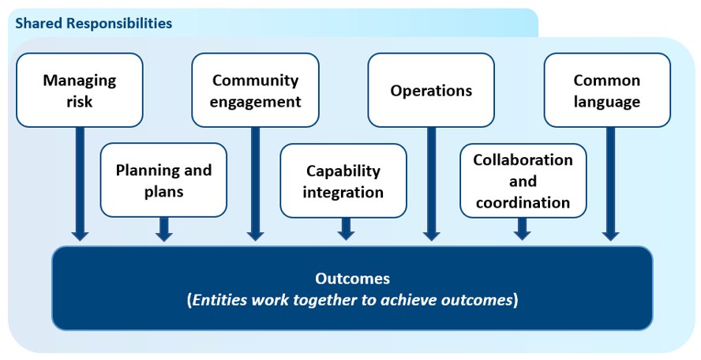

Disaster Management Priorities

The district group has the following disaster management priorities:

- Implement effective governance through sound performance management, innovation and a focus on continuous improvement.

- Ensure the consistent application of legislation, regulations and supporting policies and guidelines.

- Establish a formal reporting system that ensures that evaluation analysis is captured and communicated.

- Monitor, report on and evaluate the disaster management arrangements to:
- Ensure efficiency and effectiveness;
- Develop clear accountability, including defined roles and responsibilities at all levels;
- Improve the identification of opportunities and threats, documenting risk mitigation and incident management, and thereby minimising losses;
- Effectively mitigate disaster risks across the District;
- Improve the communication flow processes;
- Develop principles around Liaison Officer deployment;
- Develop whole-of-government media and community engagement arrangements; and
- Promote continuous improvement and integration of lessons learned.

- Integrate effective disaster risk reduction initiatives into strategic and corporate plans at all levels of government, industry and commerce.

- Ensure clear and transparent decision making through risk-based planning, collaboration, cooperation and communication.

- Promote leadership and a shared responsibility in delivering all disaster management activities and improve both governance and stakeholder confidence and trust.

These priorities are in line with the DDMG Annual Operational Plan as the tool used to outline, implement, manage and monitor current disaster management priorities for the Rockhampton Disaster District pursuant to section 53(2)(e) of the DM Act.

Review and Renew Plan

In accordance with section 16C(b) of the DM Act, the Office of Inspector-General Emergency Management (IGEM) regularly review and assess the effectiveness of local and district disaster management plans. This is facilitated through IGEM’s annual disaster management plan assessment process.

The District Disaster Management Plan shall be reviewed annually by the Planning Committee pursuant to the provisions of section 55 ‘Reviewing and renewing plan’ of the DM Act as follows:

- April-May Planning Committee reviews DDMP;
- July Draft amendments submitted to DDMG for approval;
- September Amendments (or new plans if appropriate) are disseminated to all stakeholders.

The Sub-plans of the Disaster Districts Functional Committee’s shall be reviewed annually by the respective committee as follows:

- May-July Functional Committee reviews Sub-plan;
- August Draft amendments submitted to DDMG for consideration;
- October Amendments (or new sub-plans if appropriate) are disseminated to all stakeholders.

Review and Assessment

The Emergency Management Assurance Framework - EMAF has been established by the Office of the IGEM to support accountability, build consistency and reinforce a shared responsibility for delivering better disaster management outcomes for the community. The EMAF establishes the Standard and is founded on seven shared responsibilities, good practice guidance and clear accountabilities. Assurance Activities contained within the Standard assess performance to provide a level of assurance around disaster management effectiveness.

The Rockhampton DDMG supports the review of this District Plan and support documents against the Standard to ensure disaster management activities are monitored and continuous improvement actions undertaken.

The Rockhampton DDMG, when activated in response to a relevant disaster event will facilitate a disaster event debrief to identify lessons learned and make recommendations. This debrief and disaster event report will be tabled at a meeting of the DDMG for adoption and recommendation implementation.

Should other measures of review be identified or information come to hand which supports the urgent amendment of this plan such actions will be in addition to and support the review against the Standard. All Corrective Action Recommendations made from all previous plan assessments will be considered and implemented where deemed appropriate and necessary.

Review of Local Disaster Management Arrangements

In accordance with section 23 of DM Act it is a function of the DDMG to regularly review and assess the disaster management of local groups in the district. It will be the responsibility of each LDMG to annually review their respective LDMG sub-groups and submit a status report to the Chair of the District Group for consideration. This review is to be submitted:
- June each year

Each of the Districts four LDMGs plans (and any supporting sub-plans) shall be formally reviewed annually by the DDMG as follows:
- September 30 each year (or as stated by the IGEM).

The effectiveness of the LDMG and sub-groups shall be reviewed annually against the ‘Standard’.

The outcome of these reviews will form part of the operational plan and be presented to the DDMG at the final meeting for each calendar year for consideration.

The LDMG and sub-groups may be reviewed at any other time should it become apparent that urgent attention is required to give effect to operational effectiveness of the LDMG activities. The outcome of these reviews will be presented to the DDMG at the earliest opportunity for consideration.

District Disaster Management Group

Establishment

In accordance with section 22; ‘Establishment’ the Rockhampton District Disaster Management Group (DDMG) is established to perform the ‘Functions’, section 23 of the DM Act.

This group advises the Chair and DDMG membership on the availability and specialised nature of resource requirements needed to counter the effects of an event through the provision of risk assessments, mitigation works, informed planning and communication. The Rockhampton DDMG has a continuous improvement mindset. Membership of the group is based on the risks to the disaster district area and are an integral part of the integration, collaboration and decision-making processes for disaster management and disaster operations through resourcing, information management, planning and built resilience.

Membership

The DDMG is comprised of persons as nominated in section 24: ‘Membership’ of the Disaster Management Act 2003, and section 5: ‘Membership of the District Groups, Disaster Management Regulations 2014 DM Regs, as follows:

- Chairperson – District Disaster Coordinator (DDC);
- Deputy Chairperson;
- Executive Officer;
- A person appointed by each local government or combined local government within the district;
- Persons representing a department, or a Hospital and Health Service whom the Chief Executive of the department in consultation with the DDC considers appropriate to be represented on the group having regard to effective disaster management for the disaster district;
- Other person/s appointed by the chief executive of the department that the chief executive considers appropriate to be a member of the district group, having regard to effective disaster management for the disaster district.

In accordance with section 5(7): ‘Membership of the District Groups’, DM Regs, after the appointment and as soon as practicable after the appointment the local government, chief executive (of the relevant core member department) or Hospital and Health Service chief executive must inform the chief executive of the department, and the chairperson of the district group, of the appointment.

In undertaking their normal DDMG responsibilities, members should ensure they:

- Implement risk management processes within their parent agencies to ensure capability and capacity to support the District Group in disaster management and disaster operations;
- Identify risks and implement mitigation strategies relevant to their parent agency to ensure integration of planning arrangements or communication of residual risks to the DDMG;
- Participate in DDMG activities with the full knowledge of their agency resources and services and the expectations of their agency;
- Conduct business across the comprehensive (prevention, preparedness, response and recovery) and all hazards approach to disaster management and disaster operations;
- Identify liaison officers for the coordination of agency functions consistent with Command, Operations, Planning, Intelligence and Administration and logistics;
- Are available and appropriately briefed to actively participate in DDMG activities to ensure plans, projects and operations use the full potential of their agency or function, while recognising any resource or capacity limitations;
- Are appropriately appointed and positioned within their agency to be able to commit agency resources to DDMG normal business activities;
- Have completed relevant disaster management training in accordance with their roles and responsibilities; and
- Have a deputy who is appropriately trained (with sufficient authority) to take on their responsibilities should they be unavailable to provide additional support during extended operations.
The following organisations and representatives have been considered appropriate for inclusion as members of the Rockhampton DDMG:

Core members

DDMG Position | Organisation | Organisational Position
DDC/Chairperson | Queensland Police Service (QPS) | District Officer (Superintendent)
Deputy Chairperson | QPS | District Inspector
Executive Officer | QPS | Senior Sergeant (Disaster Management Support Officer)
Member – Local Govt. | Central Highlands Regional Council | Chair LDMG
Member – Local Govt. | Livingstone Shire Council | Chair LDMG
Member – Local Govt. | Rockhampton Regional Council | Chair LDMG
Member – Local Govt. | Woorabinda Aboriginal Shire Council | Chair LDMG
Member – Govt. Dept. | Queensland Fire and Emergency Services (QFES) | Emergency Management Coordinator
Member – Govt. Dept. | Department of Energy and Public Works | District Manager, QBuild
Member – Govt. Dept. | Department Transport and Main Roads | Principal Engineer
Member – Govt. Dept. | Central Queensland Hospital and Health Service | Executive Director, Rural District wide Services
Member – Govt. Dept. | Queensland Public Health | Manager Environmental Health CQPHU
Member – Govt. Dept. | Department of Treaty, Aboriginal and Torres Strait Islander Partnerships, Communities and the Arts. | Manager Community Recovery
Member – Govt. Dept. | Queensland Ambulance Service (QAS) | Area Director (Central Queensland)
Member – Govt. Dept. | Queensland Fire and Emergency Service | Zone Commander – Fitzroy Zone

Advisors

Advisory members are invaluable in the decision-making process, supporting capability/capacity gaps and the provision of resources in support of disaster management and operations. Their knowledge and content expert information supports the decision-making process through the accurate and timely identification of risk and exchange processes through the information, collection, collation and dissemination process (including warnings).

Advisory members may also be requested to perform a task, allocate a resource, identify forward planning issues and facilitate the development of action plans within their normal core business responsibilities as if they were a core member of the DDMG.

Organisation | Organisational Position
Queensland Building and Construction Commission | Regional Manager, QBCC
Department of Youth Justice, Employment, Small Business and Training | Regional Director
Red Cross | Emergency Services Liaison Officer
Telstra | Emergency Services Liaison Officer
Rockhampton Regional Council | Local Disaster Coordinator LDMG
Central Highlands Regional Council | Local Disaster Coordinator LDMG
Woorabinda Aboriginal Shire Council | Local Disaster Coordinator LDMG
Livingstone Shire Council | Local Disaster Coordinator LDMG
Queensland Fire and Emergency Service | Director Regional Operations
Energy Queensland | Operations Manager
Regional Development, Manufacturing and Water | Director Fitzroy and Central
Department of Agriculture and Fisheries | Senior Veterinary Officer
Department of Resources | Mines Inspector
Department of Environment and Science | Senior Investigator
Department of Education | Regional Director, CQ Region
State Development, Infrastructure, Local Government and Planning
Seniors, Disability Services and Aboriginal and Torres Strait Islander Partnerships
Corrective Services | General Manager
Regional Harbour Master | Regional Harbour Master
Media Liaison Officer | QPS – Rockhampton DCPC
Australian Defence Force | Joss NQ - Liaison Officer
Australian Broadcasting Corporation – Capricornia | Chief of Staff
National Recovery and Resilience Agency | Team Leader Central and South Queensland
Department of Housing | Area Manager
Other representatives of organisations / agencies as required

A list of current members of the Rockhampton DDMG are contained within Annexure ‘B’ to this Plan Titled ‘Rockhampton DDMG Contact List’.

Functional and Supporting Committees

Supporting Committee | Agency | Meetings / Plans
Disaster Management Plan Review Committee | QPS / QFES / Local Governments representatives | District Disaster Management Plan
District Risk Management Group | All agencies | District Risk Management Plan
District Human Social Recovery Committee | DTATSIPCA | District Human Social Recovery Sub-plan
District Logistics Committee | QFES | District Logistics Sub-plan
Emergency Planning Steering Committee | Qld Health | District Health Sub-plan
District Evacuation Committee | QPS | District Evacuation Sub-plan
District Transport Committee | DTMR | District Transport Sub-plan

Meetings

In accordance with section 12, ‘Times and places of meetings,’ of the DM Regs group meetings must be held at least once every six (6) months at the times and place decided by the chair of the group.

- Ordinary – a meeting which is scheduled and convened on a regular basis at an agreed time. Ordinary meetings are used to address the general business of the group.
- Extraordinary – a special meeting convened by the Chair in response to an operational event.

The calendar for meetings will be reviewed periodically and amended as necessary to address any emerging situations that may arise. The Rockhampton DDMG has agreed to schedule meetings quarterly on or around:

- February (Priorities for disaster management)
- June (Status reports due – briefing and governance considerations)
- September (Exercise)
- November (Exercise training and seasonal outlook – Review year to date / set priorities for upcoming year)

Terms of reference have been set outlining the conduct of business by the group.

Quorum

A quorum is required in order for meeting resolutions to be officiated. DDMG members are required to achieve quorum, which in accordance with section 13 of the DM Regs, is equal to:

- one-half of its members holding office plus one; or in the case where one-half of its members is not a whole number, the next highest whole number.

An attendance sheet will be completed at the commencement of each DDMG meeting to record member attendance and ensure the meeting has reached quorum. This attendance sheet also forms part of the meeting minutes.

Where it is anticipated that a scheduled meeting will not reach quorum, the Chair may:

1. Proceed with the meeting – any proposed resolutions would need to be endorsed via a flying minute;
2. Reschedule the meeting – this option is best if there are proposed agenda items that would require a discussion from members;
3. Cancel the meeting – whilst not the preferred option, the Chair may cancel a meeting if the proposed agenda items could be held over until the next scheduled meeting;
4. Progress the business via a flying minute – this option allows progression of any urgent agenda items whilst not requiring a physical meeting of the DDMG.

Temporary district

Section 28A, ‘Temporary disaster district groups,’ of DM Act provides for the establishment of temporary districts when the chairperson of the State group (Queensland Disaster Management Committee - QDMC) is satisfied that a disaster has happened, is happening or is likely to happen, in two or more adjoining disaster districts.

The functions of the chairperson of temporary district group (section 28D), is to manage and coordinate disaster the business of the group in the performance of its functions in the temporary disaster district for the group.

Reporting

Business reporting requirements of the DDMG are to be managed by the Executive Officer. Meetings, status reports and annual operational planning requirements will be maintained in accordance with the DM Act and supporting guidelines.

Each LDMG and Core member agency is required to complete and submit a status report as soon as practicable after the end of each financial year for inclusion into the District Annual Report.

Administrative Reporting

In compliance with section 37, ‘Notice about membership of local group,’ DM Act, each relevant Local Government must at least once a year give written notice of membership to the chief executive and the chairperson of the District Group.

Agency Status Reports

Written member status reports on behalf of core member agencies are used to update other DDMG members on the status of the member agency’s disaster management initiatives, projects, training/exercises, community awareness programs, disaster management plans, operations conducted or contact information.

This information assists the DDMG to evaluate the status of the disaster management and disaster operations for the Disaster District area. Member status reports are to be provided for each DDMG meeting.

Annual Reports

The DDMG is required to complete a status report at the end of each financial year and provide the completed report to the Queensland Disaster Management Committee (QDMC).

This report will be furnished in the format and at the time stipulated by the QDMC. This report will also be furnished to the DDMG as an Annual Report on the activities of the District Group in the performance of the group functions.

The Executive Officer of the District Group is responsible for the preparation of this report.

Functions of the DDMG

The RKHDDMG is established under the authority of the DM Act and provides support to the local areas within the district and other areas on request in compliance with section 23 ‘Functions’, of this Act. The functions of the Rockhampton DDMG are:

 | DDMG FUNCTION | SUMMARY
(a) | Ensure disaster management and disaster operations in the district are consistent with the QDMC’s SPS for disaster management for the State; | The Strategic Policy Statement (SPS) and the Emergency Management Assurance Framework (EMAF) Standard establish strategies, principles, shared responsibilities and outcomes for the disaster management groups to discharge their DM responsibilities in accordance with the DM Act.
(b) | Develop effective disaster management for the district, including a District Disaster Management Plan (DDMP), and regularly review and assess disaster management; | Effective disaster management for DDMG’s follows the comprehensive (all-hazards, all agencies and prepared communities) approach of prevention, preparedness, response and recovery, whilst applying effective evidence based risk management.  Under s.53: 'Plan for disaster management in disaster district' of the DMA, a district disaster management plan must include provision for the State Group’s Strategic Policy Framework, and (section 54 ‘Requirements of Plan’) must be consistent with the disaster management standard and guidelines.  When a district group considers it appropriate the plan may be reviewed or renewed (must occur at least once a year (section 55: 'Reviewing and renewing plan' of the DMA).
(c) | Provide reports and make recommendations to the QDMC about matters relating to disaster management and disaster operations in the district; | Establishment of DDMG accountability through consistent reporting (preparation of status, annual and operational reports and post-incident reviews) on disaster management and disaster operations against the SPS ensures DDMG’s meet their responsibilities in accordance with the DM Act.
(d) | Regularly review and assess the disaster management of LDMG’s in the district; | Effective disaster management follows the national concepts and principles of a comprehensive (prevention, preparedness, response and recovery), all-hazards, all agencies and prepared communities approach, whilst applying effective risk management and resilience building. It is the role of the DDMG to review and assess LDMGs disaster management activities in the disaster district annually.
(e) | Ensure any relevant decisions and policies made by the QDMC are incorporated in its disaster management, and the disaster management of LDMG’s in the district; | QDMC decisions and policies such as the State Plan, the SPS and disaster management or operational guidelines are considered and incorporated into District and Local disaster management through planning, risk assessments and DM activities.
(f) | Ensure the community is aware of ways of mitigating the adverse effects of an event, and preparing for, responding to and recovering from a disaster; | Disaster management and disaster operational activities and requirements are communicated to the community, utilising effective public education, and awareness strategies and mechanisms.
(h) | Identify resources that may be used for disaster operations in the district; | Resources are identified and prioritised by undertaking evidenced based risk assessments of the disaster district. This identifies priorities, resources, mitigation strategies and treatment options required and accessible within the district.  A gap analysis and contingency plans are implemented to ensure the shortfall can be accessed from outside the disaster district e.g. State or Australian Government.
(i) | Make plans for the allocation, and coordination of the usage of resources mentioned in paragraph (h); | Development of disaster plans at all levels identify capability and capacity gaps which guide disaster management activities.
(j) | Establish and review communication systems for use when a disaster happens, in the group, and with and between LDMG’s in the district; | Maintain a contemporary, up to date approach to communications and communication systems. The district utilises a communication cascade where message content and contingencies are consistent, reliable and value add to the message dissemination process.  Councils have established disaster dashboards or websites to assist their communities in awareness, messaging and providing updates on current events within their area:  - Central Highlands Emergency Dashboard – http://beprepared.chrc.qld.gov.au/  - Livingstone Disaster Dashboard - https://disaster.livingstone.qld.gov.au/  - Rockhampton Disaster dashboard - http://emergency.rockhamptonregion.qld.gov.au/  - Woorabinda Aboriginal Shire Council - https://www.woorabinda.qld.gov.au/
(k) | Ensure information about an event or a disaster in the district is promptly given to the QDMC and each LDMG in the district; | Establish clear command, control and coordination arrangements to support disaster management and operations at all levels. Agencies report internally and to the DDMG on current and projected operations.  - LDMGs shall advise the DDC immediately upon the LDMG changing status (Alert/Lean Forward/Stand-up/Stand down).  - The DDC shall advise the XO of the QDMC immediately the DDMG changes status.  - Once activated situation reports (SITREPS) will be prepared and forwarded to each respective group within allocated timeframes.
(l) | Prepare, under s. 53 of the DM Act, a DDMP; | The DDMP outlines how disaster management principles are applied, how risks to the district are managed and how disaster operation arrangements are prioritised and activated.
(m) | Perform other functions given to the group under this Act; | Other functions may be accepted by members in support of a lead agency’s functional responsibilities, such as COVID-19, Avian / Equine Influenza or an oil spill.
(n) | Perform a function incidental to a function mentioned in paragraphs (a) to (m). | Members will have the resources to assist other agencies and the community from time to time. Through effective plans collaborative arrangements may be reached by agreement.

Roles and Responsibilities

Function / Role | Responsible person/agency | Key Responsibilities / Accountabilities
Group Management  - Chairperson  - District Disaster Coordinator | As appointed by the Commissioner of the Police Service under s. 25(2) and 25A of the DM Act and s. 6 of the DM Regs,  QPS District Officer  Capricornia Police District | The chairperson of a district group is to:  (i) Manage and coordinate the business of the group;  (ii) Ensure, as far as practicable, that the group performs it's functions as prescribed under section 23: 'Functions' of the DMA;  (iii) Regularly report to the State group about the performance by the district group of its functions.  District Disaster Coordinator – District group  The District Disaster Coordinator (DDC) of a district group is also the chairperson of the group. The function of a DDC of a district group is to coordinate disaster operations in the disaster district for the group, section 26A: ‘Function of district disaster coordinator’ of the DMA.  The DDC of a district group may delegate the DDC's functions to an appropriately qualified member of the Service; section 143(7): 'Delegations' of the DMA.
Deputy  Chairperson | As appointed by the Commissioner of the Police Service under s. 25(2) of the DM Act and s. 6 of the DM Regulations.  QPS District Inspector | Deputy chairperson is responsible for:  - Assisting the chairperson to manage and coordinate the business of the district group;  - Chairing meetings associated with the district group in the absence of the chairperson (see s. 16: 'Presiding at meetings' of the DM Regulations);  - Assisting the chairperson and executive officer of the district group, to review the district disaster plan;  - The provision of timely and accurate advice to the DDC in matters relating to disaster management;  - Assisting the chairperson, in their role as DDC, in coordinating disaster operations in the disaster district for the group;  - Reporting to the district group on operational issues regarding the disaster;  - Representing the chairperson when the chairperson is unavailable;  - Undertaking the role of the DDC when delegated that function pursuant to s. 143(7) of the DMA; and  - Performing any other task or functions as required by the DDC/Chairperson for the efficient and effective performance of the district group.
Executive Officer | As appointed by the Commissioner of the Police Service under s. 27 of the DM Act.  QPS Rockhampton Disaster District | The executive officer of a district group is to support the group in the performance of its functions, as directed by the chairperson of the district group. Executive officers are responsible for:  - The establishment of the DDCC including relevant standard operating procedures;  - The identification and training of staff to operate within the DDCC;  - The activation and operational management of the DDCC during times of actual or potential disaster;  - The provision of administrative and secretarial functions associated with the district group including facilitating and recording district group meetings and records relating to disaster management;  - Maintenance and distribution of a contact list of all district group members;  - In conjunction with relevant stakeholders, reviewing district disaster plans;  - Liaison with Queensland Fire and Emergency Services (QFES) in the development and conduct of exercises to test operational preparedness of district and local disaster management plans, functional sub-plans and DDCC operations;  - Assisting QFES with facilitating disaster management training in the district;  - Facilitation of post disaster event debriefs;  - Establishment of, and liaison with a network of relevant agencies, to provide advice on current and emerging trends which may have an impact on the disaster district;  - The provision of timely and accurate advice to the DDC in matters relating to disaster management and disaster operations;  - In conjunction with QFES, disseminating information on disaster preparedness to QPS and community networks;  - Representing the DDC when required, including providing briefings on behalf of the DDC;  - Ensuring the district group fulfils its legislative responsibilities, see s. 23: ‘Functions’ of the DMA;  - Performing any other tasks or functions as required by the DDC for the efficient and effective performance of the district group.
Local Government  Central Highlands  Livingstone  Rockhampton  Woorabinda | As appointed by each local government or combined local government within the disaster district (s. 5(1)(c) DM Regs. | - Primary responsibility for managing events within their local government area (section 4A)(c) Guiding Principles of the DMA.  - With the LDMG prepare a local Disaster Management Plan (section 30(c) Functions DMA.  - Provision of advice and reports to the DDMG and resource allocations relevant to the local group functions.  - To ensure it has a disaster response capability.  - To ensure information about an event or a disaster in its area is promptly given to the DDC for the disaster district in which its area is situated.  - Providing written notice of local group membership.
Liaison Officers  (Representatives from Local Government, State Government Departments and other non-government organisations). | Senior representation as appointed by organisation | - Provision of advice to the DDMG and resource allocations relevant to parent organisational functions.  - Compliance with organisational roles and responsibilities defined in the State Disaster Management Plan.  - Integrate effective disaster risk reduction initiatives into strategic and corporate plans at all levels of government, industry and commerce.  - Ensure clear and transparent decision making through risk-based planning, collaboration, cooperation and communication.  - Promote a shared responsibility in delivering all disaster management and disaster operation activities and improve both governance and stakeholder confidence and trust.

The table below provides a summary of core agency responsibilities undertaken within the Rockhampton Disaster District.

This list is not exhaustive and is to be read in conjunction with the roles and responsibilities of member agencies as outlined within the State Disaster Management Plan - QSDMP. The Rockhampton DDMG adopts these roles and responsibilities at the district level for disaster management response and recovery operations as a ‘Whole of Society’ coordinated effort.

Organisation | DDMG Position | Responsibilities
Queensland Fire and Emergency Service | Member Government Department | As contained in section 8B: ‘Functions of the service’ of the Fire and Emergency Services Act 1990 - FES Act 1990, including;  - the protection of persons, property and the environment from fire and hazardous materials emergencies; and  - protection and extrication of persons trapped in vehicles, buildings or otherwise endangered (to the extent that personnel are reasonably deployed); and  - Provide an advisory service, and undertake measures, to promote – fire prevention and control, and safety and other procedures if a fire or hazardous materials emergency happens, and  - cooperate with any entity that provides an emergency service; and  - perform other functions given to the service under this Act or another Act; and  - to perform functions incidental to its functions, and  - to identify and market products and services incidental to its functions.  - Disaster awareness including community safety and education programs  - Response and recovery services including SES and VMR volunteers, Emergency Service Units and state disaster response management.  - Actively engaging with the local government to promote disaster management and volunteer management priorities.  Emergency Supply  Arrangements for the provision and issue of emergency supplies to support disaster response and recovery operations, including;  - arrangements for the procurement;  - coordinated delivery; and  Management of emergency supplies and associated services.
Queensland Ambulance Service | Member Government Department | As contained in section 3D: ‘Service’s Functions’ of the Ambulance Service Act 1991 - AS Act 1991, including:  - the provision of ambulance services during rescue and other related activities;  - transport of persons requiring attention at medical or health care facilities;  - participate in counter disaster planning; and  - co-ordinate volunteer first aid groups for emergencies or disasters.  - perform other functions given to the service under this Act or another Act; and  - to perform functions incidental to its functions
Department of Transport and Main Roads | Member Government Department | - Functional lead agency for roads and transport recovery  - arrangements for the provision of transport resources for the transportation modes of road, rail, air and sea; and  - transport engineering to support disaster response and recovery operations.
Department of Treaty, Aboriginal and Torres Strait Islander Partnerships, Communities and the Arts. | Member Government Department | - Functional lead agency for human and social recovery  - Coordinate provision of human-social recovery services during recovery operations in partnership with local, state, federal and non-government agencies  - Work with affected individuals and communities to support their own recovery activities  - Maintain linkages with local, state, federal and non-government agencies and committees  - Maintain a register of state government officers available to assist in human-social recovery when required  - Administer relevant human and social SDRA and DRFA relief measures  - Manage corporate offers of assistance and direct offers of volunteering through appropriate channels.
Central Queensland Health and Hospital Services | Member Government Department | Arrangements for the provision of medical and health resources to support disaster response and recovery operations through:  - Command, control and coordination of medical resources;  - Public health advice and warnings;  - Transportation of patients;  - Psychological and counseling services; and  - Ongoing medical and health services required during the recovery period
Department of Energy and Public Works | Member Government Department | • Functional lead agency for Building recovery  Building and Engineering Services  Arrangements for the provision of resources and services pertaining to all engineering disciplines which may be required to assist disaster response and recovery operations.

Community Context

The Rockhampton Disaster District covers an area of approximately 78 553 km² and as at 30 June 2023, the estimated population was 154 104, with just over 14% aged 65 and over (the Queensland average is 15%). It has 6.6% indigenous persons which is higher than the Queensland average of 4.0%.

Public housing accounts for 5.9% of housing in the District which is higher than the state average of 4.4%. Two thirds of the dwellings have a SEIFA (socio-economic indexes for areas) score of 5 or less (out of 10) indicating the geographic areas is relatively socially disadvantaged.

The District has 15.5% of people moving into the District within the last 12 months and 41% moving in within the last five years. These are lower than the state averages of 17.5% and 44.1% respectively. The higher than state average (7.1%) percentage of population in the high-income bracket ($2000 + per week) of these 7.9% may also be linked to the mining industry.

The district extends from a point just south of St Lawrence (in the north) to a point just south of Marmor, to the Drummond Range west of Anakie and to the east including offshore islands. The Rockhampton Disaster District compromises the following local government areas:
- Central Highlands Regional Council (administrative centre based in Emerald);
- Livingstone Shire (administrative centre based in Yeppoon).
- Rockhampton Regional Council (administrative centre based in Rockhampton)
- Woorabinda Aboriginal Shire;

The majority of the District’s population live in the regional centres of Rockhampton, Yeppoon and Emerald. Approximately 50% of the District’s dwellings were constructed prior to 1980 which has implications for resilience to some natural hazards.

The major industries for the coastal areas are government administration, education, defence training tourism, beef cattle processing, and the centres for the Queensland Magnesium and the Stanwell power station. Rockhampton is one of the largest cattle grazing areas in Australia with more than two million head of cattle in the Region.

The Central Queensland Livestock Exchange (CQLX) conducts some of Australia’s largest sales of stud and commercial cattle. Exotic animal disease risks such as ‘foot and mouth’ disease (FMD), whilst considered low would have a significant impact on the regions economy.

The Capricorn Coast supports tourism and recreational fishing as major industries through a number of off-shore islands and is a gateway to the southern Great Barrier Reef. The grounding of the ‘Shen Neng 1’ on Douglas Shoals in April 2010 highlighted the risk posed from tankers and bulk carriers negotiating the reef to gain entry to the Port of Gladstone and Port Alma (operated by the Gladstone Ports Corporation).

Mount Morgan being an old gold mining area has risks associated with the tailings dams. These dams have the potential to overtop during heavy rain. This could cause significant contamination of local streams and creeks and possible contamination further down-stream placing the community at risk along with possible ocean contamination.

The western area has a major population point centred at Emerald with major industries being coal and gem mining, tourism, fruit/grain/cotton and grazing. Mining and mining related activities provide strong economic support across the region. These mines are actively supported by the criss-crossing of rail and heavy vehicle transport corridors which deliver large quantities of mine products to port and other service areas respectively.

The Emerald Irrigation Area is recognised for its citrus and table grapes produce, and is the most dominant citrus growing area in Queensland. The Central Highlands Gemfields is the only commercial sapphire production area in Queensland.
The District has a diverse economy that is reliant on the area’s natural assets. The major land use is agriculture, in particular beef cattle, citrus and grain farming. The construction, mining and manufacturing industries are the top three employment sectors in the area. The Shoalwater Bay Military Training Area is also an internationally recognised military training facility and offers significant returns and opportunities to the economy of the region.

The District is serviced by over 92 educational institutions, 14 health facilities and over 100 emergency service facilities (including volunteers).

Transport infrastructure in the District includes the Rockhampton and Emerald Airports which offer passenger flights in and out of each centre daily. Port Alma is a commercial port and Keppel Bay Marina provides recreational port facilities. Rockhampton is a major node in Queensland’s railway system and Aurizon operates the rail network for coal and power stations. The Bruce, Capricorn, Gregory, Burnett and Leichardt Highways pass through the District along with many secondary roads.

The District has a major power station (Stanwell) and one liquid fuel terminal (at Port Alma). Other utility infrastructure within the District includes over 350 km of gas pipeline, 26 waste management sites, eight major dam walls (6 listed referrable dams), 18 telephone exchanges and 8 radio and television broadcasting studios.

Future economic growth and development of the region will depend on the ability of this infrastructure to meet the changing demands and pressures from new industry, population growth and an increase in community expectations.

Water supply with adequate water flow and quality is critical for urban, agricultural, horticultural and industrial development and to maintain dependent freshwater terrestrial estuaries and marine ecosystems. The region relies on appropriate quality surface and groundwater for irrigation, agriculture, mining, industry, fisheries, stock watering, town water, recreation and tourism. The provision of, and access to, a safe and reliable water supply is one of the major challenges facing the region.

Central Highlands Regional Council (CHRC)

The Central Highlands Regional Council (CHRC - Central Highlands) area extends over 59 884 km² on the central tablelands west of Rockhampton. The Council area is surrounded by Banana and Murweh Shires and the Regional Councils of Barcaldine, Blackall/Tambo, Isaac, Rockhampton and Maranoa. The Woorabinda Aboriginal Shire Council lies within the boundaries of the CHRC. Townships represented within the Central Highlands Regional Council area include:

- Anakie | - Bauhinia | - Blackwater
- Bluff | - Bogantungan | - Capella
- Comet | - Dingo | - Duaringa
- Emerald | - Rolleston | - Rubyvale
- Sapphire | - Springsure | - Tieri
- Willows (Gemfields)

Emerald, 240 km west of Rockhampton, is situated on the Nogoa River at the junction of the Capricorn and Gregory Highways. It grew very rapidly in the 1980s and 1990s as a dormitory town for major new coal mines in the Bowen Basin.

Emerald is the service town for a large number of industries and extensive coal mining operations. Cotton is grown in the area and is processed at the Yamala and Emerald Cotton Gins while other agricultural activities include cattle, grape, citrus and grain growing.
The citrus industry was severely affected by a citrus canker outbreak that started in 2004 and was declared over in early 2009. During this event more than half a million citrus trees located around Emerald had to be destroyed.
During the COVID-19 pandemic event the agriculture industry supported by the, Australian Government, CHRC, Department of Agriculture and Fisheries (DAF) and others successfully implemented the Pacific Labour Scheme and Seasonal Worker Programme where workers originating from those countries that have the lowest COVID-19 risk with conditions were allowed to work while quarantining in accommodation ‘on farm’.
Lake Maraboon and Fairbairn Dam are located 18 kilometres south of Emerald almost on top of the Tropic of Capricorn line, it is Queensland's second largest lake and was constructed in 1972. The dam has a capacity of 1.3 million megalitres of water and a surface area when full of 15000 hectares. The Fairbairn Dam reached a historical low of 7.39% on 16 December 2020.

The dam was built primarily to service the Emerald Irrigation Scheme, which produces some 25% of Queensland's cotton as well as large areas of citrus. The lake is dominated by masses of standing timber, steep rocky banks and broad areas of submerged flat country from the main basin right to the headwaters.

The catchment area of the Nogoa/Mackenzie system is 79615 km² surrounded by the Denham and Broadsound Ranges to the west and east. Water security is a very real issue should prolonged drought impact the area with no rainfall or run-off into the catchment.

The Central Highlands climate is characterised by high variability in rainfall and temperature with the summer rainfalls occurring between October and March producing approximately 70-75% of the annual precipitation.

The heaviest rainfalls generally occur in January and February. Cyclones can affect the area in the form of heavy rain depressions, generally between January and March, and this is also the time for well developed troughs. Between September and December the area experiences many thunderstorms which places the region at risk of significant storm damage.

- Average annual rainfall range 630-760mm.
- Average daily mean temperature range 30-36°C in summer and 15-20°C in winter.
- Daily minimum range 6-21°C in winter.

The townships of Duaringa, Bluff, Blackwater and Dingo are comprised of plains and lowlands, the main industries being coal mining in the Blackwater area with mines B.H.P. Utah, South Blackwater, Cook, Curragh, Yarrabee and Jellinbah. Cattle grazing, agriculture and tourism at the Blackdown Tableland National Park are other industries within the area.

Springsure/Rolleston areas consists of mainly rugged ranges with the Carnarvon National Park. The main industry of cattle grazing and agriculture are confined to the Downs Country with Springsure and Rolleston being a centre for grain. Mining projects and operations are rapidly increasing within this area.

The Capella / Tieri areas main development being the coal mines of Oaky Creek, Gregory and Kestrel Mines. Grain growing and cattle are other important industries. Gem fossicking also occurs within the Gemfields (Anakie, Rubyvale and Sapphire) with the main industry being sapphire mining supported by tourism.

Livingstone Shire Council (LSC)

Livingstone Shire (Livingstone) includes the Yeppoon/Keppel Bay areas and is east of Rockhampton. It was included in the Rockhampton Regional Council between 2008 and the end of 2013. It covers an area of 11 150 km². In 2009 the coastal towns and settlements extending from Yeppoon to Emu Park accounted for 55% of the shire's population. It includes Great Keppel Island and North Keppel Island located off Yeppoon. The Shoalwater Bay military training area is also located within the shire. Townships represented within the Livingstone Shire Council area include:

- Byfield | - Cawarral | - Emu Park
- Keppel Island Group | - Keppel Sands | - Marlborough
- Ogmore | - Stanage | - The Caves
- Yamba | - Yeppoon

Major features of the area include numerous National Parks (Broad Sound Islands, Byfield, Capricorn Coast, Goodedulla, Keppel Bay Islands, Mount Etna Caves and Mount O’Connell), Great Barrier Reef Marine Park, Great Keppel Island, Capricorn Caves, Koorana Crocodile Farm, several state forests, and various beaches and small islands.

The coastal area consists of both coastal and inland plains with populated offshore islands of North and Great Keppel Islands. This area includes Byfield National Park to the Army Training Reserve of Shoal Water Bay, Ogmore, Marlborough and The Caves to the north, Cawarral, Mt Chalmers, Emu Park and Keppel Sands to the west and the south. The main industries are tourism and the cattle industry.

Industry within the shire is diverse. Timber is harvested from extensive pine plantations near Byfield in the north. Significant pineapple production takes place within the shire, as well as other agricultural crops. Tourism is increasingly becoming a mainstay of the area, with Keppel Bay and the nearby islands a major drawcard. The production of magnesia also occurs near Kunawarara.

Average annual rainfall is approximately:
Yeppoon - 1317mm

Typical daytime temperature ranges are:

Yeppoon:
Winter/dry season – max 27° C min 12° C
Summer/we season - max 30° min 23° C

Tides in this region are predominantly semi-diurnal. Therefore there are two high and two low tides each day. Rosslyn Bay tidal planes are presented below:

Highest Astronomical Tide (HAT) 5.14
Mean High Water Springs (MHWS) 4.23
Mean High Water Neaps (MHWN) 3.24
Mean Sea Level (MSL) 2.42
Australian Height Datum (AHD) 2.36
Mean Low Water Neaps (MLWN) 1.60
Mean Low Water Springs (MLWS) 0.62
Lowest Astronomical Tide (LAT) 0

Storm surge and storm tide will have an effect on flood levels experienced on coastal parts of the Shire. The risk of severe damage in the area is high along the coast and for all the offshore islands. The area has experienced some damage from storm surge, apart from wind, wave and rainfall effects, which are more common. Notable amongst these is Cyclone David which occurred in January 1976. At the peak of the storm tide, ocean water overtopped the back-beach area near Anzac Parade Council Chambers in Yeppoon, thereby requiring evacuation of the (former) nearby hospital. Land levels in this area are in the order of 3 m AHD. This event provides some indication of the extent of impact that has been experienced. Further south, marina facilities at Rosslyn Bay were severely damaged.

Storm tide into major waterways provides the possibility of significant penetration of ocean water behind the coastal beach front and the opportunity for those high waters to inundate parts of the hinterland. However, cyclones such as Fran in March 1992 which caused winds up to 140 km/hour on Great Keppel Island are not reported to have caused a significant storm tide in the area. Cyclone Hamish caused a medium storm surge but without causing any reported damages (Livingstone Shire Council, Disaster Management Risk Assessment Workshop 2014).

The risk of severe damage caused by a cyclone on the Capricorn Coast is high, as very strong and destructive winds and flooding arising from associated rainfall can occur. There is potential for several thousand tourists
and residents to require assistance as part of the emergency response to a cyclonic event. Cyclones and east coast lows have the capacity to seriously affect services such as power, telecommunications and transport due to strong winds and debris impacts severely damaging power lines, substations, telecommunication towers, and road networks.

A significant portion of development in Livingstone Shire is pre-1980. This means that in the event of a severe cyclone or east coast low, there is a high probability of significant damage and community vulnerability from the cyclone and the secondary hazard of windborne debris.

Flood risks within the Livingstone Shire come from three main sources: Fitzroy River flooding, local creek/river flooding and local flash flooding. The short duration of local catchment events (local creek/river and flash flooding events) makes them harder to predict and more difficult to provide warnings about. Flash flooding is the most dangerous form of flooding and is the most likely to cause loss of life. The Yeppoon CBD has been impacted by a heavy localised flood event impacting businesses and surrounding areas.

The entire Livingstone Shire Council’s coastal area is at risk from tsunami including Great Keppel, North Keppel and Pumpkin Islands which are popular tourist destinations. Other smaller islands, offering limited protection, have camping grounds on them that may need evacuation, including Middle, Miall, Conical, Divided, Pelican and Humpy Islands. These destinations may have several thousand tourists between them that need to be considered as part of the emergency response to a tsunami event.

Rockhampton Regional Council (RRC)

Rockhampton (Rockhampton), is located on the Fitzroy River and framed by the Berserker Range to the east. It is 640 km north-west of Brisbane with a population of approximately 81,999. The council area is 7 211 km² consisting of predominately cattle-grazing land apart from a few minor ranges. Townships represented within the Rockhampton Regional Council area include:

- Bajool | - Bouldercombe | - Gogango
- Gracemere | - Marmor | - Mount Morgan
- Ridgelands | - Rockhampton | - Westwood

The Rockhampton Regional Council areas climate may be classified as subtropical. The average annual rainfall is a little over 800mm and averages suggest a distinct wet and dry season, with the wet generally December to March and the dry June to September. Typical daytime temperature ranges are 32°C max 22°C min in the summer /wet season and 23°C max 9°C min in the winter/dry season.

With mainly river plain areas between the Berserker Range to the east and the Athelstane Range to the west. Rockhampton City is bisected by the Fitzroy River and is 40 kilometres from the river mouth located near Port Alma, south of Rockhampton. The township of Mount Morgan (west of Rockhampton) consists mainly of rugged ranges and undulating hills which can average between 900 - 1200 metres above the sea board.

The Fitzroy River catchment area is the largest in Queensland, its major rivers include the Mackenzie and Nogoa Rivers with the Dawson, Isaac, Comet and Connors Rivers being the major tributaries, these all flow to the coast through the Fitzroy River. The Fitzroy is subject to periodic slow rising floods as a result of this vast catchment area.

Flooding attributable to the Cyclone Debbie event caused flooding within Rockhampton with little to no rainfall experienced within the Rockhampton Regional Council area itself. Large areas of mainly pastoral land between Rockhampton and Gracemere may become inundated with water periodically cutting road based access and the properties within the suburbs of Depot Hill and Port Curtis.

Woorabinda Aboriginal Shire Council (WASC)

Woorabinda (WASC - Woorabinda), is located 170 km west of Rockhampton on the Mackenzie River. Woorabinda townships population is approximately 1000 persons. The only town within the Council area itself is Woorabinda, however, there are four other parcels of land separate from the main township which make up the entire council area. Woorabinda Shire Local Government Area (LGA) has a total area of 391.2 km². Woorabinda Shire LGA has an average daily temperature range of 15.4 °C to 29.2 °C and on average it receives 674 mm of rainfall each year.

The Woorabinda Aboriginal Shire Council area is situated in a valley area bounded by the Dawson and Expedition Ranges with the only significant nearby watercourse being Mimosa Creek. Blackboy Station, a youth development centre, is located on Blackboy Creek. From Woorabinda it is 50 kilometres north to the Capricorn Highway. From this junction, the township of Duaringa is 7 kilometres to the east and Blackwater township is located 74 kilometres to the west. The township of Baralaba (Banana Shire) is located approximately 33 kilometres to the east of Woorabinda.

The Council area is adjacent to a major connecting road (partly sealed) between the Dawson and Capricorn Highways. This road is trafficked by both light vehicles and large road trains. During rainy season, the township can be isolated due to road flooding. Access is via the Fitzroy Developmental Road, which is sealed north towards Duaringa and where it meets the Capricorn Highway to Rockhampton. To the south, it is gravel road to Bauhinia Downs, where it meets the Dawson Highway with access to Gladstone. East is the sealed Baralaba-Woorabinda Road, seasonally cut off by flooding. West has a number of cattle properties until the base of the Blackdown Tablelands, serviced by gravel roads. There is also a sealed airstrip along the north road into town, used by chartered flights and aeromedical retrieval services. No commercial flights operate to the airstrip.

The main risk to the township of Woorabinda remains the loss of power supply and the cascading impacts on telecommunications and water supply. Short duration power outages are manageable but longer-term outages require external power generation support.

Support to other Districts

The Rockhampton Disaster District may also be required to support neighbouring District and Local Government areas impacted by hazards and threats occurring in these areas. Such events / incidents or disasters may include animal and plant diseases carried through or into the area by transport and a failure of critical infrastructure such as power and communications.

The Rockhampton DDMG is willing and able to offer support through the available assets of the district as requested and required.

The Rockhampton DDMG will coordinate arrangements for liaison officer deployments within, and in support of other Districts on request with communication through the DDMG and recorded by the Rockhampton District Disaster Coordination Centre (DDCC).

Description of the environment

The Rockhampton Disaster District’s climate is tropical to sub-tropical, sub-humid to semi-arid inland with average daily temperature ranges of 15.2°C to 28.5°C. Yearly rainfall varies from 815mm in Rockhampton to 560mm in Emerald and even less farther west.

The Rockhampton Disaster District’s landscapes are diverse and include ranges, rivers, creeks, flood plains, estuaries, wetlands and coastal islands. The Brigalow Belt bioregion covers most of the area with dry, woody acacia and eucalyptus vegetation. There are other types of ecosystems found along the coast and on the isolated ranges. The natural assets of the area provide productive soils, supply and regulate water, habitat for important species and maintain shoreline buffers.

It sits within the Fitzroy River catchment and includes two smaller coastal catchments. The Fitzroy River and its tributaries drain the largest area of any Queensland’s east coast river systems within the North East Coast Basin, entering the ocean at Port Alma, downstream of Rockhampton.

The northern extremity of the Fitzroy Catchment is to the north of the Rockhampton Disaster District (beyond Nebo, where the Connors and Isaac Rivers begin), however during heavy rainfall this may impact the operational perspectives of the District. The westerly limit is near Blair Athol and Bogantungan, and the southern boundary is the Carnarvon Ranges which enclose the headwaters of the Nogoa, Comet and Dawson Rivers. The Dawson is a large system itself, running through Taroom and the Theodore irrigation area, before joining the Fitzroy River just north-east of Duaringa.

In addition to the Dawson River, other major tributary rivers are the Mackenzie and Connors which rise in the eastern Dividing Range and converge about 100 km west of Rockhampton. When heavy rain falls over the vast Fitzroy catchment there is the potential for major downstream flooding at Rockhampton.

The eastern extremity of the Rockhampton Disaster District is dominated by the Queensland Coastline. Extended areas of the coastline are inaccessible by conventional vehicles and part of the northern coastline around Shoalwater Bay is for the exclusive use of the Australian Military and overseas military forces.

The Great Dividing Range virtually dissects the District running from the North-east to the South-west. The District has a wide coastal plain to the east of the Dividing Range with pastoral and mining areas in the west. Tourism is a vital part of industry throughout the District and this coupled with mining and pastoral activity makes the District an attractive and vibrant part of the State.

Essential services including solid waste facilities are provided by local government with the solid waste derived from industry, mining, agriculture, commercial and domestic sources. Traditionally the disposal of solid wastes has been to landfill sites. There is now a focus toward alternative strategies for waste disposal with a growing awareness of the potential for many wastes to be considered renewable resources and the reduced capacity and longevity of the current landfill sites.

Within the district wastewaters include sewage, industrial process waste waters, urban, industrial, commercial and agricultural stormwater run-off and irrigation tailwaters. Reticulated sewerage infrastructure is generally provided only in the major urban centres, with the facilities licensed by the Department of Resources.

Climate change projections

Projections for the Central Queensland region include a decline in rainfall, with increasing temperature and evaporation, in conjunction with more extreme climate events and sea-level rises. In summary, the district can expect (sourced www.qld.gov.au/environment/climate/climate-change):

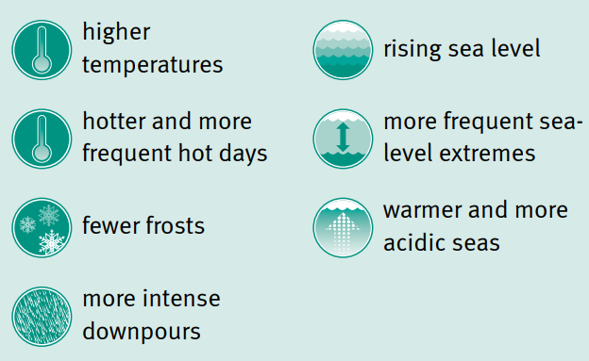

Temperature

Maximum, minimum and average temperatures are projected to continue to rise. For the near future (2030), the annually averaged warming is projected to be between 0.4 and 1.5°C above the climate of 1986–2005. By 2070, the projected range of warming is 1.0 to 3.8°C, depending on future emissions. The region’s current summer average temperature is 27°C. This could rise to over 28°C by 2030 and to over 30°C by 2070.

The table below shows the projected number of days above 35°C for two observing stations in Central Queensland with good historical records.

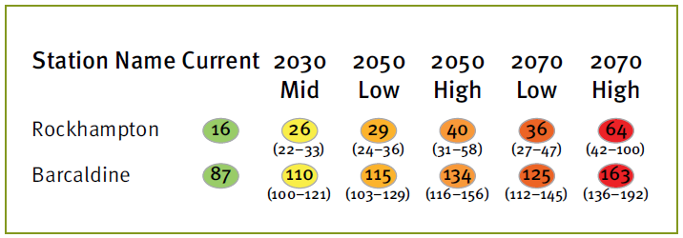

Number of hot days per year above 35°C projected for 2030 (mild emission scenario) and 2050 and 2070 (low and high emissions scenarios.

Under a high emissions scenario in 2070 for Rockhampton, the number of hot days above 35°C are projected to increase from 16 to 64 days.

- The projected higher temperatures and more hot days above 35°C can result in significant health impacts such as heat exhaustion and increased mortality among vulnerable sectors of the community such as the very young or old.
- Furthermore, increased temperatures are likely to cause more regular coral bleaching in the Great Barrier Reef. These bleaching events are very likely to become more severe as temperatures increase and such events could occur annually by 2050.

Rainfall

Average annual rainfall in the last decade fell by nearly 14 per cent compared with the previous 30 years. This is generally consistent with natural variability experienced over the last 110 years, which makes it difficult to detect any influence of climate change at this stage.

Models have projected a range of rainfall changes from an annual increase of 17 per cent to a decrease of 35 per cent by 2070. The ‘best estimate’ of projected rainfall change shows a decrease under all emissions scenarios.

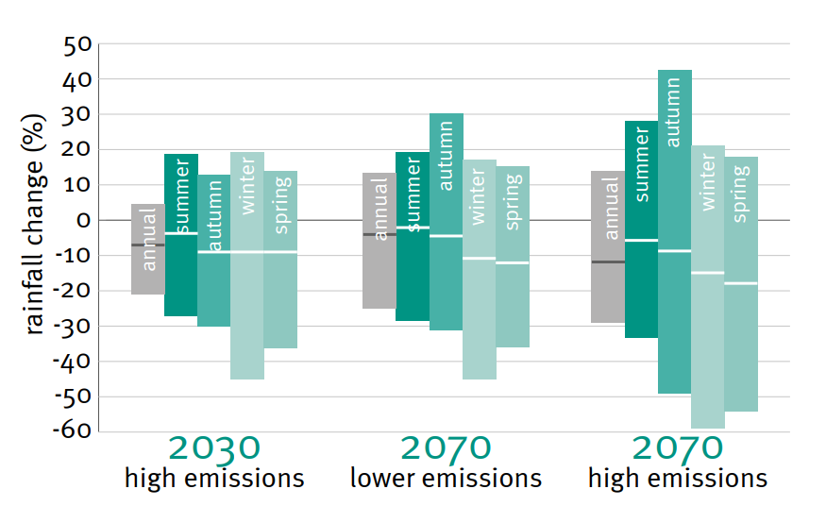

Projected annual and seasonal rainfall changes for the Central Queensland region. The horizontal line on each bar is the middle (median) projected rainfall change. The extent of the bar indicates the range of projected changes (sourced www.qld.gov.au/environment/climate/climate-change).

Extreme events

Increases in extreme storm events are expected to cause more flash flooding, affecting industry and infrastructure, including water, sewerage and stormwater, transport and communications. The higher risk areas are those closest to the coast, which can incur flash flooding, wind damage and considerable structural damage from falling trees, affecting industry, infrastructure and roads.

Recent studies have projected a slight decrease (nine per cent) in tropical cyclone frequency off the east coast of Australia by 2070; however, they also simulate an increase in the number of long-lived and severe (Category 3–5) eastern Australian tropical cyclones. Climate change is likely to exacerbate the frequency and severity of these events.

Impact

With projected increases in future cyclones and a projected rise in mean sea levels, storm surges will be able to penetrate further inland, greatly increasing the risk of damage to natural ecosystems, infrastructure and the risk of erosion in low-lying coastal regions.

The region has significant areas of land under irrigation for agricultural/horticultural production and therefore a high rural water demand. As its population increases, coastal developments and the expansion in mining and industrial activity all add to the pressure on the water resources. Any further reductions in water availability will place great pressure on consumptive uses and exacerbate competition with environmental water uses.

In addition to the impacts on water resources, climate change is expected to have long-term impacts on agriculture, human health, infrastructure, economic activity and coastal and marine ecosystems. For example:

- In the winter of 2050, under the high emissions scenario, the predicted decline in rainfall (-9 per cent), increasing high temperatures (+2.0°C) and an increase in evaporation (+8 per cent) could result in challenges in supplying sufficient water to meet demand.

Climate change also has the potential to significantly affect biodiversity in coastal areas through the alteration of habitat. In addition, the increasing concentration of carbon dioxide is set to cause increased acidification of the sea water which, in turn, impacts coral formation. This adds a further dimension to the Great Barrier Reef’s vulnerability to climate change.

The management of infrastructure and tourism activities is likely to be adversely affected by projected increases in temperature, sea-level rises and changes to rainfall patterns. Additional demands on water supplies will come from increasing agricultural, industrial, commercial and mining activity and these demands will likely be exacerbated.

Well-considered and effective adaptation measures can limit the adverse impacts of climate change on communities, the economy and natural systems.

Hazards

Hazards which may present as a risk to the Rockhampton Disaster District include, but are not limited to:

Natural Hazards
Meteorological | - Cyclone  - Storm tide  - Severe weather and thunderstorms  - Bushfire  - Flood  - Heatwave
Geological | - Earthquake  - Landslip and/or debris flow  - Tsunami  - Dam failure
Biological | - Epidemic /Pandemic human disease  - Animal and/or plant disease  - Insect and vermin plague
Non-Natural Hazards
Human-caused | - Terrorism  - Explosions  - Chemical spill  - Sabotage of essential services  - Information technology virus/significant compromise  - Major transport incident
Technological | - Failure of critical infrastructure  - Hazardous materials accident  - Dam failure  - Aeronautical and/or space debris  - Transport related mechanical failure

Cyclone

The Capricorn coast is prone to cyclones during the warmer months of the year. The risk from cyclones is high due to the location of populated areas to the coast. Actual damage from cyclones is infrequent; however, following any cyclone / storm activity widespread flooding may occur in the wider catchment area (see summary below).

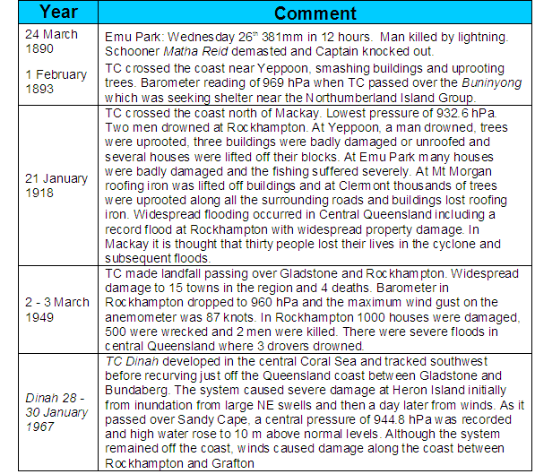

Source BoM – Historical impacts along the east coast (summarised to Rockhampton District area).

According to the Bureau of Meteorology, six (6) to eight (8) cyclones may develop in the vicinity of Australia annually. Of these one (1) or two (2) can be expected to be severe cyclones, category 3 to 5, and one (1) or two (2) can be expected to cross the coastline of eastern Queensland.

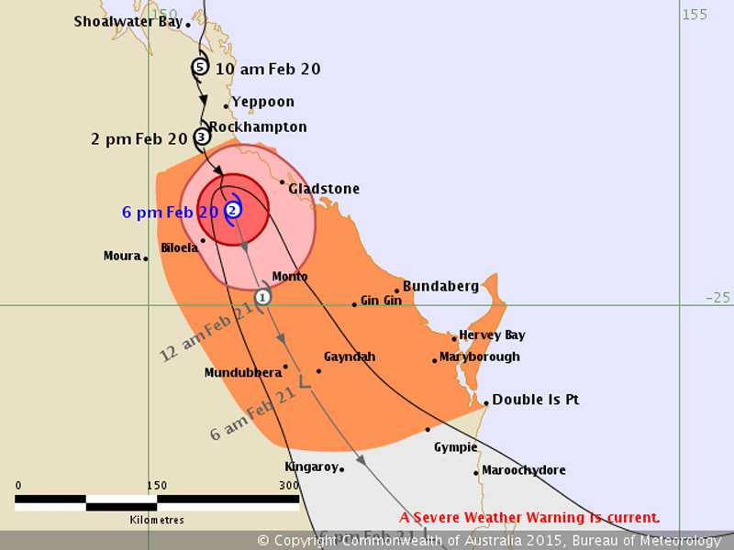

Tropical Cyclone Marcia track map 20 February 2015 (sourced BOM).

Friday 20 February 2015, Tropical Cyclone Marcia was upgraded to a Category 5 event. The Yeppoon Cyclone shelter was locked down at 7.30am with 817 residence in attendance plus the shelter management team. Tropical Cyclone Marcia crossed the coast at Shoalwater Bay at 8am and by 11am the core of the cyclone was west of Yeppoon (Yeppoon AWS records 156kph wind gusts (Cat 2) by 1pm Rockhampton AWS records wind gusts of 113kph).

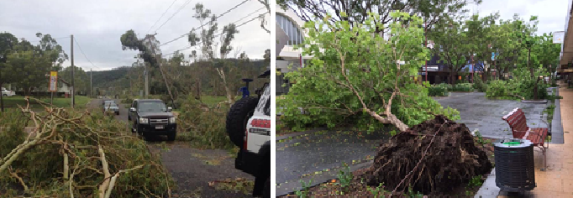

On passing, significant damage and widespread power outages were noted. Damage to Council assets was considerable with damage to the vegetation assets largely immeasurable. Approximately 14 Bunya Pines at the Rockhampton Botanic Gardens were either uprooted or severely damaged by the cyclone and these trees were around 140 years old.

Cyclone strengths are measured according to the wind speed of the strongest gusts, and are categorised as 1 to 5. The cyclone categories, including wind speeds and the typical effects may be described diagrammatically as follows:

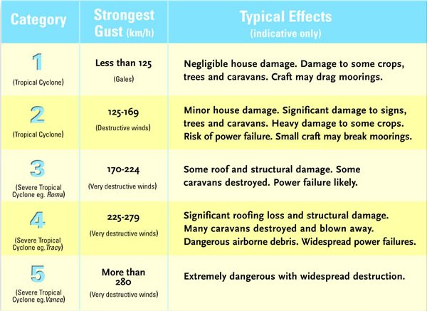

Source: Bureau of Meteorology Website: www.bom.gov.au

WARNING SYSTEMS: There is a clear need to fully understand the official warning system for cyclones.

CYCLONE WATCH: Cyclone approaching but winds not expected to reach area for next 24- 48 hours.

CYCLONE WARNING: Cyclonic winds expected within 24 hours.

The Livingstone Shire Council area has a purpose built cyclone shelter located at the Yeppoon State High School (Rawlings and Tabone Street), Yeppoon. Persons are requested to educate themselves on these facilities including the need to seek other alternatives rather than as a priority point of shelter during the passage of a cyclone. Such advice is included within the Queensland Public Cyclone Shelters – Operations Guidelines Interim 2012 as provided below:

Cyclone shelters are not intended to provide for people who should stay in their place of residence if that residence is not in the evacuation zones or vulnerable to high winds. Shelters will have space for a predetermined number of people and priority will be given to those who are told to evacuate and have nowhere else to go (Queensland Public Cyclone Shelters – Operations Guidelines Interim 2012).

The Yeppoon Cyclone Shelter is included in the facilities available for shelter however only in the occurrence of a Cyclone and Storm Surge event.

Storm tide

Storm tides (surges) are produced by all tropical cyclones and comprise the effects of the wind, waves and currents in association with the actual tide recorded, the cyclones central pressure, forward speed and direction and Bathymetry in the area where the event is occurring. The storm tide components may be described diagrammatically as follows:

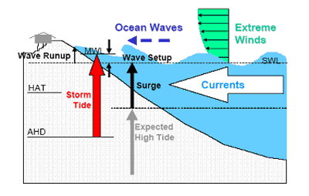

Source: Bureau of Meteorology Website: www.bom.gov.au

The height of the storm tide is obtained by adding the effect the storm has on the sea level (the storm surge) to the normal tide level at the time. In order for a storm tide to occur the cyclone must pass to the north of the affected area. The tide at the time and severity of the cyclone will determine the height of the storm tide.

Storm tide inundation and extreme wave action conditions are the coastal hazards with the greatest potential for loss or harm to the community and environment. All coastal local governments have maps which depict the varying levels of inundation that may be expected with different levels of storm tides.

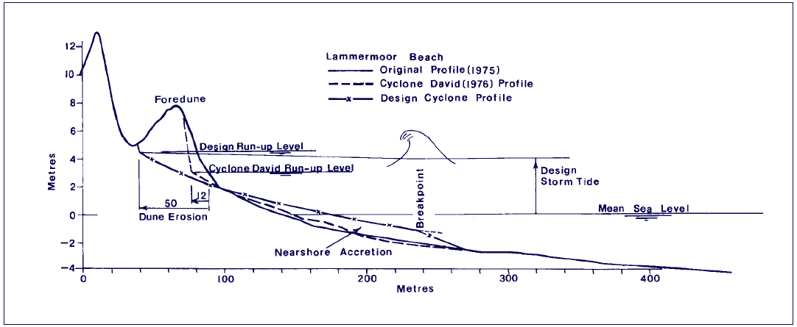

Cyclone dune erosion at Lammermoor Beach showing the erosion that occurred as a result of Cyclone ‘David’ in January 1976, and the erosion that would occur as a result of the 100 year return period cyclone and accompanying storm surge.

Source; - Murray, R. Cyclones and Their Effects on Beaches. IN: “Beach Conservation”, Issue No. 46, January 1982, Beach Protection Authority of Queensland.

Storm tides contribute to damage to coastal areas by flooding low-lying land, preventing access to and from cyclone damaged areas, contaminating water supplies, and allowing higher-than-normal wave action to cause beach erosion and attack coastal structures.

This would only affect the coastal areas of Livingstone Shire Council and around Port Alma within the Rockhampton Regional Council area and only has some effect with winds over 75 km/h, very low central pressure or the effects from tsunamis. A Storm Surge Warning is given from the Bureau of Meteorology to the Disaster District Coordinator at least 12 hours prior to the event for evacuation purposes.

Tsunami

Events have shown that, even if tsunamis occur infrequently, their effect can be catastrophic. People living or working in areas potentially affected by a tsunami need to know that they should move to safer areas if a tsunami warning affecting them is issued. The BoM advice in its land inundation warnings is for people to move at least ten metres above sea level or at least one kilometre away from all beaches and the waters edge of harbours and coastal estuaries.

The risk of Tsunamis to the Rockhampton Disaster District area is considered low however the amplification factor is comparatively higher than most areas of the State.

Tsunami events can have serious consequences with mitigation for such events being indefinable. Modelling shows that:

- Nearshore tsunami wave heights are significantly reduced by propagation across the Great Barrier Reef;
- Nearshore wave heights are greatest where there are gaps in the reef or beyond the extent of the reef;
- Attenuation of tsunami wave heights is the greatest in the Torres Strait and Gulf of Carpentaria;
- With the exception of the three modelled Queensland communities of Rockhampton, Gold Coast, and Hervey Bay, tsunami wave heights at 20 m are reduced to between 0.6 and less than 0.1 times the wave heights at the 100 m contour.

The following table shows the modelled amplification factors for Queensland.

Community | Amplification Factor
Badu Island | 0.1
Bamaga | 0.1
Weipa | < 0.1 ‐ 0.3
Lockhart River | 0.1
Aurukun | < 0.1 ‐ 0.3
Cooktown | 0.1
Lucinda | 0.3 ‐ 0.5
Karumba | < 0.1 ‐ 0.1
Innisfail | 0.2 ‐0.3
Townsville | 0.2 ‐0.6
Mackay | 0.3 ‐ 0.4
Rockhampton | 0.4 ‐ 0.6
Gladstone | 0.4 ‐ 0.7
Bundaberg | 0.6 ‐0.9
Hervey Bay | 0.6 ‐ 0.8
Brisbane | 0.2 ‐ 0.4
Gold Coast | 1.3 ‐ 2.1

Amplification Factors in 20 M water depth for Queensland communities listed from North to South.

The BoM has legislative responsibility for the issue of warnings of gales, storms and other weather conditions likely to endanger life or property.
The Joint Australian Tsunami Warning Centre (JATWC), operated by the BoM and GeoScience Australia (GA), is the issuing authority for tsunami warning products for Australia with warning information available through the BoM website.
Tsunami Warnings start with detection of an earthquake by GA. GA seismologists assess whether the earthquake has the potential to generate a tsunami and advise the Bureau of their findings. The Bureau completes the analysis and determines whether a threat exists to Australia or not.

If a threat does not exist then a No Threat Bulletin is issued to the Bureau’s Regional Forecast Centres. If a threat does exist, then a National Tsunami Watch is similarly issued.

During the Watch phase, which lasts up to 30 minutes, further information-gathering and evaluation is conducted to update the threat assessment. This will result in state-focused Tsunami Warnings, if warranted, and a cancellation once the threat is over or if it does not eventuate.

A description of the JATWC warning product suite issued is listed below:
  - National No Threat Bulletin: To advise people that the earthquake has been assessed and that no tsunami threat exists to Australia or its territories.
  - National or State / Territory Watch: To advise people that a tsunami threat to Australia or its territories may exist and that they should look out for further updates.
  - State / Territory Warning: To advise people that a tsunami threat to their state / territory does exist and to advise them of the level of threat (marine or land) and action they should take.
  - Tsunami Watch or Warning Cancellation: to advise when the main threat to Australia and its territories has passed or a tsunami fails to eventuate.
  - National Warning Summary: To provide the public, media and emergency authorities with the status of tsunami warnings nationally.
  - Event Summary: To provide the public, media, emergency authorities and government with summary information that can be used in post-event analysis.
JATWC will make these available:
  - through the BoM website (www.bom.gov.au/tsunami) and through the 1300 TSUNAMI automated recording number, and
  - directly by email and / or fax through the BoM to media outlets (for broadcast), and State Government departments, Local Government authorities, other Federal Government agencies and other major key recipients (including QPS).

Queensland’s processes to manage JATWC warning products

Queensland’s management of tsunami warnings is covered in the Queensland Tsunami Notification Protocol (QTNP), in agency plans and SOPs, and in LDMG and DDMG plans.

The Queensland Fire and Emergency Service, through the State Disaster Coordination Centre (SDCC) receives all warnings on behalf of the Queensland Government. Warnings are disseminated to Queensland Disaster Management Arrangement stakeholders by SMS, telephone and email.

The DDC will implement local arrangements to ensure the dissemination of all warnings to DDMG members.

Sequence of watches and warnings

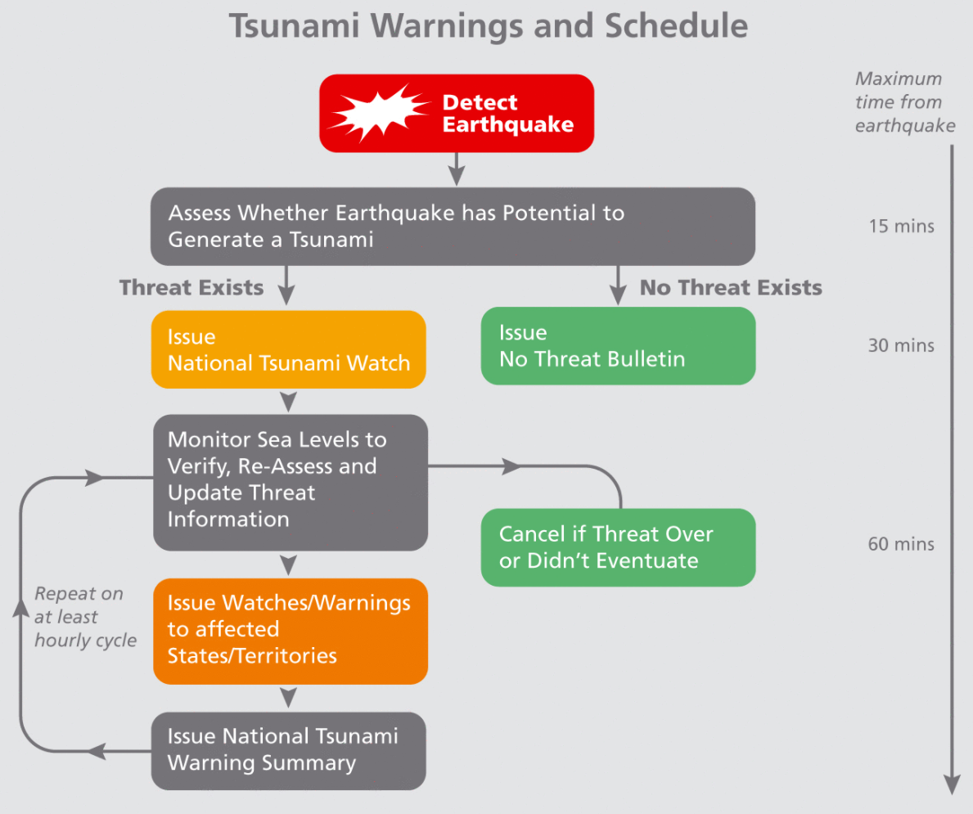

1 This advice is based on international studies documented in Preparing Your Community for Tsunamis
(http://www.preventionweb.net/files/3984_PreparingYourCommunityforTsunamisV21.pdf) and Bureau of Meteorology analysis and moderation for Australian use.

Tsunami planning

The role of the DDMG in relation to tsunami specific planning includes ensuring:

- an understanding of tsunami risk within the District;
- the integration of State agency and LDMG tsunami planning at the local level; and
- LDMG Tsunami Sub Plans are prepared, regularly reviewed and monitored.

Reliable information regarding any tsunami threat is essential for all members of the community. Reliable sources of information in Queensland regarding tsunami warning products are:
  - JATWC website, http://www.bom.gov.au/tsunami,
  - 1300 TSUNAMI (1300 878 6264),

Floods

Within the Rockhampton Disaster District flooding is most likely to occur during the summer month wet season and occurs mainly as a consequence of heavy rains associated with low pressure systems and cyclones. The Fitzroy River has a history of flooding following heavy rains across the catchment area. Flooding however does not normally occur simultaneously over the whole of the catchment. The Fitzroy Basin covers an area of 140 000 square kilometres to the east of the Great Dividing Range in Central Queensland.

Communities are not able to prevent flooding, however, they are able to plan for such events and in doing so prevent and mitigate their affects. Preventing or restricting development in known flood prone areas reduces future impacts being placed on communities.

The Fitzroy’s major tributaries, the Dawson, Mackenzie and Connors Rivers rise in the eastern coastal ranges and in the Great Dividing Range and join together about 100 kilometres west of Rockhampton. Major floods can result from either the Dawson or the Connors-Mackenzie Rivers. Significant flooding in the Rockhampton area can also occur from heavy rain in the local area below Riverslea as occurred during the Australia Day long weekend 2013, when heavy rainfall as a result of Ex tropical Cyclone Oswald resulted in a number of sites within 40 kilometres of Rockhampton exceeding 400 millimetres, including 587 millimetres at Upper Dee (near Mount Morgan) and 556.6 millimetres at Pacific Heights, while Rockhampton itself received 349 millimetres.

The highest recorded flood occurred in January 1918 and reached 10.11 metres on the Rockhampton gauge (listed as a 1 in 100 year event). Recent major flooding of the Fitzroy River spanned over the end of December 2010 and early January 2011. The Fitzroy River reached 9.20 metres on the Rockhampton gauge. This period also provided the towns of Emerald, Rolleston and Theodore with their largest floods on record (source BOM website).

The table below summarises the flood history of the Fitzroy River catchment - it contains the flood gauge heights for the more significant recent floods.

Flood Event | Yatton | Tartrus | Emerald | Taroom | Theodore | Moura | Baralaba | Yaamba | Rockhampton
Jan 1918 | - | - | - | 6.71 | - | - | - | 17.32 | 10.11
Feb 1954 | - | 17.48 | 14.12 | 8.15 | 13.64 | - | 15.52 | 16.59 | 9.40
Jan/Feb 1978 | 17.99 | 16.60 | 12.97 | 4.08 | 11.27 | 10.46 | 11.85 | 14.75 | 8.15
May 1983 | 15.39 | 14.90 | 12.00 | 7.46 | 13.24 | 12.09 | 13.60 | 14.97 | 8.25
Jan 1991 | 17.64 | 18.10 | - | 6.24 | 7.98 | 6.60 | 9.45 | 16.65 | 9.30
Jan 2008 | 17.07 | 16.20 | 15.36 | 6.07 | - | 8.00 | - | 14.25 | 7.50
Feb/Mar 2010 | 15.68 | 11.81 | 9.40 | 7.26 | 13.45 | 12.23 | 12.50 | 10.73 | 5.30
Dec 10/ Jan 11 | 16.54 | 16.34 | 16.05 | 10.43 | 14.70 | 12.66 | 15.25 | 16.55 | 9.20
Feb/Mar 2012 | 17.38 | 15.90 | - | 6.35 | 9.78 | 8.52 | - | 13.50 | 7.10
Jan/Feb 2013 | - | 15.86 | - | 5.32 | 9.03 | 9.30 | - | 15.70 | 8.61
Mar/Apr 2017 | 19.68 | 18.29 | - | - | - | - | - | 16.10 | 8.9

All heights are in metres on flood gauges BOM - Fitzroy Catchment.

Throughout the district there are a series of river systems ranging from permanent water to normally dry systems that may fill rapidly. Calculating the rise and fall of the river systems is the role of the BoM hydrology section, whilst the data obtained from this service is very accurate and timely it must be remembered that many of the river systems do not have any type of measuring systems in place.

The Bureau has developed procedures for forecasting flood levels at Rockhampton at least 72 hours prior to the waters entering the Rockhampton city area through the automatic river height recorder at Riverslea.

In consultation with the Rockhampton Regional Council, the Bureau issues predictions of flood heights for the Fitzroy River at Rockhampton whenever it is expected to exceed 7 metres on the city gauge. The objective is to provide at least 60 hours warning of flood heights above 7 metres (see Flood level classification – Fitzroy River at Rockhampton).

Times occupied by the flood to travel between Riverslea and the lower recording stations are:

Riverslea – Yaamba 41 (forty one) hours Yaamba – Rockhampton 9 (nine) hours)

Example with the flood height at Riverslea – Rockhampton 50 hours Riverslea 27.4metres at 9am on the 10th the height of the river gauge at Yaamba will be 16.55 metres at 2.am. on the 12th and 9.2m at Rockhampton at 11am on the 12th.

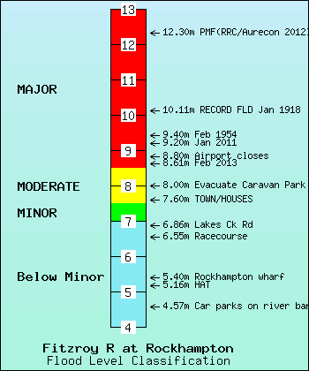

Flood level classification and effect for the Fitzroy River at Rockhampton.

A similar guide has been determined from the river gauges of the Nogoa Catchment, shown as follows:

Flow time for large to very large rain events from top of catchment to the downstream side of Emerald
Large Rain events producing large out of bank flows movement through zones
Craigmore River Gauge to Emerald | 48 hours
Raymond River Gauge to Craigmore river Gauge | 24 hours
Mantuan homestead to Raymond river Gauge | 24 hours
Top of catchment to Mantuan Homestead | 24 hours

The flow times of these events will vary with catchment conditions.

- Dry catchment and river bed with large coverage of vegetation will slow movement of flows by 25% in small to medium events.
- Wet catchments and river beds will increase movement of flows by 25% in small to medium events
- Dry catchments and river beds with good vegetation coverage in large events will slow the flows through the catchment as little as 10%
- Wet catchments and river beds will reduce the time taken for the flows to move through the catchment by 10% (sourced C&R Consulting Geochemical and Hydrobiological Solutions Pty Ltd).

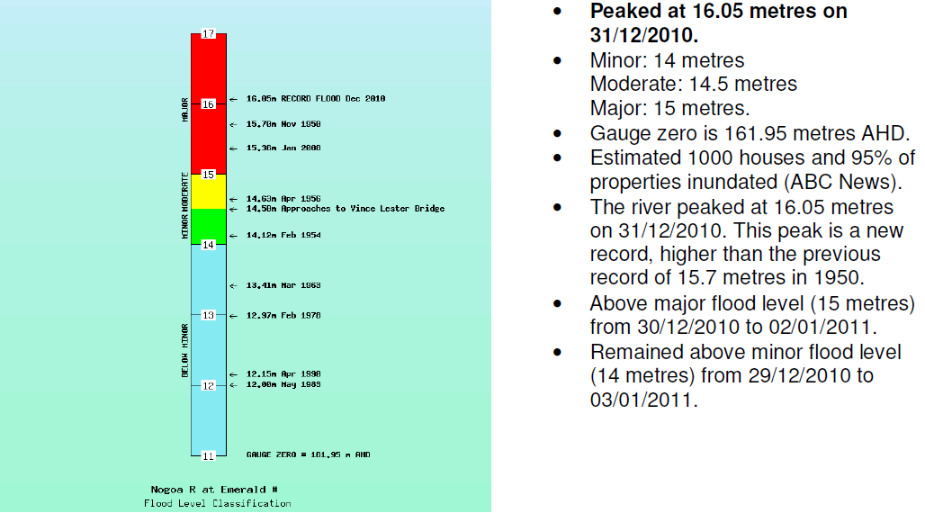

Flood level classification and effect for the Nogoa River at Emerald. Sourced: - Flood summary for the Nogoa River at Emerald – December 2010 and January 2011

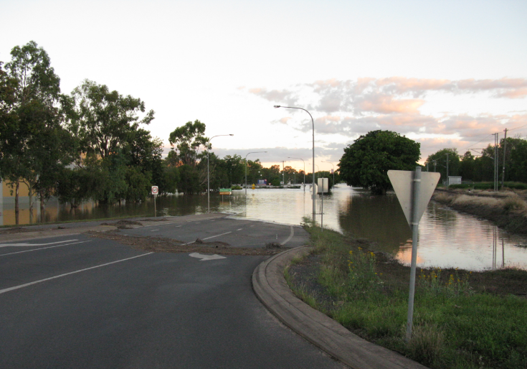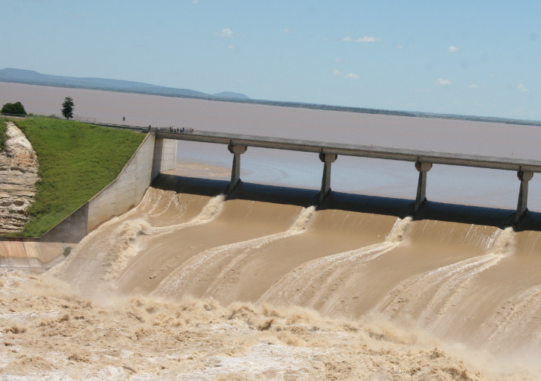

Fairbairn spillway and flooding to the highway blocking entry into Emerald from the south.

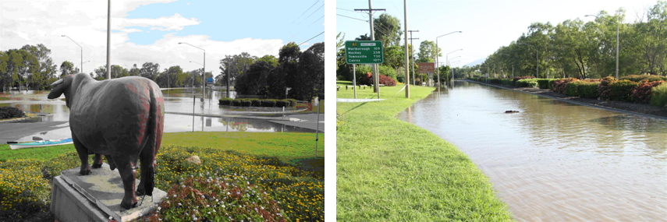

Flooding in Rockhampton January 2011 showing inundation near the Lower Dawson Road on entry to the city from the south.

Referrable Dams

There are six dams currently listed within the Rockhampton Disaster District as referrable dams. These being:

- Fairbairn Dam,
- Blackwater Coal Mine - Rockland Creek Dam,
- Russell Property Irrigation Dam (located within the Central Highlands LDMG area)
- Stanwell Water Supply Dam,
- Mount Morgan Water Supply - No. 7 Dam (located within the Rockhampton Regional Council LDMG area)
- Kelly’s Off-stream Storage (Livingstone Shire Council) LDMG area).

A Referrable Dam is defined within the Water Supply (Safety and Reliability) Act 2008 at section 341, as;

(1) A dam is, or a proposed dam after its construction will be, a referable dam if— (a) a failure impact assessment of the dam, or the proposed dam, is carried out under this part; and (b) the assessment states the dam has, or the proposed dam after its construction will have, a category 1 or category 2 failure impact rating; and (c) the chief executive has, under section 349, accepted the assessment.
(2) Also, a dam is a referable dam if— (a) under section 342B, the dam becomes a referable dam; and (b) the chief executive has not, under section 349, accepted a failure impact assessment of the dam. (3) The following are not referable dams— (a) a hazardous waste dam;
(b) a weir, unless the weir has a variable flow control structure on the crest of the weir. Note— For particular dams that are taken to be referable dams under this section, see section 611.

As referrable dams each of these dams is required to have in place an Emergency Action Plan (EAP) for monitoring the dam walls during times of extreme rainfall. These plans require the water levels and any other relevant information be provided to the relevant LDMG/DDMG.

Subject to any dam failures at each of these sites as referrable dams the owner/operators of these facilities are to notify all relevant downstream stakeholders and provide advice regarding the particular event. The role of the DDMG is to assist the LDMG in managing the event.

Whilst not classified within the definition as a ‘referrable dam’, the Mount Morgan tailings Dam (Mundic Gully), does have an Emergency Action Plan (EAP) and undergoes monitoring by The Department of Resources. The intent of this EAP is the coordination of response actions and the notification and communication of incidents involving the Mount Morgan open cut mine pit.

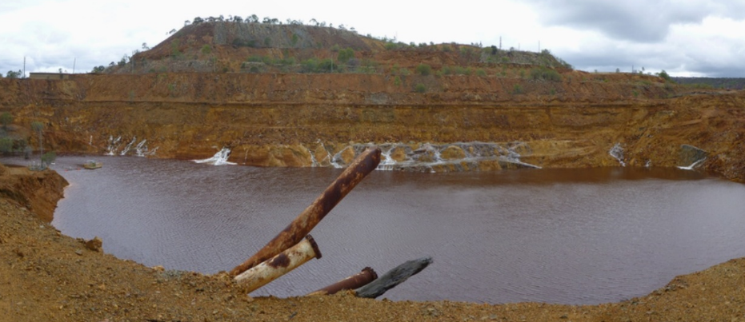

Mount Morgan Mine ‘Mundic Gully’ sourced Department of Natural Resources and Mines 27 January 2013.

A Failure Impact Assessment carried out for the mine pit has determined that there is a low risk of failure of the embankment. However, if the embankment containing the water in the mine pit was to fail, followed by failure of the slag embankment containing water in the Mundic West and East sumps, it has been shown that there is possibly a risk to property downstream as well as an environmental risk resulting from the release of contaminated water.

Should this occur warning through the Notification List (within the EAP) is to occur. The travel time for the flood wave from the failure of the embankment ranges from 2 to 6 hours depending on the breach mechanism investigated. Warning for the nominated residents should allow time to evacuate and to rescue property before any potential inundation occurs. Other sites that may be at risk include river crossings or the railway line downstream of the slag embankment. In addition to manual sampling sites automatic gauging sites are also located at:
- Dee River at Kenbula
- Dee River at Wura
- Don River at Rannes

Earthquake

Generally, the Australian continent is regarded as being very stable. However, even within our area quite a few earthquakes have been recorded as the following table highlights:

Magnitude Date Position Location
4.3 30/06/98 Swain reef 250km NE of Rockhampton
2.8 28/04/07 24.97 S 151.41 E 200km SE of Rockhampton
3.2 08/11/07 23.29 S 152.63 E 150km offshore Gladstone
2.6 22/01/10 24.47 S 151.5 E 60km S of Gladstone
3.3 04/10/19 20.68 S 152.50 E; 10 km depth 278km NNE of Yeppoon

(Source http://www.seis.com.au/ - Seismology Research Centre)

Historically reported earthquakes identified in proximity to the Rockhampton District include a 6.2 magnitude event offshore of Gladstone in 1918 and a 6.0 magnitude event north of Gayndah in 1935. This same report (1) provides that the Central Region (in particular North Burnett area) can expect on average at least a magnitude 6.0 earthquake every 85 years. (1) Earthquakes and the challenges they present to Disaster Managers in Rockhampton. M. Turnbull (2002).

The most common intensity scale used in Australia is the 12-point Modified Mercalli scale. On this scale intensities up to 5 are felt but cause no damage, with intensities from 6 to 12 causing increased amounts of damage. A Modified Mercalli Intensity of six is abbreviated as MMI 6.

Notwithstanding, the existence of even a slightly volatile seismic environment acts as a prompt for maintaining situational awareness of the threat, and its possible consequences. As with tsunamis, the mitigation for such an event is indefinable.

Modified Mercalli Intensity Scale
1 | Not felt. Recorded by seismographs.
2 | Rarely felt, usually only on top floors of high buildings.
3 | Felt indoors, like a passing light truck.
4 | Windows, dishes, doors rattle. Like passing train.
5 | Felt by all. Small objects upset.
6 | Books off shelves. Trees shake. Isolated damage.
7 | Difficult to stand. Many poor buildings damaged.
8 | Significant damage. Branches broken from trees.
9 | General panic. Serious damage. Ground cracking.
10 | Most buildings destroyed. Rails bent slightly.
11 | Rails bent greatly. Pipelines destroyed.
12 | Near total damage. Objects thrown into the air.

Heatwave

The Central Queensland Hospital and Health Service (CQHHS) Heatwave Response Plan provides guidance on prevention, preparedness, response and recovery to a heatwave. During a heatwave, health will be the lead agency and will be required to distribute specific heatwave information to the Central Queensland community.

Heatwave Levels

A heatwave is described by the Australian Bureau of Meteorology as three or more days of high maximum and minimum temperatures that are unusual for a given location (BOM, 2023). A heat wave always includes the combination of intensity and duration of high temperature periods (source The Longpaddock).

The Bureau of Meteorology’s (BoM) National Heatwave Forecasting and Assessment Service operates from the start of November to the end of March and provides advance notice of unusually hot conditions.

Heatwave Type | Temperature |  | Community Impact (see Risk)
No heatwave | White | Normal | -
Low intensity heatwave | Yellow | Top 10% | Most people expected to have adequate capacity to cope with this level of heat but begin to see health effects. Increased risk to vulnerable groups.
Severe heatwave | Orange | Top 2% | Increased morbidity and mortality for vulnerable groups, such as those over 65, pregnant women, babies and young children, and those with chronic illness (e.g. renal disease, ischaemic heart disease).
Extreme heatwave | Red | Top 1% | May impact normally reliable infrastructure, such as power and transport. Health risk for anyone who does not take precautions to keep cool, even those who are healthy.

Public Health effects of a heatwave

In the last 200 years, severe and extreme heatwaves have taken more lives than any other natural hazard in Australia. Health impacts may include clinical, mental health and public health effects. The main causes of illness and death during a heatwave are related to respiratory and cardiovascular diseases.

Other health impacts may be noted on the human population:

- In addition to direct effects on individuals, heatwaves create additional risks to health due to damage to power infrastructure resulting in loss of power.
- Loss of power results in a loss of refrigeration of food increasing the risk of food borne illness if not effectively managed. Hot weather also increases the risk of food borne disease due to stresses in food production, particularly for chicken and eggs. Salmonella outbreaks are more common in hot months. These risks can be mitigated through more careful food handling practices.
- Loss of refrigeration can cause damage to certain medicines, for example, insulin and also vaccines, reducing their efficacy.
- Loss of power can also result in the shutdown of water treatment plants and, depending on the availability of reserves in the system may require the issuing of boil water notices. These risks will be managed by drinking water providers.
- Sewerage pumps may cease to operate resulting in sewage overflows into the environment which may require advice to the community to avoid at-risk areas.

Heatwave projections for the Central Highlands (1986 to 2090) – source State Heatwave Risk Assessment Executive Summary

Understanding the data

Index | Heatwave Index | Definition
HWF | Heatwave frequency | Number of heatwave days relative to number of days in a year - i.e. [number of heatwave days/365] x 100 (%)
HWD | Heatwave duration | Number of days of the longest heatwave of the year (days)
HWMt | Temperature of heatwave magnitude | Average mean temperature (in ˚C) of all heatwave days across the year
HWAt | Temperature of heatwave amplitude | Average mean temperature (in ˚C) of the hottest heatwave days of the year
Hot days | Days >35˚C | Annual count of days with maximum temperature >35°C
Hot Nights | Nights >20˚C | Annual count of nights with minimum temperature >20°C
Note: All figures represent an absolute change from the reference period (1986 to 2005) unless expressed in negative terms, based on RCP 8.5.

Central Highlands

Index | Heatwave Index | Reference | 2030 | 2050 | 2070 | 2090
HWF | Heatwave frequency (%) | 2.7% | 3.0% | 8.1% | 16.3% | 26.5%
HWD | Heatwave duration (days) | 5 | 3 | 7 | 16 | 33
HWMt | Temperature of heatwave  amplitude (˚C) | 31.8 | 32.4 | 33.2 | 34.2 | 35.3
Hot days | Days >35˚C | 50 | 62 | 85 | 95 | 117
Hot nights | Nights >20˚C | 86 | 117 | 146 | 178 | 206

Pandemic Disease

For Pandemic Planning the Rockhampton DDMG acknowledges that Queensland Health has functional lead agency responsibility in accordance with the Queensland State Disaster Management Plan QSDMP and supporting QLD WoG Pandemic Plan 2020.

The Rockhampton DDMG also acknowledges close collaboration with the preventative strategies for exotic animal diseases in pre-pandemic surveillance – where a potential pandemic strain is circulating in animals.

The Central Queensland Hospital and Health Service (CQHHS) is responsible for the management and development of a pandemic disease response plan for disease in humans within the district. The CQHHS has prepared a Pandemic Influenza Plan for this purpose.

By definition, a novel virus, which is the most likely cause of a pandemic, would be associated with a relative lack of immunity within communities. Though the transmissibility of this type of disease will be a limiting factor, the combination of this lack of immunity and the rapid movement through modern international transport systems make it likely that once a novel influenza virus achieves efficient human to human transmission, it will spread across the globe and enter the population quite rapidly.

History demonstrates that influenza pandemics are moderately rare, but when they occur will generally be very deadly. The following table provides a summary of known influenza pandemic events worldwide:

Pandemic year of emergence and common name | Area of origin | Influenza A virus subtype (type of animal genetic introduction/recombination event) | Estimated case fatality | Estimated attributable excess mortality worldwide | Age groups most affected
1918  “Spanish flu” | Unclear | H1N1 (unknown) | 2–3% | 20–50 million | Young adults
1957–1958 “Asian flu” | Southern China | H2N2 (avian) | <0.2% | 1–4 million | All age groups
1968–1969 “Hong Kong flu” | Southern China | H3N2 (avian) | <0.2% | 1–4 million | All age groups
2009–2010 “influenza A(H1N1) 2009” | North America | H1N1 (swine) | 0.02% | 100 000–400 000 | Children and young adults
2019 – 2021  “Coronavirus (COVID-19)’ | Wuhan Region China | (COVID-19) | 2.7% | 4.29 million as at 9 August 2021 | Most impact on the elderly and those with preconditions.

Significant issues that may emerge during an influenza pandemic include:

- direct health related impacts, such as individual sickness, illness or death of a family member, and bereavement;
- significant staff absenteeism as a direct result of the illness, requirements for isolation or having to care for family members;
- impacts arising from social distancing and social isolation - accessing food or shelter, loss of income, loss of services;
- mental health impacts such as feelings of uncertainty and fear; loss of self-worth, loss of purpose, and loss of control; feelings of helplessness, resentment, or injustice;
- possible reduction of personal and community support mechanisms – absence of traditional volunteering to provide community support services, absence of social, sporting and service clubs;
- reduction in general community activity and levels of interaction (cancellation, postponement, restrictions or event venue changes); and
- disruption to economic activity caused by business continuity or supply chain disruption/failures.

Many of the measures which can be applied in response to a pandemic must be implemented early to be most effective. Pandemics are initially unpredictable and must be effectively planned for at all levels of government, business and community to ensure response and recovery is effective and sustainable improvement in their management is achieved.

Therefore, once there is sustained transmission of the pandemic disease within the community, it will be important to commence measures as quickly as possible, even though, due to the novel nature of the virus, it is unlikely there may be a good understanding of the epidemiology, clinical severity and virology of the disease.

While preventing a pandemic after person-to-person transmission becomes well established may be difficult, the systematic application of disease containment measures can significantly reduce disease transmission rates with concomitant reductions in the intensity and velocity of any pandemics that do occur. The goals of disease containment after a pandemic is underway are to delay the spread of disease and the occurrence of outbreaks in communities, to decrease the clinical attack rate in affected communities, and to distribute the number of cases that do occur over a longer interval, so as to minimize social and economic disruption and to minimize, so far as possible, hospitalization and impact on the health system.

An increase in patient presentations expected during a pandemic would significantly impact on the Districts health and hospital services capacity to respond. The preferred method of reducing the spread of disease is by supported behavioural change through increased hygiene practices, social distancing (which may include isolation), community awareness and education. In the event of a pandemic event affecting the district the DDMG may be required to assist the CQHHS in the management and containment of the disease.

The Central Queensland Hospital and Health Service will establish a Health Emergency Operations Centre (HEOC), Health Incident Command (HIC), and appoint a liaison officer to this command structure which will link to the DDMG.

The DDMG in this case may be required to assist in coordination of additional heath assets (including the establishment of fever or assessment clinics) or the distribution of anti-viral medication in the case of an influenza type disease.

Building preparedness will contribute to the resilience and sustainability of our systems. The resilience of individuals will be promoted by empowering them to manage their own exposure to the disease through public messaging about:

- the status of the disease in Australia and internationally;
- hygiene and cough/sneeze etiquette;
- disease transmission;
- understanding of how to recognise the signs and symptoms of the disease and when to seek medical assistance; and
- access to support and advice, including mental health services.

To build resilience within our most vulnerable populations, communications within the health sector will be used to raise awareness of at-risk groups and their associated needs. Measures will also be implemented with consideration of necessary adaptations to meet the needs of these individuals and communities. The needs and challenges of communicating with low socio-economic communities, which may have reduced access to healthcare, will also be considered.

On 29 January 2020, under the Public Health Act 2005, the Minister for Health and Minister for Ambulance Services made an order declaring a public health emergency in relation to coronavirus disease (COVID-19). The public health emergency area specified in the order is for ‘all of Queensland’. Its duration has been extended by regulation to 31 March 2021. Further to this declaration, the Chief Health Officer, issued directions pursuant to the powers under s 362B of the Public Health Act 2005 to assist in containing, or to respond to, the spread of COVID-19 within the community.

The Public Health Act 2005 provides the basic safeguards necessary to protect public health through cooperation between the state government, local governments, health care providers and the community.
This is achieved by:
- preventing, controlling and reducing risks to public health
- providing for the identification of, and response to, notifiable conditions
- defining obligations on persons and particular health care facilities involved in the provision of declared health services to minimise infection risk
- providing for the notification by doctors and registered nurses of child abuse and neglect, and protecting children who have been harmed or are at risk of harm when they present at health service facilities
- collecting and managing particular health information, and establishing mechanisms for health information held by the department to be accessed for appropriate research
- inquiring into serious public health matters
- responding to public health emergencies
- providing for compliance with this Act to be monitored and enforced.

A Rockhampton Disaster District Pandemic Subplan is contained at Appendix E to this plan.

Emergency Animal Disease (EAD)
Equine influenza (EI) is an acute, highly contagious, viral disease which can cause rapidly spreading outbreaks of respiratory disease in horses, donkeys, mules and other equine species. EI would have a major impact on the Australian horse industry if it were to become established here.
The disease is not generally fatal to horses however, fatalities may occur especially in old or infirmed horses and young foals. The disease is easily spread by:
- direct contact between infected and susceptible horses
- indirect contact with contaminated stock or equipment
- susceptible horses occupying buildings or vehicles recently occupied by diseased horses
- contact between contaminated horse handlers and healthy horses
Transmission of the EI virus to humans has not occurred during previous outbreaks however, it can be spread from people to horses very easily via infected skin, hair and clothing. The most recent incidents of equine influenza impacted heavily on horse related activities within Queensland and the nation.
In contrast the Hendra virus is a zoonotic disease, which means it can transfer from animals to people. Hendra virus can cause disease in horses but only rarely in humans. It can be transmitted from flying fox to horse, horse to horse, and horse to human.

There is no evidence that the virus can be transmitted from flying fox to human, or human to horse, or human to human. Flying foxes are a natural reservoir for Hendra virus. Flying foxes do not show any signs of illness when infected with Hendra virus. Although Hendra virus infection is periodically present in flying fox populations across Australia, the likelihood of horses becoming infected is very low.

Hendra virus can cause a range of clinical signs in horses and should be considered where there is an acute onset of clinical signs and rapid progression to death associated with either respiratory and/or neurological signs. The mortality rate in affected horses is approximately 75%.

Date | Location | Number of confirmed equine cases
Jul-09 | Cawarral | 3
May-12 | Rockhampton | 1
Jul-12 | Rockhampton | 3

The above table outlines the number of confirmed Hendra virus equine cases in Rockhampton Disaster District area (source DAF website).

The outbreak of an exotic animal disease would create a major problem given the large number and regular movement of livestock throughout the district. Controls may require implementing restrictions on the movement of people, livestock and animal products and extensive testing to ensure that the area remains disease free. Both the Commonwealth and State have in place plans and procedures AUSVETPLAN and QLDVETPLAN, to deal with these types of outbreaks.

In the event of an incident involving an exotic animal disease in the district the role of the DDMG is to provide support to the Department of Agriculture and Fisheries (DAF). Support will be required to initiate and maintain the investigative phase of the response as well as the maintenance of any standstill orders issued.

HAZMAT incidents

The Rockhampton Disaster District contains numerous mine sites and processing plants for minerals and explosives. As such there are numerous bulk holding facilities for chemicals (liquid, solids and gas). Many of these chemicals are considered to be harmful to humans and can cause significant environmental damage if spilled or released.

These bulk holding facilities are built to a standard that makes the likelihood of an unexpected or accidental release of chemicals unlikely. The greatest risk of chemical or gas hazard is during their transportation.

The response agency for Hazmat incidents is QFES. In conjunction with Department of Resources they are responsible for the minimization of spills and the associated clean up. Due to the remote nature of many mine, industrial and ports sites the response time to chemical incidents can be protracted. Each of these facilities are to have an Emergency Plan to manage the initial response.

Mining Subsidence / accidents

Owing to the many and varied mining activities in the District, most Companies have produced their own emergency procedures manual and have internal emergency procedures to deal with these types of events. The DDMG may be called upon in support of such incidents.

Fires

An outbreak of a large uncontrolled fire requires a coordinated response from QFES, QPS, SES, Queensland Parks and Wildlife Services (QPWS), Queensland Health, QAS and Local government. In the district there is a mixture of urban and rural fire services each with a clear commitment to prevention and mitigation for fire management and in response to fire emergencies.
Messages are issued to inform the community when a fire starts. There will be three types of alert messages: Advice, Watch and Act and Emergency Warnings.
- Advice messages will keep people informed and up to date with fire development.
- Watch and act messages will advise people to take action to prepare and protect themselves.
- Emergency Warnings, accompanied by the siren sound (Standard Emergency Warning Signal), will be activated to advise the community they must take action immediately, as they will be impacted by the fire.

When a bushfire strikes, the community expects timely and accurate information about the incident, including advice about what actions people should take to keep themselves, their family and property safe. QFES has the responsibility for issuing bushfire warnings in Queensland.
In addition Queensland Health (After-a-disaster - bushfires) also uses facts sheets to communicate messaging including:

- Bushfire smoke and your health
- Bushfires and roof-harvested rainwater
- Fire retardants and health
- Cleaning up a smoke affected home
- After a fire returning home safely
- After a fire asbestos hazards
- Airborne dust and health effects

Many smaller communities are serviced by a rural facility with limited capability in responding to a structural fire. Rural fire services do not have the capacity to enter an involved building and are focused only on reducing the spread of the fire.
Fire Danger Ratings (Fire Behaviour Index – FBI) are:

CATASTROPHIC  100+ | For your survival, leave bush fire risk areas.  If a fire starts and takes hold, lives are likely to be lost.  These are the most dangerous conditions for a fire.  Your life may depend on the decisions you make, even before there is a fire.  Stay safe by going to a safer location early in the morning or the night before.  Homes cannot withstand fires in these conditions. You may not be able to leave and help may not be available.
EXTREME  FBI 50-99 | Take action now to protect your life and property.  Fires will spread quickly and be extremely dangerous.  These are dangerous fire conditions.  Check your bushfire plan and that your property is bush fire ready.  If a fire starts, take immediate action. If you and your property are not prepared to the highest level, go to a safer location well before the fire impacts.  Reconsider travel through bush fire risk areas.
HIGH  FBI 24-49 | Be ready to act.  Fires can be dangerous.  There’s a heightened risk. Be alert for fires in your area.  Decide what you will do if a fire starts.  If a fire starts, your life and property may be at risk. The safest option is to avoid bush fire risk areas.
MODERATE  FBI 12-23 | Plan and prepare.  Most Fires can be controlled.  Stay up to date and be ready to act if there is a fire.
NO RATING  FBI 0-11 | Minimal risk.

Urban fires

The threat of major industrial fires within the district is moderate. Many fuel companies have storage depots in most towns, however, there are adequate fire services available to combat any outbreak in towns which have recognized urban brigades.

The management of urban fires is the responsibility of the QFES. The role of the DDMG in urban fires is to provide assistance to local groups in the event that an urban fire causes significant death or destruction of property and infrastructure.

The Rockhampton fires of October 2009, had fires throughout Mt Archer National Park traversing the ranges and threatening homes down through Cawarral, Koongal, Lakes Creek and Frenchville. These fires required significant coordinated effort to address their impact.

Rural fires

The likelihood of large rural fires within the District is considered moderate to high especially after a flood 'wet' season, and with the drying off of vegetation. Previous rural fires within the District have resulted in both loss of stock and crops and large expenditure by local authorities in human resources and equipment. Risk to populated areas is considered low due to the type of vegetation in the area. There is the possibility that rural fires may threaten structures located on properties within the district.

QFES is the agency responsible for response and mitigation measures in relation to rural fires. The role of the DDMG is to provide assistance to local groups in response and recovery phases of significant rural fires.

On Wednesday 28 November 2018, Rockhampton recorded catastrophic fire conditions for approximately three-and-a-half hours (between 1.30-5pm local time), described as unprecedented by the Bushfire Natural Hazards Cooperative Research Centre. The C-Haines Index – (measure of the potential for dry unstable air to contribute to large or erratic bushfires) recorded several spikes in Rockhampton, with values close to the theoretical maximum.

A predictive assessment and the subsequent warnings issued on a fire within Stanwell/Kabra area required the evacuation of approximately 8400 persons and water-bombing of the fire threat.

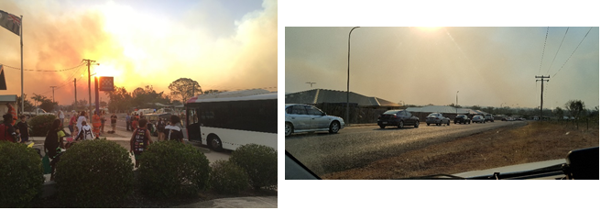
Evacuating the community of Gracemere (Gracemere Police Station assembly point). Gracemere has a resident population of approximately 8400 persons.
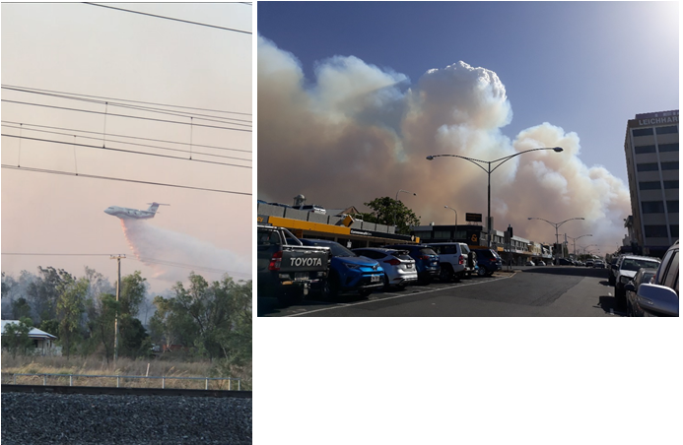
- Aerial waterbombing as fire suppression to the Stanwell fire.
- Denham Street, Rockhampton towards Gracemere

Within the Central Highlands LDMG area wildfires caused tourists to leave the Takarakka Bush Resort throughout the day of 28 November 2018. Minor damage was sustained to the ranger’s accommodation and two cabins within the wilderness lodge were destroyed and another three damaged.

CHRC flyover – smoke flowing off the western side of the Shotover Range at 6.18am 30 November 2018.

Transport access / egress / accidents (Road, Rail, Air or Sea)

Road

The potential for a major traffic accident involving tourist buses / road trains etc., is considered high. The increase in tourism and mining activities in the district together with the distances being travelled increases the potential of a major mass casualty event occurring.

Areas located on the main highways have a higher risk due to the number of coaches and other heavy vehicles frequenting these roads. The lack of medical services capable of dealing with mass casualties compounds the risk from road accidents. Whilst there is a great potential for this to occur their likelihood does not normally necessitate the involvement of the disaster management system.

Rail

The risk of a major rail accident within the confines of the Rockhampton District is considered high. The ain lines, north, west and south carry both passenger and goods trains with numerous coal trains of immense length. Major problems to be considered would be;

(1) Terrain;
(2) Distance from major medical centres;
(3) Problems with time involved in heavy recovery equipment traveling to the scene and
(4) High Performance trains - the Tilt Train can travel at speeds approaching 200 kph.

The risk of rail delays caused by a disaster event is also considered of high importance due to the economic consequences such delays can present.

Air

The potential is considered high with distances and geography creating major problems in relation to any potential medical evacuation. The District is on the flight path for numerous aircraft, both passenger and freight and there are numerous airports within the District.

Regional airports at Rockhampton and Emerald host regular Emergency Management Committee meetings and conduct regular multi-agency exercises to address issues and test local arrangements.

Access to the Rockhampton Airport may also be impacted by closure or suspension of flights due to flood inundation of the runway. This may suspend flights for an extended period as the runaway is cleared of water and final approval given.

Sea

The potential for a major sea disaster which may impact on the District is increasing given the more frequent movement of cargo through the area.

An example can be shown within the below photographs of the Shen-neng 1 in April 2010. Maritime Safety Queensland (through the Department of Transport and Main Roads) is the lead response agency to such events.

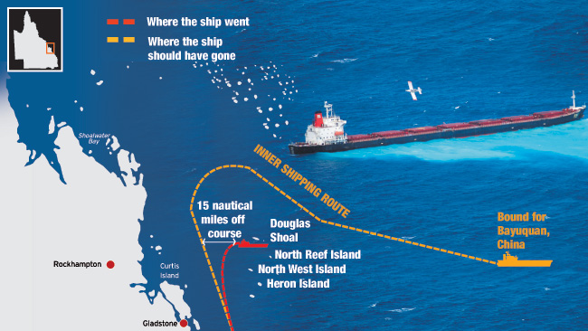

Image source news.com.au – Courier Mail April 06 2010.

Terrorist related activity

These incidents are deliberate harmful and damaging incidents caused to further various political, religious, ideological or racial causes. These incidents are usually designed to create as much media coverage and spectacle as possible.

The balance for consideration are those activities which may not be clearly defined as terrorist acts but more criminal in nature, as an example, on 29 November 1980 (day of the State election) a bomb blast ripped a seven-metre crater, caused an estimated $1 million damage and delayed construction to the ‘Iwasaki Resort’, Yeppoon (within the Rockhampton Disaster District area).

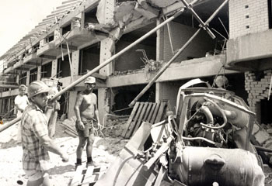

RUMBLE in the jungle ... workers clear debris at the site of the Iwasaki resort bomb blast. Picture: Graham Hutton Source: The Courier-Mail

The mining sector within the district is vast with considerable risks associated with mine, rail, road and port infrastructure, all being strategic targets. An attack on any of these areas would have significant effects on the local and state economies.

Counter Terrorism Strategies

Terrorism is an enduring threat which needs a long-term, proactive and collaborative approach. Our commitment to countering the terrorism threat and avoid complacency by making counter-terrorism part of everyday business and planning.

Key principles that ensure our efforts are focused to deliver positive outcomes (as contained within the Queensland Counter-Terrorism Strategy) includes;

- Community safety is paramount
- Our efforts are evidenced-based and proportionate
- Our actions are based on evidence and led by intelligence
- We work collaboratively, recognising that we all have a role to play
- Our arrangements are robust, agile and responsive
Five strategies will support the sustained development of the counter terrorism capability. Each strategy contributes to ensuring cohesive and coordinated arrangements are in place. These strategies are to:

- Engage: Promote the education and involvement of the broader community in preventing, preparing, responding and recovering from terrorism;
- Cooperate: Strengthen arrangements by communicating, coordinating and collaborating with stakeholders;
- Protect: Enhance detection and deterrence to maintain a safe environment;
- Exercise: Practise and test counter-terrorism arrangements through exercises; and
- Develop: Refine our preparation, planning, response and recovery arrangements.

The comprehensive approach to terrorism recognizes the need to prevent, prepare for, respond to, and recover (PPRR) from a terrorist act. The PPRR concept acknowledges that these activities will overlap and that elements of PPRR will often occur concurrently.

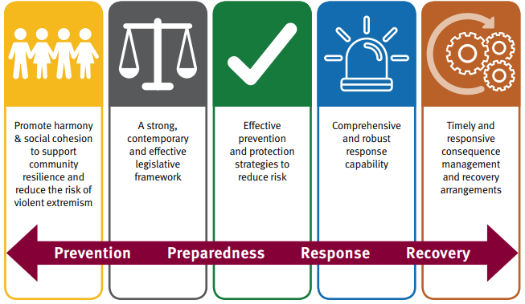
PPRR (for terrorist activity) stands for:

(i) prevention: To hinder, deter, mitigate and disrupt terrorist activity, while maintaining readiness to deal with a terrorist incident;
(ii) preparedness: To protect our people, assets, infrastructure and institutions from terrorist activity; and to establish, train for and exercise arrangements to respond to, and recover from a terrorist incident;
(iii) response: To respond rapidly and decisively to a terrorist incident, should one occur, and manage its immediate consequences; and
(iv) recovery: To return national and community life to normal as quickly as possible after a terrorist incident through the restoration of social, economic, physical and environmental wellbeing.

It should be noted the elements of preparedness and prevention are on-going activities while response and recovery are primarily distinct phases in the aftermath of a terrorist act.

The National Terrorism Threat Advisory System:

- comprises a five tier, colour coded, National Terrorism Threat scale to inform the public about the level of the terrorist threat facing the nation
- includes public advice on the nature of the threat faced and what it means for them
- helps inform the public so they can decide on what measures to take to protect themselves, their families and friends
- guides national preparation and planning to protect against the threat of a terrorist incident
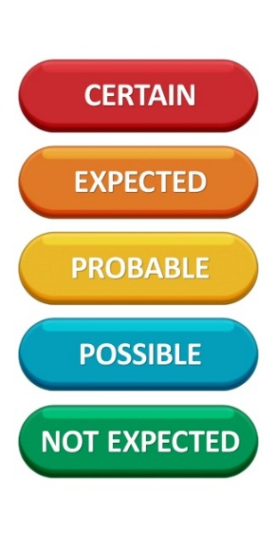
The National Terrorism Threat Level for Australia is POSSIBLE.

Credible intelligence, assessed by security agencies indicate individuals or groups have developed both the intent and capability to conduct a terrorist attack in Australia. The public should be reminded to continue to exercise caution and report any suspicious incidents to the National Security Hotline by calling 1800 1234 00. Life-threatening situations should be reported to the police by calling Triple Zero (000).

The QPS has operational responsibility for preventing and responding to terrorism in Queensland and for investigating terrorist activity, threats and incidents. This can be achieved by:

(i) providing assistance and awareness to the community in terms of preparedness while coordinating national counter-terrorism training exercises with other emergency agencies and relevant stakeholders;
(ii) operational responsibility for preventing, responding and investigating an act of terrorism; and
(iii) the coordinating role in:
(a) enabling an effective multi-agency response to an act of terrorism by providing security and traffic management; and
(b) any recovery effort through the District Disaster Coordinator role as it relates to consequence management.

Through individual and community vigilance, acknowledging the current levels of terrorism alert, timely warnings and updates and reporting suspicious behaviour the prevention of such incidents or minimisation of their affects can occur.

Police Districts ha a designated Security and Counter Terrorism Network for the coordination of training/exercising, intelligence and investigation ensuring engagement with critical infrastructure owner/operators, places of mass gathering and other interest groups.

Space debris re-entry

Owing to the vast area of the Rockhampton District, the potential to become involved in responding to space debris re-entry must be considered high. Whilst the possibility of space debris landing in the district is high the possibility of small pieces of space debris landing in populated areas is considered low due to the population density of the area.
The management of space debris is detailed in the “Australian Government Space Re-entry Debris Plan” AUSSPREDPLAN 2017. The preparation stages for space debris impact are as follows:

Stage | Meaning
White | Predicted impact minus 7 days
Yellow | Predicted impact minus 2 days
Red | Impact has occurred in Queensland

Stages may be designated “HOT” if radioactive or “Cold” if inert.

Under AUSSPREDPLAN 2017, the Australian Radiation Protection and Nuclear Safety Agency (ARPANSA) provides:

- A Principal Scientific Adviser to Emergency Management Australia in the National Emergency Management Coordination Centre.
- A Senior Scientific Adviser to the Australian Space Debris Emergency Search Team (ASDEST), is responsible for:
- technical control of the radiological operations of the ASDEST, including adequate detailed documentation; and
- provision and overall coordination of non-Defence Force radiological elements assigned to ASDEST.
- Health radiation advice and relevant physicists, technicians and equipment to meet, in conjunction with the Australian Nuclear Science and Technology Organisation (ANSTO).
- Analytical support, as necessary, within and external to the ASDEST for identification of radiation hazards to personnel and the environment.
- Advice and assistance in training of ASDEST Ground Radiological Teams on health aspects.

In concert with the ANSTO, advice on:

- likely radiological effects and measures to be taken in the event of a radioactive space debris incident.
- radiological detection equipment (other than airborne equipment) and other resources required and available for the detection and neutralization of radioactive material and contamination resulting from space debris.
- details to support the plan relating to personal and environmental hazards, public safety advice, assessment of maximum acceptable radiation levels that can be retained and identification of specialized equipment and technical and scientific personnel required.
- preparatory or preventative action that may be taken by members of the public.

The role of the DDMG in such an event would be to provide assistance to the relevant federal agencies.

Risk Assessment

The Rockhampton DDMG has established a District Risk Management Sub Group which meets at least annually to review the District Risk Management Plan. This group is comprised of identified stakeholders from Local and State Government agencies and chaired by the District Executive Officer (XO).

The District Disaster risk assessment determines community vulnerability through the identification of hazards, analysis of risks and likelihood and the consequence of a disaster occurring to the exposed elements. This district assessment is consistent with the Queensland Emergency Risk Management Framework (QERMF) and aims to support risk based planning within the wider disaster management context.

This Framework is based on ISO 31000:2009, Risk management – Principles and guidelines and the National Emergency Risk Assessment Guidelines (NERAG) and the Queensland Emergency Management Assurance Framework (EMAF) which includes the Standard for Disaster Management in Queensland.

The District risk assessment forms the basis of agency and government planning to inform and identify:

- risks to existing and proposed land uses,
- acceptable, tolerable and intolerable levels of risk for each area;
- vulnerable populations and facilities;
- options for mitigation and treatment;
- priorities for mitigation and treatment;
- opportunities for capability and capacity development; and
- residual risks* and thresholds.

This district risk assessment allows for the targeting of mitigation, preparation, response, recovery and resilience actions to achieve safer and more sustainable communities. For example, A flood risk assessment identifies how land use planning measures will work in conjunction with other risk management measures including building controls, mitigation infrastructure, early warning systems, community awareness and other disaster management arrangements to address the impacts of flooding on the community.

The Rockhampton District Disaster Management Group recognises that all State agencies, in supporting local governments within the area, should inform the risk assessment process including the management of residual risk (risk remaining after the risk treatment has been applied) beyond the capacity and capability of local and district arrangements. This includes by integrating the outcomes of departmental risk assessments into the disaster, business continuity, strategic and corporate plans and by ensuring an improved understanding, coordination and resource allocation of disaster risk management at all levels through informed evidenced based research and education.

The Disaster District supports the communication of residual risk outside normal Local and State Government departmental boundaries to ensure Whole of Government consideration and planning towards these risks.

Risk Treatment

The DDMG is committed to building knowledge, capability and capacity in support of LDMGs should an activation of the district be required. Through this process the DDMG accepts ownership of some risks and is committed to building capacity to treat those risks if and when they arise. Treatments used by the group to enable them to meet the risks accepted at district level include –

(i) Effective, informed and evidenced based planning
(ii) Building a flexible, agile and sustainable structure
(iii) Identifying lessons and seeking continuous improvement
(iv) Establishing effective information management systems
(v) Timely actions and distribution of information

Risks outlined in the District Risk Register (Annexure C) are analysed by members of the Rockhampton DDMG with a view to identifying strategies for risk treatment. The allocation of responsibility for the implementation of risk treatment strategies, monitoring and reporting shall be determined by members of the DDMG under agency functional responsibilities with guidance from the DDC. These strategies are contained in the District Risk Treatment Plan (detailed in Annexure D). Along with these strategies, the District Risk Treatment Plan contains preferred treatment options, responsibilities and timeframes for implementation.

To progress any treatment options, the DDMG requests relevant responsible agencies to incorporate specified risk treatment strategies into their agency corporate planning processes for recognition, consideration and implementation. Agencies will during the annual agency reporting process and risk management plan review report the outcome on progress of their specific treatment options.

In instances where the application of treatment strategies at district level are identified as not being adequate and where residual risks remain, the DDMG is to determine whether risk transfer or risk sharing with the QDMC is an appropriate treatment option. In those instances the DDMG is to document and notify the QDMC of these with a view to sharing or transferring these risks.

A review of the district risk treatment plan shall be conducted in conjunction with any district risk assessment review process.

District Residual Risk Profile

Due to geographical and logistical barriers (including human resourcing constraints over extended periods or locations) the District Group must be aware of its limitations and provide advice to the Queensland Disaster Management Committee (QDMC) regarding the Districts residual risks. As an example, the Rockhampton DDMG has a limited capacity to support local groups for extended periods of time or for short periods of time should multiple areas be affected simultaneously.

Each Local Group in the District is to identify risks to their area of responsibility and to take all necessary actions to prioritise and mitigate against those risks. Following this process the DDMG acknowledges there will be limitations of Local Groups to eliminate or significantly reduce all risks and therefore require District or State Group support to respond during an event, these “Residual Risks” are to be communicated to the DDMG.

The District Group will consider these risks collectively (or within the District Risk Group) and implement treatment strategies to support the management of these risks. In doing so, the DDMG only has capacity to mitigate risks through the assets that are within its span of control, it does not have capacity to mitigate risks through engineering or works programs beyond this span however can support the management of these risks through the legislated functions and responsibilities placed on individual departments within the Group.

Responsible agencies (and departments) at local and district level are to recognise, incorporate and implement treatment strategies into their corporate and business planning processes to as far as practicable reduce the residual risks at local level and those identified as district risks within normal business arrangements. This may include negotiation with other departments so as to integrate those risks within functional committee arrangements.

A detailed series of Risk Statements are contained at Annexures C and D of this document. These Risk Statements detail the risks to the District Group in supporting the actions of the local groups. They cover both short and long term operations.

Residual risks beyond the capacity and capability of the District Group are to be recorded within the District risk register and reported by briefing note to the QDMC for incorporation within the State Risk Register.

Prevention strategies

Prevention
the taking of preventative measures to reduce the likelihood of an event occurring or, if an event occurs, to reduce the severity of the event
Disaster Management Act 2003 section 4A (a)(i)

Prevention and mitigation activities include, the building of dams and levees, land use planning and improved building codes which focus on reducing the likelihood and/or consequences of the hazard event from occurring or if it does occur reducing its impact. As an example, land use planning can avoid situating new development and community infrastructure in areas prone to storm tide, riverine flooding, bushfires and landslide.

At the District level, mitigation measures have been considered in conjunction with analysis of the Queensland Emergency Risk Management Framework – (QERMF) and the Queensland Strategy for Disaster Resilience (QSDR 2017).

All agencies within the District have a responsibility to identify risks and treatment options and to mitigate against disasters. Agencies with a specific portfolio responsibility to influence mitigation should actively seek to do so with the full support of all other agencies.

Mitigation strategies

Mitigation strategies can be developed across a range of hazards or targeted to a specific hazard and associated risk mitigation strategies to reduce the risk of disaster include:

The Queensland Fire and Emergency Service (QFES) in conjunction with the Queensland Parks and Wildlife Service (QPWS), conducts Operation Cool Burn where bushfire mitigation operations are coordinated across the state.

Operation Cool Burn is a period of heightened mitigation activity, where hazard reduction burns, fireline/break maintenance and community education occur year-round.

QFES has matured its relationship with its partners during operation Cool Burn, enabling the focus to be on shared community priorities for the protection of life and property.

Taskforce Vulcan is another example whereby the QFES and Queensland Police Service (QPS) Central Region strengthen the detection, enforcement and reduction of arson related activities across the region.

Taskforce Vulcan strengthens the relationship between QFES and QPS by focusing combined resources in this area. To date Taskforce Vulcan has undertaken a number of successful operations in the detection of suspicious fire activities, which have resulted in the reduction of suspicious fires.

In accordance with the Queensland Strategy for Disaster Resilience 2017 (QSDR 2017), resilience, in a disaster management context, can be referred to as,

a system or community’s ability to rapidly accommodate and recover from the impacts of hazards, restore essential structure and desired functionality, and adapt to new circumstances.

The Strategy outlines four key objectives in working to make Queensland the most disaster resilient state in Australia:

- Queenslanders understand their disaster risk
- Strengthened disaster risk management
- Queenslanders are invested in disaster risk reduction
- Continuous improvement in disaster preparedness

Prevention functions

At the District level, the following government agencies conduct prevention functions:

Lead Agency | Functions
Queensland Fire and Emergency Services | Hazard Mapping  Bushfire Mitigation programs (Operation Cool Burn)
Department of State Development, Infrastructure Local Government and Planning | Disaster mitigation and resilience funding
Department of State Development, Manufacturing, Infrastructure and Planning | Building our Regions program  Land use planning
Queensland Reconstruction Authority | Disaster resilience and mitigation policy and planning  Disaster Mitigation and resilience funding
Department of Energy and Public Works | Building code

Preparedness Strategies

Preparedness
the taking of preparatory measures to ensure that, if an event occurs, communities, resources and services are able to cope with the effects of the event
Disaster Management Act 2003 section 4A (a)(ii)

Preparedness is critical in assisting to minimise the consequences of an event on a community and ensuring effective and timely operational response and recovery. Disaster preparedness builds on existing community and individual awareness of risk and participation in disaster management activities to enhance resilience.

The Rockhampton Disaster District acknowledges that all members have responsibility for preparedness and implementation of preparedness strategies across the community centred on the following key elements:

- Risk assessment and management
- Business continuity / disaster planning
- Education, training and lessons management
- Capability development
- Hazard specific and functional planning
- Integration and interoperability
- Community awareness and engagement
- Reporting and collaboration on functional responsibilities

Planning

Hazard identification and risk assessment are pivotal to effective disaster management planning. Comprehensive planning will occur across the phases of disaster management – prevention, preparedness, response and recovery.

Disaster management plans and arrangements must be scalable and adaptable to change. Each agency and stakeholder within the QDMA is responsible for developing their own disaster management plan including business continuity and operational plans and hazard specific arrangements. Functional Committee and agency specific plans should provide consistency, compatibility and where appropriate be integrated with this district and other plans within the QDMA.

This District plan seeks to detail the arrangements within the disaster district to provide whole-of-government planning and coordination capability to support local governments in disaster management and disaster operations.

It is a function of the DDMG to develop effective disaster management for the district. This includes a DDMP. Therefore, the DDMG needs to ensure that this DDMP is:

- developed for the disaster district (s. 23(b));
- in accordance with s. 53 of the DM Act;
- consistent with disaster management guidelines (s. 54);
- reviewed, or renewed when the group considers it appropriate (s. 55); and
- reviewed at least once a year for its effectiveness (s. 55).

Section 56: ‘Plan to be available for inspection etc.’ of the Disaster Management Act 2003, requires the District Disaster Management Plan to be made available for viewing by the public. This section also provides that members of the community may also purchase a copy of the plan upon the payment of an appropriate fee, as decided by the District Disaster Coordinator.

Functional plans
Disaster management functional plans identify important services required before, during and after the impacts of a disaster, and help to identify and define an agency’s services and responsibilities in disaster operations.
Functional plans detail arrangements relating to supporting activities undertaken by functional lead agencies of the DDMG. These plans address the functions of disaster management where government departments and agencies have a functional lead in responding to the event. Although the functional lead agency has primary responsibility, arrangements for the coordination of relevant organisations that play a supporting role are also outlined in these plans.

Functional plans will:
- address functional activities across all phases of disaster management (PPRR)
- include information on how the QDMAs link with the functional arrangements
- support the primary agency to manage the functional activity.

The following table outlines the functional lead agency in response to a specific aspect of an event.

Function | Functional Lead Agency | Roles and Responsibilities
Transport | Department of Transport and Main Roads | Arrangements for the provision of transport resources for the transportation modes of road, rail, air and sea, and transport engineering to support disaster response and recovery operations.
Emergency Supply  Warnings | Queensland Fire and Emergency Services | Arrangements for the acquisition and management of emergency supplies and services in support of displaced persons during disaster operations.  Where local capacity is exhausted, QFES coordinates the acquisition and management of emergency supplies, through the State Disaster Coordination Centre (SDCC) when activated, or through the SDCC Watch Desk outside activation periods.  Agencies are to use their own internal acquisition / supply and support resource capability before requesting further support.  The acquisition of specialist resources requiring a permit, licence or specific technical knowledge is the responsibility of the respective agency.  WARNINGS and ALERTS  Distribute and develop (where primary agency) warnings to disaster management stakeholders and communities.  Facilitate and authorise Emergency Alert campaigns to provide advice and warnings to communities affected by disasters and emergency situations.
Building and Engineering Services | Department of Energy and Public Works | Arrangements for the provision of resources and services pertaining to all engineering disciplines which may be required to assist disaster response and recovery operations.
Community Recovery | Department of Treaty, Aboriginal and Torres Strait Islander Partnerships, Communities and the Arts. | Arrangements for the coordination of community recovery services including: Information on the range of recovery services available; Information of the physical effects of a disaster;  Personal support services;  Financial assistance to eligible applicants under the following schemes: Personal Hardship Assistance Scheme;  Essential Services Safety and Reconnection Scheme;  Provision of counselling and mental health services;  Longer term accommodation services; and  Facilitation of community participation in the redevelopment of social networks and community infrastructure.
Communication | Department of Environment and Science | Arrangements for the re-establishment of electronic communication links either within a disaster affected area or within areas outside the affected area, and the provision of special communication facilities to support State and Disaster District level operations mounted in support of an affected area.
Public Health and Safety  Mass casualty management  Mass fatality management (in conjunction with police) | Queensland Health | Arrangements for the provision of medical and health resources to support disaster response and recovery operations through:  • Command, control and coordination of medical resources;  • Public health advice and warnings;  • Transportation of patients;  • Psychological and counselling services; and  • Ongoing medical and health services required during the recovery period.
Mass casualty management (in conjunction with Health)  Evacuation management  Search and Rescue  Stranded Persons | Queensland Police Service | • Arrangements for the provision and management of response requirements.  • Command, control and coordination of resources for all matters  • Protecting life and safety of members of the community  • Working in conjunction with other agency for the identification of victims and notifications  • Supply of provisions to stranded persons

Hazard-specific plans

The Rockhampton Disaster District takes an all hazards approach to disaster management. Hazard specific plans will be developed where particular hazards have been identified as a district risk with specific operational or coordination requirements.
Whilst Queensland has adopted an all hazards approach for disaster management arrangements, it is important to acknowledge that some hazards have characteristics that may require a hazard specific approach.
In this instance the primary agency has responsibility to ensure that an effective hazard specific plan is prepared. Specific planning is required for these arrangements as their coordination and operational procedures can be different to those within the QDMA.
Hazard specific plans are developed by agencies, in consultation with affected stakeholders and should be referenced as sub-plans to this District plan. The following table outlines the primary agency and associated hazard specific plan.

Specific Hazard | Primary agency | State Plan
Animal and plant disease | Department of Agriculture and Fisheries | Australian Veterinary Emergency Plan (AUSVETPLAN)
Biological (human related) | Queensland Health and Hospital Health Services | State of Queensland Multi-agency Response to CBR incidents
Bushfire | Queensland Fire and Emergency Services | Queensland Bushfire Plan
Chemical | Queensland Fire and Emergency Services | State of Queensland Multi-agency Response to CBR incidents
Influenza Pandemic | Queensland Health and Hospital Health Services | Queensland Pandemic Influenza Plan
Ship-source Pollution | Department of Transport and Main Roads | Queensland Coastal Contingency Action Plan National Plan to Combat Pollution of the Sea by Oil and Other Noxious and Hazardous Substances
Radiological | Queensland Health and Hospital Health Services | State of Queensland Multi-agency Response to CBR incidents
Terrorism | Queensland Police Service | Queensland Counter-Terrorism Strategy

All hazard specific plans are to address the hazard actions across all PPRR phases and include information on how the QDMA links with these hazard specific arrangements and provides support to the primary agency in the management of the hazard specific event.
Where relevant, primary agencies are to ensure any State hazard-specific plans link to corresponding national hazard-specific plans and arrangements, and appropriate communication and relationships with national counterparts maintained.
Hazard specific plans will:
- address the hazard actions across all phases of disaster management (PPRR)
- include information on how the QDMA links with the hazard-specific arrangements
- support the primary agency to manage the hazard-specific event
- integrate hazard specific arrangements to local and district disaster management and operations.

The table below outlines identified hazards, lead agencies and relevant responsibilities.

Threat Specific Hazard | Lead Agency | Responsibility
Oil Spill | Department of Transport (Maritime Division) | - Primary Agency for ship-sourced pollution where it impacts, or is likely to impact, on Queensland Coastal Waters  - Provide information and advice on the impact of disruptive events on maritime infrastructure as it affects the transport system  - Enable an accessible transport system through reinstating maritime infrastructure  - Assist with the safe movement of people as a result of mass evacuation of a disaster affected community  - Ensure the capability of logistics related industries are appropriately applied to disaster response and recovery activities
Bushfire | Queensland Fire and Emergency Service (Rural Fires Division)  Queensland Parks and Wildlife Service | Detail the strategy and actions to be carried out in the event of a bushfire.  - Primary agency for bushfire response  - Implementation of all aspects of this Bushfire Preparedness Plan in accordance with the criteria described in the Bushfire Preparedness Level activation table  - Lead fire-fighting on the protected area State and State forests where there is no threat to life or property
Emergency Animal Disease | Department of Agriculture and Fisheries | Lead agency for containment and eradication of emergency animal and plant diseases and pests. DAF also provides advice in the areas of agriculture, fisheries and forestry in a disaster event.  - Coordinate efforts to prevent, respond to, and recover from plant and animal pests and diseases and invasive plants and animals.  - Provide advice on animal welfare.  - Collaborate with stakeholders with shared responsibilities and other organisations to facilitate prevention, preparedness, response and recovery strategies and priorities for animal welfare management within a community.  - Provide advice in relation to agriculture, fisheries and forestry disaster impacts.  - Coordinate destruction of stock or crops in an emergency pest / disease situation.  - Administer Disaster Recovery Funding Arrangements relief measures including agriculture industry recovery operations as required  - Lead the reporting on the disaster impact assessments on the agricultural sector, including economic losses and expected recovery.  - Report on the possible impact seasonal conditions and climate events will have on the agricultural sector.  - Coordinate the Agriculture Coordination Group with agricultural industry groups to provide information about the effect that a disaster event has on the agriculture, fisheries and forestry industries and the issues that individuals and businesses are facing in responding to and recovering from a disaster event  - Engage with industry on preparedness for climate risks and aid with economic recovery.  - Assist agriculture and fishery industries in prevention and preparedness through normal business operations and service provision to industry and communities.  - Participate in district disaster management groups.
Heatwave | Queensland Health and Hospital Services | - Outline the context and risk of heatwaves in Queensland  - Articulate the roles and responsibilities of the health sector and other supporting agencies consistent with the existing QDMA  - Outline arrangements for preparedness, response and recovery for heatwaves  - Describe how the notification, assessment and activation of relevant plans will occur  - Describe heatwave triggers and response activities for QH and other agencies.  - Support a cycle of ongoing evaluation that will continue to improve the capabilities of QH and other agencies to prepare for and respond to heatwaves
Terrorism | Queensland Police Service | - Lead agency for terrorism related events and investigation.

Business continuity planning

Business continuity planning is undertaken to ensure disaster management and critical functions can continue to be delivered during a disaster event. All state and local government and non-government organisations and partner agencies within the district recognise the importance of continuity of service including supply chains, and where appropriate the integration of effort to ensure community disruptions are minimised.

Capability integration
Actions will be taken to ensure that disaster management participants are appropriately skilled, trained and practised so they are ready to respond and to enable recovery. These actions will encompass:
- training and education
- exercising
- awareness briefings
- lessons management
- community awareness and preparedness

Training and education

As one of the activities undertaken to maintain or enhance the QDMA, the DM Act; provides the legislative requirement for those involved in disaster management to be appropriately trained and for the annual reporting of training activities to occur.

Training and education involves the personal development of individuals involved in the QDMA. It is carried out according to the Queensland disaster management training framework (QDMTF), which outlines the training packages and intended stakeholders. It encompasses the arrangements themselves, the processes, hazards, functions and activities which underpin disaster management and disaster operations. Disaster management on-line training is available through the Disaster Management Learning Management System (LMS).

QFES is responsible for ensuring a coordinated approach to disaster management training within the district including the maintenance and dissemination of the QDMTF to DDMG members. This includes regularly assessing the training needs within the district and developing a suitable training program. Where possible, this training program should maximise opportunities for joint training with LDMGs and other agencies involved within the QDMA. The development of a training program should involve:

- A training needs analysis defining required competency:
- roles required
- skills and knowledge required to undertake the roles
- individuals required to undertake each role/function
- current levels of competency

- Competency can be determined from a number or sources:
- training records
- qualifications
- observations of on-the-job performance
- interview and group discussions

- Identification of knowledge gaps
- note differences between required and current levels of competency

To enhance knowledge and disaster management capabilities, the agencies and organisations represented on the DDMG (including deputies) have responsibility of providing suitable opportunities for DDMG representatives to attend training consistent with or beyond the minimum requirements of the QDMTF.

Disaster Coordination Centre Training

Each Lead Agency is to have an appropriate number of staff trained as liaison officers (appropriate skill and competency level) to work in the District Disaster Coordination Centre (DDCC) in support of disaster operations. Appropriate courses for working in a disaster coordination centre include:

- Australasian Inter-service Incident Management System (AIIMS) course.
- Public Safety Training including; coordinate resources within a multi-agency emergency response.
- QFES-EM Disaster Coordination Centre courses (QDMTF).

Training program implementation is monitored through the DDMG Annual Operational Plan.

Exercises

Exercises provide opportunities to involve all agencies and levels within the QDMA. They build stakeholder networks and relationships essential to providing a comprehensive approach in support of disaster affected communities. Exercises are to be designed to incorporate lessons learned from previous events, identified hazards, risk planning activities and be linked to risk priorities relevant to the District.

Responsibility to conduct disaster management exercises lies with each individual agency to ensure they have exercised and practiced procedures. QFES’s role is to facilitate exercises conducted for groups in the disaster management arrangements. Exercises are a key component of disaster management strategies and are conducted with the objective of:
- practicing the coordination procedures during an event including;
  - activation of Disaster Management Groups;
  - activation of District Disaster Coordination Centres;
  - information management including dissemination of information in respect to threats and warnings, requests for assistance and providing situation reports;
- enhancing the interoperability of agency representatives;
- evaluating emergency plans;
- identifying planning and resource issues;
- promoting awareness;
- developing competence;
- testing decision-makers;
- evaluating risk treatment strategies;
- validating training already conducted;
- identifying performance gaps and areas for improvement in the skills of agency representatives involved in disaster management;
- evaluating equipment, techniques and processes in general.

The DDMG will conduct at least one (1) exercise annually, which may include all functional committees. Functional committees will exercise their respective sub-plans, independent of the aforementioned district exercise, annually.

Exercise hot debriefs are to be conducted immediately on completion of the exercise to identify issues and areas for improvement. A more detailed ‘After Action Review’ is to be conducted within the next couple of days following the exercise addressing the ‘exercise design and conduct’ and the ‘responses to the scenario.’ The exercise review should identify recommendations for future action and improvements.

Identified opportunity for improvement | Recommended Action/Strategy | Responsible Agency/Officer | Timeframe | Status

Any gaps or issues identified during the exercise process will be tabled as findings to the DDMG to allow evaluation, development of capability and reporting and implementation of appropriate treatment options.

The exercise findings and treatment options may then may be captured in a wider post-exercise report noted in the Risk register and Annual Report, and included in the DDMG Operational Plan for implementation.

Lessons Management

A key outcome of exercises, post-disaster assessment and debriefs is that lessons identified are embedded into disaster management planning. Such lessons come from an examination of the effectiveness of mitigation measures, an analysis of the state of preparedness in readiness for the impacts of a disaster, of the disaster operations themselves and extend into the effectiveness of the response or recovery.

Post-disaster assessment can be undertaken by a wide range of stakeholders from disaster responders through to the Queensland Office of Economic and Statistical Research, independent research bodies and tertiary institutions.

The conduct of post-disaster assessment needs to be managed to ensure it does not impede response and recovery activities but is timed appropriately to ensure maximum benefit from the data captured. To ensure minimum impact on disaster affected communities, post-disaster assessments should be informed by impact assessments and if possible, coordinated with them.

Lessons that can be identified from contemporary events world-wide can also contribute to lessons for reviews of disaster management plans and planning. Lessons identified through post-disaster assessment and disaster management exercises can also contribute to the identification of disaster management best practice.

Post-disaster assessment evaluates performance before, during and after a disaster event and the exposed risks in order to improve future development of preparedness, response, recovery and mitigation measures. Post-disaster assessment is closely linked with, and contributes to, the elements of Disaster Research, Policy and Governance. Post-disaster assessment therefore forms part of the continuous improvement of the disaster management arrangements for the District. It is linked to, but broader than, the more immediate impact assessment, undertaken during disaster response operations and early recovery periods.

Analysis of the Queensland disaster management arrangements can lead to confirmation of good practice or identification of issues that require improvement for future disaster events. This analysis can also provide particular lessons relating to mitigation to improve community resilience, safety and sustainability. A post disaster assessment will be developed through the following process:

- During the operation of the DDCC the Executive Officer (XO) is to brief and request all participants to offer comment on the conduct and recommendations for the DDCC;
- As soon as practicable after the DDCC has stood down from operations the XO is to conduct a debrief of all personnel participating in the DDCC. Matters raised during the operation of the DDCC are to be raised and discussed.
- As soon as practicable the DDMG will conduct a debrief after the DDMG is stood down of DDMG members.

Post-disaster assessments are undertaken and documented in a Post-Disaster Analysis Report to provide opportunities for participants to comment on the success and areas for improvement of district disaster operations and arrangements. The DDMG Chair is to ensure the report findings are incorporated into the DDMG Annual Operational Plan and Disaster Management Plan for the monitoring and implementation of recommendations.

Outcomes of post-disaster assessments strengthen the districts disaster management capability.

Community Awareness and Engagement

The DDMG has responsibility for ensuring the community is aware of ways of mitigating the adverse effects of and preparing for, responding to and recovering from a disaster. These requirements are included under sections 23 (f): ‘Functions’ (Disaster District), and 30 (1) (e): ‘Functions’ (Local Government) of the DM Act. In a disaster management context, community education has a range of objectives, which can include:

- Developing awareness in communities of the nature and hazards and the potential impact and damage such hazards can bring.
- Promoting public self-reliance through personal responsibility for managing risks as much as possible. This may be through a range of preparedness measures that the public and industry can take to reduce risk to themselves, their workforce, their families, their communities and infrastructure before, during and after an event.
- Development of Emergency Action or Emergency Response Plans for business or industry to ensure they have an enhanced capability to respond.
- Developing the community’s appreciation of the Queensland Disaster Management Arrangements (QDMA) and the assistance available to communities which can be activated in a disaster. This includes local and State mitigation and preparedness strategies, emergency warnings (methods and actions required), evacuation routes and communications used during disasters (local radio, television, etc, for updates during a disaster).

Members of the DDMG shall provide LDMGs, functional committees and other NGOs all necessary assistance as may be required from time to time to give effect to their respective community awareness/education programs. This may include:

- Sharing of community education resources
- Coordination of community education activities that meet the needs of people vulnerable to the impacts of hazards
- Communicating and educating the community on disaster management information to meet their need

Community education is not an end in itself, but contributes to community resilience by providing the information and the rationale necessary to commence the process of behavioural change. Community education encompasses the public, special interest groups, commerce and industry, and may be hazard specific, or general disaster management education.

Activities and products such as publications, multimedia information packages and community information events (Emergency Services Day – July and ‘Get Ready’ campaigns - October) are the responsibility of all levels of government and other agencies and organisations, often working in partnership. Because of this, it is important for the community to be provided with consistent, accurate and timely messages, across all programs.

The DDMG considers inviting media representatives to DDMG meetings and exercises with a view to enhancing community awareness in respect to the existence of disaster management arrangements and preparedness activities.

Response Strategy

Response:
the taking of appropriate measures to respond to an event, including action taken and measures planned in anticipation of, during, and immediately after an event to ensure that its effects are minimised and that persons affected by the event are given immediate relief and support
Disaster Management Act 2003 section 4A (a)(iii)

Activation

The DDC is responsible for activating the DDMG. This would generally occur following consultation with one or more of; the Chair of the QDMC; the Chair of an LDMG; and/or a member of the DDMG.

District level arrangements can be activated by the Chairperson of the DDMG when there is a need to:

- monitor potential threats or disaster operations;
- support or coordinate disaster operations being conducted by a designated primary agency;
- coordinate resources in support of disaster operations at local level; and/or
- coordinate District disaster operations activities.

Activation does not necessarily mean the convening of the District group; rather the provision of information to disaster management group members regarding the risks associated with the hazard impact. Bottom up activations escalate through the disaster management arrangements where local groups require support and top down activations involve escalation down through the arrangements from the State Group where the imminent threat has broader implications across the state.

The QDMA is activated using a four phase model from alert through to stand up and stand down. The movement of the group through these phases is not necessarily sequential but based on flexibility and adaptability to the location and event.

Level of Activation | Definition
Alert | A heightened level of vigilance due to the possibility of an event in the area of responsibility. Some action may be required and the situation should be monitored by someone capable of assessing the potential of the threat. If lead time available, watching brief maintained.
Lean Forward | Operational state prior to ‘stand up’ characterised by a heightened level of situational awareness of a disaster event (either current or impending) and a state of operational readiness. DDCC is on standby; prepared but not activated.
Stand-up | Operational state following ‘lean forward’ whereby resources are mobilised, personnel are activated and operational activities commenced. DDCCs are activated.
Stand-down | This is the transition from responding to an event back to normal core business and/or recovery operations. There is no longer a requirement to respond to the event and the threat is no longer present.
De-briefing | - All organisations will conduct internal debriefs with respective Liaison Officers to attend.  - A full operational debrief of the DDCC staff conducted as soon as possible following the Stand Down.  - A full operational debrief of the DDMG will be conducted as soon as possible following the Stand Down.

Levels of activation, including triggers, actions and communications for state, district and local levels are outlined below:

 | Triggers | Actions | Communications
Alert | - One or more LDMGs operational  - Awareness that threat may be widespread | - XO briefs DDC on activation levels of LDMGs  - Analysis of threat  - Contact with LDCs  - Advise Frontline and Digital Services, to ready Primary and Secondary DDCC.  - Advise Media Liaison Officer. | - DDC and XO on mobile remotely
Lean Forward | - Potential requirement for DDMG to coordinate disaster operations or provide support because of threat or resource requirements | - Maintain contact with LDCs  - Communication procedures established  - Planning commenced for support to DDCC and staff briefed  - Advise State regarding status of DDMG  - Establish contacts and set-up communication systems  - Receipt of SITREPs from LDMGs  - Brief DDMG members  - Planning for potential support to LDMGs | - DDC, XO and DDMG members on mobile and monitoring email remotely  - Ad-hoc reporting  - Establish stand-by incident within DIEMS
Stand Up | - Request for assistance/support received from LDCCs  - Threat is imminent / impacting on District  - Coordinated WoG support required  - Significant State resources committed | - Develop situational awareness  - Warnings disseminated  - SDCC advised DDMG stood up  - Initial SITREP to SDCC  - DDCC activated and roster developed  - Forward planning commenced  - Administration and Logistics, Operations, Planning and Intelligence Cells in place  - Coordination of State support commenced  - Advice received from State Disaster Coordinator (if appropriate). | - DDMG meeting conducted.  - Distribution of situation brief  - DDC contact through established land lines/email  - Agency liaison officers present at DDCC for operational reporting and tasking  - DIEMS incident activated
Stand down | - LDMGs stood down from response  - Recovery arrangements functional | - Final check for outstanding requests for assistance / tasks  - Assist LDMGs with transition to recovery  - Debrief of DDCC staff and DDMG members  - Financial records consolidated  - Final SITREP sent to SDCC  - Handover to District Recovery Coordinator  - Return to core business | - DDMG members not involved in the recovery operations resume standard business and after hours contact arrangements

District Disaster Coordination Centre (DDCC)

The DDCC coordinates the collection, analysis and dissemination of relevant information, resource allocation and future planning requirements. The DDCC will implement planning and operational decisions of the DDC in the coordination of State and Australian government resources in support of the local government response.

Liaison Officers form the point of contact between the DDCC and their parent agency during disaster operations, as such their attendance (as appropriate) within the coordination centre will support the timely and prioritised allocation of resources in-line with the decisions of the DDMG.

Liaison Officers have a requirement to support disaster operations in accordance with their agency’s roles and responsibilities. Liaison Officers have the following key responsibilities for disaster management:

- coordinating requests for assistance applicable to their agency;
- providing advice and assistance on their agency’s tasks, capabilities, resources and projections;
- ensuring information (including SITREPS) on their agency activities, intelligence and plans for the next period are relayed back to the DDCC; and
- communicating situational awareness to their agency.

A Standard Operating Procedure for this centre is contained within Annexure H of this plan.

The DDCC response is based on the evolving nature of the event and supports a scalable and adaptable framework where staffing supports an identified need. When District level support is no longer required, the DDCC is deactivated.

Operational / Event Action Plans

Operational planning identifies issues for resolution and results in the development of response options. Each disaster management group is responsible for developing an operational plan and an incident action plan that defines the objectives and tactics necessary to manage their roles and responsibilities in response to an incident during an operational period.

Warning Notification and Dissemination

The Rockhampton DDMG has a responsibility to ensure warnings are disseminated to members, member agencies and the community. Multiple means of communication are used and agencies are responsible for communicating within their organization as per the QDMA structure. This process takes into consideration, rapid onset events and will utilise all available communication means including email, text messaging, emergency alert, social and commercial media.

Warning notification and dissemination in times of disaster, may include:
- community alerting and status reporting
- disaster preparedness and coordination
- community engagement and myth busting
- monitoring posts for on-the-ground intelligence gathering
- linking the community to other appropriate sources of authoritative information
- warn targeted areas of the community of imminent and severe threats
- direct those warned to other sources of information and/or direct them to move away from an imminent hazard or threat.

DDMG member agencies may be notified by a variety of channels, including, but not limited to, telephone (fixed or mobile), fax, email, radio, SMS, in person or internally through normal organisational communication channels. It will be the responsibility of the DDMG to notify and disseminate warnings to members of their agency/department, LDMGs and elements of the community, support facilities and infrastructure as appropriate. Details regarding responsibility for notification processes within DDMG member agencies are to be detailed in respective agency plans including contact registers.

Warnings will also be communicated to the vulnerable community by their respective local government in accordance with the relevant provisions of each Local Disaster Management Plan or the ‘Population at risk’, in accordance with the referrable dam owner/operators in their respective Emergency Action Plan.

Departments or organisations with specific responsibility for issuing warnings or the management of specific threats, for example, the Bureau of Meteorology for meteorological related information and the Department of Agriculture and Fisheries for Emergency Diseases in Animals, shall issue warnings in accordance with their standard operating procedures. If the warning relates to a storm tide event, refer to the provisions of the Tropical Cyclone Storm Tide Warning-response System handbook for a draft format of the warning message.

Members should be aware of the warning message cascade where a message is further disseminated through other media or communication channels and should ensure the accuracy, consistency, timeliness and consequences of the message communicated at all times.

When using any form of messaging or official social media, agencies must ensure any supporting communication forums, websites and call centres are advised in order to maximise communication consistency and accuracy when the public seek further information.

Warnings notifications are issued from a number of sources in connection with a number of hazard situations as shown below:
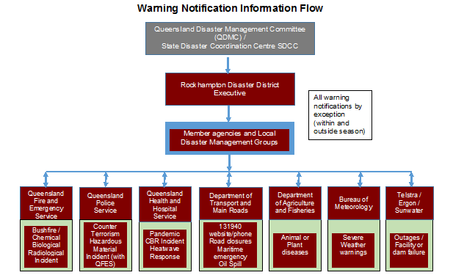

Where events require a higher level of warning, including directed evacuations, such warnings shall be issued by the DDC.

The DDC, or delegate is responsible for communicating media messages on behalf of the DDMG about the event.

The warning notification process is reviewed annually with contact lists updated quarterly by exception, as roles and positions change.

Standard Emergency Warning Signal (SEWS)

The Standard Emergency Warning Signal (SEWS) is a distinctive audio signal that has been adopted to alert the community to the broadcast of an urgent safety message relating to a major emergency/disaster. It is intended for use as an alert signal to be played on public media (such as radio, television, public address systems, mobile sirens), to draw listeners’ attention to a following emergency warning. It is meant to attract listeners’ attention to the fact that they should take notice of the emergency message.

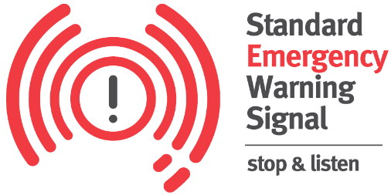

The Standard Emergency Warning Signal (SEWS), shall be utilised in respect to warning issues for events involving the following:
- Wind gusts >125 kilometres per hour (equivalent to category 2 and above cyclones);
- Storm tide >0.5 metre above Highest Astronomical Tide;
- Large hail > 4 centimetre in diameter;
- Tornado(s);
- Major floods, flash floods and/or dam break;
- Intense Rainfall leading to Flash Floods and/or landslides (1-6 hour rainfall total > 50 year Average Recurrence Interval);
- Geo-hazards including effects of earthquakes and or tsunami waves > 1 metre (tide dependent);
- Major urban and rural fires;
- Major pollution, hazardous material or bio-hazard emergency;
- Civil defence emergency (as defined in Article 61 of Protocol 1 of the 1977 Protocols Additional to the Geneva Conventions of 1949);
- Other major emergency situations.

The use of SEWS may be considered outside of the aforementioned eligible events, in which case the DDC will liaise with the Assistant Commissioner, Central Police Region, and advise the Executive Officer of the QDMC accordingly.

The process for the notification and dissemination of warning products is not a function dependant on the activation of the DDMG, rather should be an automatic responsibility of DDMG Executives and relevant members regardless of the status of activation of the DDMG.

Emergency Alert (EA)

Emergency Alert (EA) is one tool that can be used to warn communities of an impending emergency and is a critical element of emergency response. The Queensland Emergency Alert Guideline governs the use of EA in Queensland. The Emergency Alert is a national telephone warning system that provides emergency authorities with an enhanced ability to warn the community via landline and mobile telephones in the event of an emergency.

As the use of EA can be time critical, the process for requesting it does not involve a bureaucratic approval process. EA provides the capability to send warning messages to fixed line telephones based on their physical location and to mobile telephones based on the billing address within a particular area.

Social Media

Agencies using social media retain responsibility for updating, maintaining and monitoring their presence. This is to be consistent with the Principles for the official use of social media guidelines (Queensland Government Enterprise Architecture).

Websites

Agencies retain responsibility for updating their websites and content to provide relevant information about an event.

Evacuations

LDMGs are able to, and have the responsibility to, make a decision to call for a ‘voluntary’ evacuation of persons from impacted areas and will coordinate evacuations in their area of responsibility. The powers necessary to authorise a directed evacuation rest with the DDC. Considerations that must be made regarding evacuation include:

- Why evacuate (decision - risk, resourcing and support to evacuation centre/cyclone shelter etc)
- When and when not to evacuate (timeline from event / day and night considerations)
- Where to evacuate (from and too - do not move from safe location to more at risk location)
- What to evacuate (people, animals, medication)
- How to evacuate (transport arrangements)

In instances where an evacuation (including evacuation and recovery centres and Cyclone Shelter support) exhausts the capability or capacity of the LDMG, a request for assistance may be directed to the DDMG. In these instances it is the responsibility of the DDMG to make informed decisions facilitated through the DDCC the appropriate planning, resources and support requested. Agencies should consider and address resourcing support as to how they can assist local governments and other government departments with an evacuation.

There are five (5) stages to the “Evacuation Process”.

- Decision
- Warning
- Withdrawal
- Shelter
- Return

A District Evacuation Subplan is contained at Annexure ‘G’ to this document. This subplan is to be read in conjunction with respective Local Disaster Management Group Evacuation Subplan.

Requests for Assistance – (RFAs)

LDMGs who require assistance in the form of resources or services not available within their jurisdiction, or if available, have been or are likely to be expended, may request assistance (in the approved form or through the IXP portal to DIEMS) from the DDMG.

Upon receipt of a request for assistance, the DDMG shall consider the request and make all reasonable endeavours (through the relevant Liaison Officers) to locate the required resource or service from elsewhere within the disaster district. Requests that cannot be met at District level are to be forwarded to the State Disaster Coordination Centre for consideration.

DDMGs do not themselves possess any resources. All resources within the disaster district are owned and managed by the various local governments, government departments, corporate entities or private business operators.

Resources and services acquired by the DDMG and appropriated to an LDMG may be recalled and reallocated at the discretion of the DDMG.

In acquiring resources, the DDMG will enter into normal contractual arrangements at commercial rates. Normal accepted practices in terms of purchase and acquisition apply. Appropriate approvals shall be obtained prior to the expenditure of any costs.

The DDC, Deputy Chairperson and Operations Officer shall ensure that accurate records are maintained in respect to requests for assistance, resource acquisition, allocation and financial expenditures.

Assessing Support and Allocation of Resources

The DDC may use the resources within the District and only when these resources are exhausted or not suitable will the DDC request State support. The DDC may also request resources from inter-district or inter-regional areas surrounding the DDC’s affected area.

All resources allocated to the DDC from any source will remain under the control of the DDC until returned. The DDC or his / her delegate is responsible for the collection and return of all resources.

Requests for Australian Defence Force assistance under the Defence Aid to the Civil Community (DACC) arrangements shall be made in the first instance to the Officer in Charge, Joint Operations Support Staff (JOSS), Lavarack Barracks, Townsville.

As well as requesting JOSS any requests for ongoing ADF assistance, particularly where aircraft usage or cost recovery may be required, under categories other than category 1 shall be forwarded to the Executive Officer of the QDMC at the same time.

Emergency supply

During a disaster related event, the situation may arise whereby members of the community require the supply of essential items and goods to maintain their health and well-being until more permanent arrangements can be made. Where local capacity is exhausted, QFES coordinates the acquisition and management of emergency supplies, through the State Disaster Coordination Centre (SDCC) when activated, or through the SDCC Watch Desk outside activation periods.

Resupply

LDMGs will be the focal point for processing any request for resupply by any community in their area of responsibility. The role of the DDMG is to facilitate the conduct of resupply operations on behalf of the effected LDMG. The district group is only responsible for the resupply of entire communities, the LDMG is responsible for the conduct of resupply to isolated properties and persons within their area. LDMGs should advise the DDC that resupply operations to isolated properties are occurring within their local government area.

When determining the need for resupply the Local Disaster Coordinator (LDC) and the LDMG must take into account the level of goods available in the entire community rather than acting on requests from individual retailers. The purpose of resupply is not to maintain the normal trading levels of retailers during isolation. As well as retailers the LDMG must consider other organisations, this may include:

a. Hospitals and clinics,
b. Charity organisations (meals on wheels, school based feeding programs)
c. Postal contractors,
d. Fuel suppliers (aviation fuel, essential fuel supplies only)
e. Vets,
f. Ambulance,
g. Aged care facilities, and
h. Any other local organisation that supplies essential goods or services.

The DDMG has a financial responsibility to ensure resupplies are conducted in a cost effective manner. DDCs are responsible for ensuring any request for resupply from any LDMG in their Disaster District is in accordance with the “Queensland Resupply Manual”, examined and checked by the QFES member on the LDMG before consideration of endorsement by the DDC and referral to the State Disaster Coordination Centre.

Where resupply is undertaken by the DDMG a log of air and road transport companies should be maintained to aid the processing of requests.

Operational Reporting

  - Local Disaster Management Groups shall advise the DDC immediately the LDMG is activated or placed on alert;
  - The DDC shall advise the Executive Officer of the QDMC immediately the DDMG is activated or stood-up;
  - Once activated, or stood-up, Local Disaster Management Groups (through the LDCC), Functional Committees and agency liaison officers will provide situation reports (SITREPs*) in the approved form of the disaster event to the DDMG within the required timeframes;
  - Once activated, or stood-up and on conclusion of operations (Final SITREP), the DDMG will provide SITREPs (in the approved form) on the event to the SDCC within the required timeframes;
  - Following an activation of the DDMG or DDCC, the Deputy Chairperson will provide a briefing on the event for the DDC.
  - Following debriefing of operations, the District Disaster Coordinator is to provide an Operational Report to the Executive Officer, QDMC detailing the full extent of operations including debrief information.

*SITREPS - A situation report (SITREP) is a brief report that is published and updated periodically during a disaster operation which outlines the details of the disaster, the requirements generated, and the responses undertaken as they become known.

  - SITREPs are to include information on any impact assessments conducted within the disaster event area (Local Government supported by Queensland Fire and Emergency Service).

Once completed the District SITREP should be approved by the DDC, included on the Activity Log and forwarded to the SDCC by 1800hrs each day.

To achieve this timeframe all LDMG and Agency SITREPS are to be received by the DDCC as follows:

- LDMG/AGENCY SITREP is to be received at the DDCC by 1700hrs
- DDMG SITREP to be received at the SDCC by 1800hrs

During an event a ‘District Update’ is to be forwarded by the DDMG to the SDCC in ‘dot point’ format where there is a significant situational change in circumstances at the Local/District level. This ‘District Update’ is to be provided by the DDMG to the SDCC at - 2000hrs each evening and 0600hrs each morning.

Financial Management

Where members of the DDMG are coordinating purchases for their agency/department, they are to comply with their internal agency purchasing policies. Each participating agency should predetermine the type and limit of expenditure permitted (individual and cumulative expense) without further reference to senior management. This also includes predetermining management processes for the expeditious financial authorisation of support and relief staff, as may be required. Each agency is responsible for claiming their own reimbursement of funds relating to disaster operational expenses.

No purchase is to be made for the DDMG without consultation with and approval by the DDC, Deputy Chair or the Executive Officer.

Prior to any purchase being considered it must be determined whether a Standing Offer Agreement (SOA) is in existence regarding the goods/services. Where it is ascertained that an SOA does exist, the arrangements contained within that SOA are to be complied with.

Reimbursement is not an automatic process and requires solid evidence of disaster-related expenditure. The circumstances and conditions under which disaster-related expenditure may be recouped is explained in the
Queensland Disaster Funding Guidelines (QDFG) 2021. A receipt is to be obtained for all purchases conducted by the DDMG and the full details of all expenses/purchases incurred by the DDMG during a disaster are to be recorded.

Some disaster events or activities conducted may not be claimable.

- The OPSO will be responsible for the recording and payment of all approved financial expenditure by the DDMG.
- All expenses are to be recorded within a cost recovery calculator with tax invoices retained of all transactions.

All processes are to be performed in accordance with the Queensland Government Financial Management Practice Manual and therefore in compliance with section 61 of the Financial Accountability Act 2009.

Information Management

All information (incoming and outgoing) relating to disaster operations must be communicated through the DDCC. The use of the JUVARE WebEOC software (DIEMS) in the DDCC supports the management of information from all agencies involved. Recording requirements are set out as Activity Log, tasks and all actions taken within the DDCC are captured within the program for all stages of activation (Alert, Lean Forward, Stand Up and Stand Down) for disaster management operations. Hardcopy or email information received (outside of DIEMS) within the DDCC is to be scanned or copied into the relevant event to ensure an accurate and chronological activity log is maintained.

Media Management

The community shall be kept informed of the activities of the District Disaster Management Group. This includes disaster management operations in support of LDMGs across the district and reflect the role of the State.

Formal comments/interviews with the media in respect to a disaster event and disaster operations following an event on behalf of the disaster district shall only be made by the DDC or Deputy Chairperson in consultation with and assistance from other DDMG members as necessary. Comment from the DDMG must relate to district support operations and not tactical aspects of the operations at the LDMG level.

Comment on operations at the LDMG level is not to be made but left to the Chair of the LDMG in accordance with Local Disaster Management Plan arrangements.

The DDC will appoint a suitable person to perform media liaison duties and organise media representatives to attend the DDCC briefing area. The DDC shall authorise all media releases and briefing times from the DDCC. This will be carried out through an appointed Media Liaison Officer, having regard to media deadlines.

The appointment of any media liaison officer will be at the discretion of the DDC. The following officers will be responsible for the release of any information:

Media Liaison Officers: (i) Chairperson
- Police Media

Generally, media should not be provided access to the DDCC during times of activation unless approved by the DDC. Contact details for media entities within the district are included as an Annexure I to this plan.

Disaster Declarations

Where the declaration of a disaster is considered necessary by the DDC, (pursuant to section 64 of the Disaster Management Act 2003 - DM Act), and after consultation with the District Group and each Local Group who’s area is in, or partly in, the declared area for the disaster situation, the DDC is to seek approval from the Minister to declare a disaster situation.

Such declaration may be sought if the DDC is satisfied, –
        - a disaster has happened, is happening or is likely to happen, in the disaster district; and
        - it is necessary, or is reasonably likely to be necessary, for the district disaster coordinator or a declared disaster officer to exercise declared disaster powers to prevent of minimise any of the following –
          - loss of human life;
          - illness or injury to humans;
          - property loss or damage;
          - damage to the environment.

The DDC in conjunction with the Executive Officer will ensure that all members of the group are notified of the declaration.

Emergency Situation

Public Safety Preservation Act 1986 Section 5: ‘Declaration of emergency situation’ The PSPA provides a definition of an emergency situation as,

(f) any impact of a naturally occurring event such as a flood or a landslide; that causes or may cause a danger of death, injury or distress to any person, a loss of or damage to any property or pollution of the environment, includes a situation arising from any report in respect of any of the matters referred to in paragraphs (a) to (f) which if proved to be correct would cause or may cause a danger of death, injury or distress to any person, a loss of or damage to any property or pollution of the environment.

This situation occurs where the initial scale of an event may not constitute a disaster but requires a number of agencies to respond and collaborate in its resolution. An Emergency Situation may be declared by a Commissioned Officer of the Queensland Police Service.

Recovery Strategy

Recovery
the taking of appropriate measures to recover from an event, including action taken to support disaster-affected communities in the reconstruction of infrastructure, the restoration of emotional, social, economic and physical wellbeing, and the restoration of the environment
Disaster Management Act 2003 section 4A (a) (iv)

The comparative timeframes from response to recovery can be diagrammatically as:
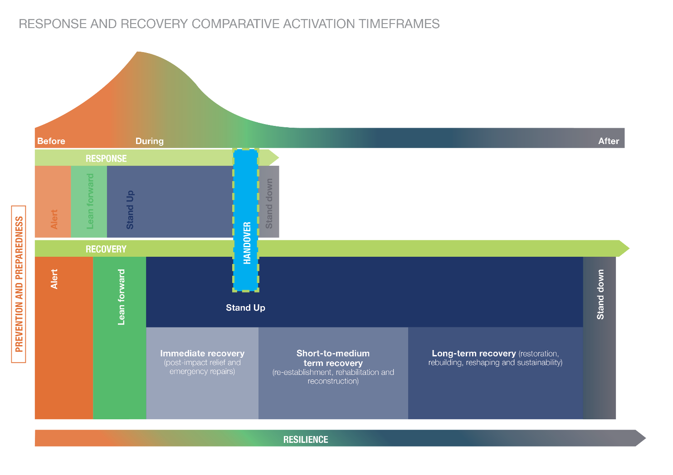
The Rockhampton DDMG recognises that recovery is a core function of the group and to be successful comprises the following principles:

Understanding the context – Appreciating the risks faced by individuals and communities, acknowledging strengths, weaknesses and past experiences, supporting people with vulnerabilities and recognising and respecting differences.

Recognising complexity – Diverse needs, wants and expectations of the community, conflicting knowledge, values and priorities, five functions of recovery often overlap and recovery arrangements must consider the inter-relationships between these functions.

Using local community-led approaches – Allowing individuals, families and communities to manage their own recovery, using and developing community knowledge, leadership and resilience, building strong partnerships between communities and those involved in the recovery process.

Ensuring coordination of all activities – Use an emergency management approach that integrates with responses and contributes to future prevention and preparedness; be inclusive; have clear and shared goals; have clear decision making and reporting structures.

Employing effective communication – Ensure two-way communication with community; ensure communication is relevant, timely, clear, accurate, targeted, credible and consistent; use a variety of communication methods; repeat key recovery messages.

Acknowledging and building capacity – Support the development of self-reliance; quickly identify and mobilise community skills and resources; develop networks and partnerships to strengthen capacity.

The Rockhampton Disaster District has been impacted by varied disaster events and their consequences. The cumulative effects and protracted recovery from these events remain an ongoing concern. Of recent, these disaster events include:

- 2008 - Central and Western Queensland Floods
- 2010/2011 – Queensland Flood event
- 2013 – Tropical Cyclone Oswald and associated flooding
- 2015 – Severe Tropical Cyclone Marcia and associated heatwave
- 2017 – Severe Tropical Cyclone Debbie and associated flooding
- 2018 – Central Queensland Fire event – Gracemere, The Caves and Expedition Range
- 2019 – Eastern Queensland Bushfires (Cobraball)
- 2020/2021 – COVID-19 Pandemic event

Each of these events have left a direct and ongoing legacy across the communities within the district and compound the complex recovery environment. The district therefore acknowledges the need to consider individual disaster impact recovery following each event but also the cumulative affects felt by communities caused from the ongoing recovery from previous events.

Disaster recovery is a continuous process from immediate relief/short term recovery through medium/long term recovery to the resumption of normal business and resilience building activities (represented below). It goes beyond immediate welfare support and includes physical repair and reconstruction, personal rehabilitation, the restoration of social well-being, community development, economic renewal and growth, and regeneration of the natural environment.
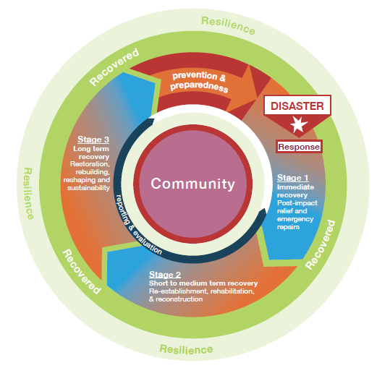
Experience has demonstrated that effective recovery management following a disaster depends on planned procedures, trained staff, identified resources and planned distribution processes. This recovery requires a range of services and is successful if the services are provided in a coordinated and streamlined way. To achieve this end the structured and effective integration of government agencies, non-government organisations, government-owned corporations, industry groups, the private sector and whole-of-community is required.

The District recognises the importance of recovery efforts being driven locally with a progression of support through District to State as required (District Recovery Subplan at Annexure F). Functional lead agencies at the district level maintain arrangements that achieve their functional responsibilities for recovery and ensure reporting of district recovery arrangements will occur to and through the DDMG.

Scope

This recovery strategy has been developed to:

- provide a framework for the coordination of recovery operations within the district and is supported by the procedures outlined in the Prevention, Preparedness, Response and Recovery Guidelines - PPRR DM Guideline;
- include all functions of recovery (human and social, economic, environmental, building and roads and transport);
- define broad parameters for the effective coordination of recovery operations within the district;
- be flexible, integrated and enable scaling up and down of recovery processes as required;
- provide assurance that common recovery themes are being addressed in a coordinated way;
- identify constraints to the coordination of recovery operations within the district;
- identify for each recovery function, a broad scale of recovery that can be managed at the district level; and
- consider the cumulative disaster consequences from previous disaster events impacting the district.

Parameters and Constraints

The scale, impact, duration, recency and cumulative nature of specific disaster events on individuals and communities has a direct bearing on the nature and scope of community recovery services provided by government and non-government agencies. It also informs the relevant governance and administrative arrangements that will be required.

Effective recovery requires an integrated, multi-disciplinary approach to needs, consequence management, community engagement, planning and service delivery. In many instances multiple agencies may be involved in the delivery of specific community recovery services. This is particularly the case with more significant or complex disaster events. In providing community recovery services agencies can adopt either a lead agency or a support role.

The following table provides a general guide on the different scales of disaster impact and the likely characteristics of the required community recovery operations that may influence agency roles and responsibilities. This guide draws on experience to date with community recovery and is not intended to serve as a definitive profile of the scale and impact of disaster events.

Scale | Likely characteristics of required Community Recovery Response
Very Small  - under 100 people affected  - one suburb/small town within one disaster district (usually)  - staff sourced from within the Region | Local and district resources are sufficient to meet community recovery needs.  Initial community recovery operation is managed through the LDMG.  Staff are encouraged to utilise local and emergency relief welfare agencies to assist affected persons in the first instance.  If LDMG advise that hardship exists in the affected area, and that local resources are exhausted the Department of Communities, Housing and Digital Economy may seek to activate the State Disaster Relief Arrangements (SDRA) and undertake limited outreach to assess individual needs and eligibility for such relief arrangements.  Recovery services can include provision of information, personal support, financial assistance (including project management of repair to uninsured dwellings) and referrals to existing community services.
Small  - from 100 to 500 people affected  - one disaster district within one region (usually)  - staff generally sourced from within 1-3 regions | Local and district resources meet the majority of community recovery needs although staff may be sourced from neighbouring regions. Free Call 1800 Hotline and a District Triage Team may be established to schedule visits from outreach teams.  A Community Recovery Hub would be established to manage the response including outreach services. Activation of the SDRA or Queensland Disaster Funding Guidelines (QDFG) 2021) can be sought if departmental staff identify personal financial hardship and local community services are unable to assist. Community Recovery Hubs may be established and a range of government and non-government agencies are likely to be involved.  Recovery services can include provision of information, personal support, financial assistance (including project management of repair to uninsured dwellings), referral to existing community services and individual case management.
Medium  - from 500 to 5,000 people affected  - may cover a number of disaster districts across more than one region  - staff may be deployed from across all regions and central office | Resources are required from across a number of regions due to the size or complex risk profile of the disaster.  More than one Community Recovery Hub may be needed to manage the recovery response.  Queensland Disaster Funding Guidelines (QDFG) 2021 funding may be activated, and other government and non-government agencies are likely to be involved in the community recovery effort.  Recovery services can include the provision of information and additional community services in the affected area, establishment of coordinated multiagency outreach response team(s), community engagement activities and individual case management.
Large  - from 5,000 to 15,000 people affected  - multiple districts affected within one or more regions  - staff may be deployed from across all regions and central office.  Some inter-state state resources may be sought | Resources are required from across multiple regions due to the size or complex risk profile of the disaster.  The community recovery response is characterised by the need to activate state-wide or national disaster recovery response plans.  It is likely to involve the establishment of multiple Community Recovery Hub(s), and coordinated multi-agency outreach teams.  Queensland Disaster Funding Guidelines (QDFG) 2021 and other disaster recovery protocols may be activated.  The community recovery response may require the provision of temporary accommodation, community engagement and development activities, provision of additional community services, a whole-of-government information strategy and individual case management.  The response may involve the formation of a Taskforce to oversee the provision of all disaster recovery elements (community, infrastructure, economic and environment) as well as the distribution of Appeal funds and material goods.
Catastrophic  - more than 15,000 people affected  - multiple districts and Regions affected  - Central office, inter-state and possible international support | Disaster events are significantly more complex in either size, risk profile or recovery resources required and may involve multiple disaster events or sites.  They may typically require a multi-level whole of government response across Australia, requests for international support, activation of other relevant Freecall 1800 Hotline(s), establishment of a number of Community Recovery Hubs and the formation of a Taskforce to oversee the provision of all disaster recovery elements (community, infrastructure, economic and environment) as well as the distribution of Appeal funds and material goods.  Significant involvement of government and non-government agencies would be required including coordinated multi-agency outreach responses, centre based and telephone service delivery, appeals, short, medium and long-term accommodation options and community recovery plans, and Taskforce coordination. Additional funding programs/grants may be available to assist with community recovery.

Transition from Response to Recovery

The transition from response operations to recovery operations will be influenced by the nature of the disaster and therefore requires a degree of flexibility.

Transition from response to recovery at the local and district level, and the need to undertake such a process, will be informed by local circumstances and determined by the chairs of the relevant LDMGs/DDMG.

Transition will be guided by:

- situation reports (SitReps) which evidence the de-escalation of response operations
- status of response and immediate recovery/relief operations
- impact and needs assessments
- response and early recovery situations that may escalate
- anticipated recovery issues and risks.

The triggers, actions and communication processes to activate the district recovery arrangements are contained below.

Response Alert |  | Triggers | Actions | Communications
Response Lean Forward | Recovery Alert | - Response phase at ‘lean forward’ level of activation | - Appointment of District Recovery Coordinator (DRC) as appropriate  - Potential actions and risk identified  - Information sharing commences  - DRC in contact with DDC/DDCC  - Initial advice to all recovery stakeholders | - DDC or District Recovery Coordinator (DRC) and Functional Recovery Group (FRG) members on mobile  - Ad-hoc reporting  - FRGs reporting for their line of responsibility
Response Stand-up | Recovery Lean Forward | - Response phase at ‘stand up’ level of activation  - Immediate relief arrangements may be required during response phase | - Monitoring of response arrangements  - Analysis of hazard impact  - Relief and recovery planning commences  - Preparations are made for the deployment of resources for the provision of immediate relief commenced by Functional Recovery lead agencies | - DDC and FRG members on mobile and monitoring email remotely  - Regular reporting  - FRG leads championing reporting for their area of responsibility.
Response Stand Down | Recovery Stand Up | - Immediate relief arrangements are required  - Medium term recovery commences.  - Response phase moves to stand down ‘level of activation.’ | - FRG activated at DDCC or alternate location  - Recovery sub-Plan activated  - Deployment of resources for the provision of immediate relief measures  - Action plan/s of Functional Recovery lead activated  - Transition arrangements from ‘response to relief and recovery activated (as appropriate) | - DDC and FRG liaison officer present at DDCC or alternate locations  - DDC and FRG members involved in medium term recovery continue as required  - FRG reporting regularly to DDC/DDMG
 | Recovery Stand Down | - FRG arrangements finalised  - Community returns to normal activities with ongoing long-term recovery support provided by functional lead agencies as required. | - Consolidate financial records  - Reporting requirements finalised  - Participate in recovery debrief  - Participate in post event debrief  - Post event review and evaluation  - Long term recovery arrangements transferred to functional lead agencies  - Return to core business | - DDC and FRG members resume standard business and after hours contact arrangements  - Functional lead agencies report to DDC/DDMG as required and during DDMG meetings.

Functions of Recovery

Recovery is conceptually grouped into five functions. It is important to acknowledge that each of these functions overlap and recovery arrangements must reflect the inter-relationship between each.

Each designated functional lead agency has responsibility for the performance of recovery which has a direct correlation to their core business. Functional lead agencies may require the assistance of supporting agencies to effectively perform their function.

Function | Lead Agency
Economic | Department of State Development, Infrastructure, Local Government and Planning
Environmental | Department of Environment and Science
Human and social | Department of Treaty, Aboriginal and Torres Strait Islander Partnerships, Communities and the Arts.
Building | Department of Energy and Public Works
Roads and Transport | Department of Transport and Main Roads

Economic

Economic recovery includes renewal and growth of the micro economy (within the affected area) and the macro economy (overall economic activity of the state). Economic recovery includes individual and household entities (e.g. employment, income, insurance claims), private and government business enterprises and industry. It includes assets, production and flow of goods and services. It includes capacity for the export of goods and services from the affected area, and securing confidence of business markets.

Economic recovery will be led by Department of State Development, Manufacturing, Infrastructure and Planning and will focus on the coordinated process of supporting affected communities in:

- Implementation of business and industry economic recovery strategies;
- Matters relating to the impact of events on tourism and tourists;
- Regional intelligence on the impact to infrastructure and business and industry.

Environment

Environment, or natural environment, recovery includes restoration and regeneration of biodiversity (species and plants) and ecosystems, natural resources, environmental infrastructure, amenity/aesthetics (e.g. scenic lookouts), culturally significant sites and heritage structures. It includes management of environmental health, waste, contamination and pollution and hazardous materials.

Environmental recovery will be led by Department of Environment and Science and will focus on the coordinated process of supporting affected communities in:

- assessing the impact of the event on the natural (e.g. water quality, ecological impact and pollution) and cultural (e.g. heritage conservation including indigenous cultural heritage) environment;
- providing advice on potential environmental issues (e.g. water quality and sewerage, etc) and monitoring current issues (e.g. monitoring pollution and animal welfare);
- the rehabilitation of the natural environment, including parks, waterways and wildlife;
- rehabilitation of the cultural environment;
- the preservation of community assets (e.g. reserves and parks);
- managing and disposing of waste;
- ensuring environmental bodies, affected communities and interest groups are involved in the decision making process; and
- monitoring and assessing the environmental consequences of clean-up operations.

Human and Social

The Department of Treaty, Aboriginal and Torres Strait Islander Partnerships, Communities and the Arts has functional lead-agency responsibility for Human and Social recovery and chairs the Rockhampton District Human and Social Recovery Group. The Department is responsible for developing the District Human and Social Recovery Plan under advice from the Human and Social Recovery Group.

The Rockhampton District Human and Social Recovery Plan provides the strategic framework for human and social recovery planning, outlining roles and responsibilities of government and non-government partners for the coordinated delivery of human and social recovery services following a disaster.

Human and social recovery includes personal support and information, physical health and emotional, psychological, spiritual, cultural and social well-being, public safety and education, temporary accommodation, financial assistance to meet immediate individual needs and uninsured household loss and damage.

Building

Building recovery includes repair and reconstruction of residential and public buildings, commercial, industrial and rural buildings and structures, government structures, utility structures, systems and services (water, sewage, energy, communications) and other essential services and dam safety.

Infrastructure recovery will be led by the various lead agencies including Department of Energy and Public Works - Qbuild and Telecommunications providers. Each will focus on the process of supporting affected communities in assessing and coordinating:

- damage to housing stock, commercial and industrial buildings and structures, rural structures, and infrastructure facilities;
- building safety inspection services and securing damaged buildings and structures;
- demolition of unsafe buildings and structures;
- repair and rebuilding matters of housing stock;
- disposal of hazardous material and debris;
- recovery of utility (water, power and telecommunications) infrastructure, which is normally undertaken by infrastructure owners and operators (e.g. Telstra and Energy Queensland, etc.);
- restoration of public schools and public building infrastructure, sporting facilities and public playgrounds;
- the restoration of damaged dam structures;
- prioritise repair and reconstruction activities, where appropriate;
- ensuring industry groups and affected communities are involved in the decision making process; and
- considering mitigation measures (e.g. flood risk reduction) when planning for rebuilding and reconstruction.

Roads and Transport

Roads and Transport recovery will be led by the various lead agencies including Department of Transport and Main Roads. Each will focus on the process of supporting affected communities in assessing and coordinating:

- recovery of road and other transport infrastructure;

District Recovery Group (DRG)

Where appropriate the medium/long term recovery phase may include the establishment of a District Recovery Group (DRG) with specific membership appointed as appropriate to the type of event and functions required.

Where a District Recovery Group is established recovery coordination is handed over to the District Recovery Coordinator (DRC) who will be the DDC or a person delegated by the DDC to Chair the District Recovery Group.

The medium/long term District Recovery Group will comprise any or all members of the DDMG, and any additional invited members as required. Organisations that are not members of the DDMG may be invited where required, for example: Chamber of Commerce, insurance companies, major employment (industry) or organisations in the area.

Once established the District Recovery Group will be provided with a Terms of Reference specific to the event. The District Recovery Group should develop an Operational Plan to meet the requirements of the Terms of Reference.

The District Recovery Group will ensure recovery, reconstruction and rebuilding is completed and community connections, preparedness and resilience enhanced. The District Recovery Group will be able to inform and reflect upon the work of the Functional Leads and provide assistance to key priority areas and support in achieving effective recovery and resilience outcomes as summarised below.
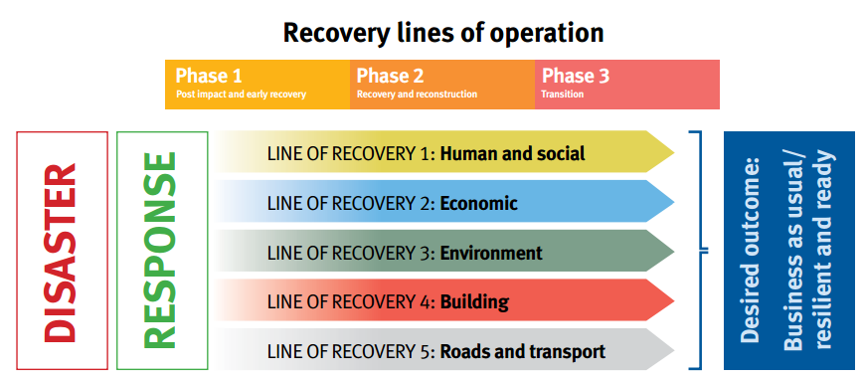
Source: State Recovery Plan 2017-2019 Operation Queensland Recovery p. 20

Activation

The district recovery strategy will continue as a standing agenda of the DDMG.

The actual activities and services will vary across the six different phases as described below:

- Preparedness
- Alert/Stand-By
- Activation
- Immediate to Short-Term Recovery
- Medium to Long-Term Recovery
- Stand-Down/De-Brief

As disaster response and immediate/short term recovery occurs concurrently, the activation of the recovery strategy will commence with immediate/short term recovery actions undertaken within the response phase. The level of district support required in the medium/long term recovery phase will be dependent on the recovery structure considered by the DDMG for each specific event.

Planning

During non-operational times the Rockhampton DDMG is to include recovery considerations in their disaster management plans, which will be informed by functional lead agencies. Functional lead agencies are to create their own specific mechanisms for planning etc.

Functional lead agencies should have a function-specific plan at the district level that is cognisant of local issues and can be used to guide service arrangements in support of local and district recovery arrangements.

Disaster specific recovery plans are developed in partnership with stakeholders, through a planning group, and include:

- short, medium and long-term recovery priorities
- consideration of local capability
- restoration of key infrastructure and services, rebuilding and rehabilitation
- lifting of restrictions or suspensions in trade and movement
- metrics for tracking progress to support accountability
- consideration of funding arrangements
- integration across all functional recovery areas
- mechanisms to engage community members in their own recovery
- anticipated end of recovery activities and the expected transition to community activities and a new normal.

Operations

During operations the District Recovery Group will include functional lead agencies from district level supported by the activation of the Rockhampton Disaster District Recovery Sub-plan (Appendix F). Functional lead agencies use their own arrangements to provide support. This group will coordinate recovery operations in liaison with functional lead agencies and the DRG.

Lead Agency | Role | Recovery Responsibilities
Department of State Development, Infrastructure, Local Government and Planning | Economic lead and coordinate planning and implementation of the economic function of recovery | - Coordinate the economic function of district/local recovery operations.  - Assess and monitor impact on economic viability, key economic assets including employment issues and capacity of local businesses to operate.  - Facilitate business, industry and regional economic recovery and renewal.  - Develop industry and business recovery plan and implementation strategies in conjunction with local government, relevant State Government agencies, regional economic development organisations and industry bodies.  - Facilitate financial assistance, access to funds and loans and employer subsidies.  - Where required, facilitate linkages with job providers and employment agencies to source labour, re-establish supply chains and joint marketing activities.  - Develop a strategy to maximize use of local resources during clean up and restoration activities.  - Support small to medium enterprise (e.g. referrals, business assistance, etc).  - Identify options for improvement or adjustment from current business operations, where required.  - Assist with contract arrangements, where required.  - Ensure involvement of local business and industry representatives and the community in decision making
Department of Environment and Science | Environmental lead and coordinate planning and implementation of the environmental function of recovery | - Coordinate the environmental function of district/local recovery operations.  - Coordinate assessment of the event on the natural (e.g. water quality, ecological impact, pollution) and cultural (e.g. heritage conservation including indigenous cultural heritage) environment.  - Provide advice on potential environmental issues (e.g. water quality, sewerage, etc).  - Coordinate rehabilitation of natural environment, including parks, waterways and wildlife.  - Coordinate the rehabilitation of the cultural environment;  - Coordinate preservation of community assets (e.g. reserves and parks).  - Consider mitigation strategies to reduce future impacts on the natural environment, where appropriate.  - Monitor issues of pollution.  - Coordinate waste management and disposal.  - Ensure effective consultation and communication with the community and relevant organisations including environmental bodies and interest groups.  - Monitor and assess the environmental consequences of clean-up operations.  - Monitor and assess animal welfare issue
Department of Energy and Public Works | Infrastructure lead and coordinate planning and implementation of the infrastructure function of recovery | - Coordinate the infrastructure function of district/local recovery operations.  - Liaise with the Insurance Council of Australia to ensure the declaration of the general insurance industry Catastrophe Coordination Arrangements and to identify nominated ICA representative.  - Coordinate building safety inspection services, secure damaged buildings and structures and coordinate demolition/repair and rebuilding  - Coordinate the assessment of damage to housing stock, commercial and industrial buildings, rural structures, and infrastructure facilities.  - Work with all sectors/stakeholders to determine prioritisation of works  - Assist with development of options for temporary accommodation  - Assist with development of a coordinated approach to housing related strategies  - Coordinate restoration of sporting facilities and public playgrounds.  - Work with affected communities and interest groups to support their involvement in the decision-making process.  - Ensure risk reduction is considered in planning for rebuilding and reconstruction.
Department of Treaty, Aboriginal and Torres Strait Islander Partnerships, Communities and the Arts. | Human and Social lead and coordinate planning and implementation of the human-social function of recovery | - advice and State Government human and social resources in support of LDMG-led recovery processes  - coordination and collaboration between agencies engaged in human and social recovery at a district and state level  - service delivery to disaster-affected people through triage assessment, outreach services and recovery hubs  - financial assistance to disaster-impacted people through:  - Emergency Hardship Assistance Grants  - Essential Services Hardship Assistance Grants  - Essential Household Contents Grants  - Structural Assistance Grants  - Essential Services Safety and Reconnection Scheme  - information, advice, referral, counselling and personal support through arrangements with partner agencies.  - The Management of Smart Service Queensland and the associated telephony systems on behalf of a number of government departments such as SES and the Community Recovery Hotline.  The Housing and Homelessness Services offerings from the Department provides –  - housing assistance and homelessness support services to Queenslanders most in need, for the duration of their need.  - quality frontline services and safe, caring and connected communities. We do this by providing secure housing options and help for people to get access to and remain in private rental homes, or to find a home with one of the social housing organisations across Queensland.  - Queenslanders in need with social and private housing assistance, remote Indigenous housing, homelessness support services and crisis accommodation though direct service delivery and arrangements with funded service providers.
Department of Transport and Main Roads | Transport lead and coordinate planning and implementation of transport recovery | • Coordinating the effective and efficient delivery of state-controlled road and transport recovery and reconstruction activities.  • Engaging directly with industry and the community on the recovery and reconstruction phases following the disaster.  • Ensure agencies and partners are prepared for disaster recovery operations

Operational and Action Plans

When convened for disaster recovery operations, the District Recovery Group (with guidance from functional agencies) will develop an Operational Plan to guide its activities and ensure the validity of decisions and consistency with the DM Act. This will be discussed and developed during the group’s first meeting. A broad timeframe should be included in this plan.

At the first meeting Action Plan’s for each recovery function will be developed. Each Action Plan will list the tasks to be performed by the group, agencies/individuals responsible for the tasks and a timeframe for completion of these tasks.

At each subsequent group meeting, respective Action Plans will be reviewed and updated, with new information. Revised plans should consider:

- emerging issues;
- additional actions that may be required;
- roles and responsibilities;
- arrangements for ongoing coordination across the functions; and
- progress against the original requirements.

Operational and Action plans should also identify proposed transitional arrangements that consider the requirements of affected individuals and communities. This should include service delivery arrangements and emerging issues. Plans should also be informed, where possible, by feedback received through ongoing community engagement strategies.

Copies of completed Action Plans should then be submitted to the recovery group at their final meeting, where the Operational Plan is also to be finalised. Copies of plans should be included in relevant agency and group event after action reports.

Considerations for Operational and Action Plans

When developing Operational and Action Plans lead functional agencies and recovery groups should consider the following:

- Issues identified from information gathered by impact assessments;
- Arrangements outlined in existing functional plans;
- How to allocate actions and responsibilities across the five recovery functions to inform the development of action plans;
- Arrangements for overall coordination of recovery operations;
- How to develop strategies for recovery with the affected community/ies which detail the vision, goals and project outcomes of the recovery strategy;
- Identifying the main short, medium and long-term priorities;
- Developing project timeframes, costs, funding priorities and funding strategies;
- Advertising and disseminating public information about the Action Plans;
- Determining appropriate community engagement and communication strategies;
- Ensuring all aspects of Operational and Action Recovery Plans adhere to the National Principles for Disaster Recovery;
- Consistency with the DM Act;
- Consistency with the QDMA;
- Transitional and exit strategies; and
- Strategies for conducting a debrief and evaluation of recovery operations.

Immediate/short term recovery

The Immediate to Short‐Term Recovery phase covers immediate community recovery service provision to meet identified individual personal and community needs, and to restore services to the level where Local Government and the normal responsible agencies can manage the continuing recovery process. The immediate/short term recovery phase occurs concurrently to response operations. Immediate/short term recovery activities of the DDMG will typically include:

- support to LDMGs to ensure the conduct of rapid damage and need assessment;
- support to LDMGs to ensure the provision of immediate community services (e.g. health services, food, clothing and shelter, financial relief);
- support to LDMGs to ensure the restoration of critical utilities and services; and
- support to LDMGs to ensure the provision of temporary housing.

During this phase, the District Recovery Group will as required prepare an Event Specific Action Plan which will assist in determining the requirement for medium/long term recovery; the type of recovery assistance will be required from the DDMG and the timeframe for the transition to the medium/long term recovery.

Transition from immediate/short term to medium/long term recovery

The Rockhampton DDMG will utilise the following as triggers to commence the process of transition from immediate/short term to medium/long term recovery:

- Emergency is contained;
- No further hazard or secondary threats are likely in the near future;
- Response organisations cease their activities;
- Public safety measures are in place and work effectively;
- Evacuation centres have closed; and
- Initial rehabilitation has commenced.

The appointment of the District Recovery Coordinator should take place at the latest during the transition phase and preferably during the response/short term recovery phase of the event.

Medium/long term recovery

The level of support required by the DDMG during the medium /long term recovery phase will be dependent on the nature and scale of the disaster. The level of involvement of the DDMG may range from supplementation of a Local Recovery Group to the establishment of a District Recovery Group.

Transition to normal business

The conclusion of the recovery phase will be determined by the relevant District Recovery Group in consultation with the District Disaster Coordinator. The Recovery Group will manage the recovery process for as long as a whole of government recovery support is required, the Terms of Reference for the Group have been achieved and government agencies have the capacity to accept the management of the workload within their agencies core business processes.

Disaster Management financial arrangements

The Queensland Reconstruction Authority (QRA) administers and is responsible for the distribution of Queensland Disaster Funding Guidelines (QDFG) 2021 and State Disaster Relief Arrangements (SDRA) funds to local government and State agencies on behalf of Queensland for disaster response and recovery activities and the reconstruction of infrastructure.

The Department of Communities, Housing and Digital Economy (DCHDE) is responsible for the distribution of DRFA and SDRA funding for activated relief measures to eligible individuals.

The Queensland Rural and Industry Development Authority (QRIDA) is responsible for the distribution of DRFA funding for activated relief measures to eligible primary producers, small businesses, and non-profit organisations. DAF is responsible for freight subsidies to primary producers. Other agencies may be responsible for delivering other funding, such as DES for environmental Cat D programs.

State Disaster Relief Arrangements (SDRA)

The State Disaster Relief Arrangements (SDRA) is a State-funded program to provide assistance in the relief of communities whose social wellbeing has been severely affected by a disaster event (natural or non-natural).

Disaster Recovery Funding Arrangements

The Disaster Recovery Funding Arrangements is an Australian Government program intended to assist the recovery of communities whose social, financial and economic wellbeing has been severely affected by a natural disaster or terrorism event. These arrangements provide a cost sharing formula between the State and Australian Government and a range of pre-agreed relief measures.

To claim for expenditure reimbursement under SDRA or DRFA arrangements:

- the relevant relief measures must be activated for the eligible disaster and the expenditure must meet the eligibility requirements of that measure; and
- documentary support for all eligible expenditure detailed in the claim must be provided by the claimant.

The activation of SDRA or DRFA and the declaration of a disaster situation are not interlinked or co-dependent.

Offers of Assistance

For the purpose of this Plan, offers of assistance are categorised under one of the following types:
- Financial donations;
- Volunteers; and
- Donated goods and services.

Considerations made by the Rockhampton DDCC in the management of offers of assistance include:
- Is there capacity or resources to manage Offers of Assistance?
- Are governance measures in place to manage these offers?
- Is there a requirement to outsource the management of Offers of Assistance to a nominated service delivery entity?

Where the answer is ‘no’, to any of the above questions consideration should be given to escalating (to State) or outsourcing the management of these offers.

Financial donations - The Rockhampton DDMG does not accept financial donations. Where donations are being offered to the DDMG (via the Rockhampton DDCC) such offer will be recorded with an appropriate Activity Log entry within DIEMS and advice to the offeree directing them to the Premiers Appeal, Mayoral Fund or reputable NGO as appropriate.

Where the complexity of arrangements of offers for financial assistance are outside the scope or to complex (given the event at hand) for the affected LDMG, the LDMG may seek the assistance of the DDMG to support the distribution of funds to reputable NGOs (where service level agreements and governance structures are in place). Under these circumstances relevant State Government agencies are to support such request within their core responsibilities.

Volunteers - The Rockhampton DDMG may support a request for volunteer assistance or escalation to State or other Service Delivery entity upon request by an affected LDMG/s. Under these circumstances responsibility for the registration and management of these volunteers is maintained by the requesting LDMG/s or Service Delivery entity.

Donated Goods and Services - The Rockhampton DDMG may self-manage (where appropriate) donated goods and services where the communication and distribution of such goods and services addresses an offer and identified need within the disaster district area. In such instance the DDCC may act as a conduit in bringing parties together to support the management of these goods or services.

Where an offer of assistance is received the relevant Group member is to ensure the accepted offer is appropriately recorded, distributed and used, corporate donations are stored appropriately and distributed equitably to those most in need; and Corporate offers which do not meet the requirements of an event are identified and managed.

Annexure Index

A Distribution List
B DDMG Contact List
C Risk Register
D Risk Treatment Plan
E Pandemic Sub-Plan
F Recovery Sub-Plan
G Evacuation Sub-Plan
H District Disaster Coordination Centre Standard Operating Procedure
I Media Contact List
J Abbreviations and Acronyms
K Definitions

Further annexure to this plan may include, but are not limited to, the following:

- Risk Maps – Storm Surge/Tsunami/Bushfire/Flood

Annexure A

Distribution List

Organisation | Organisational Position | Hard Copy √ | Electronic Copy √ | Disc  Copy √
QPS | District Officer (Superintendent) | √ | √
QPS | District Inspector |  | √
QPS | Senior Sergeant Disaster Management Support Officer |  | √
Central Highlands Regional Council | Chair LDMG |  | √
Livingstone Shire Council | Chair LDMG |  | √
Rockhampton Regional Council | Chair LDMG |  | √
Woorabinda Aboriginal Shire Council | Chair LDMG |  | √
Department of Energy and Public Works | Regional Manager |  | √
Department Transport and Main Roads | Manager, Delivery and Operations |  | √
Queensland Health | Executive Director |  | √
Queensland Public Health | Manager Environmental Health Services |  | √
Department of Treaty, Aboriginal and Torres Strait Islander Partnerships, Communities and the Arts. | Manager Community Recovery |  | √
Queensland Ambulance Service | Superintendent |  | √
Queensland Fire and Emergency Service | Superintendent Regional Operations |  | √
QBuild | Area Manager |  | √
Energy Queensland | Regional Design Manager |  | √
Red Cross | Regional Manager |  | √
Telstra | Emergency Services Liaison Officer |  | √
Rockhampton Regional Council | Disaster Management Officer LDMG |  | √
Central Highlands Regional Council | Local Disaster Coordinator LDMG |  | √
Woorabinda Aboriginal Shire Council | Chief Executive Officer LDMG |  | √
Department of Environment and Science | Senior Investigator |  | √
Energy Queensland | Regional Design Manager |  | √
Dept. Agriculture and Fisheries | Senior Veterinary Officer |  | √
Department of Seniors, Disability Services and Aboriginal and Torres Strait Islander Partnerships |  |  | √
Australian Defence Force | JOSS - Major |  | √
Department of Education | Regional Director |  | √
Department of Resources | Regional Manager |  | √
Corrective Services | General Manager |  | √
Regional Harbour Master | Regional Harbour Master |  | √
Media Liaison Officer | QPS – Rockhampton DCPC |  | √
Australian Defence Forces | Liaison Officer |  | √
Department of State Development, Infrastructure, Local Government and Planning | Regional Director |  | √
Queensland Building and Construction Commission | Regional Manager |  | √
Maritime Safety Queensland | Regional Harbour Master |  | √
Department of Housing | Area Manager |  | √

Annexure B

Rockhampton District Disaster Management Group Contact List

Name - Position | Agency | Contact Details
In accordance with the Information Privacy Act 2009, when collecting personal information members are to note that information must only be used for the purpose for which it was collected and only disclosed to persons outside the DDMG with the member’s permission. All members (core and advisory) are to be aware that the DDMG will be required to continue to keep up-to-date personal information for the purposes of disaster management. Each time membership details change, the XO should be advised and new membership details provided so that the member register can be updated, showing current DDMG membership details.

Annexure C

District Risk Register

Risk Identification (District level risks only)
Hazard | Expose Elements | Risk Statement | Inherent Risk | Treatment Options | Capability | Residual Risk | AMT

AMT (Accept/Mitigate/Transfer) to different levels within QDMA

Annexure D

District Risk Treatment Plan

Risk No. | Treatment strategy | Priority | Responsible Agency | Consequential Actions | Resource Requirements including estimated costs | Implementation Timeframe | Performance Measures  Including reporting and monitoring requirements

Annexure E

Pandemic Sub Plan

Annexure F

Recovery Sub Plan

Annexure G

Evacuation Sub Plan

Annexure H

District Disaster Coordination Centre – Standard Operating Procedure (DDCC SOP)

Standard operating procedures have been developed for the District disaster coordination Centre, including:

a. Arrangements for activating, operating and closing down the DDCC;
b. Staffing arrangements;
c. Arrangements for primary and back‐up communications equipment, and
d. Facilities to support its function;
e. Appropriate maps and displays to support decision making;
f. Activation arrangements;
g. Arrangements and rosters to allow continuous operation on a 24 hour basis; and
h. Operating procedures to cover DDCC functions, layout, staff duties, use of
i. Displays, message flows, and staff training.

• A system is in place to alert key agencies promptly to a possible emergency.
• A public warning system can be activated using various communication alternatives.
• Procedures are developed to provide warning to special locations, such as schools, hospitals, industry and places of public assembly.

Annexure I

Media Contact List

Name | Contact Details
Radio
Television
Newspapers

Annexure J

Abbreviations and Acronyms

ADF | Australian Defence Force
AUSVETPLAN | Australian Veterinary Plan
BOM | Bureau of Meteorology
CBR | Chemical, Biological and Radiological
CHRC | Central Highlands Regional Council
DACC | Defence Aid to the Civil Community
DAF | Department of Agriculture and Fisheries
DCYJMA | Department of Children, Youth Justice and Multicultural Affairs
DCHDE | Department of Communities, Housing and Digital Economy
DDC | District Disaster Coordinator
DDCC | District Disaster Coordination Centre
DDMG | District Disaster Management Group
DDMP | District Disaster Management Plan
DoE | Department of Education
DESBT | Department of Employment, Small Business and Training
DEPW | Department of Energy and Public Works
DES | Department of Environment and Science
DRDMW | Department of Regional Development, Manufacturing and Water
DRDMW | Department of Regional Development, Manufacturing and Water
DR | Department of Resources
DSDILGP | Department of State Development, Infrastructure, Local Government and Planning
DSDSATSIP | Department of Seniors, Disability Services and Aboriginal and Torres Strait Islander Partnerships
DTMR | Department of Transport and Main Roads
DTIS | Department of Tourism, Innovation and Sport
DRFA | Disaster Recovery Funding Arrangements
EMA | Emergency Management Australia
FMD | Foot and Mouth Disease
JATWC | Joint Australian Tsunami Warning Centre
LDC | Local Disaster Coordinator
LDCC | Local Disaster Coordination Centre
LDMG | Local Disaster Management Group
LDMP | Local Disaster Management Plan
LSC | Livingstone Shire Council
NGO | Non-Government Organisation
OPSO | Operations Officer
QAS | Queensland Ambulance Service
QBCC | Queensland Building and Construction Commission
QCCAP | Queensland Coastal Contingency Action Plan
QDMA | Queensland Disaster Management Arrangements
QDMC | Queensland Disaster Management Committee
QFES | Queensland Fire and Emergency Services
QPS | Queensland Police Service
QRA | Queensland Reconstruction Authority
QRIDA | Queensland Rural and Industry Development Authority
RRC | Rockhampton Regional Council
SDC | State Disaster Coordinator
SDCC | State Disaster Coordination Centre
SDMP | State Disaster Management Plan
SDRA | State Disaster Relief Arrangements
SES | State Emergency Service
SEWS | Standard Emergency Warning Signal
SITREP | Situation Report
SOP | Standard Operating Procedure
SPF | Strategic Policy Framework
WASC | Woorabinda Aboriginal Shire Council
XO | Executive Officer

Annexure K

Definitions

Advisor | A person invited to participate in the business of the DDMG in an advisory capacity on an as-needed basis.
Chair | The person appointed by the Commissioner, Queensland Police Service as the Chair of the DDMG. The Chair of the group is the District Disaster Coordinator.
Coordination | The bringing together of organisations to ensure effective disaster management before, during and after an event. It is primarily concerned with systematic acquisition and application of resources (people, material, equipment, etc) in accordance with priorities set by disaster management groups. Coordination operates horizontally across organisations and agencies.
Deputy Chair | The person appointed by the Commissioner, Queensland Police Service as the Deputy Chair of the DDMG.
Disaster | A serious disruption in a community, caused by the impact of an event, that requires a significant coordinated response by the State and other entities to help the community recover from the disruption. (Disaster Management Act 2003)
Disaster District | Part of the state prescribed under a regulation as a disaster district.
Disaster Management | Arrangements about managing the potential adverse effect of an event, including, for example, arrangements for mitigating, preventing, preparing for, responding to and recovering from a disaster. (Disaster Management Act 2003)
Disaster mitigation | The taking of preventative measures to reduce the likelihood of an event occurring or, if an event occurs, to reduce the severity of the event. (Disaster Management Act 2003)
Disaster operations | Activities undertaken before, during or after an event happens to help reduce loss of human life, illness or injury to humans, property loss or damage, or damage to the environment, including, for example, activities to mitigate the adverse effects of the event. (Disaster Management Act 2003)
Disaster response | The taking of appropriate measures to respond to an event, including action taken and measures planned in anticipation of, during, and immediately after an event to ensure that its effects are minimised and that persons affected by the event are given immediate relief and support. (Disaster Management Act 2003)
Disaster response operations | The phase of disaster operations that relates to responding to a disaster. (Disaster Management Act 2003)
Disaster recovery operations | The phase of disaster operations that relates to recovering from a disaster. (Disaster Management Act 2003)
Disaster risk assessment | The process used to determine risk management priorities by evaluating and comparing the level of risk against predetermined standards, target risk levels or other criteria. (COAG, Natural Disasters in Australia: Reforming mitigation, relief and recovery arrangements: 2002)
District Disaster Coordinator | A person appointed under the Disaster Management Act 2003 who is responsible for the coordination of disaster operations in the disaster district for the District Disaster Management Group.
District Disaster Management Group | The group established in accordance with s22 of the Act to provide coordinated State Government support and resources to LDMGs on behalf of local governments.
District Disaster Management Plan | A plan prepared in accordance with s53 of the Act, that documents planning and resource management to counter the effects of a disaster within the disaster district.
Event | (1) Any of the following:  - a cyclone, earthquake, flood, storm, storm tide, tornado, tsunami, volcanic eruption or other natural happening  - an explosion or fire , a chemical, fuel or oil spill, or a gas leak  - an infestation, plague or epidemic (example of an epidemic – a prevalence of foot-and-mouth disease)  - a failure of, or disruption to, an essential service or infrastructure  - an attack against the state  - another event similar to an event mentioned in (a) to (e).  (2) An event may be natural or caused by human acts or omissions. (Disaster Management Act 2003)
Executive Officer DDMG | A person appointed to the position of Executive Officer to the district group by the Commissioner, Queensland Police Service.
Executive Team | The Chair, Deputy Chair and Executive Officer.
Extraordinary Meeting | A meeting convened by the Chair in response to an operational event both inside and outside the disaster district.
Functional Lead Agency | An agency allocated responsibility to prepare for and provide a disaster management function and lead relevant organisations that provide a supporting role.
Guidelines | Guidelines are developed under s63 of the Act to inform the QDMC, DDMGs and local governments about the preparation of disaster management plans, matters to be included in disaster management plans and other appropriate matters about the operation of the DDMG or LDMG.
Hazard | A source of potential harm, or a situation with a potential to cause loss. (Emergency Management Australia, 2004)
Local Disaster Coordinator | A person appointed under the Act who is responsible for the coordination of disaster operations for the LDMG.
Local Disaster Management Group | The group established in accordance with s29 of the Act to support the disaster management and operational activities of local governments.
Local Disaster Management Plan | A plan that documents agreed arrangements that are in place to deal with disaster events within the local government’s area of responsibility.
Member | A person officially appointed as a member of the DDMG. Members have voting rights to validate the business of the group.
Ordinary Meeting | A DDMG meeting which is scheduled and convened on a regular basis at an agreed time (set by the Chair) to discuss routine business of the group.
Post-disaster Assessment | Addresses performance during and the risks revealed by a disaster event in order to improve future development of mitigation measures. Post-disaster assessment forms part of continuous improvement of the whole system. (Adapted from COAG, Natural Disasters in Australia: Reforming mitigation, relief and recovery arrangements: 2002)
Primary Agency | An agency allocated responsibility to prepare for and respond to a specific hazard based on their legislated and/or technical capability and authority.
Queensland disaster management arrangements | Whole-of-government arrangements to ensure the collaborative and effective coordination of planning, services, information and resources for comprehensive disaster management.
Recovery | The taking of preventative measures to recover from an event, including action taken to support disaster-affected communities in the reconstruction of infrastructure, the restoration of emotional, social, economic and physical wellbeing, and the restoration of the environment. (Disaster Management Act 2003)
Relief | Efforts to meet the immediate needs of persons affected by a disaster, to minimise further loss through the provision of immediate shelter and basic human needs.
Residual Risk | The risk remaining after risk treatment. Residual risk can contain unidentified risk. Residual risk can also be known as ‘retained risk’. (ISO Guide 73:2009 Risk management – Vocabulary)
Resilience | A continuous process of learning from experience, reassessment and adaptation. In the disaster management context, resilience can be considered as a system’s or community’s ability to rapidly accommodate and recover from the impacts of hazards, restore essential structures and desired functionality, and adapt to new circumstances.
Risk | The effect of uncertainty on objectives. (ISO Guide 73:2009 Risk management – Vocabulary)
Risk Management | Coordinated activities to direct and control a community or organisation with regard to risk. (Adapted from ISO Guide 73:2009 Risk management – Vocabulary)
Risk Register | A listing of risk statements describing sources of risk and elements at risk with assigned consequences, likelihoods and levels of risk.
Risk Treatment | Process of selection and implementation of measures to modify risk. (National Emergency Risk Assessment Guidelines)
Serious Disruption | Serious disruption means:  - loss of human life, or illness or injury to humans; or  - widespread or severe property loss or damage; or  - widespread or severe damage to the environment.  (Disaster Management Act 2003)
State Disaster Coordinator | A person appointed under the Act who is responsible for the coordination of disaster response operations for the QDMC.
State Recovery Coordinator | A person appointed under the Disaster Management Act 2003 who is responsible for the coordination of disaster recovery operations for the QDMC.
State Disaster Management Plan | A planning tool for disaster managers which provides an overview of Queensland’s disaster management arrangements, including agency roles and responsibilities.
State Recovery Coordinator | A person appointed under the Act who is responsible for the coordination of disaster recovery operations for the QDMC.
Temporary District Disaster Management Group | A DDMG established under the Act by the QDMC Chair, in consultation with the Commissioner, Queensland Police Service, as a temporary district group to manage a disaster across two or more affected disaster districts.

