Toowoomba
District Disaster
Management
Plan 2025-26

PREPARED BY THE
Toowoomba District Disaster Management Group

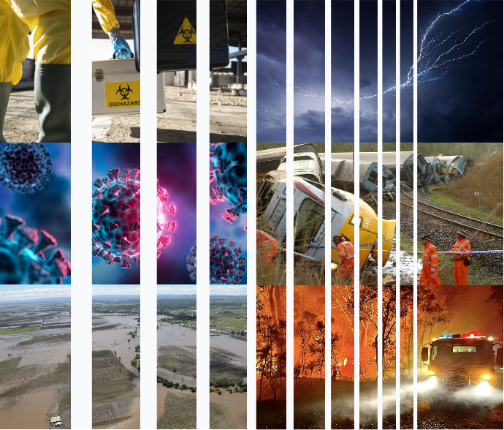

DISCLAIMER
While every care has been taken in preparing this publication, the Toowoomba District Disaster Management Group accepts no responsibility for the decisions or actions taken because of any date, information, statement or advice, expressed or implied, contained within. To the best of our knowledge, the content was correct at the time of publishing.
Any references to legislation are not an interpretation of the law. They are to be used as a guide only. The information in this publication is general and does not consider individual circumstances or situations. Where appropriate, independent legal advice should be sought.

Acknowledgement of Country
The Queensland Government respectfully acknowledges Aboriginal peoples and Torres Strait Islander peoples as the Traditional Owners and Custodians of this Country. We recognise their connection to land, sea and community. We pay our respects to them, their cultures, and to their Elders, past, present and emerging.

Table of Contents
- Introduction 6
The Toowoomba Disaster District context 6
Lockyer Valley 7
Toowoomba 7
District disaster management plan 8
Key terms 9

- Governance 11
Overview 11
Queensland disaster management arrangements 11
District disaster management group 12
Key positions 13
Responsibilities 14
Commonwealth arrangements 14
Military assistance 14
Disaster management documents 15

- Risk 16
Overview 16
Disaster risk reduction 16
Context of district disaster risk 16
District hazard risk profile 17
Drought 18
Useful terms: Hazard and risk 19
Significant recent historical events 19

- Public Information 20
Overview 20
Communication by local and district groups 20
Communication by the state 20
Media 20
Social media 20
Disinformation and misinformation 21
Warnings 21

- Resilience 23
Overview 23
What is disaster resilience? 23
Queensland Reconstruction Authority 23
Strengthening lines of resilience 23
Community led approach 23

- Prevention 24
Overview 24
Mitigation 24

- Preparedness 25
Overview 25
Planning 25
Capability integration 28
Training and education 28
Community engagement 30

- Response 31
Overview 31
System of control 31
Response functions 33
Decision making 33
Effective resource management 34
Event reporting 35

- Recovery 36
Overview 36
Queensland disaster recovery arrangements 36

- Assurance 38
Overview 38

- Appendices 39
- Toowoomba DDMG membership list 39
- Toowoomba DDMG Priorities 40
- Toowoomba DDMG annual calendar of events 2025-26 41



TOOWOOMBA DISTRICT DISASTER MANAGEMENT GROUP
APPROVAL
The Toowoomba District Disaster Management Plan
has been prepared in accordance with s53 of the Disaster
Management Act 2003 (Qld), on behalf of the Toowoomba
District Disaster Management Group.

……………………………………
Douglas McDonald
Chair
Toowoomba District Disaster Management Group
06 /08/2025



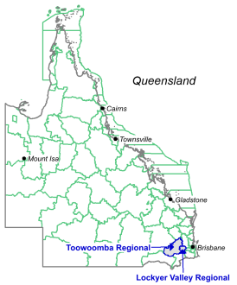
The Toowoomba disaster district context
Geography
The Toowoomba disaster district comprises the Toowoomba local government area (LGA) and the Lockyer Valley LGA and covers 15,228 km² of Queensland.
The Toowoomba disaster district shares its borders with the Ipswich disaster district, the Warwick disaster district, the Gympie disaster district, and the Dalby Disaster district.
The Great Dividing Range separates the two local government areas. The range has the highest elevations in the State, and these interact with the moisture-rich east to south-easterly trade winds. Consequently, rainfall is highest to the east of the range. The interplay between the topography and rainfall is a key factor in understanding natural disasters in Queensland, as the majority are associated with rainfall.

Climate
The Lockyer Valley typically experiences temperatures higher than the Brisbane region in summer, but colder in the winter. With an average annual rainfall of 780 mm, the Lockyer Valley is the driest part of Southeast Queensland. Rainfall is highly variable, and droughts are experienced regularly.
The Toowoomba region has a humid subtropical climate with warm summers and cool winters. Toowoomba experiences more frequent high winds, hail, fog, low maximum temperatures and is even known to have the odd snow. Average annual rainfall is 735mm.
East of the Great Dividing Range
In the zone east of the Great Dividing Range, rainfall is generally high, terrain relief is high and many of the rivers are short and steep. These characteristics combine to produce ‘high energy’ landscapes, where both rainfall and the landscape response can be rapid and often destructive, potentially leading to landslides and rapidly rising floodwaters. This zone is also characterised by narrow coastal valleys and vast sedimentary basins drained by river systems before reaching the ocean.
West of the Great Dividing Range
The zone west of the range experiences significantly lower rainfall, terrain relief is generally low and flat, and the rivers are long with low slopes. These characteristics produce ‘low energy’ landscapes that are slower to respond. When floods do occur, they are slower moving because of the lower slopes. The zone is typified by vast inland plains that are broken by occasional low tablelands and ranges. Toowoomba experiences more frequent high winds, hail, fog, low maximum temperatures.
Further explanation of these climate influencers is available from the Bureau of Meteorology.

Lockyer Valley
Location
The Lockyer Valley Regional Council area is in south-east Queensland, about 90 kilometres west of the Brisbane CBD. The Lockyer Valley Regional Council is bounded by the Somerset Regional Council area in the north and north-east, the City of Ipswich in the east, the Scenic Rim Regional Council area in the south-east, the Southern Downs Regional Council area in the south, and the Toowoomba Regional Council area in the west. 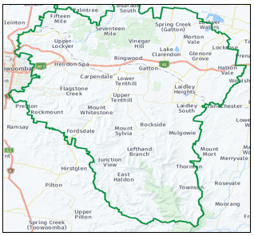
Population
Population information can be found in the 2021 Census data
Economy
The Lockyer Valley features rich farmland and is rated among the top ten most fertile farming areas in the world, and the intensively cultivated area grows the most diverse range of commercial fruit and vegetables of any area in Australia. The valley is referred to as "Australia's Salad Bowl" to describe the area as one of Australia's premium food bowls.
The valley is experiencing increasing urbanisation at both its eastern and western extremities. With a combination of vibrant rural living and affordable land and house prices, the region is experiencing rapid growth and development between the Brisbane-Ipswich conurbation in the east and Toowoomba in the west.

Toowoomba
Location
The Toowoomba Region is a local government area located within the larger Darling Downs region, 132 kilometres west of Brisbane. Perched 700 meters above sea level on the western slope of the Great Dividing Range Toowoomba is the second-most-populous inland city in Australia after the nation's capital, Canberra. It is also the second-largest regional centre in Queensland and is often referred to as the capital of the Darling Downs. 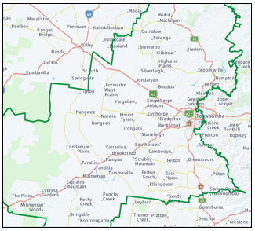
Population
Population information can be found in the 2021 Census data
Economy
Toowoomba has a growing population and a diversified economy, with strong sectors in agriculture, education, health, and manufacturing. The city has seen significant infrastructure investment in recent years, including the development of a Toowoomba Wellcamp Airport, The Toowoomba Second Range Crossing (Bypass) and a range of new residential and commercial developments.
Toowoomba retains country charm with a growing urban coffee culture and street art scene. Also known as the Garden City, Toowoomba is home to hundreds of parks and gardens as well as the iconic Carnival of Flowers Spring event.

District Disaster Management Plan
Aim
The aim of the Toowoomba District Disaster Management Plan (DDMP) is to enable communities to mitigate the effects of, prepare for, respond to, recover from, and build resilience to, disaster events.
Objectives
The objectives of the DDMP are to:
- outline the principles of disaster management
in Queensland
- describe the roles and responsibilities of
disaster management stakeholders to support
disaster management as legislated in the
Disaster Management Act 2003
- outline the Queensland arrangements for
disaster prevention, preparedness, response,
recovery, and resilience.
Scope and application
The DDMP is primarily intended for disaster management stakeholders within the Toowoomba Disaster District. Key stakeholders include the community, local government, State departments and agencies, the Australian Government, government owned corporations, non-government and not-for profit organisations, and essential service providers.
The DDMP establishes the framework, arrangements and practices that enable disaster management in the disaster district. It includes guidance for disaster management stakeholders through the provision of commentary and directions to supporting documents such as plans, strategies, and guidelines.
The DDMP makes provision for the following, in accordance with the Disaster Management Act 2003:
- Queensland Disaster Management 2016 Strategic Policy Statement
- the roles and responsibilities of entities involved in disaster operations and disaster management for the district
- the coordination of disaster operations and activities
relating to disaster management performed by those who have roles and responsibilities
- the coordination of disaster recovery operations and
activities relating to disaster management performed by those who have roles and responsibilities
- events that are likely to happen in the district

• the priorities for disaster management for the district
• matters stated in disaster management guidelines are
also matters included in the DDMP
• any other matters the Toowoomba District Disaster
Management Group considers appropriate or are
prescribed by the Disaster Management Regulation
2014.

Strategic policy statement

The Queensland Disaster Management 2016 Strategic Policy Statement informs the State’s strategic approach to disaster management. It identifies two strategic objectives that underpin disaster management in Queensland:

• strive to safeguard people, property, and the environment
from disaster
• empower and support local communities to manage
disaster risks, respond to events, and be more resilient.

Priority areas
The DDMP identifies four priority areas that contribute to effective disaster management in the district:
• risk management
• planning
• local focus
• resilience

Risk management
The Toowoomba DDMG uses an evidence-based risk assessment methodology to evaluate the potential impacts of hazards, recognise areas of exposure and their vulnerability, and identify subsequent risks to communities. Further information about disaster risk is in Section 3: Risk.
Planning
Disaster management planning is informed by risk assessments, relevant to the appropriate level within Queensland’s disaster management arrangements: local, district or State. These plans are developed through consultation, collaboration, assessment, and review.

Support by District and State groups

LDMGs are supported by their relevant DDMG and the QDMC. This support may constitute technical, financial, or material resources, and is provided when required or requested by the LDMG. The purpose of this support is to enable LDMGs to undertake disaster management across the PPRR spectrum.

Ongoing support is provided through representation at local and district levels by officers from relevant government departments, government owned corporations, representatives from nongovernment, not-for-profit organisations, essential service providers, and private organisations or subject matter experts as needed.

These representatives, where appropriate, are empowered by their respective agency or organisation to make decisions and commit resources to enable effective disaster management.

Interpretation
Key terms within the DDMP have the same definition as those provided in the Queensland Disaster Management Act 2003 and the DM Guideline.

Key terms
Disaster
A disaster is defined as a serious disruption in a community, caused by the impact of an event that requires a significant coordinated response by the State and other entities to help the community recover from the disruption (s13(1), Disaster Management Act 2003).
Serious disruption
A serious disruption is defined as:
• loss of human life, or illness or injury to humans
• widespread or severe property loss or damage
• widespread or severe damage to the environment
(s13(2), Disaster Management Act 2003).

Local focus
Local governments are primarily responsible for managing events in their local government area through their Local Disaster Management Group (LDMG). Local Disaster Management Groups (LDMGs) are empowered by legislation to act as the frontline of disaster management in Queensland. This work is undertaken from a perspective of shared responsibility amongst all stakeholders, and is characterised by consultation, collaboration, and participation. LDMGs are supported by district and State level groups, as well as relevant State departments, statutory bodies, essential service providers and non-government organisations.
Resilience
Queensland’s approach to disaster resilience is outlined in the Queensland Strategy for Disaster Resilience 2022-2027.
Comprehensive approach
The comprehensive approach to disaster management comprises four phases: Prevention Preparedness, Response and Recovery (PPRR). These phases are not mutually exclusive or chronological; they overlap, integrate, and support each other.
The comprehensive approach ensures a balance between the reduction of risk and the enhancement of community resilience, while ensuring effective response and recovery capabilities.
Queensland’s disaster management arrangements – which form the foundation of the State’s disaster management approach – are active across the four phases.
All hazards approach
The all-hazards approach applies to all events, whether natural or caused by human acts or omissions. This approach assumes that the functions and activities used to manage one event can be applied to a range of events.
Local disaster management capability
Local governments are primarily responsible for disaster management. Local level capability forms the frontline of disaster management. Local governments, through their LDMG, are primarily responsible for mitigating, preventing, preparing for, responding to, and recovering from a disaster in their local government area.

Resilience
Resilience of a community means the ability of the community and its systems:
- to recover from the impacts of a disaster, including, for example, the ability to restore essential infrastructure and community functions; and
- to accommodate or adapt to the impacts of a disaster (Schedule, Disaster Management Act 2003).

Disaster management

Disaster management is defined as the arrangements about managing the potential adverse effects of an event including, for example, arrangements for mitigating, preventing, preparing for, responding to, and recovering from a disaster (s14, Disaster Management Act 2003).

Disaster operations

Disaster operations are those activities undertaken before, during or after an event happens to help reduce loss of human life, illness or injury to humans, property loss or damage, or damage to the environment, including for example, activities to mitigate the adverse effects of the event. (s15, Disaster Management Act 2003)

Event

An event in the context of disaster management is defined as:
• a cyclone, earthquake, flood, storm, storm tide,
tornado, tsunami, volcanic eruption or other natural
happening
• an explosion or fire, a chemical, fuel or oil spill, or a gas
leak
• an infestation, plague or epidemic
• a failure of, or disruption to, an essential service or
infrastructure
• an attack against the State and
• may be natural or caused by human acts or omissions
(s16, Disaster Management Act 2003).

Disaster recovery operations

Disaster recovery operations are defined as:
• Generally – the phase of disaster operations relating to
recovery from disasters; or
- For a disaster – the phase of disaster operations
relating to recovering from the disaster (Schedule,
Disaster Management Act 2003)

Phase
Phase of disaster operations means a phase of disaster management mentioned in s4A(a)(i), (ii),(iii) or (iv), relevant to the disaster operations (Schedule, Disaster Management Act 2003).

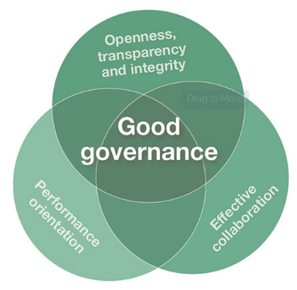
Overview
The Toowoomba District Disaster Management Plan (DDMP) was developed in accordance with s53 of the Disaster Management Act 2003 and describes disaster management arrangements for the effective management of disasters in Queensland. The DDMP is consistent with the Standard for Disaster Management in Queensland (the Standard) and Interim Queensland Prevention, Preparedness, Response and Recovery Disaster Management Guideline (the DM Guideline).
Queensland’s disaster management arrangements
Queensland’s disaster management arrangements are based on partnerships between the community and groups at the local, district, State, and Commonwealth levels to deliver coordinated, cooperative, and integrated outcomes. Each level within the arrangements is enabled by disaster management groups working collaboratively to deliver effective disaster management in Queensland.

These arrangements, shown at Figure 2.1, are responsive and scalable
- Governance

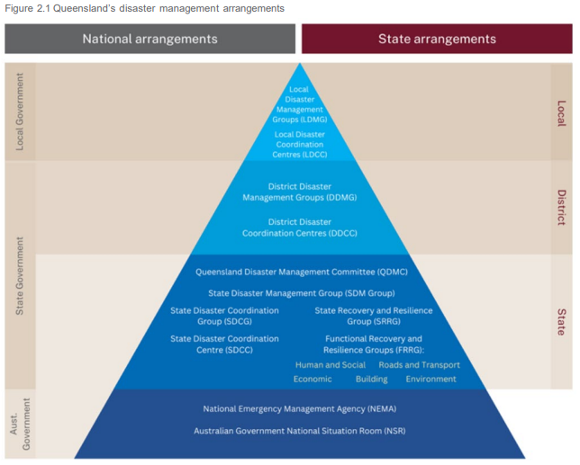

District disaster management group
Queensland’s disaster management arrangements are coordinated by groups at the local, district and State level. The State comprises 23 Disaster Districts, 77 Local Government Areas and 1 Town Authority, each represented by a group with specific functions. District disaster management group functions are detailed below.
Group District Disaster Management Group (DDMG)

• A DDMG must be established for each disaster district. Disaster district areas are
Formation
detailed in the Disaster Management Regulation 2014 and at Appendix A.
________________________________________________________________________________________________________
• Chair, Deputy Chair and Executive Officer, appointed by the Police Commissioner if
satisfied each has the necessary expertise
Members
• A representative from the relevant local government areas within the disaster district
• Representatives of a government department or Hospital and Health Service in
consultation with the department executive and the DDMG Chair.

__________________________________________________________________________________________________________

• Ensure consistency of district disaster management and operations with the
Queensland Disaster Management 2016 Strategic Policy Statement and other policies
and decisions made by the Queensland Disaster Management Committee (QDMC)
• Develop effective disaster management, including a district disaster risk assessment
and District Disaster Management Plan (DDMP), and regularly review and assess
disaster management activities
• Review and assess the disaster management risk assessments and plans of local
Functions
groups in the district
• Identify residual risks, make plans, and coordinate resources for disaster operations in
the area
• Ensure community awareness about mitigating the adverse effects of an event and

preparing for, responding to and recovering from such an event
• Establish and review communications within the district group and with relevant local
groups
• Establish, when necessary, a recovery group.

_________________________________________________________________________________________________________

Provide to the QDMC and local group:
• Reports and recommendations relating to disaster management and disaster
Communications
operations
• Prompt notification about an event or disaster in the district.
________________________________________________________________________________________________________

Key positions
At district level, Queensland’s disaster management arrangements identify several key positions to enable, drive and champion
an all hazards and shared responsibility approach to disaster management and to optimise the efficiency of the disaster
management group. These positions are:
Position Chair/District Disaster Coordinator – District Disaster Management Group

• Appointed by the Police Commissioner as legislated in the Disaster Management
Appointment
Act 2003.
________________________________________________________________________________________________________ • Manage and coordinate the business of the group
• Ensure that the group performs its functions
Role
• Report regularly to the Queensland Disaster Management Committee (QDMC), about
the performance of the district group
• Coordinate disaster operations in the disaster district for the group.
________________________________________________________________________________________________________

Position Executive Officer – District Disaster Management Group

• Appointed by the Police Commissioner as legislated in the Disaster Management Act
Appointment
2003
________________________________________________________________________________________________________
Role
• Support the district group in the performance of its functions, as directed by the Chair.
________________________________________________________________________________________________________

Commonwealth arrangements
National Emergency Management Agency
National Emergency Management Agency (NEMA) plans and coordinates Australian Government assistance to Queensland through the Australian Government National Situation Room.
Australian Government National Situation Room
The Australian Government National Situation Room (NSR) coordinates the Australian whole of government response to major emergencies. Liaison with the NSR is facilitated by NEMA liaison officers who are located at the SDCC when activated.
Commonwealth Disaster Planning Arrangements
Queensland has the responsibility for coordinating and planning the response to, and recovery from, a disaster within its borders. When the total resources (government, community and commercial) of Queensland cannot reasonably cope with the needs of the event, non-financial assistance can be sought from the Australian Government under the Australian Government Disaster Response Plan (COMDISPLAN).
The COMDISPLAN outlines the arrangements regarding Australian Government non-financial assistance to Australian States and Territories in a disaster.
Under the COMDISPLAN, the Executive Officer, QDMC, has the authority to request Australian Government non-financial assistance.
In turn, approval to provide this assistance must be authorised by the Commonwealth Attorney-General or Federal Minister responsible for emergency management.
In some circumstances, locally based Australian Government resources may be deployed in support of local authorities for limited periods without the need to activate the COMDISPLAN.
Military assistance
In accordance with the National Defence Strategy 2024 (NDS24), the Australian Defence Force (ADF) is to be the force of last resort for crisis response. The ADF may aid in response to a disaster event, following a request for Defence Assistance to the Civil Community (DACC).

Responsibilities

Government agencies
To ensure coordination and the effective use of resources and capabilities, multiple State government agencies have specific disaster management roles and responsibilities. These roles and responsibilities are based on the core function of the agency.
Government owned corporations
Queensland currently has multiple government owned corporations (GOCs) that conduct activities and provide services in a commercially oriented manner. Sectors in which GOCs operate include energy, transport, funds management, port operations, and water.
For the purposes of disaster management, GOCs are coordinated by their relevant government departments.
Private sector and non-government organisations
Owners and operators of essential services are responsible for developing disaster management plans.
The private sector plays a key role in disaster management. Organisations in this sector typically own or are responsible for operating and managing essential services, such as water, electricity, and communication.
Accordingly, they are required to manage foreseeable risk, including the development of disaster management plans, and operate within industry legislation or codes of practice. The owners/operators of this infrastructure are encouraged to actively participate in applicable DDMG’s and will be actively engaged by the Chairs of relevant groups.
Non-government organisations (NGOs) also play an important role in disaster management. Typically, they are non-profit, voluntary groups that perform a variety of functions and offer services to the community. Their role should be considered by disaster management groups at all levels.
Queensland’s referable dams
Queensland has more than 100 referable dams. A dam becomes referable if it would put a population at risk if it were to fail.
The owners of referable dams are responsible for developing emergency action plans and providing relevant local governments and DDMGs a copy of these plans for review.

DACC 3 assistance is aligned in scope to recovery activity (as defined in the Australian Government’s National Disaster Management and Recovery Continuum) and does not include reconstruction or risk reduction support. A COMDISPLAN must be activated for DACC 3 to apply.

Disaster management documents
Queensland Police Service is responsible for the development, management and review of the Queensland Prevention, Preparedness, Response and Recovery (PPRR) Disaster Management Guideline (DM Guideline).
Disaster management in Queensland is facilitated by a range of documents developed in consultation and collaboration with multiple stakeholders.
LDMGs and DDMGs must establish disaster management plans for their respective areas. These plans are informed and supported by a range of documents that exist within a hierarchy. These documents consist of sub-plans, hazard-specific plans, functional plans, the Standard for Disaster Management in Queensland (the Standard), and the DM Guideline.
The DM Guideline provides flexible, good practice recommendations and advice to those responsible for implementing disaster management practices to prevent, prepare for, respond to, and recover from disasters. It provides approaches to the implementation of legislation, the Queensland Disaster Management Strategic Policy Statement 2016, the Standard and other key disaster management doctrine.
Disaster management activities
Effective disaster management is contingent on the maintenance of an ongoing cycle of integrated activities throughout the year.
Some of these activities occur continuously (including communication, situational monitoring, stakeholder engagement and risk assessment) while other activities (such as training, exercising, planning, and reporting) are coordinated by disaster management stakeholders at various times of the year to achieve a structured and comprehensive approach.

The principle applied to the provision of emergency DACC is that State and Territory governments are primarily responsible for combating disasters, using available paid and volunteer services, and commercially available resources.
Requests for local, time sensitive emergency Defence assistance where life, persons, animals, or property is threatened, can be made directly to a local Commander. Requests for large scale or long-term military assistance are made via the request for assistance process to the State Disaster Coordination Centre (SDCC). These requests are considered by the State Disaster Coordinator and upon approval, are forwarded to the Attorney-General for consideration by NEMA.
The DACC assistance categories used within disaster management are:
- DACC 1 – Local emergency assistance: Emergency
assistance provided to authorities at a local level where deliberate and decisive action is necessary to save human life, alleviate suffering, prevent extensive loss of animal life or prevent widespread loss and damage to property; where local civilian resources are inadequate, unavailable or cannot be mobilised in time. DACC 1 support is provided from within the resources of a local Defence unit or base, or the resources already force assigned to an established Joint Task Force. DACC 1 tasks are short term in nature (generally no more than 48 hours).

- DACC 2 – Significant crisis response or relief assistance: Significant emergency non-financial assistance, beyond that provided under DACC 1, due to the location, scale, complexity or expected duration of the request and is aligned to the scope if response and/or relief activity. An emergency may arise from an extensive or continuing natural or human induced crisis, where the civil emergency authorities request additional capacity or specialist niche capability that Defence may be able to provide.

- DACC 3 – Significant recovery assistance: is assistance associated with recovery from a civil emergency or disaster, where the imminent threat to life and or property has passed. Provision of this level of support involves longer term significant recovery support, such as reconstruction of the physical infrastructure and the restoration of emotional, social, economic, and physical wellbeing. Duration of assistance shall depend on the nature and scope of recovery effort and available resources.

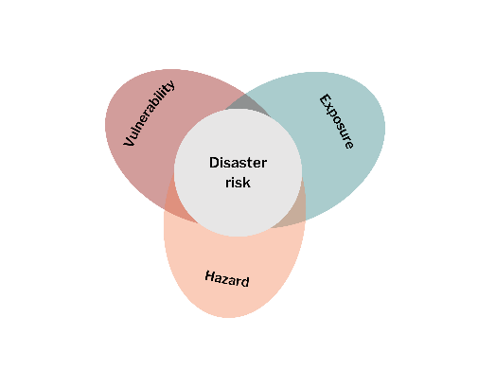

Disaster Risk Reduction
Disaster Risk Reduction (DRR) was defined by The United Nations Office for Disaster Risk Reduction (UNDRR) in the open-ended intergovernmental expert working group on indicators and terminology relating to DRR.
DRR aims to prevent new, and reduce existing, disaster risk and manage residual risk, all of which contribute to strengthening resilience and achievement of sustainable development. DRR is the policy objective of disaster risk management, and its goals and objectives are defined in DRR strategies and plans.
An example of a global agreed policy of DRR is the Sendai Framework for Disaster Risk Reduction 2015-2030. The intended outcome of the Sendai Framework is to deliver a substantial reduction of disaster risk and losses in lives, livelihoods, and health and in the economic, physical, social, cultural, and environmental assets of persons, businesses, communities, and countries.
In the Australian context, the National Disaster Risk Reduction Framework and the Second National Action Plan for Disaster Risk Reduction are two key policy documents. The Queensland Strategy for Disaster Resilience 2022-2027 promotes a systems approach to resilience that connects with a range of agencies and sectors to deliver improved outcomes for Queensland.
Context of district disaster risk
Disaster risk management governance from local, to district, to State to Commonwealth, is a foundation of Queensland’s disaster management arrangements. The intent of the arrangements is to minimise the impact of hazards on local communities by ensuring a coordinated approach and effort towards risk management.
The Queensland Reconstruction Authority (QRA) is responsible for leading Queensland’s State-level hazard and risk functions, which includes reviewing the disaster risk management space in Queensland and re-designing the State risk assessment methodology.
There are two key disaster risk assessment methodologies currently used in Queensland:
• the National Emergency Risk Assessment Guidelines (NERAG), which provides a contextualised, emergency-related risk
assessment method consistent with the Australian Standard AS/NZS ISO-31000:2018 Risk management – principles and
guidelines

• the Queensland Emergency Risk Management Framework (QERMF)¹
Benefits of undertaking risk assessment
Undertaking risk management processes promote opportunities for collaboration and communication between Government, industry stakeholders and community across the three levels (Local, District and State) in Queensland. It also promotes the need for identification and communication of residual risk across these levels.
Conduct of risk assessments assist stakeholders working within Queensland’s’ Disaster Management Arrangements (QDMA) to review existing disaster risk management processes and enhance resilience as outlined in the Queensland Strategy for Disaster Resilience.
____________________________
¹ Further detail on the review and re-design of the Queensland emergency risk assessment methodology process can be found on t Disaster Management Website

3. Risk

District hazard risk profile
The following table shows the hazard rankings for the Toowoomba disaster district.
Hazard | Overall Rank
Severe Thunderstorm /East Coast Low | 1
Flooding | 2
Bushfire (rural and interface areas) | 3
Prolonged Drought | 4
Heatwave | 5
Dam Failure | 6
Landslide | 7
Hazardous Material Accident (Land Transport Corridor) | 8
Hazardous Material Accident (Industrial) | 9
Major Passenger Transport Accident (Road/Rail) | 10
Major Air Transport Accident | 11
Rail Accident | 12
Earthquake | 13
Epidemic/Pandemic | 14
Terrorism | 15

The following table provides an overview of the prioritised 2025 district risk reduction hazards
Severe Thunderstorm / East Coast Low  Severe thunderstorms have historically been one of the district’s most damaging natural hazards. Damaging wind gusts, hail, lightning strikes (also leading to bushfires), and storm surge occur from east coast low events.  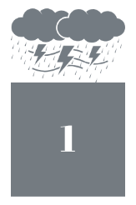 |   Flooding  Managing the risks associated with flooding is the second highest priority for the district. Climate projections present a varied picture for flood risk. However, given the proximity of population centres to rivers or creeks, flooding poses a serious risk.
Bushfire  Bushfires are frequently occurring events in the district, generally well managed and often occurring in areas less densely populated. Whilst this can reduce the risk to life there is still potential for a range of significant economic impacts to agriculture, industry, and tourism.  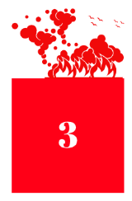 | Prolonged Drought  Droughts are extreme climatic events that can have a serious impact on health, agriculture, economies, energy, and the environment. Unlike a tropical storm or bushfire, a drought is a creeping disaster. Droughts can occur anywhere at any time. Note: Although identified in the district risk assessment, drought is not considered a ‘natural disaster’ in Queensland.  
Heatwave  Heatwaves, arguably due to their less violent, slower onset and less published nature, have only more recently begun to be recognised at a true level of risk. Heatwaves kill more Queenslanders every year than any other natural disaster.   | Dam Failure  In the event of a dam failure, the potential energy of water stored behind the bam can cause significant damage to property and livelihoods, as well as injuries and loss of life for people downstream. Sunny day failures, caused by erosion, piping, mis-operation leading to overtopping, or another event pose threats in line with traditional dam failures.  
  Landslip  Landslides or landslips can be initiated in slopes already on the verge of movement by rainfall, changes in ground water, earthquakes, disturbances by human activities, or any combination of these factors. Toowoomba range and Mt Whitestone in the Lockyer Valley pose landslip risks for the district. | Hazardous Material Accident (Land Transport Corridor)  A hazardous materials incident occurs when a chemical or other substance that may harm people’s health has been released into the air, water, or ground. Hazardous materials include explosive, flammable and combustible substances, poisons, and radioactive material.  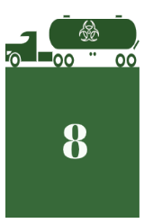
Hazardous Material Accident (Industrial)  Industrial accidents can range from chemical spills, releases if biohazardous materials to incidents involving various hazardous substances. Each situation presents unique challenges and potential dangers that require specialist skills and equipment.  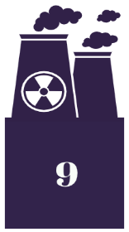 | Major Passenger Transport Accident (Road/Rail)  Several major highways intersect the disaster district, as do several rail services, including the Westlander, which travels from Brisbane to Charleville twice a week. Any major road or rail passenger accident could result in mass casualty scenario.  
Major Air Transport Accident  The airspace over the district is shared by passenger, cargo, and military aircraft. Further the Toowoomba Wellcamp Airport has a catchment area of 344,000 people, making it the 33rd busiest airport in Australia annually. Any major air transport accident would require a significant coordinated response.   | Rail Accident  Multiple train systems and services intersect the Toowoomba disaster district, catering for cattle, coal, grain, and passengers. There is a push to fast track the Toowoomba to Brisbane fast rail, as well as potential for the Inland Rail receive endorsement, which would see stages completed in Toowoomba and the Lockyer Valley.  
Earthquake  Whilst there is a low percentage chance of an earthquake impacting the disaster district, any significant seismic activity would likely result in high consequences. Since 1970 Toowoomba (within 100 km) has had 5 earthquakes of magnitudes above 2 and up to 3.8.   | Epidemic / Pandemic  An epidemic is an increase – often – sudden – in the number of cases of a disease above what is normally expected in that population in a specific area. A pandemic is an epidemic that has spread over several countries or continents and affects many people.  
Terrorism
Since 2014, various counter-terrorism disruption operations have been executed across Queensland, resulting in counter-terrorism arrests and subsequent prison sentences. The Queensland Counter-Terrorism Plan is a ‘hazard specific, plan of the Queensland State Disaster Management Plan.

Drought
In 1971 the approach shifted from trying to ‘drought-proof’ agriculture to recognising drought as a natural disaster. This allowed affected people to be helped through joint Commonwealth–state Natural Disaster Relief and Recovery Arrangements. In 1989 it was agreed between jurisdictions that drought was to be removed from these arrangements. This followed a review which found that it was poorly targeted, distorted farm input prices and worked as a disincentive for farmers to prepare for drought.
Drought and disasters require different responses. Natural hazards leading to disasters (formally referred to as natural disasters), like floods or fires, are caused by rapid-onset, short-duration events that are hard to predict with certainty. They cause large-scale damage to infrastructure and can instantly affect all aspects of community life. Governments generally respond to disasters by aiding with immediate response and recovery for affected communities. Droughts are severe weather events but are slower in their onset, easier to predict and their effects are generally more gradual. The gradual and prolonged nature of drought provides opportunities for farming businesses and communities to prepare and adjust as droughts progress. That is why our approach to drought is focused on building resilience and enabling farming businesses and communities to be prepared.

Useful terms: Hazards and risks
Floods, bushfires, heat waves, etc. are hazards – sources of potential harm.
Events are not risks themselves, rather they are sources of risk (e.g. roads may be blocked and prevent people from evacuating). A risk arises when it is possible that a hazard will cause harm.
Risk arises from the interaction between a hazard (such as a bushfire or flood), exposure to that hazard (or likelihood of a bushfire of flood occurring in a particular community) and vulnerability (or the degree to which a community, environment etc., is likely to sustain harm due to a bushfire or flood).
Significant recent historical events
- Tropical Cyclone Alfred 2025
- Southeast Queensland flooding 2022
- COVID-19 Pandemic in Australia 2020-22
- Thornton and Pechey bushfires 2019
- Lockyer Valley flooding 2013
- Toowoomba and Lockyer Valley flooding 2010-11
- Toowoomba Escarpment bushfire 2002

4. Public Information

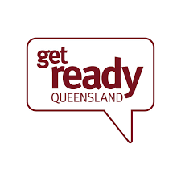
Overview
Consistent, timely and accurate information better enables communities to prepare for, respond to and recover from disasters. Communities need to know what is likely to happen (or has happened), what to expect, and what to do.
Collating, integrating, and delivering information that enhances a community’s awareness of events that may occur or are occurring, and providing advice on appropriate actions to be taken, contributes to safeguarding life, property, and the environment.

Communication by local and district groups
Local and district groups must communicate with their respective communities. Keeping the community well informed contributes to their ability to prepare for, respond to, and recover from a disaster and assists with managing community expectations. Communication to impacted local and district groups from the State is the responsibility of the Public Information Capability (PIC).
Communication by the State
The State must communicate with the Queensland community before, during and after a disaster, and it is critical that key messages from government departments align. This is achieved through the Crisis Communication Network (CNN),
As an essential element of the CCN, the PIC is responsible for gathering and editing content to produce regular whole of government key messaging.
Information relating to communication by the State in relation to disasters is outlined in the Queensland Government arrangements for coordinating public information in a crisis. Communication to impacted local communities will also be issued directly from agencies involved in the response.
Media
Media play a crucial role before, during and after disaster events. The media are essential, for example, for warnings to be effective and may be the single most important source of public information in the wake of a disaster.

Social Media
Social media allows the instant dissemination of important information in real time. On the one hand, emergency services or hazard lead agencies can send out alerts, share updates and safety tips. On the other hand, social media also provides rapid feedback from the witnesses of the events and transmits requests for help.
Also, in times of disaster events, people use social media for humour and levity, to determine disaster magnitude, to check in with people in their networks, to self-mobilize, to maintain a sense of community, and to seek emotional support and healing
Unlike traditional media such as newspapers, social media manages the content of the conversation or interaction in the online environment and allows for spontaneous two-way and multiple dialogue.
Social media include blogs, discussion forums, chat rooms, wikis, apps, YouTube, Channels, LinkedIn, Facebook, and Twitter. Also, all crowdsourcing platforms are, by definition, social media platforms.
State agencies using social media retain responsibility for updating, maintaining, and monitoring their presence. This is to be consistent with the Principles for the official use of social media guidelines.
The use of social media in times of a disaster may include:
• community alerting and status reporting
• disaster preparedness and coordination
• community engagement and myth busting
• monitoring posts for on-the-ground intelligence gathering

Warnings
Queensland uses warnings to enable communities and individuals to act in an effective manner, in relation to hazards that may arise.
What is a Warning?
A warning provides point-in-time information about a hazard that is impacting or is expected to impact communities. It describes the impact and expected consequences for communities and includes advice on what people should do.
Bureau of Meteorology Weather Warnings
The Australian Government Bureau of Meteorology (BoM) provide Severe Weather Warnings for potentially hazardous or dangerous weather relating to thunderstorms and damaging winds, tropical cyclones, bushfires, and rain and blizzards.
Australian Warning System (AWS)
The AWS is the national approach to information and warnings for hazards (bushfire, flood, storm, cyclone, extreme heat, severe weather, and other.)
It uses a nationally consistent set of icons to show incidents on websites and apps.

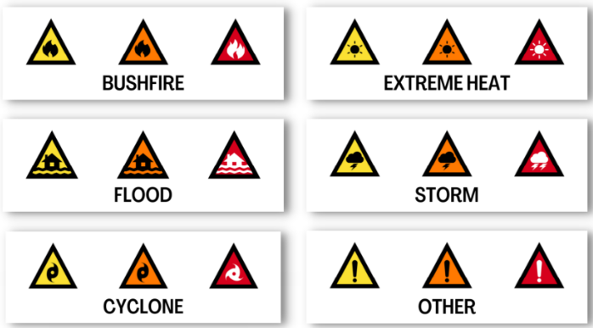

- linking the community to other appropriate sources of authoritative information.

Local disaster management groups should manage social media in accordance with their respective policies and procedures.
Disinformation and Misinformation
Misinformation and disinformation in disaster risk communication can significantly increase disaster risk by causing confusion and eroding credibility and trust in disaster risk management practices and disaster responses.
Disinformation
Disinformation is deliberately false information that is shared to deceive or cause harm.
Disaster-related disinformation usually follows known narratives of climate denialism, climate delays, government distrust and prejudice. Proactively pre-bunking to get ahead of disinformation before disasters can help people identify and refute false content.
Hazard and Lead agency specific plans should recognise and incorporate the specific needs that people may have because of disinformation campaigns, so they can be addressed and do no erode community resilience.
Misinformation
Misinformation is incorrect or misleading information spread without meaning to deceive, which is often shared by people who believe it is true.
Misinformation on social media poses complex challenges to disaster management, affecting both individual and societal resilience. Proactive communication strategies are critical, as is the development of advanced verification tools, and public education strategies to combat misinformation.
Strategies for managing rumours and misinformation during a disaster.
- Monitor and listen
- Communicate early and often
- Address rumours and misinformation directly
- Engage and empower your advocates
- Evaluate and improve
- Learn and share

Each warning level has a set of action statements to give community clearer advice about what to do. Calls to Action can be used flexibly across all three warning levels and contextualised for each hazard. Owning hazard leads are responsible for determining the level of warnings issued.
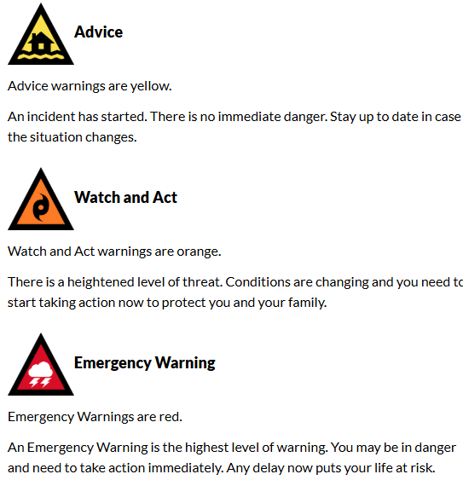
Emergency Alert
Emergency Alert is the national telephone-based emergency warning system that sends messages:
- via landlines based on the location of the handset,
- via mobile phones based on an individual’s billing address, and
- for Telstra mobile account holders based on the device's location.

View more information and frequently asked questions about Emergency Alert

Standard Emergency Warning Signal (SEWS)
As part of a coordinated national emergency plan, the Standard Emergency Warning Signal (SEWS) has been adopted to alert the community to an urgent safety message relating to an identified threat, before or during a disaster.

The SEWS tone is played over the radio, television, or public address systems in public places before an urgent public safety announcement.
The SEWS tone has also been adopted for use in the new Emergency Alert Australia system which sends standard text messages from the phone number 0444 444 444 which has information about a potential emergency, and a phone call to landlines which starts with the SEWS tone with the words "Emergency! Emergency!" followed by a message regarding the threat and a phone number and/or website with more information.
Australian Broadcasting Company (ABC) – Broadcasting Services
The ABC works with lead emergency authorities to inform and prepare the public before, during and after emergency events. ABC emergency broadcasting is usually undertaken by staff working in the 55 ABC Local Radio stations around the country.
Local Disaster Information
Local councils are the first point of call Queenslanders should turn to for information and direction at the time of a natural disaster.
Local councils provide up-to-date information before, during, and after disaster events, including information on evacuation centre openings and locations, river heights, road conditions and closures, power, and phone outages.
Both the Lockyer Valley Regional Council and the Toowoomba Regional Council maintain disaster dashboards with direct links to key disaster related information from a range of stakeholders.

Right click the below images and open link for council’s disaster dashboard.
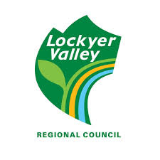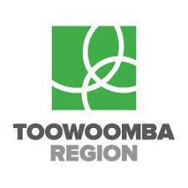

5. Resilience

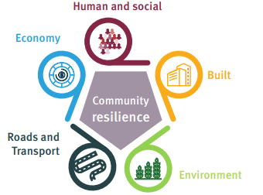
Overview
Society has always been susceptible to natural hazards. While the occurrence of these events generally cannot be prevented, the risks can often be minimised and the impacts on people and property reduced.
Natural hazard management policy throughout the world is increasingly being aligned to ideas of resilience.

The National Strategy for Disaster Resilience outlines how Australia should aim to improve social and community resilience with the view that resilient communities are in a much better position to withstand adversity and to recover more quickly from extreme events.

What is disaster resilience?
Disaster resilience is he capacity of communities to prepare for, absorb and recover from natural hazard events, and the capacities of communities to learn, adapt and transform towards resilience.

Queensland Reconstruction Authority (QRA)
The Queensland Reconstruction Authority (QRA) is the lead agency responsible for disaster recovery and resilience policy in Queensland. The Queensland Government is committed to strengthening disaster resilience to ensure communities are better equipped to deal with the increasing prevalence of disasters.
The QRA is also the lead agency responsible for developing and coordinating the Queensland Strategy for Disaster Resilience 2022-2027 (QDSR), which provides an overarching framework for how the Queensland Government collaboratively delivers disaster resilience commitments and actions to strengthen community resilience, based on local and regional needs. Queensland’s approach to resilience is outlined in the Queensland Strategy for Disaster Resilience 2022 - 2027 and the Queensland Climate Adaptation Strategy 2017-2030.

Strengthening the lines of resilience

The multi-dimensional and cross-disciplinary approach
of the QSDR aims to strengthen and reinforce the five lines
that contribute to systems-based resilience and their
potential for future planning. These lines are:

• Built
• Human and social
• Economy
• Roads and transport
• Environment. Community resilience

Community-led approach
The Queensland Strategy for Disaster Resilience Vision for Stronger, safer and more resilient Queensland communities identify Councils as key partners across all five (5) Objectives. The identification of Councils in this key document recognises that Councils understand their community and can best leverage local solutions towards building disaster resilience.

6. Prevention

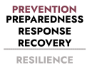

- Infrastructure – is required for a community to function effectively and can be vulnerable to hazards. Consequently, a community’s resilience or ability to respond to a disaster will be influenced by the working availability of essential infrastructure such as roads, railways, dams, bridges, electrical, digital and communications networks, water supply and sewerage systems and the buildings that house essential services (e.g., communications, health and disaster coordination centres).

- Landscape and environment – ecosystems can serve as protective buffers against natural hazards such as flooding. Further, the vegetation cover in a catchment influences run off and flood behaviour. It is increasingly recognised that non-structural measures, including the management of landscapes, can play an important role in mitigating the impact of flooding.

Mitigation
Mitigation activities are those actions taken to decrease the impacts of a disaster on people, infrastructure, and the environment.

Mitigation strategies

Mitigation strategies can be developed across a range of hazards or targeted to a specific hazard and associated risk.

Mitigation strategies to reduce the risk of a disaster include:

- Education and information – a fundamental approach to disaster management is that communities which have identified, considered and planned for a potential event will cope better than those who have not. Community awareness and education programs remind people that the threat is real and to identify what they can do to limit the impacts of disasters.

- Structural works – these works provide a range of preventative measures including, but not limited to levees, flood gates and, on a larger scale, flood mitigation dams.

- Land use planning – is the process by which the use and development of land is managed for the benefit of the whole community. Land use planning that anticipates likely risks and vulnerability of the population can reduce the impacts of future disaster events.

- Building controls – these controls are important preventative measures that compliment effective land use planning. Queensland’s building regulatory framework aims to ensure minimum necessary requirements of design and construction are met, including the effects of natural disasters.

Overview
Prevention is the elimination or reduction of the exposure to a hazard on communities at risk. Prevention activities, such as the building of dams and levees, land use planning and improved building codes, are focused on reducing the likelihood and/or consequences of a hazard.
Local and District Disaster Management Groups and the Queensland Disaster Management Committee (QDMC), each have responsibility for prevention activities.

- Preparedness
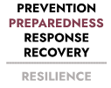
Overview
Preparedness is the taking of preparatory measures to ensure that, if a disaster event occurs, communities, resources and services are able to cope with the effects of that event. It is a critical element in minimising the consequences of an event on a community and ensuring effective response and recovery.
Disaster preparedness builds on existing community and individual awareness of risk and participation in disaster management activities to enhance resilience. Queensland’s preparedness activities are centred on three key elements:
• planning
• capability integration
• community engagement.
Planning
In Queensland, planning is undertaken at local, district and State levels, in accordance with Queensland’s disaster management arrangements, Disaster Management Act 2003, the Standard for Disaster Management in Queensland (the Standard), and the DM Guideline.
The subsequent plans operate within the context of a tiered structure of legislation, policy, and the DM Guideline.
Comprehensive planning occurs across all phases of disaster management – prevention, preparedness, response, and recovery – and all plans are scalable and adaptable.
Local Disaster Management Plans
Each local government, supported by their Local Disaster Management Group (LDMG), must prepare a plan for disaster management. The Local Disaster Management Plan (LDMP) must be reviewed on an annual basis, be consistent with the Standard and the DM Guideline, and include provision for:

• the Queensland State Disaster Management 2016 Strategic Policy Statement for disaster management and the local
government’s policies for disaster management

• the roles and responsibilities of entities involved in disaster operations and disaster management in the area

• the coordination of disaster operations and activities relating to disaster management performed by each entity

• potential hazards/events likely to happen in the area, based on the risk assessment

• strategies and priorities for disaster management in the area including steps to mitigate potential risks as well as response
and recovery strategies

• any other matters considered appropriate.

Hazard specific plans

Queensland adopts an all hazards approach to disaster management. However, hazard specific plans are developed when particular hazards have distinct operational or coordination requirements (e.g. animal and plant disease, bushfire, pandemic).

Hazard specific plans:

• address the hazard actions across all phases of disaster
management

• include information on how Queensland’s disaster management
arrangements link with the hazard specific arrangements

• support the primary agency to manage the hazard specific event.

At the State level, primary agencies are identified for a range of hazards and are responsible for the development of a hazard specific plan, in consultation with affected stakeholders (see Table 7.1). Hazard specific primary agencies have a responsibility to communicate and maintain relations with national hazard specific counterparts.

Where relevant, primary agencies are to:

• ensure any State hazard specific plans link to and align with
corresponding national hazard specific plans and arrangements

• maintain appropriate communication and relationships with
national counterparts.

Hazard specific plans may also be necessary at the local and district levels if applicable hazards are identified for those areas. These plans are established as sub-plans of the Local or District Disaster Management Plan. As an example, disaster management areas that contain agricultural industries may assess and plan for plant or animal disasters within the context of the Commonwealth Government’s AUSVETPLAN and PLANTPLAN.

District Disaster Management Plans

Each District Disaster Management Group (DDMG) must prepare a plan for disaster management. The District Disaster Management Plan (DDMP) must be reviewed on an annual basis and be consistent with the Standard and the DM Guideline. Further, the plan must be developed in consideration of the LDMPs relevant to the district and include provision for:

• the Queensland State Disaster Management 2016 Strategic Policy Statement for disaster management for the State

• the roles and responsibilities of entities involved in disaster
operations and disaster management in the district

• the coordination of disaster operations and activities relating to
disaster management performed by each entity

• potential hazards/events that are likely to happen in the district,
based on the risk assessments.

• steps to mitigate potential risks, including residual risks identified
at the local level as well as response and recovery strategies

• priorities for disaster management for the district

• any other matters considered appropriate.

State Disaster Management Plan

The Queensland Disaster Management Committee (QDMC) is
required – as specified in the Disaster Management Act 2003 – to
have a State Disaster Management Plan (SDMP) in place, in
preparation for, and to direct Queensland’s response to and
recovery from, disaster events.

Table 7.1 Identified Hazards, Primary Agencies and Relevant Plans
Hazard Plan Primary Agency

Australian Veterinary Emergency Plan
AUSVETPLAN

Australian Aquatic Veterinary Emergency Plan
AQUAVETPLAN
Department of Primary Industries
Animal and plant disease
Australian Emergency Plant Response Plan
(PLANTPLAN)
National Priority Plant Pests (2024) - DAFF

Biosecurity Emergency Operations Manual
Queensland Biosecurity Manual
____________________________________________________________________________________________________________
State of Queensland Multi-Agency Response to
Queensland Health
Biological (human related)
Chemical, Biological & Radiological Incidents
State CBR Plan
____________________________________________________________________________________________________________
Radiological
State of Queensland Multi-Agency Response to
Queensland Health
Chemical, Biological & Radiological Incidents
State CBR Plan
____________________________________________________________________________________________________________
Bushfire
Queensland Bushfire Plan
Queensland Fire Department
QLD Bushfire Plan
____________________________________________________________________________________________________________
State of Queensland Multi-Agency Response to
Queensland Fire Department
Chemical
Chemical, Biological & Radiological Incidents
State CBR Plan
____________________________________________________________________________________________________________
Heatwave
Heatwave Management Sub-Plan
Queensland Health
Heatwave Management Sub-plan
____________________________________________________________________________________________________________
Pandemic Influenza Plan
Queensland Health pandemic influenza plan
Queensland Health
Pandemic

Australian Health Management Plan for Pandemic
Influenza
Australian Health Management Plan for Pandemic Influenza
____________________________________________________________________________________________________________
Queensland Coastal Contingency Action Plan
Maritime Safety Queensland
Ship Sourced Pollution
(QCCAP)
Queensland Coastal Contingency Action Plan
____________________________________________________________________________________________________________
Terrorism
Queensland Counter Terrorism Plan
Queensland Police Service
QLD counter-terrorism plan
____________________________________________________________________________________________________________

Functional plans

Functional plans identify important services required before, during and after the impacts of a disaster and help to identify and define an agency’s services and responsibilities in disaster operations.
Functional plans are sub-plans to the DDMP.

Functional plans:

• address functional activities across all phases of disaster
management

• include information on how Queensland’s disaster management
arrangements link with the functional arrangements

• outline the arrangements for coordination of relevant
organisations that undertake a supporting role.

At the district level, functional planning is established, as necessary, as sub-plans to the District Disaster Management Plan.

Business continuity planning

Business continuity planning is undertaken by State government agencies to ensure their disaster management and critical functions can continue to be delivered during a disaster event.

Where possible, business continuity planning in the private and non-government sectors should be undertaken to assist in the continuity of service during an event and re-establishment of business, post event.

These plans should be integrated with disaster management planning at the local, district and State levels.

Capability integration

People performing functions under the Disaster Management Act 2003 are required to be appropriately skilled, trained and practiced so they are ready to enable response and recovery activities. This is achieved through:
• training and education
• exercising
• lessons management
• pre-season briefings

Training and Education

Disaster Management Training

Queensland Police Service is responsible for maintaining the Queensland Disaster Management Training Framework; all disaster management stakeholders are responsible for actively participating in relevant training.

The Disaster Management Act 2003 requires that people performing functions in relation to disaster operations are appropriately trained.

Training for key disaster management stakeholders is provided via modules within the Queensland Disaster Management Training Framework (QDMTF), a comprehensive training program of disaster management activities in Queensland.

The QDMTF covers the core training courses and inductions relevant to key disaster management stakeholders to support the effective performance of their role. This training includes mandatory modules for members of disaster management groups such as:

• disaster management planning
• exercise management
• warnings and alerts
• disaster coordination centres and evacuation
• funding arrangements.
Refresher training is also available under the QDMTF to ensure current skills are maintained.

Actively participating in disaster management training is a shared responsibility between all disaster management stakeholders. Online training options are provided via the Disaster Management Learning Management System.

Specific training for functions

The QDMTF also provides for ‘needs based’ modules for disaster management stakeholders engaged in more specific functional roles.

Agencies, local governments, and non-government organisations will provide appropriate training for their staff and volunteers, to ensure they are skilled and prepared for the function their agency/organisation provides.

Further, wider training programs may be made available to address specific functional needs. An example of this is the Ready Reserve Program, where the Queensland Government has a Ready Reserve Workforce made up of personnel from across State government agencies. Training is provided to the Ready Reserve workforce to support disaster effected communities.

Lessons Management

Lessons management is a key element of continuous improvement.

It includes establishing a learning culture to support captured observations and insights from monitoring, debriefing, and reviewing activities – before, during and after events – which are then analysed for trends, risks and lessons.

Debriefing and lessons learned must be documented, analysed, and acted upon across all levels of the disaster management arrangements.

The Office of the IGEM is responsible for a lessons management framework which provides guidance on good practice and opportunities for improvement, and ensure lessons identified are learnt.

The DM Guideline contains guidance regarding the process for debriefing. The QDMTF also includes a ‘Briefing and Debriefing’ module.

Debriefing and lessons learned strategies should be consistent with The Australian Institute for Disaster Resilience Handbook for Lessons Management.
Exercising

Queensland Police Service is responsible for developing a program cycle of exercises.

Exercises are an essential component of preparedness and should be used to enhance capability and contribute to continuous improvement. An exercise can be as simple as a planning group discussing an emergency plan, or as complex as a major multi-agency event involving several organisations and participants. Regardless of size, exercises are useful to:
- evaluate plans
- explore issues
- evaluate equipment, techniques and processes
- develop or assess competence
- demonstrate capability
- practise interoperability
- validate training
- identify gaps
- promote awareness

Exercising is integral to the development of capability, as well as to the preparation of personnel to carry out their functions during actual events.

The DM Guideline outlines a process for undertaking exercises to determine the effectiveness of relevant disaster management plans, including planning for and evaluating outcomes from the exercise.

Local, district and State groups must undertake and evaluate targeted exercises to identify any issues to be specifically addressed in subsequent planning or response activities. Disaster management exercises should be developed in response to an identified need (e.g. activation in response to an event, post event/evaluation, a previous exercise or a change in the operational environment) and evaluated against identified objectives.

Emergency Management Coordinators deliver training under the QDMTF within the Toowoomba Disaster District. Regular training updates are forwarded to the district group which enables the district disaster management stakeholders to collaborate on dates for training and exercising.

Agencies and organisations represented on the DDMG are responsible for enabling development of staff representing at district level through attendance at training, workshops, meetings, or any other related disaster management capability development opportunities deemed appropriate.



Local engagement activity

Local governments may conduct specific community engagement activities within their communities.

LDMGs and DDMGs will consider necessary community engagement activities as part of preparedness planning.

Within the Toowoomba Disaster District both the Lockyer Valley Regional Council and the Toowoomba Regional Council alternate years to host a ‘Get Ready’ day within their community.

These family friendly events provide an opportunity for the public to chat with emergency services and other agencies who are experts in disaster prevention, preparation, response and recovery.

Previous events have showcased a host of emergency service equipment, with some utilised in educational games. Other key activities included:

• a walk over community BIG MAPS

• sandbagging demonstrations

• preparing a household emergency plan

• learning about collating an emergency kit

• colouring in competition

Community engagement

The engagement and preparedness of communities has a significant influence on their resilience. Community engagement has a range of objectives, which can include:

- developing awareness in communities about the nature and
- potential impact of hazards

- promoting self-reliance through personal responsibility for
managing risks.

Some community engagement strategies include, but are not limited to:

- public information campaigns
- social media presence
- websites and online material
- local engagement activity.

These activities are a shared responsibility and should be conducted in a coordinated approach between local, district and State groups.

Public information campaigns

Public information campaigns may be conducted to disseminate preparedness messages across the wider community. These campaigns can include television, radio, online and print media.

Examples of public information campaigns include:

- The Get Ready Campaign, which is run throughout the
year with information about preparing for severe weather
events

The Get Ready Queensland funding program provides a
total of $2 million in Queensland Government funding to
help local governments improve their communities’
resilience.

- the "If it's flooded, forget it" annual safety campaign, which educates Queenslanders to avoid driving through flood waters by mapping an alternative route or rescheduling their travel. Information is available on the Flood Water Safety Website

- school-based education programs, such as StormSafe, raise awareness about the risks associated with storms

- the annual Bushfire Safety campaign, which aims to change behaviours around risk identification and acceptance, bushfire preparedness and monitoring conditions.

- Response

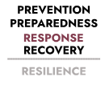
Overview
Disaster response involves taking appropriate measures to respond to an event, which includes actions taken and measures planned before, during and immediately after an event, to ensure that its effects are minimised, and persons affected by the event are given immediate relief and support.

These response measures will often involve multiple organisations simultaneously engaging in response functions.

Queensland’s response activity is underpinned by:
• a system of control that provides for coordination across entities and facilitates cooperation and integration of services
• effective decision making
• effective resource management.

System of control

The system of control is designed to facilitate coordination, cooperation and integration across disaster management entities and services. The system encompasses:
• the disaster management arrangements as they relate to response
• commonly understood levels of activation
• a framework of lead agencies for particular response functions.

Arrangements

Disaster management arrangements for Queensland encompass:
• primary responsibilities
• a framework of groups and committees
• specialist roles
• disaster coordination centres

Liaison Officers (LOs) may be appointed to coordination centres, as determined by the relevant group. In the case of the SDCC, the SDCC Commander will advise which agencies are required.

LOs are the point of contact between the coordination centre and their parent agency during disaster operations. They have the following key responsibilities:

• coordinating requests for assistance applicable to their agency
(LOs must be at an appropriate level to commit agency
resources)

• providing advice and assistance on their agency’s tasks,
capabilities, and resources

• communicating situational awareness to their agency
State agencies will provide staff to support response operations in
the SDCC as outlined in the Queensland Public Sector
Commission’s Directive 10/14 Critical Incident Response and Recovery.

This directive also guides arrangements for agency personnel in
local and district coordination centres.

Levels of activation

Activation of response arrangements will occur in accordance with a four-level model encompassing: Alert, Lean Forward, Stand Up and Stand Down, as outlined in Figure 8.1.

These levels of activation drive response activity and guide the scale of response.

The transition of disaster management groups through these phases is not necessarily sequential. It is based on flexibility and adaptability to the location and event. Further, activation may not necessarily mean the convening of disaster management groups but rather the provision of information to disaster management groups regarding the risks associated with the potential impact of an event.

Levels of activation, including triggers, actions and communications for local and district disaster management groups are further described in the DM Guideline.

Primary Responsibilities

The primary responsibilities of disaster management stakeholders are outlined in the following:

• the Queensland State DM2016 Strategic Policy Statement has
the primary objective of safeguarding of people, property and the
environment

• the Queensland State Disaster Management Plan (SDMP) which
draws together the responsibilities of all disaster management
stakeholders

• the DM Guideline which clearly articulates specific
responsibilities and requirements of disaster management
stakeholders. Local governments are primarily responsible for
managing events in their local government area. District groups
and the QDMC provide local governments with appropriate
resources and support to help carry out these disaster
operations.

Disaster Management Groups

At the core of Queensland’s disaster management arrangements is the involvement of disaster groups at the local, district and State level to respond to disasters. These levels adopt a coordinated and collaborative approach to enable an effective response for the benefit of all Queenslanders.

Additional information about the specific functions of these groups can be found in Section 2: Governance.

Disaster Coordination Centres

Disaster coordination centres may be established, as required, at the local and district level, depending on the scale of the event.

Coordination centres operationalise group decisions, as well as plan and implement strategies and activities on behalf of the group during disaster operations. Coordination centres have the capability to coordinate resources, gather, and disseminate information and act as the conduit for the escalation of requests for additional resources.

An activation sub-plan may be produced to detail the standard operating procedures for the activation and management of the coordination centre.

At the District level, the District Disaster Coordination Centre (DDCC) may be activated to coordinate the provision of resources to local groups upon request.

Figure 8.1 Activation Response Model

Figure 8.1 Activation Response Model
Level of activation | Definition
Alert | A heightened level of vigilance and preparedness due to the possibility of an event in the area of  responsibility. Some action may be required, and the situation should be monitored by staff capable  of assessing and preparing of the potential threat.
Lean Forward | An operational state prior to ‘Stand Up,’ characterised by a heightened level of situational awareness  of a disaster event (either current or impending) and a state of operational readiness. Disaster  coordination centres are on standby – prepared but not activated.
Stand Up | The operational state following ‘Lean Forward,’ where resources are mobilised, personnel are  activated, and operational activities commenced. Disaster Coordination centres are activated.
Stand Down | Transition from responding to an event back to normal core business and/or continuation of recovery  Operations. There is no longer a requirement to response to the event and the threat is no longer present.

Response functions
Multiple State agencies are responsible for various disaster response functions within Queensland.
These responsibilities are allocated in accordance with an agency’s role in administering relevant legislation or ability to provide specialist resources. In some circumstances, these agencies will also coordinate with other agencies and organisations to undertake the nominated function.
Decision making
Effective decision making when managing disaster events is supported by:
• a clear legislative basis for disaster operations and the exercise of power
• formal event management systems, where relevant
• the DM Guideline
• systems for intelligence collation and event reporting
• access to technical information.

Effective resource management

Effective resource management ensures the best use of resources and contributes to streamlined, efficient disaster management processes. Resource management encompasses:

• logistics
• deployment of personnel
• volunteers
• assistance arrangements for both money and goods.

Logistics

Logistics is the range of operational activities concerned with supply, handling, transportation and distribution of materials, equipment, and people.

Deployment of personnel

The deployment of personnel is usually undertaken to:

• assist communities in preparation for an impending event
• support limited local resources in disaster affected
communities
• provide specialist skills not locally available.

Deployments may be in response to requests from, and subsequently coordinated through LDMGs, and should not be a burden on local resources.

The deployment of personnel can also be undertaken by agencies in accordance with their response functions, roles, and responsibilities, including the identification and training of staff, briefings and debriefings. Relevant LDMGs and DDMGs are to be advised of such deployments, to ensure a coordinated approach is achieved.

Volunteers

Volunteers play a key role in local disaster management response.

During disasters, individuals and communities inevitably seek to assist through spontaneous or ad hoc volunteering. Local arrangements should include the effective management of spontaneous volunteers prior to an event, to maximise the opportunities of strong community goodwill following a disaster and minimise any negative impacts from an influx of spontaneous volunteers.

Volunteering Queensland (VQ) is the central point of recruitment and referral for spontaneous and ad hoc volunteers associated with disasters through its Emergency Volunteering – Community Response to Extreme Weather (EV CREW) function. This function identifies locally available people who are able to provide initial relief as part of the response for impacted people or communities.

To enable effective planning and resource allocation, the use of volunteers should be reported through Queensland’s disaster management groups at the relevant level.

Disaster declarations

Disaster declarations can be made by the District Disaster Coordinator (DDC), with the approval of the Minister responsible for the Disaster Management Act 2003, for a disaster district or part of a disaster district. The Minister and Premier may make a disaster declaration for the State, or part of the State.

The circumstances in which declarations can be made and the arrangements for establishing them are specified in the Disaster Management Act 2003. Provisions regarding disaster management powers and how they may be exercised are also included in the Act.

To declare, extend or end a disaster situation, the appropriate form must be completed by the appropriate authorised officer. These forms can be found in the DM Guideline Supporting Resources.

The relationship between the Disaster Management Act 2003 and the Public Safety Preservation Act 1986 allows for a disaster to be declared, while an emergency has also been declared under the PSPA, to effect operational provisions under the PSPA.

Event management

Disaster management stakeholders utilise event management systems when responding to an event. Each stakeholder should use a system that is appropriate to their circumstances, and which has a flexible and scalable structure capable of assembling resources and coordinating response efforts.

Technical information

A range of technical information will be provided, as required,
across the disaster management system to support effective
decision making. This information can include:

• Weather briefings – a Bureau of Meteorology (BOM) officer is
embedded within the SDC year round, to undertake analysis
and reporting of weather forecasts from the BOM, and to
provide briefings for key stakeholders as well as direct liaison
with the BOM. Requests can be made through the SDCC State
Watch desk SDCC@Police.Qld.Gov.au or directly to
SDCC.Bom@Police.Qld.Gov.Au

• Geospatial Information Services (GIS) – mapping and GIS
support is available by request through the SDCC. This includes
spatial data services, maps, web mapping applications and
rapid damage assessment support. A 24/7 services roster is
activated during the response phase

• Predictive modelling – predictive modelling services are
available via the SDCC from key agencies relating to natural
hazards such as flooding, coastal inundation, and bushfire to
support coordination and planning decisions.

Event Management System

During an activation, district updates submitted via DIEMS are used to produce the State update and Premier’s executive summary.

The key messages within agency reports are consolidated through the Police Information Centre to form the whole of government message which is then distributed to relevant key stakeholders following Community Communication Network (CNN) approval.

A Toowoomba District Disaster Recovery Committee (DDRC) may be established to assist the transition from response to recovery, particularly for significant disaster events.

If established, the Toowoomba DDRC will be chaired by the Toowoomba DDCC or an appointed Deputy DDC, and co-chaired by an appointed Queensland Reconstruction Authority (QRA) nominee.

Standing members will include the five functional recovery and resilience groups, and representatives from both Lockyer Valley Regional Council, and Toowoomba Regional Clouncil, including local recovery group chair and Council executives.

The National Emergency Management Agency (NEMA) will also appoint a representative for membership of the DDRC.

An event specific Toowoomba District Disaster Recovery Strategy will be developed and guide the transition activities.

Offers of assistance

During disaster events, the broader community offers assistance to affected people and communities in the form of financial donations, goods and services.

GIVIT is a not-for-profit organization that provides a mechanism to register and match donations with community need. The service is managed in accordance with the Queensland Policy for Offers of Assistance and the DM Guideline.

It aims to harness the goodwill and generosity of people and organisations wishing to donate goods and services and to ensure such offers are managed in a timely manner. The service also aims to enable GIVIT, in conjunction with affected local governments and relevant service providers, to identify the needs of the community during disaster recovery and, if necessary, broker donations to meet specific requests.

Event reporting

Event reporting procedures are activated during disaster management operations to provide real time situational awareness for disaster coordinators at all levels of the disaster management system. This situational awareness enables coordinators to base operational decisions on comprehensive and timely information.

Whilst multiple information management systems (IMS) are available for use at local level, within the Toowoomba Disaster District both the Lockyer Valley Regional Council and the Toowoomba Regional Council utilise Guardian IMS. These systems are capable of collating information and raising requests for assistance. Each local group is responsible for managing their respective system. Situation reports (SITREPs) are used to update the relevant district level during a disaster operation.

At the district level, the Disaster, Incident and Event Management System (DIEMS) is used to provide information to the State level.

During activation of the SDCC, State level reports may be produced for identified stakeholders, including the QDMC and lead agencies.

Information systems are maintained to ensure collection and storage of relevant records.

- Recovery

Queensland disaster recovery arrangements
The Queensland disaster recovery arrangements demonstrate a collaborative approach bringing together agencies, stakeholders and resources for planning, coordinating and delivering recovery functions.
Queensland's disaster recovery arrangements align with those articulated in the Disaster Management Act 2003.
These arrangements reflect the priority given to the impacted community and the lead role of Local Disaster Management Groups (LDMGs) and Local Recovery Groups (LRGs).
When appointed the State Recovery Coordinator (SRC) will facilitate the sharing of information between impacted councils/LDMGs, District Disaster Management Groups (DDMGs), the State Recovery Policy and Planning Coordinator (SRPPC) and the Queensland Government, including the state level Functional Recovery and Resilience Groups (FRRGs).

Functional Recovery and Resilience Groups (FRRGs)
Functional Recovery and Resilience Groups (FRRGs) coordinate and support the planning and implementation of Queensland's whole-of-community recovery activities across the five functional lines of recovery and resilience – Roads and Transport, Building, Economic, Environment and Human and Social – supporting local government in fulfilling its recovery and resilience objectives.

FRRGs leverage strong existing partnerships between state and local governments to ensure close collaboration and coordination during the management of recovery activities. Activities are in accordance with the needs and priorities identified by communities and the state and include those outlined in local recovery plans.
The FRRGs are responsible for providing resources and supporting Local Recovery Groups (LRGs) and District Recovery Groups (DRGs) in their recovery efforts across impacted communities. The FRRGs coordinate, link and facilitate recovery planning, issues management and activities at the state level across their different functional group areas.
The communication loop between LRGs, DRGs and state level FRRGs is a crucial element of the recovery governance arrangements.
FRRGs through their representation on the District Disaster Management Groups (DDMGs) establish a formal reporting relationship with the LRGs to ensure effective information sharing.
Figure 9.1 Functional Recovery and Resilience Groups
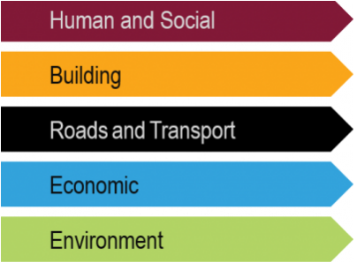

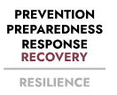
Overview

The Queensland Reconstruction Authority (QRA) is the lead agency responsible for disaster recovery in Queensland.
Queensland’s approach to recovery is outlined in the Queensland Recovery Plan.
Disaster funding arrangements are outlined in the Queensland Disaster Funding Guidelines 2021
and explain Queensland's two disaster relief and recovery arrangements: the Disaster Recovery Funding Arrangements (DRFA) and the State Disaster Relief Arrangements (SDRA).

Roads and Transport FRRG

Lead Agency: Department of Transport and Main Roads (membership)

The effects of a disaster on transport networks, including road, rail, aviation and maritime normally result in difficulty accessing communities and disruption to critical supply chains (both within and outside of the impacted area). Restoration of these networks, or the identification of alternatives, is a priority in disaster recovery.
The purpose of the Roads and Transport Functional Recovery and Resilience Group (FRRG) is to provide functional leadership to support the recovery and resilience of Queensland communities with a specific focus on the transport network. RT FRRG provides support and oversight for roads and transport policy and operational considerations progressed through the SRRG.

Economic FRRG

Lead Agency: Department of State Development, Infrastructure (membership)

The effects of a disaster on the economic environment can be classified in terms of direct and indirect impacts. The tangible impacts can usually be given a monetary value and may include loss of tourism, employment opportunities and reduction in cash flow for businesses.

The Economic Functional Recovery and Resilience Group (FRRG) provides advice on the economic impacts of disaster events such as cyclones, bushfires and major flooding events. It also provides information on the needs of local government and industry in responding to the events and getting the economy back to full production.

Environment FRRG

Lead agency: Department of the Environment, Tourism, Science, and Innovation (membership)

The effects of a disaster on the natural environment may be a direct result of the disaster or through a secondary impact or flow on from the disaster response or recovery process. Impacts to the environment may include damage or loss of flora and fauna, poor air quality, reduced water quality, land degradation and contamination, or damage to heritage listed places.

The role of the Environment FRRG is to determine the potential and/or actual environmental impacts of disaster hazards and events, coordinate the efficient and effective planning and implementation of strategic environment recovery activities post event, and champion environmental resilience in policy and practice when dealing with disaster risk.

Human and Social FRRG
Lead agency: Department of Families, Seniors, Disability Services, and Child Safety (membership)

Human and social recovery relates to the emotional, social, physical and psychological health and well-being of individuals, families and communities following a disaster. The Human and Social Functional Recovery and Resilience Group (FRRG) aims to address:
- access to timely information
- assistance to reconnect with families, friends and community networks
- enabling people to manage their own recovery through access to information and a range of services and/or practical assistance, including financial assistance for those individuals and households who are most vulnerable and do not have the means to finance their own recovery.
- access to emotional, psychological and mental health support at individual, family and community levels (psychosocial support), and
- assistance to maintain a sense of equilibrium in life and move forward into a changed reality.

Building FRRG
Lead Agency: Department of Housing and Public Works (membership)

The effects of a disaster on the built environment often result in damage and disruption which inhibits the capacity of essential services and services such as housing, accommodation, education and health facilities.

The Building Functional Recovery and Resilience Group (FRRG) coordinates the efficient and effective information exchange, issues identification and resolution between government agencies, local government, building industry and insurance providers to ensure efficient and prioritised use of available resources in rebuilding dwellings following a disaster.

Overview
The Office of the Inspector-General of Emergency Management (Office of the IGEM) is responsible for providing the Premier of Queensland, the Queensland Government, and people of Queensland an assurance of public safety through the establishment and implementation of an assurance framework to direct, guide and focus work of all agencies, across all tiers of government, to the desired outcomes of the disaster management arrangements for Queensland.
The Office of the IGEM assesses an entity’s disaster management arrangements across five areas of accountability:
• governance
• doctrine
• enablers
• performance
• capabilities.
Disaster management may be considered effective if it is scalable, comprehensive, interoperable, adaptable and value for money.
Queensland’s approach to assurance is outlined in the Emergency Management Assurance Framework (EMAF) and the Standard for Disaster Management in Queensland (the Standard).



- Assurance

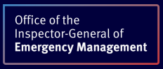
The Office of the Inspector-General of emergency Management is responsible for providing an assurance of public safety.

The Toowoomba DDMG undertake an annual review and assessment of local and district disaster
management plans. This review is conducted pursuant to section 16C(b) of Queensland’s Disaster
Management Act 2003. Toowoomba DDMG members are invited to participate in the process, with
responses to be provided to the Office of the Inspector-General Emergency Management by 30 August.

Appendix A – Toowoomba DDMG Membership
This page is intentionally left blank. This document is restricted and not available for general access by the public.

- Appendices

Appendix B – Toowoomba DDMG Priorities
Queensland Disaster Management Strategic Objectives
- Strive to safeguard people, property and the environment from disaster impacts
- Empower and support local communities to manage disaster risk, respond to events and to be more resilient
Understanding disaster priorities is crucial for effective disaster risk reduction and management. These priorities guide district actions across prevention, preparedness, response, and recovery, ensuring a coordinated and efficient approach to minimising harm and loss.
Toowoomba District Priorities
- Understanding disaster risk
- Strengthening disaster risk governance
- Investing in risk reduction
- Enhancing disaster preparedness
Understanding disaster risk | Assess and analyse potential hazards, vulnerabilities, and impacts of disasters.  Understand the characteristics of hazards, the exposure and capacity of populations and assets, and the environment.
Strengthening disaster risk governance | Establish effective frameworks, policies and processes to manage disaster risk.  Define roles and responsibilities, promoting collaboration between different sectors, and ensuring accountability.
Investing in disaster risk reduction | Implement strategies to reduce the potential impacts of disasters  Develop and review of emergency plans  Train disaster management teams and equip them with the necessary skills and knowledge
Enhancing disaster preparedness | Ensure the district has the resources and capacity to effectively respond to a disaster  Support development of plans to ensure essential services and businesses can continue operating during and after a disaster  Prepare for the recovery phase
Appendix C – Toowoomba DDMG annual activities calendar 2025-26
Activity | Performance Indicators | Date | Responsible Member/s
Development, review and assessment of effective disaster management for the district | - Review of DDMG membership list including roles and responsibilities | Ongoing | XO
 | - Member inductions and compulsory training | Ongoing | XO/EMC
 | - Review of district disaster risk management plan | 30 June | DDMG
 | - DDMG Annual Report | 30 June | DDC/XO
 | - Review of local and district disaster management plans | 31 August | DDMG
 | - Develop and deliver DDCC training | 30 September | XO
 | - Promote and support ‘Get Ready Queensland’ week | 6-12 October | DDMG
 | - DDMG meetings | At least twice annually (Toowoomba DDMG meet 3 times per annum) | DDC/XO
 | - Report and make recommendations to the QDMC about matters relating to disaster management and disaster operations in the district, including After-Action Reviews | As required | DDMG
 | - Develop and deliver DDMG exercise | Annually (timeframe for delivery of district exercise should be flexible, and consider operational environment) | DDMG
 | - Support LDMG and DDMG member agency activities (community education and engagement, exercises, training etc.) | Ongoing | XO

