MACKAY DISTRICT

DISASTER MANAGEMENT PLAN
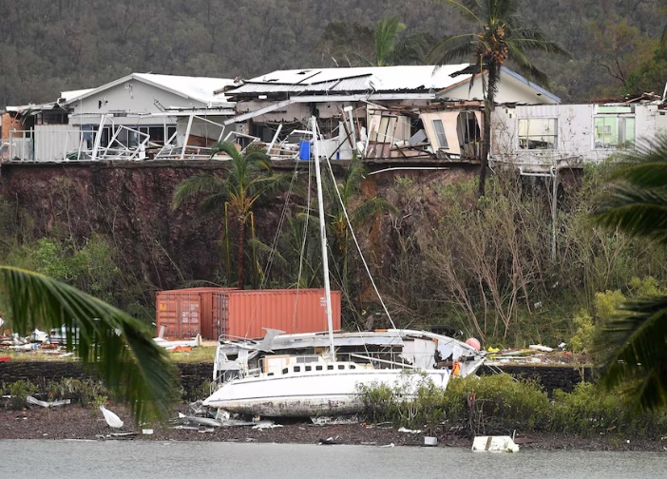
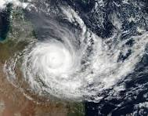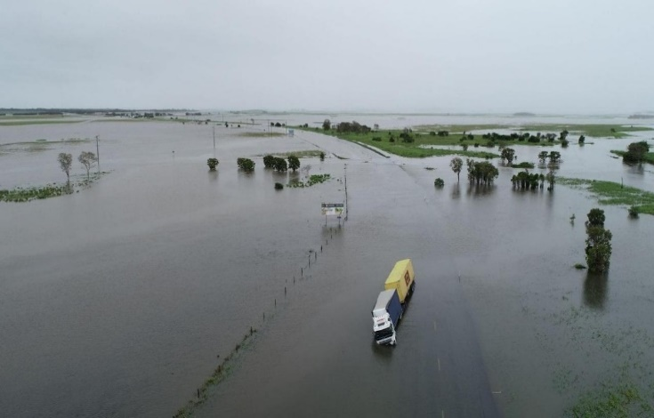
Mackay District Disaster Management Group



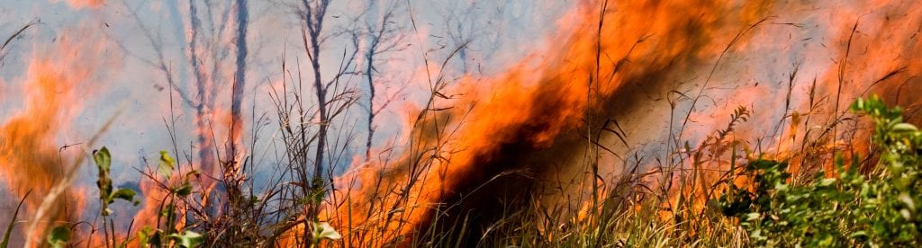
Revised: 6.0
2025 - 2026

ENDORSEMENT

The Mackay District Disaster Management Plan is endorsed under the authority of the District Disaster Management Group.

This plan has been developed in accordance with the Disaster Management Act 2003 and the following documents to provide for effective disaster management in the Mackay Disaster District:

- Queensland State Disaster Management Plan
- Queensland Recovery Plan
- Queensland Emergency Management Assurance Framework
- Queensland Risk Management Framework
- Queensland Prevention Preparedness, Response and Recovery Disaster Management Guidelines
- Queensland Disaster Management Strategic Policy Statement
- Queensland Disaster Management Training Framework

The plan will be maintained by the District Disaster Coordinator and will be reviewed annually unless otherwise required.

……………………………………..
Superintendent Dean Cavanagh
District Disaster Coordinator
Mackay District Disaster Management Group

Dated: 1st of September 2025

DOCUMENT CONTROL

AMENDMENTS

This District plan is a controlled document. The controller of the document is the Mackay District Disaster Coordinator (DDC).
Any proposed amendments to this plan should be forwarded as follows:

By Mail: Executive Officer
Mackay District Disaster Management Group
PO Box 261
Mackay QLD 4740

By Email: DDC.Mackay@police.qld.gov.au

Any changes to the intent of the document must be endorsed by the Mackay District Disaster Management Group (DDMG).

A copy of each amendment is to be forwarded to those identified in the distribution list. On receipt, the amendment is to be inserted into the document and the Amendment Register updated and signed.

AMENDMENT REGISTER

No | Issue Date | Comments
¹ | ^{05/2015} | ^{Review and Update}
² | ^{11/2017} | Update of Membership and DDCC Instructions
³ | ^{01/2019} | ^{Update of Membership}
⁴ | ^{08/2019} | ^{Review and Update}
⁵ | ^{07/2022} | ^{Full Review and Update}
⁶ | ^{10/2024} | Review and Update -SSGT Jaella Christensen
⁷ | ^{09/2025} | Review and Update – MoG updates – SSGT Jaella Christensen

DISTRIBUTION

This plan has been disseminated in accordance with the DDMG Membership Register at Annexure A.

In compliance with s 56 of the Disaster Management Act 2003, a copy of the plan is available on the Queensland Police Service website: www.police.qld.gov.au

This plan is also available for inspection, free of charge, to members of the public. All applications are to be made to the Executive Officer.

Contents
1. GOVERNANCE 8
1.1 AUTHORITY TO PLAN 8
1.2 PURPOSE OF THE PLAN 8
1.3 OBJECTIVES OF THE PLAN 8
1.4 STRATEGIC POLICY STATEMENT 8
1.5 QUEENSLAND DISASTER MANAGEMENT ARRANGEMENTS 9
1.6 SCOPE 10
1.7 PLAN REVIEW AND ASSURANCE 10
2. MACKAY DISTRICT DISASTER MANAGEMENT GROUP 11
2.1 ESTABLISHMENT 11
2.2 ROLE OF THE DDMG 11
2.3 DDMG FUNCTIONS 11
2.4 DDMG RESPONSIBILITIES 12
2.5 DDMG MEMBERSHIP 12
2.5.1 Chairperson / District Disaster Coordinator (DDC)- DDMG 13
2.5.2 Deputy Chairperson / DDC 13
2.5.3 Executive Officer / “XO” 13
2.5.4 Local Government Members 13
2.5.5 State Government Members 14
2.5.6 Other Members and Advisors 14
2.6 MEMBER RESPONSIBILITIES 14
2.7 BUSINESS AND MEETINGS 14
2.7.1 Meetings and Quorum 14
2.7.2 Attendance 15
2.7.3 Minutes 15
2.7.4 SDMG Briefing Paper / Noting Brief 15
2.7.5 Records Management 15
2.8 REPORTING 15
2.8.1 DDMG Annual Operational Plan 15
2.8.2 DDMG Annual Report 16
2.8.3 DDMG Member Agency Reports 16
3. DISTRICT PROFILE 17
3.1 GEOGRAPHY 17
3.2 TOPOGRAPHY 17
3.3 CLIMATE 18
3.4 DEMOGRAPHY 18
3.5 INDUSTRY 19
2.5.1 Resources 19
3.5.2 METS 19
3.5.3 Agriculture 19
3.5.4 Tourism 19
3.5.5 Construction 20
3.5.6 Additional Key Industries 20
3.6 TRANSPORT 20
3.6.1 Roads 20
3.6.2 Rail 21
3.6.3 Seaports 21
3.6.4 Airports 21
3.7 UTILITIES 21
3.7.1 Power 21
3.7.2 Water 22
3.8 COMMUNICATIONS 22
3.8.1 Telecommunications 22
3.9 HEALTH FACILIITIES 23
4. CAPACITY BUILDING 24
4.1 POST DISASTER ASSESSMENTS 24
4.2 TRAINING 24
4.3 EXERCISES 25
4.4 LESSONS MANAGEMENT 25
4.5 PLANNING 25
4.5.1 State Disaster Management Plan 25
4.5.2 Local Disaster Management Plans 26
4.5.3 Functional Plans 26
4.5.4 Hazard Specific Plans 26
4.6 RISK MANAGEMENT 26
4.7 IDENTIFIED HAZARDS 27
1. Cyclone 27
2. Bushfire 27
3. Flooding 27
4. Severe thunderstorm 27
5. Pandemic 27
6. Biosecurity 27
7. Earthquake 27
5. RESPONSE 28
5.1 PUBLIC INFORMATION AND WARNINGS 28
5.1.1 EMERGENCY ALERT 28
5.1.2 STANDARD EMERGENCY WARNING SIGNAL 29
5.2 ACTIVATION AND TRIGGERS 30
5.3 DISTRICT DISASTER COODINATION CENTRE 31
5.3.1 Activation 31
5.3.2 Function 31
5.3.2 Venue 31
5.3.3 Staffing 32
5.3.4 Agency Liaison Officers 32
5.4 SITUATION REPORTING 32
5.5 DISASTER DECLATION 33
5.6 REQUESTS FOR ASSISTANCE 34
5.7 EMERGENCY SUPPLY 34
5.8 RESUPPLY 35
5.8.1 Resupply of isolated communities 35
5.8.2 Isolated rural property resupply 35
5.8.3 Resupply of stranded persons 36
5.9 AIR SUPPORT 36
5.10 AUSTRALIAN DEFENCE FORCE 36
6. RECOVERY 37
6.1 OVERVIEW 37
6.2 ACTIVATION 37
6.3 TRANSITION TO RECOVERY 37
6.4 FUNCTIONS OF RECOVERY 37
6.4.1 HUMAN AND SOCIAL RECOVERY 38
6.4.2 ECONOMIC RECOVERY 38
6.4.3 ENVIRONMENT RECOVERY 38
6.4.4 BUILDING RECOVERY 38
6.4.5 ROADS & TRANSPORT RECOVERY 39
6.5 DISTRICT RECOVERY COMMITTEE 39
6.6 DISTRICT RECOVERY OPERATIONAL PLANNING 39
ANNEXURE A – MACKAY DDMG MEMBERSHIP REGISTER 40
ANNEXURE B – MACKAY DDMG OPERATIONAL PLAN 41
ANNEXURE C – MACKAY DISTRICT AND LOCAL MAPS 42
ANNEXURE D – DDCC INSTRUCTIONS 46
ANNEXURE E - ACRONYMNS 47
ANNEXURE F - DEFINITIONS 49

1. GOVERNANCE

1.1 AUTHORITY TO PLAN
This District Disaster Management Plan (DDMP) is prepared under the provisions of section 53 of the Queensland Disaster Management Act 2003 (‘the Act’).

1.2 PURPOSE OF THE PLAN
The overall purpose of the DDMP is to articulate the arrangements within the Mackay Disaster District to provide whole-of-government planning and coordination capability to support local governments in disaster management.

1.3 OBJECTIVES OF THE PLAN
The objectives of the Mackay DDMP are to facilitate the implementation of efficient and effective disaster management strategies and arrangements including:
- the development, review, and assessment of effective disaster management for the district including arrangements for mitigating, preventing, preparing for, responding to and recovering from a disaster.
- compliance with relevant legislation, policy and guidelines including:
  - the development, implementation, and monitoring of priorities for disaster management for the district.

1.4 STRATEGIC POLICY STATEMENT
Disaster management planning and operations in the Mackay Disaster District are consistent with the Queensland Disaster Management 2016 Strategic Policy Statement which is achieved by:
- ensuring a comprehensive, all hazards, all agencies approach by achieving the right balance of prevention, preparedness, response, and recovery.
- supporting the mainstreaming of disaster preparedness and mitigation into relevant areas of activity of government, non-government, small business, and corporations.
- aligning disaster risk reduction, disaster mitigation, disaster resilience and climate change adaptation policy, strategies, and actions with international and national reforms.
- promoting a transparent, systematic, and consistent approach to disaster risk assessment and management.
- recognising the commitment of stakeholders and the need for collaboration and integration across all levels of government, community, industry, commerce, government owned corporations, private and volunteer organisations, and local communities in all aspects of disaster management.
- emphasising building and maintaining sincere relationships, trust and teamwork which instils collaboration, consultation, and interoperability across the sector.
- Incorporating risk-based planning, consultative decision-making, and shared responsibilities among stakeholders; and
- promoting community resilience and economic sustainability through disaster risk reduction, innovation, research and lessons learned.
Refer: Qld Disaster Management Strategic Policy Statement.

1.5 QUEENSLAND DISASTER MANAGEMENT ARRANGEMENTS

Queensland's disaster management arrangements enable a progressive escalation of support and assistance through the four tiers as required as shown in the below figure. These arrangements comprise several key management and coordination structures for achieving effective disaster management in Queensland.
The management and coordination structures are:
- Disaster management groups that operate at local, district and state levels and are responsible for the planning, organisation, coordination, and implementation of all measures to mitigate/prevent, prepare for, respond to and recover from disaster events.
- Coordination centres at local, district and state levels that support disaster management groups in coordinating information, resources, and services necessary for disaster operations.
- Disaster management plans, developed to ensure appropriate disaster prevention, preparedness, response, and recovery at local, district and state levels.
- Functional lead agencies through which the disaster management functions, and responsibilities of the state government are managed and coordinated.
- Hazard specific primary agencies, responsible for the management and coordination of combating specific hazards.
- Specific-purpose committees, either permanent or temporary, established under the authority of disaster management groups for specific purposes relating to disaster management.

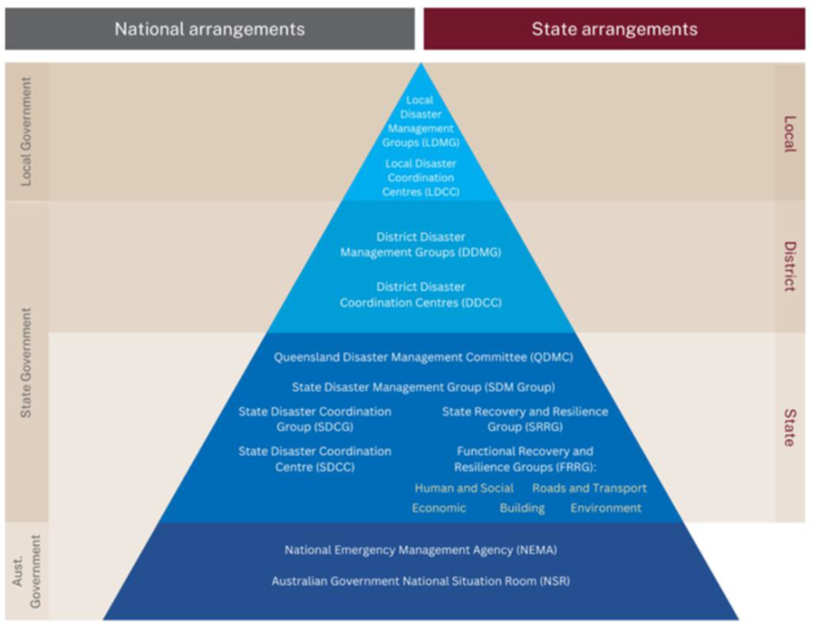

1.6 SCOPE

The scope of this plan is limited to the arrangements necessary to undertake disaster management operations and planning within the Mackay Disaster District which encompasses the following local government authorities:

- Isaac Regional Council (IRC)
- Mackay Regional Council (MRC)
- Whitsunday Regional Council (WRC)

1.7 PLAN REVIEW AND ASSURANCE

In accordance with Section 55 of the Act, the District Disaster Management Plan and associated sub-plans shall be reviewed annually. The effectiveness of the DDMP and Sub-plans shall be reviewed and assessed against the IGEM Assurance Framework.

In addition to the programmed reviews of disaster management plans, there are a range of conditions that may trigger the need for the review of the Mackay District Disaster Management Plan including:

- An exercise or operational activity that identifies significant deficiencies in arrangements, systems, or processes.

- Changes to the boundaries to which the plan is applicable resulting in increased risk levels.

- Changes within the environment, community population, demographics, or hazards, resulting in increased risk levels.

- Changes to available resources or agencies with a role in delivery of disaster management response and recovery which impacts on group capability.

- Changes to state disaster management guidelines or doctrine; or

- At the request of the DDC.

2. MACKAY DISTRICT DISASTER MANAGEMENT GROUP

2.1 ESTABLISHMENT

The Mackay District Disaster Management Group (DDMG) is established in accordance with Section 22 of the Disaster Management Act.

2.2 ROLE OF THE DDMG

The group performs a ‘middle Management’ function within Queensland Disaster Management Arrangements (QDMA) by providing coordinated state government support when requested by one of more of the following Local Disaster Management Groups.
- Isaac Local Disaster Management Group
- Mackay Local Disaster Management Group
- Whitsunday Local Disaster Management Group

2.3 DDMG FUNCTIONS

In accordance with the section 23 of the Disaster Management Act the Mackay DDMG will fulfil the following functions:
- ensure that disaster management and disaster operations in the district are consistent with the State group’s strategic policy framework for disaster management for the State.
- develop effective disaster management for the district, including a district disaster management plan, and regularly review and assess that disaster management.
- provide reports and make recommendations to the State group about matters relating to disaster management and disaster operations in the district.
- regularly review and assess the disaster management of local groups in the district.
- the disaster management of local groups in the district; and
- local disaster management plans prepared by local governments whose areas are in the district.
- to ensure that any relevant decisions and policies made by the State group are incorporated in its disaster management, and the disaster management of local groups in the district.
- to ensure the community is aware of ways of mitigating the adverse effects of an event, and preparing for, responding to, and recovering from a disaster.
- to coordinate the provision of State resources and services provided to support local groups in the district.
- to identify resources that may be used for disaster operations in the district.
- to make plans for the allocation, and coordination of the use, of resources mentioned in paragraph (h);
- to establish and review communications systems in the group, and with and between local groups in the district, for use when a disaster happens.

- to ensure information about an event or a disaster in the district is promptly given to the State group and each local group in the district.
- to prepare, under Section 53, a district disaster management plan.
- to perform other functions given to the group under this Act; and
- to perform a function incidental to a function mentioned in paragraphs (a) to (m).

2.4 DDMG RESPONSIBILITIES

In addition to the legislated functions, the Mackay DDMG accepts the following responsibilities.
- Ensure consistency of district disaster management and operations with the Queensland Disaster Management 2016 Strategic Policy Statement and other policies and decisions made by the Queensland Disaster Management Committee (QDMC).

- Develop effective disaster management, including a district disaster risk assessment and District Disaster Management Plan, and regularly review and assess disaster management activities.

- Review and assess the disaster management risk assessments and plans of local groups in the district.

- Identify residual risks, make plans, and coordinate resources for disaster operations in the area.

- Ensure community awareness about mitigating the adverse effects of an event and preparing for, responding to, and recovering from such an event.

- Establish and review communications within the district group and with relevant local groups.

- Establish, when necessary, a recovery group.

- Establish a DDCC to support the DDMG in providing state level support to local government. The DDCC implements decisions of the DDC and DDMG and coordinates State and Australian government resources in support of LDMGs.

2.5 DDMG MEMBERSHIP

The Mackay DDMG is comprised of representatives from regionally based Queensland government agencies, government owned corporations, non-government organisations, industry and commerce and key community representatives, who can provide and coordinate whole-of-Government support and assistance to disaster affected communities.

Refer: ANNEXURE A – Mackay DDMG Membership Register

2.5.1 Chairperson / District Disaster Coordinator (DDC)- DDMG

In accordance with section 25 (1), 25 (2), and 25 (3) of the Act, the Commissioner of the Queensland Police Service (QPS) has appointed a Chairperson/DDC position for each Disaster District. The DDMG Chairperson is also the DDC, in accordance with section 25A of the Act. The DDC is the State’s representative on the ground in a disaster within the disaster district.
As the organisational position is the appointee and not the person, when an individual is acting in the appointed organisational position, he/she then is the Chairperson/DDC, for the period he/she is acting in the organisational position.

Role of Chair DDC
- Manage and coordinate the business of the group
- Ensure that the group performs its functions
- Report regularly to the Queensland Disaster Management Committee (QDMC), about the performance of the district group
- Coordinate disaster operations in the disaster district for the group

2.5.2 Deputy Chairperson / DDC

In accordance with s.25(1)(a) of the Act, the Commissioner of the QPS has appointed Deputy Chairperson’s incumbent by position for each Disaster District.
During normal business activities, the role of the Deputy Chair is to preside over meetings in the absence of the chair.
The deputy chair has no legislated role in operational activities however it may be appropriate for the deputy chair to be delegated the responsibilities of the DDC in the absence of the DDC.

2.5.3 Executive Officer / “XO”

In accordance with section 27 of the Act the Commissioner of the QPS has appointed by position a member of the police service as XO for each DDMG.
The function of the XO in accordance with section 28 of the Act is to support the group in the performance of its functions, as directed by the Chairperson/DDC.
The role of the XO during normal business activities is to provide advice and support to the DDC and DDMG in the undertaking of prevention, preparedness, response and recovery activities.

2.5.4 Local Government Members

Local government appointments to the Mackay DDMG are in accordance with section 24 (1) (d) of the Act. Local government representatives appointed to the DDMG should be available to participate as a member of the DDMG during activation.

2.5.5 State Government Members

Departmental appointments to the Mackay DDMG are made with section 24 of the Act and read in conjunction with section 5 of the Regulation.

2.5.6 Other Members and Advisors

In accordance with section 24(f) of the Act the Mackay DDC has the discretion to appoint individuals and/or organisations to the Mackay DDMG having regard to the effective disaster management for the Mackay District.

2.6 MEMBER RESPONSIBILITIES

Agency specific functions, role and responsibilities are articulated in the Queensland State Disaster Management Plan. The Mackay DDMG adopts these functions at a district level.

The personal responsibilities of appointed members of the Mackay DDMG will include the following:
- Attendance and participation at DDMG activities with a full knowledge of their agency’s resources and services and the expectations of their agency.

- Are available and appropriately briefed to actively participate in the DDMG activities to ensure their plans projects and operations use the full potential of their agency of function, while recognising any resource or capacity limitations

- Are appropriately positioned within their agency to be able to commit agency resources to DDMG normal business activities.

- Have completed relevant disaster management training; and

- Have a deputy who is appropriately trained to take on the responsibilities should they be unavailable or to provide additional support during extended operations.

2.7 BUSINESS AND MEETINGS

2.7.1 Meetings and Quorum

Ordinary meetings of the Mackay DDMG will occur at least once every 6 months at the times and places decided by the chairperson.
Extraordinary Meetings will be conducted as required at the determination of the Chairperson.
A quorum is required for meeting resolutions to be officiated and is equal to one-half of DDMG members plus one. An appointed deputy attending a meeting on behalf of a DDMG member is to be counted in quorum.
The chairperson or deputy chairperson is to preside at all meetings of the group. If both are absent, the meeting will be presided by a member determined by the Chair.
Meetings may be held, or member may participate using any technology that reasonably allows members to hear and take part in discussions, Members participating in these means are taken as being present.

2.7.2 Attendance

A formal register of DDMG Member attendance at meetings will be maintained by the Executive Officer.

2.7.3 Minutes

The DDMG meeting minutes will be maintained by the Executive Officer and should provide a summary of key discussion points and resolutions and is subject to the Right to Information Act 2009.
A flying minute may be used to progress business of an urgent nature. The passing of a resolutions via a flying minute is allowed under s.42 of the Act if the majority of members provide written agreement.
In addition to minutes, the DDMG XO will produce a Resolution Statement to provide a running log of actions undertaken and an audit trail through to the acquittal of these resolutions. Once acquitted the resolution should be recorded on a resolution register.

2.7.4 SDMG Briefing Paper / Noting Brief

In accordance with s.23(c) of the Act, the Mackay DDMG will provide reports and recommendation to the SDMG in relation to relevant matters relating to disaster management and disaster operations within the Mackay District.

2.7.5 Records Management

The Mackay DDMG will comply with requirements of the Public Records Act 2002 and acknowledges that its records may be subject to scrutiny under the Right to Information Act 2009.

2.8 REPORTING

2.8.1 DDMG Annual Operational Plan

The Mackay DDMG will develop and maintain an Annual Operational Plan which documents specific projects, programs, and strategies required to enhance disaster management in the district. The operational plan will include:

- Ongoing disaster management goals and objectives for the district aligned to the SPF, SDMG and state government agency disaster management priorities the Chair considers appropriate.
- Enabling strategies
- Prioritised activities
- Responsibilities for activities
- Performance measure and targets; and
- Other issues the Chair considers appropriate

Clear focus on community safety across the four phases of Prevention, Preparation, Response and Recovery the Queensland State Disaster Coordinator (SDC) has listed priorities for up coming 2025- 2026 Higer Risk Weather Season.

- Protection of Life - Ensure, as far as reasonably practicable, that preventable deaths do not occur through proactive disaster management actions and timely interventions.
- Protection of Property – Minimise the loss or damage of property by ensuring that appropriate preparedness and mitigation measures are in place across affected communities and sectors.
- Critical Infrastructure – Protect and enable the rapid restoration of critical infrastructure services (including power, water, sewage and communications).
- Recovery – Facilitate and expedite the transition to recovery operations, supporting affected communities in line with the State Recovery and Resilience Plan to ensure timely and sustainable recovery outcomes.

Refer: Annexure B – Mackay DDMG Operational Plan

2.8.2 DDMG Annual Report

On behalf of the Mackay DDMG, the Executive Officer will prepare and submit an Annual Report to the DDC in relation to disaster management and disaster operations in the Mackay District.
This annual report will be compiled using DDMG member agency and LDMG reports that are submitted on a regular basis at DDMG meetings.
Once approved this Annual Report will be forwarded to the State Disaster Coordinator.

2.8.3 DDMG Member Agency Reports

Members of the Mackay DDMG will be expected to regular reports on behalf of their respective department/ agency with respect to disaster management initiatives, projects, training/exercises, community awareness programs, disaster management plans, operations conducted or contact information.
A schedule and Member Agency Report Template will be provided by the Executive Officer.

3. DISTRICT PROFILE

3.1 GEOGRAPHY

The Mackay Disaster District is situated in Central Queensland, roughly halfway between Brisbane and Cairns and encompasses an area of approximately 90,000 square kilometres. The boundary encompasses the area from Bowen in the north, to St Lawrence in the south, east to the Whitsunday Islands and west to the Belyando River. The district includes the following three local government areas (LGA):
- Isaac Regional Council (IRC)
- Mackay Regional Council (MRC)
- Whitsunday Regional District (WRC)
Refer: Annexure C – Mackay District and Local Maps

3.2 TOPOGRAPHY

The Mackay District is renowned for its natural environment, in particular its proximity to the Great Barrier Reef and lagoon system, and numerous coastal islands and national parks that have international, national, state and district environmental significance. The island national parks comprise beaches, coral reefs and remnant vegetation and are part of the Great Barrier Reef World Heritage Area.
The district’s biodiversity includes a variety of ancient, rare and threatened plants and animals. The diversity of ecosystems and habitat include coral reefs, forests, streams, and wetlands. This includes a variety of ancient, rare and threatened plant and animal species. Prominent natural resources supporting the district include productive agricultural land, freshwater resources, forests, minerals and marine waters.
The district contains substantial, high-quality natural resources, particularly mineral resources and productive agricultural land. The Bowen Basin has Australia’s largest coal deposit and is one of the nation’s largest coal producers. Coal mining is the major industry in the district and the largest employer. The sugar, horticulture, cropping and grazing industries benefit significantly from the district’s productive agricultural land.
These resources provide a diverse range of ecosystems that underpin the wellbeing of the community in addition to supporting industries that rely on their quality and accessibility. The environment and natural resources of the district face many challenges in the future, including ensuring sustainable management to meet growing energy and water demands, adequate protection of environmentally valuable areas, restricting encroachment of urban development into agricultural lands, and land fragmentation.
The district has a complex network of river systems and substantial water storage infrastructure including:
- Burdekin River Catchment
- Don River Catchment
- O’Connell River Catchment
- Pioneer River Catchment
- Plane Creek Catchment
- Proserpine River Catchment
- Burdekin Falls Dam
- Eungella Dam
- Kinchant Dam
- Peter Faust Dam
- Teemburra Dam

3.3 CLIMATE

The Mackay area has a tropical climate. Summers are generally hot and wet, though the coast has the benefit of a regular afternoon sea breeze. Winter days are generally warm and sunny, while winter nights can be cool away from the coast.
Mackay's average annual rainfall is 1585mm. A large proportion falls in the months December through to March with the driest months being August/September.
Maximum daytime temperatures are typically 29-30 degrees during the summer/wet months and 21-25 degrees during the winter/dry months. Minimum overnight temperatures are typically around 23 degrees during the summer/wet months and 13-14 degrees during the winter/dry months.
The region lies in the trade wind belt for most of the year resulting in south to southeast winds. During the warmer months afternoon northeast sea breezes are common. Fresh south-easterlies can blow along the coast for lengthy periods during summer and autumn, but gale force winds are rare and normally only occur with a tropical cyclone.
The cyclone season is from December through to April with 43 tropical cyclones passing within 150km of Mackay during the years 1910-1992. Mackay has 17 thunder days per year on average with the majority of these occurring from late spring through to early autumn. Fog occurs on average 9 times each year. Maximum temperatures have reached the high 30's and minimum temperatures have dropped to less than 4 degrees.
The Pioneer River has a quite well recorded flood history with documented evidence of flooding as far back as 1884. Since that time many devastating floods have occurred, with the highest occurring in February 1958 which peaked at a height of 9.14 metres on the Mackay flood warning gauge at the Forgan Bridge.

3.4 DEMOGRAPHY

The Mackay District is made up of many vibrant local communities and places, each with its own unique character and identity. The district’s diverse culture is a mix of Aboriginal and Torres Strait Islander and Australian South Sea Islander communities, descendants of early European settlement, agricultural and mining foundations, as well as the structural heritage retained in many townships.
The district’s heritage is a unique and diverse resource which connects the community to its past and strengthens its district identity. Conservation of heritage values and its integration within new and evolving communities is a critical aspect of sustainable planning and development.
The non-resident population of the district, comprising non-resident workers, is not recognised in official resident population estimates. This poses a challenge in planning for the growth of the district, where non-resident populations place further demand on existing community services and infrastructure.
Other demographic factors that are acknowledged as influencing the social wellbeing of the district’s residents include limited access to services and a lack of public transport to support the highly dispersed settlement within the district.
LGA | Population (2021) | Median Age | Indigenous status | Private Dwellings
Isaac | 22,046 | 34 | 5.3% | 10.939
Mackay | 121,691 | 38 | 6.2% | 52,200
Whitsunday | 37,152 | 40 | 5.8% | 17,885
TOTAL | 180,889 |  |  | 81, 024

3.5 INDUSTRY

Resources

The region’s proximity to the Galilee, Bowen and Surat Basins makes it one of Queensland’s largest areas of coal, energy and gas production. The region’s mining and resource activity includes underground and opencut thermal and metallurgical, minerals and coal seam gas (CSG). The dominant minerals commodity is coal and comes from the Bowen Basin region.

3.5.2 METS
The region is home to one of Australia’s most advanced Mining Equipment, Technology and Services (METS) sectors. This sector focuses on innovation, precision and highly technical skills which have a global focus and a myriad of export opportunities

3.5.3 Agriculture

The Mackay Isaac Whitsunday region has the capability to competitively produce some of the world’s most energy dense and productive feedstocks, such as sugar cane, eucalypts and algae, to fuel the emerging Bio futures sector.
In recent years, global interest in reducing waste, creating circular economy opportunities and producing Biofuels is increasing at an incredible rate. Bioproducts offer a renewable and environmentally beneficial alternative to existing conventional chemical and fossil fuel refining processes.

3.5.4 Tourism

The Mackay Isaac Whitsunday region offers an abundance of natural attractions including national parks, gorges, the Great Barrier Reef, numerous tropical islands and beaches. The region also boasts presents strong opportunities in the adventure, heritage, ecotourism, grey nomad and agritourism space.
The Mackay region continues to grow a strong reputation as a fast-emerging tourism destination with an extensive nature-based offering. Nature has been established as the region’s core hero experience and, as a result, locations such as the Eungella and Cape Hillsborough National Parks have gained strong national and international exposure – particularly around the themes of the platypus and the Sunrise Wallaby Experience.
The Isaac region has a mix of authentic inland and coastal experiences. The inland towns of Moranbah and Clermont have rich cultural and heritage stories to share, and Clairview provides a stunning coastal scene ideal for fishing and crabbing – home to a Dugong Sanctuary and close to the St Lawrence Wetlands.
The Whitsundays is truly a world class destination and is recognised as a key marine and coastal playground for both the region and Queensland. The Whitsunday region offers numerous unspoilt and reef fringed islands to explore; great sailing; a place to unwind and party; luxury resorts and a romance destination. Not to mention its growing popularity as a winter escape for grey nomads from the south who flock to fill caravan parks and enjoy coastal activities (particularly fishing)

3.5.5 Construction
The construction sector is a fundamental component in building the infrastructure of an economy and community
In the Mackay and Whitsunday region, this activity has mainly focused on residential and commercial construction. However, engineering construction such as enabling transport infrastructure such as roads, rail and port also plays a significant role across all three government areas.
The Isaac region boasts a large number of mining construction projects, and this will be an ongoing integral component of the regional economy

3.5.6 Additional Key Industries

- Aviation
- Beef processing
- Biobased products
- Education
- Energy production / renewable energy
- Manufacturing / engineering
- Fabricated metal production
- Food manufacturing
- Light industries
- Rail manufacturing
- Marine
- Retail trade

3.6 TRANSPORT

The region’s transport network is characterised by intraregional connections between the larger regional centres along the coast and smaller inland centres. It incorporates both road and rail links that are recognised as being of state and national significance.

3.6.1 Roads

The Mackay District Road network is critical to the economic development of the Mackay Isaac Whitsunday region as it facilitates the transport of export goods to market and enables the movement of critical materials and technology across the region (fuel; mining equipment etc).
The road network is also a vital connector for growth in the tourism sector. The region is supported by several national roads, including the Bruce Highway and the Peak Downs Highway, as well as an extensive network of strategic state and district roads.

3.6.2 Rail

The rail network is particularly critical to the economy of the Mackay District. It serves the agriculture, resources and tourism industry sectors but also plays a significant role in containerised freight transport.
Aurizon’s Central Queensland Coal Network is one of the world’s largest and most complex rail supply chains and connects domestic coal users to the export terminals at Abbot Point, Dalrymple Bay, and Hay Point.
The North Coast Rail line runs parallel to the Queensland coastline between Nambour in the south and Cairns in the north and is the principal regional freight and passenger line in Queensland's rail network. The line carries various freight products, including containerised freight, minerals, livestock, and commodities such as sugar and grain.

3.6.3 Seaports

The region is home to several major ports including coal ports at both Hay Point in the south of the region and Abbot Point in the north.
The Port of Mackay is vital for fuel distribution into resource areas as well as agricultural exports.

3.6.4 Airports

The region is home to three regional airports servicing more than 1.3 million passengers annually.
Mackay Airport, Moranbah Airport and Whitsunday Coast Airport in Proserpine are serviced by major airlines with convenient destinations and connections.

3.7 UTILITIES

3.7.1 Power

Ergon Energy owns and manages the electricity distribution network which distributes electricity to the Mackay Disaster District.
Powerlink Queensland is a Government Owned Corporation that owns, develops, operates and maintains the high voltage electricity transmission network throughout the Mackay District and the state of Queensland

3.7.2 Water

Mackay Regional Council sources fresh water from the Dumbleton Weir on the Pioneer River (supplemented by groundwater bores). Wastewater plants located at Nebo Road, Bakers Creek, Bucasia, Mirani, and Sarina.

Whitsunday Regional Council sources water for Proserpine and Whitsunday by pumping from the sand bed of the Proserpine River upstream of the town and bore fields located at various sites. The primary water supply for Bowen is sourced from sand beds in the Proserpine River downstream from the Peter Faust Dam (80%) and sand beds in the Don River (20%). The primary water supply for Collinsville and Scottsville is sourced from sand beds in the Don River by a pumping system to a holding facility and then gravity feed to a treatment plant. Wastewater is treated at plants located at Proserpine, Cannonvale, Bowen, and Collinsville.
Isaac Regional Council operates eight (8) water treatment plants and networks including Carmilla, Clermont, Dysart, and Glenden.

3.8 COMMUNICATIONS

3.8.1 Telecommunications

Telecommunications infrastructure within the Mackay District comprise overhead, underground cables and telephone exchanges operated by Telstra.
Mobile Phone Networks are operated by Telstra, Optus and Vodaphone, with towers strategically located throughout the district.
Personnel from telecommunications companies are represented on the Mackay DDMG as Advisory Members.
Satellite, UHF/VHF/HF radio, pager and other technologies are used by Emergency Services, some government departments and commercial users throughout the Mackay District.

3.8.2 Television

The Mackay District is serviced by the ABC and the all the commercial television broadcasters transmission sites. Terrestrial reception is available in all populated areas.

3.8.3 Radio Stations

The Australian Broadcasting Corporation operates ABC Tropical North which transmits on a number of FM frequencies throughout the Mackay District. There is also a range of commercial and community FM radio stations with a footprint throughout the District.

3.9 HEALTH FACILIITIES

The bulk of public health services are delivered by the Mackay Hospital and Health Service (MHHS), which provides an integrated approach to service delivery and offers an extensive range of specialist services delivered by resident and visiting medical specialists.
MHHS supports service delivery to hospitals in Bowen, Clermont, Collinsville, Dysart, Glenden, Middlemount, Moranbah, Proserpine and Sarina.

4. CAPACITY BUILDING

4.1 POST DISASTER ASSESSMENTS

The review of operational activities undertaken during a disaster is a key component in ensuring capability development and the continuous improvement of disaster management arrangements.
Post-disaster reviews are conducted to:
- assess disaster operations undertaken for a given disaster including actions, decisions, or processes.
- document those processes that worked well and identify a course of action to ensure that they are captured and updated in relevant doctrine for use in the next operation; and
- assess capability and consider where additional training and/or exercises may enhance capacity.

The review of operations is to be conducted through one or more of the following formats:
- Hot debrief: - Undertaken immediately after operations are complete to give participants the opportunity to share learning points while the experience is still fresh in their minds. During protracted events multiple hot debriefs may be appropriate.

- Post-event debriefs: - Conducted days or weeks after the event when participants have had the opportunity to take a considered view of the effectiveness of the operation. Debriefs will be coordinated by the DDMG XO and depending on the scale of the event may employ an external facilitator not involved in the event.

- Post event analysis Report: - A post event analysis will be prepared by the QPS in consultation with relevant agencies. This process is designed to look for district and state level issues that can be maintained or improved across the QDMA and should support the notion of continuous improvement.

The DDMG Chair will ensure that following the activation of the DDMG for a disaster event, an appropriate debrief is conducted and a Post Event Analysis Report is completed and disseminated appropriately.

4.2 TRAINING

Disaster management training has been identified as an essential means through which agencies can develop and maintain their disaster management capabilities and capacity.
The DDMG Executive officer and Emergency Management Coordinator will conduct ongoing training needs analysis and provide advice to the DDMG Chair on training opportunities and capability deficiencies.
Agencies and organisations represented on the DDMG have the responsibility of providing suitable opportunities for DDMG representatives (including deputies) to attend required training. In addition, each agency also has a responsibility to conduct relevant internal training/exercising of their staff and where appropriate, offer other agencies the opportunity to participate.
To enhance knowledge and disaster management capabilities DDMG representatives (including deputies) are encouraged to complete training courses beyond their relevant minimum requirements of the Queensland Disaster Management Training Framework.

4.3 EXERCISES

Exercising the DDMG is a legislative requirement under s.55(2) and provides opportunities to involve all agencies and levels within the QDMA.
The DDMG Chair will ensure that the Mackay DDMG conduct at least once exercise per annum and may include one or more of the following objectives:
- evaluate plans
- explore issues
- promote awareness
- develop or assess competence
- demonstrate capability
- practice interoperability
- validate training
- identify gaps
- evaluate equipment, techniques and processes

Any gaps or issues identified during the exercise process will be tabled as findings to the DDMG to allow evaluation, development of capability and reporting and implementation of appropriate treatment options.
The exercise findings and treatment options may then be captured in a wider post-exercise report noted in the Risk register and Annual Report and included in the DDMG Operational Plan for implementation.

4.4 LESSONS MANAGEMENT

A key outcome of exercises, post-disaster assessment and debriefs is that lessons identified are embedded into disaster management planning.
Such lessons come from an examination of the effectiveness of mitigation measures, an analysis of the state of preparedness in readiness for the impacts of a disaster, of the disaster operations themselves and extend into the effectiveness of the response or recovery.
The DDMG Chair with the support from the Executive Officer is to ensure that all findings from Post Disaster Assessments and Exercise Reports are incorporated into the DDMG Annual Operational Plan and Disaster Management Plan for the monitoring and implementation of recommendations.

4.5 PLANNING

4.5.1 State Disaster Management Plan

The State Disaster Management Plan describes Queensland’s disaster management arrangements, through which the guiding principles and objectives of the Act and the Standard are implemented.
All disaster events that occur within the Mackay Disaster District, whether natural or caused by human acts, will be managed in accordance with the SDMP. The plan is consistent with the Standard and this Guideline as per section 50 of the Act and is supported by supplementary hazard-specific plans and functional plans.

4.5.2 Local Disaster Management Plans

In accordance with section 57 of the Act, the three local governments within the Mackay Disaster District have prepared a Local Disaster Management Plan for their respective LGA.
The development of these LDMP’s is based on a comprehensive, all hazards approach to disaster management which incorporates all aspects of PPRR and specific provisions under sections 57 and 58 of the Act.

4.5.3 Functional Plans

Functional plans are developed by lead agencies to address specific planning requirements. The lead agencies for each function are detailed in the State Disaster Management Plan. The Mackay DDMG adopts these responsibilities at a district level.

4.5.4 Hazard Specific Plans

In addition to the DDMP, hazard specific plans developed by the relevant lead agencies will be referred to in the response to a specific event. All hazard specific plans are to address the hazard actions across all Prevention, Preparedness, Response and Recovery (PPRR) phases and include information on how the QDMA links with the hazard specific arrangements and provides support to the primary agency in the management of the hazard specific event.

4.6 RISK MANAGEMENT

The Mackay DDMG will conduct an annual Risk Assessment which will be in accordance with the Queensland Emergency Risk Management Framework (QERMF).
This process applies a proven, standardised and internationally recognised approach to the prioritisation, mitigation and management of risk including the identification of capacity gaps and residual risk between stakeholders and the QDMA.
The outcomes of these two processes are used to populate multiple risk management documents including the Risk Assessment Table, Risk Register and Decision Log.

4.7 IDENTIFIED HAZARDS

Credible hazards that may impact the Mackay District are listed below in order of likelihood. The likelihood, consequence and treatment of these hazards will form the Annual Risk Management Assessment undertaken by the Mackay DDMG.

Cyclone

Bushfire

Flooding

Severe thunderstorm

Pandemic

Biosecurity

Earthquake

For more specific details relating to these hazards please refer to the relevant Local Disaster Management Plan

5. RESPONSE

5.1 PUBLIC INFORMATION AND WARNINGS

Public information during the response phase of a disaster management operation provides the community with awareness of hazards and information about events and recommended actions, such as local evacuation arrangements and specific measures available for vulnerable groups.
Traditional media, including radio, television and print, is used for public information in most events, however local governments and emergency service agencies should also use social media, local warning systems, websites and other channels to provide information to stakeholders and the community.
The BoM is responsible for issuing meteorological warnings such as severe weather warnings, tropical cyclone advice, and tsunami warnings. Local governments should constantly monitor these messages to ensure situational awareness. Warnings about incidents such as bushfire, biosecurity threats, chemical spills, dams and water releases are issued by the relevant functional lead agency.
The notification and dissemination of information and warnings does not rely on the activation of a disaster management group. Rather, they should be the automatic responsibility of disaster management agencies, regardless of the status of activation of a disaster management group.
The Watch Desk – the 24/7 disaster monitoring unit in the SDCC – is key in disseminating warnings from BoM to agencies across all levels of Queensland's disaster management arrangements. Additionally, the Watch Desk is the primary authority for disseminating non-opt-in warnings via the EA system.
The following diagram represents information flow of warning notification/s from a district level only. This flow chart does not diminish from the methodology local governments use to manage warnings in their respective areas

5.1.1 EMERGENCY ALERT
Refer: Queensland Emergency Alert Guideline

EA is a national telephone warning and alert system used to send voice messages to landlines and text messages to mobile phones, within a defined spatial area about a likely or actual disaster and/or emergency situation.
EA relies on Australian based telecommunication networks to send warning messages to landlines and mobile telephones. Text messages can be sent to the last known location of mobile handsets at the time of the disaster or emergency situation. This includes visitors and travellers if the mobile phones are registered to “roam” on an Australian network. International tourists who have not enabled international roaming on their mobile device and are not connected to an Australian network, will not receive an EA warning.
The LDC DDC, SDC or delegated officer of the referable dam owner (as listed in the approved dam emergency action plan), can request, through the QPS EMC or SDCC Watchdesk advisor on their respective disaster management group, for an EA campaign to be delivered via landline and text messages to potentially affected people. QFD Incident Controllers may also choose to request an EA campaign for a fire or hazardous material incident.

5.1.2 STANDARD EMERGENCY WARNING SIGNAL
Refer: Queensland Standard Emergency Warning Signal Manual

The Standard Emergency Warning Signal (SEWS) is a distinctive audio signal that has been adopted to alert the community to the broadcast of an urgent safety message relating to a major emergency/disaster. It is intended for use as an alert signal to be played on public media (such as radio, television, public address systems, mobile sirens), to draw listeners’ attention to a following emergency warning. It is meant to attract listeners’ attention to the fact that they should take notice of the emergency message.

The Standard Emergency Warning Signal (SEWS), shall be utilised in respect to warning issues for events involving the following:
- Wind gusts >125 kilometres per hour (equivalent to category 2 and above cyclones);

- Storm tide >0.5 metre above Highest Astronomical Tide;

- Large hail > 4 centimetre in diameter;

- Tornado(s);

- Major floods, flash floods and/or dam break;

- Intense Rainfall leading to Flash Floods and/or landslides (1-6 hour rainfall total > 50 year Average Recurrence Interval);

- Geo-hazards including effects of earthquakes and or tsunami waves > 1 metre (tide dependent);

- Major urban and rural fires;

- Major pollution, hazardous material or bio-hazard emergency;

- Civil defence emergency (as defined in Article 61 of Protocol 1 of the 1977 Protocols Additional to the Geneva Conventions of 1949);

- Other major emergency situations.

5.2 ACTIVATION AND TRIGGERS

Alert | A heightened level of vigilance and preparedness due to the possibility of an event in the area of responsibility.  Some action may be required, and the situation should be monitored by staff capable of assessing and preparing for the potential threat.
Alert | Triggers | Actions | Communications
Alert | - One or more LDMGs operational  - Awareness that threat may be widespread | - XO briefs DDC on activation levels of LDMGs  - Analysis of threat  - Contact with LDCs  - Advise Frontline and Digital Services, to ready Primary and Secondary DDCC.  - Advise Media Liaison Officer. | - DDC and XO on mobile remotely
Lean forward | An operational state prior to ‘stand up’ characterised by a heightened level of situational awareness of a disaster event (either current or impending) and a state of operational readiness.  Disaster coordination centres are on stand-by; prepared but not activated.
Lean forward | Triggers | Actions | Communications
Lean forward | - One or more LDMGs operational  - Awareness that threat may be widespread | - XO briefs DDC on activation levels of LDMGs  - Analysis of threat  - Contact with LDCs  - Advise Frontline and Digital Services, to ready Primary and Secondary DDCC.  - Advise Media Liaison Officer. | - DDC and XO on mobile remotely
Stand Up | The operational state following ‘Lean Forward” whereby resources are mobilised, personnel are activated, and operational activities commenced.  Disaster coordination centres are activated.
Stand Up | Triggers | Actions | Communications
Stand Up | - Request for assistance/support received from LDCCs  - Threat is imminent / impacting on District  - Coordinated WoG support required  - Significant State resources  - committed | - Develop situational awareness  - Warnings disseminated  - SDCC advised DDMG stood up  - Initial SITREP to SDCC  - DDCC activated and roster developed  - Forward planning commenced  - Administration and Logistics, Operations,  - Planning and Intelligence Cells in place  - Coordination of State support commenced  - Advice received from State Disaster Coordinator (if appropriate). | - DDMG meeting conducted.  - Distribution of situation brief  - DDC contact through established land lines/email  - Agency liaison officers present at DDCC for operational reporting and tasking  - DIEMS incident activated
Stand Down | Transition from responding to an event back to normal core business and/or recovery operations.  There is no longer a requirement to respond to the event and the threat is no longer present.
Stand Down | Triggers | Actions | Communications
Stand Down | - LDMGs stood down from response  - Recovery arrangements functional | - Final check for outstanding requests for assistance / tasks  - Assist LDMGs with transition to recovery  - Debrief of DDCC staff and DDMG members  - Financial records consolidated  - Final SITREP sent to SDCC  - Handover to District Recovery Coordinator  - Return to core business | - DDMG members not involved in the recovery operations resume standard business and after hours contact arrangements

5.3 DISTRICT DISASTER COODINATION CENTRE

5.3.1 Activation

The Mackay DDCC will be established to support the DDMG in the provision of state level support to affected local governments within that district.

5.3.2 Function

The Mackay DDCC coordinates the collection and prompt dissemination of relevant information to and from LDCCs and the SDCC about disaster events occurring within their disaster district.
The DDCC implements decisions of the DDC and DDMG and coordinates state and Australian Government resources in support of LDMGs and disaster affected communities in the Mackay district.

5.3.2 Venue

The Primary Venue for the Mackay DDCC is:
Queensland Police Service
Mackay District Office
Level 1, 67 Sydney Street,
Mackay Qld 4740

An alternative venue is located at:

Queensland Police Service
Mackay Wood Street Police Facility
Training Room
110 Wood Street,
Mackay Qld 4740

5.3.3 Staffing

The staffing model for the DDCC will be at the direction of the DDC and in consultation with the Deputy DDC, XO and relevant LDC or combatant authority. A typical DDCC structure will consist of the following functional roles:
- Command
- Operations
- Planning
- Intelligence
- Administration
- Logistics

5.3.4 Agency Liaison Officers

Agency Liaison Officers will attend the District Disaster Coordination Centre as required. Liaison Officers form the point of contact between the DDCC and their parent agency during disaster operations, as such their attendance (as appropriate) within the coordination centre will support the timely and prioritised allocation of resources in-line with the decisions of the DDMG.
Liaison Officers have a requirement to support disaster operations in accordance with their agency’s roles and responsibilities. Liaison Officers have the following key responsibilities for disaster management:
- coordinating requests for assistance applicable to their agency;

- providing advice and assistance on their agency’s tasks, capabilities, resources and projections;

- ensuring information (including SITREPS) on their agency activities, intelligence and plans for the next period are relayed back to the DDCC; and

- communicating situational awareness to their agency.

5.4 SITUATION REPORTING

The district level within the Qld Disaster Management Arrangements has adopted a system of live reporting during a disaster event, recorded directly into the Disaster Incident Event Management System (DIEMS) and therefore no longer produces a standardised sitrep. DIEMS is monitored during activation of the SDCC and relevant information is included in the state level reporting.
The Mackay DDCC will ensure sitreps are received from activated/affected LDMGs to inform districts’ operational response and forward planning. The DDC will determine and advise LDMGs of the frequency of sitreps, relative to the disaster event.

5.5 DISASTER DECLATION

Sections 64, 65, 66, 67, 67A, 68, 69, 70, 71, 72, 72A and 73 of the Act give the legislative authority for declaring a disaster situation, notice of declaration, duration, extension and ending the disaster situation.
The declaration of a disaster situation provides additional powers to nominated officers as per sections 75, 76, 77, 78 and 79 of the Act.
A disaster situation will normally only be declared by the Mackay DDC, Minister for Police and Emergency Services or Premier when it is necessary to exercise those additional powers to prevent or minimise:
- loss of human life
- illness or injury to humans
- property loss or damage
- damage to the environment.

It is not necessary to declare a disaster situation to activate the disaster management arrangements or to obtain financial assistance through established disaster relief schemes.

Where the District Disaster Coordinator considers it is necessary for a disaster declaration within the Mackay Disaster District, the District Disaster Coordinator will, subject to availability, take reasonable steps to consult with the district group and each local government whose area is in, or partly in, the declared area for the disaster situation.
Where possible and if time permits, the Mackay DDC will also discuss the outcome of any consultation with members of the Mackay DDMG during an extra-ordinary meeting of the group. The Executive Officer is responsible for preparing relevant documentation on behalf of the District Disaster Coordinator for consideration by the Minister for Police and Emergency Services.
If circumstances prevent such processes to be undertaken the Mackay DDC will act independently to declare the disaster and subsequently seek verbal approval in accordance with the DM Act and report the decision subsequently to the Mackay DDMG and the Local Disaster Management Group/s.

5.6 REQUESTS FOR ASSISTANCE

The logistics function in the Mackay DDCC plays a central role in managing RFAs. To support this function, Liaison Officers are responsible for coordinating RFAs applicable to their agency and providing advice and assistance on their agency's capabilities and resources.
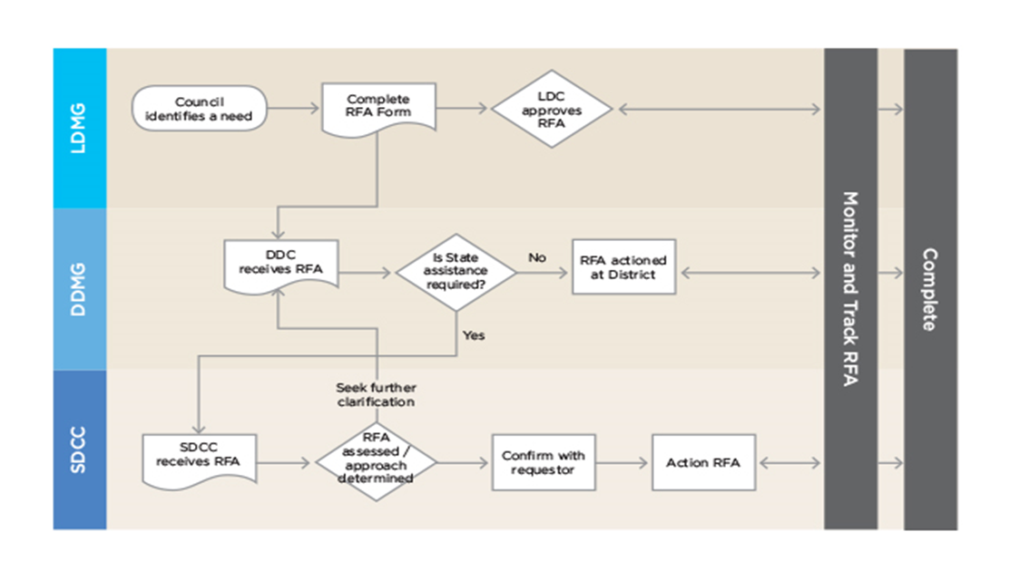

5.7 EMERGENCY SUPPLY

Emergency supply is the acquisition and management of emergency supplies and services in support of disaster operations. It is best delivered by a logistics cell or capability at either the Local, District or State Disaster Coordination Centre, depending on the specific situation.
When local and district operations require additional resources during a disaster, QPS, as the functional lead agency for emergency supply, coordinates the acquisition and management of supplies and services, either through the SDCC Watch Desk or by its logistics capability when the SDCC is activated. Emergency supply is generally conducted as an RFA.
The escalation of requests from local to district to state should not be a strategy to shift financial risk. Uncertainty at the local level about request or resource eligibility under the DRFA, should be addressed with the responsible QPS Emergency Management Coordinator or Queensland Reconstruction Authority liaison officer.
Supplies should first be sought locally, using the Local Emergency Supply Register developed as part of the LDMP.

5.8 RESUPPLY

Due to the nature of some disasters, there will be occasions where areas within the disaster district become isolated for a lengthy period of time, triggering the need to resupply provisions to that area.
Local Disaster Management Groups, that require assistance in the form of resupply of provisions, shall request the assistance from the Mackay DDMG. Efforts should be made in the first instance to provide the requested resupply of provisions from within the capability and capacity of the Mackay DDMG.
Where a District Disaster Coordinator organises a resupply operation from within district resources, they should ensure that suitable measures have been activated under State Disaster Relief Arrangements (SDRA) or Disaster Recovery Funding Arrangements (DRFA) to ensure cost recovery. Should such measures NOT be activated, then they should seek State approval under this policy to ensure financial cover is available.
The DDMG has a financial responsibility to ensure resupplies are conducted in a cost-effective manner. DDCs are responsible for ensuring any request for resupply from any LDMG in their Disaster District is in accordance with the “Queensland Resupply Manual”, examined and checked by the QPS member on the DDCC before consideration of endorsement by the DDC and referral to the State Disaster Coordination Centre. Where resupply is undertaken by the DDMG a log of air and road transport companies should be maintained to aid the processing of requests.

5.8.1 Resupply of isolated communities

This operation occurs when people residing in a community have access to retail outlets, but those outlets are unable to maintain the level of essential goods required due to normal transport routes being inoperable because of a natural disaster event. In this scenario, the state government contributes to the cost of transporting goods by alternate methods.
This operation ensures essential goods are available to the community through the normal retail facilities within that community. This maintains the safety and wellbeing of humans and domestic animals during the period of isolation.

5.8.2 Isolated rural property resupply

Isolated rural properties are groups of individuals isolated from retail facilities due to normal transport routes being inoperable because of a natural disaster event. This may include primary producers, outstations or small communities that have no retail facilities and require resupply. The aim of resupply operations to isolated rural properties is to maintain access to essential goods, including medications.
Isolated rural property owners are responsible for placing and paying for their orders with retailers. The LDCC and DDCC facilitate and meet the cost of transport only. Resupply to isolated rural properties may continue for some time after resupply to isolated communities is no longer required.
LDMGs whose area of responsibility contains rural properties that are subject to isolation should ensure that all rural properties are aware of the resupply process, protocols and contacts.

5.8.3 Resupply of stranded persons

This operation provides essential goods to individuals who are isolated from retail facilities due to normal transport routes being inoperable because of a natural disaster event and are not at their normal place of residence. This is usually stranded travellers and campers.
The resupply or evacuation of stranded persons is coordinated by the QPS. QPS may also use the resources of the LDCC – if it is activated – in response to a disaster event in the LGA.
QPS determines the most appropriate course of action: whether to resupply stranded individuals or to evacuate them to a safer environment. If the LDCC is not activated, QPS will resupply or evacuate stranded individuals and report through the normal police reporting system.

5.9 AIR SUPPORT

The Mackay DDMG as an entity does not possess any Aviation resources. All resources within the disaster district are owned and managed by government departments, corporate entities, or private business operators. Where a resource or service, which is required to conduct disaster response activities, is not available within the jurisdiction of the Local Disaster Management Group, the Local Disaster Management Group may request assistance from the Mackay DDMG to provide such resources.
The Mackay DDMG may make the request for assistance for air support to the State Disaster Coordination Centre for consideration. Any aviation assets deployed to Mackay Disaster District for local control and tasking should be done in accordance with District Operational Plans.

5.10 AUSTRALIAN DEFENCE FORCE

The Australian Government may aid in response to a disaster event, following a request for Defence Assistance to the Civil Community (DACC).
Except for DACC 1, requests for DACC are made via the Request for Assistance (RFA) process to the SDCC. These requests are considered by the SDC and upon approval are forwarded to NEMA via the Crisis Coordination Centre for consideration.

6. RECOVERY

6.1 OVERVIEW

Disaster recovery is the coordinated process of supporting disaster-affected communities’ psychosocial (emotional and social), and physical well-being; reconstruction of physical infrastructure, and economic and environmental restoration (including restoration of the natural environment, associated infrastructure and heritage sites and structures, and the management of pollution and contamination).
The Queensland Recovery Plan outlines recovery requirements for operations, planning and arrangements at the local, district and state level. It drives a collaborative and co-ordinated approach across all functions of recovery, all levels of government and the whole community and ensures recovery operations are appropriate to the scale of the disaster event.
The Queensland Recovery Plan describes the arrangements for transition from response to recovery - highlighting the roles and responsibilities of the State Recovery Policy and Planning Coordinator and the State Recovery Coordinator and the functional recovery groups - to assist disaster impacted communities achieve optimum recovery outcomes.
The Mackay DDMG adopts the recovery arrangements articulated in the Queensland State Recovery Plan at the District level

6.2 ACTIVATION

The Mackay DDMG will develop event specific District Recovery Strategies which will provide a framework for the coordination of recovery operations within the district may be activated upon the direction of the District Disaster Coordinator or the Queensland Disaster Management Committee.

6.3 TRANSITION TO RECOVERY

Transition from response to recovery at the district level, will be informed by local circumstances and determined by the Chairs of the relevant LDMGs/DDMGs.

6.4 FUNCTIONS OF RECOVERY

The Mackay DDMG adopts the following recovery functions articulated in the State Recovery Plan at the district level.

6.4.1 HUMAN AND SOCIAL RECOVERY

Human and social recovery includes personal support and information, physical health and emotional, psychological, spiritual, cultural, and social well-being, public safety and education, temporary accommodation, financial assistance to meet immediate individual needs and uninsured household loss and damage.

The Department of Local Government, Water and Volunteers has functional lead-agency responsibility for Human and Social recovery and chairs the Mackay District Human and Social Recovery Group. The Department is responsible for developing the District Human and Social Recovery Plan under advice from the Human and Social Recovery Group.

The Mackay District Human and Social Recovery Plan provides the strategic framework for human and social recovery planning, outlining roles and responsibilities of government and non-government partners for the coordinated delivery of human and social recovery services following a disaster.

6.4.2 ECONOMIC RECOVERY

Economic recovery includes individual and household entities, private and government business enterprises, and industry. It includes assets, production and flow of goods and services. It also includes capacity for the export of goods and services from the affected area and securing confidence of business markets.

Economic recovery will be led by the Department of State Development, Infrastructure and Planning.

6.4.3 ENVIRONMENT RECOVERY

Environment, or natural environment, recovery includes restoration and regeneration of biodiversity (species and plants) and ecosystems, natural resources, environmental infrastructure, amenity/aesthetics, culturally significant sites and heritage structures. It also includes management of environmental health, waste, contamination and pollution and hazardous materials.

Environmental recovery will be led by Department of Environment, Tourism, Science and Innovation.

6.4.4 BUILDING RECOVERY

Building recovery includes repair and reconstruction of residential and public buildings, commercial, industrial, and rural buildings and structures, government structures, utility structures, systems and services (water, sewage, energy, communications) and other essential services and dam safety.

Infrastructure recovery will be led by the various lead agencies including Department of Housing and Public Works.

6.4.5 ROADS & TRANSPORT RECOVERY

Roads and Transport recovery includes repair and reconstruction of the road network and will be led by Department of Transport and Main Roads.

6.5 DISTRICT RECOVERY COMMITTEE

The purpose of the District Recovery Committee is to provide support at the local level by coordinating individual agency efforts to ensure a timely, efficient, cohesive, and cost-effective approach is taken to manage recovery.
Where appropriate to the scale of the disaster the medium/long term recovery phase may include the establishment of a District Recovery Committee with specific membership appointed as appropriate to the type of event and functions of recovery. Where a District Recovery Committee is established, the recovery coordination is handed over to the Recovery Coordinator who will be the DDC or a person appointed by the DDC.

6.6 DISTRICT RECOVERY OPERATIONAL PLANNING

When convened for disaster recovery operations, the Mackay District Recovery Committee will develop an Operational Plan to guide its activities. This will be discussed and developed during the group’s first meeting and will be developed to supplement the local government disaster recovery operational plan. A broad timeframe will be included in this plan.

ANNEXURE A – MACKAY DDMG MEMBERSHIP REGISTER

The Mackay DDMG Membership Register is a controlled document and is maintained and disseminated by the Executive Officer. Copies of the register can be requested from:

Executive Officer
Mackay District Disaster Management Group
PO Box 261
Mackay QLD 4740

DDC.Mackay@police.qld.gov.au

ANNEXURE B – MACKAY DDMG OPERATIONAL PLAN

The Mackay DDMG Operational Plan is a controlled document and is maintained and disseminated by the Executive Officer. Copies of the register can be requested from:

Executive Officer
Mackay District Disaster Management Group
PO Box 261
Mackay QLD 4740

DDC.Mackay@police.qld.gov.au

ANNEXURE C – MACKAY DISTRICT AND LOCAL MAPS

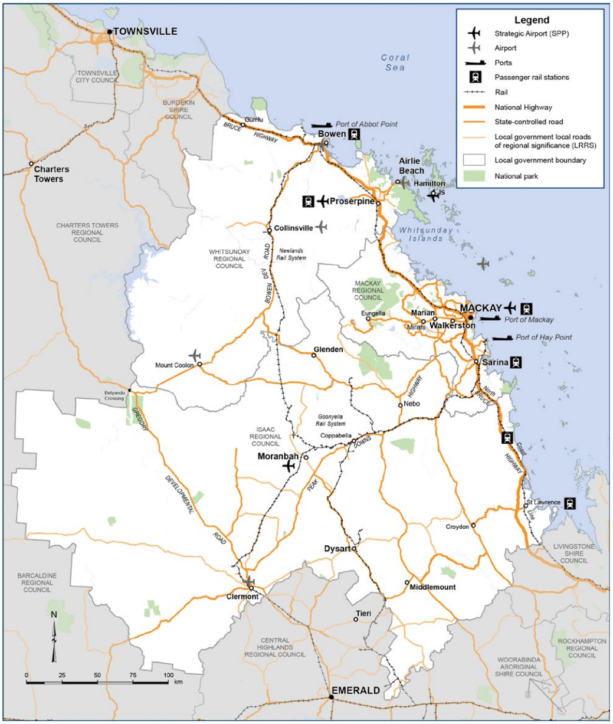

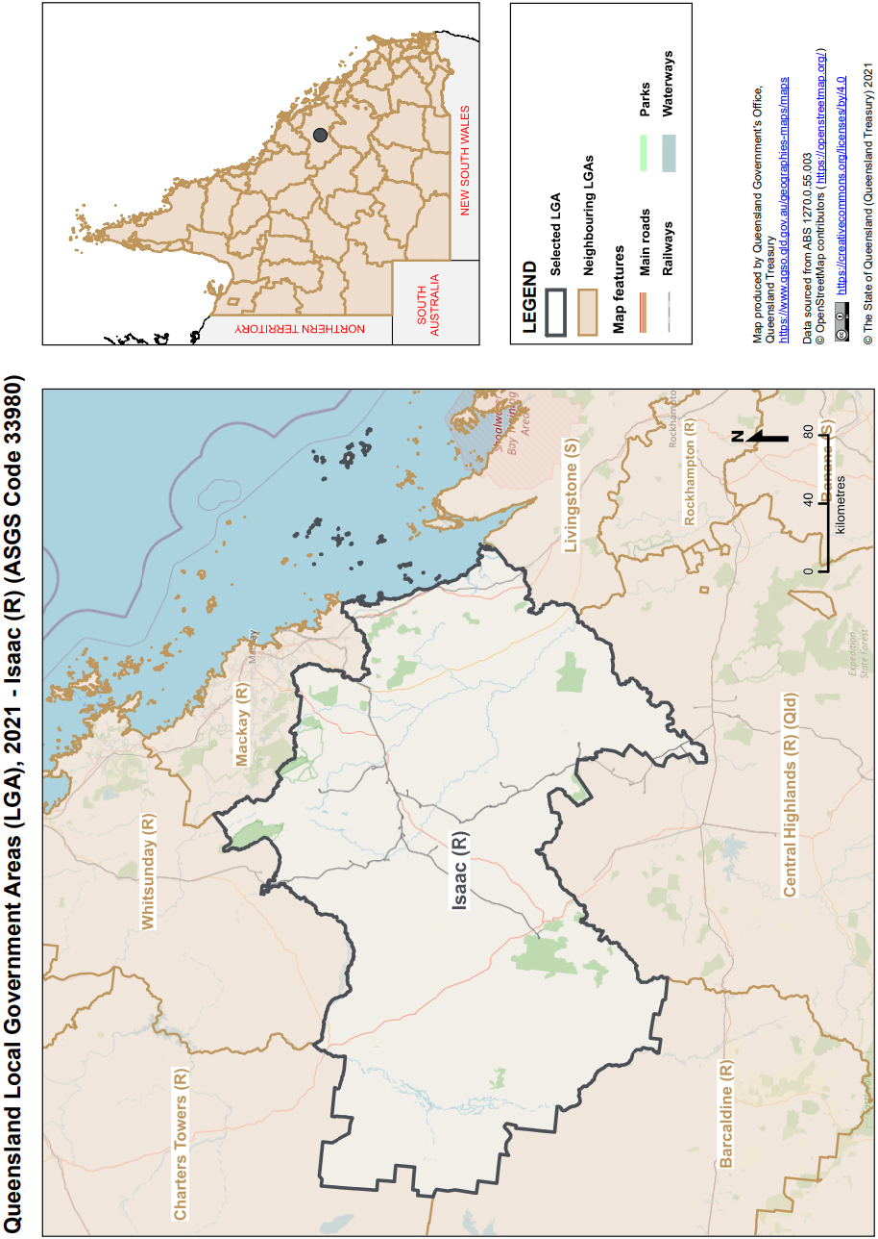

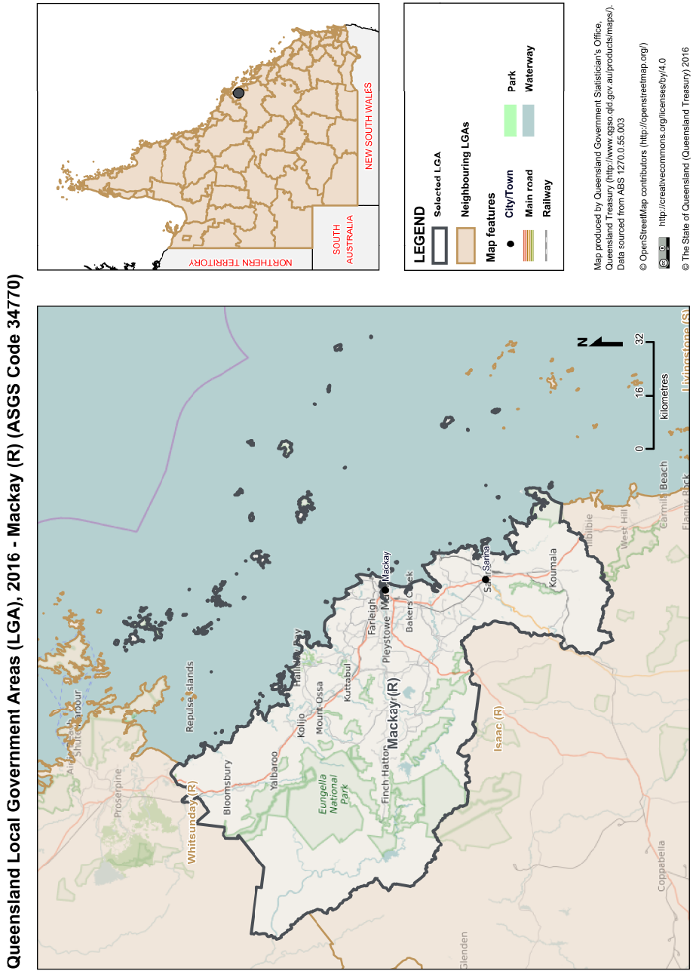
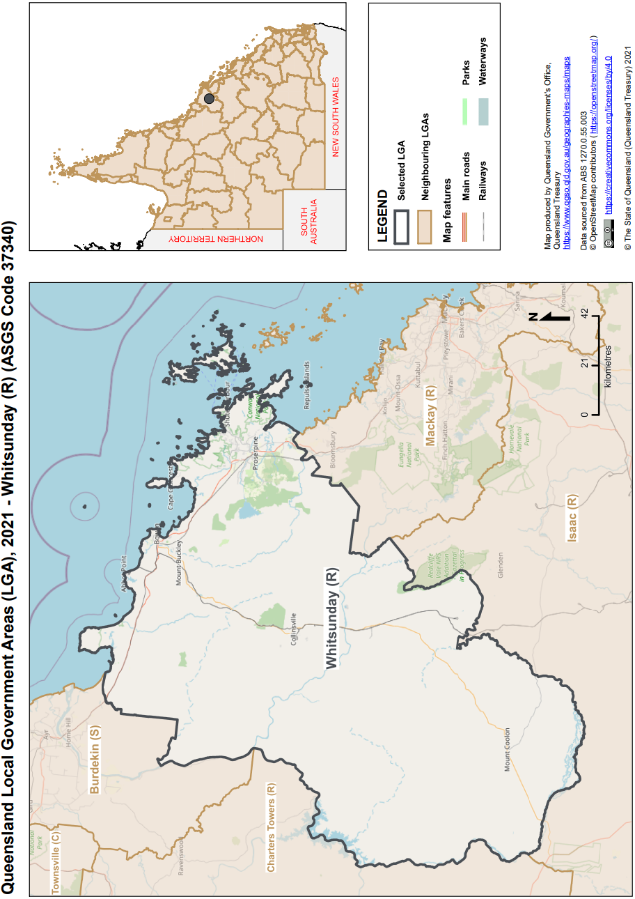

ANNEXURE D – DDCC INSTRUCTIONS

The Mackay District Disaster Coordination Centre (DDCC) Instructions is a controlled document and is maintained and disseminated by the Executive Officer. Copies of the register can be requested from:

Executive Officer
Mackay District Disaster Management Group
PO Box 261
Mackay QLD 4740

DDC.Mackay@police.qld.gov.au

ANNEXURE E - ACRONYMNS

- ADF Australian Defence Force
- ARC Australian Red Cross
- AUSVETPLAN Australian Veterinary Plan
- BOM Bureau of Meteorology
- CBR Chemical, Biological and Radiological
- DACC Defence Aid to the Civil Community
- DDC District Disaster Coordinator
- DDCC District Disaster Coordination Centre
- DDMG District Disaster Management Group
- DDMP District Disaster Management Plan
- DoE Dept. of Education
- DETSI Dept. of Environment, Tourism, Science, and Innovation
- DFSDSCS Dept. Families, Seniors, Disability Services and Child Safety
- DHPW Dept. of Housing and Public Works
- DoJ Dept. of Justice
- DLGWV Dept. of Local Government, Water and Volunteers
- DNR Dept. of Natural Resources and Mines, Manufacturing and Regional and
Rural Development
- DPC Dept. of the Premier and Cabinet
- DPI Dept. Primary Industries
- DRFA Disaster Recovery Funding Arrangements
- DSI Dept. of State Development, Infrastructure and Planning
- DSR Dept. of Sport, Racing and Olympic and Paralympic Games
- DTET Dept. of Trade, Employment and Training
- DTMR Dept. of Transport and Main Roads
- DWATSLM Dept. Women, Aboriginal and Torres Strait Islander Partnerships and
Multiculturalism
- DYJ Dept. of Youth Justice and Victim Support
- EQ Energy Queensland
- FMD Foot and Mouth Disease
- IRC Isaac Regional Council
- JATWC Joint Australian Tsunami Warning Centre
- LDC Local Disaster Coordinator
- LDCC Local Disaster Coordination Centre
- LDMG Local Disaster Management Group
- LDMP Local Disaster Management Plan
- LGAQ Local Government Association of Queensland
- MRC Mackay Regional Council
- MRQ Marine Rescue Queensland
- NEMA National Emergency Management Agency
- NBA Co National Broadband Australia
- NGO Non-Government Organisation
- IGEM Office of the Inspector- General of Emergency Management
- OPSO Operations Officer
- QAS Queensland Ambulance Service
- QBCC Queensland Building and Construction Commission
- QCCAP Queensland Coastal Contingency Action Plan
- QCS Queensland Corrective Services
- QDMA Queensland Disaster Management Arrangements
- QDMC Queensland Disaster Management Committee

- QFD Queensland Fire Department
- QHealth Queensland Health
- QPS Queensland Police Service
- QRA Queensland Reconstruction Authority
- QRIDA Queensland Rural and Industry Development Authority
- RSPCA Royal Society for the Prevention of Cruelty to Animals
- SDC State Disaster Coordinator
- SDCC State Disaster Coordination Centre
- SDMP State Disaster Management Plan
- SDRA State Disaster Relief Arrangements
- SES State Emergency Service
- SEWS Standard Emergency Warning Signal
- SLSQ Surf Life Saving Queensland
- SITREP Situation Report
- SOP Standard Operating Procedure
- SPF Strategic Policy Framework
- WRC Whitsunday Regional Council
- XO Executive Officer

ANNEXURE F - DEFINITIONS

Advisor A person invited to participate in the business of the DDMG in an advisory capacity on an as-needed basis.
Chair The person appointed by the Commissioner, Queensland Police Service as the Chair of the DDMG. The Chair of the group is the District Disaster Coordinator.
Coordination The bringing together of organisations to ensure effective disaster management before, during and after an event. It is primarily concerned with systematic acquisition and application of resources (people, material, equipment, etc) in accordance with priorities set by disaster management groups. Coordination operates horizontally across organisations and agencies.
Deputy Chair The person appointed by the Commissioner, Queensland Police Service as the Deputy Chair of the DDMG.
Disaster A serious disruption in a community, caused by the impact of an event, that requires a significant coordinated response by the State and other entities to help the community recover from the disruption. (Disaster Management Act 2003)
Disaster District
Part of the state prescribed under a regulation as a disaster district.
Disaster Management
Arrangements about managing the potential adverse effect of an event, including, for example, arrangements for mitigating, preventing, preparing for, responding to and recovering from a disaster. (Disaster Management Act 2003)
Disaster mitigation
The taking of preventative measures to reduce the likelihood of an event occurring or, if an event occurs, to reduce the severity of the event. (Disaster Management Act 2003)
Disaster operations
Activities undertaken before, during or after an event happens to help reduce loss of human life, illness or injury to humans, property loss or damage, or damage to the environment, including, for example, activities to mitigate the adverse effects of the event. (Disaster Management Act 2003)
Disaster response
The taking of appropriate measures to respond to an event, including action taken and measures planned in anticipation of, during, and immediately after an event to ensure that its effects are minimised and that persons affected by the event are given immediate relief and support. (Disaster Management Act 2003)

Disaster response operations
The phase of disaster operations that relates to responding to a disaster. (Disaster Management Act 2003)
Disaster recovery operations
The phase of disaster operations that relates to recovering from a disaster. (Disaster Management Act 2003)
Disaster risk assessment
The process used to determine risk management priorities by evaluating and comparing the level of risk against predetermined standards, target risk levels or other criteria. (COAG, Natural Disasters in Australia: Reforming mitigation, relief and recovery arrangements: 2002)
District Disaster Coordinator
A person appointed under the Disaster Management Act 2003 who is responsible for the coordination of disaster operations in the disaster district for the District Disaster Management Group
District Disaster Management Group
The group established in accordance with s22 of the Act to provide coordinated State Government support and resources to LDMGs on behalf of local governments.
District Disaster Management Plan
A plan prepared in accordance with s53 of the Act, that documents planning and resource management to counter the effects of a disaster within the disaster district.

Event (1) Any of the following:
a. a cyclone, earthquake, flood, storm, storm tide, tornado, tsunami, volcanic eruption or other natural happening
b. an explosion or fire , a chemical, fuel or oil spill, or a gas leak
c. an infestation, plague or epidemic (example of an epidemic – a prevalence of foot-and-mouth disease)
d. a failure of, or disruption to, an essential service or infrastructure
e. an attack against the state
f. another event similar to an event mentioned in (a) to (e).
(2) An event may be natural or caused by human acts or omissions. (Disaster Management Act 2003)

Executive Officer
A person appointed to the position of Executive Officer to the district group by the Commissioner, Queensland Police Service.

Executive Team
The Chair, Deputy Chair and Executive Officer.

Extraordinary Meeting
A meeting convened by the Chair in response to an operational event both inside and outside the disaster district. Functional Lead Agency An agency allocated responsibility to prepare for and provide a disaster management function and lead relevant organisations that provide a supporting role.

Guidelines Guidelines are developed under s63 of the Act to inform the QDMC, DDMGs and local governments about the preparation of disaster management plans, matters to be included in disaster management plans and other appropriate matters about the operation of the DDMG or LDMG.

Hazard A source of potential harm, or a situation with a potential to cause loss. (Emergency Management Australia, 2004)

Local Disaster Coordinator
A person appointed under the Act who is responsible for the coordination of disaster operations for the LDMG.

Local Disaster Management Group
The group established in accordance with s29 of the Act to support the disaster management and operational activities of local governments.

Local Disaster Management Plan
A plan that documents agreed arrangements that are in place to deal with disaster events within the local government’s area of responsibility.

Member
A person officially appointed as a member of the DDMG. Members have voting rights to validate the business of the group.

Ordinary Meeting
A DDMG meeting which is scheduled and convened on a regular basis at an agreed time (set by the Chair) to discuss routine business of the group.
Post-disaster Assessment
Addresses performance during and the risks revealed by a disaster event in order to improve future development of mitigation measures. Post-disaster assessment forms part of continuous improvement of the whole system. (Adapted from COAG, Natural Disasters in Australia: Reforming mitigation, relief and recovery arrangements: 2002)

Primary Agency
An agency allocated responsibility to prepare for and respond to a specific hazard based on their legislated and/or technical capability and authority.

Queensland disaster management arrangements
Whole-of-government arrangements to ensure the collaborative and effective coordination of planning, services, information and resources for comprehensive disaster management.

Recovery The taking of preventative measures to recover from an event, including action taken to support disaster-affected communities in the reconstruction of infrastructure, the restoration of emotional, social, economic and physical wellbeing, and the restoration of the environment. (Disaster Management Act 2003)

Relief Efforts to meet the immediate needs of persons affected by a disaster, to minimise further loss through the provision of immediate shelter and basic human needs.

Residual Risk
The risk remaining after risk treatment. Residual risk can contain unidentified risk. Residual risk can also be known as ‘retained risk’. (ISO Guide 73:2009 Risk management – Vocabulary)

Resilience A continuous process of learning from experience, reassessment and adaptation. In the disaster management context, resilience can be considered as a system’s or community’s ability to rapidly accommodate and recover from the impacts of hazards, restore essential structures and desired functionality, and adapt to new circumstances.

Risk The effect of uncertainty on objectives. (ISO Guide 73:2009 Risk management – Vocabulary) Risk Management Coordinated activities to direct and control a community or organisation with regard to risk. (Adapted from ISO Guide 73:2009 Risk management – Vocabulary)

Risk Register
A listing of risk statements describing sources of risk and elements at risk with assigned consequences, likelihoods and levels of risk.
Risk Treatment
Process of selection and implementation of measures to modify risk. (National Emergency Risk Assessment Guidelines) Serious Disruption Serious disruption means: (a)loss of human life, or illness or injury to humans; or (b)widespread or severe property loss or damage; or (c)widespread or severe damage to the environment. (Disaster Management Act 2003)

State Disaster Coordinator
A person appointed under the Act who is responsible for the coordination of disaster response operations for the QDMC.
State Recovery Coordinator
A person appointed under the Disaster Management Act 2003 who is responsible for the coordination of disaster recovery operations for the QDMC.
State Disaster Management Plan
A planning tool for disaster managers which provides an overview of Queensland’s disaster management arrangements, including agency roles and responsibilities.

State Recovery Coordinator
A person appointed under the Act who is responsible for the coordination of disaster recovery operations for the QDMC.

Temporary District Disaster Management Group
A DDMG established under the Act by the QDMC Chair, in consultation with the Commissioner, Queensland Police Service, as a temporary district group to manage a disaster across two or more affected disaster districts.

