Roma District
Disaster Management Plan
2025-2026

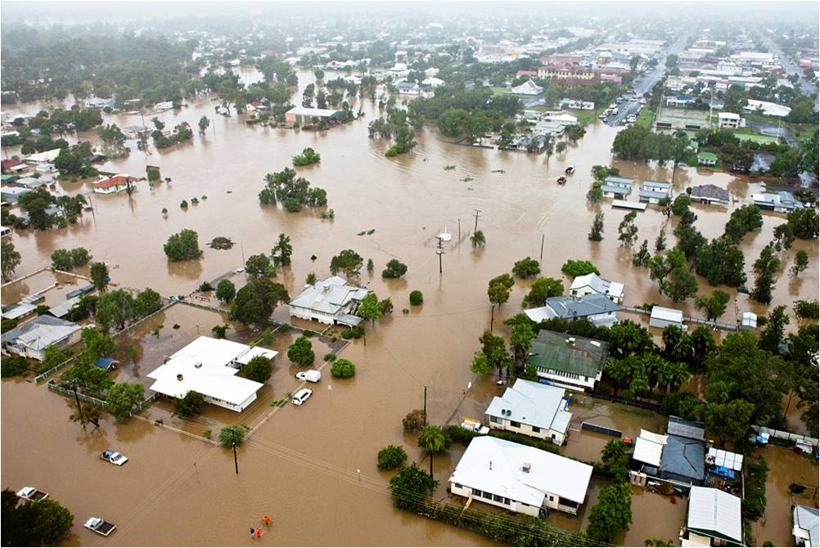

`

Document Control

Amendments version control

The Roma District Disaster Management Plan (DDMP) is a controlled document. The controller of the document is the Chair, Roma District Disaster Management Group (DDMG). Any proposed amendments to this plan should be forwarded in writing to:

Post Executive Officer
Roma District Disaster Management Group
PO Box 222
Roma QLD 4455

Email DDC.Roma@police.qld.gov.au

Minor amendments will be addressed administratively by the Executive Officer, Roma DDMG and endorsed by the Chair, Roma DDMG. Any changes to the intent of the document must be endorsed by the Roma DDMG. A copy of each amendment is to be forwarded to those identified in the distribution list. On receipt, the amendment is to be inserted into the document and the Amendment Register updated and signed.

Amendment Register

The Amendments Register is documented in Annexure A.

Abbreviation and Acronyms

The Abbreviation and Acronyms register is documented in Annexure B.

Definitions

The Definition Register is documented in Annexure C.

Distribution

The DDMP has been distributed to all core member and advisory members of the Roma DDMG as documented in Annexure D. The DDMP is a controlled document, and it is not to be distributed outside of member agencies without written permission of the Chair, Roma DDMG.

In accordance with the Act, a controlled master copy of the DDMP is available on the Queensland Police Service website.

The DDMP is available for inspection free of charge to members of the public. All applications are to be made to the Executive Officer via post or email.

Post Executive Officer
Roma District Disaster Management Group
PO Box 222
Roma QLD 4455
Email DDC.Roma@police.qld.gov.au

Foreword

The communities located within the Roma Disaster District are susceptible to the impacts from a variety of natural, non-natural, and technological hazards.

The Roma DDMP has been prepared under the authority of the Disaster Management Act 2003 (the Act) to provide a framework for comprehensive disaster management within the Roma Disaster District and to ensure that disaster management and disaster operations in the district are consistent with the State group’s Disaster Management Strategic Policy Statement and State Disaster Management Plan.

The DDMP is designed to enhance the district’s disaster management capacity by ensuring the necessary strategies are in place to provide a comprehensive (Prevention/Mitigation, Preparedness, Response and Recovery), all-agency, whole of government approach to disaster management through effective disaster management arrangements that may be applied in an all-hazards context.

The DDMP incorporates strategies for disaster management specific to hazards identified through hazard analysis.

The DDMP will be reviewed periodically and amended as necessary to address the districts most significant risks.

Michael Thiesfield
Chair
Roma DDMG
18/09/2025

Endorsement and Authorisation

The Roma DDMP has been prepared in accordance with section 53 of the Disaster Management Act 2003, on behalf of the Roma DDMG.

The Roma DDMP is endorsed under the authority of the Roma DDMG and will be maintained by the Executive Officer, Roma DDMG.

Michael Thiesfield
Chair
Roma DDMG
18/09/2025

Table of Contents

Document Control 2
Amendments version control 2
Amendment Register 2
Abbreviation and Acronyms 2
Definitions 2
Distribution 2
Foreword 3
Endorsement and Authorisation 4
Table of Contents 5
Administration, Governance and Assurance 8
Purpose and Authority to Plan 8
Scope 8
Objectives 8
Disaster Management Priorities 8
Strategic Policy Statement 8
District Priorities 9
Annual Operational Priorities 9
Review and Renew Plan 9
Review of Local Disaster Management Arrangements 9
Roma District Disaster Management Group 11
Establishment 11
Functions of the DDMG 11
Membership 11
Roma DDMG Member Responsibilities 12
Cross Border Arrangements 12
Hazard Specific Arrangements 12
Functional and Supporting Committees 12
Meetings and Quorum 13
Administrative Reporting 13
Disaster Risk Assessment 15
Community Context 15
Climate and Weather 15
Population 15
Economy / Industry 15
Risk Overview 16
Risk Assessment 16
Prevention and Preparedness 18
Prevention 18
Preparedness 18
Training 18
Exercises 18
Response Strategy 20
Situational Awareness 20
Activation and Triggers for Response 20
Media Management 20
Post Disaster Assessment 20
District Disaster Coordination Centre 20
Disaster Declaration 21
Functional Lead Agencies and Functional Plans 21
Functional Plans 21
Financial Management 21
Recovery Strategy 23
Functions of Recovery 23
Transition from Response Operations to Recovery Operations 23
District Recovery Coordinator 23
District Recovery Group 24
District Recovery Group Operational and Action Plans 25
Considerations for Recovery Operational and Action Plans 25
Reporting 25
Annexure Index 26
Annexure A – Amendments Register 27
Annexure B – Abbreviations and Acronyms 28
Annexure C - Definitions 29
Annexure D – Distribution List 30
Annexure E – Roma DDMG Map 32
Annexure F – DDMG Membership List 33
Core members 33
Advisors 33
Annexure G – Functional and Supporting Committees and Subplans 34

Administration, Governance and Assurance

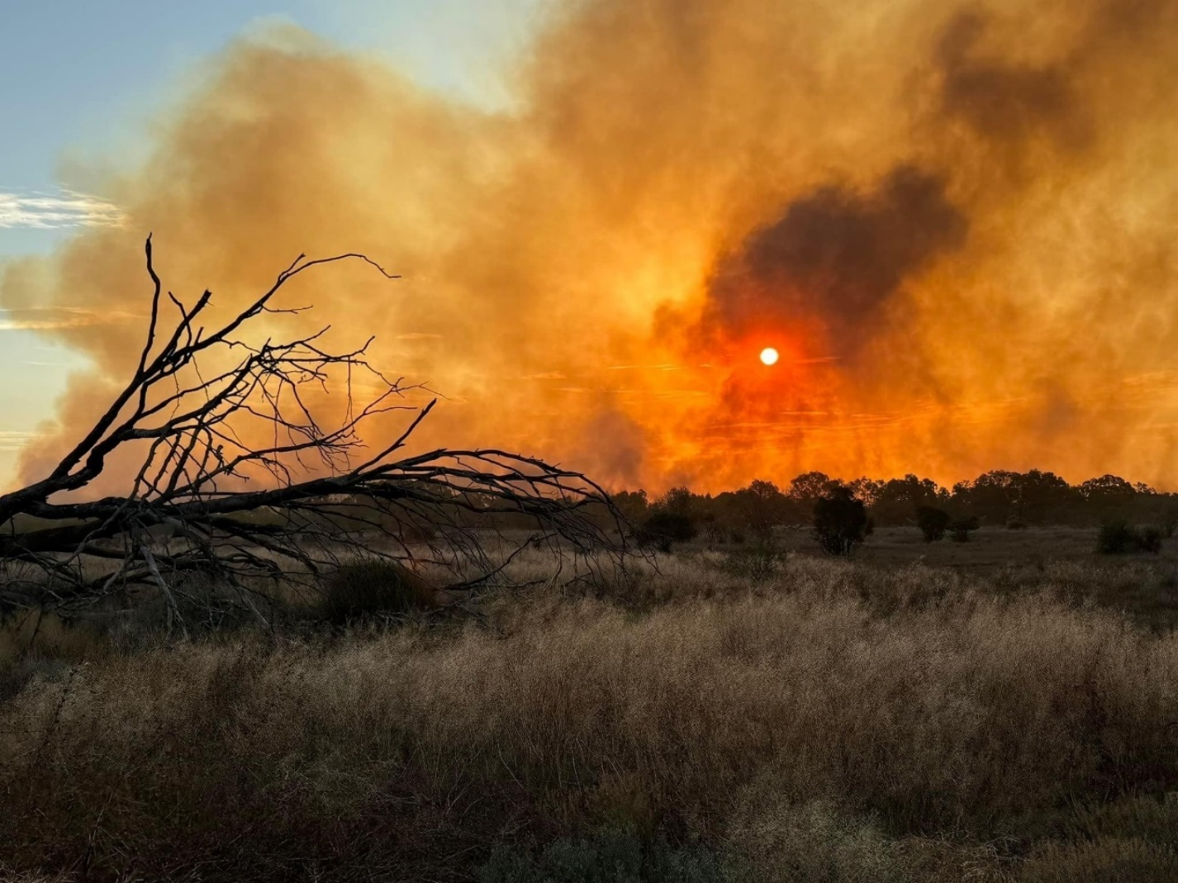

Administration, Governance and Assurance

Purpose and Authority to Plan

The Roma DDMG has a legislative responsibility to prepare a DDMP in accordance with the Act.

Scope

The DDMP details the arrangements necessary to undertake disaster management within the Roma Disaster District in support if the Maranoa Regional Council and Balonne Shire Council.

The Roma DDMG primarily coordinates the provision of State resources and services in support of local groups in the district. The DDMG is to identify resources that may be used for disaster operations in the district.

The Roma DDMP has been developed to comply with and should be read in conjunction with the following documents.
- Disaster Management Act 2003
- Disaster Management regulation 2014
- The State Disaster Management Plan
- The Standard for Disaster Management in Queensland
- Queensland Emergency Management Assurance Framework
- District Disaster Management Group’s Members Responsibilities Manual
- Queensland Disaster Management 2016 Strategic Policy Statement
- Roma DDMG Operational Plan and DDCC Manual

Objectives

The objective of the Roma DDMP is to facilitate the implementation of effective and efficient disaster management strategies and arrangements including:
- Application of Queensland Disaster Management 2016 Strategic Policy Framework.
- To articulate the roles and responsibilities of entities involved in disaster management in the Roma Disaster District.
- To coordinate disaster operations and activities relating to disaster management within the Roma Disaster District.
- To identify and plan for events that are likely to happen in the Roma Disaster District.
- To develop priorities for disaster management in the Roma Disaster District.
- To develop, review, and assess the effectiveness of disaster management for the Roma Disaster District, including arrangements for mitigating, preventing, preparing for, responding to and recovering from a disaster.
- To ensure disaster management operations and planning adhere to the principles of the Emergency Management Assurance Framework and Standard for Disaster Management in Queensland.

Disaster Management Priorities

Strategic Policy Statement

Disaster management and disaster operations in the Roma Disaster District are consistent with the Disaster Management 2016 Strategic Policy Statement. This is achieved by:
- Ensuring a comprehensive, all hazards, all agencies approach;
- Promoting the benefits of including disaster mitigation and preparedness into relevant areas of activity of government, non-government, small business and the private sector;
- Aligning disaster risk reduction, disaster mitigation, disaster resilience and climate change adaptation policy and actions with international and national reforms;
- Promoting a transparent, systematic and consistent approach to disaster risk assessment and management, based on the Queensland Emergency Risk Management Framework;
- Recognising the commitment of stakeholders and the need for collaboration across all levels of government, community, industry, commerce, government owned corporations, private and volunteer organisations, and local communities in all aspects of disaster management;
- Emphasising building and maintaining sincere relationships, trust, teamwork, consultative decision-making, and shared responsibilities among stakeholders; and
- Promoting community resilience and economic sustainability through disaster risk reduction.

District Priorities

The priorities for the Roma DDMG are to:
- Manage training of DDMG members in line with the Queensland Disaster Management Training Framework;
- Support the integration of effective disaster risk reduction initiatives into strategic and corporate plans at appropriate levels of government, community organisations, industry and commerce;
- Monitor and evaluate the disaster management arrangements to:
  - streamline arrangements ensuring efficiency and effectiveness;
  - develop clear accountability, including defined roles and responsibilities at all levels;
  - improve the communication processes;
  - support the development of whole-of-government, media and community engagement arrangements; and
  - support and promote the continuous improvement and integration of lessons learned.

Annual Operational Priorities

The DDMG Operational Priorities are contained within the DDMG Operational plan.

Review and Renew Plan

The Roma DDMG is required to review or renew the DDMP at least once a year, or when the group considers it appropriate. Reviews may be triggered through the lessons management process associated with an event or exercise, machinery of government changes, or the annual IGEM review.

The district scheduled plan update shall be conducted by members of the DDMG identified by the Chair Roma DDMG and shall be conducted as follows:
- April – September - Review conducted; draft amendments submitted to DDMG for endorsement
- September - New plan disseminated to all stakeholders

Review of Local Disaster Management Arrangements

The Roma DDMG will regularly review and assess the disaster management plan of local groups in the district as well as Local Disaster Management Plans prepared by local governments in the district.

Roma District
Disaster Management Group

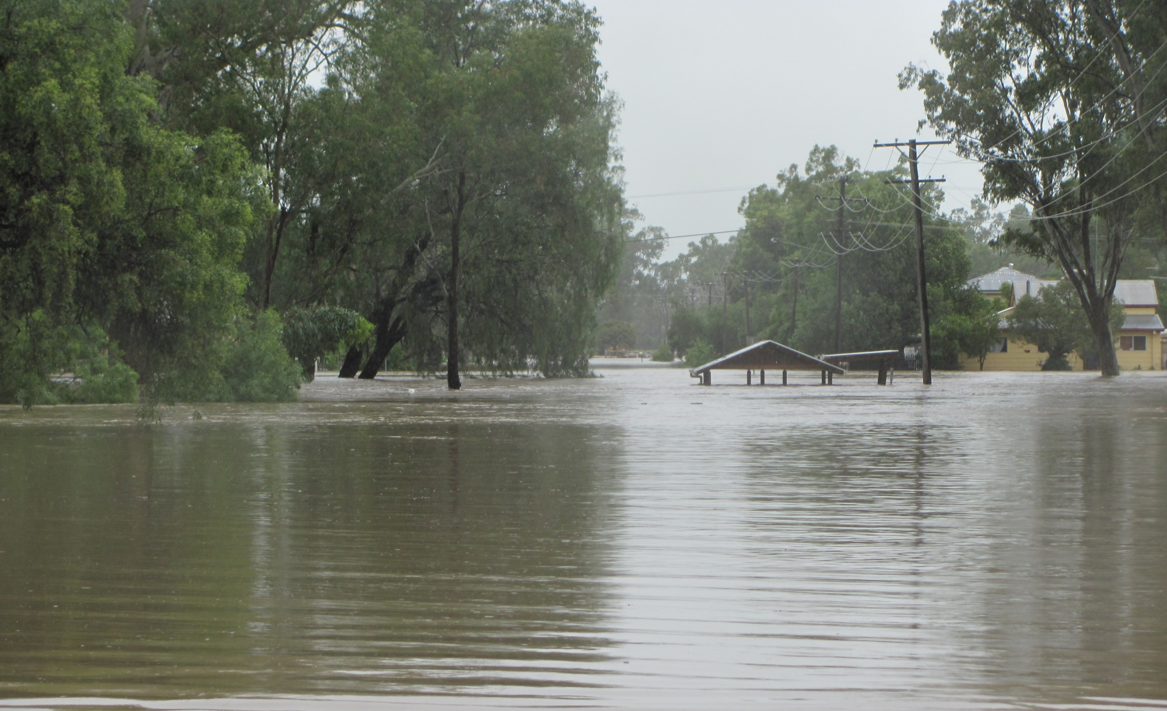

Roma District Disaster Management Group

Establishment

The Roma DDMG is established in accordance with the Act and incorporates the Maranoa Regional and Balonne Shire Council LGA’s.

Functions of the DDMG

The Roma DDMG has the following functions for which it is established:
- to ensure that disaster management and disaster operations in the district are consistent with the State group’s strategic policy framework for disaster management for the State;
- to develop effective disaster management for the district, including a district disaster management plan, and regularly review and assess that disaster management;
- to provide reports and make recommendations to the State group about matters relating to disaster management and disaster operations in the district;
(d) to regularly review and assess—
(i)the disaster management of local groups in the district; and
(ii)local disaster management plans prepared by local governments whose areas are in the district;
(e) to ensure that any relevant decisions and policies made by the State group are incorporated in its disaster management, and the disaster management of local groups in the district;
(f) to ensure the community is aware of ways of mitigating the adverse effects of an event, and preparing for, responding to and recovering from a disaster;
(g) to coordinate the provision of State resources and services provided to support local groups in the district;
(h) to identify resources that may be used for disaster operations in the district;
(i) to make plans for the allocation, and coordination of the use, of resources mentioned in paragraph (h);
(j) to establish and review communications systems in the group, and with and between local groups in the district, for use when a disaster happens;
(k) to ensure information about an event or a disaster in the district is promptly given to the State group and each local group in the district;
(l) to prepare, under section 53, a district disaster management plan;
(m) to perform other functions given to the group under this Act; and
(n) to perform a function incidental to a function mentioned in paragraphs (a) to (m).

Membership

The Roma DDMG consists of two classes of membership:
- Core members; and
- Advisory members.

The Roma DDMG core membership consists of the following roles and representatives:
- Chairperson / District Disaster Coordinator;
- Deputy Chairperson;
- Executive Officer;
- A representative of each local government within the district;
- Persons representing departments of Hospital and health Service that the Commissioner of Police considers appropriate to be represented on the group, having regard to effective disaster management for the disaster district; and
- Any other person appointed by the chief executive of the department that the Commissioner of Police considers appropriate to be a member of the district group, having regard to effective disaster management for the disaster district.

The Roma Disaster District core and advisory members are documented in Annexure F.

Roma DDMG Member Responsibilities

Roles and responsibilities of member agencies are outlined within the State Disaster Management Plan and the District Disaster Management Group Member Responsibilities Manual. The Roma DDMG adopts these roles and responsibilities at the district level.
In considering appropriate membership to the DDMG, member Agencies should ensure appointed members:
- Attend DDMG activities with an understanding of their agency resources and roles and responsibilities within disaster management.
- Are available and appropriately briefed to actively participate in DDMG activities to ensure that planning, projects and operations use the full potential of their agency or function, while recognising any resource or capacity limitations.
- Are appropriately positioned within their agency to be able to commit agency resources.
- Attend meetings and report to the district group on disaster management arrangements within their agency.
- Report annually on agency member responsibilities and integration of disaster management activities.
- Undertake training in accordance with the Queensland Disaster Management Training Framework (QDMTF).
- Ensure their agency deputy is appropriately trained and has the relevant authority to take on their responsibilities should they be unavailable, and/or to provide additional support during extended operations.
- Participate in risk management activities (including the identification of mitigation strategies and treatment options).
- Plan for disaster management on behalf of the district group.
- Participation in community awareness activities on behalf of the district group.

Core members are required to advise the Roma DDMG Chair in writing of any change in title or position within their organisation or change in contact details. The core member is to also advise if they are leaving their position.
The DDMG is to review its membership every May, or as circumstances dictate.

Cross Border Arrangements
Roma Disaster District includes parts of the Queensland / New South Wales border (Balonne Shire Council borders Brewarrina, Walgett and Moree). To ensure effective Disaster Management, representatives from NSW including Police Regional Emergency Management Officers are included as advisors on the group. Information is shared between States to allow coordinated planning and response.

Hazard Specific Arrangements

Whilst Queensland has adopted an all-hazards approach to disaster management, it is important to acknowledge that some hazards have characteristics that may require a hazard specific approach. The Roma DDMG adopts the hazard specific plans outlined within the SDMP, at the district level.

Functional and Supporting Committees

The Roma DDMG may establish permanent or temporary functional and supporting committees as deemed necessary. The appointed chairs of each sub-committee are responsible for providing regular updates to the DDMG, or as requested by the Chair on the activities of the sub-committee.

The Functional and Supporting sub-committees are documented in Annexure G.

Meetings and Quorum

The Roma DDMG will schedule 2 ordinary meetings a year to ensure compliance with legislative requirements of the Act. Extraordinary meetings may be called in response to an event to address operational business as required. Details of the meeting dates are contained in the Roma DDMG Operational Plan.
A quorum of members is required for meeting resolutions to be officiated. A quorum is a number equal to one-half of its members holding office plus one; or in the case where one-half of its members is not a whole number, the next highest whole number.
Personal attendance at meetings is preferred, however if this cannot be achieved a member may be able to participate by using any technology that reasonably allows members to hear and take part in discussions as they happen. For example, if teleconferencing facilities are available the member is taken to be present at the meeting.
A record of attendance shall be kept as part of the governance of the Roma DDMG meetings, and the Roma DDMG must keep minutes of its meetings. Minutes will be distributed to members after any meeting held for verification of accuracy. Minutes will be adopted at subsequent meetings and will be held by the Chair on behalf of the Roma DDMG.
Action items identified during a meeting must be recorded and must be actioned by the representative identified during the meeting as being the appropriate agency to progress the identified item, issue or query. Progress or conclusion of action items must be recorded in a subsequent meeting.

Administrative Reporting

Member agencies are required to provide a status report at each scheduled meeting. The status report can be submitted either in writing prior to a meeting, or verbally during a meeting.

Disaster Risk Assessment

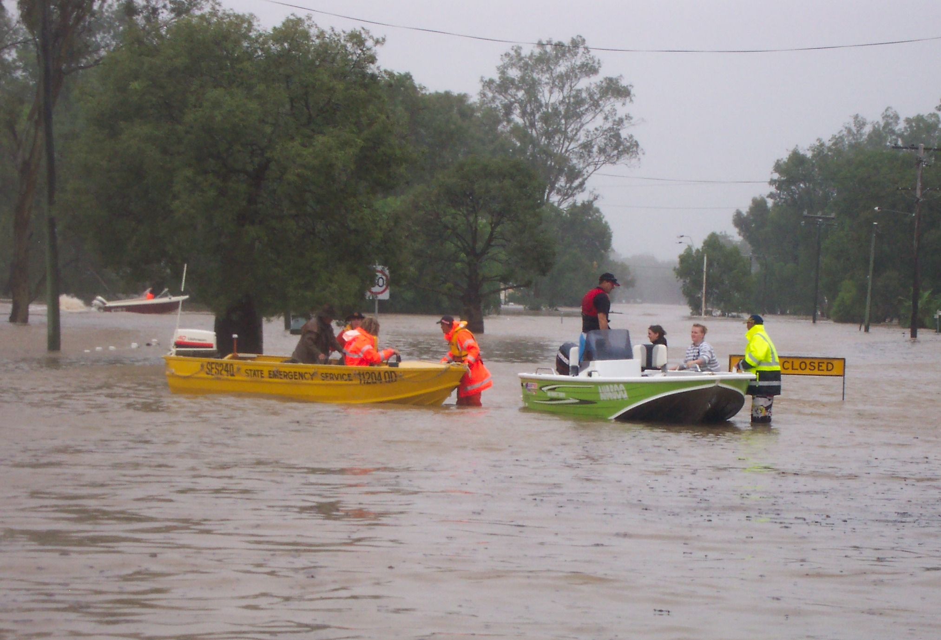

Disaster Risk Assessment

Community Context

Geography

The Roma DDMG is located in Southwest Queensland with an area of approximately 89, 823.4km². The DDMG shares borders with Western Downs, Warwick, Charleville, Rockhampton and Gladstone within Queensland, and borders Brewarrina, Walgett and Moree in New South Wales (NSW).

The DDMG has four (4) major river Catchments including Bungil Creek, the Maranoa River, the Condamine/Balonne River, The Moonie River and the Barwon River. Each catchment consists of the main river system as well as tributary creeks and floodplains that have historically impacted local communities.

Climate and Weather1

The Roma Disaster District experiences a semi-arid influenced humid subtropical climate with hot, moderately rainy summers and mild, dry winters with occasional frosts. Rainfall is mild and peaks in summer due to frequent showers and thunderstorms. The average rainfall in Roma averages 560.9mm which rises south at St George to 478.3mm.

The average air temperature ranges between 34.6°C to 20.5°C across the DDMG area with a mean maximum temperature in summer of 35.3°C and a mean minimum temperature in winter of 3.7°C.

Population2

The Roma DDMG area consists of two major population centres of Roma (Maranoa Regional Council) and St George (Balonne Shire Council). As of 30 June 2023, the estimated census population for Roma Disaster District was 17,600 persons with an annual growth rate of 0.4% over five years.

Economy / Industry

It is estimated that more than 17,400 people work in the Roma Disaster district while there is an unemployment rate of 1.2%3.

The top five (5) industry subdivisions of employment for Roma Disaster District are agriculture, preschool and school education, hospitals, public administration, and construction services.

The Maranoa Region holds approximately 1 – 2 million head of cattle representing 13% of Queensland’s beef cattle heard and boasts the largest saleyards in the Southern Hemisphere.

The Balonne Shire is primarily agriculture based on grazing sheep and cattle with some dryland cropping and a robust irrigated crop sector.

The Disaster District also supports a thriving Gas/Oil and Energy sector and was the site of Australia’s first oil and gas discoveries and incorporates the Surat Basin.

Risk Overview

Risk Assessment

The Queensland Emergency Risk Management Framework (QERMF) is the methodology for assessing disaster related risk in Queensland. Based upon the QERMF each Local Government has assessed the risks to their area as well as having identified any appropriate mitigation strategies that may be implemented.
The role of the DDMG and DDCC is not to manage these individual risks but to provide support to the LDMGs in implementing their respective Local Disaster Management Plans and arrangements.

Prevention and Preparedness

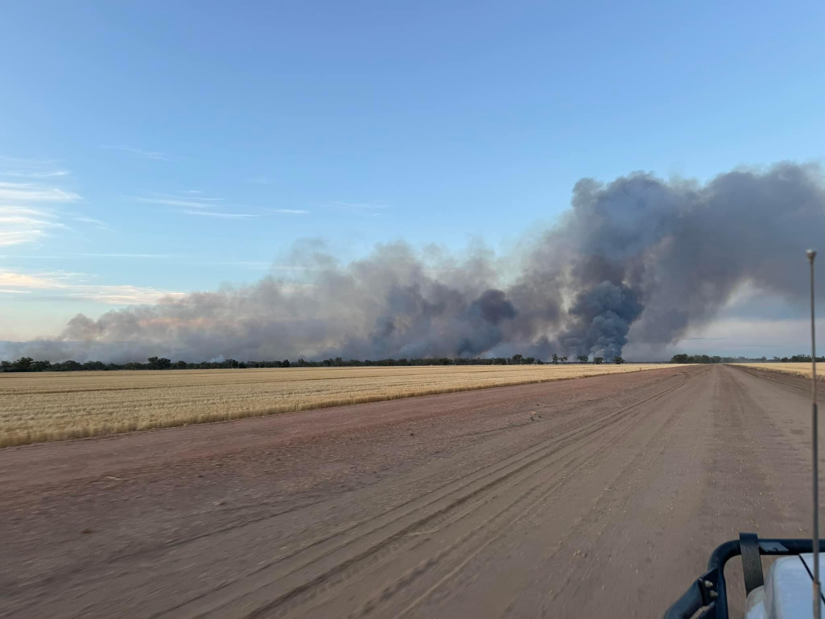

Prevention and Preparedness

Prevention

Prevention and mitigation measures reduce the likelihood of a disaster event occurring, or the severity of an event should it eventuate. The DDMG has a responsibility to support all agencies with the implementation of prevention strategies to enhance resilience in the community.

Preparedness

Preparedness is crucial in disaster situations to ensure the response is optimum and the consequences are as minimal as possible. Preparedness activities are to include but are not limited to plan development and review, training, exercises, and pre-season and event specific briefings.

Training

Disaster management training has been identified as an essential means through which agencies can develop and maintain their disaster management capabilities and capacity. Training is important in ensuring that all agencies can seamlessly integrate their arrangements and contribute to an effective and coordinated disaster management response.

The Queensland Police Service Emergency Management Coordinator is responsible for facilitating and delivering disaster management training within the Disaster District.

Exercises

The DDMG and functional committees will conduct at least one exercise annually. To ensure continuous improvement, each exercise will be evaluated for its effectiveness and relevance to disaster management. The evaluation can take many forms including written or oral feedback but will primarily be based on a hot debrief and a formal debrief which should identify opportunities and recommendations to enhance the capacity and capability of the DDMG and its arrangements.

Response Strategy

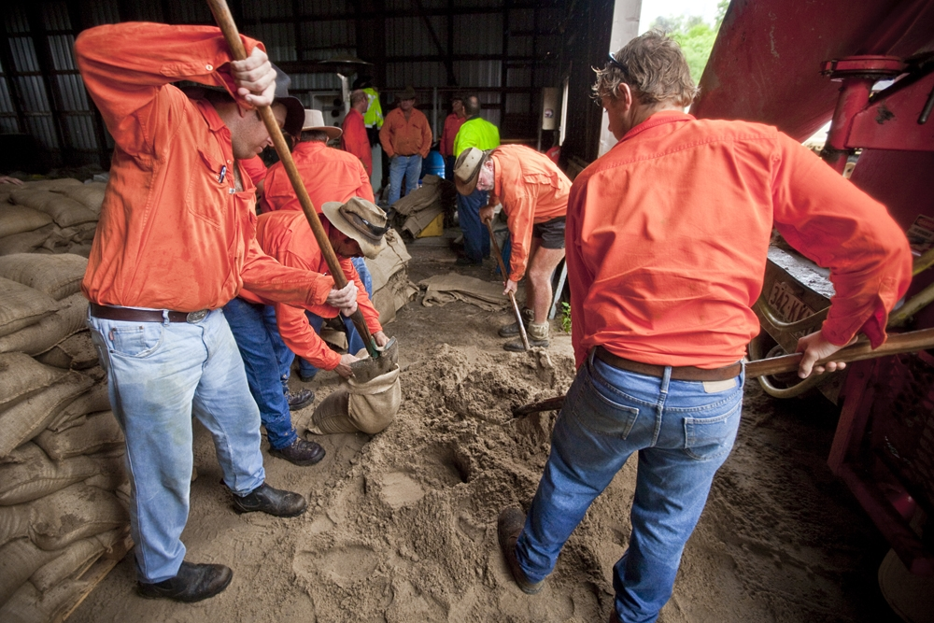

Response Strategy

Situational Awareness

The Roma DDMG has a responsibility to ensure event briefings and advice is disseminated to members of the DDMG and QDMC.

The Roma DDMG has an established notification and dissemination process, ensuring fit for purpose information and warnings can be shared with members.

Activation and Triggers for Response

The authority to activate the Roma DDMG is vested in the Chairperson, or in that person’s absence, the Deputy Chairperson.

The Chairperson should determine when, and to what extent, the DDMG should activate in support of an event, and may bypass initial levels of activation where appropriate. Activation is scalable and the DDMG Chair is to ensure that advice is provided to the DDMG on the group status and briefings schedule.

Media Management

The Roma DDCC operations manual provides advice and guidance regarding media engagement.

Post Disaster Assessment

The review of operational activities undertaken during a disaster is a key component in ensuring capability development and the continuous improvement of disaster management arrangements.

Lessons Management is a key element of post disaster assessment and promotes continuous improvement. It includes establishing a learning culture to support captured observations and insights from monitoring, debriefing, and reviewing activities – before, during and after events – which are then analysed for trends, risks and lessons. Debriefing and lessons learned must be documented, analysed, and acted upon across all levels of the disaster management arrangements. The Office of the IGEM is responsible for a lessons management framework which provides guidance on good practice and opportunities for improvement, and ensure lessons identified are learnt.
The DM Guideline contains guidance regarding the process for debriefing. The QDMTF also includes a ‘Briefing and Debriefing’ module. Debriefing and lessons learned strategies should be consistent with The Australian Institute for Disaster Resilience Handbook for Lessons Management.

Post-disaster reviews may be conducted after each event at the discretion of the Chair and ideally should be conducted within four weeks of the DDMG standing down post event.

District Disaster Coordination Centre

The Roma DDMG District Disaster Coordination Centre operations manual provides guidance to the establishment and operation of the DDCC. The DDCC operations manual distribution is at the discretion of the Chair, Roma DDMG.

Disaster Declaration
Where the DDC considers it necessary for a disaster declaration within the Roma Disaster District, the DDC must take reasonable steps to consult with the DDMG and each local government whose area is in, or partly in, the declared area for the disaster situation. A failure to consult does not affect the validity of the declaration.

The Executive Officer is responsible for preparing relevant documentation on behalf of the DDC for consideration by the Minister for Police. Disaster declaration templates are available on the Disaster management website.

If circumstances prevent such processes to be undertaken the DDC will act independently to declare the disaster and subsequently seek verbal approval in accordance with the Act and report the decision subsequently to the DDMG and LDMG.

Functional Lead Agencies and Functional Plans

A detailed itemisation of the disaster response functions, associated lead agencies and functional plans is outlined within the SDMP. The Roma DDMG adopts the itemisation of these functions at the district level.

Functional Plans

The SDMP is supported by functional plans that address the functions of disaster management where government departments and agencies have a functional lead agency role. The Roma DDMG adopts the itemisation of these functions at the district level.

Financial Management

Due to the nature of many disaster events, finance operations will often be conducted with compressed time constraints and other pressures. Expenditure may be eligible for cost-recovery if the event and/or expenditure meets eligibility requirements of the Disaster Recovery Funding Arrangements (DRFA).

The DDMG should predetermine event-related financial management arrangements to ensure costs are appropriately endorsed and captured from the onset of operations. The DDC, in consultation with the Executive Officer is responsible for establishing and maintaining financial management procedures for disaster operations, as per the DDCC Operations Manual.

Each agency is responsible for providing their own financial services and support to its response operations relevant to their agency.

All processes are performed in accordance with the Queensland Government Financial Management Practice Manual to comply with section 46M of the Financial Administration and Audit Act 1977 and other prescribed requirements.

Recovery Strategy

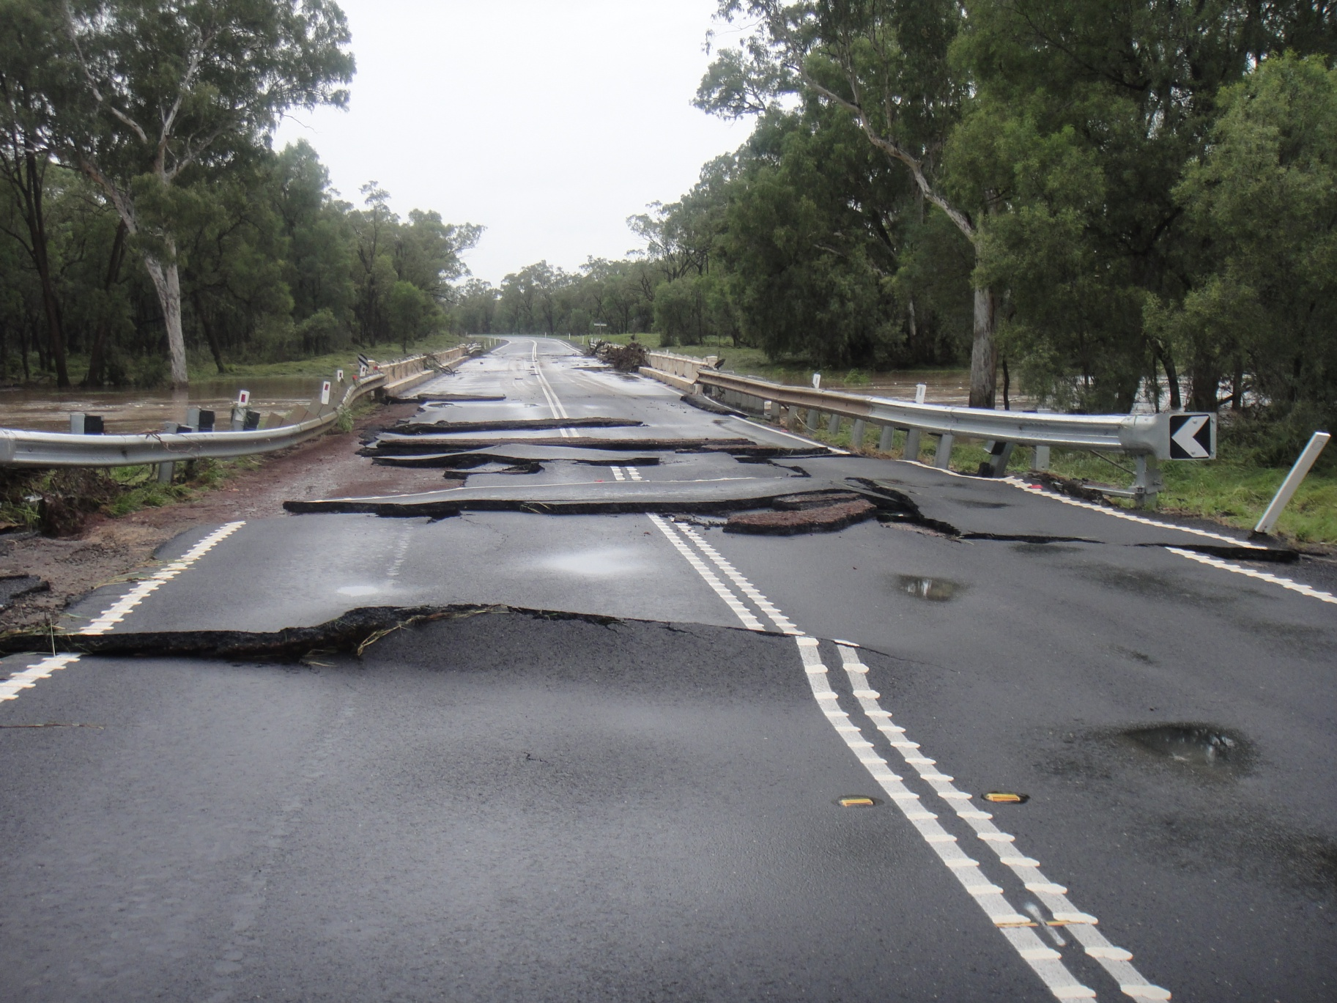

Recovery Strategy

Recovery at the District level will be activated upon direction from the Chair/DDC. Recovery provides a framework for the coordination of recovery operations within the district and is supported by the procedures outlined in the Prevention, Preparedness, Response and Recovery Disaster Management Guideline and the Queensland Recovery Plan.

The Queensland Reconstruction Authority (QRA) is responsible for disaster recovery, resilience, and mitigation policy. This principle-based strategy is consistent with the Queensland Recovery Plan and has been developed to be flexible and scalable in support of the recovery efforts being driven locally.

Functions of Recovery

The SDMP outlines the functional portfolios and coordination functions for recovery. The Roma DDMG adopts these functions at the district level.

Transition from Response Operations to Recovery Operations

The Queensland Recovery Plan outlines that transition from response operations to recovery operations will be influenced by the nature of the disaster and therefore requires a degree of flexibility. For example, transition from response to recovery in large scale or geographically dispersed events may be staged, with response and recovery operations being undertaken concurrently.

Transition from response to recovery at the local and district level, and the need to undertake such a process, will be informed by local circumstances and determined by the Chairs of the relevant LDMGs/DDMGs. Transition will be guided by:

- Situation reports (SitReps) which evidence the de-escalation of response operations;
- Status of response and immediate recovery/relief operations;
- Impact and needs assessments;
- Response and early recovery situations that may escalate; and
- Anticipated recovery issues and risks.

District Recovery Coordinator

The District Recovery Coordinator (DRC) is appointed by the chair. This appointment is made at the time of the event, if required. If a DRC is not appointed, the duties will be managed by the Chair.

Indicative duties of the DRC include:

- Coordinate and chair the district recovery group, reporting to the DDMG;
- Liaise with functional lead agency representatives at the local and state levels;
- Liaise with the Local Disaster Management Group/s and State Functional Recovery Groups / State Disaster Coordination Group;
- Coordinate the short to medium-term recovery where local resources are exhausted to address the immediate effects of the disaster and develop longer-term measures as appropriate;
- Perform the role of conduit between local and state;
- Develop and implement effective strategies for district participation and partnership in the recovery process work with identified agencies and Local Recovery Group/s to develop the district event-specific recovery plan;
- Ensure the district event-specific recovery plan addresses all relevant functional areas of recovery – human and social, economic, environment, building, and roads and transport;
- Undertake post-operations debrief and providing a final report to the DDMG at the conclusion of recovery operations; and
- Provide or delegate the responsibility for ongoing recovery reporting on the progress of the district event-specific recovery plan.

District Recovery Group

During recovery operations, the DDMG will coordinate support to the local level in a timely, efficient, cohesive, and cost-effective manner. This support may be provided to the local level though joint local and district meetings.

Where appropriate the recovery phase may include the establishment of a District Recovery Group (DRG) with specific membership appointed by the DRC and DDMG Chair. Where a DRG is established, the recovery coordination is transitioned to the Recovery Coordinator who will be the DDC, or a person appointed by the DDC. All other times, recovery operations will be managed by the DDMG. If the group is stood up, the Chair of DRG is the DRC.

The role of the DRG is as follows:

- Identify members for the DRG and sub-groups as required;
- Ensure recovery operations; planning; logistics and communications are included in overall disaster management activities at the district level;
- Monitor the recovery needs of the local level, ensuring FRGs are supporting local recovery activities;
- Identify district impact assessment and recovery needs;
- Facilitates communication and information sharing, including situation reporting, within the district and between local and state FRGs during recovery operations;
- Promote council-to-council arrangements where possible to facilitate recovery operations;
- Delivery of Outreach Services;
- Investigate opportunities for local government collaboration and to build resilience and recovery resource capacity;
- Facilitates ‘regional’ leadership discussions to support the State Recovery Coordinator; and
- Establish a District Recovery Strategy, if required.

Membership of the DRG consists of the following roles and representatives:

- DDMG Chairperson or District Recovery Coordinator (if appointed).
- Queensland Reconstruction Authority – Co-Chair
- Executive Officer.
- Emergency Management Coordinator.
- Local Recovery Coordinator for each LGA.
- Chair of each District Recovery subgroup.
- Any other member agency nominated by the Chair having regard to the event and requirements within the disaster district.

During recovery operations, the DDMG may be required to facilitate communication and information sharing within the district, and to State Functional Recovery Groups (FRGs), through their FRG lead. It is recognised that with large disasters, a State Recovery Coordinator (SRC) may be appointed by the Chairperson of the QDMC to coordinate recovery operations. The DRG may be used to facilitate ‘regional’ leadership discussion in conjunction with regional organisations to support the SRC where required.

District Recovery Group Operational and Action Plans
When conveyed for disaster recovery operations, the Roma District Human and Social Recovery and Resilience Committee will develop an Operational Plan to guide its activities. This will be discussed and developed to support the local government disaster recovery operational plan. A broad timeframe will be included in this plan.

At the first meeting Action Plans for each recovery function will also be developed. This Action Plan will list the tasks to be performed by the group, agencies/individuals responsible for the tasks and will be developed to support the local government disaster recovery action plan.

As the Local Disaster Management group have a lead role in the disaster recovery process, any District Community Recovery Committee’s operational or action plans will be developed to support of LDMG disaster recovery plans.

Considerations for Recovery Operational and Action Plans

When developing Operational and Action Plans lead functional agencies and recovery committees should consider the following:

- Issues identified from information gathered by impact assessments;
- Arrangements outlined in existing functional plans;
- Allocation of actions and responsibilities across the five recovery functions to inform the development of action plans;
- Arrangements for overall coordination of recovery operations;
- Development of recovery strategies with the affected community which detail the vision, goals and project outcomes;
- Identifying short, medium and long-term priorities;
- Developing project timeframes, costs, funding priorities and funding strategies;
- Promote and disseminate public information about the Action Plans;
- Determining appropriate community engagement and communication strategies;
- Transitional and exit strategies; and
- Strategies for conducting a debrief and evaluation of recovery operations.

Reporting

If stood up, the DRG and sub-groups are to provide regular reports to the DDMG, LDMG and relevant State functional recovery groups with the frequency to be determined at the time of the event.

Annexure Index

A | Amendment Register
B | Abbreviations and Acronyms
C | Definitions
D | Distribution List
E | Roma DDMG map
F | DDMG Membership List
G | Functional and Supporting Committees and Sub Plans

Annexure A – Amendments Register

No / Ref | Endorsement Date | Inserted by | Comment
1. | 15/08/2022 | C. Mitchell | MOG/DDC update
2. | 17/08/2023 | C. Mitchell | DDC update
3. | 18/09/2025 | Executive Officer, Roma DDMG - J.Paul | - Operational contents moved to DDMG Operational manual.  - Event specific details moved to DDCC Manual.  - DDMP restructured and creation of annexures to improve governance.  - MoG updates completed.  - DDC and Executive Officer updates.

Annexure B – Abbreviations and Acronyms

DDC | District Disaster Coordinator
DDCC | District Disaster Coordination Centre
DDMG | District Disaster Management Group
DDMP | District Disaster Management Plan
DRC | District Recovery Coordinator
DRFA | Disaster Recovery Funding Arrangements
DRG | District Recovery Group
FRG | Functional Recovery Group
IGEM | Inspector-General Emergency Management
LDMG | Local Disaster Management Group
LGA | Local Government Area
QDMA | Queensland Disaster Management Arrangements
QERMF | Queensland Emergency Risk Management Framework
QDMC | Queensland Disaster Management Committee
QRA | Queensland Reconstruction Authority
SDMP | State Disaster Management Plan
The Act | Disaster Management Act 2003

Annexure C - Definitions

Advisor | A person invited to participate in the business of the DDMG in an advisory capacity on an as-needed basis.
Chair | The person appointed by Governor in Council as the Chairperson of the DDMG. The Chair of the group is the District Disaster Coordinator.
Deputy Chair | The person appointed by Governor in Council as the Deputy Chairperson of the DDMG.
Disaster | A serious disruption to the community, caused by the impact of an event, that requires a significant coordinated response by the state and other entities to help the community recover from the disruption (Disaster Management Act 2003).
Disaster District | Part of the state prescribed under a regulation as a disaster district.
Disaster Management (DM) | Arrangements about managing the potential adverse effect of an event, including, for example, arrangements for mitigating, preventing, preparing for, responding to and recovering from a disaster (Disaster Management Act 2003).
Disaster mitigation | The taking of preventative measures to reduce the likelihood of an event occurring or, if an event occurs, to reduce the severity of the event (Disaster Management Act 2003).
Disaster operations | Activities undertaken before, during or after an event happens to help reduce loss of human life, illness or injury to humans, property loss or damage, or damage to the environment, including, for example, activities to mitigate the adverse effects of the event (s. 15, the Act).
Disaster Response | The taking of appropriate measures to respond to an event, including action taken and measures planned in anticipation of, during, and immediately after an event to ensure that its effects are minimised and that persons affected by the event are given immediate relief and support (Disaster Management Act 2003).
Disaster response operations | The phase of disaster operations that relates to responding to a disaster (Disaster Management Act 2003).

Annexure D – Distribution List

Position | Organisation | Hard Copy √ | Electronic Copy √
DDMG Chair | Roma DDMG | √ | √
Deputy Chair | Roma DDMG | √ | √
Executive Officer | Roma DDMG | √ | √
Emergency Management Coordinator | Roma DDMG | √ | √
District Disaster Coordination Centre | Roma DDMG | √ | √
District Disaster Coordination Centre – Secondary Location | Roma DDMG | √ | √
Member and Deputy | Maranoa Regional Council |  | √
Member and Deputy | Balonne Shire Council |  | √
Member and Deputy | Queensland Police Service |  | √
Member and Deputy | Department of Transport and Main Roads |  | √
Member and Deputy | Queensland Health SWHHS |  | √
Member and Deputy | Queensland Fire Department |  | √
Member and Deputy | Queensland Ambulance Service |  | √
Member and Deputy | Department of Housing and Public Works |  | √
Member and Deputy | Department of Environment, Tourism, Science and Innovation |  | √
Member and Deputy | Department of Families, Seniors, Disability Services and Child safety |  | √
Advisor | Department of Corrective Services |  | √
Advisor | Department of Education |  | √
Advisor | Defence (JOSS Qld) |  | √
Advisor | Department of Primary Industries |  | √
Advisor | Queensland Reconstruction Authority |  | √
Advisor | Department of Regional Development, Manufacturing and Water |  | √
Advisor | Department of Natural Resources and Mines, Manufacturing and Regional and Rural Development |  | √
Advisor | Department of State Development, Infrastructure and Planning |  | √
Advisor | Red Cross |  | √
Advisor | ABC |  | √
Advisor | Ergon Energy |  | √
Advisor | Telstra |  | √
Advisor | NBN |  | √

Annexure E – Roma DDMG Map

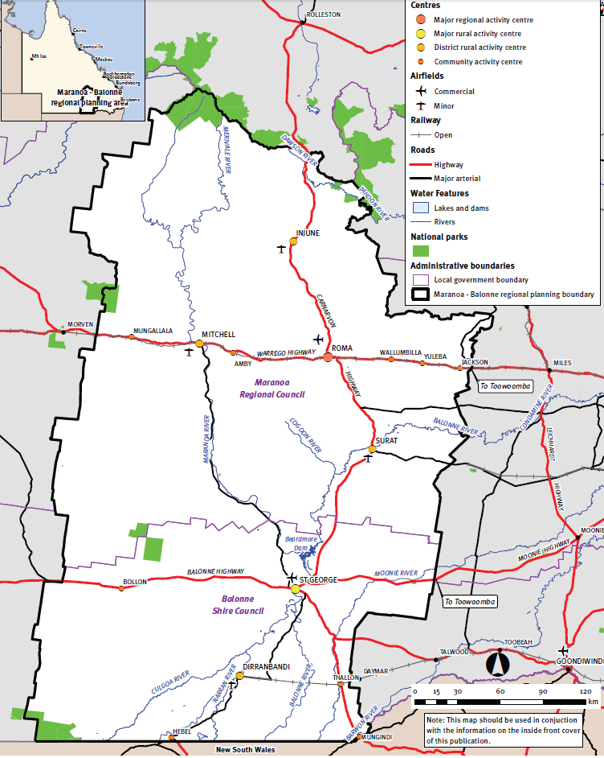

Annexure F – DDMG Membership List

Core members
Core membership of the Roma DDMG comprises a representative from each local government and state government departments.

The core membership of the Roma DDMG comprises of:
- DDMG Chairperson
- DDMG Deputy Chairperson
- DDMG Executive Officer
- DDMG Deputy Executive Officer
- Queensland Police Service - Emergency Management Coordinator
- State Emergency Service
- Balonne Shire Council
- Maranoa Regional Council
- Queensland Fire Department
- Queensland Ambulance Service
- Department of Families, Seniors, Disability Services and Child Safety
- Department of Housing and Public Works
- Department of Environment, Tourism, Science and Innovation - DETSI
- Queensland Health - SWHHS
- Department of Transport and Main Roads – TMR
- Department of Primary Industries
- Queensland Reconstruction Authority
- Department of Education
- Department of Natural Resources and Mines, Manufacturing and Regional and Rural Development
- Department of State Development, Infrastructure and Planning

Advisors
Representatives of the following departments / agencies may be invited to attend DDMG meetings and assist in disaster operations in an advisory and cooperative disaster capacity as required:
- Australian Broadcasting Corporation
- Australian Defence Force - Joint Operational Support Staff
- Australian Red Cross
- Department of Regional Development, Manufacturing and Water
- Queensland Corrective Services
- Ergon
- Telstra
- NBN
- Persons representing departments whom the Executive Officer of the District Disaster Management Group in consultation with the DDC considers appropriate to be represented on the group as advisors.

Annexure G – Functional and Supporting Committees and Subplans

Supporting Committee | Agency | Meetings
Roma District Human and Social Recovery and Resilience Committee | Department of Families, Seniors, Disability Services and Child Safety | Triannual

Roma District Disaster Management Group

Roma DDMG
PO BOX 222
Roma Qld 4455
DDC.Roma@police.qld.gov.au

1 Climate Data Online
2 Queensland Regional Profiles
3 Queensland Regional Profiles
Disaster Management / Queensland Government

