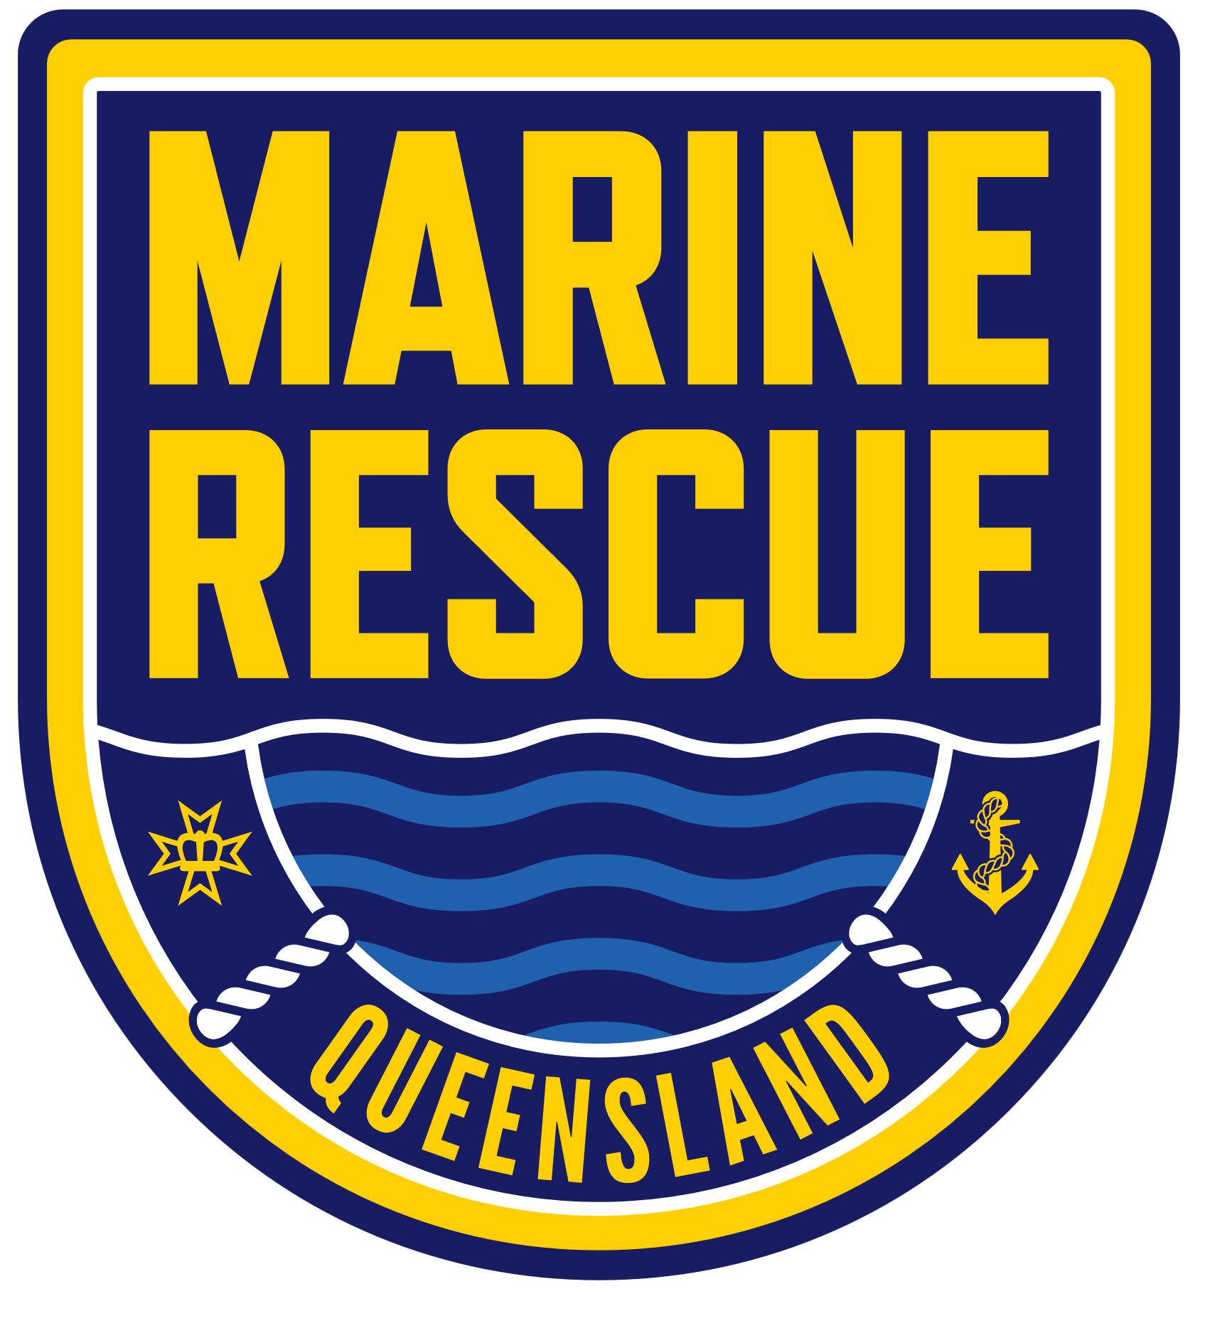
Queensland Police Service
Belonging & Inclusion Plan 2026-2030

QPS Vision
A safer, more resilient Queensland.

QPS Purpose
Keeping our community safe and feeling safe.
The Queensland Police Service is responsible for the functions of:
- Policing and community safety.
- State Emergency Service (SES).
- Marine Rescue Queensland (MRQ).

Our Vision for Belonging & Inclusion

Together, Side by Side
A Queensland Police Service where everyone experiences a genuine sense of belonging and inclusion, collectively united by our shared purpose of keeping Queensland’s communities safe and feeling safe.

Acknowledging the Voices of our Workforce
Belonging and inclusion are collective responsibilities that we create through our everyday actions. This plan is shaped by the voices of our workforce, including frontline officers, staff members, and volunteers, and those with lived intersectional experiences. We thank every member of our workforce for their insights and honesty, which have guided and grounded this work.

Acknowledgement of Country
The Queensland Police Service respectfully acknowledges First Nations peoples as the Traditional Owners and Custodians of Queensland. We recognise their connection to land, sea, and community. We pay our respects to them, their cultures, and to their Elders, past, present and emerging.

Our Human Rights Commitment
The Queensland Police Service is committed to respecting, protecting and promoting human rights in our decision-making and actions.

Our People
- Our People: Over 19,500 employees and 6,200 volunteers in over 300 different roles in 426 locations. Our people bring unique skills, perspectives, and experiences to serve Queensland communities.
- Volunteer Locations: 15% Remote. 51% Regional. 34% Urban. They bring local knowledge and strong community connections, helping us provide meaningful services and support.
- Multiple Generations: 18 to 82 Years Old. Generational diversity brings a mix of experience, fresh ideas, and innovative approaches to problem-solving.
- Born Overseas: 16.6% Born Overseas. Representing over 100 countries and speaking more than 100 languages. This diversity strengthens our ability to connect with and serve Queensland’s multicultural communities.
- Gender Diverse: 0.7% Gender Diverse. Gender diversity brings different perspectives, helps create safer and more respectful workplaces, and builds stronger connections with the community.
- First Nations: 3.4% First Nations. Their cultural knowledge and leadership are essential for building trust and delivering culturally appropriate services.
- Disability. 8.2% Disability. Their lived experiences inspire innovation and ensure our workplace is accessible and inclusive for everyone.
- LGBTQIA+. 4.7% LGBTQIA+. Their visibility and contributions help create a workplace culture that values authenticity, respect, and inclusion.
Source: Working for Queensland 2025 | Volunteering for Queensland 2025 | QPS workforce data as at 30 June 2025

Benefits of Belonging & Inclusion
- Safer, Healthier Workplaces. Belonging and inclusion build trust, improve wellbeing, and reduce workplace harms.
- Stronger Retention & Recruitment. Inclusive workplaces attract, engage, and retain talented people.
- Better Operational Outcomes. Diverse and inclusive teams can work smarter and more effectively.
- Greater Community Trust. When communities see themselves reflected, it fosters trust, safety, and cooperation.

Opportunities
- Embed belonging and inclusion as core principles for meaningful, sustainable change.
- Empower our workforce by including their voices and their lived experience in decisions.
- Align leadership and professional development programs with safety, wellbeing, and inclusion.
- Recognise individuals and teams who exemplify belonging and inclusion to inspire others.

Risks
- Competing organisational priorities may reduce the focus on belonging and inclusion efforts.
- Limited data and ineffective systems make it harder to measure progress and identify improvements.
- The workforce perceive belonging and inclusion as top-down initiatives, with limited relevance at the local level.
- Differences in leadership skills and operational pressures result in inconsistent application.
- Expansion of AI technologies amplifies inherited biases and creates unintended inequity.

Our Belonging & Inclusion Objectives

Strength in Diversity
A workforce that reflects Queensland’s diverse communities and values the unique strengths, perspectives, and experiences that everyone brings.

Strategies
A1. Create inclusive recruitment campaigns that show the QPS as a place where everyone belongs.
A2. Identify and remove barriers in recruitment to ensure fairness for all applicants.
A3. Partner with diverse communities to attract talent and build trust.

Healthy & Inclusive Workplaces
A workplace where everyone – police, staff members, and volunteers – feels safe, valued, supported, and empowered to be and do their best.

Strategies
B1. Make safety, wellbeing, and inclusion a shared responsibility across the QPS.
B2. Provide culturally safe and inclusive mental health and wellbeing support.
B3. Ensure workspaces and practices are inclusive, accessible, and flexible to meet individual needs.
B4. Build a culture of inclusion and belonging by celebrating diversity and supporting each other.

Fair & Accessible Systems
Our systems, policies, and processes are inclusive, equitable, and deliver fair outcomes for everyone.

Strategies
C1. Incorporate a person-centred, culturally informed approach to policy and process design.
C2. Use workforce data, diverse voices, and lived experiences to guide decisions, track progress, and drive reform.
C3. Include belonging and inclusion in governance, reporting, and planning cycles.

Leadership with Care & Accountability
Our leaders model inclusive, fair, and authentic leadership, creating a QPS where everyone feels valued and respected.

Strategies
D1. Build a leadership culture that prioritises respect, inclusion, safety, and wellbeing.
D2. Include inclusive leadership in training programs and support ongoing growth and development.
D3. Incorporate inclusive leadership into performance expectations.

Performance Measures
- Employee Engagement.
- Volunteer Engagement.
- Delivery of Outcomes & Initiatives.
- Workforce Data & Analytics.

Our Framework for Belonging & Inclusion

This plan is grounded in our Belonging & Inclusion Framework which places people at the centre of everything we do. It is built on shared accountability, recognising that belonging is achieved through the collective actions of individuals, teams, supervisors, and the organisation.

Belonging & Inclusion Domains
Where we take action to make belonging and inclusion real:
- Attraction & Recruitment. Welcoming diverse talent and ensuring their success from day one.
- Health, Safety & Wellbeing. Creating safe, respectful, and supportive workplaces for all.
- Ways of Working & Workspaces. Building inclusive and accessible environments where everyone can thrive.
- Growth, Development & Career Progression. Ensuring fair access to learning and advancement.
- Performance & Recognition. Valuing everyone’s contribution and fostering motivation through fairness.
- Transitions & Beyond. Supporting people with care through all types and stages of change.

Enablers of success
How we approach our strategies and activities to ensure belonging and inclusion succeed:
- Inclusive Leadership & Governance
- Communication & Everyday Engagement
- Capability & Learning
- Systems, Processes & Policies
- Data, Evidence & Insights

QPS Values
- Integrity. We are honest, trustworthy and serve the community with the highest standards of professional conduct at all times.
- Respect. We treat everyone fairly and with dignity, embrace diversity, and consider and value all perspectives.
- Courage. We serve in the fact of adversity and lead by example.

Delivering for Queensland | Queensland Government
Queensland Police Service
Belonging & Inclusion Action Plan 2026-2027

Purpose of this Action Plan
The Queensland Police Service (QPS) Belonging & Inclusion Action Plan 2026-2027 details the practical steps the QPS will take over the next 18 months to promote equity, diversity, respect, and inclusion (EDRI) in the workplace.
This action plan aligns with the vision for belonging and inclusion outlined in the Belonging & Inclusion Plan 2026-2030 and is underpinned by the Belonging & Inclusion Framework.

Strategic Context
This action plan focuses on key activities to help achieve our shared vision of a QPS where everyone experiences a genuine sense of belonging and inclusion, collectively united by our shared purpose of keeping Queensland’s communities safe and feeling safe.
The action plan is informed by the findings of the QPS Equity and Diversity Audit (April 2025) and is part of a larger framework of strategies, plans, and initiatives that together promote EDRI across the QPS.
To avoid duplicating existing efforts, this action plan builds on the progress already underway by addressing gaps and leveraging opportunities for improvement. It is supported by key priorities, reform programs, and legislation, including:
- Queensland Government election commitments
- Ministerial Charter Letter
- QPS Strategic Plan
- QPS Operational Plan
- Commissioner’s 100-Day Review of the Queensland Police Service (100DR)
- QPS Transformation Roadmap
- QPS Multicultural Action Plan
- QPS Reframing the Relationship Plan
- QPS Disability Service Plan
- Public Sector Act 2022
- Anti-Discrimination Act 1991
- Human Rights Act 2019
- Work Health and Safety Act 2011

Monitoring Progress & Impact
Performance against this action plan will be monitored through regular reporting via the QPS governance framework and reviewed annually through our equity and diversity audit.
These audits collect information about our workforce, evaluate the effectiveness of our belonging and inclusion activities, and identify areas for improvement. They draw on workforce surveys, data, and analytics, and serve as a valuable tool for measuring progress over time.

Enablers of Success
The Enablers of Success from the Belonging & Inclusion Framework provide the foundation for achieving belonging and inclusion. They act as practical tools to guide the planning, delivery, and evaluation of the activities in this action plan.
Responsible officers and areas should use the enablers as a framework to embed belonging and inclusion into every activity, project, and decision

Belonging & Inclusion Enablers of Success

Inclusive Leadership & Governance
Leaders must model respect, accountability, and inclusion through their actions.
Governance ensures that belonging and inclusion are part of the planning, measurement, and delivery of programs and services.
Reflective Questions:
- How are EDRI principles being integrated into the planning, delivery, and evaluation of our work?
- How will leaders demonstrate inclusive behaviours and take accountability for belonging and inclusion outcomes?

Communication & Everyday Engagement
Inclusive language, open communication, and active engagement are essential for belonging and inclusion.
They ensure that everyone’s voice is heard and valued.
Reflective Questions:
- How will we ensure that our communication is inclusive, accessible, and respectful of diverse perspectives?
- How will we create opportunities for meaningful engagement with all stakeholders in our work?

Capability & Learning
Building skills and knowledge in the application of EDRI principles is critical for success.
Training, resources, and development opportunities are key to creating cultural awareness and inclusive practices.
Reflective Questions:
- What will we do to ensure people understand and can apply EDRI principles?
- How are we supporting our people to develop the skills needed to identify and address EDRI challenges and opportunities?

Systems, Processes & Policies
Fair, accessible, and inclusive systems, processes, and policies are the foundation of belonging and inclusion.
Removing barriers ensures that everyone has fair access and is treated equitably.
Reflective Questions:
- How will we ensure our systems, processes, and policies are fair, accessible, and inclusive?
- How will we identify and address barriers to access and inclusion?

Data, Evidence & Insights
Data, feedback, and lived experiences help identify opportunities, evaluate progress, and improve outcomes.
These insights ensure programs and services align with our belonging and inclusion goals.
Reflective Questions:
- What data will we use to monitor the impact of our work and identify areas for improvement?
- Are we incorporating diverse perspectives and lived experiences into the design, delivery, and evaluation of our work?

Key Activities for 2026-2027
Performance Measures
Employee engagement Volunteer engagement
Delivery of outcomes and initiatives Workforce data and analytics
No. | Key Activities | Responsible Officer | Completion Date | Strategy Alignment ^{(a)}
Strength in Diversity
 | Use inclusive language and diverse imagery in attraction activities and recruitment campaigns, to strengthen employer branding and position the QPS as a champion of equity, diversity, respect, and inclusion, and a workplace that attracts and retains talent from all backgrounds. | Executive Director, Communications Culture & Engagement Division  Assistant Commissioner, Recruiting & Development Command  Executive Director, Human Resources Division  Executive Director, First Nations Division  Chief Officer, State Emergency Service  Chief Officer, Marine Rescue Queensland | Ongoing | A1
 | Deliver improvements to the Psychological Assessment Unit policies and procedures to ensure contemporary psychological selection practices for recruitment. | Executive Director, Health & Wellbeing Division | 30/06/2026 | A2
 | Strengthen partnerships and collaboration with stakeholders and community groups to improve and expand talent pathways into the QPS. | Assistant Commissioner, Recruiting & Development Command  Executive Director, Human Resources Division  Executive Director, First Nations Division  Executive Director, Communications Culture & Engagement Division | 30/06/2027 | A3
Healthy & Inclusive Workplaces
 | Embed shared responsibility for health, safety, and belonging into organisational strategy and leadership development, emphasising the important protective role of social support. | Executive Director, Implementation Program 100-Day Review  Executive Director, Health & Wellbeing Division  Assistant Commissioner, Recruiting & Development Command | 30/06/2027 | B1, B4, D1
 | Undertake the Q-Tool inclusivity audit of mental health and wellbeing support services. | Executive Director, Health & Wellbeing Division | 30/06/2026 | B2
 | Review and improve QPS training programs to make them more accessible, and inclusive, to meet the diverse needs of employees, including those with caregiving responsibilities, neurodiverse individuals, people needing reasonable adjustments, and those with specific needs. | Assistant Commissioner, Recruiting & Development Command | 30/06/2027 | B3, C1
 | Recognise and reward contributions that promote belonging, inclusion and a positive workplace culture through the QPS awards program. | Assistant Commissioner, Recruiting & Development Command | 30/06/2027 | B4
Fair & Accessible Systems
 | Refresh the QPS Individual Development and Performance (DAP) program to prioritise a person-centred approach, that recognises the diversity of individuals and roles across the QPS. | Executive Director, Human Resources Division | 30/06/2027 | C1, B3
 | Establish the 70:20:10 learning model to strengthen workforce capability and support continuous development, ensuring it reflects the diverse strengths, aspirations, and responsibilities of individuals and their roles. | Executive Director, Human Resources Division | 30/06/2026 | C1, B3
 | Deliver a technical solution to streamline and improve the administration of the QPS higher duties and relieving (EOI) processes, to ensure transparency, fairness, and enable the identification and mitigation of barriers to accessibility and inclusion. | Executive Director, Human Resources Division | 30/06/2027 | C1, C2
 | Integrate equity, diversity, respect, and inclusion principles into the QPS performance management framework to promote and drive organisational change. | Executive Director, Policy & Insights Division | 30/03/2027 | C3

Performance Measures
Employee engagement Volunteer engagement
Delivery of outcomes and initiatives Workforce data and analytics
No. | Key Activities | Responsible Officer | Completion Date | Strategy Alignment ^{(a)}
Leadership with Care & Accountability
 | Embed equity, diversity, respect, and inclusion principles into QPS Executive Performance and Development Agreements, to strengthen accountability and alignment with QPS belonging and inclusion objectives | Executive Director, Policy & Insights Division | 30/06/2027 | D3, D1, C3
 | Develop and implement a communications and engagement strategy to promote and embed the Belonging & Inclusion Framework, fostering awareness, understanding, and a greater commitment to equity, diversity, respect, and inclusion across the QPS | Executive Director, Policy & Insights Division | 30/06/2027 | D1, B4
 | Continue to support the implementation of the QPS Reframing the Relationship Plan, QPS Multicultural Action Plan, QPS Disability Service Plan and associated initiatives as key drivers of equity, diversity, respect, and inclusion across the QPS. | Executive Director, First Nations Division  Executive Director, Communications Culture & Engagement Division  Executive Director, Policy & Insights Division | Ongoing | All Strategies
 | Embed equity, diversity, respect, and inclusion principles into the design and delivery of priority initiatives under the 100-Day Review and Transformation Office, ensuring they consider the needs of a diverse and inclusive workforce. | Executive Director, Implementation Program 100-Day Review  Executive Director, Transformation Office  implemented by Senior Responsibility Officers / Project Sponsors | 30/06/2027 | All Strategies
 | Support implementation of the QHRC review recommendations to increase diversity and inclusion within the QPS. | Executive Director, Communications Culture & Engagement | 30/06/2027 | All Strategies
(a) Alignment with Belonging & Inclusion Strategies as detailed in the Belonging & Inclusion Plan 2026-2030.

