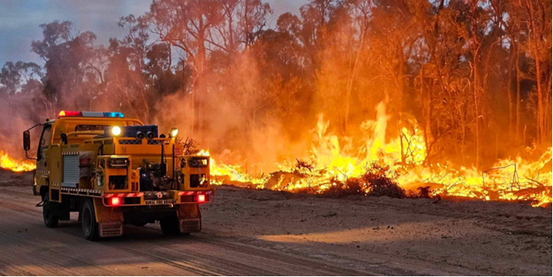
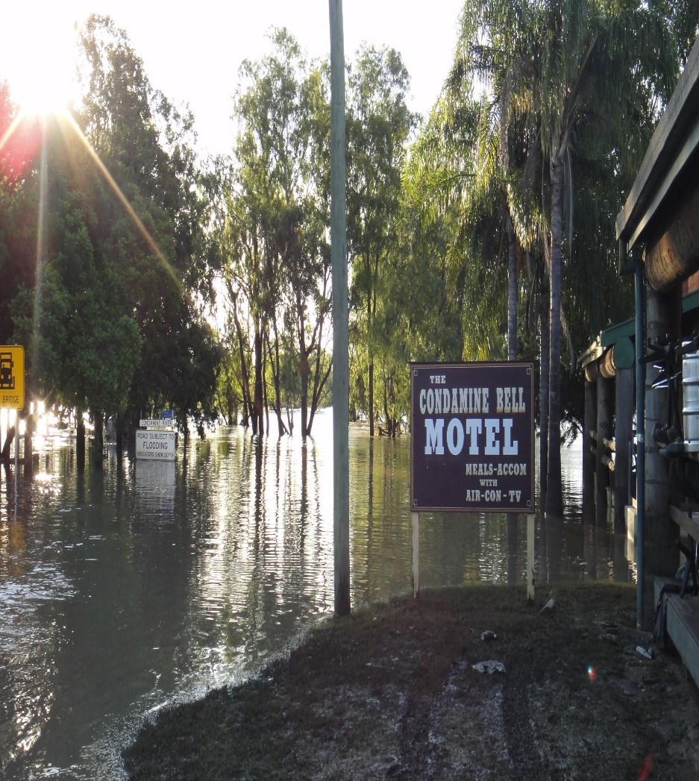
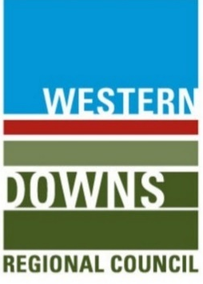


Dalby

District

Disaster

Management

Plan

2026

Incorporating Local Disaster Management Group

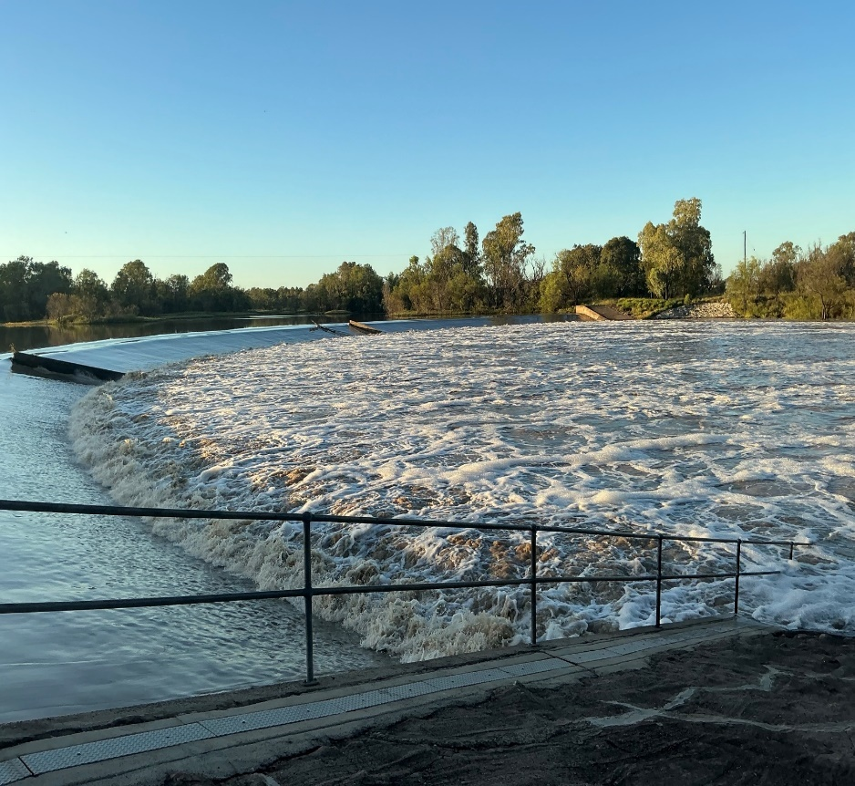

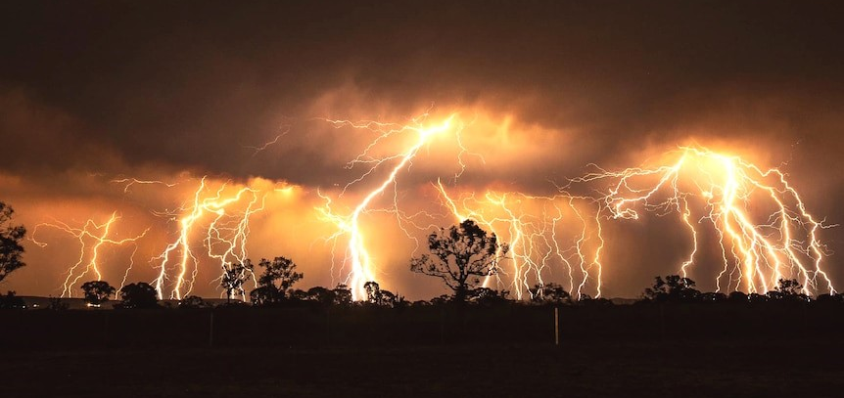

DOCUMENT CONTROL

Amendments Version Control
This Dalby District Disaster Management Plan (DDMP) is a controlled document. The controller of the document is the Chair, Dalby District Disaster Management Group (DDMG). Any proposed amendments to this plan should be forwarded in writing as follows:
By Mail: Executive Officer
Dalby District Disaster Management Group
PO Box 402,
Dalby, QLD, 4405
By Email: DDC.Dalby@police.qld.gov.au
Any changes to the intent of the document must be endorsed by the Dalby District Disaster Management Group (DDMG). Minor amendments will be addressed administratively by Executive Officer, Dalby DDMG and endorsed by the Chair, Dalby DDMG.
A copy of each amendment is to be forwarded to those identified in the distribution list. On receipt, the amendment is to be inserted into the document and the Amendment Register updated and signed.

Amendment Register
The amendments register is documented in Annexure A.

Abbreviation and Acronyms
The Abbreviation and Acronyms register is documented in Annexure B.

Definitions
The definition register is documented in Annexure C.

Distribution
This plan has been disseminated to all core members and advisory members of Dalby District Disaster Management Group (DDMG) as documented within the Dalby DDMG Distribution list in Annexure D.
In compliance with s56 of the Disaster Management Act 2003 (Qld), a copy of the plan is available on the Queensland Police Service website: www.police.qld.gov.au.
This plan is also available for inspection, free of charge, to members of the public. All applications are to be made to the Executive Officer, Dalby District Disaster Management Group.

By Mail: Executive Officer
Dalby District Disaster Management Group
PO Box 402,
Dalby, QLD, 4405
By Email: DDC.Dalby@police.qld.gov.au

FOREWORD
The communities located within the Dalby Disaster District are susceptible to the impacts from a variety of natural, non-natural and technological hazards.
The Dalby District Disaster Management Plan (DDMP) has been prepared under the authority of the Disaster Management Act 2003 (QLD) to provide a framework for comprehensive disaster management within the Dalby Disaster District and to ensure disaster management and disaster operations in the district are consistent with the State group’s Disaster Management Strategic 2016 Policy Statement and State Disaster Management Plan.
The DDMP is designed to enhance the district’s disaster management capacity by ensuring the necessary strategies are in place to provide a comprehensive (Prevention/ Mitigation, Preparedness, Response and Recovery), all hazards all-agency, whole-of-government approach to disaster management.
Through hazard analysis the DDMP also incorporates hazard specific strategies for disaster management.
The DDMP will be reviewed periodically and amended as necessary to address the districts most significant risks as identified through hazard analysis and risk assessments to ensure compliance with best practice procedures in disaster management planning.

Inspector Deb Harris- Taaffe
Chair /District Disaster Coordinator
Dalby District Disaster Management Group
Dated:- 7th April 2026
Endorsed Dalby DDMG – 28th May 2026

ENDORSEMENT and AUTHORISATION

The Dalby District Disaster Management Plan (DDMP) is endorsed under the authority of the Dalby District Disaster Management Group (DDMG) and will be maintained by the Executive Officer, Dalby DDMG.
This plan has been developed and prepared in accordance with the Disaster Management Act 2003 (Qld) on behalf of the Dalby District Disaster Management Group. The following documents to provide for effective disaster management and disaster operations within the Dalby Disaster District.

- Queensland State Disaster Management Plan (Interim)
- Queensland Emergency Management Assurance Framework
- Queensland Emergency Risk Management Framework
- Queensland Prevention, Preparedness, Response and Recovery Disaster Management Guidelines 2018
- Queensland Disaster Management 2016 Strategic Policy Statement

Inspector Deb Harris- Taaffe
Chair District Disaster Coordinator
Dalby District Disaster Management Group
Dated:- 7th April 2026
Endorsed Dalby DDMG – 28th May 2026

Contents
DOCUMENT CONTROL 2
Amendments Version Control 2
Amendment Register 2
Abbreviation and Acronyms 2
Definitions 2
Distribution 2
FOREWORD 3
ENDORSEMENT and AUTHORISATION 4
ADMINSTRATION and GOVERANCE 8
Authority to Plan 8
Purpose of the Plan 8
Objectives of the Plan 8
Strategic Policy Statement 8
Scope of the Plan 9
Disaster Management Priorities 9
Annual Operational Priorities 9
DALBY DISTRICT DISASTER MANAGEMENT GROUP 10
Establishment 10
Role of the DDMG 10
Functions of the DDMG 10
Key Positions of DDMG 11
Membership 12
Dalby DDMG Members Responsibilities 13
Functional and Supporting Role/Committees 13
DDMG Business and Meetings 13
Meetings 13
Quorum 14
Administrative Reporting 14
DISASTER RISK ASSESSMENT 15
Community Context 15
Economy/ Industry 15
Power Stations 16
Gas Resources 16
Surat Gas Project – Arrow Energy 16
Talinga Orana Gas Gathering Station (TOGGS) 16
Coal 17
Wind Farms 17
Solar Energy 17
Clean Hydrogen Energy 18
Forestry and National Parks 18
Rivers, Creeks and Tributaries 18
Climate and Weather 19
Referable Dams 19
Disaster Risk Overview 20
Hazard Specific Arrangements 20
Prevention Strategies 22
Preparedness Strategies 22
Local focus and disaster management capability 22
Hazard Specific Plans 22
Support by District and State Groups 23
State Disaster Coordinator intent 23
Capacity Building 24
Training and Education 24
Exercises 24
Lessons Learnt Management Process 25
Response Strategies 25
Levels of Activation 26
Disaster Coordination Centres 26
Public Information 26
Communication by Local and District Groups 27
Media 27
Social Media 27
Disinformation and Misinformation 27
Warnings 27
Bureau of Meteorology Weather Warning 27
Australian Warning System (AWS) 27
Standard Emergency Warning Signal 28
AusAlert Emergency System 28
Response functions 29
Disaster Declarations 29
Operational Reporting 29
Evacuations 29
Resupply 30
Request for Assistance 30
Recovery Strategy 30
Functional Recovery and Resilience Groups (FRRGs) 31
Review and Assurance 31
Review and Renew Plan 31
Review of Local Disaster Management Arrangements 31
Post Disaster Assessment 31
Annexure A. Amendment Register 32
Annexure B. Abbreviation and Acronyms 32
Annexure C. Definitions 33
Annexure D. Distribution List & Membership Register 36
Annexure E – DDMG Operational Priorities 37
Annexure F - Dalby DDMG Boundaries 38
Annexure G - Roles and Responsibilities of Government Departments/ Agencies 39
Annexure H -Functional and Supporting sub-committees and associated plans 49
Annexure I - Power Plant map 50
Annexure J - Primary Agencies and Specific Hazards Plans 51
Annexure K - Activation levels and relevant triggers 52
Annexure L – District Operational Plan (2026) 53

ADMINSTRATION and GOVERANCE

Authority to Plan
This District Disaster Management Plan (DDMP) is prepared under the provisions of s.53 of the Disaster Management Act 2003 (Qld).

Purpose of the Plan
This plan details the arrangements with the Dalby disaster district to provide whole-of-government planning and coordination capability to support local government in disaster management and disaster operations.

Objectives of the Plan
The objective of the Dalby DDMP is to facilitate the implementation of efficient and effective disaster management strategies and arrangements including:
- To articulate the roles and responsibilities of entities involved in the disaster operations and disaster management in the Dalby Disaster District.
- To coordinate disaster operations and activities relating to disaster management in the Dalby Disaster District.
- Development, review and assessment of effective disaster management for the Dalby Disaster District including arrangements for mitigating, preventing, preparing for, responding to and recovering from a disaster.
- To ensure disaster management operations and planning adhere to the principles of the Emergency Management Assurance Framework, Standard for Disaster Management and any other relevant legislation and guidelines relevant to district level disaster management.
- Development, implementation, and monitoring of priorities for disaster management for the district.
- To develop priorities and identify and plan for events for disaster management in the Dalby Disaster District.

Strategic Policy Statement
Disaster management planning and operations in the Dalby Disaster District are consistent with the Queensland Disaster Management 2016 Strategic Policy Statement which is achieved by:
- Ensuring a comprehensive, all hazards, all agencies approach by achieving the right balance of prevention, preparedness, response, and recovery.
- Supporting the mainstreaming of disaster preparedness and mitigation into relevant areas of activity of government, non- government, small business, and corporations.
- Aligning disaster risk reduction, disaster mitigation, disaster resilience and climate change adaptation policy, strategies, and actions with international and national reforms.
- Promoting a transparent, systematic, and consistent approach to disaster risk assessment and management.
- Recognising the commitment of stakeholders and the need for collaboration and integration across all levels of government, community, industry, commerce, government owned corporations, private and volunteer organisations, and local communities in all aspects of disaster management
- Promoting community resilience and economic sustainability through disaster risk reduction, innovation, research and lessons learned; and
- Incorporating risk-based planning, consultative decision-making, and shared responsibilities among stakeholders.

Scope of the Plan
The plan details the arrangements necessary to undertake disaster management within the Dalby disaster district. This includes the local government area of the Western Downs Regional Council.
Local governments are primarily responsible for managing events in their local government area through their Local Disaster Management Group (LDMG).
The Dalby DDMP has been developed to comply with and should be read in conjunction with the following documents.
  - Disaster Management Act 2003
  - Disaster Management Regulation 2014
  - State Disaster Management Plan (SDMP) (interim)
  - Queensland Emergency Management Assurance Framework
  - Queensland Disaster Management 2016 Strategic Policy Statement
  - Queensland Recovery Plan
  - Queensland Emergency Risk Management Framework

Disaster Management Priorities
The priorities for the Dalby District Disaster Management Group are to:
- Improve community (including business) disaster planning/ mitigation and preparation;
- Manage training of DDMG members in line with the Queensland Disaster Management Training Framework
- Support the integrate effective disaster risk reduction initiatives into strategic and corporate plans at appropriate levels of government, community organisations, industry and commerce.
- Monitor and evaluate the disaster management arrangements to:
  - Streamline arrangements ensuring efficiency and effectiveness
  - Develop clear accountability, including defined roles and responsibilities at all levels of the disaster management arrangements
  - Improve the flow of communication; and
  - Support the development of whole-of-government, media and community engagement arrangements
  - Support the active promotion and encourage continuous improvement and integration of lessons learned
The overarching disaster management priority for the Dalby DDMG is to provide coordination and support, when required and requested by Western Downs LDMG during disaster events and disaster operations.

Annual Operational Priorities
The Dalby DDMG Annual Operational Priorities are seen in Annexure E.
The operational plan outlines the operational priorities for the forthcoming year pursuant to the provisions of s53(2)(e) of the Disaster Management Act 2003, Operational plan, see Annexure L.

DALBY DISTRICT DISASTER MANAGEMENT GROUP

Establishment
The Dalby District Disaster Management Group (DDMG) is established in accordance with s22. of the Disaster Management Act 2003 (Qld).

Role of the DDMG
The Dalby DDMG is comprised of representatives from Queensland Government agencies, government owned corporations, non-government organisations, industry and commerce and key community representatives, who can provide and coordinate whole-of-government support and assistance to disaster affected communities.

Functions of the DDMG
The DDMG has the following functions for which it is established s23. Disaster Management Act 2003
- Ensure that disaster management and disaster operations in the district are consistent with the State group’s strategic policy framework for disaster management for the State
- Develop effective disaster management for the district, including a district disaster management plan, and regularly review and access that disaster management
- Provide reports and make recommendations to the State group about matters relating to disaster management and disaster operations in the district.
- Regularly review and assess –

- the disaster management of local groups in the district; and
- local disaster management plans prepared by local governments whose areas are in the district

- Ensure that any relevant decisions and policies made by the State group are incorporated in its disaster management, and disaster management of local groups in the district.
- Ensure the community is aware of ways of mitigating the adverse effects of an event, and preparing for, responding to, and recovering from a disaster
- Coordinate the provision of State resources and services provided to support local groups in the district
- Identify resources that may be used for disaster operations in the district
- To make plans for the allocation, and coordination of the use, of resources mentioned in paragraph (h)
- Establish and review communications systems in the group, and with and between local groups in the district, for use when a disaster happens
- Ensure information about an event or a disaster in the district is promptly given to the State group and each local group in the district
- To prepare, under section 53, a district disaster management plan
- To perform other functions given to the group under this Act
- To perform a function incidental to a function mentioned in paragraphs (a) to (m)

Key Positions of DDMG
Position Chairperson/ District Disaster Coordinator – Dalby DDMG
Appointment Appointed by the Commissioner of Police as legislated in s25(1), 25(2) and 25(3) of the Disaster Management Act 2003 (QLD)
Role Manage and coordinate the business of the group
Ensure that the group performs its functions
Report regularly to the Queensland Disaster Management Committee (QDMC), about
the performance of the district group
Coordinate disaster operations in the disaster district for the group
Position Executive Officer – Dalby DDMG
Appointment Appointed by the Commissioner of Police as legislated in s27 of the Disaster Management Act 2003 (QLD)
Role Support the district group in the performance of its functions, as directed by the Chair
Position Local Government Members - Dalby DDMG
Appointment Accordance with s24 of the Disaster Management Act 2003 (QLD)
Role Local government representatives appointed to the DDMG should be available to participate as a member of the DDMG during activations, operations or activity
Ensure coordination and the effective use of resources and capabilities within the core function of the agency
Have the authority within their agency to be able to commit agency resources to support DDMG functions, operations, activities and planning
Have the qualifications and experience required for a person to be a member of a district group
Position Other Members/ Advisors - Dalby DDMG
Appointment Accordance with s24(e) of the Disaster Management Regulations 2014 (QLD)
Role Dalby DDC has discretion to appoint individual and/ or organisations to DDMG having regard to the effective disaster management for the Dalby District.
Representatives appointed to the DDMG should be available to participate as a member of the DDMG during activations
Have the authority within their agency to be able to commit agency resources to support DDMG functions, operations, activities and planning
Have the qualifications and experience required for a person to be a member of a district group

A map of the Dalby DDMG and LDMG boundaries are included in Annexure F.

Membership
The Dalby DDMG is comprised of persons and representatives as nominated in s. 24 of the Disaster Management Act 2003 - ‘Membership’.
- Chairperson – District Disaster Coordinator (DDC)
- Deputy Chairperson
- Executive Officer
- A representative of each local government within the district and;
- Persons representing departments that the Queensland Disaster Management Committee, in consultation within the DDC, considers appropriate to be represented on the group
- A representative from non-government agency within the disaster district in which the DDC considers appropriate to be represented on the group
The core membership of the Dalby DDMG is comprised of the following members/ representatives:
- Queensland Police Service
- Chairperson and Deputy Chairperson
- Executive Officer
- Emergency Management Coordinator
- Queensland Fire Department
- Fire and Rescue
- Rural Fire Service
- Queensland Ambulance Service
- State Emergency Service
- Local Government within Disaster District – Western Downs Regional Council
- Department of Transport and Main Roads
- Department of Health
- Darling Downs Hospital and Health Service
- Public Health
- Department of Housing & Public Works
- Department of Families, Seniors, Disability & Child Safety

Representatives of the following departments/ agencies may be invited to attend DDMG meetings and assist in disaster operations in an advisory and co-operative disaster capacity as required:
- Department of Primary Industries
- Ergon Energy
- Department of Education
- Department of Natural Resources & Mines, Manufacturing & Regional & Rural Development
- Department of State Development, Infrastructure & Planning
- Department of Environment, Tourism, Science and Innovation
- Department of Local Government, Water and Volunteers
- Queensland Reconstruction Authority
- Queensland Rail

- Australian Red Cross
- Australian Broadcasting Commission (ABC)
- Any other department/ agency as deemed appropriate

Dalby DDMG Members Responsibilities
A detailed itemisation of roles and responsibilities of member agencies, agency specific functions, are articulated in the Queensland State Disaster Management Plan. The Dalby DDMG adopts the itemisation of these roles and responsibilities at the district level, see Annexure G.
In considering appropriate membership to the Dalby DDMG, member Agencies should ensure appointed members:
- Attendance and participation at DDMG activities with a full knowledge of their agency resources and services and the expectation of their agency.
- Available and appropriately briefed to actively participate in the DDMG activities to ensure that planning and operations use the full potential of their agency or function, while recognising any resource or capability limitations
- Appropriately positioned within their agency to be able to commit agency resources
- Have completed all relevant disaster management training in accordance with QDMTF.
- Have a deputy who is appropriately trained to take on the responsibilities should they be unavailable or to provide additional support during extended operations.

Functional and Supporting Role/Committees
Multiple state agencies are responsible for various disaster response function within Queensland. These responsibilities are allocated as a result of an agency’s role in administering relevant legislation or ability to provide specialist resources.
The Dalby DDMG may establish permanent or temporary Functional and Supporting committees as deemed necessary in response to or recovery from a disaster event. The appointed Chairs of each sub-committee are responsible for providing regular updates to the DDMG or as requested by the Chair on the activities of the sub-committee. A detailed itemisation of the disaster response functions, and associated lead agencies, is outlined Functional and Supporting sub-committees and associated plans are documented in Annexure H.

DDMG Business and Meetings

Meetings
Reporting requirements within the Dalby Disaster District shall be in accordance with s38 of the Disaster Management Act 2003 (Qld). The DDMG may conduct its business, including its meetings, in a way it considers appropriate.
Ordinary – a meeting which is scheduled and convened on a regular basis at an agreed time (set by the Chairperson). Ordinary meetings are used to address the general business of the group, should occur at least once every six (6) months.
Extraordinary – a special meeting convened by the Chairperson in response to an operational event.

Quorum
A quorum is required for meeting resolutions to be officiated and is equal to one- half of the DDMG members plus one. An appointed deputy attending a meeting on behalf of a DDMG members is to be counted in quorum. Personal attendance at meetings is preferred, however if this cannot be achieved a member may be able to participate by using any technology that reasonably allows members to hear and take part in discussions as they happen.

Administrative Reporting
A formal record of attendance shall be kept and maintained of the Dalby DDMG meetings, and the Dalby DDMG must keep minutes of its meeting. Minutes from the Dalby DDMG meetings will be disseminated to members for confirmation of accuracy. Minutes will be adopted at subsequent meetings and will be held by the Executive Officer.
Member agencies are required to provide a status report at each scheduled meeting. The status report can be either in writing prior to a meeting, or verbally during the meeting.
Action items identified during a meeting must be recorded and must be actioned by the representative identified during the meeting as being the appropriate agency to progress the identified item, issue or query. Progress or conclusion of action items must be recorded in a subsequent meeting.

DISASTER RISK ASSESSMENT

Community Context
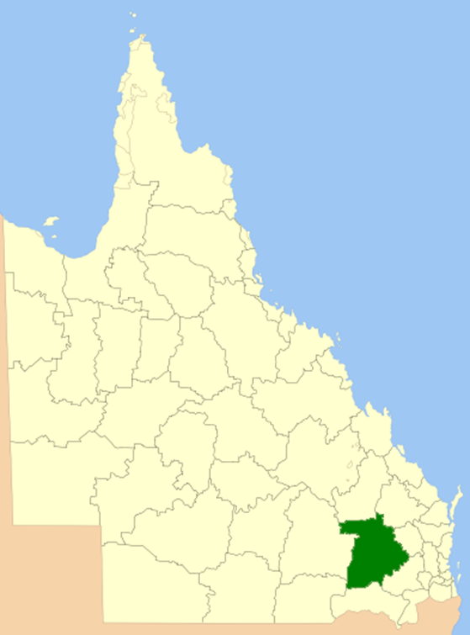
The Dalby Disaster District comprises the local government area of the Western Downs Regional Council and encompasses an area of 38,039 km² .
The Dalby Disaster District highest risk and credible disaster cases are riverine flooding, severe storm and bushfires. The risk of riverine flooding is mainly due to the large Condamine River – Balonne catchment area and potential widespread impacts from the Condamine River entering the region at Springvale, running through the centre of the region, and then exiting on the western edge between Meandarra and Condamine.
Some larger creeks that feed the Condamine River such as Myall Creek, Jandowae Creek and Charleys Creek can also experience significant flooding. To the South, the Moonie and Weir Rivers can also create significant issues due to riverine flooding, which have historically impacted local communities.
There is an increased impact to the region due to riverine flooding affecting major transport corridors such as the Leichardt Highway travelling south from Miles to Goondiwindi into New South Wales, Warrego Highway travelling west from Toowoomba to Charleville and Moonie Highway south-west Dalby to St George

Economy/ Industry
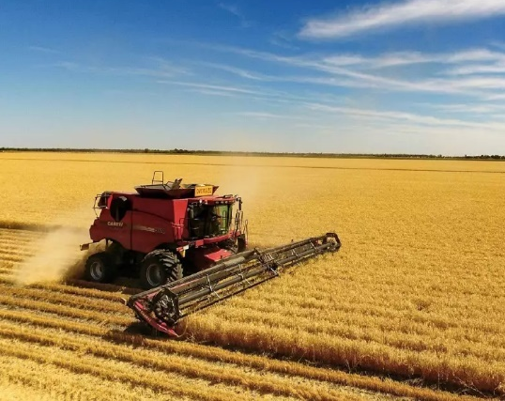
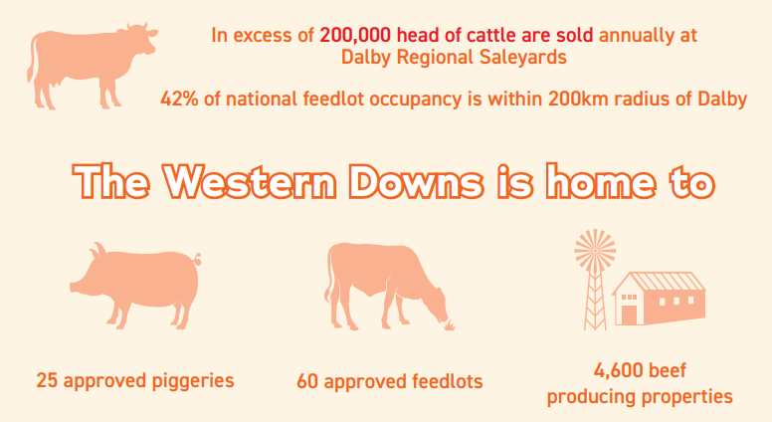
Rural land is used largely for agriculture, particularly grain and cotton growing, with some sheep and cattle grazing and broadacre farming. Forestry and mining are also important industries, with the Western Downs proudly trademarked as the Energy Capital of Queensland, with coal, gas, solar, wind and hydrogen operations.

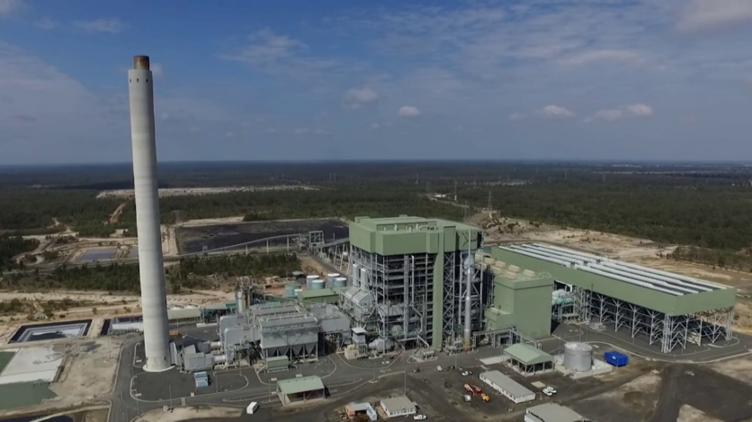
Power Stations
There are six (6) power stations in Dalby disaster district located at Braemar, Condamine, Daandine and Kogan Creek
- Kogan Creek Power Station owned by CS Energy located near Chinchilla
- Darling Downs Power Station owned by Origin Energy located west of Dalby
- Braemar 1 Power Station owned by Alinta Energy located in Braemar (25kms SW of Dalby)
- Braemar 2 Power Station owned by Arrow Energy (25 kms SW of Dalby)
- Condamine Power Station owned by Shell QGC located near Miles
- Daandine Power Station owned by APA Group located at Kogan
Kogan Creek Power Station
Surat Gas Project

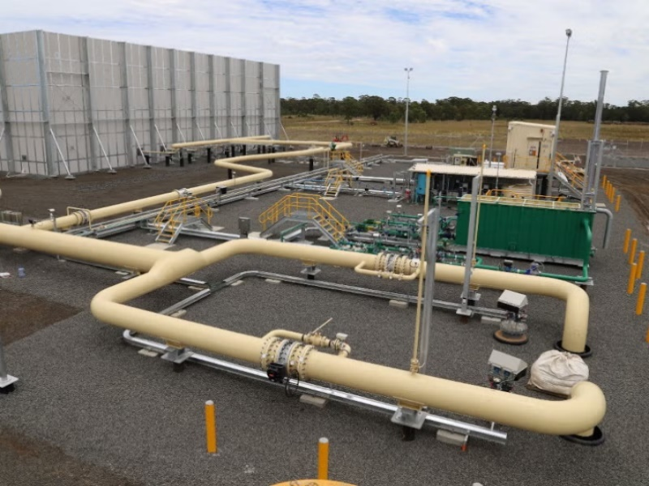
Gas Resources
Coal seam gas is natural gas that is sourced from coal deposits. In Australia major coal seam gas resources are found along the eastern coast in the onshore Surat and Bowen basins.
The Surat Basin district of the Western Downs currently boasts the most coal seam gas activity in the country.

Surat Gas Project – Arrow Energy
Arrow Energy is an integrated coal seam gas (CSG) company that develops gas fields, produces and sells CSG and generates electricity. The company has been producing and selling gas from the Surat Basin since 2006. Construction on the first phase of the Surat Gas Project started in late 2020. More than 600 wells are being developed in this initial phase.

Talinga Orana Gas Gathering Station (TOGGS)
The TOGGS is now operational and enable Origin Energy to maximise coal seam gas (CSG) production from the Talinga and Orana gas fields in the Surat Basin. Located approximately 30kms south-west of Chinchilla, TOGGS is a dual train gas gathering station consisting of two (2) electric motor-driven compressor trains. There are more than 111 CSG wells across the field and produces at around 98 terajoules of gas per day.

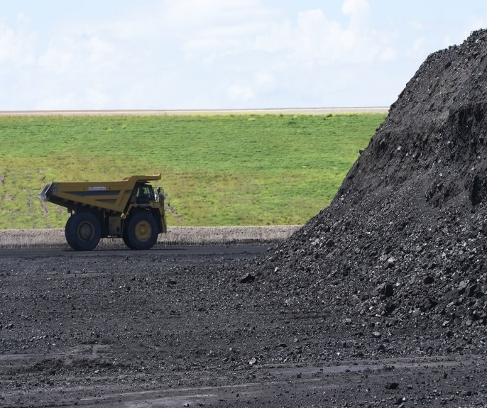
Coal
CS Energy’s Kogan Creek open cut black coal mine located near Chinchilla commenced operations in 2007 to supply coal to the adjacent Kogan Creek Power Station.
Cameby Downs is an open cut operation located 16kms east of Miles. It is owned and operated by Syntech Resources and is managed by Yancoal. The mine produces a low ash export thermal coal. The coal from Cameby Downs Mine is loaded onto trains, for transport to the Port of Brisbane for export.
Kogan Creek Open Cut Mine

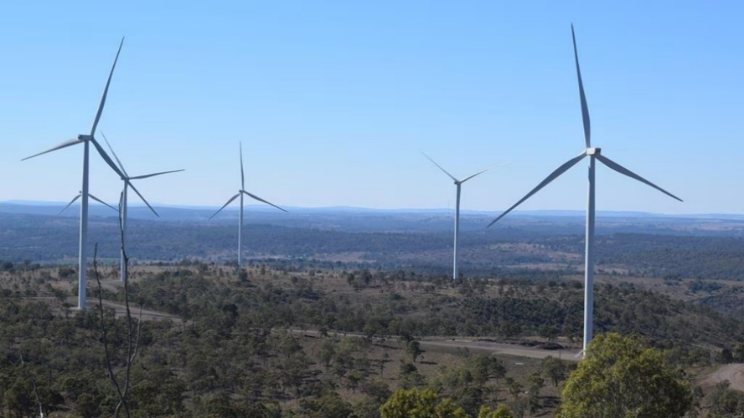
Wind Farms
- Wambo Wind Farm - owned by Cubico Sustainable Investments located near Jandowae (110 wind turbines) Stage 2 under construction with total of 42 towers and battery storage
- Coopers Gap Wind Farm - owned by AGL located near Dalby is one of Australia’s largest wind farm (123 wind turbines)
- Dulacca Wind Farm - owned by RES Group located near Dulacca (43 wind turbines), this site will include a wind and battery energy storage facility

Wambo Wind Farm

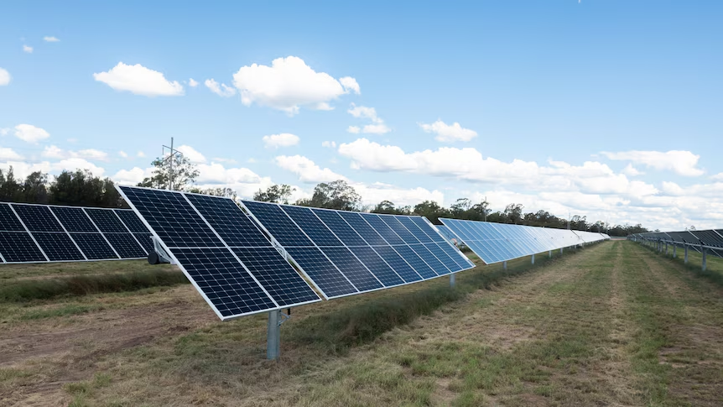
Solar Energy
Currently there are four (4) fully operational solar farms in the region, currently 10 under construction
- Western Downs Green Power Hub- owned by Neoen Australia located in Hopeland (south of Brigalow).
- Gangarri Solar Project- owned by Shell Australia located near Wolebee (near Wandoan)
- Darling Downs Solar Farm- owned by APA located near Dalby.
- Chinchilla Solar Farm- owned by Diamond Energy located near Chinchilla

Darling Downs Solar Farm

Clean Hydrogen Energy
The Western Downs region is excited to play its part in a globally significant hydrogen industry.
Kogan Clean Energy Hub is located within the Kogan Creek Power Station and currently operates two (2) hydrogen projects
- Brigalow Power Plant – hydrogen- ready, natural gas power station
- Kogan Renewable Hydrogen Demonstration Plant – includes solar farm, battery, hydrogen electrolyser, hydrogen fuel cells, storage and loading facility.
Refer to Power Plant map in Annexure I.
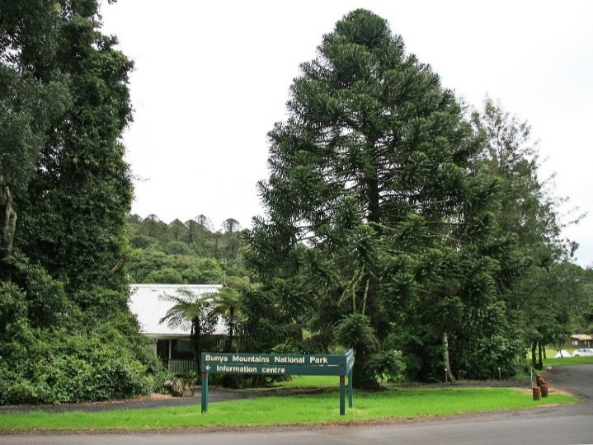

Forestry and National Parks
The region boasts some expansive forested areas which subsequently carry a large bushfire risk. The Barakula, Jarrah, Nudley, Diamondy and Kumbarrila State Forests, Bunya Mountains, Erringibba and Southwood National Parks and Broadwater Conservation Park, as well as numerous wooded areas around the region are closely monitored for bushfire risk. Although most of these areas are not highly populated the forested areas around Tara Estates and Bunya Mountains are considered the highest risk to property and life.

Rivers, Creeks and Tributaries
The Western Downs region is significantly impacted by flood risks due to its geographical and climatic conditions. The area is crisscrossed by several rivers and creeks, including the Condamine River, Myall Creek, and Charley’s Creek.
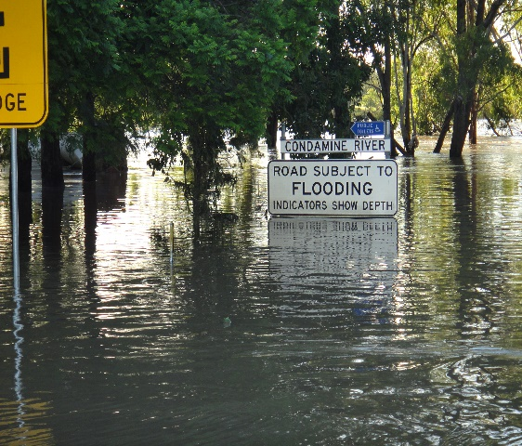
A large part of the Dalby District is located on the floodplain of the Condamine River and its tributaries, and the Town of Dalby is located on the floodplain of Myall Creek, areas are characterised by low gradients with floodwaters being widespread.
Tara District is located on the Western Downs at the headwaters of the Undulla Creek, Moonie River and Weir River systems. History of periodic flooding in low lying areas, associated with heavy storm run- off rains. Communities such as Flinton, Meandarra and The Gums, within the district can also be isolated.
Moonie River,
Condamine River – Balonne Basin Map
Upper Condamine River
Queensland River Basin and Weather Forecast Districts

Climate and Weather
Western Downs has a sub-tropical climate with hot summers, frosty winters, and significant rainfall. The region experiences a range of temperatures throughout the year. The average high temperature is around 29C, while the average low temperature drops 12C in coldest months. It is not uncommon to experience temperatures between 2C- 31C with lows in areas going below freezing. The average rainfall for Western Downs area is approximately 526m per year.

Referable Dams
The Dalby Disaster District has (or is potentially) affected by referable dams, Western Downs dams include Jandowae Water Supply Dam, Chinchilla Weir, Riverside Dam, Narlagoon Dam.
A Referrable Dam is defined within the Water Supply (Safety and Reliability) Act 2008 as
A dam, or proposed dam after its construction will be a referable dam if –
- A failure impact assessment of the dam, or the proposed dam, is required to be carried out under the Act; and
- The assessment states that dam has, or the proposed dam after its construction will have, a category 1 or category 2 failure impact rating; and
- The chief executive has, under section 349 of the Act, accepted the assessment
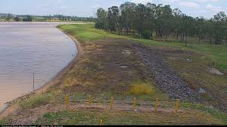
The role of the DDMG is to assist the LDMG in managing the event.
The source of flooding comes from Jandowae. Jinghi, Downfall and Cooranga creeks. These creeks arise in the Bunya Mountains and spill out onto the flood plains to the west. Jandowae creek passes through the town of Jandowae and only has 3-4 hours warning. Referable Dam by legislation sits on the Jandowae creek above the town. In case of major flooding, Jandowae may be isolated for 24 hours – to the north of Jinghi Creek and to the south by Downfall Creek.
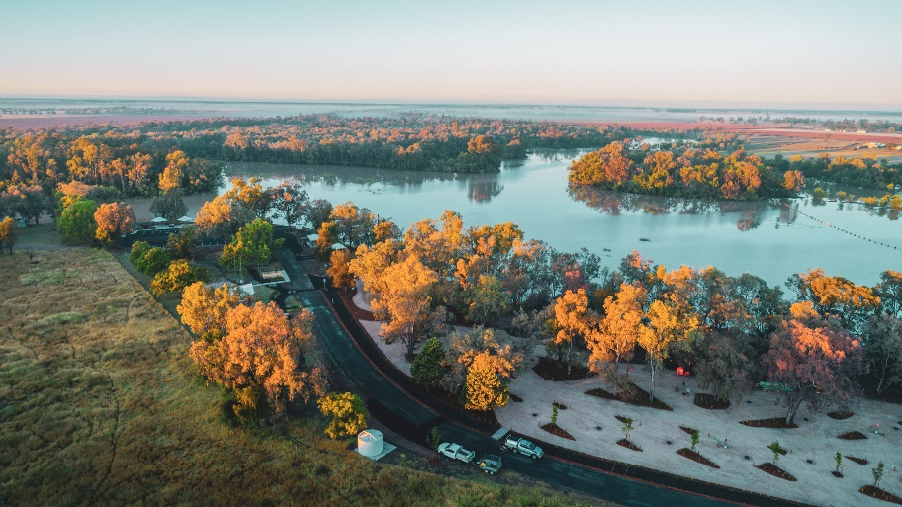
Jandowae

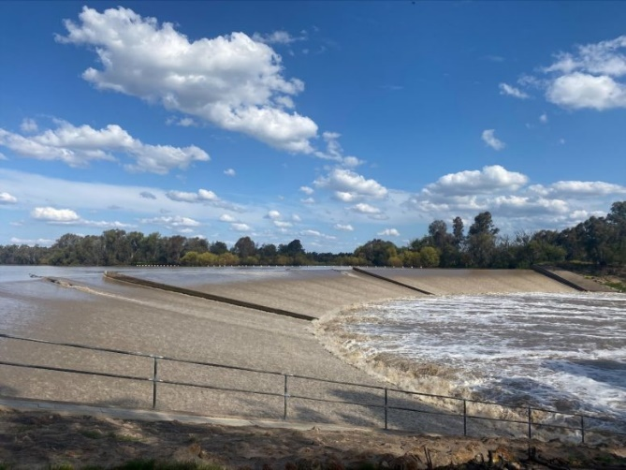
Chinchilla Weir

Chinchilla Weir eight (8) kilometres south of Chinchilla with the purpose of providing irrigation water to the farming flats of the Condamine River, as well as boosting the water supply to the town. A uniquely curved concrete- faced earth fill structure which can hold a full supply volume of 9,780 megalitres and a minimum of 120 megalitres. Sunwater now operate the Chinchilla weir.

Disaster Risk Overview

Disaster risk management governance from local, to district, to State, to Commonwealth, is a foundation of the Queensland’s disaster management arrangements. The intent of the arrangements is to minimise the impact of hazards on local communities by ensuring a coordinated approach towards risk management.
The Queensland Reconstruction Authority (QRA) is responsible for leading Queensland’s State- level hazard and risk functions, which includes reviewing the disaster risk management space in Queensland and re-designing the State risk assessment methodology.
There are key disaster risk assessment methodologies currently used in Queensland:
- National Emergency Risk Assessment Guidelines (NERAG)
- Sendai Framework for Disaster Risk Reduction 2015-2030
- Queensland Emergency Risk Management Framework (QERMF)
The Dalby DDMG uses the Queensland Emergency Risk Management Framework (QERMF), the methodology for assessing disaster related risk. Based upon the QERMF each local government has assessed the risks to their area as well as having identified any appropriate mitigation strategies that may be implemented. Reducing exposure to hazards, lessening vulnerability of people and property, managing land and the environment, improving preparedness and early warning for adverse events are all examples of disaster risk reduction.

Hazard Specific Arrangements
Whilst Queensland has adopted an all-hazards approach to the development of disaster management arrangements, it is important to acknowledge some hazards have characteristics that may require a hazard specific approach. Hazard specific plans are developed by associated agencies, which form appendices to and should be read as complementing this plan. The Dalby DDMG adopts the itemisation of these hazard specific plans within the SDMP at the district level.
The primary agency and specific hazard plans see Annexure J
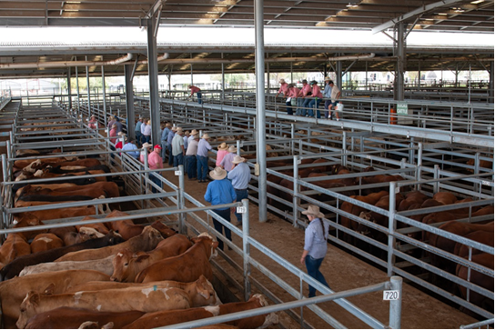
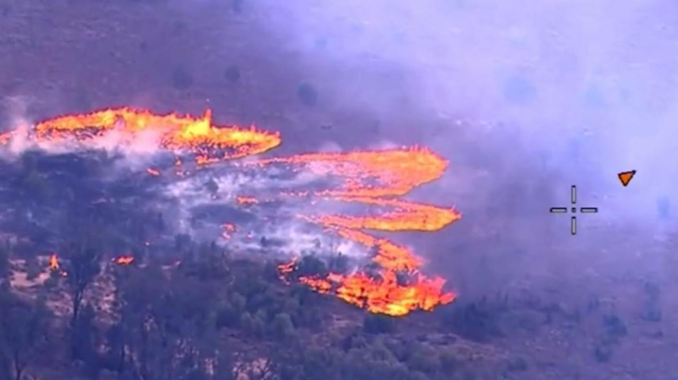
The following table provides an overview of the prioritised 2026 district risk reduction hazards.
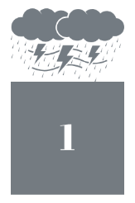  Severe Thunderstorm  Severe thunderstorms have historically been one of the district’s most damaging natural hazards.  Typically, these storms often with heavy rain or hail and high winds causing severe damage in the path of the front. The risk is considered moderate with main problems being localised flooding, damage to crops, building damage & disruption to power supplies. Lightning strikes during storms may also cause power outages and start bushfires | Flooding    Western Downs region is significantly impacted by flood risks due to its geographical and climate conditions. The area is crisscrossed by several rivers and creeks, which are prone to overflowing during heavy rainfall events. The region’s flat topography can exacerbate flooding, as water trends to spread over large areas, affecting both urban and rural communities. Managing the risks associated with flooding is the second highest priority for the district.
  Bushfire  Western Downs region’s susceptibility to bushfires is largely attributed to its extensive rural landscapes, which encompass vast areas of agricultural land, forests, and grasslands. These areas often contain significant amounts of dry vegetation, which can act as fuel for fires, especially during the hot and dry seasons. The region’s topography, with its mix of flat plains and undulating hills, can also facilitate the rapid spread of fires, posing significant risk to both the natural environment and the communities within the Western Downs. | 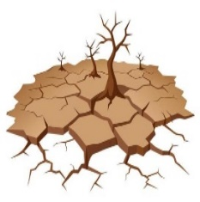  Prolonged Drought  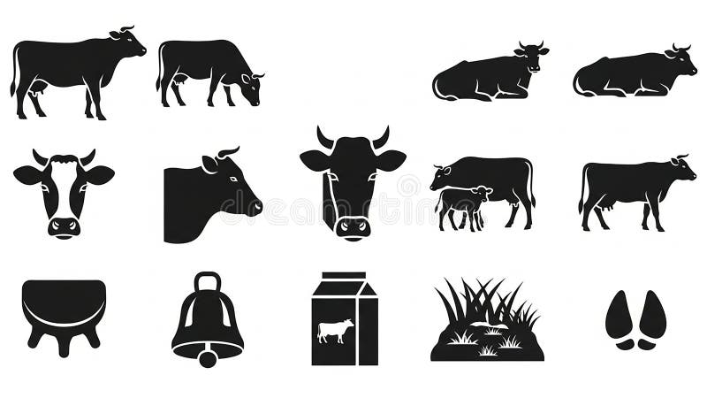  Droughts are extreme climatic events that can have a serious impact on health, agriculture, economics, energy, and the environment. Western Downs could have severe impacts for agricultural and grain production. 42% of the national feedlot is located within 200km radius of Dalby. Dalby is second largest cattle saleyards in Australia. Note: although identified in the district risk assessment, drought is not considered a ‘natural disaster’ in Queensland
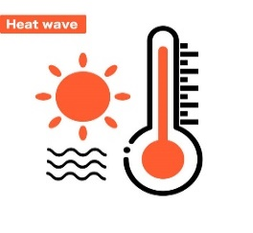  Heatwave  Heatwaves, arguably due to their less violent, slower onset and less publicised nature, have only more recently begun to be recognised at a true level of risk. Heatwaves kill more Queenslanders every year than any other natural disaster. |   Pandemic -Epidemic  Until the emergence of the COVID-19 Pandemic in 2020, epidemic and pandemic diseases were not considered high priority in Queensland. The importance of globally dependent industries to Queensland’s economy, future pandemics will pose a significant risk for Queensland, and lessons from the most recent pandemic will assist in ensuring that Queensland is prepared.
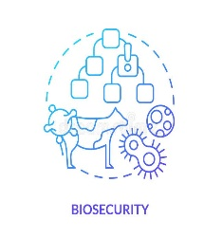  Biosecurity Emergency  Exotic Animal or Plant Disease  An outbreak in the Western Downs region could have severe impacts. Agricultural sector, which is a cornerstone of the local economy, an outbreak could lead to significant losses in livestock and crop yields. Diseases affecting animals, could result in the culling of large numbers of livestock, to prevent the spread, causing financial strain, disrupting the supply chain. | Chemical, Biological or Radiological Incident  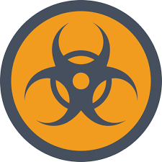  CBR events can have potentially catastrophic consequences. A substance spill in the Western Downs region could have severe environmental, economic, and social impacts. Environmentally, a spill could contaminate soil, water sources, and local ecosystems, leading to long-term damage to flora and fauna. Can disrupt agricultural activities, as the soil and water quality would be comprised, affecting crop yields and livestock health.
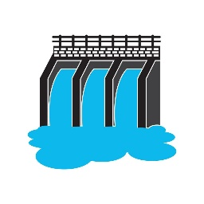  Dam Failure  In event of a dam failure, the potential energy of water stored behind the dam can cause significant damage to property and livelihoods. Sunny day failures, caused by erosion, seepage, piping, failure of spillway or another event pose threats in line with traditional dam failures. Western Downs regional dams: Jandowae Water Supply Dam, Chinchilla Weir, Riverside Dam, Narlagoon Dam | Earthquake    Whilst there is a low percentage chance of an earthquake impacting the disaster district, any significant seismic activity would likely result in high consequence.  Western Downs, located in the stable continental interior, experience very little seismic activity. Since 1970, Dalby has had seven (7) quakes of magnitudes above 2 and up to 3.9 within up to 100km distance
Major Passenger Transport Accident (Road/Rail)  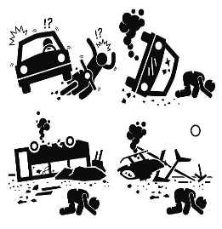  Road  Heavy volumes of traffic use the Leichardt, Moonie and Warrego Highways which include heavy transport vehicles carrying all types of general goods and hazardous chemicals together with multi-passenger vehicles. There is no hazardous bypass for Dalby. The potential exists for multiple casualty accident which may be beyond the resources of the emergency services.  Rail  As rail is utilised as commercial, passenger and industry products including hazmat materials, the risk is moderate as it is the gateway to the west from Brisbane. | Terrorism      Since 2014, various counter-terrorism disruption operations have been executed across Queensland. The Queensland Counter -terrorism Plan is a ‘hazard specific’ plan. Critical infrastructure provides services that are essential for everyday life such as energy, food, water, transport, communications, health and banking and finance. A disruption to critical infrastructure could have serious implications for business, government and community, impacting supply security and service continuity. The National body is the National Counter-Terrorism Committee. Governments at every level are working closely with the Australian community to prevent terrorism and violent extremism, combat online violent extremist content and promote early intervention programs.

Prevention Strategies
Prevention and mitigation reduce the likelihood of a disaster event occurring or the severity of an event should it eventuate. The implementation of proactive, targeted prevention and mitigation strategies designed to address likely risk factors, the vulnerability or the population and reduce or eliminate the possible impact of disasters ultimately ensures safer, more resilient, and sustainable communities.
All agencies within the district have a responsibility to identify risks and consider treatment options to mitigate against disasters. Agencies with specific responsibility to influence mitigation should actively seek to do so with the full support of other agencies.
This may include, but is not limited to:
- Infrastructure design and planning
- Road development/ redevelopment
- Land clearing considerations
- Community education and awareness
In accordance with the Queensland Strategy for Disaster Resilience 2022-2027, resilience, in a disaster management context, can be referred to as, a system or community’s ability to rapidly accommodate and recover from the impacts of hazards, restore essential structures and desired functionality, and adapt to new circumstances.

Preparedness Strategies
Preparedness is crucial in disaster situations to ensure consequences are as minimal as possible and the response is optimum. Coordinated action from member agencies of the DDMG ensure timely and effective response and an increase in community safety. All member agencies have a responsibility to undertake preparedness activities both within their agency and as part of the DDMG.

Local focus and disaster management capability
Local governments are primarily responsible for managing events in their local government area through their Local Disaster Management Group (LDMG). Local level capability forms the frontline of disaster management. Local governments, through their LDMG, are primarily responsible for mitigating, preventing, preparing for, responding to, and recovery from a disaster in the local area.

Hazard Specific Plans
Hazard specific plans:
- Address the hazard actions all phases of disaster management
- Include information on how Queensland’s disaster management arrangements link with the hazard specific arrangements
- Support the primary agency to manage the hazard specific event
At State level, primary agencies are identified for a range of hazards and are responsible for the development of a hazard specific plan, in consultation with affected stakeholders. Hazard specific primary agencies have a responsibility to communicate and maintain relations with national hazard specific counterparts.
Specific Hazards with corresponding primary agencies and plans see annexure J.

Support by District and State Groups
LDMG’s are supported by their relevant DDMG and the QDMC. This support may constitute technical, financial, or material resources, and is provided when required or requested by the LDMG. The purpose of this support is to enable LDMG to undertake disaster management across the Prevention, Preparedness, Response and Recovery spectrum.
Ongoing support is provided through representation at local and district levels by officers from relevant government departments, government owned corporations, representatives from non-government, not- for-profit organisations, essential service providers and private organisations or subject matter experts as needed.

State Disaster Coordinator intent
Clear focus on community safety across the four phases of Prevention, Preparation, Response and Recovery, the Queensland State Disaster Coordinator (SDC) has listed priorities for the 2025- 2026 Higher Risk Weather Season.

- Protection of Life - Ensure, as far as reasonably practicable, that preventable deaths do not occur through proactive disaster management actions and timely interventions.
- Protection of Property - Minimise the loss or damage of property by ensuring that appropriate preparedness and mitigation measures are in place across affected communities and sectors
- Critical Infrastructure – Protect and enable the rapid restoration of critical infrastructure services (including power, water, sewage and communications).
- Recovery - Facilitate and expedite the transition to recovery operations, supporting affected communities in line with the State Recovery and Resilience Plan to ensure timely and sustainable recovery outcomes.

Capacity Building
People performing functions under the Disaster Management Act 2003 are required to be appropriately skilled, trained and practiced so they are ready to enable response and recovery activities. This is achieved through:
- Training and education
- Exercising
- Lessons management

Training and Education
Disaster management training has been identified as an essential means through which agencies can develop and maintain their disaster management capabilities and capacity. Training and
Education can provide the knowledge, skills and attitudes required to address the issues of disaster management through prevention, preparedness, response, and recovery. Furthermore, training is important in ensuring that all agencies can seamlessly integrate their arrangements and contribute to an effective and coordinated disaster management response.

It is a requirement under s16A(c) Disaster Management Act 2003, for all those performing functions in relation to disaster operations are appropriately trained. This legislative obligation is achieved through the Queensland Disaster Management Training Framework (QDMTF). All DDMG members must undertake training in accordance with this Framework.

The Queensland Police Service Emergency Management Coordinators (EMC) are responsible for ensuring a coordinated approach to disaster management training within the Dalby district. The EMC will develop a suitable training program for the district, where practicable, will maximise opportunities for joint multiagency training with the LDMG, other agencies and stakeholders.

Exercises
Exercises are a key component of disaster management strategies and are conducted with the objective of:
- practicing the coordination procedures during an event including
  - activation of Disaster Management Groups
  - activation of District Disaster Coordination Centres
  - information management including dissemination of information in respect to threats and warnings, request for assistance and providing situation reports
- enhancing the interoperability of agency representatives
- evaluating emergency plans
- identifying planning and resource issues
- promoting awareness
- developing competence
- evaluating risk treatment strategies
- identifying performance gaps and areas for the potential improvement in the skills of agency representatives involved in disaster management
- evaluating equipment, techniques and processes in general

The Dalby DDMG will conduct a least one (1) exercise annually, to include all core members of the Dalby DDMG. Immediately on completion of exercises, hot debriefs will be conducted to identify issues and areas for improvement. A more detailed ‘After Action Review’ is to be conducted, addressing the ‘exercise design and conduct’ and the ‘response to the scenario’. The exercise review should identify recommendations for future action and improvements.

However, if the DDMG activates in an operational capacity, an annual exercise is not required.

Lessons Learnt Management Process
Dalby DDMG recognises the importance of lessons management for driving continuous improvement across disaster prevention, preparedness, response and recovery. Dalby DDMG adheres to the Queensland Disaster Management Lessons Management Framework. Lesson management refers to collecting, analysing, disseminating, and applying learning experiences from events, exercises, programs and reviews. The framework provides strategies that capture observations, nurtures insight, identifies lessons and allows learnings. This process is known as the OILL Process (Observation, Insight, Lesson Identified, Lesson learned.

Observation: - A record of a noteworthy fact or occurrence someone has heard, seen, noticed, or experienced as an opportunity for improvement or an example of good practice.
Insight: - A deduction drawn from the evidence collected (observations), which needs to be further considered. An insight defines the issue, not the solution.
Lesson Identified: - A conclusion with a determined root cause based on the analysis of one or more insights and a viable course of action that can either sustain a positive action or address an area for improvement.
Lesson Learned: - A lesson is learned when the approved change is implemented and embedded in the organisation. Depending on the changes required it may take several years for the change to be institutionalised across the organisation.

Response Strategies
Disaster response involves taking appropriate measures to respond to an event, which includes action taken and measures planned before, during and immediately after an event, to ensure that its effects are minimised, and persons affected by the event are given relief and support.
These response measures will often involve multiple organisations simultaneously engaging in response functions. The DDC should determine when, and to what extent, the DDMG should activate in support of an event, and may bypass initial levels of activation where appropriate to the event. Activation is scalable and does not necessarily mean the convening of all members of the DDMG or the activation of the DDCC. Activation activities can be as minimal as the provision of information of the DDMG members regarding the risks associated with a potential or imminent hazard impact.

Levels of Activation
Activation of response arrangements will occur in accordance with a four-level model: Alert, Lean Forward, Stand Up and Stand Down.
These levels of activation drive response activity and guide the scale of response.
Levels of activation and relevant triggers are detailed in annexure K.

Disaster Coordination Centres
Dalby District Disaster Coordination Centre (DDCC) operationalises the strategic intent of the DDMG and will be activated to coordinate the management of resources as part of the whole-of – government approach in the Dalby Disaster District, in the event of a disaster which is threatening or impacting upon the area. Depending on the scale of the event coordination centres have the capability to coordinate resources, gather, and disseminate information and act as the conduit for the escalation of requests for additional resources.
The Dalby DDCC has Standing Operating Procedures (SOP’s) and an Operations Manual. These documents are held by the Executive Officer. Both documents are to be reviewed annually by the XO or at the conclusion of any activation where an issue or deficiency is identified.
Liaison Officers (LOs) may be appointed to coordination centres, as determined by the relevant group. LOs are the point of contact between the coordination centre and their parent agency during disaster operations. They have the following key responsibilities:
- Coordinating requests for assistance applicable to their agency (LOs must be at an appropriate level to commit agency resources)
- Providing advice and assistance on their agency’s tasks, capabilities, and resources
- Communicating situation awareness to their agency
The location of the District Disaster Coordination Centre will be determined by the DDC in consultation with the LDC and appropriate members of the DDMG. DDCC staff and DDMG members will be advised of the location when the DDMG moves to Lean Forward statue.

The primary DDCC is located at: Dalby Police Complex, Dalby District Office, Training Room
47 Drayton Street, Dalby, Qld

The alternate DDCC is located at: as nominated by DDC

Public Information
Consistent, timely and accurate information better enables communities to prepare for, respond to and recover from disasters. Communities need to know what is likely to happen (or has happened), what to expect, and what to do.

Collating, integrating and delivering information that enhances a community’s awareness of events that may occur or are occurring, and providing advice on appropriate actions to be taken, contributes to safeguarding life, property, and the environment.

Communication by Local and District Groups
Local and district groups must communicate with their respective communities. Keeping the community well informed contributes to their ability to prepare for, respond to, and recover from a disaster and assists with managing community expectations.

Media
Media play a crucial role before, during and after disaster events. The media are essential, for example, for warning to be effective and may be the single most important source of public information in the wake of a disaster.

Social Media
Social media allows the instant dissemination of important information in real time. On the one hand, emergency services or hazard lead agencies can send out alerts, share updates and safety tips. On the other hand, social media also provides rapid feedback from the witnesses of the events and transmit request for help.

Also, in times of disaster events, people use social media form humour and levity, to determine disaster magnitude, to check in with people in their networks, to self-mobilize, to maintain a sense of community, and to seek emotional support and healing.

Disinformation and Misinformation
Disinformation and misinformation in disaster risk communication can significantly increase disaster risk by causing confusion and eroding credibility and trust in disaster risk management practices and disaster responses.
Disinformation is deliberately false information that is shared to deceive or cause harm
Misinformation is incorrect, or misleading information spread without meaning to deceive, which is often shared by people who believe it is true.

Warnings
Queensland uses warnings to enable communities and individuals to act an effective manner, in relation to hazards that may arise.

Bureau of Meteorology Weather Warning
The Australian Government Bureau of Meteorology (BoM) provide Severe Weather Warnings for potentially hazardous or dangerous weather relating to thunderstorms and damaging winds, tropical cyclones, bushfires, and rain and blizzards.

Australian Warning System (AWS)
The AWS is the national approach to information and warnings for hazards (bushfires, flood, cyclone, extreme heat, sever weather, and other). It uses a nationally consistent set of icons to show incidents on websites and apps. Note: The emergency alert phone number is +61 444 444 444

Each warning level has a set of action statement to give community clearer advice about what to do. Calls to Action can be used flexibly across all three warning levels and contextualised for each hazard. Owning hazard leads are responsible for determining the level of warnings issued.

Standard Emergency Warning Signal

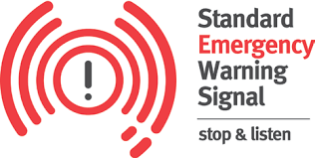
The Standard Emergency Warning Signal (SEWS) is a distinctive audio signal that has been adopted to alert the community to the broadcast of an urgent safety message relating to a major emergency/ disaster. It is intended for use as an alert signal to be played on public media as radio, television, public address systems, mobile sirens.

AusAlert Emergency System
AusAlert is a new national emergency warning system that sends urgent messages to compatible mobile phones and other mobile devices in a specified area. AusAlert brings cell- broadcast to Australian emergency warnings. AusAlert will allow emergency services organisations to send targeted warning messages. The system will be more reliable, accurate and efficient that current systems. This means authorities can reach people quickly when it matters most, keeping Australians informed, system launching in Australia, operational by October 2026.

Response functions
Multiple State agencies are responsible for various disaster response functions within Queensland.
These responsibilities are allocated in accordance with an agency’s role in administering relevant legislation or ability to provide specialise resources. In some circumstances, these agencies will also coordinate with other agencies and organisations to undertake the nominated function.
Roles and responsibilities for Government departments/ agencies, see annexure G.

Disaster Declarations
In accordance with s. 64 of the Disaster Management Act 2003, the District Disaster Coordinator (DDC), with the approval of the Minister, declare a disaster situation for the district, or part of the district. In declaring a disaster situation, the DDC is to be satisfied that a disaster has happened, is happening or is likely to happen and it will be necessary or reasonably likely to be necessary to exercise declared disaster powers to prevent or minimise the loss of human life, illness or injury to humans, property loss or damage, or damage to the environment.
Before declaring a disaster situation, the DDC must take reasonable steps to consult with the DDMG and local government whose area is in, or partly in, the declared area for the disaster situation. A failure to consult does not affect the validity of the declaration (s.64(3) of the Act).
The Minister and Premier may make a disaster declaration for the State, or part of the State.

Operational Reporting
Information management is essential for the operation of the DDCC. Information accuracy and the timely provision of this information assist in decision making and forward planning considerations for the DDMG.
- A LDC shall advise the DDC immediately if there is a change to the level of activation by the LDMG or LDCC
- The DDC shall advise the SDC immediately if there is a change of the activation level by the DDMG or LDCC
- When activated, LDC and DDMG members will provide situation reports (SITREP) on the event and disaster management operations in the approved form to the XO within the timeframes as required
- It is the responsibility of the XO to maintain the Disaster Incident Event Management System (DIEMS) so that the SDCC is provided with situational awareness.

Evacuations
To safeguard the lives of community members it may be necessary for evacuations to occur. LDMG will coordinate evacuations in their area of responsibility. It is the position of the DDMG to support LDMG in taking appropriate measures to undertake an evacuation.
Queensland uses the Australian Red Cross national database system Register.Find.Reunite which assists in locating individuals and responding to enquiries regarding people who may be in a disaster affected area. It is the responsibility of the DDMG organisations to ensure that recording of information regarding potentially displaced persons is consistent with the Register.Find.Reunite process.

Resupply
Resupply is the response to ensure that essential goods remain available to communities, impacted by disaster and/or isolation, through the normal retail arrangements, but the additional cost for the transportation are not passed on to the retailer or consumer. Resupply is not intended to substitute individual and retailer preparation and preparedness. Resupply must be used as a last resort.
The process of resupply operations can be found in the Queensland Resupply Manual.
LDMG will coordinate resupply as part of response operations within their area of responsibility. The Dalby DDMG will support LDMG in resupply operations upon request.

Request for Assistance
The Dalby DDMG does not possess any resource reserves. All resources within the disaster district are owned and managed by various local governments, government departments, corporate entities, or private business operators.
When resources or services are not available within their jurisdiction, or if available, have been or are likely to be expended, a LDMG may request assistance from the DDMG to provide such resources. Request shall be in the approved Request for Assistance (RFA) form.
The DDMG shall make all reasonable endeavours to locate the required resource or service from the within the disaster district. In the event the required resource or service is not available elsewhere in the disaster district, the DDMG shall forward a request, to the SDCC for consideration.

Recovery Strategy
The Queensland Reconstruction Authority (QRA) is responsible for disaster recovery, resilience, and mitigation policy in Queensland. This principle-based strategy is consistent with the Queensland Recovery Plan and has been developed to be flexible and scalable in support of the recovery efforts being driven locally by the Dalby Local Recovery Groups.
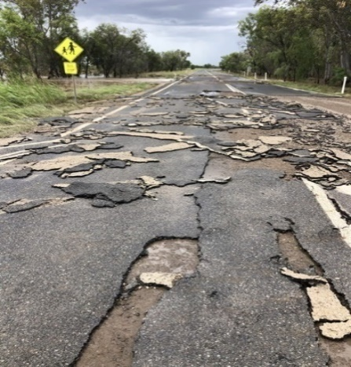
Recovery is complex and often long process. It goes beyond immediate welfare support and includes physical repair and reconstruction, personal rehabilitation, the restoration of social well-being, community development, economic renewal and growth, and regeneration of the natural environment.
Effective recovery requires a range of services and is successful if the services are provided in a coordinated and streamlined way. To achieve this end the structured and effective integration of government agencies, non-government organisations, government-owned corporations, industry groups, the private sector and whole of community is required.
Disaster funding arrangements are outlined in the Queensland Disaster Funding Guidelines 2024 and explain Queensland’s two disaster relief and recovery arrangements: the Disaster Recovery Funding Arrangements (DRFA) and the State Disaster Relief Arrangements (SDRA).

Functional Recovery and Resilience Groups (FRRGs)
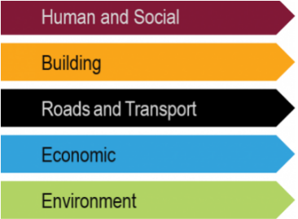
Functional Recovery and Resilience Groups (FRRGs) coordinate and support the planning and implementation of Queensland’s whole- of-community recovery activities across the five functional lines of recovery and resilience – Human and Social, Building, Roads and Transport, Economic and Environment – supporting local government in fulfilling its recovery and resilience objectives, see annexure H.

Review and Assurance

Review and Renew Plan
In accordance with s. 55 of the Disaster Management Act 2003, the District Disaster Management Plan (DDMP) shall be reviewed annually. The DDMP review may be triggered by a number of reasons including but not limited to the annual Inspector General of Emergency Management (IGEM) review, State Plan updated, District Plan update, an event debriefs or independent review. The review and assessment process for the DDMP will be reflected in amendment register.

Review of Local Disaster Management Arrangements
In accordance with s. 23(d) of the Disaster Management Act 2003, it is a function of the DDMG to regularly review and access the disaster management of local group in the district.
It will be the responsibility of Western Downs Regional Council to annually review their local disaster management arrangements, including their respective Local Disaster Management Plans, as well as sub-plans. The review and assessment process should be in consultation with the XO and EMC.

A map of the Dalby DDMG and LDMG boundaries are included in Annexure F.

Post Disaster Assessment
To aid the development of effective disaster management for the district, the Dalby DDMG may conduct a post-disaster assessment. The assessment will review operational activities undertaken during a disaster, and is a key component in ensuring capability development and the continuous improvement of disaster management arrangements.
Post- disaster reviews are conducted to:
- Assess disaster operations undertaken for a given disaster including actions, decisions or processes.
- Document those processes that worked well and identify a course of action to ensure that they are capture and updated in relevant doctrine for use in the next operation; and
- Assess capability and consider where additional training and/or exercises may enhance capability.

Annexure A. Amendment Register

No/Ref | Issue Date | Inserted By | Comments
1 | 27/04/2026 | JV CHRISTENSEN | - Full rewrite,  - Review and update DDC and Executive Officer  - MoG updated completed

Annexure B. Abbreviation and Acronyms
ADF | Australian Defence Force | ARC | Australian Red Cross
AUSVETPLAN | Australian Veterinary Plan | BoM | Bureau of Meteorology
DFSDSCS | Department of Families, Seniors, Disability Services and Child Safety | DDC | District Disaster Coordinator
DDCC | District Disaster Coordination Centre | DDMG | District Disaster Management Group
DDMP | District Disaster Management Plan | DoE | Department of Education
DETSI | Department of Environment, Tourism, Science and Innovation | DHPW | Department of Housing and Public Works
DIEMS | Disaster Incident and Event Management System | DJ | Department of Justice
DLGWV | Department of Local Government, Water and Volunteers | DM Act | Disaster Management Act 2003 (Qld)
DM Regulation | Disaster Management Regulation 2014 | DNRMMRRD | Department of Natural Resources and Mines, Manufacturing and Regional and Rural Development
DPI | Department of Primary Industries | DRC | District Recovery Coordinator
DRFA | Disaster Recovery Funding Arrangements | DRG | District Recovery Group
DSDIP | Department of State Development, Infrastructure and Planning | DTET | Department of Trade, Employment and Training
DTMR | Department of Transport and Main Roads | DWATSIPM | Department of Women, Aboriginal and Torres Strait Islander Partnerships and Multiculturalism
DYJVS | Department of Youth Justice and Victim Support | EAP | Emergency Action Plan
EMAF | Emergency Management Assurance Framework | EOC | Emergency Operations Centre (Commonwealth)
HHS | Hospital and Health Service | IGEM | Inspector General Emergency Management
LDC | Local Disaster Coordinator | LDCC | Local Disaster Coordination Centre
LDMG | Local Disaster Management Group | LDMP | Local Disaster Management Plan
MRQ | Marine Rescue Queensland | NEMA | National Emergency Management Australia
PHN | Public Health Network | PPRR | Prevention, Preparedness, Response and Recovery
QAS | Queensland Ambulance Service | QCCAP | Queensland Coastal Contingency Action Plan
QCS | Queensland Corrective Services | QDMA | Queensland Disaster Management Arrangements
QDMC | Queensland Disaster Management Committee | QDMTF | Queensland Disaster Management Training Framework
QFD | Queensland Fire Department | QH | Queensland Health
QPS | Queensland Police Service | QR | Queensland Rail
SDC | State Disaster Coordinator | SDCC | State Disaster Coordination Centre
SDCG | State Disaster Coordination Group | SDMP | State Disaster Management Plan
SDRA | State Disaster Relief Arrangements | SES | State Emergency Services
SEWS | Standard Emergency Warning Signal | SOP | Standing Operating Procedure
XO | Executive Officer

Annexure C. Definitions
Advisor | A person invited to participate in the business of the DDMG in an advisory capacity on an as-needed basis.
Chairperson | State Group – the person prescribed by regulation under section 20 Disaster Management Act 2003 (DM Act)  District Group – the person prescribed by regulation under section 25 DM Act  Local Group – the person prescribed by regulation under section 34 DM Act
Coordination | The bringing together of organisations to ensure effective disaster management before, during and after an event. It is primarily concerned with systematic acquisition and application of resources (people, material, equipment, etc) in accordance with priorities set by disaster management groups. Coordination operations horizontally across organisations and agencies.
Declared Area | Declared Area means –  - for a disaster situation declared under s.64(1)DM Act – the disaster district, for which the disaster situation is declared; or  - for a disaster situation declared under s.69 DM Act – the State or, if the disaster situation is declared for a part of the State, the part.
Declared Disaster Officer | For disaster situation, means –  - a police officer; or  - a person authorised under s.75(1) DM Act to exercise declared disaster powers for the disaster situation
Declared Disaster Powers | Declared disaster powers means the powers of a District Disaster Coordinator or a declared disaster officer under s.77 and s.78 DM Act
Deputy Chair | The person appointed under s.25 DM Act as the Deputy Chairperson of the DDMG.
Disaster | A serious disruption to the community, caused by the impact of an event, that requires a significant coordinated response by the state and other entities to help the community recover from the disruption. (s13(1) DM Act)
Disaster District | Part of the state prescribed under a regulation as a disaster district.
Disaster Management | Arrangements about managing the potential adverse effect of an event, including, for example, arrangements for mitigating, preventing, preparing for, responding to, and recovering from a disaster (s14 DM Act).
Disaster Management Group | One of or a number of any of the following: the QDMC, DDMGs or LDMGs.
Disaster Management Strategic Policy Framework | A strategic tool which identifies principles that guide the development and implementation of policy and initiatives to achieve disaster management priorities.
Disaster Mitigation | The taking of preventative measures to reduce the likelihood of an event occurring or, if an event occurs, to reduce the severity of the event.
Disaster Operations | Activities undertaken before, during or after an event happens to help reduce loss of human life, illness or injury to humans, property loss or damage, or damage to the environment, including, for example, activities to mitigate the adverse effects of the event (s15 DM Act)
Disaster Response | The taking of appropriate measures to respond to an event, including action taken and measures planned in anticipation of, during, and immediately after an event to ensure that its effects are minimised and that persons affected by the event are given immediate relief and support.
Disaster Response Operations | The phase of disaster operations that relates to responding to a disaster.
Disaster Recovery Operations | Disaster recovery operations are defined as: (Schedule, DM Act)  -Generally – the phase of disaster operations relating to recovery from disasters; or  -For a disaster – the phase of disaster operations relating to recovering from the disaster
Disaster Risk Assessment | The process used to determine risk management priorities by evaluating and comparing the level of risk against predetermined standards, target risk levels or other criteria.  (COAG, Natural Disasters in Australia: Reforming mitigation, relief, and recovery arrangements: 2002).
Disaster District Coordinator | A person appointed under s.25A DM Act who is responsible for the coordination of disaster operations in the disaster district for the DDMG.
District Disaster Management Group | The group established in accordance with s.22 DM Act to provide coordinated State Government support and resources to LDMGs on behalf of local governments.
District Disaster Management Plan | A plan prepared in accordance with s.53 DM Act, that documents planning and resource management to counter the effects of a disaster within the disaster district.
Emergency Management Assurance Framework | The EMAF provides the foundation for guiding and supporting the continuous improvement of entities, disaster management programs across all phases of disaster management. The framework also provides the structure and mechanism for reviewing and assessing the effectiveness of Queensland Disaster Management Arrangements.
Event | (1) Any of the following:  - a cyclone, earthquake, flood, storm, storm tide, tornado, tsunami, volcanic eruption or other natural happening  - an explosion or fire, a chemical, fuel or oil spill, or a gas leak  - an infestation, plague, or epidemic (example of an epidemic – a prevalence of foot-and-mouth disease)  - a failure of, or disruption to, an essential service or infrastructure  - an attack against the state  - another event similar to an event mentioned in (a) to (e).  (2) An event may be natural or caused by human acts or omissions. (s 16 DM Act)
Executive Officer (XO) DDMG | The person appointed by the Commissioner of QPS as the XO of the DDMG. (s.27 DM Act)
Extraordinary Meeting | A meeting convened by the Chairperson in response to an operational event both inside and outside the disaster district.
Functional Lead Agency | An agency allocated responsibility to prepare for and provide a disaster management function and lead relevant organisations that provide a supporting role.
Guidelines | Guidelines are developed under s.63 DM Act to inform the QDMC, DDMGs and local governments about the preparation of disaster management plans, matters to be included in disaster management plans and other appropriate matters about the operation of a DDMG or LDMG.
Hazard | A source of potential harm, or a situation with a potential to cause loss. (EMA 2004).
Local Disaster Coordinator | A person appointed under s.35 of the DM Act who is responsible for the coordination of disaster operations for the LDMG.
Local Disaster Management Group | The group established in accordance with s. 29 of the DM Act to support the disaster management and operational activities of local governments. The specific functions of the LDMG are outlined in s. 30 of the DM
Local Disaster Management Plan | A plan that documents agreed arrangements that are in place to deal with disaster events within its area of responsibilities.
Member | A person officially appointed as a member of the DDMG. Members have voting rights to validate the business of the group.
Minister | Minister for Police and Emergency Services.
Ordinary Meeting | A DDMG meeting which is scheduled and convened on a regular basis at an agreed time (set by the Chairperson) to discuss routine business of the group.
Post-Disaster Assessment | Addresses performance during and the risks revealed by a disaster event in order to improve future development of mitigation measures. Post-disaster assessment forms part of continuous improvement of the whole system. (Adapted from COAG, Natural Disasters in Australia: Reforming Mitigation, Relief and Recovery Arrangements: 2002).
Primary Agency | An agency allocated responsibility to prepare for and respond to a specific hazard based on their legislated and/or technical capability and authority.
Queensland Disaster Management Arrangements | Whole-of-Government arrangements to ensure the collaborative and effective coordination of planning, services, information, and resources for comprehensive disaster management (referred to as ‘QDMA’)
Queensland Disaster Management Committee | The group established in accordance with s.17 of the DM Act who is responsible for disaster management and operational arrangements for the state of Queensland. The specific functions of the QDMC are outlined in s.18 of the DM Act.
Quorum | The minimum number of DDMG members required to validate the business of the group.
Recovery | The taking of preventative measures to recover from an event, including action taken to support disaster-affected communities in the reconstruction of infrastructure, the restoration of emotional, social, economic, and physical wellbeing, and the restoration of the environment.
Relief | The provision of immediate shelter, life support and human needs of persons affected by, or responding to, an emergency.
Residual Risk | The risk remaining after risk treatment. Residual risk can contain unidentified risk. Residual risk can also be known as ‘retained risk’.  (ISO Guide 73:2009 Risk management - Vocabulary)
Resilience | Resilience of a community means the ability of the community and its systems:  - To recover from the impacts of a disaster, including, for example, the ability to restore essential infrastructure and community functions; and  - To accommodate or adapt to the impacts of a disaster  (Schedule, Disaster Management Act 2003)
Risk | The effect of uncertainty on objectives.  (ISO Guide 73:2009 Risk management - Vocabulary)
Risk Management | Coordinated activities to direct and control a community or organisation with regard to risk. (Adapted from ISO Guide 73:2009 Risk management – Vocabulary)
Risk Register | A listing of risk statements describing sources of risk and elements at risk with assigned consequences, likelihoods, and levels of risk.
Risk Treatment | Process of selection and implementation of measures to modify risk.  (National Emergency Risk Assessment Guidelines)
Serious Disruption | Serious disruption means:  (a) loss of human life, or illness or injury to humans; or  (b) widespread or severe property loss or damage; or  (c) widespread or severe damage to the environment.  S13(2) Disaster Management Act 2003
State Disaster Coordinator | A person appointed under s.21 of the DM Act who is responsible for the coordination of disaster response operations for the QDMC.
State Disaster Management Plan | A planning tool for disaster managers which provides an overview of Queensland’s all-hazards disaster management arrangements, including agency roles and responsibilities at each tier of the arrangements.
State Recovery Coordinator | A person appointed under s.21D of the DM Act who is responsible for the coordination of disaster recovery operations for the Queensland Disaster Management Committee.
Temporary District Disaster Management Group | A DDMG established under s.28A of the DM Act by the QDMC Chair, in consultation with the Commissioner, QPS as a temporary district group to manage a disaster across two or more affected disaster districts.

Annexure D. Distribution List & Membership Register
Position | Organisation | Hard Copy ✓ | Electronic Copy✓
Core Members
Chairperson - District Disaster Coordinator (DDC) | Dalby DDMG – Queensland Police Service
Deputy DDC/ Deputy Chairperson | Dalby DDMG – Queensland Police Service
Executive Officer (XO) | Dalby DDMG – Queensland Police Service
Emergency Management Coordinator (EMC) | Dalby DDMG – Queensland Police Service
Chairperson/ LDC  Member/ Deputy | Western Downs Regional Council  Local Disaster Management Group
Representative (Member & Deputy) | Queensland Fire Department  Rural Fire Service
Representative (Member & Deputy) | Queensland Ambulance Service
Representative (Member & Deputy) | State Emergency Service
Representative (Member & Deputy) | Department of Transport and Main Roads
Representative (Member & Deputy) | Queensland Health  Darling Downs Hospital and Health Services  Public Health Unit
Representative (Member & Deputy) | Department of Housing and Public Works  Housing  Public Works – QBuild
Representative (Member & Deputy) | Department of Families, Seniors, Disability & Child Safety  Communities  Child Safety (Advisor)
Representative Advisor | Department of Education
Representative Advisor | Department of Environment, Tourism, Science & Innovation  Environment  Qld Parks & Wildlife
Representative Advisor | Department of Local Government, Water and Volunteers
Representative Advisor | Department of Natural Resources & Mines, Manufacturing & Regional & Rural Development
Representative Advisor | Department of Primary Industries
Representative Advisor | Department of State Development, Infrastructure & Planning
Representative Advisor | Energy Queensland – Ergon Energy
Representative Advisor | Queensland Rail
Representative Advisor | Queensland Reconstruction Authority
Representative Advisor | Australian Red Cross
Representative Advisor | Australian Broadcasting Commission (ABC)
Representative Advisor | NBN
Representative Advisor | Telstra
Representative Advisor | Resources Safety & Health Queensland
Representative Advisor | Australian Defence Force – Joint Operational Support Staff

District Disaster Management Group (DDMG) Membership Register
Not for public release (available for DDMG members via Executive Officer Dalby DDMG)

Annexure E – DDMG Operational Priorities
Dalby District Disaster Management Group Priorities
Queensland Disaster Management Strategic Objectives
- Strive to safeguard people, property and the environment from disaster impacts
- Empower and support local communities to manage disaster risk, respond to events and to be more resilient

Understanding disaster priorities is crucial for effective disaster risk reduction and management. These priorities guide district actions across prevention, preparedness, response and recovery, ensuring a coordinated and efficient approach to minimising harm and loss.

Dalby District Priorities
- Understanding disaster risk
- Strengthening disaster risk governance
- Investing disaster risk reduction
- Enhancing disaster preparedness

Understanding disaster risk | - Assess and analyse potential hazards, vulnerabilities, and impacts of disaster.  - Understand the characteristics of hazards, the exposure and capacity of populations and assets, and the environment
Strengthening disaster risk governance | - Establish effective frameworks, policies and processes to manage disaster risk  - Define roles and responsibilities, promoting collaboration between different sectors, and ensuring accountability
Investing disaster risk reduction | - Implement strategies to reduce the potential impacts of disasters  - Develop and review of emergency plans  - Train disaster management teams and equip them with the necessary skills and knowledge
Enhancing disaster preparedness | - Ensure the district has the resources and capacity to effectively respond to a disaster  - Support development of plans to ensure essential services and businesses can continue to operate during and after a disaster  - Prepare for the recovery phase

The Dalby District Disaster Management Group (DDMG) develop a District Annual Operational Plan for the forthcoming year pursuant to the provisions of s.53(2)(e) of the Disaster Management Act 2003. The operational plan is used as a tool to outline, implement, manage and monitor current disaster management priorities for the district.
The Annual Operational Plan is contained in annexure L.

Annexure F - Dalby DDMG Boundaries
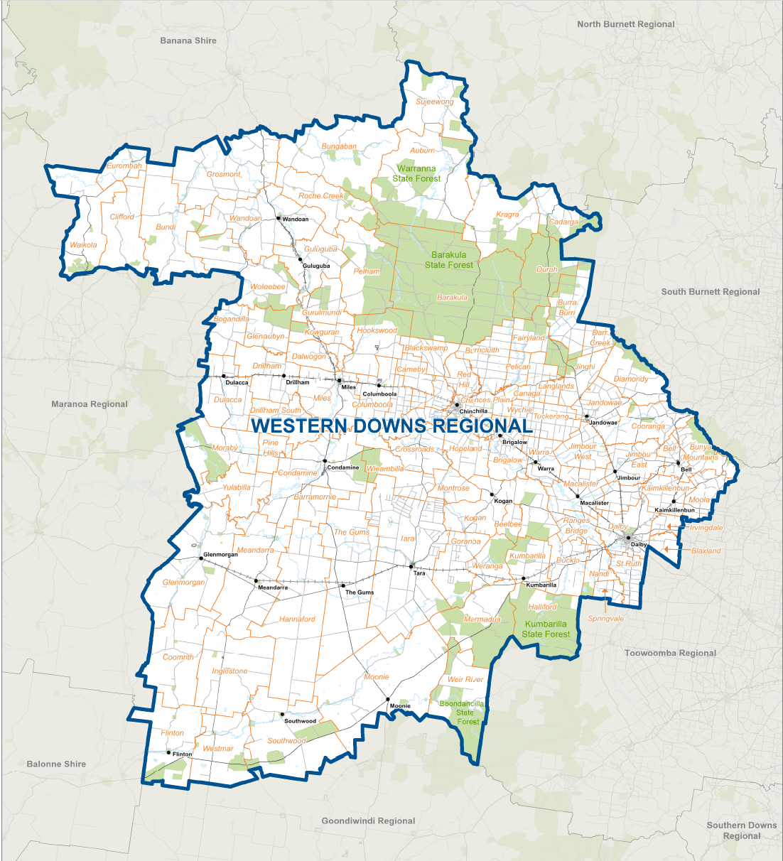

Annexure G - Roles and Responsibilities of Government Departments/ Agencies
Agency | Responsibilities | Roles as detailed in the SDMP
Queensland Ambulance Service | Relevant Legislation  Ambulance Service Act 1991  Functions – s3 Ambulance Act  1) to provide, operate and maintain ambulance services  2) for ambulance services provided during rescue and other related activities—to protect persons from injury or death, whether or not the persons are sick or injured  3) to provide transport for persons requiring attention at medical or health care facilities  4) to participate with other emergency services in counter disaster planning | - Provide, operate and maintain ambulance service delivery during disasters and other related activities  - Provide transport for persons requiring attention at medical or health care facilities  - Participate with other emergency services in counter disaster planning including collaboration with Hospital and Health Services and active membership of State, District and Local Disaster Groups  - Coordinate all volunteer first aid groups during a disaster
Queensland Fire Department | Relevant Legislation  Fire Services Act 1990  Disaster Management Act 2003  - Primary response agency for structural fire, bushfire, and hazardous materials emergencies  - Protection of persons, property and the environment from fire and hazardous materials emergencies  - Prevention of, and response to, fires and other emergencies  - Declaration of State of Fire Emergency  - Support communities or other entities prepare for, respond to, and enhance resilience to, bushfires, disasters, and other events  - Cooperate with other entities providing emergency services  Emergency powers  • Queensland Fire Department utilises a range of powers to manage disasters and emergencies. These powers are contained within the Fire Services Act 1990  • Fire officers as defined under the Fire Services Act 1990 may also exercise declared disaster officer powers under s77 of the Disaster Management Act 2003 | - Hazard lead, primary response agency for structural fire, bushfire, and hazardous materials emergencies  - Responsible for relevant components of the Chemical, Biological and Radiological hazard  - Plays an important role in building safety, assessments, and compliance, which contributes to preparedness for disasters  - Fire and hazardous materials suppression and control  - Protect persons trapped in a vehicle or building or otherwise endangered  - Develop and distribute warnings relating to bushfire, structure fires and hazardous materials emergencies  - Provide specialist rescue capability – including Urban Search & Rescue and Technical Rescue, Swiftwater Rescue  - Provide strategic oversight and coordination of bushfire mitigation activities  - Coordination of air operations  - Provision of response capability for fires and other relevant emergency incidents  - Undertake initial damage assessments following disaster events  - Declaring a State of Fire Emergency  - Provide advice and support regarding disaster management and disaster operations as it related to bushfires, structure fires and hazardous materials emergencies to disaster management groups  - Community engagement  - Promote fire prevention and fire control and safety and other procedures for fire and hazardous materials emergencies  - Provide advice and support regarding disaster management and disaster operations as it relates to bushfires, structure fire and hazardous materials emergencies to disaster management groups  - Provide mass and technical decontamination capability  - Provide advice in relation to chemical analysis and atmospheric monitoring at relevant incidents
Queensland Police Service | Relevant Legislation  Disaster Management Act 2003  Police Powers and Responsibilities Act 2000  Police Service Administration Act 1990  s2.3 The functions of the police service are the following—  (a) the preservation of peace and good order— (i) in all areas of the State; and (b) the protection of all communities in the State;  (e) the upholding of the law generally; (g) the provision of the services, and the rendering of help reasonably sought, in an emergency or otherwise, as are— (i) required of officers under any Act or law or the reasonable expectations of the community; or (ii) reasonably  Public Safety Preservation Act 1986  Coroners Act 2003  s15 Help in investigation  (2) The duty of a police officer to help a coroner is stated in the Police Powers and Responsibilities Act 2000, section 794  Marine Rescue Queensland 2024 Act  Functions of Commissioner  s 9 The commissioner’s functions relating to MRQ are—  (c) the giving of directions and guidance to the MRQ chief officer, MRQ unit commanders, MRQ coordinators and other MRQ members; and  (d) the performance of any other function relating to MRQ that is given to the commissioner under this or another Act.  State Emergency Service Act 2024  Functions of Commissioner and related matters  s9 The commissioner’s functions relating to the State Emergency Service (SES) are—  (e) the giving of directions and guidance to the SES chief officer, local controllers, SES commanders and SES members; and  (f) the performance of any other function relating to the SES that is given to the commissioner under this Act or another Act. | - Administer of the Disaster Management Act 2003 and Disaster Management Regulation 2014  - Exercise the functions and powers of the Police Commissioner in accordance with any relevant legislation  - Exercise the functions and powers of the State Disaster Coordinator in accordance with the Disaster Management Act 2003  - Provide the Chair and Executive support to district disaster management groups  - Provide advice and support regarding disaster management and disaster operations to disaster management groups  - Prepare and maintain the District Disaster Management Plan (DDMP)  - Maintain operational readiness and activate, coordinate and command the operation of the SDCC & DDCC  - Manage the Queensland Disaster Management Training Framework (QDMTF)  - Operational responsibility for first response to terrorism  - Resupply of essential goods to isolated communities, properties and individuals in partnership with Local Disaster Management Groups (LDMGs)  - Provide aircraft assets to Whole of Government disaster response via QGAIR including:  - supplying coordinators to SDCC & (depending on event DDCC) aviation cell to support all aircraft deployments  - deployment of assets  - Manage registration of directed evacuees and work in partnership with LDMGs and Red Cross  - Preserve peace and good order  - Traffic management including assistance with road closures and maintenance of roadblocks  - State Search and Rescue authority and responsible for coordination of search and rescue operations  - Disaster Victim Identification
Health | Relevant Legislation  Public Health Act 2005  Food Act 2006  Radiation Safety Act 1999  Medicines and Poisons Act 2019 Biosecurity Act 2014  National Health Security Act 2007  - Primary agency for heatwave, pandemic, biological and radiological incidents  - Maintain critical health services to impacted communities  - Lead agency for response functions of public health, mental health, medical services, mass causality management, mass fatality management and emergency medical retrieval.  - Coordination of aeromedical transport and emergency medical retrieval (with QAS)  - Clinical response to mass casualty management (with QAS providing pre-hospital response)  - Provision of forensic and scientific health services to mass fatality management and terrorism (with QPS)  - Provision of mental health support to affected communities  - Provide health-related information to the public and disaster management stakeholders, including public health messaging  - Provide public health and environment health advice and support, including risk assessment advice, to local government, industry, and other agencies  - Work across the health sector (including primary health, community, and private providers) and with residential aged care facilities to maintain services to the community  - Conduct communicable diseases surveillance and epidemiological investigation | - Coordinate and manage the health aspects of a disaster or emergency incident across the full spectrum of prevention, preparedness, response, and recovery including clinical care, public health, mental health, forensic support, and health related messaging to the community
State Emergency Service (SES) | Relevant Legislation  State Emergency Service Act 2024  s.7 State Emergency Service Act  - Perform rescue or similar operations in an emergency situation  - Perform search operations in an emergency or similar situation  - Perform activities in response to a severe weather event  - Perform other activities to help communities or other entities prepare for, respond to, recover from, and enhance resilience to, an event or a disaster  - Provide services, and give help reasonably requested, in an emergency or another situation, as required of a member of the SES under any Act or law or the reasonable expectations of the community | - Help injured persons, as well as protect persons, property or the environment from danger or potential danger in emergency situations. This includes operations for road crashes, vertical rescue, or assistance to other entities responding to an emergency  - Assist in searches for missing persons or evidence  - Provide storm and water damage operations to support residents and critical community services  - Conduct operational preparedness and resilience activities with community and agencies such as community engagement, exercises, agency liaison and joint planning  - Support multi-agency response and recovery activities within SES capability  - Provide operational support in emergencies and public events including, but not limited to, welfare, evacuations and evacuation centres support, cyclone shelter support, public event support, fire ground support, air base operations and management (bushfire), traffic management, communications, resupply, incident management, or lighting
Western Downs Regional Council | Relevant Legislation  Local Government Act 2009 | The Western Downs LDMG are to:  - ensure that disaster management and disaster operations in the area are consistent with the QDMC’s strategic policy framework for disaster management for the State.  - develop effective disaster management and regularly review and assess the disaster management.  - help the local government for its area to prepare a local disaster management plan.  - identify, and provide advice to the relevant district group about, support services required by the local group to facilitate disaster management and disaster operations in the area.  - ensure the community is aware of ways of mitigating the adverse effects of an event, and preparing for, responding to and recovering from a disaster.  - manage disaster operations in the area under policies and procedures decided by the QDMC.  - provide reports and make recommendations to the relevant district group about matters relating to disaster operations.  - identify, and coordinate the use of, resources that may be used for disaster operations in the area.  - establish and review communications systems in the group, and with the relevant district group and other local groups in the disaster district of the relevant district group, for use when a disaster happens.  - ensure information about a disaster in the area is promptly given to the relevant district group.  - perform other functions given to the group under this Act.

Department of Education (DoE)
Roles and Responsibilities as detailed in the SDMP
Relevant Legislation

Disaster Management Act 2003
Public Safety Preservation Act 1986
Education (General Provisions) 2006
Education (General Provisions) Regulation 2017
Human Rights Act 2019

Responsibilities | Role
- Maintain the safety & wellbeing of students, staff, and volunteers who work or participate in DoE schools, institutions, and workplaces  - Ensure that state schools, regional offices and other workplaces have a documented emergency response plan  - Ensure that DoE is prepared to respond to and recover from disaster and emergencies  - Temporarily close and facilitate the return of affected state schools to normal operations as soon as safe and practicable following an event  - Facilitate the transition of DoE facilities to cyclone shelters, place of refuge and evacuation centres as required or directed  - Contribute to the State-wide response to disasters and emergencies as required | - Lead, manage, and coordinate the department’s planning, preparation, response and recovery from disasters and emergencies  - Provide departmental buildings that can be transitioned to cyclone shelters, places of refuge and evacuation centres  - Support communication prior to, during and after an event
Department of Environment, Tourism, Science and Innovation (DETSI)
Roles and Responsibilities as detailed in the SDMP
Responsibilities | Role
Relevant Legislation

Environmental Protection Act 1994
Coastal Protection and Management Act 1995
Queensland Heritage Act 1992
Waste Reduction and Recycling Act 2011
Environmental Offsets Act 2014

Environment
- Protecting the environment, including its resources and biological diversity, through ecologically sustainable development, involving the setting of contaminant standards, and the conservation, rehabilitation and management of the coastal zone and cultural heritage significance of places and artefacts  - Integrating environmental values into land use planning and management of natural resources, including for safeguarding life and property from the threat of coastal hazards and effects on cultural heritage significance  - Minimising the disposal of waste by encouraging waste avoidance and the recovery, re-use, and recycling of waste  - Counterbalancing any significant residual impacts of activities using environmental offsets Enhancing knowledge on the effect of human activities and promoting environmental responsibility and community involvement  - Conducting investigations pursuant to the Environmental Protection Act 1994 and other environment and conservation legislation  - Giving an emergency direction pursuant to the Environmental Protection Act 1994 for a person to take reasonable action to deal with an emergency | Regulatory support to affected stakeholders:  - Provide environmental expert assessment and advice on:  o impacts and potential harm of incidents on environmental values  o priorities for protection of environmental values  o contaminant containment and treatment measures  o environmental harm mitigation measures  o clean up measures for environments and wildlife  o transport and disposal of wastes and contaminated materials  - Provide environmental risk assessment of events and incidents affecting infrastructure, mining, and industrial sites and, where necessary, authorise emergency actions and releases  - Provide situational monitoring of local government infrastructure including landfills, sewage treatment plants and sewage pump stations, and the provision of expert advice  - Provide environmental management advice, assistance and direction during incident response and recovery phases as required under the State Chemical, Biological and Radiological Plans (and associated agency CBR plans), Queensland Coastal Contingency Action Plan, National Plan for Maritime Environmental Emergencies, and related Memorandums of Understanding and agreements  - Establish mechanisms for industry, landowners, and local governments to receive necessary environmental approvals for recovery (e.g. temporary landfills, beach replenishment, replacement of coastal infrastructure, fill extraction for road repairs, port facility dredge spoil disposal, retrieval of hazardous materials, repairs to heritage listed places and dispensation to nature refuge holders)
Parks and Wildlife
Relevant Legislation

Nature Conservation Act 1992
Marine Parks Act 2004
Recreation Areas Management Act 2006
Forestry Act 1959
Fisheries Act 1994 (Fish Habitat Areas)
Wet Tropics World Heritage Protection and Management Act 1993

- Conservation of nature, including the management of protected areas and recreational areas, recognising the interests of First Nations people, the protection of native wildlife and its habitat, and through the education and cooperative involvement of the community, particularly landholders  - Conservation of the marine environment, including the management of designated and highly protected areas, with the cooperative involvement of public authorities and other interested groups including First Nations people, and through public appreciation, understanding and enjoyment  - Management of the wet tropics area, including natural heritage values, through cooperative management agreements and entering arrangements for the provision of rehabilitation and restoration works, public and community education programs, and having regard to First Nations people, ecologically sustainable development, and obligations under the World Heritage Convention | Management of protected areas to support the community and biodiversity:  - Through the Queensland Parks and Wildlife Service (QPWS), respond to bushfires that occur on land it manages, and maintain a firefighting capability (and hazard mitigation function) to meet this responsibility  - Manage bushfire incidents on national parks, conservation parks and state forests unless there is a threat to life or property  - Coordinating closures and evacuations with the Queensland Police Service, along with the management of impacts and careful reopening of national parks, conservation parks, state forests and department owned visitor attractions  - Monitor and advise on management of impacted native wildlife outside the protected areas and reduce conflict and risks to the community due to their displacement  - Partnering with First Nations people to steward country and culture, and incorporate traditional knowledge into programs and management practices, along with connecting people with nature and sustainable ecotourism opportunities
Department of Families, Seniors, and Disability Services and Child Safety (DFSDSCS)
Roles and Responsibilities as detailed in the SDMP
Whole of Department
Responsibilities | Role
- Provide staff to Ready Reserve for Community Recovery operations
- Monitor and act as required in relation to property/buildings impacted by disasters
- Provision of procurement and property services resources to assist Community Recovery during disaster events
Community Recovery
Responsibilities | Role
Relevant Legislation | Disaster Management Act 2003
- State and District Disaster Human and Social Recovery and Resilience Plans  - Provision of practical information  - Referral to support services  - Access to financial assistance through grant applications  - The Australian Government Disaster Recovery Funding Arrangements (DFRA) provide a cost sharing formula between the Queensland and Australian Governments on a range of pre-agreed relief and recovery measures.  - State funding for non-DRFA eligible disasters are administered under the State Disaster Relief Arrangements (SDRA), a wholly State funded program that may be activated for all hazards to provide assistance to alleviate personal hardship and distress | - Act as key contact point for human and social-related nongovernment organisation contracts and services during and post disaster events  - Administer the Personal Hardship and Assistance Scheme (PHAS) and Essential Services Safety and Reconnection Scheme (ESSRS)  - Coordinate development of Requests for Assistance submission to National Emergency Management Agency for long-term human and social recovery and resilience services for communities affected by disaster  - Coordinate and administer human and social recovery and resilience services for affected communities, including activation of DRFA category A, C & D measures  - Coordinate the deployment of the Community Recovery Ready Reserve workforce to assist with human and social recovery operations
Department of Housing and Public Works (DHPW)
Roles and Responsibilities as detailed in the SDMP

Housing  - Lead agency temporary emergency accommodation  - Provision of temporary accommodation solutions and services for impacted members of a community and/or government response/ recovery staff | Public Works  - Coordinate temporary office accommodation for the us by Government agencies  - Coordinate technical advice on structural suitability of buildings to use as place of refuge, evacuation centres and cyclone shelters  - Provide building response & recovery services, as requested to government agencies  - Facilitate Structural Assistance Grant assessments as requested, on behalf of the Department of Local Government, Water and Volunteers  - Maintain contact registers of professional service providers, specialist building contractors, building services and trades for registered suppliers to QBuild
Department of Local Government, Water and Volunteers (DLGWV)
Roles and Responsibilities as detailed in the SDMP

Responsibilities | Role
Relevant Legislation

Water Supply (Safety and Reliability) Act 2008
Water Act 2000

- Chief Executive may give a direction to a dam owner or operator to take actions if they are satisfied or reasonably believe there is danger of the failure of a dam s342A of the Water Supply (Safety and Reliability) Act 2008  - The Chief Executive may also authorise an authorised officer to take reasonable steps to prevent or minimise the impact of dam failure s359A of the Water Supply (Safety and Reliability) Act 2008  - The Regulator can give a direction to any person if an event has happened or is likely to happen, in relation to a recycled water scheme or drinking water scheme that may have an adverse effect on public health s436 of the Water Supply (Safety and Reliability) Act 2008  - The Regulator may give a direction to a service provider to take action if there is an imminent risk to water security or continuity of supply of a water service or sewage service s448 of the Water Supply (Safety and Reliability) Act 2008  - The Minister may make a water supply emergency declaration and direct a service provider to make available water including recycled and desalinated water, operate infrastructure, restrict the volume of water supplied to customers or restrict the way water is used s25B of the Water Act 2000  - NOTE: Stakeholders associated with dam safety and water supply are responsible for managing their own emergency response arrangements and supply issues; any government intervention mechanisms are a last resort, following failure of market-based mechanisms  - The Regulator can give a direction to any person if an event has happened or is likely to happen, in relation to a recycled water scheme or drinking water scheme that may have an adverse effect on public health s436 of the Water Supply (Safety and Reliability) Act 2008  - The Regulator may give a direction to a service provider to take action if there is an imminent risk to water security or continuity of supply of a water service or sewage service s448 of the Water Supply (Safety and Reliability) Act 2008 | - Provide information and advice on the issues of dam safety and drinking water supply (continuity and/or safety) as required  - Ensure emergency action plans are in place for referable dams to ensure appropriate action is taken in event of incidents or failures of dams (referable water dams are dams that have a population at risk of 2 or more persons)  - Collate information from dam owners on event impacts  - Exercise dam safety powers in needed to minimise the risk or failure or consequences of a dam failure  - Ensure drinking water quality management plans are in place by registered drinking water service providers (this does not include private or unregistered providers)  - Collate information from service providers and operators of drinking water schemes  - Work in partnership with Public Health Units (Queensland Health) regarding drinking water quality issues  - Act as a conduit of information between all relevant parties including the support and enactment of emergency powers  - Establish and communicate arrangements for an emergency event that impacts or has the potential to impact on security of water supply or pose a life safety risk from a referable dam  - Develop and maintain departmental emergency management procedures that provide guidance in the response to a water supply emergency, regardless of hazard  - Contribute to disaster management responses across those areas where the department has responsibilities or special expertise, including the management of departmental stream gauges that provide stream height, flow and rainfall data used by the Bureau of Meteorology  - Deliver innovative policy, planning and regulatory solutions in partnership with stakeholders to support reliable water supply
Department of Natural Resources and Mines, Manufacturing and Regional and Rural Development (DNRMMRRD)
Roles and Responsibilities as detailed in the SDMP

Relevant Legislation

Water Supply (Safety and Reliability) Act 2008
Environmental Protection Act 1994
Mineral Resources Act 1989
Petroleum and Gas (Production and Safety) Act 2004
Vegetation Management Act 1999
Planning Act 2016
Land Act 1994
Land Regulation 2020

- Comply with the obligations of a referable dam owner including execution of the relevant emergency action plan  - Liaison with Dam Inspection Officers and Dam Inspection Engineers  - Provide Populations at Risk with warnings and evacuate communities in event of an emergency  - Advise and support Local Disaster Management Group/s and local emergency service agencies  - Comply with all relevant legislation including the Environmental Protection Act 1994  - Exercise powers under the Mineral Resources Act 1989 and Petroleum and Gas (Production and Safety) Act 2004 | - Manage Satellite basemap for emergency planning and response  - Manage impacts on unallocated State land and other land where the Department is identified as the land manager and ensure compliance with relevant legislation  - Provide advice on vegetation management clearing exemptions that apply in the event of a disaster  - Provide track maps, warning modelling and satellite imagery to support disaster management groups  - Provide framework spatial data  - Provide advice on vegetation management clearing exemptions that apply in the event of a disaster
Department of Primary Industries (DPI)
Roles and Responsibilities as detailed in the SDMP

Relevant Legislation
Biosecurity Act 2014
Animal Care and Protection Act 2001

Agriculture  - Assist the ongoing supply of fresh food as an essential service  - Provide advice on agriculture, fisheries, and forestry disaster impacts (including advice on agriculture supply chains and animal welfare incidents)  - Support Disaster Recovery Funding Arrangements (DRFA) relief measures, including agricultural industry recovery and resilience officers as required  - Engage with industry on preparedness for climate and biosecurity risks and aid with economic recovery  - Assist agriculture industries in prevention and preparedness through normal business operations  - Report on the disaster impact assessments for agriculture sector, including economic losses, and expected recovery  - Report on the possible impact of seasonal conditions and climate events will have on the agricultural sector  - Support agriculture, fisheries, and forestry with workforce disruptions that may occur  - Assist supply chains in the event of a cyber incursion that significantly disrupts agricultural meat processing  Fisheries  - Provide advice on fisheries disaster impacts (including advice on agriculture supply chains and animal welfare incidents)  - Assist fisheries industries in disaster prevention and preparedness through normal business operations  - Provide resources to assist in disaster management and recovery, including personnel, vehicles, vessels and ancillary equipment | Biosecurity  - Hazard Specific Primary Lead Agency for containment and eradication of emergency animal and plant diseases and  pests, invasive plants and animals, residues, and contaminants in agriculture commodities  - Provide advice on animal welfare in emergency incidents including natural disasters  - Coordinate efforts to prevent, respond to, and recover from emergency plant and animal pests and diseases and invasive plants and animals  - Collaborate with stakeholders with shared responsibilities and other organisations to facilitate prevention, preparedness, response, and recovery strategies and priorities for animal welfare within a community  Forestry  - Provide advice on disaster impacts to the forestry and timber industries, including advice on supply chains  - Assist State owned and plantation forests in disaster prevention and preparedness through normal business operations  - Support fire management activities on the State Forest estate through a contingent of trained firefighters within the Forestry business unit
Department of State Development, Infrastructure and Planning (DSDIP)
Roles and Responsibilities as detailed in the SDMP

Whole of Department
Relevant Legislation
Planning Act 2016
- Provide strategic advice to the Queensland Government and relevant stakeholders on economic impacts, and assist with the development of immediate recovery actions
- Coordinate the economic function of recovery and resilience operations
- provide initial situation reports on economic impacts on jobs, business and industry in disaster affected areas
- provide ongoing coordination and reporting on the economic recovery tasks for the life of the recovery plan
Planning
- Support the implementation of the State Planning Policy (SPP) which outlines 17 State interests to be considered in development assessment and in every planning scheme across Queensland and includes the State interest of natural hazards, risk, and resilience  - Prepare and implement regional plans that identify and interpret relevant matters of state interest for a particular region including natural hazards, risk and resilience to achieve desired outcomes  - The Planning Minister may declare an applicable event to make advance preparations or respond to emerging circumstances that may affect a State interest under the Planning Act 2016 | - Ongoing work with local governments to ensure State interest in the State Planning Policy (SPP) are incorporated into local government planning schemes  - Support implementation of the State Planning Policy
Department of Transport and Main Roads (DTMR)
Roles and Responsibilities as detailed in the SDMP
Responsibilities |  | Roles
Relevant Legislation

Transport Operations Act 1995
Transport Operations Regulation
Transport Operations (Marine Safety) Act 1994
Transport Operations (Marine Safety) Regulation 2016
Maritime Safety Queensland Act 2002
- Provide information & advice regarding the impact of the event on road, rail & maritime infrastructure
- Assist with the safe movement of people resulting from mass evacuation
- Enable an accessible transport network through reinstating road, rail and maritime infrastructure. Rail infrastructure reinstatement remains the responsibility of Queensland Rail or private rail infrastructure owners

- MSQ, a branch of TMR, is responsible for ensuring maritime safety for shipping and is the lead for dealing with ship sourced pollution that impacts, or is likely to impact, Queensland coastal waters and the waters of the Great Barrier Reef World Heritage Area and Torres Strait. The arrangements for mitigating the effects of ship-sourced pollution on Queensland’s marine and coastal environment are described in the Queensland Coastal Contingency Action Plan (QCCAP)
- Maritime response/recovery to severe weather events including tropical cyclones and floods

Energy Queensland
Roles and Responsibilities as detailed in the SDMP

Relevant Legislation

Electricity Act 1994 (QLD) and Regulation 2006 (QLD)
Electrical Safety Act 2002 (QLD) and Regulation 2013 (QLD)
Disaster Management Act 2003 (QLD)
Security of Critical Infrastructure Act 2018 (SoCI)
Security Legislation Amendment (Critical Infrastructure Protection) Act 2022

Commonwealth:
Australian Energy Market Operator
National Electricity Market
- Energy Queensland takes an all- hazards approach to the preparation and response to disasters
- Restore any supply interruptions to the electricity distribution network across Queensland
- Develop an Electricity Restoration Plan based upon impact assessments in affected locations that align with business operational plans
- Work with disaster management groups where required to manage the consequences of disruption to Energy Queensland’s networks and provide timely and accurate information
- Retail electricity through Ergon Energy to over 746,000 customers in regional Queensland
- Deployment of mobile generators and support equipment into impacted communities to deliver temporary supply while the network is restored following a natural disaster event
- Mobilise field crews, vehicles, generators and support equipment into impacted communities to deliver temporary supply while the network is restored following a natural disaster event
- Deploy workforce of field crew and design, construction maintenance, inspection, and vegetation workers as necessary for disaster response operations
- Distribute electricity to 2.3million connected customers and approximately 770,000 regional Queensland retail customers through the combined Ergon Energy and Energex networks

Annexure H -Functional and Supporting sub-committees and associated plans
Human and Social | Department of Families, Seniors, Disability Services and Child Safety
Human Social Recovery and Resilience Plan

Human and social recovery relates to the emotional, social, physical and psychological health and well-being of individuals, families and communities following a disaster. The Human and Social Functional Recovery and Resilience Group (FRRG) aims to address:
- Access to timely information
- Assistance to reconnect with families, friends and community networks
- Enabling people to manage their own recovery through access to information and a range of services and/or practical assistance, including financial assistance for those individuals and households who are most vulnerable and do not have the means to finance their own recovery
- Access to emotional, psychological and mental health support at individual, family and community levels and assistance to maintain a sense of equilibrium in life and move forward into a changed reality

Infrastructure/ Building | Department of Housing and Public Works
QBuild Regional Disaster Management Plan 2025-2026

The effects of a disaster on the built environment often result in damage and disruption which inhabits the capacity of essential services and services such as housing, accommodation, education and health facilities.

The Building Functional Recovery and Resilience Group (FRRG) coordinates the efficient and effective information exchange, issues identification and resolution between government agencies, local government, building industry and insurance providers to ensure efficient and prioritised use of available resources in rebuilding of dwellings following a disaster.
Roads and Transport | Department of Transport and Main Roads
Transport Disaster Management Plan & Natural Disaster Program

The effects of a disaster on transport networks, including road, rail, aviation and maritime normally result in difficulty accessing communities and disruption to critical supply chains (both within and outside of the impacted area).
Restoration of these networks, or the identification of alternatives, is a priority in disaster recovery.

The purpose of the Roads and Transport Functional Recovery and Resilience Group (FRRG) is to provide functional leadership to support the recovery and resilience of Queensland communities with a specific focus on the transport network.
Road and Transport FRRG provides support and oversight for roads and transport policy and operational considerations progressed through the SRRG.

Economic | Department of State Development, Infrastructure and Planning
Queensland Recovery Plan
The effects of a disaster on the economic environment can be classified in terms of direct and indirect impacts. The tangible impacts can usually be given a monetary value and may include loss of tourism, employment opportunities and reduction in cash flow for businesses.

The Economic Functional Recovery and Resilience Group (FRRG) provides advice on economic impacts of disaster events such as cyclones, bushfires and major flooding events. It also provides information on the needs of local government and industry in responding to the events and getting the economy back to full production.

Environment | Department of the Environment, Tourism, Science and Innovation
DAF Disaster Management Plan 2024, AUSVET Plan
The effects of a disaster on the natural environment may be a direct result of the disaster through a secondary impact or flow on from the disaster response or recovery process. Impacts to the environment may include damage or loss of flora and fauna, poor air quality, reduced water quality, land degradation and contamination, or damage to heritage listed places.
The role of the Environment Group is to determine the potential and/or actual environment impacts of disaster hazard and events, coordinate the efficient and effective planning and implementation of strategic environment recovery activities post event, and champion environmental resilience in policy and practice when dealing with disaster risk

Annexure I - Power Plant map
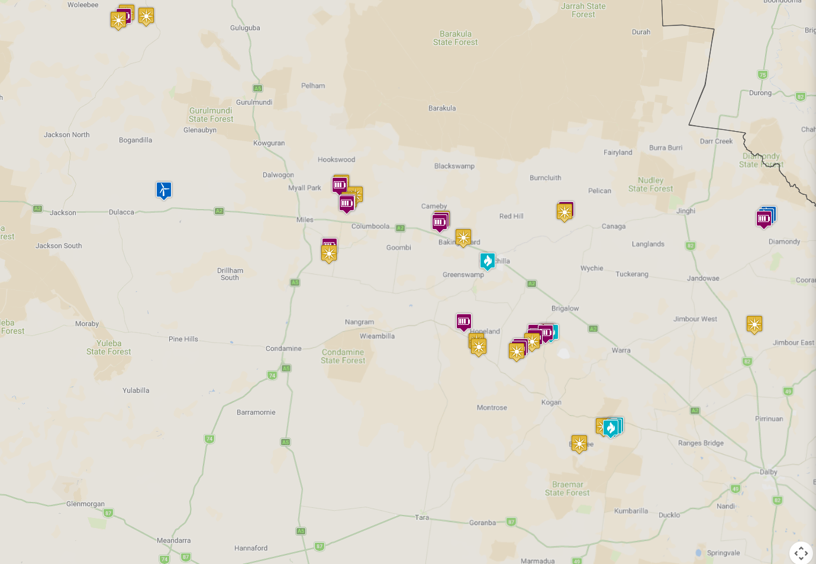
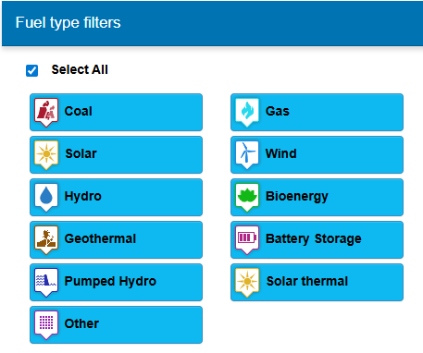

Annexure J - Primary Agencies and Specific Hazards Plans
Specific Hazard | Plan | Primary Agency
Animal and plant disease | - Australian Veterinary Emergency Plan (AUSVETPLAN)  - Australian Aquatic Veterinary Emergency Plan (AQUAVETPLAN)  - Australian Emergency Plant Pest Response Plan (PLANTPLAN)  - Biosecurity Emergency Operations Manual  Queensland Biosecurity Manual | Department of Primary Industries
Biological  (human related) | State of Queensland Multi-Agency Response to Chemical, Biological & Radiological Incidents  (State CBR Plan) | Queensland Health
Radiological | State of Queensland Multi-Agency Response to Chemical, Biological & Radiological Incidents  (State CBR Plan) | Queensland Health
Bushfire | Queensland Bushfire Plan | Queensland Fire Department
Chemical | State of Queensland Multi-Agency Response to Chemical, Biological & Radiological Incidents  (State CBR Plan) | Queensland Fire Department
Heatwave | Heatwave Management Sub-Plan | Queensland Health
Pandemic | - Pandemic Influenza Plan  - Australian Health Management Plan for Pandemic Influenza | Queensland Health
Ship Sourced Pollution | Queensland Coastal Contingency Action Plan  (QCCAP) | Department of Transport and Main Roads
Terrorism | Queensland Counter Terrorism Plan | Queensland Police Service

These plans address specific hazards where government departments and agencies have a primary management responsibility. The primary agency has responsibility to ensure that an effective hazard specific plan is prepared.

Annexure K - Activation levels and relevant triggers

Alert | A heightened level of vigilance and preparedness due to the possibility of an event in the area of responsibility. Some action may be required, and the situation should be monitored by staff capable of assessing and preparing for the potential threat
Alert | Triggers | Actions | Communications
Alert | - LDMG operational  - Awareness that threat may be widespread | - XO briefs DDC on activation level  - Analysis of threat  - Contact with LDC  - Advise IT, to ready Primary DDCC | - DDMG advised by email  - DDC and XO on mobile remotely
Lean Forward | An operational state prior to ‘stand up’ characterised by a heightened level of situational awareness of a disaster event (either current or impending) and a state or operational readiness. District Disaster Coordination Centre (DDCC) are on standby – prepared but not activated.
Lean Forward | Triggers | Actions | Communications
Lean Forward | - LDMG operational  - Awareness that threat may be widespread | - XO briefs DDC on activation level  - Analysis of threat  - Contact with LDC  - Advise IT, to ready Primary DDCC  - Advise Media Liaison Officer | - DDMG advised by email  - DDC and XO on mobile remotely
Stand Up | The operational state following ‘lean forward’ whereby resources are mobilised, personnel are activated, and operational activities commenced. DDCC is activated
Stand Up | Triggers | Actions | Communications
Stand Up | - Request for assistance/ support received from LDCCs  - Threat is imminent/ impacting on District  - Coordinated WoG support required  - Significant State resources committed | - Develop situational awareness  - Warnings disseminated  - DDCC activated and roster developed  - Initial SITREP to SDCC  - SDCC advised DDMG stood up  - Forward planning commenced  - Coordination of State support commenced  - DDCC cells in place  - Advice received from State Disaster Coordinator (if appropriate)  Depending on Event  - Operations cell in place  - Planning cell in place  - Intelligence Cells in place  - Administration and Logistics cells in place | - DDMG meeting conducted  - Distribution of situation brief  - DDC contact through established landlines/ email  - Agency liaison officers present at DDCC for operational reporting and tasking (depending on event)  - DIEMS incident reporting  - SDCC reporting briefs
Stand Down | Transition from responding to an event back to normal core business and/or recovery operations. The event is no longer requires a coordinated operational response.
Stand Down | Triggers | Actions | Communication
Stand Down | - LDMG stood down from response  - Recovery arrangements functional | - Final check for outstanding request for assistance/ tasks  - Assist LDMG with transition to recovery  - Debrief DDCC staff and DDMG members  - Financial records consolidated  - Final SITREP sent to SDCC  - Handover to District Recovery Coordinator/ Group  - Return to Core Business | - DDMG members not involved in the recovery operations resume standard business and after hours contact arrangements  - Recovery updates provided to DDMG recovery members  - XO on mobile remotely

Annexure L – District Operational Plan (2026)

Priorities | Key Performance Indicators | Activities | Date | Responsible Person
DDMG Meeting | Dalby DDMG will meet at least twice yearly |  | 28th of May 2026  November 2026 | Executive Officer (XO)
The continual development, review and assessment of effective disaster management for the district including arrangements for mitigating, preventing, preparing for, responding to and recovering from a disaster | - Stakeholder engagement  - Capability Development  - Disaster Mitigation/ Prevention  - Disaster Preparedness  - Disaster Response  - Disaster Recovery  - Member Appointments / Governance | - Review of Dalby DDMP  - Review of Dalby District Disaster Risk Assessment  - Ensure member appointments are in accordance with governance and legislative requirements, and review prior to each DDMG meeting  - Member induction  - Review of DDMG membership list including roles and responsibilities | By 31 August 2026 or after IGEM assessment date  Ongoing  Conducted when required after DDMG meetings  As per legislation or as required by Chair/ DDC | DDMG Members/ Advisors  Executive Officer  DDC, XO and QPS Emergency Management Coordinator (EMC)  XO/ EMC  DDC/ XO
The regular review and assessment of disaster management arrangements of:  - Dalby DDMG  - Western Downs LDMG | - Stakeholder engagement  - Review of DDMP  - Review of LDMP | - Undertake formal review Western Downs LDMP  - Participate in the formal review and assessment of DDMP in line with timeframe established by IGEM  - Completion of After-Action Review Report (if activated) | By 31 August 2026 or after IGEM assessment date | Executive Officer, LDC and other LDMG members as required  Executive Officer, DDC and other DDMG members as required  XO
Contribute towards building disaster resilient communities | - Stakeholder engagement  - Promotion of and participation in community education and training programs  - Community awareness campaigns | - Support/ participation in annual ‘Get Ready’ campaign  - Attendance of event and distribution of preparedness messages | 5- 11 October 2026 | DMO Western Downs Regional Council (WDRC)  LDC/ LDMG members  Executive Officer/ EMC  DDC/ DDMG members
Strengthening Emergency Management Capability | - Ensure disaster readiness through coordinated multi-agency response and proactive community preparedness  - Training will be provided to DDMG members in accordance with the QLD Disaster Management Training Framework (QDMTF) | - Coordination Centre operational and liaison officers identified and trained  - Continual improvement in Preparation, Preparedness, Response and Recovery  - Training conducted Plan Review as a training outcome (where appropriate) | Dates to be provided by EMC | EMC, XO, DMO- WDRC

