Step-by-Step Process: Queensland Police NPC Online Application
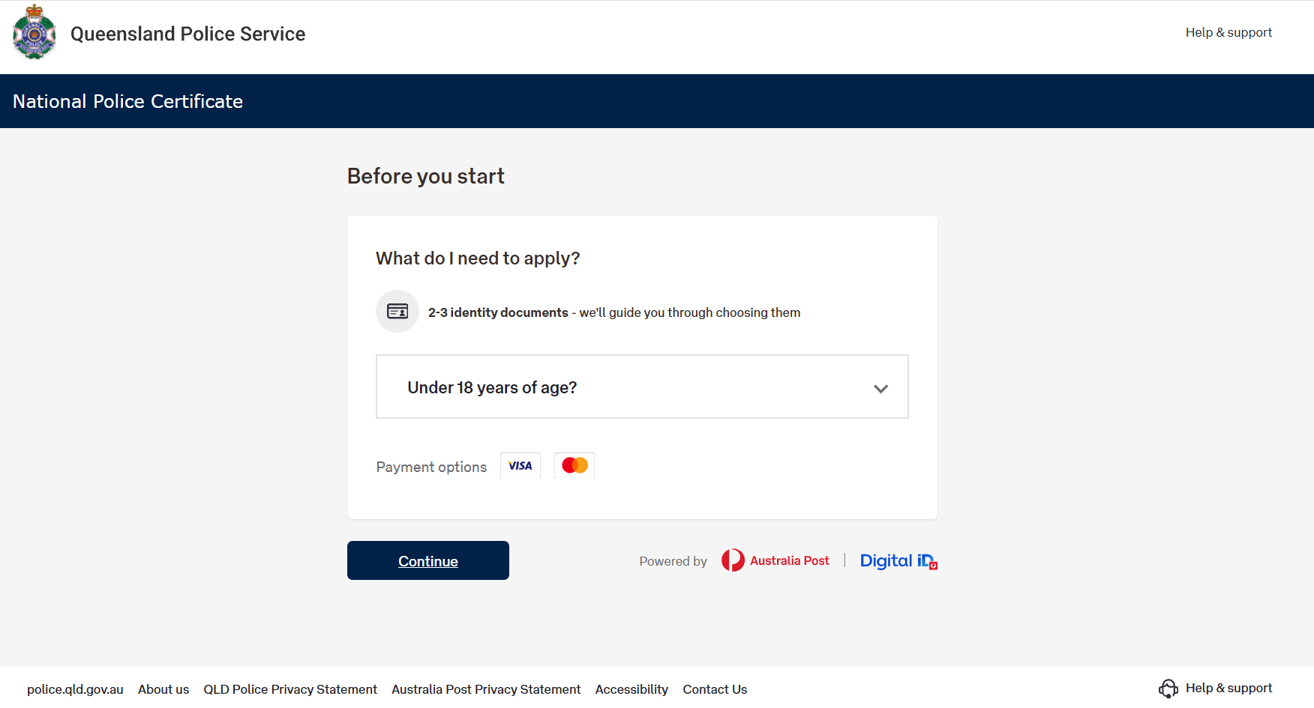
This document explains the end-to-end process of applying for a National Police Certificate online through QPS, in a linear series of steps that an applicant (sometimes referred to here as “you”) will follow. Each step corresponds to a screen or set of screens in the online application. All key instructions and information displayed on each screen are described in text below. Where applicable, alternative outcomes are also explained to ensure you know what to do in different scenarios.

Screenshot of the QPS online ‘Before you start’ page for a National Police Certificate. The page outlines requirements: ‘What do I need to apply?’ with bullet points stating ‘2 identity documents (we’ll guide you through choosing them), a note for applicants under 18 years of age, and accepted payment options (Visa and MasterCard). A blue ‘Continue’ button is at the bottom to start the application.”
Step 1: Access the Online Application (Landing Page)
Navigate to the QPS National Police Certificate online application (for example, via the “Apply Online” link on the QPS website).
You will arrive at a “Before you start” landing page that introduces the process and lists what you need to have ready before you begin:
- Two identity documents: You must provide details of two valid (original) identification documents. As noted above, at least one must be a primary or “commencement” document (such as your birth certificate or Australian citizenship certificate) and at least one must include a photograph (e.g. a driver licence or passport). The online form will guide you to choose acceptable documents.
- Under 18 years of age? The application may include special instructions or eligibility information for applicants under 18. [EDITOR NOTE: Insert the specific guidance shown to under-18 applicants, if any, or remove this bullet if not applicable. Confirm whether candidates under 18 require a parent/guardian or different process.]
- Payment method: An accepted credit or debit card (Visa or MasterCard) is required for the online payment. The landing page indicates the accepted payment options (e.g., Visa and MasterCard logos appear).
Once you have the necessary documents and information, you can click the “Continue” button on the landing page to proceed to the next step.
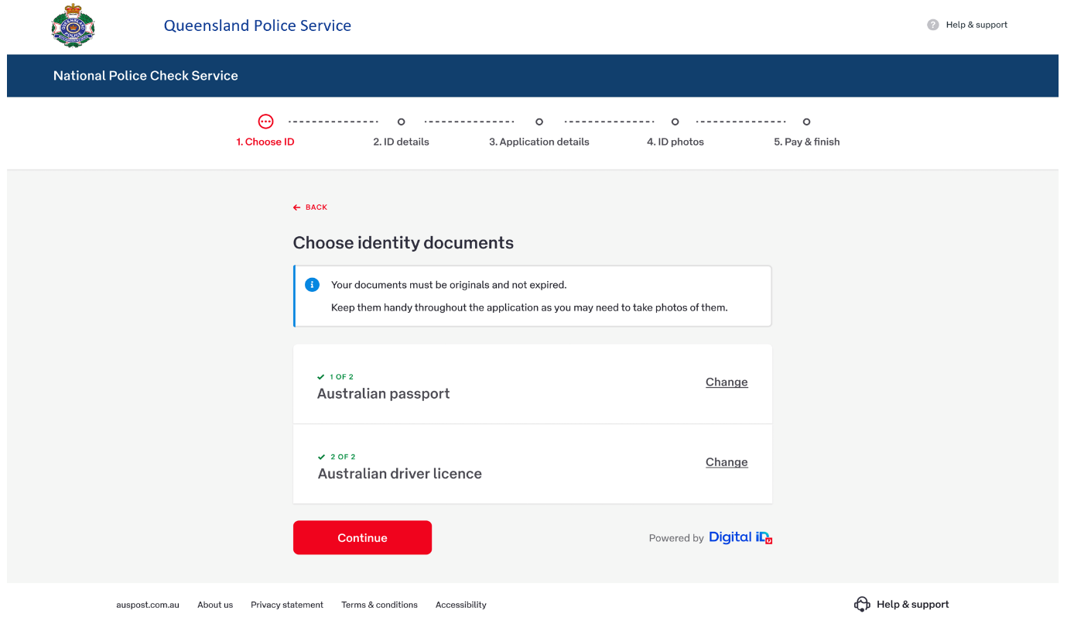
Step 2: Choose Your Identity Documents
Screenshot of the online form step ‘Choose identity documents.’ The page shows instructions that documents must be original and current, and it lists options such as Australian driver licence, Australian passport, foreign passport with Australian visa, Medicare card, etc. The applicant has to select the required identity documents (example shows ‘Australian passport’ and ‘Australian driver licence’ selected as Document 1 and Document 2).
The first part of the form guides you to select your identity documents. On the “Choose identity documents” screen, you must pick two forms of identification from a list of acceptable ID types. The instructions remind you that your documents must be original, valid, and not expired, and to keep them handy in case you need to take photos of them during the process. Typically, you will be asked to choose one document from a list of “commencement” (primary) identity documents (e.g. Australian birth certificate, Australian citizenship certificate, ImmiCard) and one from a list of photo identity documents (e.g. driver licence, passport, or others). The interface will help ensure you select the correct combination of documents.
For example, on the first “Choose identity documents” page you might see options such as: Australian Driver Licence, Australian Passport, Foreign Passport (with an Australian Visa), Medicare Card, or Health Care Card, etc., with instructions to select one. After you select your first document type and click “Continue”, you will be prompted to choose your second required document (from any remaining acceptable types). Once you have selected both required ID documents, you can proceed to the next step.
Step 3: Enter Identity Document Details & Personal Information
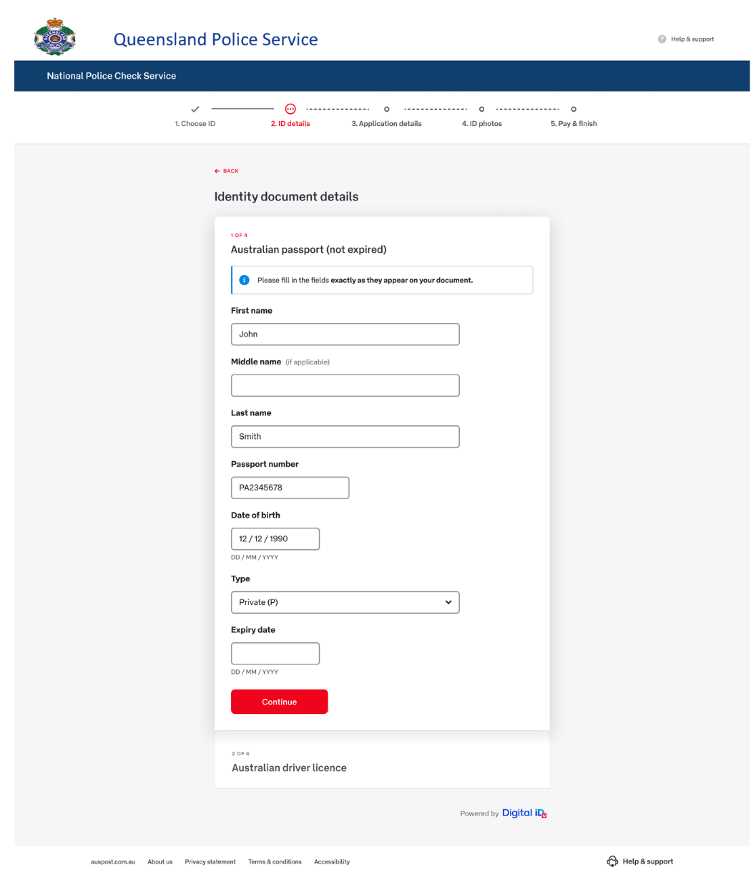

Screenshot of the online form section where the applicant enters identity document details. The form is titled ‘Identity document details’ and includes fields such as document type (e.g., Australian passport – not expired), first/middle/last name, document number (e.g., passport number), date of birth, and expiry date.”
After choosing the types of ID, the form will prompt you to enter details from each selected identity document and your personal information. This typically occurs over one or two screens:
- Identity Document Details: Fill in the details for each of the documents you chose. For example, if you selected Australian Passport, you may be asked to enter your name exactly as it appears on that passport, the passport number, and its expiry date, etc. If you chose a driver licence, you would enter details like licence number and expiry date. Ensure all details are accurate and match your documents.
- Personal Details: Next, provide your personal information as required. This includes your full name (and any previous or other names you have been known by), date of birth, gender, place/country of birth, and possibly other details depending on the form. Enter these details carefully, as they will appear on your police certificate and be used for the background check.
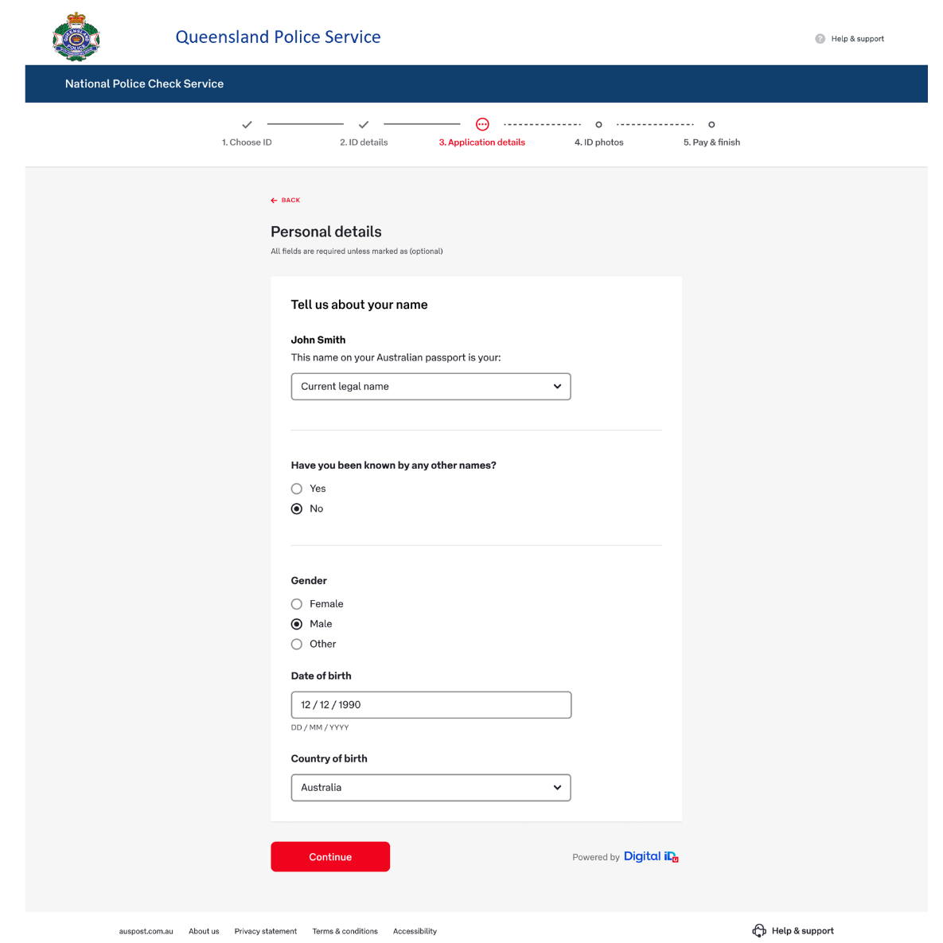

Screenshot of the online form section where the applicant enters personal details. The form (titled ‘Personal details’) shows fields for the applicant’s current legal name, any other names used, gender (Male/Female/Other options), date of birth, and country of birth. A ‘Continue’ button is at the bottom to proceed.
Step 4: Provide Additional Details & Purpose of Check
After entering your identity and personal details, the next screens will capture some additional information required for the police check:
- Purpose of the Police Check: You will be asked to specify why you are requesting the National Police Certificate (for example, “Employment – new job”, “Volunteer work”, “Licensing or accreditation”, etc.). Choose the option that best fits your situation from the provided list or dropdown menu. You may also need to provide context such as the position title/role or the name of the organisation requiring the police check, and the location (e.g., state/territory) of that organisation or role.
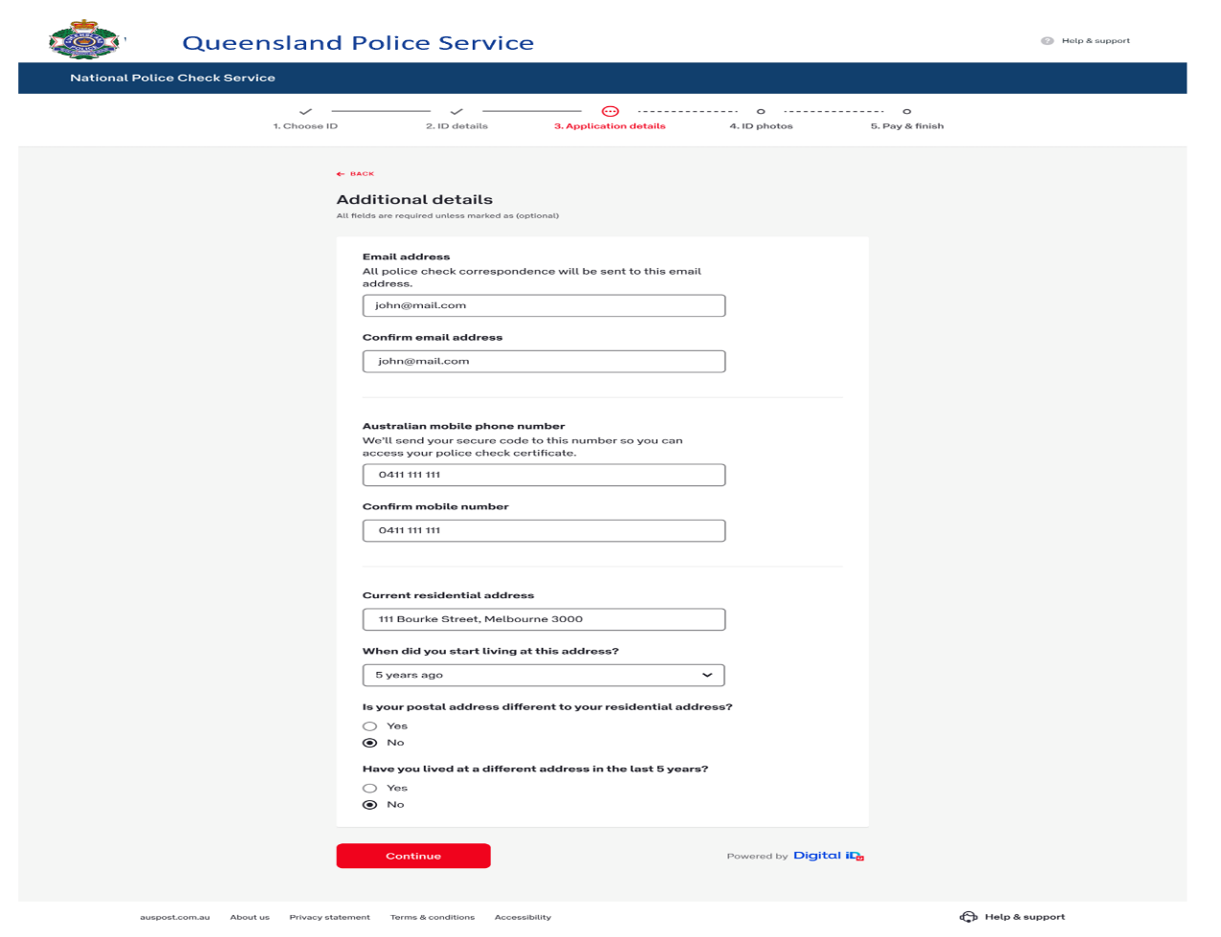
- Contact and Address Details: Provide up-to-date contact information, such as your email address (you will typically need to enter it twice to confirm accuracy) and mobile phone number. This information is important because your police check results will be delivered electronically, and a phone number is used for verification codes if needed. You also need to enter your current residential address. If you have not lived at your current address for a specified period (e.g., 5 years), you may be prompted to provide your previous addresses or indicate if you have had any other addresses or names in the past X years. Answer all questions and provide any additional details as prompted by the form.
Screenshot of the online form section titled ‘Additional details,’ where the applicant enters contact information. Fields shown include Email address and Confirm email address, Contact mobile number, current residential address, duration at current address, and questions asking if the applicant has previous addresses or different names in the last 5 years (with Yes/No options).
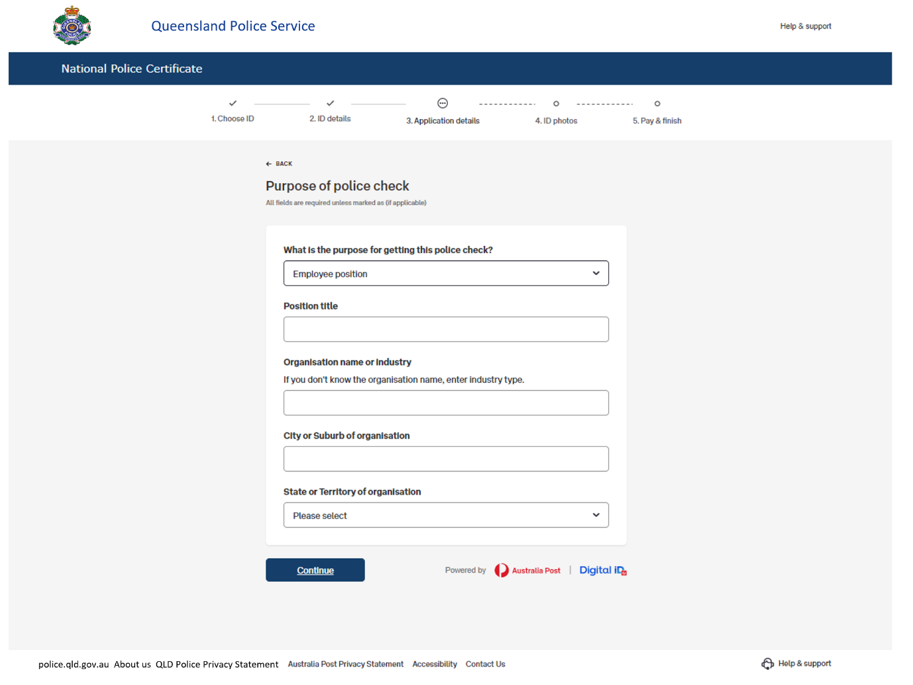
“Screenshot of the online form section titled ‘What’s the purpose for getting this police check?’ The applicant selects a reason (e.g., ‘Employment position’), and enters details such as Position title, Organisation name or industry, and the State/Territory of the organisation.
Step 5: Review Your Application & Provide Consent
Before final submission, the online system will display a summary of all the information you’ve entered so far, allowing you to review and confirm its accuracy. This Review & Consent page is typically the last step before payment and submission:
- Review Information: The page will list your provided personal details, identity document details, contact and address information, and the purpose of the check. Carefully review each section to ensure all information is correct and complete. If you need to adjust anything, the form normally allows you to go back to the relevant section to make edits.
- Consent/Declaration: The bottom of the review page includes a declaration or consent checkbox (for example, acknowledging that the information you provided is true and that you consent to the criminal history check). Read the declaration carefully. If you agree, tick the checkbox (or select the “I agree” button) confirming your consent to proceed. You may also need to provide a digital signature or full name as confirmation, depending on the system’s requirements.
- Proceed to Submit: Once you have verified all details and provided the required consent, click the button to submit and continue. This will typically lead you to the final payment step (if your application can be completed online).
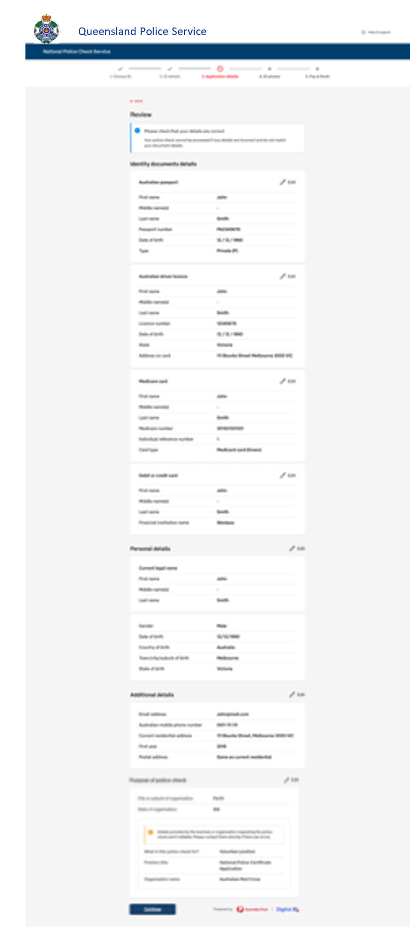

“Screenshot of the Review and Consent page. It displays a read-only summary of all details entered earlier (identity documents, personal details, contact details, etc.) so that the applicant can double-check them. At the bottom, there is a statement requiring the applicant’s agreement (e.g., a consent checkbox and notice reading ‘You must agree to the terms before submitting your police check’), which the applicant must tick to proceed.
Completing the Application – Two Possible Outcomes
After you have reviewed your details and confirmed consent, the final stage of the NPC application may proceed in one of two ways depending on whether your identity can be verified online:
- Option A: Finish Online (All ID Verified) – If your identity documents and details are successfully validated online (for example, through instant document verification services), you will be able to complete the application entirely online. You will be taken to a payment page to finalize the submission.
  - Payment & Submission: On the payment screen, provide your payment details (credit/debit card information) and confirm your order. You may also have an option to request a mailed hardcopy of the certificate (for example, by checking a box such as “Would you like a hardcopy sent to your postal address?”). After entering your card details (e.g., card number, expiry date, CVV) and ensuring everything is correct, submit the payment to finalize your application.
  - Confirmation & Next Steps: If payment is successful, the website will show an “Application complete” confirmation message. This confirmation screen typically includes a reference number for your application and explains what will happen next. For example, you may see a note that your payment has been pre-authorised (not fully charged yet) and that the system will now verify your identity details. If everything is in order, your card will be charged and your NPC will be processed. The page will also inform you that your National Police Certificate will be delivered to you electronically (via email with a secure link to download your certificate). If you opted for a physical copy of the certificate, it will be mailed to your postal address as well. You might also receive an email confirming your application submission.
  - Processing Time: In many cases, online NPC applications that do not require any manual intervention or investigation can be completed quickly (often within an hour) once submitted. If additional checks or reviews are required by the police, processing might take several days. The QPS will typically inform you that if you do not receive your result within a certain number of business days, you can follow up via their contact channels.

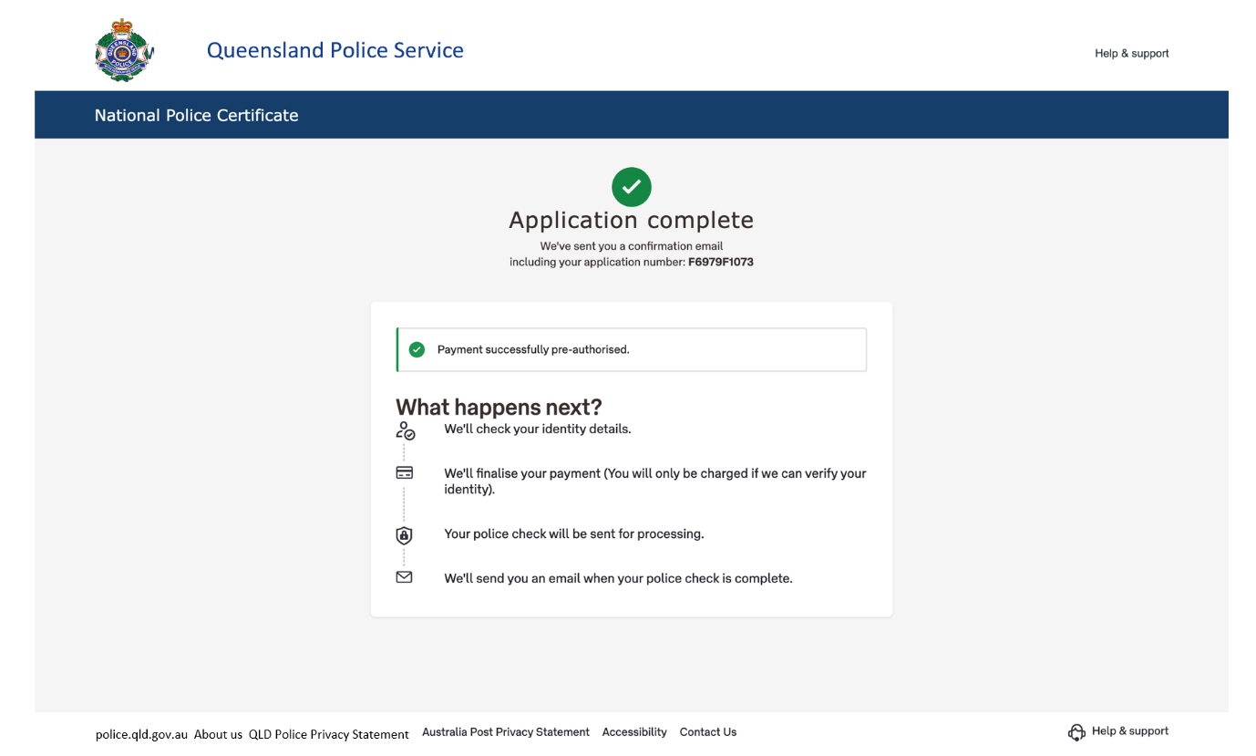
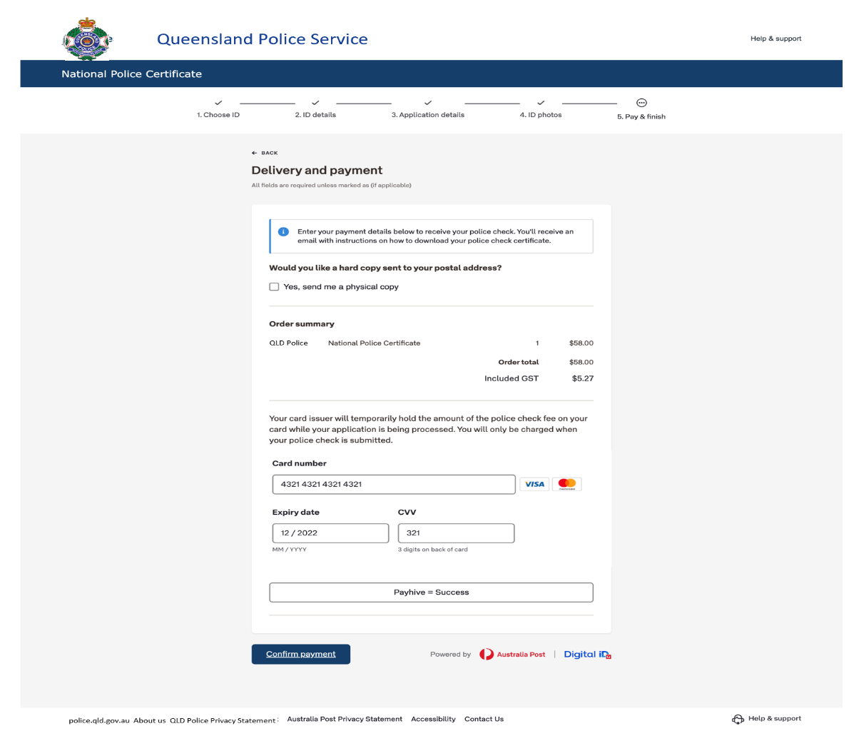
“Screenshot of the online ‘Delivery and Payment’ step, where the applicant reviews the National Police Certificate order and enters credit card details (card number, expiry date, CVV) for payment. A checkbox option labeled ‘Send me a physical copy’ is available for requesting a mailed paper certificate. A ‘Confirm Payment’ button is at the bottom of the form.
Screenshot of the ‘Application complete’ confirmation page. A green checkmark icon is shown with a message ‘Payment successfully pre-authorised’, and a section titled ‘What happens next?’ describing that the application will be reviewed and if identity verification is successful the police check will be processed and the result sent via email (with a secure link to the certificate).
- Option B: Finish in Person at a Post Office (ID Verification Needed) – If the online system cannot verify one or more of your identity documents or details, you will be prompted to complete the application offline. In this case, after attempting to submit online, you will see a message indicating that the application cannot be finished online. Don’t worry – this just means you’ll need to visit a participating Australia Post outlet in Queensland to verify your identity and finalise the process.
  - On-Screen Message: The website will display an “unable to complete online” notification, explaining why the online process stopped (for example, your details might not have matched the records or an automated check could not be completed). It will list “Next steps” to follow. Typically, it will say that the system has saved your progress and sent you an email with instructions and your application reference number.
  - Instructions via Email: Check your email for a message from QPS/Australia Post (usually sent immediately after the online attempt). This “Complete your application at the Post Office” email will contain your Application Reference Number and further instructions. Print out this email or have it available on your phone, and gather the identity documents you selected in your application. You will need to take these to a designated Australia Post outlet (the email or webpage will provide a link to find a “participating Post Office” near you).
  - Complete at Post Office: At the Post Office, an Australia Post staff member will verify your identity documents in person and help you finalise payment for the police check (since the online payment was not completed when the process couldn’t be finished online). After the in-person visit, your application will be fully submitted for processing. You will receive your National Police Certificate via email once it’s ready, just as with the fully-online process. (If you requested a hardcopy, it will be posted to you as well.) The processing time for results will be similar to the online process, although the overall turnaround might be slightly longer due to the in-person step.

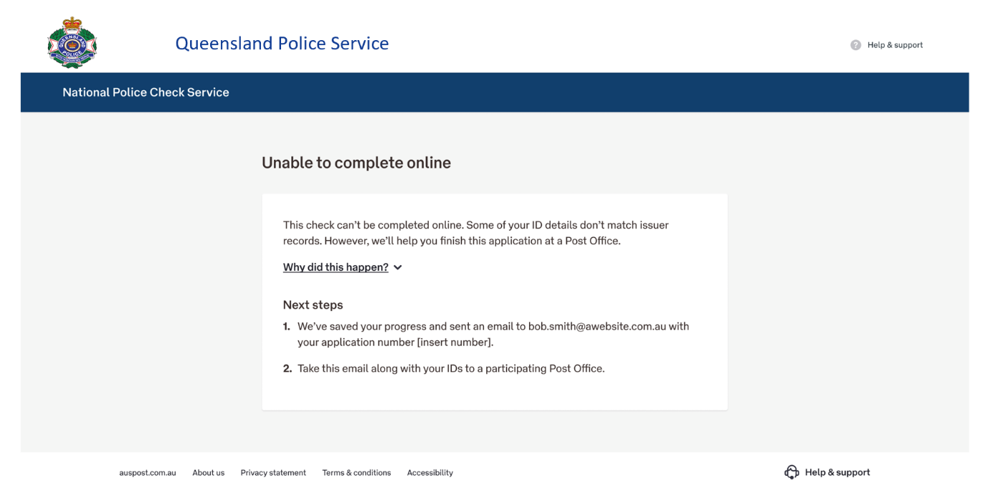
Screenshot of an online message: ‘Unable to complete online.’ The page explains that the application cannot be finished online and provides Next Steps. It informs the applicant that their progress is saved and that an email with their application number has been sent, and advises them to take that email and their documents to a participating Post Office to complete the application.
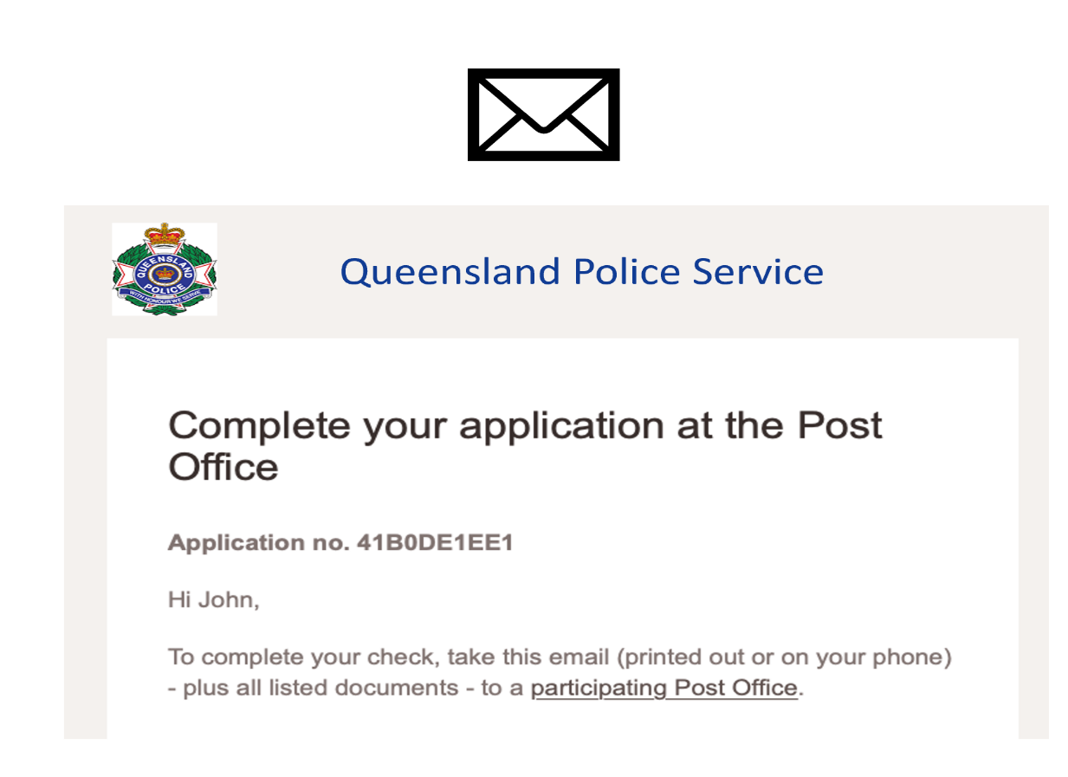

Screenshot of a notification email titled ‘Complete your application at the Post Office’. The email is addressed to the applicant (e.g., ‘Hi John’) and includes the application number (e.g., 41B0DE1EE1) and instructions: to finish the check, the applicant should take the email (printed or on their phone) along with all the listed identity documents to a participating Post Office for completion.

