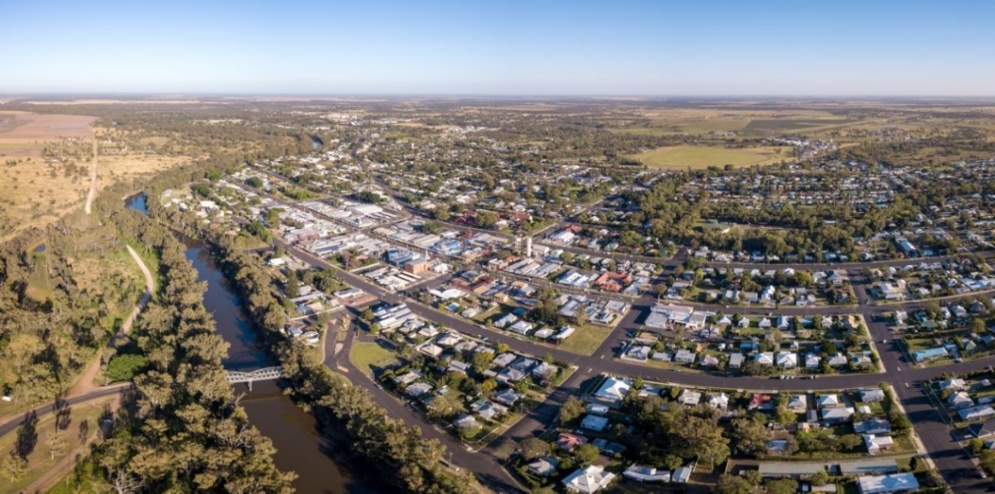


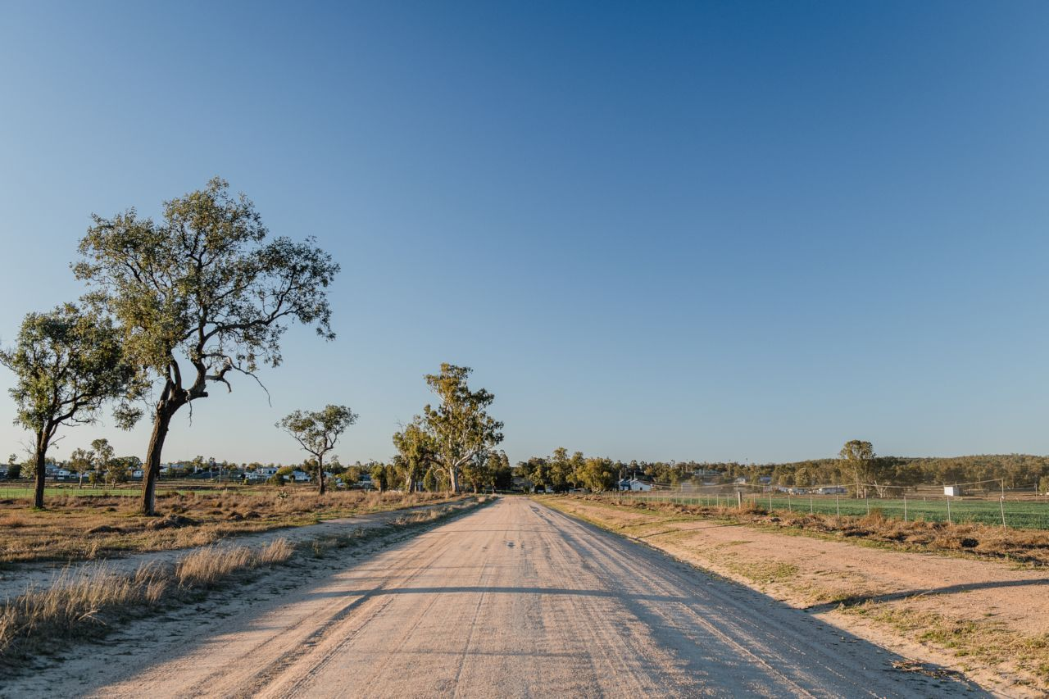
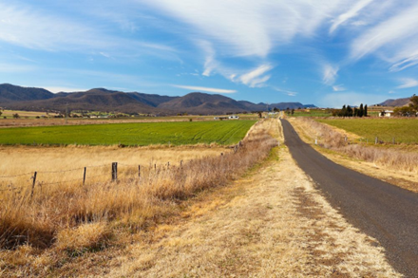
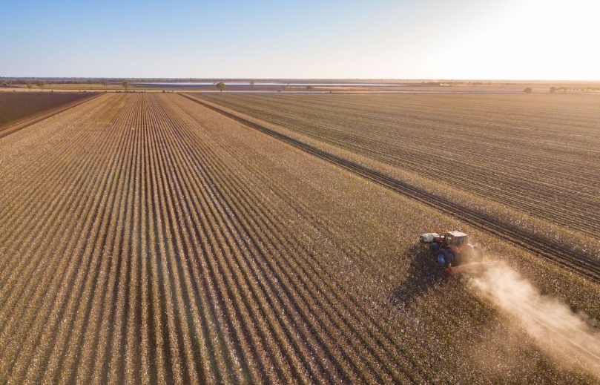
Image: Southern Downs Regional Council

WARWICK DISTRICT
DISASTER MANAGEMENT PLAN 2026

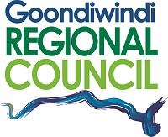
Image: Southern Downs Regional Council
Image: Southern Downs Regional Council
Image: Rachel Walker
Image: Tim Bateup
Image: Southern Downs Regional Council
Image: Tim Bateup
Image: Southern Downs Regional Council
Business

Endorsement and Authorisation

The Warwick District Disaster Management Plan (DDMP) is endorsed under the authority of the Warwick District Disaster Management Group (DDMG).

The Warwick DDMP has been developed in accordance with the Disaster Management Act 2003 [QLD] (the Act) and the following documents to provide for effective disaster management in the Warwick Disaster District:

- Queensland State Disaster Management Plan
- Queensland Emergency Management Assurance Framework
- Queensland Prevention, Preparedness, Response and Recovery Disaster Management Guideline
- Queensland Disaster Management 2016 Strategic Policy Statement

The plan will be maintained by the District Disaster Coordinator and will be reviewed annually unless otherwise required.

……………………………………………
Inspector Kelly Hanlen
District Disaster Coordinator/Chair
Warwick District Disaster Management Group

Dated: 16 July 2026

Amendments and Document Control

The Warwick District Disaster Plan is a controlled document. The controller of the document is the Warwick District Disaster Coordinator (DDC). Any proposed amendments to this plan should be forwarded in writing to:

Sergeant Catherine Lowe
Executive Officer
Warwick District Disaster Management Group
Warwick Police Station
86 Fitzroy Street
WARWICK QLD 4370

Email: DDC.Warwick@police.qld.gov.au

Minor amendments will be addressed by the Executive Officer, Warwick District Disaster Management Group (DDMG) and endorsed by the Warwick DDC.

Any changes to the intent of the document must be endorsed by the Warwick DDMG.

A copy of each amendment is to be forwarded to those identified in the distribution list. On receipt, the amendment is to be inserted into the document and the Amendment Register updated and signed.

Amendment Register

No / Ref | Issue Date | Comment | Inserted by | Date

Distribution

This DDMP has been disseminated in accordance with the distribution list at Annexure A.

In compliance with Section 56 of the Act a copy of the plan is available on the Queensland Police Service website: District Disaster Management Plans.

This plan is also available for inspection free of charge to members of the public. All applications are to be made to the Executive Officer via the above address or email contact.

Contents

BUSINESS
Endorsement and Authorisation
Amendments and Document Control
Amendment Register
Distribution
Contents
Abbreviations and Acronyms see Annexure D
Definitions see Annexure E
Governance
Authority to Plan
Purpose
Objectives
Strategic Policy Statement
Scope
Disaster Management Priorities
District Disaster Management Group
Establishment
Role
Functions
Functional Lead Agencies – Roles and Responsibilities…………………………
Supporting Lead Agencies – Roles and Responsibilities……………….…………
Membership
Member Roles and Responsibilities………………………………………………………….
Meetings
Administration
Reporting
Administrative Reporting
Member Status Reports
Annual Reports
Capacity Building
Post Disaster Assessment
Training
Exercises
Integrated Lessons Learned Management Process
Disaster Risk Assessment
Community Context
Administrative Centres
Transport
Shopping Facilities
Geography
Southern Downs Regional Council Local Government Area - Geography
Goondiwindi Regional Council Local Government Area – Geography…….
Significant Recent Historical Events
Southern Downs Regional Council – A Snapshot……………………….…………….
Goondiwindi Regional Council – A Snapshot………………………………….………..
Risk Management Process
Risk Identification
Risk Analysis
Likelihood
Vulnerability
Consequences
Risk Matrix
Risk Evaluation
Risk Treatment
Decision Log
Monitoring and Review

OPERATIONS
Response Strategy
Warning Notification and Dissemination
Emergency Alerts
Australian Warning System
Activation and Triggers for Response
District Disaster Coordination Centre
Business Continuity
Induction/Briefings
Power Supply
Staffing – Roles and Responsibilities
QPS Agency Liaison Officers
Operational Reporting
District Situational Reports (SITREPs)
Disaster Declaration
Functional Plans
Hazard Specific Arrangements
Threat Specific Plans – Referrable Dams
Requests for Assistance
Request for Supplies and Equipment
Resupply
Emergency Supply
Australian Defence Force Assistance to the Civil Community (DACC)
Financial Management
Operational Plans
Recovery Strategy
Transition Triggers
Warwick District Disaster Management Recovery Activation Levels
Immediate/Short Term Recovery
Medium/Long Term Recovery
Warwick District Human and Social Recovery and Resilience Committee
Parameters
Operational and Action Plans
Recovery Lead Agencies
Review and Assurance
Review and Renew Plan
External Assessment
Review of Local Disaster Management Arrangements………………………….….

Annexure Index

A Distribution List
B Warwick District Disaster Management Group Contact List
C Warwick District Risk Register
D Abbreviations and Acronyms
E Definitions
F Warwick DDMG Operational Plan

Governance

Authority to Plan

The Warwick DDMP is prepared under the provision of Section 53 of the Disaster Management Act 2003 [QLD] (the Act).

Purpose

The Warwick DDMP details the arrangements for the Warwick Disaster District to provide whole-of-government planning and coordination capability to support disaster management groups.

The local governments of Southern Downs Regional Council and Goondiwindi Regional Council have primary responsibility for disaster management in their Local Government Area. The Warwick DDMG provides coordinated support to these Councils through the Local Disaster Management Groups (LDMGs).

The Warwick DDMG also coordinates the provision of State resources and services in support of LDMGs in the District.

Objectives

The objectives of the Warwick DDMP are to facilitate the implementation of effective and efficient disaster management strategies and arrangements including:

- The development, review and assessment of effective disaster management for the District including arrangements for mitigating, preventing, preparing for, responding to, and recovering from a disaster;
- Compliance with, and application of:
  - Disaster Management Act 2003 [QLD];
  - Disaster Management Regulation 2014 [QLD];
  - Queensland Disaster Management Strategic Policy Statement;
  - Queensland State Disaster Management Plan;
  - Queensland Emergency Management Assurance Framework
  - District Disaster Management Group Members Responsibilities Manual
  - Queensland Prevention, Preparedness, Response and Recovery Disaster Management Guideline; and
  - Standard for Disaster Management in Queensland.
- The development, implementation and monitoring of priorities for disaster management for the District.

Strategic Policy Statement

Disaster management and disaster operations in the Warwick Disaster District are consistent with the Queensland Disaster Management Strategic Policy Statement which informs the State’s strategic approach to disaster management.

It identifies two strategic objectives that underpin disaster management in Queensland.

- Strive to safeguard people, property and the environment from disaster impacts; and

- Empower and support local communities to manage disaster risks, respond to events and be more resilient.

This will be achieved through:

- Ensuring disaster operation capabilities are responsive and effective;
- Building capacity, skills and knowledge to enable adaption to changing environments;
- Effectively collaborating and sharing responsibilities for disaster management across all levels of government, industry and communities;
- Effectively communicating to engage all stakeholders in disaster management;
- Incorporating risk-based planning into disaster management decision making;
- Continuously improving disaster management through implementation of innovation, research and lessons learned;
- Adopting the four principles of leadership, public safety, partnership and performance in the Inspector-General of Emergency Management (IGEM) Emergency Management Assurance Framework to drive effective disaster management and continual improvement of the disaster management system; and
- Recognising that communities are at the forefront of disaster impacts and the importance of supporting communities to prevent, prepare for, respond to, recover from, and become more resilient to disasters.

Scope

This plan details the arrangements necessary to undertake disaster management within the Warwick Disaster District in support of the Southern Downs and Goondiwindi Local Disaster Management Groups (LDMGs).

This entails the use of any State and/or Commonwealth Government Departments resources, community organisations, industry or commercial enterprises and all other resources available for the prevention of, preparedness for, response to and recovery from, the effects of disasters or events having a community consequence, while adopting an all-hazards approach.

Disaster Management Priorities

The priorities for the Warwick DDMG are to:
- improve community (including business) disaster planning/mitigation and preparation;
- manage training of DDMG members in line with the Queensland Disaster Management Training Framework;
- integrate effective disaster risk reduction initiatives into strategic and corporate plans at appropriate levels of government, community organisations, industry and commerce; and
- monitor and evaluate the disaster management arrangements to:
  - streamline arrangements ensuring efficiency and effectiveness;
  - develop clear accountability, including defined roles and responsibilities at all levels of the disaster management arrangements;
  - improve the communication flow process;
  - support the development of whole-of-government, media and community engagement arrangements; and
  - support the active promotion and encourage continuous improvement through the integration of lessons learned.

Annual Operational Priorities

The Annual Operational Priorities for the Warwick DDMG are contained within the DDMG Operational Plan (see Annexure F).

This Operational Plan outlines the operational priorities for the forthcoming year, pursuant to the provisions of Section 53(2)(e) of the Act.

The Operational Plan will be reviewed annually by the Warwick District Disaster Coordinator in consultation with Warwick DDMG member and advisory agencies.

Warwick District Disaster Management Group

Establishment

The Warwick DDMG is established pursuant to Section 22 ‘Establishment’ of the Act.

Role

The Warwick DDMG is comprised of representatives from regionally based Queensland Government agencies, government owned corporations, non-government organisations, industry and commerce, and key community representatives who can provide and coordinate whole-of-government support and assistance to disaster affected communities.

The Warwick DDMG performs a ‘middle management’ function within the Queensland Disaster Management Arrangements (QDMA) by providing coordinated state government support when requested by the Southern Downs and Goondiwindi LDMGs.

Functions

The Warwick DDMG has prescribed ‘Functions’ pursuant to Section 23 of the Act. The Warwick DDMG is responsible:

- to ensure that disaster management and disaster operations in the district are consistent with the State group’s (the Queensland Disaster Management Committee) strategic policy statement for disaster management for the State;
- to develop effective disaster management for the district, including a district disaster management plan, and regularly review and assess that disaster management;
- to provide reports and make recommendations to the State group about matters relating to disaster management and disaster operations in the district;
- to regularly review and assess-
  - the disaster management of local groups in the district; and
  - local disaster management plans prepared by local governments whose areas are in the district;
- to ensure that any relevant decisions and policies made by the State group are incorporated in its disaster management, and the disaster management of local groups in the district;
- to ensure the community is aware of ways of mitigating the adverse effects of an event, and preparing for, responding to and recovering from a disaster;
- to coordinate the provision of State resources and services provided to support local groups in the district;
- to identify resources that may be used for disaster operations in the district;
- to make plans for the allocation, and coordination of the use, of resources mentioned in paragraph (h);
- to establish and review communications systems in the group, and with and between local groups in the district, for use when a disaster happens;
- to ensure information about an event or a disaster in the district is promptly given to the State group and each local group in the district;
- to prepare, under section 53, a district disaster management plan;
- to perform other functions given to the group under this Act; and
- to perform a function incidental to a function mentioned in paragraphs (a) to (m).

DDMG Governance

Membership

The DDMG is comprised of representatives as nominated in Sections 24, 25, 25A and 27 of the Act and Sections 5 and 6 of the Disaster Management Regulation 2014 [QLD].

- Chairperson – District Disaster Coordinator
- Deputy Chairperson
- Executive Officer
- a representative of each local government within the District; and
- a representative of departments the QDMC, in consultation with the Chairperson of the DDMG, considers appropriate to be represented on the group.

The core membership of the Warwick DDMG is comprised of the following representatives;
- Queensland Police Service
  - Chairperson
  - Deputy Chairperson
  - Executive Officer
  - Emergency Management Coordinators
- Queensland Fire Department
- Queensland Ambulance Service
- Queensland State Emergency Service
- Department of Families, Seniors, Disability Services and Child Safety (Community Recovery)
- Department of Transport and Main Roads
- Queensland Health (Darling Downs Hospital and Health Service)
- Department of Education
- Goondiwindi Regional Council
- Southern Downs Regional Council

Representatives of the following departments/agencies may be invited to attend DDMG meetings and assist in disaster operations in an advisory and co-operative disaster capacity as required:
- Australian Broadcasting Commission
- Australian Defence Forces – MJOSS
- Department of Housing and Public Works
- Department of Environment, Tourism, Science and Innovation
- Department of Primary Industries
- Department of State Development, Infrastructure and Planning
- Department of Natural Resources and Mines, Manufacturing and Regional and Rural Development
- Australian Red Cross
- Ergon
- Essential Energy
- Telstra
- Services Australia (Centrelink)
- NBN Co
- Sunwater
- Queensland Reconstruction Authority
- Australian Bureau of Meteorology (BoM)
- Primary Health Network
- Disaster Management Committees from NSW that align with the Warwick Disaster District boundaries, both local and regional
- Any other department/agency as deemed appropriate

The Warwick DDMG contact list is regularly updated at DDMG meetings and is included as Annexure B to this plan.

Member Roles and Responsibilities

A detailed itemisation of the roles and responsibilities of agencies are outlined within the State Disaster Management Plan. The Warwick District Disaster Management Group adopts the itemisation of these roles and responsibilities at the District level.

The State Disaster Management Plan is available at:

State Disaster Management Plans

A detailed itemisation of the responsibilities of DDMG Members is outlined in the District Disaster Management Group Members Responsibilities Manual available at:

DDMG Members Responsibilities Manual

Members are required to advise the Chair of the Warwick DDMG in writing of any change in title or position within their organisation or change in contact details. The member is to also provide advice if they are leaving their position.

The DDMG is to review its membership annually unless a deficiency is identified in the interim.

DDMG Business

Meetings

Pursuant to Section 38 of the Act and Section 12(1) of the Disaster Management Regulation 2014 [QLD], DDMG meetings must be held at least once every six (6) months at the time and place decided by the Chairperson of the group.

Ordinary – a meeting which is scheduled and convened on a regular basis at an agreed time (set by the Chairperson). Ordinary meetings are used to address the general business of the group.
Extraordinary – a special meeting convened by the Chairperson in response to an operational event.

The calendar for meetings will be reviewed periodically and amended as necessary to address any emerging situations that may arise (see Annexure F).

Pursuant to Section 13 of the Disaster Management Regulation 2014 [QLD], a quorum for a meeting of the Warwick DDMG is the number equal to one-half of its members for the time being holding office plus one; or if one-half of its members for the time being holding office is not a whole number, the next highest whole number.

Reporting requirements within the Warwick Disaster District shall be consistent with the requirements of Queensland’s Prevention, Preparedness, Response and Recovery Disaster Management Guideline as follows:

Queensland Disaster Management Guideline

Disaster Management Act 2003 [QLD]:

Disaster Management Act 2003

Administration

Reporting

Business reporting requirements of the DDMG are to be managed by the Executive Officer. Meetings, status reports and annual operational planning requirements will be maintained in accordance with the Act and guidelines.

Administrative Reporting

The Chairperson of each LDMG shall provide details in respect to the membership of their group annually to the Executive Officer of the DDMG.
The District Disaster Coordinator shall provide details in respect to the membership of the DDMG annually to the Executive Officer of the QDMC.
LDMGs and the DDMG shall, at least twice annually, conduct full meetings of their respective groups and report the outcomes to the Executive Officer, QDMC.
Disaster District Functional Committees shall, at least twice annually, conduct full meetings of their respective committee and report the outcomes to the District Disaster Coordinator.

Member Status Reports

Written member status reports on behalf of core member agencies are used to update other DDMG members on the status of the member agency’s disaster management initiatives, projects, training/exercises, community awareness programs, disaster management plans, operations conducted or contact information.

This information assists the DDMG to evaluate the status of the disaster management and disaster operations for the disaster district. Member status reports are to be provided for each DDMG meeting.

Annual Reports

A district annual report is to be furnished to the QDMC prior to the end of each financial year. This allows for relevant information to be considered for inclusion in the State group’s annual report. The Executive Officer of the DDMG is responsible for the preparation of this report.

Capability Capacity Building

Post Disaster Assessment

The review of operational activities undertaken during a disaster is a key component in ensuring capability development and the continuous improvement of disaster management arrangements.

Post-disaster reviews are conducted to:

- Assess disaster operations undertaken for a given disaster including actions, decisions or processes;

- Document those processes that worked well and identify a course of action to ensure that they are captured and updated in relevant doctrine for use in the next operation;

- Assess capability and consider where additional training and/or exercises may enhance capacity; and

- Identify capacity gaps for consideration and mitigation prior to future operational activations.

Post Disaster Assessments may be reported through the undertaking of After Action Reviews or other appropriate processes.

Training

Disaster management training has been identified as an essential means through which agencies can develop and maintain their disaster management capabilities and capacity. Training and education can provide the knowledge, skills and approaches required to address the issues of disaster management through prevention, preparedness, response and recovery. Furthermore, training is important in ensuring that all agencies can seamlessly integrate their arrangements and contribute to an effective and coordinated disaster management response.

The QPS Emergency Management Coordinator (EMC) is responsible for delivering disaster management training within the district with the help of coordination by the Local Government Disaster Management Officers and the Executive Officer of the Warwick DDMG. The EMC is also responsible for maintaining a calendar of disaster management training conducted within the District. This process enables the District to collaborate on dates for training, exercising and meetings.

Agencies and organisations represented on the DDMG have the responsibility of providing suitable opportunities for DDMG representatives (including deputies) to attend required training. In addition, each agency also has a responsibility to conduct relevant internal training/exercising of their staff and where appropriate, offer other agencies the opportunity to participate.

To enhance knowledge and disaster management capabilities DDMG representatives (including deputies) are encouraged to complete training courses beyond their relevant minimum requirements of the Queensland Disaster Management Training Framework.

Exercises

Exercises are a key component of disaster management strategies and are conducted with the objective of practicing the coordination procedures for an event including:

- activation of Disaster Management Groups;
- activation of District Disaster Coordination Centres;
- information management including dissemination of information in respect to threats and warnings, requests for assistance and providing situation reports;
- enhancing the interoperability of agency representatives;
- evaluating emergency plans;
- identifying planning and resource issues;
- promoting awareness;
- developing competence;
- evaluating risk treatment strategies;
- validating training already conducted;
- understanding the capacity of DDMG partner agencies;
- identifying performance gaps and areas for potential improvement in the skills of agency representatives involved in disaster management; and
- evaluating equipment, techniques and processes in general.

The DDMG will conduct at least one exercise annually, to include all core members of the DDMG, unless the DDMG has been activated in response to an event which has strengthened the capabilities and capacity of the DDMG during the activation. Additionally, on an annual basis, functional committees will exercise their respective sub-plans, independent of the aforementioned disaster district exercise.

Integrated Lessons Learned Management Process

Lessons learned by activation or exercises from the Warwick DDMG, Southern Downs LDMG or Goondiwindi LDMG is shared within the three groups. This is achieved by way of a standing DDMG meeting agenda item that engages the three groups to share lessons learned (by way of evaluations and/or report), share any improvements and identify any deficiencies, providing an integrated management and monitoring process to drive improvements benefitting all stakeholders.

Disaster Risk Assessment

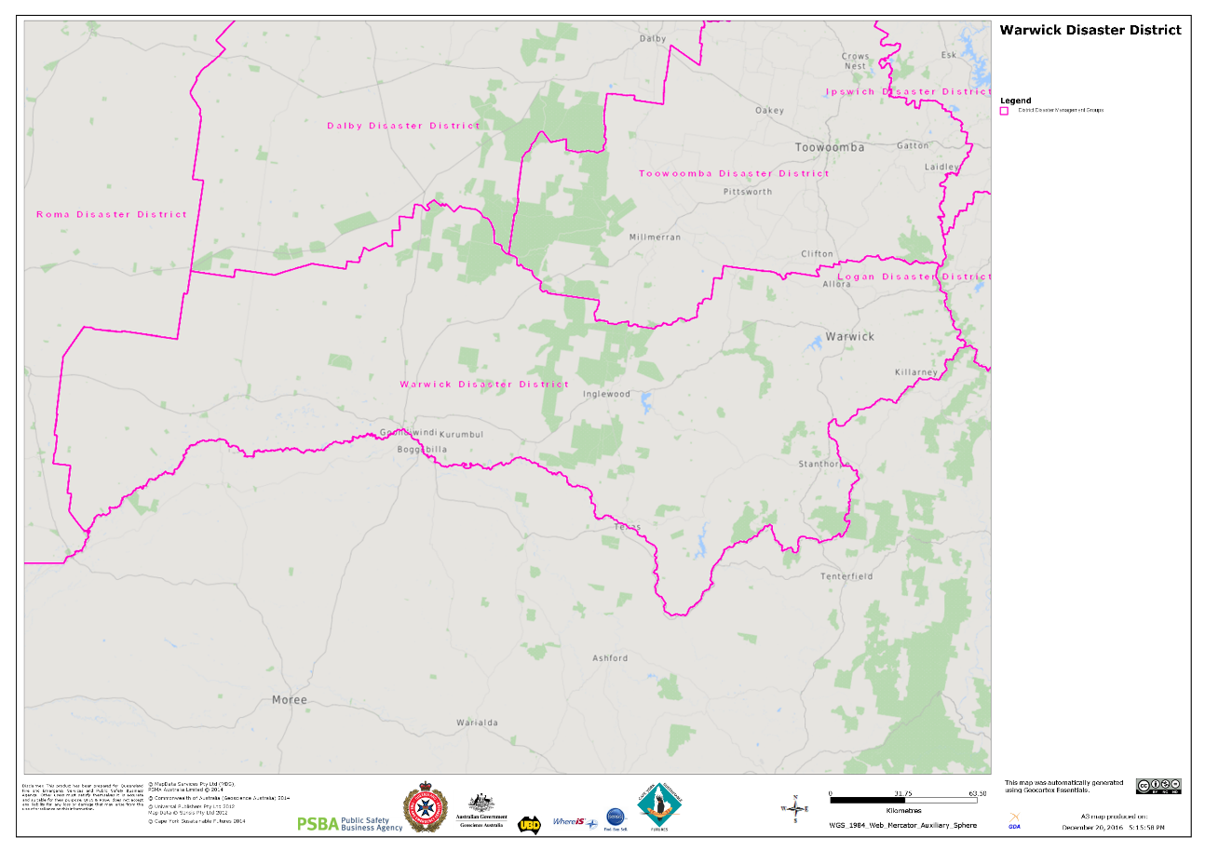
Figure 1: Map of the Warwick Disaster District – Incorporating the Southern Downs and Goondiwindi Regional Council areas

Community Context

The Warwick Disaster District comprises the Local Government Areas of the Southern Downs and Goondiwindi Regional Councils, both of which are required to form Local Disaster Management Groups in accordance with Section 29 of the Act.
The Warwick Disaster District is bounded by Toowoomba Disaster District and Dalby Disaster District to the north, Roma Disaster District to the west, Logan Disaster District to the east and New South Wales to the south.

Administrative Centres

Warwick is the largest town within the district and has all the essential infrastructure and services of any major town. Goondiwindi and Stanthorpe are the other major towns in the district and provide administrative and commercial hubs for the region. A large number of government departments and other companies have their regional offices based in Warwick. A significant portion of the Warwick Disaster District borders New South Wales.

Transport

The main road transport corridors traversing the district are the New England, Cunningham, Gore, Barwon, and Leichhardt Highways. Light aircraft strips are located in Warwick, Stanthorpe and Goondiwindi and there are restrictions on the types of aircraft which each strip can accommodate. Queensland Rail operates rail services for freight, livestock and passenger transport throughout the Warwick Disaster District.

Geography

The Warwick Disaster District covers an area of 26,411km² and is comprised of the Southern Downs Regional Council (7,119km²) and Goondiwindi Regional Council (19,292km²). With a combined population of approximately 47 000 people, the top employment sectors include primary production/agriculture, labour workers and construction. The Disaster District is situated in South-West Queensland and forms part of the Southern Queensland Police Region.

Popular attractions within the Region include Girraween, Abivilla and Main Range National Parks as well as Leslie, Glenlyon, Coolmunda, Connolly, and Storm King Dams. The Granite Belt wine country takes in many small villages and communities along the New England Highway, with Stanthorpe as the main commercial centre. Visitors are attracted by the four distinct seasons, orchards, vineyards and wineries, and an excellent range of restaurants and accommodation options.

Southern Downs Regional Council

Community Context
Detailed community context, population, geography, climate, critical infrastructure, essential services, industry and local hazard information is included in the Southern Downs Local Disaster Management Plan.

Southern Downs Local Disaster Management Plan

Emergency Services Organisations

Queensland Police Service
Police Stations are located at: Warwick, Stanthorpe, Clifton, Allora, Leyburn, Yangan, Killarney and Wallangarra.

Queensland Ambulance Service
Ambulance Stations are located across the Warwick region including Clifton, Stanthorpe and Warwick.

Queensland Fire Department
There are six Urban Auxiliary Fire Stations located across the Warwick region, whilst Warwick Fire Station has permanent fire fighters on a 24-hour basis.

Rural Fire Service
Southern Downs Regional Council and Queensland Fire Department Rural Operations support the District Rural Fire Brigade Groups which comprises of over twenty five brigades spread throughout the region.

State Emergency Service
SES Units are active with groups located at Warwick, Stanthorpe and Wallangarra.

Goondiwindi Regional Council

Community Context
Detailed community context, population, geography, climate, critical infrastructure, essential services, industry and local hazard information is included in the Goondiwindi Local Disaster Management Plan.

Goondiwindi Local Disaster Management Plan

Emergency Services Organisations

Queensland Police Service
Police Stations are located at Inglewood, Yelarbon, Texas, Goondiwindi and Talwood.

Queensland Ambulance Service
Ambulance Stations are located at Inglewood, Texas and Goondiwindi.

Queensland Fire Department
Fire Stations are located at Inglewood, Texas and Goondiwindi.

Rural Fire Service Queensland Brigades
Goondiwindi Regional Council and Queensland Fire Department Rural Operations support the District Rural Fire Service Brigade Groups which comprises of over twenty brigades spread throughout the region.

State Emergency Service
SES Units are active with groups located at Goondiwindi, Inglewood and Texas.

Referrable Dams
The Warwick Disaster District has a total of six referrable dams. All of the Emergency Action Plans for dams in the Warwick Disaster District are available here.

Goondiwindi Regional Council
- Coolmunda Dam

Southern Downs Regional Council
- Connolly Dam
- Glen Niven Dam
- Glenlyon Dam
- Leslie Dam
- Storm King Dam

District Hazards
The Warwick Disaster District adopts an all-hazards approach to disaster management. Hazards which have been identified for the Warwick Disaster District include, but are not limited to:

- Flood
- Cyclone
- Bushfire
- Severe Storm
- Earthquake
- Dam Failure
- Landslide
- Heatwave
- Major Transport Incident
- Pandemic
- Animal or Plant Disease
- Hazardous Material Incident
- Essential Services Threat
- Terrorism

Southern Downs and Goondiwindi LDMGs regularly review their hazard and disaster risk assessments, improving preparedness and the understanding of hazards and the consequences of potential impacts within their communities. The outcomes of these disaster risk assessments are key factors in the development of preparation and mitigation strategies for all agencies.

The Warwick DDMG recognises that hazards may impact beyond the boundaries of one local government and while the relevant LDMG or lead agency will respond within their capabilities, it is incumbent upon the DDMG to support local governments, lead agencies or the Queensland Government during any event in collaboration with the LDMGs, lead agencies and other DDMGs as necessary.

District Risk Assessment

Risk Management Process

Risk management processes conducted by the Warwick DDMG are to be in line with the Queensland Emergency Risk Management Framework (QERMF). This process applies a proven, standardised and internationally recognised approach to the prioritisation, mitigation and management of risk. This includes the identification of capacity gaps and residual risk between stakeholders and the Queensland Disaster Management Arrangements. This assists to directly inform planning and resource allocation, and to promote active communication, cooperation and coordination.

The QERMF Risk Assessment Process Handbook provides detailed information and diagrams of the risk assessment process.

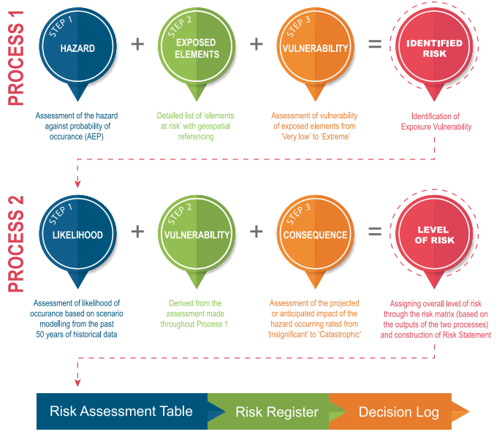

The QERMF derives risk methodology from Australian and International sources, including AS/NZS ISO 31000:2018 Risk Management – Guidelines, and National Emergency Risk Assessment Guidelines (NERAG).

Disaster District risk assessments and any subsequent reviews are conducted by members of the Warwick DDMG and any other key advisors as deemed appropriate.

Risk Identification

Sources of risk will be identified on the basis of available information and in consultation with relevant stakeholders. A comprehensive and systematic approach will ensure all risks are identified and recorded. This will be achieved through effective consultation with local expertise and through the analysis of historical information.

Risk Analysis

Risk analysis is the process through which the level of risk and its characteristics are determined through assessing the adequacy and appropriateness of existing controls and the prioritisation of risks. Risk analysis will examine the interaction between the likelihood, vulnerability and consequences to determine the overall risk. It involves consideration of the likelihood of a hazard eventuating, the vulnerabilities associated with the area under consideration and the consequences that may occur if the risk eventuates.

To establish risk, the methodology will consider likelihood, vulnerability and exposure and consequence. This inject of vulnerability into the process assists to assess what aspects of the area/community are vulnerable prior to an event occurring.

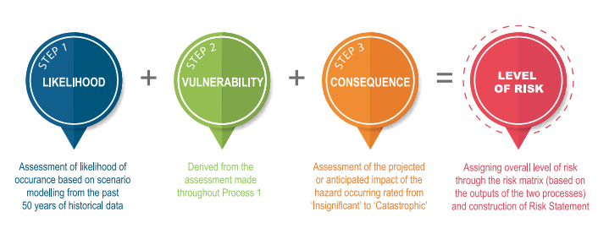
Likelihood

This step assists in identifying the most credible likelihood of an event occurring, based on historical data. It relies on applying the Likelihood Table (below) which provides rankings based on frequency and severity of hazards using the past 50 years of meteorological and geological observations. The same system can be applied to anthropological hazards.

Whilst information specific to the Warwick Disaster District can be derived from agencies, including the Bureau of Meteorology and Geoscience Australia, consideration should also be given to local area observations.

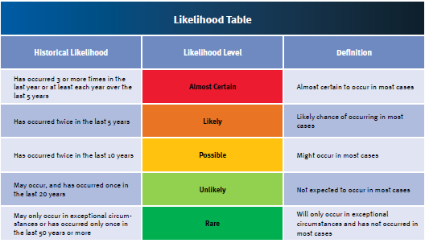

Vulnerability

Vulnerability considers the level of vulnerability for an area/site/community. The vulnerability table provides levels ranging from ‘extreme’ vulnerability to ‘very low’ vulnerability. In assessing the level of vulnerability, key concepts are included that assess the level of vulnerability for an area/site/community which considers certain aspects that sustain a community. These include:

- recovery from a loss of essential infrastructure;
- rebuild/repair of essential infrastructure;
- access/resupply to or evacuation from the area/site/community;
- topographic features of the area/community/site that have a direct relationship to a hazard;
- demographic features of the area/site/community that typify the population as vulnerable; and
- health support services available in the area/site/community.

Factoring vulnerability into the methodology allows for consideration of individual characteristics of a community ensuring risk management planning is ‘fit for purpose’ for that particular area. Opportunities to reduce risk can often be attained through addressing community vulnerabilities.

Consequences

In determining the level of consequence of an event, or risk eventuating, an assessment is conducted of key features of a community, including:

- people – in terms of numbers of casualties and deaths from a risk eventuating;
- financial/economic – impacts from a risk eventuating to the Queensland economy, which may include Gross Domestic Product (GDP), significant industries and essential infrastructure;
- community/social – aspects such as objects of cultural significance and community cohesion;
- public administration – governing bodies’ ability to cope within the response and recovery phases and the level of critical media reporting directed at governing bodies associated with the event and the level of public confidence in governing bodies; and
- environmental – the level of damage of destruction to ecosystems or species.

The levels range from ‘catastrophic’ to ‘insignificant’ consequences for each of these features.

Risk Matrix

In determining risk levels, a risk matrix is used. The Risk Matrix (below) combines the likelihood, vulnerability and consequence levels to determine the risk level which ranges from ‘extreme’ to ‘very low’.

The scores range from 1 (lowest) to 13 (highest).

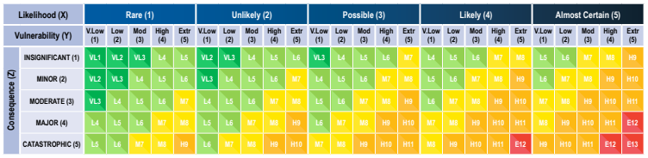
Risk Evaluation

Evaluating risks involves determining which risks are tolerable and which risks require further attention or treatment. The criteria for determining tolerability could depend on various internal and external influences such as:

- prevailing political, stakeholder or community sensitivities and expectations;
- the nature and type of event;
- existing or emerging event trends;
- strategic or organisational priorities;
- resources available for treatment, and
- the ability of the organisation/community to absorb the losses.

Decisions on the level of tolerability of risk establish criteria for treatment of risks. These may include categories such as:

- treat immediately;
- treat in the near future;
- treat in the longer term; and
- monitor.

Risk Treatment

Risk treatment strategies aim to determine and implement the most appropriate action/s to reduce risk to community elements. Residual risk is the risk that exists beyond the capacity and capability of the local community and disaster management arrangements to manage, in consideration of available risk controls.

Risks outlined in the District Risk Register are analysed by members of the Warwick DDMG with a view to identifying strategies for risk treatment. These strategies are contained in the District Risk Treatment Plan (Annexure C). The District Risk Treatment Plan also contains preferred treatment options, responsibilities and timeframes for implementation.

The allocation of responsibility for the implementation of risk treatment strategies, monitoring and reporting shall be determined by members of the DDMG under the guidance of the DDC. The District Risk Treatment Plan is to be presented to the Warwick DDMG for ratification.

To progress any treatment options, the DDMG is to request relevant responsible agencies to incorporate specified risk treatment strategies into their agency corporate planning processes for recognition and implementation.

In instances where the applications of treatment strategies at district level are identified as not being adequate and residual risks remain, the DDMG is to determine whether risk transfer or risk sharing with the QDMC is a treatment option. In those instances, the DDMG is to document and notify the QDMC of these with a view to transferring or sharing the risks.

A review of the District Risk Treatment Plan shall be conducted in conjunction with any district risk assessment review process.

Decision Log

The decision log and any supporting documentation associated with the risk register should outline and record predominately ‘key decisions’ in the assessment of risks, including the rationale behind judgements and who has been involved in making these decisions while preparing the risk register. In instances where the risk is transferred to the QDMC, the rationale should be clearly outlined and defensible. The decision log captures succinctly and efficiently critical attributes of key decisions made during the risk assessment process where additional detail is required. This allows for transparency in decision making and clearly outlines those involved in the process.

Monitoring and Review

The risk assessment must be reviewed annually and where required updated to ensure it is current and relevant, given changing priorities, perception and culture. Lessons learned from training exercises and the results of evaluations after responses to events will be used to inform assessment activities. Issues identified as a part of the risk management assessment process will inform future exercise programs as part of treatment options.

The monitoring and review process is to be documented as part of the risk assessment reporting, including:

- ensuring the identified controls are operating effectively and adequately and have not changed over time;
- ensuring the most credible and contemporary available information is used as evidence for the likelihood, vulnerability and consequence levels;
- incorporating information from emergency events that may have occurred since the last risk assessment;
- accounting for changes in the context of the risk assessment; and
- identifying and accounting for emerging risks.

Operations

Response Strategy

Warning Notification and Dissemination

The Warwick DDMG has a responsibility to ensure warnings are disseminated to members of the LDMGs, DDMG, QDMC, member agencies, the community, and cross border disaster management groups and agencies. Multiple communication methods are employed and agencies are responsible for communicating within their organisation as stated in the QDMA structure.

This process takes rapid onset events into consideration and will utilise all available communication methods.

The warning notification process is reviewed annually, with contact lists updated quarterly and also by exception, as roles and positions change.

Methods of communication include (but are not limited to):
- Email
- Telephone (landline/mobile/satellite)
- Text message
- Teleconference/videoconference calls
- Social media platforms (Facebook, Instagram etc)
- Disaster Dashboard information
- Fax
- HF radio

Emergency Alert

Emergency Alert (EA) is one of the tools that can be used to warn communities of an impending emergency and is a critical element of emergency response. The Queensland Warnings Manual govern the use of EA in Queensland.
These guidelines are located at: Emergency Alert
Each local government has pre-prepared Emergency Alerts for hazards in their area. Further, Goondiwindi and Southern Downs Regional Councils have prepared Communications/Public Information and Warnings sub-plans.

Australian Warning System

The Australian Warning System (AWS) is a national approach to warnings. It includes:
- consistent warning levels (Advice, Watch and Act, Emergency Warning);
- call-to-action statements;
- icons; and
- colour scheme
to achieve consistency and give the community clear and targeted information about what to do to stay safe before, during and after an incident or disaster. The system builds on existing warning frameworks and applies nationally to bushfire, flood, severe storm, cyclone and extreme heat. It is designed to be adaptable and scalable to other hazards in the future.
For more information regarding Warnings refer to the Australian Warning System website.
Activation and Triggers for Response

The authority to activate the Warwick District Disaster Management Plan is vested in the Chairperson/DDC, or in that person’s absence the Deputy Chairperson. This should occur following consultation with one or more of the following; the Chair of the QDMC and/or DDMG; the Chair of a LDMG; a member of the DDMG and/or a member of a response agency.

The DDC should determine when, and to what extent, the DDMG should activate in support of an event, and may bypass initial levels of activation where appropriate to the event. Activation is scalable and does not necessarily mean the convening of all members of the DDMG or the activation of the DDCC. Activation activities can be as minimal as the provision of information to DDMG members regarding the risks associated with a potential or imminent hazard impact.

The four levels of activation, as defined in the SDMP, are tabled below.

Level of Activation | Definition
Alert | A heightened level of vigilance and preparedness due to the possibility of an event in the area of responsibility. Some action may be required and the situation should be monitored by staff capable of assessing and preparing for the potential threat.
Lean Forward | An operational state prior to ‘stand up’ characterised by a heightened level of situational awareness of a disaster event (either current or impending) and a state of operational readiness. Disaster coordination centres are on stand-by; prepared but not activated.
Stand Up | The operational state following ‘Lean Forward’ whereby resources are mobilised, personnel are activated and operational activities commenced. Disaster coordination centres are activated.
Stand Down | Transition from responding to an event back to normal core business and/or recovery operations. There is no longer a requirement to respond to the event and the threat is no longer present.

District Disaster Coordination Centre

Primary DDCC Site:

The primary DDCC is located at Warwick Police Station, 86 Fitzroy Street Warwick. Within that complex, the conference room is allocated as the primary DDCC.

Contact details for the primary DDCC are available in the DDCC Standard Operating Procedures.

Secondary DDCC Site:

The secondary DDCC is located at the Department of Transport and Main Roads Complex, 306 Wood Street Warwick. Within that complex, the training room is allocated as the secondary DDCC.

Contact details for the secondary DDCC are available in the DDCC Standard Operating Procedures.

Business Continuity

It is necessary to take reasonable steps towards planning for unplanned events that are likely to impact on normal DDCC functionality. To this end, a secondary DDCC site has been identified. The nature of disaster management is dynamic and planning cannot cover all possible scenarios. Decisions regarding business continuity with respect to the functioning of a DDCC will be made during the course of the event.

Induction/Briefings

An induction briefing will be provided to all new personnel rostered to perform duty in the DDCC. This induction will include issues relating to the layout of the building, DDCC processes, evacuation procedures, and workplace health and safety matters.

Power Supply

The Warwick Police Station complex has a diesel fuelled emergency backup generator which will automatically start should power failure be experienced during DDCC operations. The Warwick Police Station Business Continuity Plan contains information relating the generator (maintenance contractor details and refuelling information) and should be read in conjunction with this document.

Staffing – Roles and Responsibilities

The Warwick DDCC adopts with the COPIA incident command model, however is flexible and can change in consideration of the event and staff availability.

The DDCC Structure will consist of the following cells:

- Command
- DDC
- Executive Officer
- Deputy DDC/Deputy Executive Officer
- Operations Officer/s (OPSO)
- Planning Officer/s
- Intelligence Officer/s
- Administration and Logistics Officer/s
The Support Team will/may include:

- Telephonist/s
- Registry Officer/s
- Logging Officer/s
- Media Liaison Officer/s
- Agency Liaison Officer/s (to attend as required)

The minimum staffing level required to operate the DDCC is at the discretion of the DDC. In general, there will be two teams working opposite shifts who will staff the DDCC. DDCC staff will be drawn from the Warwick Patrol Group and personnel from various participating Government and non-Government departments/agencies.

In the event the activation continues for an extended period of time, fatigue management principles will apply. DDCC staff will be sourced in the first instance from the Warwick Patrol Group. Requests for additional QPS staff will be managed internally in conjunction with the stand up of a Police Operations Centre (POC).

Member and advisory agencies will be required to manage fatigue of their staff in line with internal agency, policy and procedures.

Overall management of the district disaster response is the responsibility of the DDC.

Management of the DDCC is the responsibility of the appointed Executive Officer.

QPS Agency Liaison Officers (QPS LOs)

Generic Agency Liaison Officer Duty Statements as well as specific QPS LO Information Management processes and Communication flow chart is contained with the Warwick DDCC Standard Operating Procedures (SOPs). The SOPs contain specific localised instructions for QPS LOs at Council Local Disaster Coordination Centres, Agency Incident Command Centres and at Agency Regional Operations Centres. A LO Quick Reference Guide and compendium is available to Officers undertaking these duties.

General instructions outlining how the DDCC will be operated are contained within the Warwick DDCC Standard Operating Procedures which should be read in conjunction with this document.

Operational Reporting

District Situational Reports (SITREPs)

When the Warwick DDCC receives local and agency SITREPs, it is the responsibility of the Executive Officer to maintain the SITREP update board on DIEMS so that the SDCC is provided with timely and accurate situational awareness and reporting to enable the preparation of the ‘State Update’.

Details should include all relevant information and issues in relation to the disaster situation, and planning projections into the future.

The DDCC shall advise the SDCC Watch Desk once the DDMG is activated and update DIEMS accordingly.
Once activated, the DDMG will provide ongoing situational reporting on the event and disaster management operations of local and district groups via the SITREP Update Board.

Disaster Declaration

Where the DDC considers it necessary for a disaster declaration to be made under Section 64 of the Act, the DDC will take reasonable steps to consult with the district group and each local government whose area is in, or partly in, the declared area for the disaster situation.

If time permits, the DDC will also discuss the outcome of any consultation with members of the Warwick DDMG during an extraordinary meeting of the group.

The declaration can be made orally or in writing, but if made orally must be then made in written form as soon as reasonably practicable thereafter. The disaster declaration period may be extended past the initial 14 day period (section 66 of the Act) if required. The disaster situation must be ended as soon as the declared disaster powers are no longer required.

The Executive Officer is responsible for preparing relevant documentation on behalf of the DDC for consideration by the Minister for Police and Emergency Services.

A declaration can also be made in accordance with Section 69 of the Act by the Premier and Minister for Police and Emergency Services for the State of Queensland or part of the State.

If circumstances prevent such processes to be undertaken, the DDC will act independently to declare the disaster and subsequently seek verbal approval in accordance with the Act and report the decision subsequently to the DDMG and the relevant LDMGs.

Functional Plans

The Queensland State Disaster Management Plan outlines that functional plans address the functions of disaster management where government departments and agencies have a functional lead agency role. The plans and procedures are developed by the functional lead agency and are sub-plans to the State Plan.

The functional plans detail arrangements relating to supporting activities undertaken by functional lead agencies of the DDMG. At the district level, functional planning is established, as necessary, as sub-plans to the District Disaster Management Plan.

Hazard Specific Arrangements

While Queensland has adopted an all-hazards approach to the development of disaster management arrangements, it is important to acknowledge that some hazards have characteristics that may require a hazard specific approach.
There may be a range of hazard specific plans developed by the relevant hazard specific primary agency the DDMG needs to consider as supporting references to the main DDMP.
These may include:
- Plant and Animal Disease;
- Terrorism;
- Bushfire; and
- Pandemic.
These plans address specific hazards where government departments and agencies have a primary management responsibility. The primary agency has responsibility to ensure that an effective hazard specific plan is prepared.
All hazard specific plans are to address the hazard actions across all PPRR phases and include information on how the QDMA links with the hazard specific arrangements and provides support to the primary agency in the management of the hazard specific event.
Specific planning is required for these arrangements as their coordination and operational procedures can be different to those of the QDMA.
Coordination centres and the structures within them can be outside the local, district and state coordination centres and the passage of information and resources may be managed using different processes.
Primary agencies also have a role in ensuring state hazard specific plans link to national hazard specific plans and arrangements and that appropriate communication and relationships with counterparts at the national level are maintained.
Specific Hazard | Primary Agency | State and National Plans/Strategies
Animal and plant disease | Department of Agriculture, Fisheries and Forestry  Department of Primary Industries | Queensland Government Biosecurity Manual  Queensland Biosecurity Strategy 2024-2029  Commonwealth Government AQUAVETPLAN  Commonwealth Government AUSVETPLAN  Commonwealth Government ANIMALPLAN  Australian Emergency Plant Pest Response Plan PLANTPLAN  Department of Agriculture and Fisheries Disaster Management Plan
Biological (human related) | Queensland Health | State of Queensland Multi-Agency Response Plan to CBR Incidents (State CBR Plan)  State of Queensland Biological Response Plan
Heatwave | Queensland Health | Queensland Health Heatwave Management Sub-Plan (Sub-plan of the QHDISPLAN)
Bushfire | Queensland Fire Department | Queensland Bushfire Plan  Wildfire Mitigation and Readiness Plans (Regional)
Chemical | Queensland Fire Department | State of Queensland Multi-Agency Response Plan to CBR Incidents (State CBR Plan)  State of Queensland Chemical/HAZMAT Response Plan
Pandemic | Queensland Health | Queensland Health Pandemic Influenza Plan  Queensland Whole-Of-Government Pandemic Plan  Australian Health Management Plan for Pandemic Influenza
Radiological | Queensland Fire Department | State of Queensland Multi-Agency Response Plan to CBR Incidents (State CBR Plan)
Terrorism | Queensland Police Service | Queensland Counter-Terrorism Plan  Australian National Counter-Terrorism Plan

Threat Specific Plans – Referrable Dams
Referrable Dams are required to have an Emergency Action Plan (EAP), which provides guidance for actions required as a result of any hazardous situations or emergency events occurring at the dam.

Chapter 4 of the Water Supply (Safety and Reliability) Act 2008 [QLD] provides a definition for a referrable dam and associated information about EAPs.

The Warwick Disaster District has a total of six referrable dams. All of the Emergency Action Plans for dams in the Warwick Disaster District are available here.

Goondiwindi Regional Council
- Coolmunda Dam

Southern Downs Regional Council
- Connolly Dam
- Glen Niven Dam
- Glenlyon Dam
- Leslie Dam
- Storm King Dam

Requests for Assistance (RFAs)

The Warwick DDMG does not possess any resource reserves. All resources within the disaster district are owned and managed by the various local governments, government departments, corporate entities and private business operators.

Where resources or services are not available within their jurisdiction, or if available, have been or are likely to be expended, an LDMG may request assistance from the DDMG to provide such resources. Requests shall be in the approved Request for Assistance (RFA) form.

RFAs may be received by:
- Email/phone
- Guardian

Upon receipt of an RFA, it will be prioritised by the DDC, Deputy DDC or Executive Officer. The DDMG shall make all reasonable endeavours to locate the required resource or service from within the disaster district.

Resources and services acquired by the DDMG and appropriated to a LDMG may be recalled and reallocated at the discretion of the DDC.
In the event the required resource or service is not available elsewhere in the disaster district, the DDMG shall forward a request via DIEMS to the State Disaster Coordination Centre (SDCC) Operations Group.

Appropriate approvals shall be obtained prior to the incurrence of any financial expenses.

The Executive Officer shall ensure that accurate records are maintained in respect to requests for assistance, resource acquisition and allocation and financial expenditures.

Request for Supplies and Equipment

The Warwick DDMG as an entity does not possess any resource reserves. All resources within the disaster district are owned and managed by the Goondiwindi and Southern Downs Regional Councils, government departments, corporate entities and private business operators. Available resources which may be necessary for disaster response activities may be requested from these entities as required.
Where a resource or service which is required to conduct disaster response activities is not available within the jurisdiction of the LDMG, the LDMG may request assistance from the DDMG to provide such resources.

Resupply

Due to the nature of some disasters there will be occasions where areas within the disaster district become isolated for a lengthy period of time, requiring the need to resupply provisions to that area. The Warwick DDMG has adopted the Queensland Resupply Manual and all resupply operations will be undertaken within these guidelines.

Local Disaster Management Groups which require assistance in the form of resupply of provisions, shall request the assistance from the DDMG in arranging this resupply. Such requests shall be in the approved form (Request for Assistance).

Efforts should be made in the first instance to provide the requested resupply of provisions from within the capability and capacity of the DDMG. Where a DDC facilitates a resupply operation from within District resources they should ensure that suitable measures have been activated under SDRA or DRFA to ensure cost recovery. Should such measures not be activated, then they should seek State approval under this policy to ensure financial cover is available.

Where a DDC receives a RFA for resupply operations which is outside of the capability or capacity of the DDMG, the RFA is to be forwarded to the SDCC to enable the provision of the request from the LDMG.

The Queensland Resupply Manual outlines in detail the governance and operational process relating to the resupply of essential goods to communities in Queensland and are located at: Queensland Resupply Manual.

Emergency Relief

Emergency relief is the provision and management of emergency supplies and services to support disaster operations. It is delivered by a logistics cell or capability at either the local, district or state disaster coordination centre, depending on the specific situation. The goods or resources required to support emergency relief are generally provided through the RFA process.

The escalation of requests from local to district to state should not be a strategy to shift financial risk. Uncertainty at the local level about request or resource eligibility under the DRFA should be addressed with the responsible Emergency Management Coordinator or Queensland Reconstruction Authority Liaison Officer.

Supplies should first be sought locally, using the local emergency supply register developed as part of the LDMP.

Australian Defence Force Assistance to the Civil Community (DACC)

The Australian Government may provide assistance in response to a disaster event, following a request for Defence Assistance to the Civil Community (DACC). The principle applied to emergency DACC is that state and territory governments are primarily responsible for combating disasters using available paid and volunteer services and commercially available resources. Requests for DACC are made via the RFA process to the SDCC. These requests are considered by the SDC and upon approval are forwarded to the National Emergency Management Agency via the National Situation Room for consideration.

Information about the DACC initiative is available at DACC Initiative.

Financial Management

Due to the nature of many disaster situations, finance operations will often be conducted with compressed time constraints and other pressures, necessitating the use of non-routine procedures.

Expenditure is on a cost-recovery basis and must meet current Government Disaster Relief and Recovery Arrangements Guidelines to be considered for reimbursement. Guidelines for these arrangements are located at Queensland Disaster Financial Guidelines.
The DDMG should predetermine event-related financial management arrangements to ensure costs are appropriately endorsed and captured from the onset of operations. The DDC, in consultation with the DDMG Executive Team, is responsible for establishing and maintaining financial management procedures for the DDCC.

Each agency is responsible for providing their own financial services and support to its response operations relevant to their agency. All processes are performed in accordance with the Queensland Government Financial Management Practice Manual and therefore in compliance with section 46M of the Financial Administration and Audit Act 1977 and other prescribed requirements.

Operational Plans

The DDMG has developed a number of operational plans for use during response and recovery phases undertaken prior to, during and after disaster events. These operational plans have been developed to assist in the mitigation of residual risk passed from the local to district level. It is the responsibility of the Executive Officer to ensure these plans are reviewed annually in consultation with the Chair of the DDMG and member agencies.

These plans include:

- District Disaster Coordination Centre Standard Operating Procedures (separate document)
- District Human Social Recovery and Resilience Sub Plan (available upon request to the Department of Families, Seniors, Disability Services and Child Safety (Community Recovery))
- DDMG Operational Plan (Annexure F)
- DDMG Bushfire Action Plan (separate document)

Recovery Strategy

The Warwick District Recovery Strategy may be activated upon direction from the DDC or the QDMC. This recovery strategy provides a framework for the coordination of recovery operations within the district and is supported by the procedures outlined in the Queensland Recovery Plan.
Recovery Lead Agencies
Function | Lead Agency
Economic | Department of State Development, Infrastructure and Planning
Environmental | Department of Environment, Tourism, Science and Innovation
Human and Social | Department of Families, Seniors, Disability Services and Child Safety (Community Recovery)
Infrastructure | Transportation Infrastructure (Department of Transport and Main Roads)  Building Recovery (Department of Housing and Public Works)  Telecommunications (telecommunications providers and  energy infrastructure)  Electricity, gas, fuel (Department of Natural Resources and Mines, Manufacturing and Regional and Rural Development)  Water Supply and Sewerage Infrastructure  (Department of Natural Resources and Mines, Manufacturing and Regional and Rural Development)  Water Entities (local government)
DRFA and SDRA Coordination | Queensland Reconstruction Authority
Recovery Coordination and  Monitoring | Queensland Reconstruction Authority

Transition Triggers

The triggers to activate recovery for the Warwick Disaster District are outlined in the table below.
Warwick District Disaster Management Recovery Activation Levels

Response  Alert |  | Triggers | Actions | Communications
Response Lean Forward | Recovery Alert | Response phase at ‘lean forward’ level of activation | - Appointment of Local Recovery Coordinator/s (LRC/s)  - Essential elements of District Operational Recovery Group (DORG) activated  - Potential actions and risks identified  - Information sharing commences  - DORG members in contact with DDC/DDCC and LRC/s.  - Initial advice to all recovery stakeholders | - LRC/s and DORG members monitoring communications  - Ad hoc reporting
Response Stand Up | Recovery Lean Forward | Response phase at ‘stand up’ level of activation  Immediate relief arrangements are required during the response phase | - Monitoring of response arrangements.  - Analysis of hazard impact or potential impact  - Relief and recovery planning commences  - Deployments for immediate relief commenced by recovery functional agencies | - LRC/s and DORG members monitoring communications  - Ad hoc reporting
Response Stand Up | Recovery Stand Up | Immediate relief arrangements continue  Medium term recovery commences  Response phase moves to ‘stand down’ level of activation | - DORG activated at LDCC or alternate location  - Recovery plan activated  - Deployments for immediate relief response  - Action plans for 5 functions of recovery activated as required  - Community information strategy employed  - Participate in response debrief  - Transition arrangements from ‘response and recovery’ to ‘recovery’ activated including handover from DDC to LRC  - Action plans for 5 functions of recovery continue  - Community information strategies continue | - LRC and DORG members present at LDCC or alternate location on established landlines and/or mobiles, monitoring emails  - LRC and DORG members involved in medium term recovery continue as required  - Regular reporting to LDMG/LDCs/DDC
Response Stand Down
 | Recovery Stand  Down | DORG arrangements are finalised  Communities return to normal activities with ongoing long term recovery support provided by functional lead agencies as required | - Consolidate financial records  - Reporting requirements finalised  - Participate in recovery debrief  - Participate in post event debrief  - Post event review & evaluation  - Long term recovery arrangements transferred to functional lead agencies  - Return to core business | - LRC and DORG members resume standard business and after hours contact arrangements  - Functional lead agencies report to LRC/DORG as required

Immediate/Short Term Recovery

As disaster response and immediate/short term recovery occurs concurrently, the activation of the strategy will commence with immediate/short term recovery actions undertaken during the response phase. The concept of operations for immediate/short term recovery is located in Section 3 of the Queensland Recovery Plan.

Medium/Long Term Recovery

The level of district support required in the medium/long term recovery phase will be dependent on the recovery structure advised by the SDMG for each specific event. The concept of operations for medium/long term recovery is located in Section 3 of the Queensland Recovery Plan.

Warwick District Recovery Groups

Where required and in consideration of the scale of the disaster and the needs of the local government/s, the medium/long term recovery phase may include the establishment of a District Recovery Group with specific membership appointed as appropriate to the type of event and functions of recovery. The following committees may be established:

- Human and Social Recovery and Resilience Committee
• Environmental Recovery and Resilience Committee
• Economic Recovery and Resilience Committee
• Building Recovery and Resilience Committee
• Infrastructure and Roads Recovery and Resilience Committee

The Chairperson of each recovery committee will be the DDMG representative from the relevant recovery functional lead agency.

Once established, each committee are to consider the support requested by the local government/s. The Chairperson of each recovery committee is to liaise with the DDC and the Local Recovery Coordinator/s to provide the relevant support to local government/s as requested.

The Chairperson of each committee is to ensure Operational and Action Plans are developed to support the local government/s to affect the recovery of impacted communities and individuals.

Warwick District Human and Social Recovery and Resilience Committee

The Warwick District Human and Social Recovery and Resilience Committee meets every three months. Group members:

- Attend local subgroup meetings as required;
- Participate in exercises; and
- Update contact list each meeting.

The Warwick District Human and Social Recovery and Resilience Plan is available to view by contacting the Warwick Disaster District Executive Officer.

As part of the disaster recovery phase, the Chairperson of the Human and Social Recovery and Resilience Committee may establish a Community Recovery Coordination Centre. The Coordination Centre is established to coordinate:

- Community recovery operations; planning; logistics and communications;
- Administration within the region responding to the disaster;
- Delivery of Outreach Services; and
- Multi-agency situational awareness.

It is recognised that with large scale disasters, multiple disaster districts neighbouring the Warwick Disaster District and within the region may be affected and could require simultaneous recovery. This may place a strain on functional lead agencies and other member agencies and organisations to provide staff from district resources to sit on multiple recovery groups or within multiple coordination centres.

This may require deployment of staff from outside the district and does not restrict the Chairperson of the Warwick District Human and Social Recovery and Resilience Committee from forming one coordination centre to address the recovery of multiple districts within the Government Region.

Operational and Action Plans
When convened for disaster recovery operations, the Chairperson of each committee will develop an Operational Plan to guide its activities. This will be discussed and developed during the group’s first meeting and will be developed to supplement the local government disaster recovery operational plan. A broad timeframe will be included in this plan.
At the first meeting Action Plans for each recovery function will also be developed. Action Plans will list the tasks to be performed by the group and agencies/individuals responsible for the tasks.
As Local Recovery Groups have a lead role in the disaster recovery process, the district committee’s Operational or Action Plans will be developed to supplement and support local disaster recovery plans. Each committee will operate closely with LDMGs to assist in the recovery process.
Copies of amended Action Plans should be submitted to the recovery group of the appropriate level at their final meeting, where the Operational Plan is to be finalised. Copies of plans should be included in relevant agency and committee event files.

Review and Assurance

Review and Renew Plan

In accordance with section 55 of the Act, the District Disaster Management Plan shall be reviewed annually. This review shall be conducted by members of the DDMG identified by the DDC and shall be conducted as follows:

- Review conducted;
- Draft amendments formally submitted to DDMG for approval; and
- Approved amendments (or new plans, if appropriate) disseminated to all stakeholders.

The sub-plans of the Disaster District’s Functional Committees shall be reviewed annually by the same members and shall be conducted as follows:

- Functional Committee reviews sub-plan;
- Draft amendments submitted to DDMG for consideration and approval; and
- Approved amendments (or new sub-plans, if appropriate) disseminated to all stakeholders.

The effectiveness of the DDMP and sub-plans shall be reviewed and assessed against the Inspector-General Emergency Management Standard for Disaster Management in Queensland.

The DDMP and sub-plans may be reviewed at any other time should it become apparent that urgent amendment is required to improve the operational effectiveness of DDMG activities.

External Assessment

The Inspector-General Emergency Management (IGEM) is responsible for providing the Premier, Government and people of Queensland an assurance of public safety, through the establishment and implementation of an assurance framework to direct, guide and focus work of all agencies, across all tiers of Government to the desired outcomes of the disaster and emergency management arrangements for Queensland.

The IGEM supports the planning, developing and undertaking of a range of review and assessment projects, and consulting stakeholders, to enable confidence in Queensland’s disaster and emergency management arrangements.

The Emergency Management Assurance Framework (the Framework) has been established by IGEM to support accountability and build consistency across all levels of the disaster management arrangements and reinforces a shared responsibility for delivering better disaster management outcomes for the community.

The Framework establishes the Standard for Disaster Management in Queensland and is founded on shared responsibilities, good practice attributes and clear accountabilities.

The Standard describes the attributes of effective disaster management, outlines to stakeholders the required outcomes against the Standard and provides indicators that will contribute to the likelihood of disaster management entities achieving these outcomes. The Standard also forms the basis of Assurance Activities undertaken by the Office of the IGEM. IGEM utilise the Framework and the Standard to continually conduct assurance activities around the disaster management operations of disaster management groups to ensure quality and continuous improvement.

The Warwick DDMG will ensure its disaster management operations and planning adhere to the principles of the Framework and Standard.

Comprehensive information in relation to the requirements and components of the Framework and the Standard may be found on the IGEM website.

Review of Local Disaster Management Arrangements

In accordance with section 23 of the Act; the Queensland Prevention, Preparedness, Response and Recovery Disaster Management Guideline, Strategic Policy Statement and Emergency Management Assurance Framework, it is a function of the DDMG to regularly review and assess the disaster management arrangements of local groups in the district.

All review and assessments of local disaster management arrangements conducted by the DDMG will be undertaken in accordance with the direction provided by IGEM.

The DDMG Executive Officer and Emergency Management Coordinators attend all meetings of the Goondiwindi and Warwick LDMGs.

Annexure Index

A Distribution List
B Warwick District Disaster Management Group Contact List
C Warwick District Risk Register
D Abbreviations and Acronyms
E Definitions
F Warwick DDMG Annual Operation Plan

Annexure A - Distribution List

Position | Organisation | Electronic Copy
District Disaster Coordinator | Queensland Police Service
Deputy District Disaster Coordinator | Queensland Police Service
Executive Officer | Queensland Police Service
District Disaster Coordination Centre – Primary Location | Queensland Police Service
District Disaster Coordination Centre – Secondary Location | Queensland Police Service
Emergency Management Coordinators | Queensland Police Service
Disaster Management Officer | Goondiwindi Regional Council
Disaster Management Officer | Southern Downs Regional Council
Disaster Management Officer | Queensland Department of Transport and Main Roads
Operations Superintendent | Queensland Ambulance Service
Manager of Public Health | Queensland Health
Regional Facilities Manager | Department of Education
Warwick Area Commander | Queensland Fire Department
Goondiwindi Area Commander | Queensland Fire Department
Liaison Officer | Red Cross
Regional Facilities Manager | Department of Primary Industries
Regional Engagement Manager | Telstra
Environmental Services Manager | Department of Environment, Tourism, Science and Innovation
Principal Community Recovery Officer | Department of Families, Seniors, Disability Services and Child Safety (Community Recovery)
Manager | Department of Housing and Public Works
Principal Economic Development Officer | Department of State Development, Infrastructure and Planning
Service Manager | Sunwater
Manager | Ergon Energy
Regional Editor | ABC Southern Queensland
JOSS | Australian Defence Force
Regional Program Manager | Queensland Reconstruction Authority
Regional Emergency Management Officer | New England Region - NSW Police Force
Queensland Police Service Website | Queensland Police Service

Annexure B – Warwick DDMG Contact List

Available as a separate document.

Annexure C – Warwick DDMG Risk Register

Risk Assessment Table
(Bushfire) (Warwick DDMG)
Hazard  x  (13%) | Exposed Elements | Vulnerability | Risk Statements | Likelihood | Consequence | Risk Treatments | Risk Level
BUSHFIRE | Essential Infrastructure:  Power infrastructure including 1 electricity substation, Amiens Road Stanthorpe likely to be impacted. Warwick substation not impacted. Main power lines likely to be impacted; significant 330kv overhead lines running north-south approx. 20km east of Yelarbon in the south and 20km east of Kindon in the north, eventually crossing over the Gore Highway to the north of the disaster district. 110kv overhead line running north-south from Stanthorpe to Warwick also likely to be impacted west of Dalveen and The Glen and east of Leslie Dam. | Moderate | Bushfire Hazard - in forestry areas. Large areas of forestry land may be affected and some farm area. Likely disruption to power supply and damage to power infrastructure, anticipated disruption period would be short to medium term. | Possible | Moderate | Engage stakeholders (identify owner/operator of asset) to identify the level of redundancy for specific assets in exposed areas.  Engage stakeholders (identify short-term contingencies/back-up assets) for exposed assets that will provide capacity for affected populations.  Establish long-term plans for the replacement and repair of potential exposed sites. | M7
BUSHFIRE | Access & Resupply: Roadways - Millmerran Inglewood Road impacted to the north 30km from Inglewood then becoming a part of the Toowoomba Disaster District. Cunningham Highway impacted from approx. 2km east of intersection with Leyburn Cunningham Road south-west to Goondiwindi (including Inglewood). Texas Yelarbon Road impacted west of the intersection with Inglewood Texas Road for approx. 8kms. Inglewood Texas Road impacted from Texas north to Inglewood, Leyburn Cunningham Road impacted east from Leyburn to the intersection with Ryeford Pratten road. | Moderate | Bushfire hazard - forestry areas and farmland areas. Roadways affected by visibility from smoke, fire may have impact on the roadway surface as well as road users, roads may have to be closed for the short term. | Possible | Moderate | Engage stakeholders (local government and DTMR) to identify the level of redundancy or mitigation strategies for specific assets identified in exposed areas. | M7
BUSHFIRE | Community & Social: There was no observed directly exposed elements with interaction with the bushfire layer | Very Low | Bushfire layer exposes very little interaction of historical data with the community and social layer. There may be some residual considerations in relation to smoke hazard. | Possible | Moderate | Nil identified | L5
BUSHFIRE | Medical: There were no observed directly exposed elements with interaction with the bushfire layer | Very Low | Bushfire layer exposes very little interaction of historical data with the medical layer. There may be some residual considerations in relation to smoke hazard. | Possible | Minor | Nil identified | L4
BUSHFIRE | Significant Industries: Nil significant industries exposed to the bushfire layer | Very Low | Bushfire layer exposes very little interaction of historical data with the significant industries layer. There may be some residual considerations in relation to smoke hazard. | Possible | Minor | Nil identified | L4
BUSHFIRE | Environmental: The bushfire layer indicates that impact is mostly in forested areas within state and local forestry areas. | High | Bushfire layer exposes a large area of state and local forestry that has a high potential to impact the environment. | Possible | Moderate | Engage with Queensland Parks and Wildlife Service (QPWS) to identify mitigation, response & management strategies. Engage with environmental & conservation groups active in the area. | M8

Risk Assessment Table
(Earthquake) (Warwick DDMG)
Hazard  x  (13%) | Exposed Elements | Vulnerability | Risk Statements | Likelihood | Consequence | Risk Treatments | Risk Level
EARTH  QUAKE | Essential Infrastructure: communications infrastructure, water and waste treatment plants.  Power infrastructure including high voltage main line at Main Camp. | Low | Power assets supplying the district population, communications infrastructure, water and waste treatment plants are unlikely to be impacted by an earthquake. | Possible | Insignificant | Engage stakeholders (identify asset owner/operator) to identify the level of redundancy for specific assets in exposed areas. | L4
EARTH  QUAKE | Access & Resupply: Roadways - Barwon Highway, air access and re- supply. | Low | Access/resupply by road is unlikely to be impacted by earthquake in the locations identified. Access/resupply by air is unlikely to be impacted by earthquake in the locations identified. | Possible | Insignificant | Engage stakeholders (identify asset owner/operator) to identify the level of redundancy for specific assets in exposed areas.  Engage stakeholders (identify short-term contingencies/ back-up assets) for exposed assets that will provide capacity for affected populations. | L4
EARTH  QUAKE | Community & Social: There were no observed directly exposed elements with interaction with the earthquake layer. | Low | Community and social layer is unlikely to be impacted by earthquake in the locations identified. | Possible | Insignificant | Review current community and social engagement plan for the severity and expected duration of disruption. | L4
EARTH  QUAKE | Medical: There were no observed directly exposed elements with interaction with the earthquake layer. | Low | Medical layer is unlikely to be impacted by earthquake in the locations identified. | Possible | Insignificant | Review current health/medical engagement plans for the severity and expected duration of disruption. | L4
EARTH  QUAKE | Significant Industries: Nil significant industries exposed to the earthquake layer. | Low | Significant industries layer is unlikely to be impacted by earthquake in the locations identified. | Possible | Insignificant | Review current planning arrangements in this area for the severity and expected duration of disruption. | L4
EARTH  QUAKE | Environmental: There were no observed directly exposed elements with interaction with the earthquake layer. | Low | Environmental layer is unlikely to be impacted by earthquake in the locations identified. | Possible | Insignificant | Review current planning arrangements in this area for the severity and expected duration of disruption. | L4

Risk Assessment Table
(Riverine Flooding) (Warwick DDMG)
Hazard  x  (Probability) | Exposed Elements | Vulnerability | Risk Statements | Likelihood | Consequence | Risk Treatments | Risk Level
RIVERINE  FLOODING | Essential Infrastructure:  Power infrastructure including National Electricity Transmission Line Warwick to Stanthorpe, National Electricity Transmission Line Warwick to Middle Ridge, National Telephone Exchange Warwick. Communications and water/sewage treatment plants not affected. | Low | Riverine flooding has varying rates of impact and dissipation across the District and is highly dependent on location. Access to power infrastructure may be limited in the short term. | Likely | Moderate | Engage stakeholders (identify asset owner/operator) to identify the level of redundancy for specific assets in exposed areas.  Engage stakeholders (identify short-term contingencies/ back-up assets) for exposed assets that will provide capacity for affected populations.  Establish long-term plans for the replacement and repair of potential exposed sites. | M7
RIVERINE  FLOODING | Access & Resupply: Roadways - New England Highway, Wallangarra to Clifton, Cunningham Highway at Leslie Dam, Cunningham Hwy, Toowoomba Karara Road. Dalrymple Creek Road, Allora Warwick Road, Warwick Yangan Road, Yangan Killarney Road, Warwick Killarney Road and bridges on theses roadways which will be affected. Airfield/aerodrome access and resupply not affected. | High | Riverine flooding has varying rates of impact and dissipation across the District and is highly dependent on location. Townships and roadways immediately adjacent to catchment areas will be affected, low lying areas and infrastructure will be inundated with water and other debris. | Likely | Moderate | Identify alternative roads for evacuation and re supply. Review current traffic management plan for the severity and expected duration of disruption. | H9
RIVERINE  FLOODING | Community & Social:  Townships, farms and communities in the Warwick Disaster District. | Moderate | Riverine flooding has varying rates of impact and dissipation across the District and is highly dependent on location. Townships and farming land immediately adjacent to catchment areas will be affected, low lying areas and infrastructure will be inundated with water and other debris. | Likely | Moderate | Monitor planning of public messaging that is applicable and appropriate for identified vulnerable populations. Establish the public messaging medium that will target exposed populations.  Monitor planning of evacuation routes to evacuation centres and sites from the exposed population locations.  Monitor capacity of evacuation centres and sites for exposed populations to hazard.  Establish the capacity of the response contingent that will respond to the exposed populations.  Monitor planning of the resupply timeframes for evacuation centres and sites. | M8
RIVERINE  FLOODING | Medical: Hospitals/medical centres in the Warwick Disaster District. | Low | Riverine flooding layer has limited impact in the medical exposed element. | Likely | Moderate | Review the traffic management plan.  Liaise with the State level under QDMA  arrangements to establish arrangements and the responsible areas for the establishment of long-term treatments for access/resupply to hospitals/health services in the Warwick Disaster District. | M7
RIVERINE  FLOODING | Significant Industries: The Riverine Flooding layer indicates that impact is mostly in farming areas and forestry areas. There could be a substantial economic loss to the agricultural and farming industries. | Moderate | Riverine flooding has varying rates of impact and dissipation across the District and is highly dependent on location. Farming and agricultural land affected by floods could be unproductive for the short to medium term. | Likely | Moderate | Review the traffic management plan.  Liaise with the State level under QDMA  arrangements to establish arrangements and the responsible areas for the establishment of long-term treatments for significant industries in the Warwick Disaster District. | M8
RIVERINE  FLOODING | Environmental: The Riverine Flooding layer indicates that some forestry areas and natural grasslands could be affected by flooding. | Low | Riverine flooding could have a minor impact on environmental areas within the District. | Likely | Minor | Engage with Queensland Parks and Wildlife Service (QPWS) to identify mitigation, response & management strategies.  Engage with environmental & conservation groups active in the area. | L6

Risk Assessment Table
(Severe Weather Event) (Warwick DDMG)
Hazard  x  (Probability) | Exposed Elements | Vulnerability | Risk Statements | Likelihood | Consequence | Risk Treatments | Risk Level
SEVERE WEATHER EVENT | Essential Infrastructure:  Power infrastructure including National Electricity Transmission Line Warwick to Stanthorpe, National Electricity Transmission Line Warwick to Middle Ridge, National Telephone Exchange Warwick. | Moderate | A severe weather event is likely to result in flash flooding, storm surge, damaging wind and/or hail. Riverine flooding may also become a secondary hazard.  Power, communications and water/sewerage infrastructure may be susceptible to major riverine flooding due to their close proximity to the hazard.  Potential damage to essential infrastructure from hail and/or wind, is likely to be restricted to above ground powerlines and sub-stations, and communications towers in close proximity to trees and other potential falling or airborne debris. | Likely | Moderate | Engage stakeholders (asset owner/operator) to identify redundancies/ back-up assets) for exposed assets that will provide capacity for affected populations.  Development of public messaging that is applicable and appropriate for the affected areas. | M8
SEVERE WEATHER EVENT | Access & Resupply: Roadways – some roads may be susceptible to flash flooding within the following areas and communities, Warwick, Stanthorpe, Inglewood, Goondiwindi, Allora and Killarney. Air – not likely to be impacted. | Moderate | Flash flooding may temporarily impact access and resupply to identified communities. Rail and air operations are unlikely to be affected by flash flood.  Impacts may occur to road/rail/air access/resupply operations due to visibility issues (rain/hail) and dangerous wind conditions. Fallen or airborne debris may also temporarily restrict access/resupply. Roads becoming potholed or washed away, washouts affecting integrity of rail supports/line, and washouts/potholed airstrips are also considerations. This may require identification of alternate routes to achieve operational imperatives. | Likely | Moderate | Utilise rail/air access routes in lieu of road. Establish the road access to and from drop zone/rail sites for evacuation and/or resupply.  Review current traffic management plan for the severity and expected duration of disruption. | M8
SEVERE WEATHER EVENT | Community & Social: There were no observed directly exposed elements with interaction with the Severe Weather event. | Low | Identified communities may be susceptible to the effects of hail and damaging winds (including fallen trees and airborne debris) Property damage may occur.  Debris may impact communities by causing road/rail/air closures.  Vulnerable persons, including the aged/less mobile may require assistance to relocate and/or secure property. Medical supplies and other emergency resupply items may be in demand.  Major riverine flooding, as a secondary hazard, may inundate housing/businesses and/or isolate communities due to road closures.  Short-term impacts expected. | Likely | Minor | Develop public messaging that is applicable and appropriate for identified vulnerable populations, and establish public messaging medium that will target exposed populations.  Engage community groups to identify resilience & management strategies.  Establish safe routes to evacuation centres and sites from the exposed population locations.  Establish the capacity of evacuation centres.  Establish the capacity of the response contingent that will respond to the exposed populations.  Establish the resupply timeframes for evacuation centres and sites. | L5
SEVERE WEATHER EVENT | Medical: There were no observed directly exposed elements with interaction with the Severe Weather Event layer. | Low | Wind and/or hail may cause damage to hospital and other medical facilities, restricting/ceasing their capability/capacity.  Flash flooding and secondary riverine flooding may temporarily restrict access to medical facilities via road.  Aged/medically dependant persons being treated in the facilities may require relocation or may be subjected to short-term inconveniences due to power/communications outages. | Likely | Minor | Develop public messaging that is applicable and appropriate for identified vulnerable populations. Establish the public messaging medium that will target exposed populations.  Review the traffic management plan.  Identify appropriate alternate medical facilities with the capacity to accept displaced patients and treat injured. | L5
SEVERE WEATHER EVENT | Significant Industries: Nil significant industries exposed to the Severe Weather Event layer, however there could be a significant economic loss to the agricultural and farming industries. | Moderate | Flood water may submerge crops/livestock and/or wash away soil and/or equipment. This may result in loss or total destruction of crops/livestock and/or equipment.  Hail and gale force wind would likely damage/destroy crops and farming/industrial equipment, slowing or ceasing business altogether.  Employees may not be able to get to work due to temporary road closures.  Short-term economic hardship may occur to the local and regional areas. | Likely | Moderate | Develop public messaging that is applicable and appropriate for identified vulnerable populations. Establish the public messaging medium that will target exposed populations. | M8
SEVERE WEATHER EVENT | Environmental: The Severe Weather event layer indicates that impact is mostly in farming areas and forestry areas. | Low | Gale force wind and/or hail would cause some damage to forestry, however it is unlikely to have any significant impact on ecosystems contained within.  Flash flood would have no impact on areas of ecological significance. | Likely | Minor | Engage with Queensland Parks and Wildlife Service (QPWS) to identify mitigation, response & management strategies.  Engage with environmental & conservation groups active in the area.  Engage with relevant tourism operators within the area. | L5

Risk Assessment Table
(Tropical Cyclone) (Warwick DDMG)
Hazard  x  (8%) | Exposed Elements | Vulnerability | Risk Statements | Likelihood | Consequence | Risk Treatments | Risk Level
TROPICAL CYCLONE | Essential Infrastructure:  Power infrastructure including National Electricity Transmission Line Warwick to Stanthorpe, National Electricity Transmission Line Warwick to Middle Ridge, National Telephone Exchange Warwick, water and communications infrastructure: There were no observed directly exposed elements that interacted with the Tropical Cyclone layer. | Low | Warwick District unlikely to be affected by a Tropical Cyclone, however the District has been impacted in the past from weather systems generated by Ex Tropical Cyclones, the effects of which can be categorised as severe weather events. For further information, refer to the Severe Weather Event Risk Assessment. | Unlikely | Minor | Risk Treatments as outlined in the Severe Weather Event Risk Assessment. | L4
TROPICAL CYCLONE | Access & Resupply: Roadways/railways and airfields/aerodromes - There were no observed directly exposed elements that interacted with the Tropical Cyclone layer. | Low | Warwick District unlikely to be affected by a Tropical Cyclone, however the District has been impacted in the past from weather systems generated by Ex Tropical Cyclones, the effects of which can be categorised as severe weather events. For further information, refer to the Severe Weather Event Risk Assessment. | Unlikely | Minor | Risk Treatments as outlined in the Severe Weather Event Risk Assessment. | L4
TROPICAL CYCLONE | Community & Social: There were no observed directly exposed elements that interacted with the Tropical Cyclone layer. | Low | Warwick District unlikely to be affected by a Tropical Cyclone, however the District has been impacted in the past from weather systems generated by Ex Tropical Cyclones, the effects of which can be categorised as severe weather events. For further information, refer to the Severe Weather Event Risk Assessment. | Unlikely | Minor | Risk Treatments as outlined in the Severe Weather Event Risk Assessment. | L4
TROPICAL CYCLONE | Medical: There were no observed directly exposed elements that interacted with the Tropical Cyclone layer. | Low | Warwick District unlikely to be affected by a Tropical Cyclone, however the District has been impacted in the past from weather systems generated by Ex Tropical Cyclones, the effects of which can be categorised as severe weather events. For further information, refer to the Severe Weather Event Risk Assessment. | Unlikely | Minor | Risk Treatments as outlined in the Severe Weather Event Risk Assessment. | L4
TROPICAL CYCLONE | Significant Industries: There were no observed directly exposed elements that interacted with the Tropical Cyclone layer. | Low | Warwick District unlikely to be affected by a Tropical Cyclone, however the District has been impacted in the past from weather systems generated by Ex Tropical Cyclones, the effects of which can be categorised as severe weather events. For further information, refer to the Severe Weather Event Risk Assessment. | Unlikely | Minor | Risk Treatments as outlined in the Severe Weather Event Risk Assessment. | L4
TROPICAL CYCLONE | Environmental: There were no observed directly exposed elements that interacted with the Tropical Cyclone layer. | Low | Warwick District unlikely to be affected by a Tropical Cyclone, however the District has been impacted in the past from weather systems generated by Ex Tropical Cyclones, the effects of which can be categorised as severe weather events. For further information, refer to the Severe Weather Event Risk Assessment. | Unlikely | Minor | Risk Treatments as outlined in the Severe Weather Event Risk Assessment. | L4

Risk Assessment Table
(Heatwave) (Warwick DDMG)
Hazard  x  (8%) | Exposed Elements | Vulnerability | Risk Statements | Likelihood | Consequence | Risk Treatments | Risk Level
HEATWAVE | Essential Infrastructure:  Power infrastructure including National Electricity Transmission Line Warwick to Stanthorpe, National Electricity Transmission Line Warwick to Middle Ridge, National Telephone Exchange Warwick, water, communications and internet infrastructure. | Moderate | Essential infrastructure including power, internet and communications may experience malfunction or cease of operations due to extreme heat.  Additional demand is likely to occur on power infrastructure for residential and commercial cooling strategies (air conditioning etc).  Impacts are likely to be short-term and will reduce upon contraction of heatwave. | Likely | Minor | Engage stakeholders (identify asset owner/operator) to identify the level of redundancy for specific assets in exposed areas.  Engage stakeholders (identify short-term contingencies/ back-up assets) for exposed assets that will provide capacity for affected populations.  Establish long-term plans for the replacement and repair of potential exposed sites.  Development of public messaging that is applicable and appropriate in relation to impacts and affected areas. | M7
HEATWAVE | Access & Resupply: Roadways/railways and airfields/aerodromes. | Low | Potential for roadways to become impacted or impassible due to extreme heat.  Damage to road transport routes may occur, requiring immediate repairs.  Railway transport may cease operation due to extreme heat. Railway transport routes may require inspection prior to the recommencement of operations.  Airfields and aerodromes may become impacted due to extreme heat. Damage may occur to runways, taxiways and aprons. | Likely | Minor | Engage stakeholders (asset owner/operator) to identify redundancies/ back-up assets) for exposed assets that will provide capacity for affected populations.  Identify alternate methods of transport.  Development of public messaging that is applicable and appropriate in relation to impacts and affected areas. | L6
HEATWAVE | Community & Social: Vulnerable community groups, residential aged care facilities and retirement villages, disability services, schools, childcare providers. | High | Large community demographic of elderly and young persons who experience higher vulnerability to heatwave impacts due to age.  Vulnerable community groups are likely to require additional support and assistance during heatwave events.  Increased demands on community and disability services may occur during heatwave.  Impacts are likely to be short-term and will reduce upon contraction of heatwave. | Likely | Moderate | Implement strategies and procedures developed by Queensland Health as outlined in their Heatwave Plans.  Develop public messaging that is applicable and appropriate for identified vulnerable populations, whilst establishing the public messaging medium that will target exposed populations. | H9
HEATWAVE | Medical: Queensland Health hospitals, community medical centres, allied health practices and emergency medical services. | High | Increased presentations to medical service facilities with heat-related illness/stress/injury during heatwave events.  Increased demands on medical services, health practices and resources.  Increased demand on Queensland Ambulance Service services and resources.  Impacts are likely to be short-term and will reduce upon contraction of heatwave. | Likely | Moderate | Implement strategies and procedures developed by Queensland Health as outlined in their Heatwave Plans.  Develop public messaging that is applicable and appropriate for identified vulnerable populations, whilst establishing the public messaging medium that will target exposed populations.  Identify appropriate alternate medical facilities with the capacity to accept/treat patients. | H9
HEATWAVE | Significant Industries: Agricultural, primary producers and transport. | Moderate | Extreme heat may result in loss or total destruction of crops, livestock and/or agricultural equipment, slowing or ceasing business altogether.  Employees may not be able to work in their roles due to extreme heat.  Short-term and long-term economic hardship may occur to the local and regional areas. | Likely | Moderate | Establish long-term plans for the replacement and repair of potential exposed sites.  Develop public messaging that is applicable and appropriate for identified vulnerable populations, whilst establishing the public messaging medium that will target exposed populations. | M8
HEATWAVE | Environmental: National Parks, waterways, bushland areas, native and introduced vegetation and fauna. | Moderate | Extreme heat may result in damage or destruction of native and introduced flora and fauna.  Extreme heat may result in changes to ecosystems and wildlife food chains.  Short-term and long-term environmental impacts may occur throughout the District. | Likely | Moderate | Engage with Queensland Parks and Wildlife Service (QPWS) to identify mitigation, response & management strategies.  Engage with environmental & conservation groups active in the area.  Engage with relevant tourism operators within the area. | M8

Annexure D – Abbreviations and Acronyms

A comprehensive list of disaster management abbreviations and acronyms is available in the ‘Acronyms and Abbreviations’ section of the Queensland Prevention, Preparation, Response and Recovery Disaster Management Guideline.

PPRR Guideline
Annexure E – Definitions

A comprehensive list of disaster management definitions is available in the ‘Glossary’ of the Queensland Prevention, Preparation, Response and Recovery Disaster Management Guideline.

PPRR Guideline

Annexure F – 2026 Annual Operational Plan

Warwick District Disaster Management Priorities

As outlined in the Warwick District Disaster Management Group (DDMG) Disaster Management Operational Plan 2026, the priorities for the Warwick DDMG are –
- The continual development, review and assessment of effective disaster management for the district including arrangements for mitigating, preventing, preparing for, responding to and recovering from a disaster;
- The regular review and assessment of the disaster management arrangements of the
  - Goondiwindi Regional Council Local Disaster Management Group; and
  - Southern Downs Regional Council Local Disaster Management Group;
- Ensuring the community is aware of ways of mitigating the adverse effects of an event, and preparing for, responding to and recovering from a disaster;
- Coordinating the provision of State resources and services to support the
  - Goondiwindi Regional Council Local Disaster Management Group; and
  - Southern Downs Regional Council Local Disaster Management Group;
in all phases of disaster management;
- The identification, allocation and coordination of resources that may be used for disaster operations in the district;
- The establishment and review of communications systems in the group, and with the
  - Goondiwindi Regional Council Local Disaster Management Group; and
  - Southern Downs Regional Council Local Disaster Management Group;
for use when a disaster happens;
- Addressing disaster management training needs of the district through the delivery of a structured training program;
- Implement effective governance through sound performance management and a focus on continuous improvement;
- Ensure the consistent application of legislation, regulations and supporting policies and guidelines;
- Establish a formal reporting system that ensures that evaluation analysis is captured and communicated;
- Monitor and evaluate the disaster management arrangements to:
- Ensure efficiency and effectiveness of arrangements;
- Develop clear accountability, including defined roles and responsibilities at all levels of the disaster management arrangements;
- Improve the communication flow processes; and
- Develop whole-of-government media and community engagement arrangements.
- Integrate effective disaster risk reduction initiatives into strategic and corporate plans at all levels of government, industry and commerce;
- Ensure clear and transparent decision making through collaboration, cooperation and communication; and
- Promote a shared responsibility in delivering all disaster management activities.

Principles of Disaster Management:
As part of the ongoing management goals and objectives for the Warwick DDMG, the group has adopted the principles of disaster management as listed in the State Disaster Management Plan and reflected in the Queensland Disaster Management Strategic Policy Statement; namely –
- A comprehensive approach;
- An all hazards approach;
- Local disaster management capability;
- Support to LDMGs by DDMGs and the QDMC; and
- Consideration of how community resilience to disasters can be improved across the Prevention, Preparedness, Response and Recovery (PPRR) phases of disasters.

Warwick District Disaster Management Group Operational Plan 2026

Activity | Key Performance Indicators | Performance Measures | Date | Responsible Person/s or Agency
DDMG Meetings | DDMG will meet at least twice yearly | Currency of meetings conducted  Address District priorities  Invitation to Cross Border Disaster Management Committees/meetings | 5 March 2026  16 July 2026  12 November 2026 | Executive Officer
LDMG Meetings -  Southern Downs LDMG  Goondiwindi LDMG | LDMGs will meet at least twice yearly | Currency of Meetings Conducted  Address Local priorities | SDRC  19 March 2026  4 June 2026  24 September 2026  26 November 2026  GRC  17 March 2026  20 October 2026 | Southern Downs Regional Council (SDRC)  Goondiwindi Regional Council (GRC)
Activation (as required) | Operational activation in response/recovery to/from an event. | Implementation of the DDMP  District Disaster Coordination Centre (DDCC) activation for disaster response and recovery operations: forward planning, resource and information management | Event dependent | DDMG Executive  DDMG Member and Advisory Agencies  DDMG member activities include:  - Act as a liaison officer, attending the DDCC as necessary;  - Convey the DDC’s directions/instructions to their respective organisation;  - Manage information flows from the DDCC to their respective Department/Agency;  - Provide support and advice across agencies and the DDMG/DDC as required;  - Have the authority to commit their organisation’s resources in support of operational requirements;  - Undertake functional agency responsibilities as necessary to support the functions of the DDMG and as directed by the DDC;  - Ensure Situation Reports are forwarded at the request of the DDC;  - Implement agency plans as required; and  - Assist in the development of coordination/response plans as required.
Communications/  Information Systems | Consultation of Executive Officer, Emergency Management Coordinators (EMCs) and Council DMOs after LDMG and DDMG meetings and/or as required  Maintenance of DDMG and LDMG contact list  Currency of Guardian usage  Currency of DIEMS usage  Maintenance of Cross Border Disaster Management Groups contact list  Engagement with Cross Border Disaster Management Groups | Currency of meetings conducted  Update at meetings and as required  Attendance at Guardian Training  Attendance at DIEMS training  Update at meetings and as required  Currency of meetings attended | Continual  Continual  Continual – dates determined by SDRC  Continual – dates determined by QPS  Continual  Continual – dates determined by Cross Border Disaster Management Groups | Executive Officer, EMCs and LDMGs  Executive Officer, Disaster Management Officers and LDMG/DDMG Members and Advisors  SDRC  Executive Officer  Executive Officer  Executive Officer, EMCs and LDMGs
Community Awareness | Community awareness campaigns conducted | Attendance and dissemination of community awareness messages  Attendance at events and distribution of preparedness messages. | Dates determined by identified events including ‘Get Ready Queensland’ Campaign  Community engagement activities in collaboration with QFD, QPS, SDRC, GRC and agencies | DDMG and Whole-of-Government  Executive Officer – participation in community awareness activities
Readiness | Continual improvement in PPRR activities  DDCC operational and Liaison Officers identified and trained  Member knowledge and expertise in disaster response and recovery | Capability through participation in training, exercises and event response and recovery  Post event reviews and exercises incorporated into district business  DDCC SOP reviewed and DDCC staff and Liaison Officers trained  Recommendations monitored to ensure application | Continual | DDMG and Whole-of-Government  Overview of training exercises by Executive Officer/EMCs
Training | Training will be provided to DDMG members and advisors in accordance with the Queensland Disaster Management Training Framework | Training conducted  Plan Review as a training outcome (where appropriate)  Discuss Training Needs Analysis as a standing agenda item at every DDMG meeting, identify members/advisors with outstanding disaster management training requirements and arrange for delivery of training | Dates to be provided by EMCs | Executive Officer/EMCs
Exercises | DDMG/LDMG exercises conducted  Review report to DDMG/post exercise action items, review/debrief to DDMG planning arrangements  Consideration to invite Cross Border Disaster Management Committees as required  DDMG/LDMG exercise results and evaluation to be shared between the three groups of the Warwick DDMG to inform of lessons learned | Exercises conducted  All or a number of post–exercise action items and recommendations implemented  Standing agenda item on DDMG meeting agenda | DDMG dates to be provided by Executive Officer in consultation with EMCs  SDRC -  Type and duration to be determined  GRC-  Type and duration to be determined  Dates as per DDMG meeting schedule | Executive Officer/EMCs and LDMGs  Executive Officer  Executive Officer
Disaster Risk Management | Risk based planning workshop | Risks identified, assessed and treatment options considered/implemented  Residual risk communicated to State Group | Dates to be provided by Executive Officer in consultation with EMCs | Executive Officer/EMCs
Review | DDMP review workshop | Workshop conducted, engagement, collaboration and agreement on DDMP content  DDMP presented to the DDMG for consideration  Plan adopted by DDMG | To be advised | DDMG  DDC/Chair signs the DDMP (or endorses amendments)
Reporting | Annual Report to State Group | Annual Report completed incorporating comprehensive approach to disaster management | To be advised | Executive Officer/EMCs
Assessment | Review of Local Disaster Management Plans  Review of District Disaster Management Plan | Annual review of LDMP completed  Annual review of DDMP completed | Prior to October 2026  Prior to October 2026 | Executive Officer/EMCs/SDRC/GRC  Executive Officer/EMCs/State Representative(s)

Compiled by Approved by

Sergeant Catherine Lowe Inspector Kelly Hanlen
Executive Officer District Disaster Coordinator
Warwick Disaster District Warwick Disaster District

Dated: 16 July 2026 Dated: 16 July 2026

