
This annual report provides information about the Queensland Police Service’s financial and non-financial performance information for 2025-26. It has been prepared in accordance with the Financial Accountability Act 2009, the Financial and Performance Management Standard 2019 and the Annual report requirements for Queensland Government agencies.
Enquiries and further information
Telephone: (07) 3364 6081 Email: QPS.Reporting@police.qld.gov.au
Visit: www.police.qld.gov.au
This annual report can be obtained in paper form by calling 13 QGOV (13 7468) or online at www.police.qld.gov.au/corporatedocs/reportsPublications/annualReport/default.htm.
Feedback
Feedback on the annual report can be provided through the Get Involved website:
https://www.getinvolved.qld.gov.au/gi/
Copyright
© The State of Queensland, Queensland Police Service 2026
Licence
This is licensed by the State of Queensland, Queensland Police Service under a Creative Commons Attribution (CC BY) 4.0 Australian licence.
CC BY Licence Summary Statement
In essence, you are free to copy, communicate and adapt this annual report, as long as you attribute the work to the State of Queensland, Queensland Police Service. To view a copy of this licence, visit: www.creativecommons.org/licenses/by/4.0
Attribution
Content from this annual report should be attributed as: The State of Queensland, Queensland Police Service Annual Report 2025-2026.
ISSN:
Online: 1837-235X Print: 1837-2341
Other languages and formats
The Queensland Government is committed to providing accessible services to Queenslanders from all cultural and linguistic backgrounds. If you have difficulty understanding the annual report, you can contact us on telephone (07) 3364 6081 or free call the Translating and Interpreting Service (TIS National) on telephone number 131 450 and an interpreter will be arranged to communicate the report to you.
Queensland Police Service (www.police.qld.gov.au)
 | www.mypolice.qld.gov.au |  | www.youtube.com/QueenslandPolice
 | www.facebook.com.au/QueenslandPolice |  | www.instagram.com/qldpolice
 | www.twitter.com/QldPolice

Letter of compliance

25 September 2026

The Honourable Dan Purdie MP
Minister for Police and Emergency Services
Level 35, 1 William Street
BRISBANE QLD 4000

Dear Minister,

I am pleased to submit for presentation to the Parliament the Annual Report 2025-2026 and financial statements for the Queensland Police Service.

I certify that this Annual Report complies with:
- the prescribed requirements of the Financial Accountability Act 2009 and the Financial and Performance Management Standard 2019, and
- the detailed requirements set out in the Annual report requirements for Queensland Government agencies.

A checklist outlining the annual reporting requirements is provided at page 117 of this annual report.

Yours sincerely

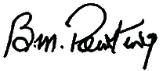
BRETT POINTING APM
ACTING COMMISSIONER

Acknowledgement of Country
The Queensland Police Service respectfully acknowledge First Nations peoples as the Traditional Owners and Custodians of Queensland. We recognise their connection to land, sea and community. We pay our respects to them, their cultures, and to their Elders, past, present and emerging.

Table of contents
Letter of compliance 2
Acknowledgement of Country 3
Acting Commissioner’s Message 5
About the Queensland Police Service 7
Human Rights Act 2019 11
Partners 12
Organisational chart 15
Locations 17
Financial Summary 19
Key performance measures 23
Key highlights for 2025-26 31
Governance 43
Ethics and code of conduct 51
Government Bodies 57
External Scrutiny 57
Risk management and accountability 59
Internal audit 59
Information systems and records management 60
Human Resources 61
Appendices 109
Government Bodies 109
Acronyms 115
Compliance checklist 117

Information about overseas travel, consultancies, the Queensland Language Services Policy and the Victims’ Charter complaints for 2025-26 is available on the Queensland Government Open Data Portal (www.data.qld.gov.au).

Acting Commissioner’s Message
I am pleased to present the Queensland Police Service (QPS) Annual Report for the 2025–26 financial year, which reflects a year of strong operational performance, substantial reform and continued progress towards a safer and more resilient Queensland.
Throughout the year, the QPS remained focused on its core purpose of community safety. We enhanced operational capability, supported our people, modernised our services and worked with communities and partner agencies to prevent crime, respond to emerging challenges and maintain public confidence in policing.
Since my appointment as Acting Commissioner in February 2026, I have focused on ensuring our decisions and investments reflected our values of integrity, respect and courage, while delivering practical benefits for our people and the community.
Within my first month as Acting Commissioner, I launched Operation Yankee Forge, a statewide response targeting robbery, unlawful entry and the unlawful use of motor vehicles. Guided by intelligence and operational data, the operation identified offences, locations and repeat offenders responsible for community harm. This enabled specialist resources to be strategically aligned with local policing efforts, ensuring they were deployed where they could achieve the greatest impact.
Road safety remained a critical priority. Operation Interpose, launched in April 2026, established a year-round statewide response combining high-visibility enforcement, targeted interventions and community engagement to encourage safer road-user behaviour and reduce road trauma.
Delivering these operational priorities required sustained investment in frontline capacity. More than $147 million was allocated over five years to critical equipment, including Taser 10s, body-worn cameras, integrated load-bearing vests, tactical first aid kits, roadside breath-testing devices, tyre-deflation devices and portable radios. Complementing this investment, additional funding was directed towards new and upgraded police facilities and expanded aerial capability. By modernising both our infrastructure and operational resources, we strengthened the Service's capacity to prevent crime, respond to emerging threats and deliver safer communities across Queensland.
Alongside this investment, the QPS continued to implement the 65 recommendations of the 100-Day Review, improving organisational efficiency, workforce morale, accountability and conditions for frontline policing. Safety and wellbeing reforms included the Northern Region Wellbeing Hub, which brought health, safety, injury-management and wellbeing services together through a coordinated access point and strengthened early intervention and person-centred support. Safety and wellbeing services were further strengthened by offering a broader and more inclusive range of services through internal and external programs. Together, these initiatives supported a more locally led and centrally coordinated approach to workforce wellbeing, while we maintained our focus on attracting, developing and retaining a capable and inclusive workforce.
The reform program also extended to the QPS’s financial management and governance. The Independent Financial Review, tabled in Parliament on 4 June 2026, provided a detailed assessment of the organisation’s financial management and position. A dedicated taskforce was established to oversee the implementation of the review’s 21 recommendations and support lasting improvements in financial discipline, transparency and decision making.
Modernising service delivery was another important priority. The QPS advanced its digital and data capacity through frontline-focused investment planning and the evaluation of emerging technologies. A notable example was the establishment of Digital Evidence Hubs, which centralised specialist technology, skilled personnel and streamlined processes to enhance the collection and management of digital evidence. This initiative better positioned the Service to meet the growing demands of an increasingly complex digital environment.
This focus on organisational capability and improvement was matched by significant legislative change during 2025–26. The QPS supported major reforms, including the establishment of the Queensland Community Protection and Public Child Sex Offender Register under Daniel’s Law, stronger enforcement responses to hate crime and extremist behaviour, and the permanent operation of Jack’s Law to prevent knife crime and improve public safety.
The QPS also progressed significant domestic and family violence initiatives, including Police Protection Directions, the expanded use of video-recorded evidence-in-chief and electronic monitoring arrangements for high-risk respondents. Following the commencement of the coercive control offence, police personnel completed dedicated training, supported by specialist education for members performing domestic and family violence roles. Together, these initiatives strengthened victim-centred responses, reduced unnecessary trauma and reinforced perpetrator accountability.
Across the broader emergency-services portfolio, the year marked important milestones. The State Emergency Service celebrated 50 years of dedicated service to Queensland communities, recognising generations of volunteers and the importance of training, preparedness, local capacity and strong partnerships. Marine Rescue Queensland continued to strengthen marine safety and search-and-rescue services through its dedicated volunteer network, supported by the opening of Queensland’s first dedicated Marine Rescue Training Academy to deliver consistent, high-quality training and strengthen emergency response capability.
Across all areas of service delivery, professional, ethical and transparent conduct remained a central priority. We continued to engage respectfully with communities, support victims with dignity and compassion, and collaborate with partners to deliver services responsive to local needs. The professionalism, courage and dedication of all QPS members and volunteers, often demonstrated in demanding circumstances, made this work possible. I thank them for their outstanding contribution.
The progress achieved during 2025–26 has positioned the QPS strongly for the challenges and opportunities ahead. Building on these foundations, we will continue to invest in our people, strengthen our capability and harness innovation to enhance service delivery across the state. Working in partnership with Queenslanders, we remain committed to reducing crime and improving community safety.
BRETT POINTING APM
ACTING COMMISSIONER
September 2026

About the Queensland Police Service (QPS)
The QPS is the primary law enforcement and community safety agency for Queensland. It fulfils this role throughout the state, 24 hours a day, seven days a week, 365 days a year, upholding the law and assisting the community, particularly in times of emergency, disaster and crisis.
The QPS is responsible for the functions of policing and community safety, State Emergency Service (SES) and Marine Rescue Queensland (MRQ).
Our Vision: A safer, more resilient Queensland.
Our Purpose: Keeping our community safe and feeling safe.
Our Accountabilities
Under the Police Service Administration Act 1990, the QPS is responsible for:
- preserving peace and good order in all areas of Queensland
- protecting and supporting the Queensland community
- preventing and detecting crime
- upholding the law
- administering the law fairly and efficiently
- bringing offenders to justice.
Our Values
Consistent with the QPS Strategic Plan 2025-2029, QPS members value:
- Integrity: We are honest, trustworthy and serve the community with the highest standards of professional conduct at all times.
- Respect: We treat everyone fairly and with dignity, embrace diversity, and consider and value all perspectives.
- Courage: We serve in the face of adversity and lead by example.
The QPS also shares the Queensland Public Service Values of:
 | Customers first  - Know your customers  - Deliver what matters  - Make decisions with empathy
 | Ideas into action  - Challenge the norm and suggest solutions  - Encourage and embrace new ideas  - Work across boundaries
 | Unleash potential  - Expect greatness  - Lead and set clear expectations  - Seek, provide and act on feedback
 | Be courageous  - Own your actions, successes and mistakes  - Take calculated risks  - Act with transparency
 | Empower people  - Lead, empower and trust  - Play to everyone’s strengths  - Develop yourself and those around you
Queensland Government objectives
The QPS supports the government’s objectives for the community which are structured around building future prosperity and growth across the state.
Safety where you live – Making Queensland safer with stronger laws, better-equipped courts and more police with better tools, while restoring consequences for actions, fixing our Child Safety system, ensuring early intervention and a bigger focus on rehabilitation, giving victims more rights and better support, and taking critical action to arrest skyrocketing rates of domestic and family violence (DFV).
Health services when you need them – Restoring health services when Queenslanders need them most through transparent and targeted investment with real-time data, boosting frontline health services, driving resources where they’re needed most, improving our emergency departments, reopening regional maternity wards, fast-tracking access to elective surgeries and helping patients to be seen faster.
A better lifestyle through a stronger economy – Growing our economy to drive down the cost of living and give Queenslanders a better lifestyle and a place to call home by respecting your money and reinstating the Productivity Commission, growing the economy in our regions and backing small and family business, boosting home ownership, easing pressure on rents, ensuring affordable and reliable energy and public transport, delivering more community housing and homelessness services, and boosting women’s economic security, taking care of Queensland’s vital existing and emerging industries.
A plan for Queensland’s future – Planning for Queensland’s future, by building the roads and infrastructure needed for a growing population – including a safer Bruce Highway, putting more teachers in safer schools and preparing young Queenslanders for the future, conserving our pristine environment that draws visitors from across the world and improving water security, delivering a world-class Olympic and Paralympic Games that leaves a positive legacy for Queenslanders.
Our Objectives
Healthy and engaged workforce
To build an engaged and capable workforce with health, safety and wellbeing of our people a priority, the QPS:
- keeps our people safe and feeling supported, embedding a shared responsibility for prioritising wellbeing
- grows a capable workforce that represents and understands the community we serve
- develops authentic leaders who empower and engage our people
- builds a more connected and inclusive workplace that reflects our values.
Community Safety
To deliver effective and responsive policing and community safety services, ensuring our communities are safe and feel safe, the QPS:
- provides culturally safe, victim-centric and trauma-informed practices to support victims
- prevents harm, builds resilience and reduces demand through contemporary problem-solving approaches
- recognises and maximises the experience and skills of our volunteers to deliver community safety responses that complement and build on existing capability
- targets serious and repeat offending behaviours.
Engaged and trusted relationships
To provide better services through connected and trusted relationships, the QPS:
- builds and enhances partnerships to develop new ways of preventing crime, reducing harm and building resilience, to support system delivery and community safety outcomes
- delivers community safety through strong and trusted partnerships
- nurtures and strengthens our relationships with Queensland communities.
Effective and efficient service delivery
To deliver transformational reform, informed by insights, to innovate and strengthen our capability to deliver community safety services in a fiscally responsible manner, the QPS:
- enhances our capability and capacity to ensure the right resources are in the right place, at the right time
- accelerates the adoption of digital, alongside other innovative approaches, to improve service delivery
- optimises business processes to support the delivery of contemporary community safety services
- restores fiscal responsibility through improved financial management practices and sound and efficient governance.
Our environment
The QPS operates in an increasingly complex and dynamic environment, shaped by interconnected social, economic, technological, environmental, demographic and legal factors. Queensland's vast geographical footprint and decentralised population present unique challenges in maintaining community safety and delivering effective services across the state.
The demand for policing services continues to evolve as communities experience changing expectations, ageing population, economic pressures and rapidly evolving technological advancements, influencing service delivery.
Rapid technological advancement is reshaping both the opportunities and challenges the QPS faces. Emerging technologies are influencing community behaviours and service expectations, while also creating new and evolving criminal threats. At the same time, technology is enhancing the capability of QPS to prevent, disrupt, investigate and respond to crime, improving operational decision making and support more effective service delivery.
The complexity of DFV, mental health, and youth offending reinforces the importance of collaboration across government, non-government and community sectors. Strong partnerships are critical to developing coordinated and integrated responses that address the underlying drivers of harm and improve community safety outcomes.
Queensland continues to experience significant exposure to natural hazards including severe floods, fires, storms and heatwaves. More frequent and severe extreme weather events place increasing pressure on communities, emergency services and critical infrastructure. These challenges require coordinated approaches to prevention, preparedness, response and recovery to strengthen community resilience and support effective disaster management.
Within our challenging environment, the QPS remains focused on its commitment to community safety.
Our challenges and opportunities in 2025-26
The QPS acknowledges the importance of addressing a range of potential strategic challenges to ensure we keep our community safe. The Service identified these challenges and opportunities to respond to in 2025-26, linking them to the strategic objectives.

Key challenges for QPS during 2025-26 included:
- meeting growing service demands and evolving community needs
- meeting the needs of the QPS workforce including health, safety and wellbeing of our people
- building community trust and confidence in the integrity and professionalism of police
- staying ahead of the rapidly evolving landscape of online and technology-enabled crime
- effectively preparing for disasters, unpredictable extreme weather events and addressing the broader impacts of climate change.
To address these challenges, the following opportunities were identified to best position the QPS to make the community safer:
- supporting our community and vulnerable groups, including victims of crime, through evidence-based integrated service responses
- developing a skilled and resilient workforce to respond to future challenges and evolving demands
- harnessing data driven insights and decision making to drive policing excellence and efficiency
- leveraging government, private and voluntary sector partnerships to support improved system delivery
- adopting digital innovation with ethical and transparent practices.
2026-27 Outlook
In 2026-27, the QPS will work to address:
- reducing victims of crime and holding perpetrators to account through tough new laws and ongoing legislative reform
- trust and confidence in the QPS
- rapid technological change outpacing law enforcement capability
- workforce health, safety and wellbeing gaps undermining organisational capability and continuity
- escalating social pressures and system challenges that risk overwhelming frontline capacity
- emerging cyber and technology-driven harms undermining community safety.
For 2026-27, the QPS identified the following opportunities, including:
- providing victim-centric and trauma-informed responses to support victim-survivors of DFV
- strengthening trust and legitimacy through transparency and community engagement
- harnessing technology and data insights to enhance policing capability and effectiveness
- driving workforce transformation, promoting inclusion and prioritising health and wellbeing
- expanding interagency and international partnerships to improve community safety outcomes
- building resilience to environmental impacts and major events
- enhancing financial sustainability and driving service innovation based on evidence and impact.

Human Rights Act 2019
On 1 January 2020, the Human Rights Act 2019 (Qld) (the Act) came into effect, creating obligations for public entities to act and make decisions in a way that is compatible with human rights and to properly consider human rights when making a decision. The QPS has made a commitment to respect, protect and promote human rights in our decision making and actions.
Each time the QPS received a complaint, human rights limitations were assessed to determine if any rights were unreasonably limited. The human rights aspect of each complaint was considered along with the allegation/s, which assisted in determining the appropriate resolution.
In 2025-26, the QPS received 2,370 distinct complaints which were reviewed to identify if human rights may have been limited. In most cases there was no further action taken as no human rights limitations were detected, or an explanation was provided to the complainant as the officers’ actions were identified as being proportionate, lawful, reasonable, accountable, and necessary.
As at 30 June 2026, the following outcomes were recorded:
- 2,902 individual human rights limitations connected to the 2,370 complaints, noting one complaint can include more than one human rights limitation
- 762 instances where there were no human rights limitations identified
- 28 instances where human rights were unreasonably limited, resulting in:
- 3 apologies
- 2 explanations
- 23 disciplinary actions
- 1,803 (of the 2,370) distinct complaints were finalised as at 30 June 2026 (567 remain open).
Each time the QPS received a complaint, human rights limitations were assessed to determine if any rights were unreasonably limited. The human rights aspect of each complaint was considered along with the allegation/s, which assisted in determining the appropriate resolution. Of the 2,370 distinct complaints received, in most cases there was no further action taken as no human rights limitations were detected, or an explanation was provided to the complainant as the officers’ actions were identified as being proportionate, lawful and reasonable, accountable and necessary.
Notes:
- A human rights complaint is a complaint about an alleged contravention of Section 58(1) of the Act by a public entity in relation to an act or decision of the public entity (i.e. that an act or decision is not compatible with human rights and/or that a decision does not properly consider relevant human rights).
- It is expected that sometimes a complainant will not identify human rights matters within a complaint they make to the QPS. Where the QPS identifies that the complaint may include a contravention of Section 58(1) of the Act, the QPS will record this and respond appropriately.
- The total number of human rights complaints includes all those identified by a complainant and the QPS. A human rights complaint is counted as one regardless of the number of alleged acts, decisions or human rights limited within a complaint made to the QPS.
- The total number of complaints where one or more human rights were allegedly unreasonably limited relates to all complaints made to the QPS by both internal and external complainants.
Information security attestation
During the mandatory annual Information Security reporting process, the Commissioner of Police attested to the appropriateness of the information security risk management within the QPS to the Queensland Government Chief Information Security Officer, noting that appropriate assurance activities have been undertaken to inform this opinion and the QPS information security risk position.

Our partners
The QPS continued to foster strong relationships with its partners in the community throughout 2025-26.
- Queensland Police-Citizens Youth Welfare Association (QPCYWA)
The QPCYWA, known as Police-Citizens Youth Club (PCYC) Queensland, is a not-for-profit organisation that delivers accessible and affordable youth development programs, helping young people build skills and make positive life choices. Operating across urban, rural and remote communities, each PCYC is led by a QPS Sergeant and a Youth Club Program Manager, fostering strong connections between police and young Queenslanders. Since its establishment in 1948, PCYC has grown to 53 clubs supported by 74 police officers and dedicated staff members, providing a valuable platform for community connection, early intervention and youth development. For more information or to find a club near you, visit the PCYC Queensland website at www.pcyc.org.au.
- Crime Stoppers Queensland (CSQ)
CSQ is a community volunteer organisation that helps prevent and solve crime by providing a safe and anonymous way for the public to share information with police. Information submitted through the CSQ hotline and website is forwarded to the relevant QPS investigators.
The QPS assists CSQ through the following:
- the Assistant Commissioner, Crime Command is on the Board of Directors as the Commissioner’s representative
- the Officer in Charge of the QPS Crime Stoppers Unit represents Queensland on the National State and Territory Police Coordinators Group
- a dedicated police unit manages the partnership deliverables, administers intelligence reports, handles investigator inquiries and assists Crime Stoppers State Office personnel with promotional displays and presentations
- police officers act as partnership representatives in many of the 19 Volunteer Area Committees across the state.
During 2025-26, the QPS Crime Stoppers Unit, in partnership with CSQ, received 24,748 phone calls and 43,876 digital contacts from members of the public, resulting in:
- the apprehension of 444 people
- 1,729 charges laid
- the confiscation of more than $4.5 million worth of drugs
- the seizure of approximately $368,750 in proceeds of crime.
For more detailed information, visit the Crime Stoppers Queensland website at www.crimestoppersqld.com.au.
- Neighbourhood Watch Queensland (NHWQ)
NHWQ is a partnership between the QPS and local communities, aimed at enhancing community safety. Operating across 14 out of the 15 police districts, NHWQ supports approximately 252 active groups that promote home security, reduce fear of crime and encourage the reporting of suspicious activity to police. By fostering informal networks among residents, NHWQ strengthens community resilience and complements QPS’s broader crime prevention strategies. For more information or to find your local group, visit the NHWQ website at www.nhwq.org.
- Queensland Homicide Victims Support Group (QHVSG)
The QHVSG provides specialised support to individuals and families affected by homicide, assisting more than 250 family members each year to cope with the profound impacts of loss and trauma. The Commissioner of Police is the Patron of QHVSG, which works closely with the QPS to deliver immediate practical and emotional support, coordinate crime scene clean-up services, and provide long-term case management for families following a homicide.

- Volunteers in Policing (ViP)
The ViP program is a community engagement initiative that recruits and trains volunteers to support police in delivering non-operational services that enhance community safety. ViPs assist with victim support, crime prevention activities, and home and business security assessments. They also contribute to Police Recruiting and specialist unit support. As at 30 June 2026, 193 ViPs were working across 35 police establishments in 15 districts and two specialist units. For more information or to become a ViP, visit the QPS website at https://www.police.qld.gov.au/careers-with-the-qps/volunteers-in-policing.
- SES volunteers
The SES is a volunteer emergency service that helps Queensland communities prepare for, respond to, and recover from disasters and emergencies. With around 5,500 volunteers from diverse backgrounds, SES members share a commitment to supporting their local communities.
SES operates through 290 groups in 77 units across Queensland, supported by a partnership between the Queensland Government and local governments. The Queensland Government provides organisational support, training and key equipment, while local governments provide facilities, vehicles, maintenance and local operational support.
Together, these arrangements enable SES volunteers to deliver timely and effective emergency assistance to communities across Queensland.
- Marine Rescue Volunteers
Marine Rescue Volunteers respond to more than 12,000 rescues each year, operating across 46 locations along Queensland’s coast, from the Torres Strait to Currumbin.
A transition program is underway to bring Volunteer Marine Rescue Association Queensland and Australian Volunteer Coast Guard Association into Marine Rescue Queensland (MRQ). Throughout the transition, marine rescue services will continue without interruption. United by a shared commitment to saving lives at sea, the integrated service will remain focused on keeping Queensland’s waterways safe.
- Surf Life Saving Queensland (SLSQ)
As Queensland’s leading authority on aquatic safety and surf rescue, SLSQ is one of Australia’s largest volunteer-based community service organisations. Established in 1930, SLSQ supports 58 surf lifesaving clubs patrolling 8,000 kilometres of coastline from Port Douglas to Rainbow Bay. More than 36,000 Queenslanders volunteer with surf lifesaving clubs, supported by over 462,000 affiliated club members. SLSQ’s vision is simple: zero preventable deaths in Queensland public waters.
- Royal Life Saving Society Queensland (RLSSQ)
RLSSQ is Queensland’s peak body for water safety and a leader in drowning prevention and water safety education. Founded in 1894, it is Australia’s oldest lifesaving organisation.
Through education, training, aquatic risk management and community programs, RLSSQ helps keep Queenslanders safe in and around water, supported by a network of staff, volunteers, training partners and service providers.
- PCYC Emergency Services Cadets
The Emergency Services Cadets is a free youth program delivered through a partnership between PCYC Queensland and Queensland’s emergency services. Open to young people aged 12 to 17, the program provides a safe and inclusive environment where participants develop practical skills and leadership opportunities. Cadets meet weekly during the school term and can participate in volunteer activities on weekends. The program currently operates in 23 active units across Queensland.
- Jack Beasley Foundation (JBF)
The JBF is a Gold Coast based, not-for-profit organisation, dedicated to reducing youth violence through knife crime education. Through its One Moment Education Program, JBF delivers school-based presentations across the state, raising awareness about the dangers of carrying knives and the long-term impacts on offenders, victims, their families and friends. JBF has played a pivotal role in advocating for legislative reform, including the introduction of Jack’s Law and continues to support community awareness through education, media engagement and operational activities. For more information, visit the JBF website at https://www.jackbeasleyfoundation.org/.
- Top Blokes
Top Blokes Youth Program is a targeted initiative supporting young men aged 13-17. Delivered by the Top Blokes Foundation, the program promotes resilience, emotional maturity and positive decision making through structured mentoring and education. For further information, visit the Top Blokes Foundation website at https://www.topblokes.org.au/.
- Queensland Blue Light Association Incorporated (QBLAI)
The QBLAI is a not-for-profit charity that has partnered with the QPS for over 40 years to deliver early intervention and prevention programs for young people, particularly those at risk. While widely recognised for its Blue Light discos, QBLAI also delivers programs such as Blue Edge and ELEVATE, which promote positive life choices, resilience and respectful relationships. Led by police officers, these programs can be delivered in any community, including rural and remote areas. The QPS supports QBLAI through the allocation of a Blue Light Policing Coordinator, with the Commissioner serving as the association’s Patron. For more information, visit the QBLAI website at https://bluelightqld.org/.
- Australian Retail Council (ARC)
The ARC is a key industry partner supporting the QPS to educate retailers and quick service restaurants about their obligations under the Summary Offences (Prevention of Knife Crime) and Other Legislation Amendment Act 2024. Through policy advocacy, legal support and direct engagement, the ARC helps retail operators understand and comply with legislative requirements, while contributing to initiatives that address retail crime and violence. For further information, visit the ARC website at https://www.retail.org.au/.
- Bullyproof Australia
Bullyproof Australia is a registered charity delivering the AMAYDA Resilience Program to primary and secondary schools across Queensland. The program focuses on bullying prevention and conflict resolution, mental health improvement and academic performance by fostering resilience, respect and positive relationships. For more information, visit the Bullyproof website at https://bullyproofaustralia.org.au/.
- Balin Stewart Foundation (BSF)
The BSF is a not-for-profit community organisation committed to preventing harm caused by knife-related violence. Through education, awareness and community events, BSF works with schools and communities to promote positive conflict resolution and discourage the carrying of edged weapons. Its grassroots campaign, #BinTheBladeForBalin, fosters safer environments by addressing the root causes of youth violence and advocating for legislative reform. For more information, visit the BSF website at https://www.balinstewartfoundation.org.au/.

QPS organisational chart
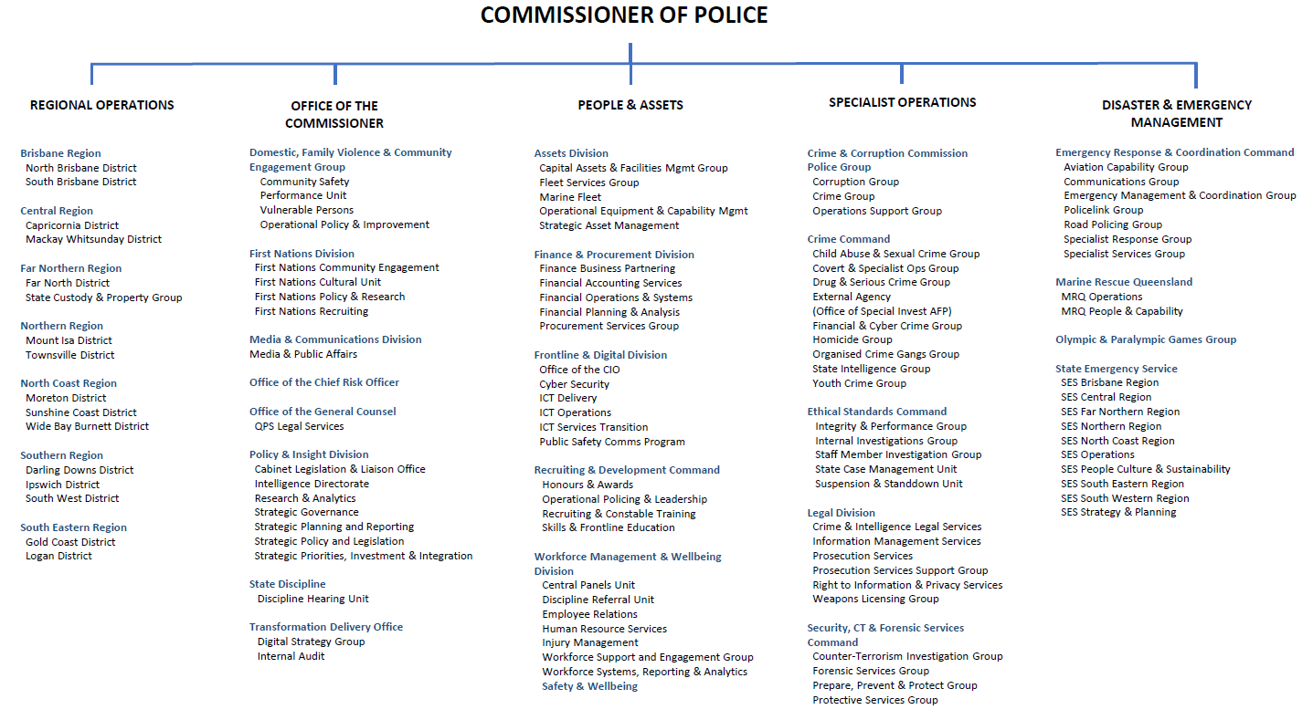
Independent Financial Review
On 4 June 2026, the Independent Financial Review was released detailing a broad, organisation-wide financial assessment. The review outlines 21 recommendations spanning workforce and resourcing, financial management and budgeting, governance and assurance, procurement capability, and organisational accountability. QPS has established a dedicated Taskforce, supported by Queensland Treasury Corporation and the Department of the Premier and Cabinet, to oversee implementation of the recommendations and drive sustainable organisational reform.
The QPS remains committed to strengthening financial management, governance and organisational accountability while maintaining a strong frontline policing presence for the Queensland community.
100 Day Review of the QPS
In March 2025, then Commissioner Steve Gollschewski AO APM, commenced a 100 Day Review of the QPS to assess its alignment with the Police Service Administration Act 1990 and identify opportunities to better support frontline policing and community safety. The review focused on strengthening frontline policing by examining resource, capability and wellbeing challenges, improving organisational efficiency through enhanced leadership and governance, rebuilding workforce morale and trust and increasing accountability through transparent decision making.
The review, released on 15 July 2025, made 65 recommendations. These recommendations provide a roadmap to refocus the QPS on its core policing responsibilities, improve workforce wellbeing and retention and strengthen frontline service delivery. The review also recommends a more decentralised and regionally responsive operating model to enhance organisational effectiveness and community safety.
In August 2025, the QPS established the 100 Day Review Implementation Program to restore frontline policing, improve community safety and support officer wellbeing, through workforce reprioritisation, governance reform and wellbeing initiatives. The Program remains focused on:
- redefining core policing functions under legislation
- reforming rostering, wellbeing support and fatigue management
- addressing attrition with flexible work, leadership uplift, and recognition reform
- shifting to a more decentralised operating model.
The QPS has implemented a strategic realignment to better support its frontline and restore workforce wellbeing, including:
- strengthening DFV capability by aligning it with broader organisational reform priorities
- establishing a strong governance framework
- focusing on strengthening frontline capacity by returning sworn members to operational roles and reducing administrative burden on police officers.
Watch-house Review
The QPS is progressing implementation of the 34 recommendations arising from the Watch-house Review, released in July 2025. The review examined the operation, management and design of watch-houses across Queensland and identified opportunities to enhance safety, consistency and service delivery for staff and people in custody.
The recommendations focus on strengthening governance, workforce capability and wellbeing, infrastructure, technology, and access to health and support services. The QPS remains committed to improve outcomes for vulnerable persons in custody, reducing time spent in custody.

Locations
QPS delivers its services from various types of facilities throughout the state including:
Police facilities | 341
Police neighbourhood beats and shopfronts | 52
Mobile police beats | 27
Headquarters and regional offices | 8
District offices | 15
Communication centres and Policelink | 15
Police academies | 2
MRQ bases and support centres | 52
SES depots and offices | 305
Each police district is further supported by a range of specialist units, including the Child Protection Investigation Units, Criminal Investigation Branches, Intelligence Units, Scenes of Crime and Scientific Units, Dog Squad Units, Forensic Crash Units, Road Policing Units, Prosecutions Corp and Water Police Units. Additionally, purpose-built investigation centres are strategically located at various stations and district offices across the state to respond to major incidents.
In 2025-26, the QPS delivered minor and medium capital works, as well as major capital investment projects, including:
- Burleigh Heads and Nambour Police Beats
- Kirwan replacement police facility
- Ripley new police facility.
In addition, the following capital works projects were under construction during the reporting period:
- Mackay police facility upgrade
- Maryborough police facility upgrade
- Mount Isa new residential accommodation
- Proserpine replacement police facility.

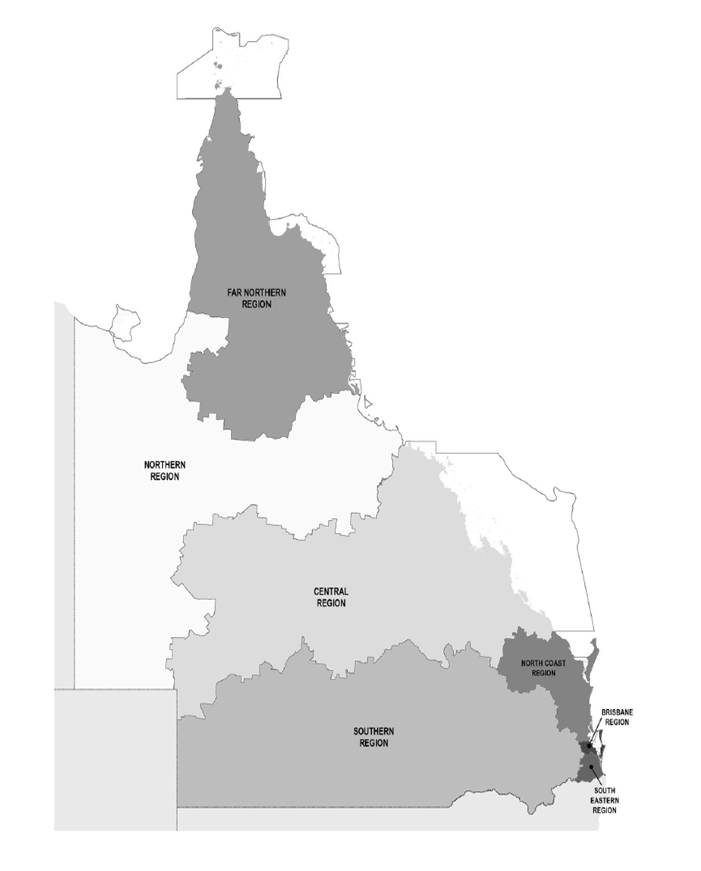
Police regions map

Financial Summary
Summary of financial performance
The following table summarises the operating result and financial position for the QPS for 2025-26 and the previous financial year.
Statement of comprehensive income | 2025-26  $’000 | 2024-25  $’000
Total income from continuing operations | 4,204,798 | 3,743,556
Total expenses from continuing operations | 4,170,608 | 3,873,740
Total other comprehensive income | 203,927 | 99,697
Total comprehensive income | 238,117 | (30,486)
Statement of financial position | 2025-26  $’000 | 2024-25  $’000
Total assets | 3,619,049 | 3,228,763
Total liabilities | 642,699 | 552,834
Net assets/equity | 2,976,350 | 2,675,929

Income and expenses from continuing operations
The QPS is committed to safeguarding the people, places and communities of Queensland through excellence in policing and community safety. The integration of the SES and the establishment of MRQ within QPS have strengthened Queensland's emergency management capability by bringing together policing, disaster preparedness and maritime rescue functions within a coordinated service delivery model. This integrated approach enhances collaboration, operational readiness and response capabilities across the state, supporting the effective delivery of emergency and disaster management services and contributing to safer, more resilient Queensland communities.
Funding for these services is primarily provided through parliamentary appropriations.
In 2025-26, the QPS recorded a surplus of $34.190 million.
QPS remains committed to delivering safe and secure communities through innovation, collaboration and best practice. A summary of expenses incurred in delivering these services is provided below.
For 2025-26, the QPS received income from continuing operations totalling $4,204.798 million and incurred total expenditure from continuing operations of $4,170.608 million. This was comprised of:

Income

Expenses

Summary of financial position
QPS was in a positive financial position at the end of the financial year. The total equity (assets less liabilities) of QPS at the end of 2025-26 was $2,976.350 million. This is an increase from 2024-25 $2,675.929 million which includes $203.927 million increase in asset revaluation surplus. This was comprised predominantly of:
Assets

Liabilities

Events occurring after balance date
Following the completion of Tranche 1 in 2024-25, under which specific Frontline Digital Division functions supporting other departments were transferred from QPS to Queensland Fire Department (QFD) and Queensland Health (QH), the remaining functions comprising Tranche 2 will be transferred from QPS to QFD and Queensland Ambulance Service (QH) effective 1 July 2026, as prescribed by the Public Service Departmental Arrangements Notice (No. 3) 2026.
There were no other events occurring after balance date that management considers would have a material impact on the information disclosed in these financial statements.

Key performance measures – Police and Community Safety
The services provided by the QPS are designed to uphold and administer the law responsibly, fairly and efficiently; to preserve peace and good order; to protect and support the community; to prioritise the safety of victims of DFV and other serious offences; to work toward fair, just and lasting outcomes for victims and offenders; to coordinate responses to disaster events and emergencies; and to promote road safety. This includes, but is not limited to:
- working with partner agencies to reduce victim of crime numbers and providing support through victim-centric and trauma-informed approaches
- working to prevent and reduce youth crime
- working with partner agencies and service providers to ensure perpetrators are held to account
- protecting property and personal safety
- maintaining public order and safety during disasters and major events
- working with partner agencies and service providers to reduce demand on the criminal justice system and address over-representation of vulnerable groups, including First Nations people
- working collaboratively with partner agencies and stakeholders to minimise the impact of disaster events to ensure the Queensland community is kept safe and supported in their recovery
- preventing and responding to driver behaviours contributing to road trauma.
The following tables provide an overview of the key performance measures for the QPS for 2025-26. Data for 2024-25 is sourced from the QPS 2024-25 Annual Report unless otherwise stated in the notes.
Service Area: Police Services
Performance measures | Notes | Strategic Plan | 2025-26 SDS | RoGS | 2024-25  Actual | 2025-26 Target  /Estimate | 2025-26 Actual
Percentage of offences against the person cleared within 30 days: | 1,2,3
- Homicide |  |  |  |  | 73.6% | 70-83% | 71.6%
- Assault |  |  |  |  | 54.6% | 54-63% | 51.5%
- Sexual assault |  |  |  |  | 32.4% | 48-57% | 37.2%
- Robbery |  |  |  |  | 55.3% | 60-68% | 60.8%
- Total personal safety |  |  |  |  | 50.0% | 54-61% | 48.3%
Percentage of offences against property cleared within 30 days: | 1,4
- Unlawful entry |  |  |  |  | 22.1% | 18-21% | 24.3%
- Other property damage |  |  |  |  | 35.1% | 25-27% | 32.3%
- Motor vehicle theft |  |  |  |  | 37.8% | 36-40% | 40.2%
- Other theft (excluding unlawful entry) |  |  |  |  | 27.4% | 26-28% | 29.3%
- Total offences against property cleared |  |  |  |  | 29.3% | 28-30% | 30.5%
Percentage of good order offences cleared within 30 days | 1,5 |  |  |  | 72.0% | 80-85% | 70.0%
Rate of DFV-related offences per 100,000 population | 1,6,7
- Total personal offences |  |  |  |  | 754 | 600-700 | 654.1
- Total property offences |  |  |  |  | 278 | 200-300 | 239.3
Rate of crime victimisation per 100,000 population | 6,7,8
- Total personal offences |  |  |  |  | 1500 | <1200.0 | 1420
- Total property offences |  |  |  |  | 4620 | <4400.0 | 4670
Rate of repeat victimisation per 100,000 population | 6,7,8
- Total personal offences |  |  |  |  | 383 | <240.0 | 350
- Total property offences |  |  |  |  | 2527 | <2170.0 | 2562
Proportion of young offenders subject of a diversion who do not  reoffend within the following 24 months |  |  |  |  | New measure | >60% | 58%
Percentage of code 1 and code 2 incidents attended within 12 minutes (Triple Zero calls only) | 9 |  |  |  | 74.5% | >80% | 76.8%
Percentage of disaster management training participants with enhanced capability |  |  |  |  | 91% | 80% | 93%
Rate of complaints against police per 100 sworn staff | 10 |  |  |  | 13.1 | <9.8 | 12.0
Road fatalities per 100,000 population | 11 |  |  |  | 5.27 | 4.28 | 5.66
Hospitalised road casualties per 100,000 population | 11,12 |  |  |  | 150.81 | 110 | --
Cost of police services per person | 13 |  |  |  | $628 | $670 | $675
Agency engagement | 14,15 |  |  |  | 48% | >55% | 51%
Culture | 14,16 |  |  |  | 73% | >73% | 74%
Innovation | 14,17 |  |  |  | 54% | >54% | 58%
Health, safety and wellbeing | 14,18 |  |  |  | 52% | >52% | 50%
Organisational leadership | 14,19
- Senior Managers |  |  |  |  | 41% | >41% | 46%
- Executive Group |  |  |  |  | 36% | >36% | 38%
Workforce diversity | 20
- Women in Senior Officer, Senior Executive Service positions and above | 20,21 |  |  |  | 32.1% | 30.0% | 33%
- First Nations | 20,21 |  |  |  | 2.6% | 4.0% | 2.7%
- People with Disability | 20,21,22 |  |  |  | 4.8% | 6.0% | 5.2%
- People who speak a language other than English at home | 20,21 |  |  |  | 3.9% | 8.0% | 4.9%
Discontinued measures
Public perception of safety | 23,24,25
- Feelings of safety walking alone in neighbourhood during the night |  |  |  |  | 43.6% | >50% | 44.8%
- Feelings of safety travelling alone on public transport during the night |  |  |  |  | 27.3% | >30% | 28.1%
Satisfaction of members of the public who had contact with police in the last twelve months | 23,26 |  |  |  | 69.2% | >85% | 70.3%
Public satisfaction with police dealing with emergencies and disasters | 23,26 |  |  |  | 67.8% | >85% | 69.6%
Public confidence to contact the police to report DFV | 23,26 |  |  |  | 60.1% | >75% | 60.3%
Public perception of police integrity | 23,26
- Police perform their job professionally | 23,26 |  |  |  | 68.3% | >85% | 68.6%
- Police treat people fairly and equally | 23,26 |  |  |  | 51.4% | >75% | 52.3%
- Police are honest | 23,26 |  |  |  | 56.1% | >75% | 55.9%
- I do have confidence in the police | 23,26 |  |  |  | 64.5% | >85% | 63.8%
- I trust the police | 23,26 |  |  |  | 66.1% | >75% | 65.9%
Key
RoGS – Report on Government Services
SDS – Service Delivery Statement
Strategic Plan – QPS Strategic Plan 2025-29
Notes
- Performance is reported against a range rather than a single figure. The target ranges for 2025-26 consider recent results and any known factors that are likely to have an impact in the reporting period. Upper and lower values account for past variation from the recent historical average.
- The offence categories reported separately are those classified as ‘violent’ crimes and are the most significant personal safety offence categories in terms of their impact on the community. The ‘total personal safety’ offences figure also includes the offence categories of extortion, kidnapping, abduction and deprivation of liberty and other offences against the person. Homicide includes the offence categories of murder, attempted murder and conspiracy to murder.
- The variance between the 2025-26 Actual and the 2025-26 Target/Estimate may be due to changes in volume of offences together with greater focus on the needs of victims, and unique characteristics of reported offences regarding complexity, quality and availability of evidence or evidentiary requirements affecting the investigation and finalisation of these offences.
- The offence categories reported separately are considered high volume property offences. The total property offences figure also includes arson, fraud and handling stolen goods.
- Good order offences include offences relating to public nuisance, obstructing police and other offences against good order. An increase in good order offences generally indicates an increase in policing activity around public spaces and major events, and a range of related proactive policing strategies often focusing on liquor-related enforcement.
- Rates of crime victimisation, repeat crime victimisation and DFV-related offending are above their respective targets mostly due to various societal influences.
- To maintain consistency with reporting in other publications/forums, these measures have been amended to report as a rate per 100,000 population, not per 1,000 population.
- The measure counts the number of people or addresses classed as a ‘victim’ of a personal or property offence in the preceding 12-month period and represents this as a rate per 100,000 population. The figure is separate and distinct from the rates of offending. It is possible to have a reduction of the number of victims without a reduction in offences.
- Code 1 and 2 incidents include very urgent matters when danger to human life is imminent and urgent matters involving injury or present threat of injury to person or property.
- ‘Complaints’ are defined as statements by members of the public regarding police conduct, including officers on, off or unknown duty, when a person was in police custody or had voluntary or involuntary dealings with the police. Sworn staff refers to a police officer employed by the QPS who has sworn the Oath of Office under the Police Service Administration Act 1990, delivering a police or police-related service to an external customer.
- The variance between the 2025-26 Target/Estimate and the 2025-26 Actual is due to a number of societal influences and increased high-risk behaviours like drink and drug driving, distraction, failure to wear a seatbelt, speeding and fatigue that can vary throughout the year resulting in changes in numbers of road crashes.
- The 2025–26 Actual is not available due to delays in receiving data sets which has resulted in Department of Transport and Main Roads being unable to calculate an Actual result for the 12-month period ending 31 December 2025. The most recent data received is for the 12-month period ending 30 September 2025, where the preliminary number of hospitalised road casualties is 8521 which equates to a rate of 150.81 hospitalised casualties per 100,000 population.
- Cost of police services per person is the total cost of delivering policing services divided by the estimated population of Queensland. This measure is reported in line with the RoGS methodology. Supplies and services costs have increased mainly due to inflationary pressures in relation to plant and equipment, ICT software and hardware maintenance and property related costs including escalating lease costs.
- Data for this measure is taken from responses of QPS employees to the whole-of-government Working for Queensland survey, conducted annually.
- The measure describes employees’ level of engagement with the organisation in relation to motivation, inspiration and pride.
- The measure describes the extent to which employees feel confident about how unethical behaviour and discussions about ethical behaviours are managed in the workplace.
- The measure describes the extent to which employees feel the QPS is capable of creating and/or adopting new ideas which result in more effective products, processes and services.
- The measure describes the extent to which employees feel the QPS places a value on health, safety, and wellbeing of its employees.
- The measure describes employee perceptions that senior leadership have the ability to lead the organisation to achieve its objectives with particular focus on performance and quality. Leadership also relates to senior leaders’ ability to model appropriate workplace behaviours.
- From 1 July 2023, revised sector-wide diversity targets were adopted. Data is based on substantive placements and includes paid and unpaid employees, excluding staff members engaged on a casual relief basis. Figures are based on self-reported data that is not mandatory which may result in under-reporting on at least some of the diversity categories included.
- The QPS workforce generally changes at a slower rate compared to other agencies, and generally police officer positions are filled internally only. Consequently, it is challenging to achieve changes to the workforce except over an extended period.
- Due to the operational requirements of police, the target is based on non-operational staff members only.
- These service standards have been discontinued due to state and territory police agencies agreeing not to extend the National Survey of Community Satisfaction with Policing (NSCSP) contract beyond 30 June 2026.
- Public perception of safety is secured from the NSCSP. The figure refers to the percentage of Queensland survey respondents who selected “very safe” or “safe” for each of the following activities:
- walking alone in your neighbourhood during the night
- travelling alone on public transport during the night.
- The measures for feelings of safety on public transport are based on the entire survey population and includes those participants who have not used public transport. The figure is reported to match the existing RoGS standard.
- Public satisfaction with police and perceptions of police are sourced from the results of the NSCSP. The NSCSP is a general community survey. Respondents to these questions may or may not have had contact with police in the last 12 months.

Key performance measures – SES
The services provided by the SES are designed to respond to disaster events and emergencies ensuring the safety of all individuals and communities affected. The SES provides a community-based, volunteer, all hazards response capability that prepares for and responds to disaster events and emergencies that affect Queensland communities.
Service Area: SES
Performance measures | Notes | Strategic Plan | 2025-26 SDS | RoGS | 2024-25 Actual | 2025-26 Target  /Estimate | 2025-26 Actual
Percentage of statewide SES volunteers that meet minimal operational training requirements | 1 |  |  |  | 80% | 65% | 79%
Percentage of volunteers who are proud of, feel attached to, and are  willing to recommend SES | 2 |  |  |  | 80% | 80% | 81%
Key
RoGS – Report on Government Services
SDS – Service Delivery Statement
Strategic Plan – QPS Strategic Plan 2025-29
Notes:
- This measure represents the percentage of active SES volunteers who have completed the most common minimum training competency of Storm Damage Operations and have a current Storm Damage Operator appointment.
- The measure is sourced from the Volunteering for Queensland Survey conducted annually in April/May each year. The wording of the service standard has been amended from ‘Volunteer engagement’ to clarify for readers what is being measured. The definition and target are unaffected.

Key performance measures – MRQ
The services provided by MRQ are designed to deliver community safety in Queensland by preparing for and responding to maritime search and rescue incidents and disaster events at sea, ensuring the safety of all individuals and communities. MRQ provides locally led community-based volunteer search and rescue capabilities to those in, near or on blue water environments across Queensland.
Service Area: MRQ
Performance measures | Notes | Strategic Plan | 2025-26 SDS | RoGS | 2024-25 Actual | 2025-26 Target  /Estimate | 2025-26 Actual
Percentage of statewide Marine Rescue Queensland volunteers that meet the minimum training requirements | 1 |  |  |  | 80% | 65% | 73%
Percentage of volunteers who are proud of, feel attached to, and are  willing to recommend Marine Rescue Queensland | 2,3 |  |  |  | New Measure | 80% | 72%
Key
RoGS – Report on Government Services
SDS – Service Delivery Statement
Strategic Plan – QPS Strategic Plan 2025-29
Notes:
- This measure represents the percentage of active MRQ volunteers who have completed national operational qualifications and training (to meet Australian Maritime Safety Authority requirements) and the minimum training requirements to performance legislative functions noted in the Maritime Rescue Queensland Act 2024.
- The measure is sourced from the Volunteering for Queensland Survey conducted annually in April/May each year. The target is set to the same value as for volunteers of the State Emergency Service.
- MRQ’s internal review processes identified gaps in the volunteer experience in early 2026, which is reflected in the lower-than-target result. In response, MRQ has commenced a range of targeted initiatives and improvement activities to strengthen volunteer engagement. It is anticipated that these initiatives and improvement activities will contribute to improved results in the 2026–27 survey.

Jack’s Law
In June 2025, Parliament passed the landmark Making Jack's Law Permanent Bill, allowing police to search for weapons beyond designated precincts to any public area, enabling faster, intelligence-led interventions wherever the need arises. The law empowers police to use hand held metal detectors (wanding devices) to detect and seize concealed weapons in public places. The Police Powers and Responsibilities (Making Jack's Law Permanent) and Other Legislation Amendment Act 2025 commenced on 18 July 2025.
Under this legislation, officers can use a hand held scanner in a "relevant place" without the need to seek authorisation from a senior officer. A "relevant place" is defined as licensed premises, public transport stations, public transport vehicles, retail premises, safe night precincts, shopping centres, sporting or entertainment venues. The legislation also makes Jack’s Law permanent by removing the sunset clause that scheduled initial expiry on 30 October 2026.
The Expanding Adult Crime, Adult Time and Taking a Stronger Stance on Drugs and Anti-Social Behaviour Amendment Bill 2026 makes changes to the Police Powers and Responsibilities Act 2000 (PPRA) by adding a 'designated business and community precinct' as a "relevant place" under the PPRA from 1 July 2026. Under the amendments, officers will have the power to conduct hand held scanning of individuals in a designated business and community precinct, as they would with any other "relevant place".
During the reporting period from 1 July 2025 to 30 June 2026, the QPS recorded the following information:
- number of hand held scanner authorities issued: 1,114
- number of people who were required to submit to the use of hand held scanners: 164,218
- number of knives or other weapons that were detected using hand held scanners: 1,282
- number of times a power to search a person without a warrant was exercised under chapter 2, part 2, division 2 as a result of the use of hand held scanners: 1,230
- number of charges made against persons as a result of the use of hand held scanners: 5,137
- Weapons Act 1990: 903
- Drugs Misuse Act 1986: 3,120
- Police Powers and Responsibilities Act 2000: 187
- Bail Act 1990: 150
- Other Legislation: 777.

Key highlights for 2025-26
This section reports on the objectives of the QPS Strategic Plan 2025-2029:
- Healthy and engaged workforce to build an engaged and capable workforce with health, safety and wellbeing of our people a priority
- Community Safety to deliver effective and responsive policing and community safety services, ensuring our communities are safe and feel safe
- Engaged and trusted relationships to provide better services through connected and trusted relationships
- Effective and efficient service delivery to deliver transformational reform, informed by insights, to innovate and strengthen our capability to deliver community safety services in a fiscally responsible manner.
The below is a snapshot of the key performance highlights from 2025-26 and is not representative of all work undertaken during the reporting period. For more information and to keep up to date with QPS news, follow QPS on social media or Mypolice blog (refer to page 1).
Strengthening Frontline Policing across Queensland
The QPS achieved a significant workforce milestone, welcoming more than 1,600 new police recruits within 18 months, increasing the number of officers past 13,000 for the first time, strengthening frontline policing across Queensland. The number of Drawn from diverse professional and cultural backgrounds, the recruits brought valuable skills, experience and perspectives to the service. Deployed across metropolitan, regional and remote districts, the new officers are enhancing frontline capability, supporting community safety and reinforcing QPS’s commitment to meeting growing policing demands. This milestone reflects QPS’s continued focus on workforce growth, capability and service delivery.
Since 1 November 2024 to 30 June 2026, the QPS had welcomed more than 1,950 new recruits into the Service, boosting the Service’s frontline capability.
Community Protection and Public Child Sex Offender Register (Daniel’s Law)
Since its commencement on 31 December 2025, the Queensland Community Protection and Public Child Sex Offender Register has enabled Queenslanders to make informed decisions to support the safety and wellbeing of children in their care.
During the first six months of operation up to 30 June 2026, the Register recorded significant community engagement, including:
- more than 381,000 visits to the Register website
- more than 44,000 locality search applications submitted by Queenslanders
- more than 200 parent and guardian disclosure applications received.
The parent and guardian disclosure application process enabled QPS to identify 14 reportable offenders. Safeguarding action was undertaken in more than one-quarter of all disclosure applications assessed, reinforcing the Register’s role in supporting child safety and community protection.
Increased police powers in combating terrorism
The Queensland Fighting Antisemitism and Keeping Guns out of the Hands of Terrorists and Criminals Amendment Act 2026 has had a direct operational and legal impact on the QPS by expanding police powers, responsibilities and enforcement capabilities, particularly in relation to firearms control and extremist activity.
The Act strengthens the QPS’s role in proactive, preventative and intelligence-led policing by broadening enforcement across hate crimes, extremist behaviour and firearms related offences.
Through these reforms, the QPS continues its commitment to community-focused policing and supporting public safety while maintaining trust and engagement with the community.

Counter-terrorism exercises strengthen QPS readiness
The QPS conducted nine major counter-terrorism exercises across Queensland to strengthen the first response capability for active armed offender incidents in crowded places. During these exercises, all participating large shopping centres were able to test and validate their community messaging and procedures of ‘Escape, Hide, Tell’- that will save lives. The exercises, delivered with support from the Australia and New Zealand Counter-Terrorism Committee, tested operational readiness, interagency coordination and decision making in realistic, high-pressure environments. These exercises reinforced QPS’s commitment to ensuring officers are trained, equipped and ready to protect the community.
POLAIR – QPS’s eye in the sky
POLAIR Queensland provides critical aerial capability in support of frontline policing, enabling enhanced situational awareness, improved officer safety and more coordinated responses to complex and high-risk incidents. The POLAIR capability supports a broad range of operational requirements, including offender apprehension, search and rescue activities and the provision of real-time intelligence during emergencies and major events, strengthening the Service’s ability to protect the community across Queensland.
During 2025-26, POLAIR achieved a significant expansion of its statewide footprint through the establishment of a dedicated North Queensland capability. This included the introduction of three Bell 429 helicopters operating from Townsville and Cairns under a new service delivery model, providing sustained aerial support across North Queensland. The transition to full operational capability was formalised in April 2026, with aircraft and mission systems aligned to those deployed in South East Queensland to ensure consistency of the capability statewide.
A key milestone was the official launch of the POLAIR capability in Cairns on 20 May 2026, supported by a newly established base and supporting infrastructure at Cairns Airport. This expansion with the Bell 429 fleet further enables rapid aerial response across vast and remote areas of Far North Queensland, significantly improving response times and operational reach in challenging environments.
The POLAIR capability has also continued on the Sunshine Coast with the introduction of a full-time base at Caloundra. A cohort of new Tactical Flight Officers based on the Sunshine Coast have commenced operations, providing airborne law enforcement capabilities to the Moreton Bay region in addition to the Sunshine Coast.
During 2025-26, POLAIR Queensland:
- responded to 5,311 calls for service and were the first QPS response on scene for 1,868 incidents, providing situational awareness and supporting operational decision making
- maintained safer communities by responding to 1,244 priority code 1 and 2 jobs in under 12 minutes
- assisted with 264 searches, including missing and vulnerable persons
- minimised the impact to victims of crime by responding to 1,212 unlawful use of motor vehicle jobs and through the recovery of 626 stolen vehicles
- employed airborne law enforcement tactics, techniques and procedures to support the frontline through the apprehension of 2,373 offenders, including 628 young offenders
- attended 603 serious DFV incidents as a first response capability and have been involved in containing or locating 354 respondents.
In addition, the QPS used Remotely Piloted Aircraft Systems capability for investigations, intelligence gathering and incident response. During 2025-26, POLAIR authorised 2,435 requests for remotely piloted aircraft operational flights within Civil Aviation Safety Authority guidelines.
Enhancing Officer Safety and Emergency Response Capability
During 2025-26, the QPS completed the rollout of 12,500 Tactical First Aid Kits to frontline officers across the state, strengthening officer safety and operational capability. The kits contain critical trauma care equipment, including torniquets, compression bandages and chest seals, enabling officers to provide immediate lifesaving intervention during high-risk incidents involving serious injuries. This ensures officers are better equipped to protect themselves, their colleagues and members of the community while responding to emergency situations.
Rollout of Taser 10 Devices
The QPS commenced the statewide rollout of Taser 10 devices during 2025-26, which will continue into 2026-27, representing a significant enhancement to officer safety and operational capability. The Taser 10 features increased range and accuracy, multi-shot capability, and enhanced data collection functionality, enabling officers to maintain safer stand-off distances and respond more effectively to dynamic incidents. The rollout will continue in 2026-27.
To support the rollout, QPS Operational Training Services delivered a comprehensive training program to ensure the safe and effective deployment of the new technology. During the reporting period, 612 instructors were trained across Queensland and subsequently delivered training to more than 4,000 operational users. Training incorporated scenario-based exercises that reflected real-world policing environments and reinforced tactical communication and de-escalation principles.
Two new police beats boost policing presence
Two new police beats in Nambour and Burleigh were established in 2025-26 to enhance police visibility, strengthen community engagement and support local safety. These facilities provide an additional operational base for frontline and specialist policing activities, improving responsiveness to community needs and supporting safer communities.
Operation Yankee Forge
In February 2026, the QPS launched Operation Yankee Forge, a statewide initiative aimed at reducing victimisation and targeting offenders responsible for the greatest harm in Queensland communities. The operation brought together local police and specialist units to focus on high-harm offending in identified high-crime locations.
Operation Yankee Forge concentrated on unlawful use of motor vehicles, robbery and unlawful entry offences. Through a highly visible policing presence and targeted enforcement activities, the operation sought to prevent, disrupt and investigate criminal activity while enhancing community safety.
The operation was designed to address offences that have a significant impact on everyday Queenslanders by reducing victims of crime, supporting frontline policing efforts and delivering a smarter, more targeted operational response.
Across the state, local knowledge and expertise were combined with district and specialist capabilities to deliver a coordinated and timely approach to crime reduction. Local resources included investigators and personnel from Tactical Crime Squads, Intelligence Offices, Dog Squad, Scenes of Crime and Crime Prevention units. These capabilities were supplemented by specialist support from the State Flying Squad, Public Safety Response Team and Youth Co-Responder teams.
Since its inception on 27 February to 30 June 2026, Operation Yankee Forge resulted in:
- 4,737 offenders
- 12,636 charges
- 7,754 unlawful entry charges
- 4,038 unlawful use of a motor vehicle charges
- 844 robbery charges.
Operation Marshall
Operation Marshall commenced on 1 July 2025 following the successful completion of Operation Unison on 30 June 2025.
A combination of disruption strategies and targeted tactical enforcement activities was implemented to address youth offending and associated criminal activity. These activities included the deployment of Remote Piloted Aerial Systems where available, coordinated tyre deflation sites, and the use of Automatic Number Plate Recognition and closed-circuit television networks to enhance operational capability and intelligence gathering.
High-visibility patrols were conducted at crime hotspot locations, including parks, shopping centres, fast food outlets and service stations. Additional proactive activities included hand held scanning operations within Safe Night Precincts, transport hubs and on associated public transport services. High-visibility neighbourhood deployments also provided opportunities for officers to engage directly with community members, discuss local policing concerns, and deliver crime prevention advice and security assessments where required.
Operation Marshall further included patrols of high-risk infrastructure and locations frequented by the public, including hospitals, places of worship, schools, tertiary institutions and airports. Complementing these activities were targeted high-visibility enforcement operations and road safety initiatives addressing priority policing issues, including hooning behaviour.
From 1 July 2025 to 30 June 2026, Operation Marshall resulted in:
- 7,655 offenders, comprising 1,687 juvenile offenders charged with 2,870 offences
- 12,566 charges
- 68,316 street checks
- 59,778 random breath tests.
Tablelands Property Crime Unit
The QPS Tablelands Property Crime Unit, was established in February 2026, to target repeat offenders, stolen vehicles and serious property crime across Far North Queensland.
The unit brings together detectives and plain-clothes officers working alongside specialist resources including the Far North Tactical Crime Squad, Dog Squad, general duties police and POLAIR. This coordinated approach enhances the QPS’s ability to disrupt offending, respond to emerging crime trends and hold offenders to account.
Building on the success of the Cairns Property Crime Unit, the Tablelands Unit provides a targeted, intelligence-led response to property crime, strengthening frontline capability and supporting community safety across the region.
Officers work collaboratively to reduce harm in the community and maintain pressure on repeat offenders, with continued operations focused on preventing and disrupting property crime in Far North Queensland.
Since its inception on 21 February 2026 to 30 June 2026, the Tablelands Property Crime Unit has charged 165 offenders with 697 offences.
New Ripley Police Facility
Frontline policing was strengthened in Ipswich’s growing western corridor with the opening of the Ripley Police Facility, a major new district hub supporting community safety now and into the future.
The purpose-built facility, which officially opened in May 2026, serves as the Ipswich District Headquarters. It accommodates around 200 personnel and has delivered an additional 30 frontline officers to the district, enhancing visibility and rapid response capability across the region.
The facility brings together key operational and investigative units under one roof, including the Criminal Investigation Branch, Child Protection and Investigation Unit, Vulnerable Persons Unit, Forensics, and District Intelligence. This integrated approach improves coordination, operational efficiency and outcomes for victims.
Designed to meet the needs of a rapidly expanding population, the Ripley Police Facility supports communities across Ripley, South Ripley, Swanbank and surrounding areas.
The modern facility provides a significant uplift in policing capability, equipping officers with contemporary resources and infrastructure to deliver effective, intelligence-led policing and enhance community safety across the Ipswich area.
Operational initiatives delivering safer communities
Across Queensland, targeted operations delivered significant outcomes in disrupting organised crime, reducing recidivist offending, enhancing community safety and preventing criminal activity through intelligence-led enforcement and strong multi-agency partnerships.

- Operation Xray Lox targeted an organised criminal syndicate responsible for the theft of late-model Toyota Land Cruiser’s across South East Queensland allegedly intended for export to the United Arab Emirates for resale. The operation solved 66 theft and attempted theft offences, recovered 15 stolen vehicles and led to eight offenders being charged with 379 offences. Strong partnerships with interstate and national agencies supported the disruption of a network linked to more than $9 million in stolen vehicles.
- Operation Xray Steeler coordinated intelligence-led, high-visibility policing activities to address priority crime trends and high-risk offenders across the South Brisbane district. The operation resulted in 1,925 offenders, including 375 juvenile offenders, being charged with 5,646 offences, including 78 robbery charges and 1,727 unlawful entry and vehicle-related offences. The initiative demonstrates the effectiveness of a coordinated district-wide approach to reducing community harm.
- Operation Whiskey Firestorm operating from 1 January 2025 to 31 December 2025, was a statewide initiative to strengthen firearms safety, compliance and the disruption of illicit firearm activity across Queensland. The operation contributed to a 6.6% reduction in firearms reported stolen. The successful strategies of Operation Whiskey Firestorm and risk-based approach have since been embedded into business-as-usual policing strategies, ensuring ongoing community safety benefits.
- Operation Xray Volt concluded a long-term investigation into the trafficking and distribution of dangerous drugs across Queensland. The operation resulted in 51 offenders being charged with 220 drug and weapons offences and the seizure of cash, firearms, luxury vehicles and significant quantities of illicit drugs. Coordinated enforcement activity across multiple regions disrupted established trafficking networks and reduced the availability of dangerous drugs within the community.
Disrupting Organised Crime
The Bayside Property Crime Team led a coordinated investigation into more than 60 linked break and enter offences targeting businesses across Southeast Queensland, impacting more than 40 businesses and causing over $200,000 in damages. Through intelligence-led investigations and coordinated enforcement action, police arrested three offenders, including one primary offender charged with 52 offences. The investigation cleared more than 48 offences across 12 patrol groups, disrupting organised property crime.
Breaking down barriers to DFV reporting in the Isaac region
During 2025-26, the Mackay Whitsunday District strengthened specialist DFV responses in rural and regional communities through the expansion of the High-Risk Team response into the Isaac region and continued its embedded DFV officer initiative with Mackay Women’s Services.
The Isaac High-Risk Team trial addressed a regional service gap across Moranbah, Clermont, Nebo, Dysart and Middlemount, resulting in 24 engagements and improved culturally responsive pathways for First Nations victim-survivors. Following its success, the model transitioned to a permanent response.
The embedded officer initiative provided a specialist QPS DFV officer within Mackay Women’s Services two days per week, supporting 75 recorded engagements and creating an alternate trauma-informed pathway for victim-survivors and practitioners to access police advice and support.
Mount Isa District Youth Crime Reduction Initiative
Mount Isa District has achieved significant reductions in property and youth-related offending through targeted, intelligence-led policing and strong community partnerships. Focused operations addressing recidivist youth offenders, combined with proactive patrols and engagement strategies, have disrupted offending patterns and reduced property crime rates. Collaboration with local stakeholders, schools and youth services has strengthened early intervention and diversion pathways, contributing to a decrease in youth crime incidents. High-visibility policing, offender management strategies and problem-oriented policing initiatives have enhanced community confidence and safety outcomes. These coordinated efforts reflect a sustained commitment to reducing harm, addressing underlying drivers of youth offending and delivering tangible crime reduction outcomes for the Mount Isa community.
Introduction and Roll Out of Starlink to Darling Downs and South West Districts
Following an organisation-wide investigation into known communications black spots,, the QPS is trialling portable Starlink satellite communication kits in identified areas across the state. Thirty kits have been deployed, with additional units scheduled for installation in police vehicles. The first ‘in-vehicle’ kit was deployed to Tara Police Station during early June 2026. This capability will enable reliable, uninterrupted communication for officers attending incidents in remote and rural locations, significantly enhancing operational effectiveness and officer safety. Several deployments to known black spot areas have already been undertaken with no impediment to clear and reliable communication identified.
Organised Crime Gangs Group (OCGG)
The OCGG comprising Taskforce Maxima units based in Brisbane and Coomera, Protracted Operations, the Gold Coast and Logan Major and Organised Crime Squads, and the OCGG Highway Patrol provided QPS’s frontline operational capability in policing Outlaw Motorcycle Gang events across the state.
Working in close partnership with police districts, interstate law enforcement partners and Commonwealth agencies, the OCGG delivered a coordinated and intelligence-led response to criminal activity associated with organised crime groups.
During 2025-26, this resulted in:
- 691 gang members and criminal associates charged with 2,836 offences
- 45 official consorting notices issued to deter the expansion of criminal networks, supported by statewide assistance and learnings, resulting in 157 consorting occurrences across Queensland
- 30 operable privately manufactured firearms seized on the Gold Coast
- Operation Yankee Revelry/Skywalk, which resulted in the seizure of over 800 kilograms of cocaine, ice, ketamine and heroin across Queensland and New South Wales.
Protecting our children
The specialist Argos Unit is dedicated to investigating organised child exploitation, including technology-facilitated offences. Through proactive and reactive operations, Argos investigators target a wide range of websites, online platforms and mobile applications used by child sex offenders to engage with and exploit children.
The QPS continues to strengthen national and international partnerships to prevent, disrupt and investigate child exploitation. Argos victim identification specialists are embedded within the Australian Centre to Counter Child Exploitation, enhancing collaboration with the Australian Federal Police and strengthening national investigative capability to improve community safety outcomes.
The Argos Unit also plays a significant role in global law enforcement efforts, contributing expertise to international forums including the INTERPOL Specialist Group on Crimes Against Children and Europol’s European Multidisciplinary Platform Against Criminal Threats on global covert internet investigations. Through these partnerships, the Unit supports coordinated international responses to combat child exploitation and protect vulnerable children.
During 2025-26, Argos investigators:
- contributed to the identification of 322 children in circumstances of sexual harm (nationally and internationally)
- arrested 73 child sex offenders on 913 criminal charges
- referred 417 cases to law enforcement agencies nationally and internationally.
In August 2025, the Argos Unit hosted its annual Youth, Technology and Virtual Communities Conference on the Gold Coast, centred on the theme ‘Prevent, Protect, Prosecute’, with a particular focus on recidivism. The conference brought together 406 delegates from 110 organisations across 13 countries and featured 77 national and international guest speakers.
State Flying Squad (SFS) focuses on crime hot spots
In January 2025, the QPS launched a strengthened SFS to respond to crime hotspots across Queensland. The SFS, comprising 58 specialist officers, provided targeted support to frontline police addressing high-risk DFV offenders, property crime, road safety and anti-social behaviour.
Between 1 July 2025 and 30 June 2026, the SFS deployed on 121 occasions resulting in:
- 923 adults charged with 2,832 offences
- 653 young persons charged with 1,971 offences
- 329 young persons diverted from the criminal justice system.
Operation XRAY MODRED
Operation XRAY MODRED targeted an organised crime network involved in large-scale money laundering associated with illicit tobacco sales across Queensland. Conducted in collaboration with interstate and national partners, the operation identified and disrupted sophisticated laundering methodologies, including the use of white-label ATMs, cash-in-transit services and interstate remittance channels.
During 2025-26, the operation resulted in:
- the seizure of approximately $7.5 million in cash, including $3.5 million seized in Queensland and further $4 million seized in Victoria
- partner agency seizures of more than $50 million in illicit tobacco products
- $1.5 million in fines.
Youth Crime Group (YCG)
The YCG became permanent on 1 July 2025 to support QPS's response to high-harm and repeat youth offending through targeted prevention, compliance, and multi-agency intervention strategies. Working closely with the Department of Youth Justice and Victim Support (DYJVS) and other partner agencies, QPS strengthened leadership, governance, and the delivery of government priorities aimed at reducing youth offending and improving community safety.
The Youth Co-Responder Teams, comprising dedicated police and youth justice workers, were established as a permanent service model across all 15 police districts. This enduring partnership between the QPS and the DYJVS strengthened the early identification of at-risk youth to enhance support for young people and their families and improve monitoring of bail compliance. The integration of Child Safety Officers in selected locations further enhanced information sharing, frontline collaboration and coordinated interventions for children with complex protection and offending needs.
QPS will continue to work collaboratively with DYJVS and other agencies to maintain strong governance arrangements and support a coordinated, whole-of-government approach to addressing youth offending.
Right to Review Policy
On 2 March 2026, the QPS implemented the Right to Review Policy for victim-survivors of sexual violence, providing an accessible and transparent mechanism for individuals to seek a review of investigative or prosecutorial decisions relating to sexual violence matters.
The policy was developed in response to a recommendation of the Women’s Safety and Justice Taskforce Report 2 and was jointly led by QPS and the Office of the Director of Public Prosecutions, which introduced a complementary review process. While similar prosecution review mechanisms exist in other Australian jurisdictions, Queensland is the first and only state to establish a police-led Right to Review policy.
Under the policy, a victim-survivor may request a review of decisions to:
- not charge an identified suspect
- classify a matter as unfounded
- discontinue a charge or prosecution
- substantially alter or reduce a charge.
Since its introduction, six eligible reviews have been received, of which two were conducted by a Principal Legal Officer, and four were conducted by Sexual Violence Liaison Officers across the state. The policy represents a significant step in strengthening victim-centred and trauma-informed policing practices and reinforces QPS’s commitment to continuously improving outcomes and experiences for victim-survivors of sexual violence in Queensland.

Digital Evidence Hubs strengthen crime fighting capability across Queensland
QPS has established a network of Digital Evidence Hubs to improve the secure extraction and management of digital evidence from mobile phones, tablets and other devices.
Following a successful pilot at Alderley in July 2025, these hubs have been established at Logan, Police Headquarters in Brisbane and Cairns, providing statewide support to investigators. The hubs use standardised technology and secure systems to extract and preserve digital evidence while maintaining evidential integrity.
By centralising specialist expertise, the hubs reduce the time investigators spend processing devices, enabling faster access to critical evidence and improving investigative outcomes across a range of crime types. The Digital Evidence Hub network is enhancing QPS's ability to manage growing volumes of digital evidence and strengthens a modern, future-focused approach to policing.
Enhancing Dog Squad capability
The QPS Dog Squad has achieved its highest operational capacity in 2025-26, with 95 handlers and 115 operational police dogs deployed across Queensland. Twenty-four new police dogs were trained and deployed to Mount Isa, Rockhampton, Ipswich, Brisbane, Sunshine Coast, Moreton, Townsville and Mackay, providing enhanced coverage in regional areas. New purpose-built vehicles equipped with air-conditioned pods were delivered and ensure the welfare of police dogs during transit.
Delivery of armoured vehicles and regional placement
In 2025-26, the Special Emergency Response Team acquired seven new light armoured vehicles, significantly enhancing their operational capabilities in specialist policing. These state-of-the-art vehicles are being strategically deployed across regional Queensland to ensure a rapid and effective response to high-risk incidents, improving safety for both police officers and the Queensland community. This initiative represents a critical investment in the protection of Queenslanders, enabling law enforcement to respond to complex and dangerous situations with greater efficiency and resilience.
Road Policing and dangerous driving behaviours
The QPS is focused on reducing road trauma throughout Queensland. Through targeted covert and high-visibility enforcement operations, QPS continues to address the most dangerous driving behaviours, which include speeding, impaired (drink and drug) driving, not wearing a seat belt, driving while fatigued and driver distraction and inattention.
In 2025-26, the QPS conducted:
- over 2.5 million Roadside Breath Tests, leading to the detection of approximately 17,000 drink drivers
- more than 59,000 Roadside Drug Tests, resulting in approximately 13,000 drug driving offences.
These sustained enforcement activities are part of QPS’s broader strategy to reduce high-risk behaviours on Queensland roads.
Targeting anti-social and deliberate dangerous driving behaviours
The QPS continues to investigate and deter hooning behaviour as part of the broader commitment to reducing road trauma and enhancing community safety.
In 2025-26, enforcement activities have resulted in:
- 175 vehicles being impounded (47 of which were forfeited)
- 196 vehicles being immobilised
- 86 persons charged with offences relating to unlawful participation, spectating or promoting a group hooning event.
Operation Interpose
In April 2026, Operation Interpose was launched as a statewide year-round road safety operation, building on the success of major road safety operations. Road safety remains an operational focus with ongoing commitment to reducing road trauma across Queensland. The operation incorporates a range of road safety strategies through highly visible enforcement, targeted interventions, and community engagement aimed at influencing safer road user behaviour.
As at 30 June 2026, officers had conducted more than 542,490 random breath tests. These enforcement activities resulted in the detection of 3,374 drink driving offences and 2,528 drug driving offences. In addition, drug driving offences accounted for approximately one in four roadside drug testing outcomes, demonstrating the significant scale of roadside drug testing undertaken by the QPS to deter dangerous driving behaviours and improve road safety outcomes.
Operation Interpose supports and further complements local and district efforts, adapting to the unique needs and challenges of each region.
QPS Road Safety Campaign Operation X-Ray Mistletoe
In December 2025, the Road Policing Group and Media and Public Affairs, in partnership with the Motor Accident Insurance Commission, launched a drink driving social media campaign in the lead up to Christmas to deter unsafe behaviours. The social media campaign was targeted at high-risk groups across Queensland to deter impaired driving over the Christmas period in support of the broader Queensland road safety campaign for Operation X-Ray Mistletoe. The campaign was deemed to be highly successful, with a reach of more than 7.6 million people.
MRQ Mornington Island expands marine rescue services to the Gulf region
In August 2025, Volunteer Marine Rescue Association Queensland Mornington Island joined MRQ and became the sixteenth rescue unit to join the service, and the first in the Gulf Country. Remote communities can face challenges accessing essential services due to their isolation, so maintaining a marine rescue service in the islands provides an important community service.
Many people in the region rely on small vessels for transport, fishing and cultural activities. A dedicated marine rescue service that can provide a swift response during an emergency is vital as the community relies on the support of their experienced volunteers.
MRQ launches Training Academy on the Gold Coast
In May 2026, state-of-the-art, marine rescue training facility has officially opened near Jacobs Well in southeast Queensland, marking an important milestone in the history of Marine Rescue Queensland (MRQ).
The new facility will prepare volunteers to take on the unique challenges of marine rescue operations, serving as a central hub for delivering consistent, high-quality training programs as part of the MRQ Training Academy. ﻿﻿MRQ established its own Registered Training Organisation in 2025, to offer volunteer members nationally recognised, commercially qualified training accreditation.
The location of the MRQ Academy is strategically important. It is in a diverse navigational area that can showcase almost all elements of the International Association of Lighthouse Authority buoyage system, including easy access to smooth, partially smooth and open waters along with three very different bar crossings.
The facility features training rooms, shared office spaces, a secure, dedicated hardstand area for vessel maintenance and training activities, as well as three dedicated marina berths for MRQ vessels.
SES celebrates 50 years
In 2025-26, the SES celebrated 50 years of dedicated service to Queensland communities, commemorating its establishment on 11 December 1975. The celebrations honoured the contributions of SES volunteers, reflected on their achievements and acknowledged the organisation’s role in supporting Queenslanders through emergencies and disasters over five decades.
A central feature of the celebrations was a statewide flag relay, where commemorative anniversary flags toured the state and were signed by SES units and groups, symbolising a shared legacy of resilience and service. A reception hosted by the Governor of Queensland at Government House further recognised the tireless efforts of past and present SES members. The year-long celebrations culminated in a parade and community showcase in Brisbane on 6 June 2026. The parade brought together representatives from each region, who proudly carried the signed anniversary flags, while the streets of Brisbane turned orange as current and former SES members, their family and friends, walked in celebration of half a century of service to Queensland.
SES Week
The annual celebration of SES Week ran from 18 to 24 August 2025 acknowledging the outstanding contribution, passion, hard work and commitment of SES staff and volunteers. The week concluded with the Queensland SES State Awards Ceremony where the most outstanding and exemplary volunteers were recognised and awarded for their service.
Strengthening Disaster Response Capability in Moreton Bay
In December 2025, the SES officially opened a new purpose-built depot at Deception Bay, enhancing the disaster response capability in the Moreton Bay region. The expanded facility provides significantly increased operational, training and storage capacity, enabling the SES to support a larger volunteer workforce and strengthen preparedness for emergency events. The Deception Bay SES is now better equipped to respond to severe weather, floods and other emergencies, supporting safer and more resilient communities across the region.
Enhancing Disaster Communications in Remote Communities
The QPS disaster response capability has been strengthened in Far Northern Queensland through the deployment of Airbridge Resilient Network Infrastructure (ARNI) communication trailers for the SES. Equipped with Starlink satellite connectivity, high-capacity battery systems and WiFi capability, the trailers can rapidly restore critical communications and internet connectivity when traditional networks are disrupted during disasters such as floods, cyclones and other severe weather events.
The mobile units further support frontline disaster operations by enabling emergency responders to establish temporary communication and coordination hubs in isolated communities.
The ARNI communication units were successfully deployed during Tropical Cycles Koji in January 2026 and Narelle in March 2026. This capability enhances the ability of emergency responders to support isolated communities, maintain critical communications and improve coordination during severe weather events and other emergencies.
Queensland turns orange to celebrate Wear Orange Wednesday
On 20 May 2026, Queenslanders united in orange to celebrate Wear Orange Wednesday (WOW Day) and honour the efforts of SES volunteers across the state. Held during National Volunteer Week, WOW Day is dedicated to thanking SES volunteers for their commitment to supporting communities during disasters and emergencies.
Schools, businesses, community groups and individuals across the state joined the celebration by donning orange in a bright display of solidarity.
QPS preparing for Olympic and Paralympic Games 2032
QPS maintains a dedicated full-time Games planning capability through the Olympic and Paralympic Games Group (OPGG), which provides specialist strategic, operational and protective security advice to Government and Games stakeholders, including the Games Independent Infrastructure and Coordination Office, the Brisbane 2032 Organising Committee and the Department of Sport, Racing and Olympic and Paralympic Games. OPGG also supports whole-of-government coordination, ensuring security and safety considerations are embedded in cross-government planning, coordinated decision making, and the identification of risks and issues relating to Games delivery priorities. During 2025-26, OPGG conducted 606 stakeholder engagements across Commonwealth, State and Games partner organisations, supporting protective security planning, venue and precinct security requirements, Games overlays and broader operational preparedness activities.
Video Recorded Evidence-in-Chief
The QPS understands that the court process can be challenging and traumatic for victim-survivors of domestic and family violence, who are often required to recount their experiences multiple times throughout an investigation and prosecution. Time passing, combined with the impacts of trauma sustained, can make recalling events difficult and distressing.
From 1 January 2026, Video Recorded Evidence-in-Chief (VREC) was implemented statewide, enabling trained officers to capture a victim-survivor's account through an audio and video recording at an earlier stage of the investigation in a more trauma-informed manner, preserving evidence closer to the time of the offending while reducing the need for repeated retelling of traumatic events. VREC represents a significant advancement in trauma-informed policing and victim-centred responses. QPS supported the rollout through specialised training, frontline resources and system enhancements, enabling consistent application across Queensland.
Between 1 January and 30 June 2026, police obtained 665 VREC statements statewide, supporting a victim-centric and trauma-informed approach to domestic and family violence investigations. By allowing a recorded statement to be used as a victim-survivor's evidence-in-chief during criminal proceedings, VREC can replace traditional written statements and reduce the number of times victim-survivors are required to recount their experiences. This approach helps minimise re-traumatisation and repeat victimisation, strengthens engagement with the justice process, and supports the delivery of safer, more responsive outcomes for victim-survivors. It also ensures perpetrators are held to account through the preservation of timely and reliable evidence.
Referral services to support vulnerable persons
The QPS continued to prioritise early intervention by connecting vulnerable community members with support services through a network of more than 530 providers, helping to address DFV, mental health, alcohol and drug misuse, homelessness and other social vulnerabilities.
During 2025-26, the QPS submitted over 135,000 referrals to support a wide range of needs, including over 50,000 for DFV-related matters, more than 12,000 for mental health support, over 5,700 for homelessness and more than 14,500 collectively for alcohol, drug support, aged care, parenting and youth support.
Electronic Monitoring Device Pilot
In October 2025, the QPS commenced a two-year Electronic Monitoring Device pilot in Townsville and Caboolture, representing a significant initiative to strengthen responses to high-risk DFV. Under the pilot, the Magistrates Courts will have the power to impose electronic monitoring conditions on Domestic Violence Orders for eligible high-risk respondents, enhancing the ability of police to monitor compliance with court-imposed conditions and respond proactively to escalating risk.
The GPS-enabled devices strengthen monitoring and compliance with court orders, increase accountability for persons using violence, and support timely police responses to potential breaches or concerning behaviours. As part of the pilot, victim-survivors may also choose to carry a personal safety device that provides alerts if a person using violence breaches their order or enters a specified proximity zone, enabling victim-survivors to immediately enact their safety plan and take informed actions to protect their safety and wellbeing.
The pilot also places victim-survivors at the centre of the response by enhancing access to safety planning, risk information and tailored support services, while increasing oversight of high-risk offenders and reinforcing compliance with court orders. QPS supported implementation through targeted training, operational guidance and dedicated resources for frontline officers, ensuring the effective and consistent application of the initiative.
During 2025-26, electronic monitoring devices were placed on 16 persons using violence, contributing to enhanced victim-survivor safety, strengthened compliance with court orders and increased accountability for DFV offenders.
DFV Reform
In August 2025, new legislation was introduced to strengthen protection for DFV victim-survivors and enhance police powers to intervene earlier and hold perpetrators to account.
From 1 January 2026, legislative reforms empowered police to issue Police Protection Directions (PPD), providing an immediate and enforceable mechanism to protect victim-survivors and other persons at risk. PPDs require a person to comply with enforceable conditions for up to 12 months, supporting earlier intervention where court action is not required. The reforms place victim safety at the centre of decision making and enables earlier intervention. PPDs strengthen protection for victim-survivors while reinforcing accountability for perpetrators and helping to prevent further violence.
The legislation also enables courts to impose GPS electronic monitoring on high-risk offenders, particularly those who breach orders or directions. Victim-survivors may also access personal alert devices to support safety planning.
These measures strengthen QPS’s ability to respond swiftly, prevent further harm and reinforce a zero-tolerance approach to DFV, while maintaining existing investigative safeguards and oversight.
QPS honours NAIDOC Week, with a renewed focus on legacy and the next generation
The QPS proudly honoured NAIDOC Week in July 2025 with a flag-raising ceremony and cultural performance at Police Headquarters in Brisbane. The ceremony brought together police, staff, Elders and community members to reflect on the strength, vision and legacy of Queensland’s First Nations communities.
The NAIDOC Week theme in 2025 was ‘The Next Generation: Strength, Vision and Legacy’, highlighting the powerful role that young people play in carrying forward the stories, culture and leadership of their Elders.
QPS celebrates NAIDOC Week as part of our ongoing commitment to the Reframing the Relationship Plan 2024–2027, which aims to strengthen partnerships, listen deeply and ensure First Nations perspectives are embedded in everything we do.
Twelfth Annual First Nations Mayors Summit: Strengthening community voice and decision making
In October 2025, members of the QPS joined mayors and council representatives from discrete First Nations communities and the Torres Strait Islands at the twelfth annual First Nations Mayors Summit in Cairns. This significant gathering reflected QPS’ ongoing commitment to strengthening enduring partnerships and building mutual trust through open, respectful dialogue. By prioritising collaboration, listening and engagement, QPS and community leaders continued to work together to support stronger, safer communities. The Summit provided community representatives with a direct platform to raise local priorities and discuss opportunities to improve community safety. The theme, Strong Communities, Safe Futures, highlighted the shared responsibility of QPS and First Nations community leaders to move beyond consultation towards lasting change, ensuring communities are not only safe, but feel safe. For the first time, the agenda was shaped by the Mayors Working Group, ensuring community voices remained central to conversations about safety and policing.
The Summit provided an important opportunity for Mayors and council representatives to engage directly with the Commissioner, QPS executives and regional leaders, and external government partners. The event reinforced the Service’s commitment to Queensland’s First Nations communities and to strengthening community safety through genuine partnership. Key outcomes included the re-establishment of Mayors Working Group meetings, and the co-design and delivery of the first draft Community Safety Charter with Mayors. The Charter strengthens shared accountability and aligns QPS efforts with local Community Safety Plans.
Queensland Police Pipes and Drums performed at the Royal Edinburgh Military Tattoo
The Queensland Police Pipes and Drums (QPP&D) was selected to perform at the Royal Edinburgh Military Tattoo in Brisbane from 12-15 February 2026 and in New Zealand from 19-21 February 2026. The prestigious event brought together world-class military bands and performers in a spectacular celebration of music, culture and tradition.
For more than 60 years, the QPP&D has proudly represented the QPS across the state and beyond, honouring our Service and strengthening community connections through music.

Governance
Executive Management profiles
The QPS Senior Executive Team is comprised of the following members (as at 30 June 2026):
Brett Pointing APM
Acting Commissioner (from February 2026)
The Commissioner is responsible for the efficient and proper administration, management and functioning of the QPS.
The Commissioner provides the business direction and represents the organisation at local, community, state, national and international forums as well as ceremonial functions.
The Commissioner is a Chairperson, Council Member and Board Member on numerous national boards, committees and professional organisations. He also performs the role of Patron and Ambassador for a number of police and community groups.
Significantly, the Commissioner is a representative on the Australian Criminal Intelligence Commission, Australia New Zealand Policing Advisory Agency and Australian Institute of Police Management Boards.
During 2025-26, Shane Chelepy was acting Commissioner from July to August 2025. Steve Gollschewski returned as the Commissioner in September 2025 before retiring in January 2026.
Cheryl Scanlon APM
Deputy Commissioner, Specialist Operations
The Office of the Deputy Commissioner, Specialist Operations is responsible for providing expert, specialist and investigative support, advice and direction in all areas of crime, counter-terrorism, ethical standards, intelligence, forensic services and other specialist operations.
The Specialist Operations portfolio include the Crime and Corruption Commission (Police Group), Crime Command, Ethical Standards Command, Legal Division and Security, Counter-Terrorism and Forensic Services Command. Each portfolio delivers specialised, technical, logistical and operational support and advice to policing activities across the state to prevent, disrupt and investigate crime.
John Tims
Deputy Commissioner, Regional Operations
The Deputy Commissioner, Regional Operations portfolio oversees operations across all police regions in Queensland (Far Northern Region, Northern Region, Central Region, North Coast Region, Brisbane Region, Southern Region and South Eastern Region) and the State Custody and Property Group.
The Regional Operations portfolio oversees frontline policing priorities, not limited to, watch-houses, youth crime, road safety, DFV and mental health. It also covers a broad range of policing environments, such as rural and remote areas, metropolitan centres, First Nations communities and sectors including industry and mining, agriculture and tourism.
Mark Kelly APM
Deputy Commissioner, People and Assets
The Deputy Commissioner People and Assets portfolio is responsible for the strategic leadership and delivery of organisational capability across workforce, assets and enabling services within the QPS.
The portfolio brings together key functions relating to human resources, workforce analytics, infrastructure, fleet, property, equipment, and logistical support, ensuring that the organisation is appropriately resourced to meet current and future service demands. It focuses on building a sustainable and capable workforce while optimising asset management and service delivery across all operational environments.
The People and Assets portfolio supports whole-of-organisation priorities through the development and implementation of strategies that enhance workforce capability, wellbeing and performance, alongside the effective planning, procurement and management of critical assets. This includes aligning people and asset strategies to operational requirements, emerging demand pressures and government priorities.
Operating across a diverse and complex policing environment, the portfolio underpins frontline service delivery by ensuring officers and staff are equipped, supported and resourced to respond to community needs. It also drives continuous improvement, innovation and reform in workforce and asset management practices.
Cathy Ford
General Manager, Office of the Commissioner
The General Manager, Office of the Commissioner is responsible for providing strategic leadership, organisational oversight and coordination of key corporate and operational priorities to support the Commissioner and Senior Executive Leadership Team. The role focuses on organisational performance, policy direction and service delivery outcomes for the Queensland community.
The Office of the Commissioner portfolio has direct responsibility for the Policy and Insight Division, Digital Strategy Group, Domestic, Family Violence and Community Engagement Group, Transformation Delivery Office, Media and Communications Division, State Discipline Office, Office of the General Counsel and the Office of the Chief Risk Officer. These functions collectively support strategic reform, operational effectiveness and organisational governance across the Service.
Chris Stream APM
Deputy Commissioner, Disaster and Emergency Management
The Deputy Commissioner, Disaster and Emergency Management is responsible for overseeing specialist police capabilities, including road policing, and disaster response in Queensland through the Emergency Response and Coordination Command. The Deputy also oversees the Olympics and Paralympic Games Group, SES and MRQ.
Deputy Commissioner Stream is the appointed State Disaster Coordinator along with performing other key governance roles including board member of the Queensland Reconstruction Authority and other state and national committees.

Boards and Committees
The QPS Governance Framework as at 30 June 2026:
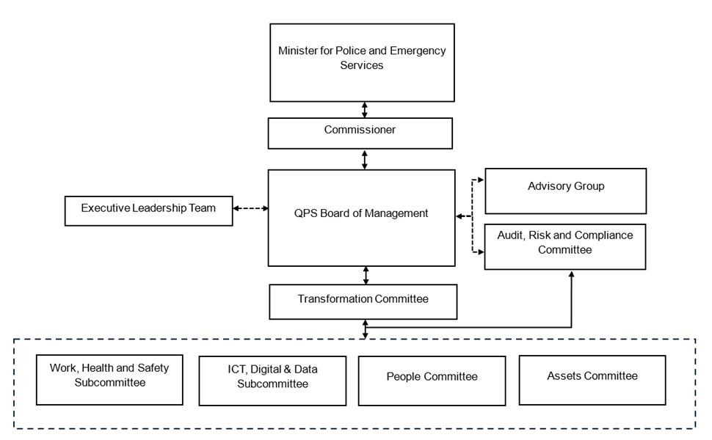
QPS Board of Management (BoM)
The purpose of the BoM is to set strategy, vision, tone, culture and risk appetite and drive performance for the Service.
The role of the BoM is to support and provide expert advice and endorsement to the Commissioner in making key decisions that deliver strategic or Service-wide impact. In doing so, the BoM advises on and oversees performance against strategic and organisational priorities.
The BoM meetings are chaired by the QPS Commissioner.
The BoM meets once a month or as determined by the Chair. In 2025-26, the BoM met on 13 occasions and considered two matters out-of-session.
Board Members
- Brett Pointing, A/Commissioner
- Cathy Ford, General Manager, Office of the Commissioner
- Mark Kelly, Deputy Commissioner, People and Assets
- Cheryl Scanlon, Deputy Commissioner, Specialist Operations
- Chris Stream, Deputy Commissioner, Disaster and Emergency Management
- John Tims, Deputy Commissioner, Regional Operations
Standing attendees:
- Malcolm Wilson, Chief Finance Officer, Finance and Procurement Division
- Michelle Holland, Chief Risk Officer, Office of the Chief Risk Officer
Key outcomes for 2025-26
During 2025-26, the BoM considered a number of significant matters including:
- implementation of the QPS 100-Day Review
- strengthening of the corporate governance framework
- financial performance and budget sustainability
- risk appetite and enterprise risk management
- workforce strategy and organisational capability
- ICT, digital and data priorities
- asset, fleet and infrastructure planning
- audit, assurance and compliance matters
- performance monitoring
- integrity, discipline and organisational culture
- health, safety and wellbeing reforms
- government priorities and election commitments
- the Independent Financial Review and implementation of recommendations
- procurement transformation
- significant projects and programs of work.

QPS Transformation Committee
The purpose of the QPS Transformation Committee is to:
- oversight governance of the portfolio of improvement work that the QPS is undertaking to support successful delivery of the Transformation Portfolio
- prioritise the key project work that is required for the delivery of benefits to the frontline and the communities we serve
- support fiscal sustainability of the QPS
- ensure horizontal integration across subcommittees to foster collaboration in strategic efforts.
The committee meets fortnightly or as determined by the Chair. During 2025-26, the Committee met on 28 occasions.
Committee members
- Clare Miller, Executive Director, Transformation Office (Chair)
- Cathy Ford, General Manager, Office of the Commissioner
- Mark Kelly, Deputy Commissioner, People and Assets
- Cheryl Scanlon, Deputy Commissioner, Specialist Operations
- Chris Stream, Deputy Commissioner, Disaster and Emergency Management
- John Tims, Deputy Commissioner, Regional Operations
Standing attendees:
- Jessica Wellard, A/Executive Director, Policy and Insight Division
- Malcolm Wilson, Chief Finance Officer, Finance and Procurement Division
- Cameron Allen, Chief Information Officer, Frontline and Digital Division

Achievements
In 2025-26, the Transformation Committee provided governance oversight of organisational transformation and strategic change initiatives, considering matters relating to prioritisation, implementation, interdependencies and enterprise-wide impacts. The Committee supported decision making through ongoing monitoring and review of transformation activities across the organisation.

QPS Audit and Risk and Compliance Committee (ARCC)
The purpose of the ARCC is to scrutinise, challenge and oversee the QPS Commissioner’s legislated management responsibilities under the Police Service Administration Act 1990, the Financial Accountability Act 2009 and the Financial and Performance Management Standard 2019.
The ARCC provides assurance to the Commissioner and BoM through scrutiny of QPS risk management, review of internal control and compliance, confirmation of financial compliance, audit, fraud and corruption control and regular and necessary engagements.
The Committee meets quarterly or as determined by the Chair. During 2025-26, the Committee met on four occasions. The independent members collectively received $48,087.50 in remuneration.
Committee members
- Geoff Waite, Independent Member (Chair)
- Peter Aitken, Independent Member
- Anita Macartney, Independent Member
- Leanne Raiser, Independent Member
- Dallas Stower, Independent Member
Standing attendees:
- Cathy Ford, General Manager, Office of the Commissioner
- Mark Kelly, Deputy Commissioner, People and Assets
- Malcolm Wilson, Chief Finance Officer, Finance and Procurement Division
- Michelle Holland, Chief Risk Officer, Office of the Chief Risk Officer
- Warren Dries, Director, Internal Audit
- Representative from Queensland Audit Office
Achievements
During 2025-26, the ARCC provided strategic advice and support to the BoM by considering matters of risk management, internal control and compliance, financial compliance and auditing and reporting. The ARCC considered significant matters including:
- enterprise risk management
- business continuity management
- internal audit planning, audit findings and monitoring of audit recommendations
- external audit matters, including consideration of Queensland Audit Office reports and plans
- financial accountability and compliance
- fraud and corruption prevention, governance and reporting arrangements
- information security, cyber security and digital risks
- significant organisational risk briefings
- organisational reform programs
- compliance and inspection activities, including annual inspection planning and organisational compliance reporting
- governance framework improvements, including updates to committee governance arrangements and terms of reference

QPS Executive Leadership Team (ELT)
The purpose of the ELT is to inform and operationalise strategy and monitor organisation-wide risk and performance.
The role of the ELT is to share strategic level information, problem solve through identification, investigation and analysis of strategic issues and risks, operationalise decisions through a coordinated approach and inform decision makers by operating as a consultative forum.
In 2025-26, the ELT met on eight occasions with meetings taking place in Police Headquarters. The ELT also conducted 17 bi-weekly virtual meetings.
ELT members
- Brett Pointing, A/Commissioner
- Cathy Ford, General Manager, Office of the Commissioner
- Mark Kelly, Deputy Commissioner, People and Assets
- Cheryl Scanlon, Deputy Commissioner, Specialist Operations
- Chris Stream, Deputy Commissioner, Disaster and Emergency Management
- John Tims, Deputy Commissioner, Regional Operations
Regions
- Kevin Fitzgibbon, A/Assistant Commissioner, Far Northern Region
- Adam Guild, Assistant Commissioner, Central Region
- Kevin Guteridge, Assistant Commissioner, North Coast Region
- Chris Hodgman, Assistant Commissioner, South Eastern Region
- Glenn Morris, Assistant Commissioner, Brisbane Region
- Virginia Nelson, Assistant Commissioner, Northern Region
- Matthew Vanderbyl, Assistant Commissioner, Southern Region
Commands
- Brian Connors, Assistant Commissioner, Crime Command
- Shane Holmes, A/Assistant Commissioner, Recruitment and Development Command
- Chris Jory, Assistant Commissioner, Ethical Standards Command
- Charysse Pond, Assistant Commissioner, Security, Counter Terrorism and Forensic Services Command
- Rhys Wildman, Assistant Commissioner, Emergency Response Coordination Command
Divisions
- Cameron Allen, Chief Information Officer, Frontline and Digital Division
- Penny Dahl, A/Executive Director, Media and Communications Division
- Carolyn Harrison, Executive Director, Legal Division
- Paul Hyde, Executive Director, Assets Division
- Clare Miller, Executive Director, Transformation Office
- Helen Spencer, Executive Director, Workforce Management and Wellbeing Division
- Jessica Wellard, A/Executive Director, Policy and Insight Division
- Malcolm Wilson, Chief Finance Officer, Finance Division
Standing attendees:
- Katherine Innes, Assistant Commissioner, QPS 100 Day Review
- Robert Fleischer, A/Chief Superintendent, Chief of Staff, Commissioner’s Office
Achievements
During 2025-26, the ELT considered a number of significant matters, including:
- community safety outcomes, crime trends, operational performance and strategies to address emerging community safety issues across Queensland
- workforce sustainability, including workforce planning, absenteeism, workforce availability, health and wellbeing and strategies to support organisational capability and operational readiness
- implementation of organisational priorities, strategic initiatives and whole-of-Service reform activities
- financial sustainability, budget management, expenditure controls and procurement reform
- enterprise risk, including monitoring of strategic risks and organisational priorities
- ICT, digital and data priorities, cybersecurity, critical technology risks and service delivery capabilities;
- asset, fleet, accommodation and infrastructure planning to support frontline and corporate operations
- emergency management, operational preparedness and service delivery considerations impacting the organisation and the community
- policy, legislative and regulatory matters affecting service delivery.

QPS Subcommittees
During 2025-26, the QPS Board of Management was supported by four standing subcommittees which met regularly to provide focused oversight and advice across key areas of organisational activity. The subcommittees supported the Board's governance and decision making responsibilities through detailed consideration of matters within their respective areas of accountability.
Assets Subcommittee
The Assets Subcommittee met 11 times during 2025-26 and provided oversight of asset, infrastructure and fleet-related matters, including strategic asset planning, capital investment priorities, accommodation, operational capability requirements and asset management initiatives. The Subcommittee supported informed decision making through consideration of opportunities, risks and emerging issues associated with the Service's asset portfolio.
People Subcommittee
The People Subcommittee met ten times during 2025-26 and provided oversight of workforce strategy and organisational capability matters, including workforce planning, leadership, culture, inclusion and workforce sustainability. The Subcommittee considered workforce-related risks, opportunities and priorities to support organisational capability and performance.
ICT, Digital and Data Subcommittee
The ICT, Digital and Data Subcommittee met nine times during 2025-26 and provided oversight of information and communication technology, digital transformation and data-related initiatives. The Subcommittee considered matters relating to technology strategy, cybersecurity, digital capability, major ICT investments and data governance to support effective service delivery and organisational resilience.
Work Health, Safety and Wellbeing Subcommittee
The Work Health, Safety and Wellbeing Subcommittee met seven times during 2025–26 and provided oversight of organisational health, safety and wellbeing matters. The Subcommittee considered emerging risks, performance trends and initiatives aimed at promoting a safe, healthy and supportive workplace for QPS employees.

Ethics and code of conduct
The delivery of professional policing services must be underpinned by ethical decisions and actions. These ethical decisions and actions provide the QPS with its most valuable asset, namely its reputation and the confidence and trust that such a reputation inspires in the community. The QPS has a broad range of programs, policies and initiatives that support professional and ethical practice including a robust internal complaints system, policies on conflicts of interest, declarable associations, gifts and benefits as well as discipline, integrity and ethical awareness training. The QPS Integrity Framework and Standard of Professional Practice supplement the Queensland Government values and the Code of Conduct for the Queensland Public Service and outlines the standards of conduct and professional practice expected of all QPS employees.
The QPS Integrity Framework concisely demonstrates how the Service acts to ensure integrity. The Integrity Framework is a practical way of building and sustaining ethical behaviour across the organisation by strengthening the systems, culture and leadership that prevent misconduct, responding proportionately when issues arise and using what’s learned to continuously improve, so integrity is embedded in everyday decisions.
The QPS Integrity Framework is underpinned by the Dual Ethical Responsibility to:
- create and drive conditions, systems and processes in support of an ethical police service
- ensure the processes of discipline and professional conduct assurance do not unnecessarily interfere with, burden or slow the ability of the QPS and its members to deliver services to the community.
The Dual Responsibility is supported by the organisation’s integrity systems and organisational practices, which collectively strengthen ethical decision making, professional conduct and effective service delivery. These systems include governance arrangements, leadership expectations, policies, training, controls, reporting mechanisms and cultural practices that embed the QPS values and ethical standards into day-to-day operations.
Together, these integrity systems and organisational practices provide a practical basis to assess maturity, identify gaps, clarify accountability and evidence improvement through measurable activity and reporting. They support the ethical health of the organisation by ensuring prevention, attention and continuous improvement are built into governance, management oversight and operational practice across the Service.
The purpose of Ethical Standards Command (ESC) is to promote and uphold professional standards and ethical practice to foster community trust and confidence in our policing services. We do this in partnership with our stakeholders delivering activities in a timely, consistent and fair manner to prevent and respond to matters that impact the ethical health of the organisation. Our approach is underpinned by principles of guidance, correction, rehabilitation and when necessary, discipline, to support a culture of integrity and professional standards.
In 2025-26, ESC continued to promote, monitor and enforce ethical behaviour, integrity and professional practice through education, deterrence and systems improvements. ESC continued to be the conduit between QPS and oversight bodies such as the Crime and Corruption Commission.
Reported complaints are continually monitored and reviewed by the QPS to identify primary contributing factors and/or trends which may arise from complaint types and/or the complaint data more generally. All complaints are considered, actioned and investigated as required. In 2025-26, the QPS received 1,564 complaints by members of the public against officers on or off duty.
This figure counts the number of distinct individuals who have either lodged a complaint or lodged a complaint on behalf of another person even if it relates to the same incident. When applying relevant context to this figure, the QPS undertakes millions of interactions with people in the community every year. Comparatively, very few of those interactions result in complaints relating to the conduct of police.
ESC delivers an inspection and compliance assurance function across QPS establishments to assess adherence to legislative, policy and operational requirements. During 2025-26, ESC enhanced its inspections framework to align with the Annual Inspections Plan and strengthen the effectiveness of compliance monitoring activities. This included analysis of inspection outcomes from ESC led and regional/command conducted inspections to identify systemic issues, emerging risks and statewide trends. Insights from these activities are provided to the Executive Leadership Team and the Audit, Risk and Compliance Committee to inform governance, oversight and continuous improvement across the Service.
Discipline outcomes
ESC is responsible for the management of all complaints of misconduct and disciplinable conduct reported to the QPS. All complaints are considered, actioned and investigated as required.
In 2025-26, the QPS recorded 2,370 complaints containing 5,394 allegations from internal QPS members and members of the public. A complaint is an expression of dissatisfaction made to or about the Service, related to the conduct of members or provision of services, where a response or resolution is reasonably expected. A complaint can contain multiple allegations depending on the specific nature of dissatisfaction as outlined in the complaint.
A breakdown of the complaint categories and discipline outcomes is included in the below table.
In 2025-26, Professional Development Strategies (PDS), formerly known as Local Management Resolution, were used as an outcome on 445 occasions across 13 allegation categories.
A PDS is a resolution process where strategies are formulated and implemented to address inappropriate conduct. The purpose of implementing a PDS plan will be to improve performance through appropriate training and guidance to the member whose conduct has come into question due to an identified underlying issue. A PDS is a remedial approach which recognises members will make genuine mistakes and provides a learning and development approach to improve performance and align the member’s behaviour with the organisation’s principles. A PDS should not merely default to the delivery of managerial guidance or chastisement as a tool to address behaviour, but rather genuine engagement by a supervisor with the member or complainant, where a raft of management options is explored.
Allegation Category | Total number of Allegations | Allegation Outcome
Failure of Duty | 2,098 | No further action: 1,544  PDS: 195  Hearing: 2  Abbreviated Discipline Process: 0
Unprofessional Conduct (excluding QPS members involved in DFV) | 731 | No further action: 488  PDS: 99  Hearing: 13  Abbreviated Discipline Process: 0
Unprofessional Conduct (QPS members involved in DFV only) | 70 | No further action: 27  PDS: 4  Hearing: 1  Abbreviated Discipline Process: 0
Assault/Use Excessive Force | 628 | No further action: 552  PDS: 21  Hearing: 2  Abbreviated Discipline Process: 0
Misuse of authority | 486 | No further action: 380  PDS: 16  Hearing: 2  Abbreviated Discipline Process: 0
Misuse of information | 351 | No further action: 200  PDS: 42  Hearing: 3  Section 95 Process: 2
Inappropriate exercise of operational discretion | 253 | No further action: 238  PDS: 6  Hearing: 0  Abbreviated Discipline Process: 0
Unlawful or Unauthorised Operational Practice | 207 | No further action: 154  PDS: 30  Hearing: 0  Abbreviated Discipline Process: 0
Interfere with or undermine an investigation, legal process or conduct matter | 182 | No further action: 153  PDS: 5  Hearing: 0
Other Offence | 135 | No further action: 61  PDS: 8  Hearing: 4  Show Cause – Volunteer Appointment Revoked: 2
Misappropriation or unauthorised use of resources | 64 | No further action: 24  PDS: 6  Hearing: 1  Abbreviated Discipline Process: 0
Discrimination/Sexual Harassment | 59 | No further action: 40  PDS: 5  Hearing: 1  Abbreviated Discipline Process: 0
Professional Conduct | 53 | No further action: 22  PDS: 7  Hearing: 0  Abbreviated Discipline Process: 0
Sexual Offence | 37 | No further action: 18  PDS: 1  Hearing: 0  Abbreviated Discipline Process: 0
Drug related offence | 32 | No further action: 20  PDS: 0  Hearing: 1  Abbreviated Discipline Process: 0
Bribery/Secret Commissions | 6 | No further action: 6  PDS: 0  Hearing: 0  Abbreviated Discipline Process: 0
Significant Event | 1 | No further action: 0  PDS: 0  Hearing: 0  Abbreviated Discipline Process: 0
False Complaint | 1 | No further action: 1  PDS: 0  Hearing: 0  Abbreviated Discipline Process: 0
Extortion | 0 | N/A.
Police related death | 0 | N/A.

Notes:
- The object of the Act is to improve performance and provide a system which focuses on guiding, correcting, rehabilitating and, if necessary, disciplining officers. This is essential to protect the public, uphold ethical standards within the Service and promote and maintain public confidence and officers’ confidence in the Service.
- The total number of complaints recorded includes complaints against sworn and unsworn members received internally or from members of the public.
- Upon assessment of an incident/complaint, the actions of members are reviewed and distilled into individual allegations for assessment inquiries, investigation or possible 'no further action' if the actions were considered lawful and reasonable. The review process can result in multiple allegations for assessment.
- The allegation of ‘Unprofessional Conduct’ has been split into two categories. QPS members involved as a respondent in a DFV matter is recorded separately in response to recommendation 31 of the Women’s Safety and Justice Taskforce Report One.
- The above table provides data on allegations that have been determined. The variation between the total number of allegations and outcomes are those that are still under investigation or awaiting assessment as at 30 June 2026.
Discipline Hearing outcomes – State Discipline
State Discipline, led by an Assistant Commissioner, is an independent central unit responsible for conducting disciplinary proceedings (police officers) and show cause proceedings (staff members) for the QPS and is separate and distinct from ESC.
Under the Police Service Administration Act 1990 (PSAA) the Assistant Commissioner, State Discipline, is conferred the sanctioning powers of a Deputy Commissioner to impose any disciplinary sanction provided for by the Act including dismissal, suspension without pay (up to 12 months), probation (up to 12 months) and the comprehensive transfer of a member. The Chief Superintendent, State Discipline, is assigned the sanctioning powers of an Assistant Commissioner. The Superintendent, State Discipline, makes decisions on less serious grounds for a disciplinary action.
Disciplinary Hearings for police officers can include a full disciplinary proceeding, an Abbreviated Disciplinary Proceeding (ADP), and where members have separated from the Service, there is provision under Part 7A of the PSAA for a Disciplinary Declaration to be made.
A Director level position also operates within State Discipline to undertake show cause proceedings under the Public Sector Act 2002 (PSA) for discipline action against staff members. The Director also considers disciplinary declarations where a staff member’s employment ends prior to any disciplinary action being finalised.
It should be noted, where a member resigns prior to the completion of an investigation, the decision to progress the consideration of a Disciplinary Declaration by State Discipline is made by ESC.

Discipline matter breakdown – hearings and outcome 2025-26
Proceeding Type | Quantity | Sanction Types per subset
Hearing (PSAA)  Police officers | 51 matters finalised | Community Service | 10
Hearing (PSAA)  Police officers | 51 matters finalised | Demotion (permanent) | 0
Hearing (PSAA)  Police officers | 51 matters finalised | Demotion (temporary) | 10
Hearing (PSAA)  Police officers | 51 matters finalised | Dismissal | 0
Hearing (PSAA)  Police officers | 51 matters finalised | Fine | 4
Hearing (PSAA)  Police officers | 51 matters finalised | Local transfer | 1
Hearing (PSAA)  Police officers | 51 matters finalised | Professional Development Strategy only | 0
Hearing (PSAA)  Police officers | 51 matters finalised | Probation | 4
Hearing (PSAA)  Police officers | 51 matters finalised | Reprimand | 8
Hearing (PSAA)  Police officers | 51 matters finalised | Suspension from duty | 1
Hearing (PSAA)  Police officers | 51 matters finalised | Unsubstantiated | 2
Hearing (PSAA)  Police officers | 51 matters finalised | Decision not to commence | 7
Hearing (PSAA)  Police officers | 51 matters finalised | Discontinued for legal reason | 4
Hearing (PSAA)  Police officers | 51 matters finalised | Total: | 51*
*Of those 51 matters finalised, the total number of Professional Development Strategies imposed in addition to a disciplinary sanction: 30

Proceeding Type | Quantity | Sanction Types per subset
Hearing (PSA)  Staff members | 21 matters considered in total | Deferment of remuneration | 3
Hearing (PSA)  Staff members | 21 matters considered in total | Reduction in classification (permanent) | 1
Hearing (PSA)  Staff members | 21 matters considered in total | Reduction in classification (temporary) | 1
Hearing (PSA)  Staff members | 21 matters considered in total | Demotion (temporary) | 1
Hearing (PSA)  Staff members | 21 matters considered in total | Fine | 2
Hearing (PSA)  Staff members | 21 matters considered in total | Management Action Plan | 1
Hearing (PSA)  Staff members | 21 matters considered in total | Substantiated, no disciplinary action imposed | 2
Hearing (PSA)  Staff members | 21 matters considered in total | Reprimand | 6
Hearing (PSA)  Staff members | 21 matters considered in total | Unsubstantiated | 1
Hearing (PSA)  Staff members | 21 matters considered in total | Decision not to commence | 2
Hearing (PSA)  Staff members | 21 matters considered in total | Discontinued for legal reason | 1
Hearing (PSA)  Staff members | 21 matters considered in total | Total: | 21*
*Of those 21 matters finalised, the total number of Management Action Plans imposed in addition to a disciplinary sanction: 12

Proceeding Type | Quantity | Sanction Types per subset
Post separation declaration (7A PSAA)  Police officers | 12 matters finalised | Declaration – Dismissal | 1
Post separation declaration (7A PSAA)  Police officers | 12 matters finalised | Declaration – Demotion (permanent) | 2
Post separation declaration (7A PSAA)  Police officers | 12 matters finalised | Declaration – Demotion (temporary) | 3
Post separation declaration (7A PSAA)  Police officers | 12 matters finalised | Declaration – Probation | 0
Post separation declaration (7A PSAA)  Police officers | 12 matters finalised | No declaration | 4
Post separation declaration (7A PSAA)  Police officers | 12 matters finalised | Decision not to commence | 2
Post separation declaration (7A PSAA)  Police officers | 12 matters finalised | Total: | 12

Proceeding Type | Quantity | Sanction Types per subset
Post separation declaration (s95 PSA)  Staff members | 5 matters finalised | Declaration – Termination | 0
Post separation declaration (s95 PSA)  Staff members | 5 matters finalised | Declaration – Reduction of classification level | 0
Post separation declaration (s95 PSA)  Staff members | 5 matters finalised | Discontinued | 1
Post separation declaration (s95 PSA)  Staff members | 5 matters finalised | No declaration | 1
Post separation declaration (s95 PSA)  Staff members | 5 matters finalised | Decision not to commence | 3
Post separation declaration (s95 PSA)  Staff members | 5 matters finalised | Total: | 5

Notes:
- Section 7.34 of the PSAA outlines the disciplinary sanctions available for police officers in a ‘hierarchical order’ from most serious sanction of ‘dismissal’ to least serious sanction of ‘reprimand’. Section 7.35(4) provides that more than one disciplinary sanction can be imposed on a subject officer. Where more than one disciplinary sanction has been imposed on an officer, only the more serious disciplinary sanction has been recorded in the sanction types’ ‘total’ count.
- Section 7.42 of the Act provides that Professional Development Strategies can be imposed instead of, or in addition to, a disciplinary sanction. Where Professional Development Strategies have been imposed in addition to a disciplinary sanction, this has been noted separately in the tables capturing proceedings: ‘Hearing (PSAA), ADP (PSAA).
Charter of Victims’ Rights
The Charter of Victims’ Rights (the Charter) describes the way a victim should be treated, as far as practicable and appropriate, by government and non-government entities that receive government funding and those that work in these entities. The Charter sets out the general rights of victims and specific rights relating to the criminal justice system. When dealing with a victim of crime, officers are to comply with the provisions of the Charter which places an onus on agencies to provide information to victims. Victims have the right to make a complaint if this Charter is not followed. The complaints data for 2025-26 is available on the Open Data Portal at www.data.qld.gov.au.

Government bodies
- Commissioner for Police Service Reviews
- Controlled Operations Committee
- Public Interest Monitor.
For further information about the government bodies refer to page 109 within the appendices.
External scrutiny
This section provides information on external agencies and processes that have reviewed QPS operations, outlining any findings or issues that require consideration by, or may impact, the QPS.
Queensland Audit Office (QAO)
The QAO supports the Auditor-General of Queensland in delivering independent assessments of the financial management and performance of public sector entities to Parliament. It provides independent audit services and reports its findings to Parliament, strengthening accountability across the public sector. QAO reports are publicly accessible at www.qao.qld.gov.au/reports-resources/parliament. The QPS remains dedicated to identifying and implementing efficiency improvements across all areas of service delivery.
The following reports were published by the QAO during the reporting period:
- Managing the ethical risks of artificial intelligence Report 2: 2025-26
This QAO report assessed whether the Queensland public sector has effective policies and governance arrangements to manage the ethical risks of artificial intelligence (AI). While the audit did not focus on QPS, the report recommends all Queensland public sector entities should implement ethical risk assessment processes for AI systems that are in use or being developed to ensure ethical risks are identified, assessed and managed comprehensively throughout the AI lifecycle. This report made one recommendation applicable to all public entities, including the QPS.
- Managing third-party cyber security risks Report 13: 2025-26
This QAO report examined how effectively Queensland public sector entities manage cyber security risks arising from third-party suppliers, contractors, and vendors. The report concludes that all Queensland public sector entities, along with central agencies responsible for cyber security and procurement guidance, need to strengthen governance, oversight and controls to better identify, assess, monitor and mitigate third-party cyber security risks across the sector. This report made five recommendations applicable to all public entities, including the QPS.
Crime and Corruption Commission (CCC)
The CCC is Queensland’s independent statutory body established to combat major crime and for investigating the most serious or systemic allegations of corruption. Its corruption functions extend to state government departments, the QPS, local councils, government-owned corporations, universities, prisons, courts, tribunals, and elected officials. CCC reports can be accessed online at: https://www.ccc.qld.gov.au/publications.
Queensland Ombudsman (QO)
Under the Ombudsman Act 2001, the QO operates as an independent body responsible for investigating complaints about the actions and decisions of Queensland state government departments, local councils, and public authorities. QO reports can be accessed online at: http://www.ombudsman.qld.gov.au/publications/all-publications.

Queensland Sentencing Advisory Council (QSAC)
The QSAC is an independent body that provides research and advice on sentencing, engages with the community to understand public views, and helps improve public understanding of sentencing in Queensland. It also advises the Attorney-General on sentencing matters when requested and operates under the Penalties and Sentences Act 1992.
- The Tangled Web: Examining DFV sentencing reforms
This QSAC report was published in February 2026. It reviews whether Queensland’s
2015–16 DFV sentencing reforms, including higher penalties for breaching Domestic Violence Orders and the introduction of a domestic violence aggravating factor, have strengthened sentencing outcomes and offender accountability. The report made one recommendation relevant to QPS. The QPS will work collaboratively with the relevant agencies to address and implement the recommendation.
State Coroner
During 2025-26, 18 recommendations arising from five coronial inquests were directed to the QPS as either a lead or supporting agency. The Findings of Inquest are available at www.courts.qld.gov.au/courts/coroners-court/findings.

Risk management and accountability
Enterprise risk management
The Commissioner and Senior Executives are committed to managing risks that may affect the QPS’s strategic and operational objectives. The QPS Enterprise Risk Management Framework, aligned with ISO 31000:2018 Risk Management – Guidelines, embeds risk-informed decision making across the organisation and defines governance, accountability, and responsibilities for risk management.
Risk management supports the achievement of organisational objectives and is guided by the QPS Risk Appetite Statement, which informs policy, investment, and operational decisions. The BoM provides leadership and commitment to the framework, while the ARCC oversees its effectiveness. The Office of the Chief Risk Officer maintains the framework, promotes best practice, monitors emerging risks, and provides risk management advice and support across the Service.
Internal audit
The QPS Internal Audit Unit provides independent and objective assurance and advisory services to QPS and the Office of the Inspector-General Emergency Management (IGEM) under a portfolio service delivery model. The Head of Internal Audit for QPS is also the nominated Head of Internal Audit for IGEM, in accordance with the Financial Accountability Act 2009.
Internal Audit contributes to strengthening service delivery by providing independent, risk-based and objective assurance, advice and insight on governance, risk management, control and compliance processes. This spans across a wide range of disciplines including compliance, performance, financial management, information technology, and includes advisory and consulting services for QPS and IGEM.
In line with the Financial and Performance Management Standard 2019, the unit operates under an approved annual internal audit plan and a rolling three-year strategic audit plan. The plans are based on a structured risk assessment process that considers key organisational risks and priorities. The Annual Internal Audit Plan 2025-26 and Strategic Internal Audit Plan 2026-29 were endorsed by the QPS Audit, Risk and Compliance Committee (ARCC) and approved by the Commissioner on 23 September 2025.
The Internal Audit Unit reports directly to the ARCC, which provides independent oversight of audit activities and outcomes, consistent with Queensland Treasury’s Audit Committee Guidelines.
Internal Audit operates under an approved Charter and develops its plan and charter in accordance with the Institute of Internal Auditors’ Global Internal Audit Standards and the International Professional Practices Framework. Systems and processes are in place to support the effective, efficient and economical operation of the function.
During 2025-26, the Internal Audit Plan was delivered through a blended model using internal resources and a co-sourced provider, Ernst & Young.
Achievements for Internal Audit Unit for the period 1 July 2025 to 30 June 2026 included:
- preparing a program of work based on risk, materiality, and contractual and statutory obligations
- delivering audits in accordance with the Internal Audit Plan and reporting results to the ARCC and Commissioner
- monitoring and reporting on the implementation of internal audit recommendations
- coordinating with the QAO to minimise duplication and support a whole-of-assurance approach
- providing advice to management on corporate governance and related matters.
Information systems and records management
During 2025-26, the Records Management Unit administered and maintained recordkeeping systems for the QPS, including MRQ and SES.
In November 2025, the revised QPS Retention and Disposal Schedule received formal approval from the Queensland State Archivist. The approved Schedule aligns with the requirements of the Public Records Act 2023 and provides a contemporary framework for the lawful retention and disposal of QPS records. Subsequent implementation activities included updating guidance materials, aligning business systems and engaging stakeholders to support the Schedule’s adoption across QPS.
During the reporting period, the Records Management Unit delivered strategic recordkeeping advice, support and training, contributing to improved recordkeeping practices and operational efficiency including:
- delivery of ongoing training to strengthen staff capability in capturing and managing records, including through the corporate Electronic Document and Records Management System (eDRMS). More than 215 QPS members attended training delivered by the Records Management Unit during the reporting period
- continued engagement with police stations and business units across the state to assess recordkeeping practices, identify compliance risks, and support improvement activities
- collaboration with QPS business areas to reduce reliance on hardcopy records and support transition to more efficient electronic business processes
- compliant destruction of 1,900 archive boxes containing payroll records which had reached their retention period, supporting improved record governance
- transferring 10 QPS personnel records identified for permanent retention to Queensland State Archives
- management and processing of records submitted for disposal in accordance with applicable retention periods specified in QPS and General Retention and Disposal Schedules.
There were no known breaches of information security relating to records managed within the corporate eDRMS during the reporting period.

Human Resources
Strategic workforce planning and performance
Workforce Profile
The QPS workforce comprises more than 20,000 paid employees including police officers and staff members, including staff members from SES and MRQ.
QPS workforce data below is presented by headcount. Substantive headcount equals the number of employees engaged by the QPS at a particular point in time regardless of the hours of employment, based on Aurion Human Resource Information System data.
The Minimum Obligatory Human Resource Information (MOHRI) Full Time Equivalent (FTE) aligns with workforce information that is provided quarterly to the Public Sector Commission by all Queensland Government agencies to inform the annual State of the Sector report.
Workforce profile data (June 2026 reporting quarter)
Total workforce
Substantive Headcount | 20,176
MOHRI paid FTE | 19,256.37
Occupation Type by Substantive Headcount – reported as a % of total substantive workforce
Corporate | 6.7%
Frontline and Frontline Support | 93.3%
Appointment Type by Substantive Headcount – reported as a % of total substantive workforce
Permanent | 91.5%
Temporary | 4.1%
Casual | 0.9%
Contract | 3.5%
Employment Status by Substantive Headcount – reported as a % of total substantive workforce
Full-time | 93.8%
Part-time | 5.3%
Casual | 0.9%

Target group data*
Gender Identity** | Number  (Headcount) | Percentage of total workforce  (Calculated on headcount)
Woman | 7,759 | 38.5%
Man | 12,222 | 60.6%
Non-binary | 41 | 0.2%
Another term | <5 | 0.0%
Not disclosed | 149 | 0.7%
Diversity Groups* | Number  (Headcount) | Percentage of total workforce  (Calculated on headcount)
Aboriginal Peoples and Torres Strait Islander Peoples | 547 | 2.7%
Non-operational people with disability^ | 281 | 5.2%
Culturally and Linguistically Diverse  Speak a language other than English at home^^ | 985 | 4.9%

*All diversity figures rely on employees self-identifying through a voluntary questionnaire, where they have the option to select that they prefer not to disclose across any or all questions.
**Gender identity reported when available. Respondents who select “Prefer not to disclose” have been excluded.
^Disability data is based on non-operational workforce only and excludes Police Officers, Watch-house Officers, Protective Services Officers, Police Liaison and Torres Strait Islander Liaison Officers, Recruits and Police Pipes and Drums.
^^ This includes Aboriginal and Torres Strait Islander languages or Australian South Sea Islander languages spoken at home.
Diversity figures are based on actual placements, including relieving arrangements, and include paid and unpaid employees.
To ensure privacy, in tables where there are fewer than five respondents in a category, specific numbers are replaced by <5.
Women in Leadership Roles* | Women  (Headcount) | Women as percentage of total leadership cohort  (Calculated on headcount)
Senior Officers  (classified, s122 and s155 combined) | 181 | 32.6%
Senior Executive Service, high-level Senior Executives and Chief Executives (classified, s122 and s155 combined) | 19 | 38.0%
* Women in leadership are defined as those in classified roles or on s122 or s155 contracts, salary equivalency data is excluded.
Strategic workforce planning and performance
The QPS Strategic Workforce Plan 2025–2029 supports the delivery of the QPS Strategic Plan 2025–2029 by building a healthy, engaged and capable workforce, with a strong focus on our work, workforce and workplace. The plan recognises that our people are critical to delivering safer communities and a more resilient Queensland and strengthens the alignment between workforce planning, organisational performance and strategic priorities.
During the year, QPS progressed a range of initiatives to strengthen workforce capability, capacity and wellbeing, including:
- prioritising the health, safety and wellbeing of our people, with continued reform and enhancement of wellbeing and support services to help ensure our workforce receives the right support, at the right time and in the right way
- strengthening recruitment, retention, leadership and development initiatives to attract, support and grow a capable workforce that better represents and understands the communities we serve
- fostering a respectful, inclusive and culturally safe workplace aligned with QPS values and supporting greater workforce engagement and inclusion
- growing workforce planning capability through improved workforce data, analytics and insights to support evidence-based decision making, forecasting and future workforce preparedness
- strengthening partnerships across government, the private sector and the community and embracing innovative ways of working, including leveraging technology and workforce intelligence to support service delivery outcomes.
The QPS 100-Day Review identified enhancing workforce wellbeing, capability and capacity as a key enabler of organisational reform and performance. Several of the review recommendations align with and reinforce the objectives of the Strategic Workforce Plan 2025–2029, particularly in relation to leadership, workforce sustainability, wellbeing, culture, performance and capability development. These reforms will continue to inform QPS workforce planning and performance activities into the future.
From 2026-27, strategic workforce planning will be integrated within the QPS strategic planning framework as a core organisational priority, strengthening alignment between strategic priorities, workforce initiatives, performance measures and reporting, and supporting a more coordinated approach to delivering workforce outcomes across the Service.
Safety and Wellbeing
Safety and Wellbeing support our people through providing evidence-based and integrated safety, health and wellbeing services. It is through these services, and in partnership with people capability owners across the Service, that we drive the strategic objective to build an engaged and capable workforce with the health, safety and wellbeing of our people a priority.
In 2025-26, Safety Strategy Division with Health and Wellbeing Division merged to achieve a fully integrated safety, health and wellbeing system. In alignment with 100 Day Review recommendations, the transformed Safety and Wellbeing works to promote a safety-first culture, ‘Safety First: Safe Work, Healthy Outcomes’ incorporating physical and psychological safety at all levels of the organisation.
Safety and Wellbeing has continued to embed and mature the integrated model of wellbeing, promoting the interconnectedness of biological, psychological, social and spiritual wellbeing. This resulted in a refined range of internal and external support options being available to members, former members and their loved ones to ensure they are supported and feel supported. These support services include:
- Regional Senior Social Workers and Psychologists. These members play an active and visible role in supporting the wellbeing of police officers through their participation in operational activities, including simulated counter-terrorism exercises and observational police patrols. This integrated approach provides the practitioners with a first-hand understanding of the complexities, pressures and realities of frontline policing, enabling them to deliver more informed, relevant and responsive support. Direct engagement with operational officers builds trust and stronger professional relationships, fostering greater collaboration and accessibility. This approach bridges the gap between clinical support services and operational policing, while creating new opportunities to strengthen relationships, improving opportunities for early intervention and promoting psychological health and resilience across the workforce.
- Wellbeing Senior Human Services Officer (SHSO) Team within SES and MRQ consisting of experienced mental health practitioners, including Senior Social Workers and a Senior Psychologist, who provide support across four major regional areas in Queensland. Support is delivered through four dedicated People Hubs operating across all regions. Regional SES and MRQ SHSOs provide tailored, region-specific support that responds to the unique needs of each community while strengthening relationships and promoting trust and accessibility.
- the Support Management Team (SMT) which provides support to members following critical incidents or the sudden death of a serving member and intervenes early to ensure appropriate support and referrals are provided for individuals based on their needs. The SMT also proactively contacts members at known high-risk touchpoints during their career life cycle to intervene early, prior to a possible psychological injury occurring. Through the support of the State Coroner, SMT is an embedded resource for QPS witnesses in all upcoming coronial inquests. Additionally, SMT is engaged in disciplinary processes to support members from an early stage of the process to deliver timely support.
- delivery of the career transition program for members approaching medical or mandatory age retirement
- the Peer Support Coordination Unit which provides significant reform of the QPS’s Peer Support Officer (PSO) Program and continued training of PSOs across the SES and MRQ during 2025-26. Ongoing reform initiatives included skills enhancement in motivational interviewing and hot debriefing, further strengthening the capability of PSOs. These initiatives continue to support an integrated approach to wellbeing, enabling PSOs to provide meaningful social support across all agencies.
- the Chaplaincy Unit which continues to provide confidential 24/7 pastoral, spiritual and welfare support to QPS members, former members and their families. The unit provides important critical incident support, including immediate trauma-informed responses for impacted members and their families, as well as supporting regular station visits, ongoing wellbeing engagements and ceremonial duties for official QPS ceremonies. In 2025-26, services were enhanced within the realm of trauma-informed care and understanding trauma focused cognitive behavioural therapy, enabling enriched provision of pastoral care following critical incidents and potentially traumatic events.
- the Psychological Assessment Unit which continues to deliver standardised psychological assessment services for personnel selection and psychological health screening purposes.
- HealthStart Program which facilitated an early engagement initiative with recruits to foster a health-aware culture and individual responsibility for positive physical health.
The QPS also offers a SelfRefer Program that allows current employees to anonymously access up to six free QPS-funded sessions with external psychological services.
The SelfRefer Program is completely voluntary and confidential. The SelfRefer Providers are all qualified health professionals in the mental health field with experience in dealing with first responders and the illnesses and injuries that first responders may experience. The network of providers includes psychologists, social workers and counsellors who are bound by their own professional code of ethics regarding confidentiality.
A broader and more inclusive range of services is available through external programs, recognising the diversity of our workforce and the nexus between work and other life-domains.
Cop Care Mental Health Framework
During the reporting period, the Queensland Government committed $5.5 million to establish Cop Care, a new charity dedicated to supporting the mental health and wellbeing of current and former police officers. A flagship program for Cop Care is Copline, a new triage service and 24/7 support line. The support line is to be staffed by veteran police officers, providing frontline personnel with immediate access to independent support.
Cop Care will deliver immediate, confidential and culturally competent world-leading programs including interventions proven to reduce post-traumatic stress disorder, depression and anxiety in police cohorts, extending this support to former members and families.
Operating alongside existing QPS wellbeing programs, Cop Care will strengthen access to early intervention, peer support and specialist mental health services for current and former members. This significant investment reinforces a shared commitment to supporting the wellbeing of Queensland police personnel and sustaining a healthy, capable and resilient workforce.
Northern Region Wellbeing Hub
The Northern Region Wellbeing Hub pilot, delivered as part of Recommendation 1 of the QPS 100-Day Review, successfully introduced a locally-led, integrated wellbeing hub providing a single point of access to services including injury management, health coaching, chaplaincy and peer support.
During its 12-weeks of operation, the Hub supported more than 90 referrals and engaged over 500 members across 55 stations and organisational units, including remote communities. Referrals covered more than 30 wellbeing themes, demonstrating the value of a holistic, preventative approach that extended beyond health and injury management to areas such as financial wellbeing, career planning and retirement support. Strong positive feedback from members and stakeholders confirmed the effectiveness of the regionally coordinated model in improving access to support. The success of the model has already resulted in the continuation of the Wellbeing Hub in Townsville and provided a strong evidence base for potential statewide implementation, with anticipated benefits including earlier intervention, improved resilience, increased organisational trust and enhanced workforce morale.
Belonging and inclusion
The QPS continues to demonstrate its commitment to fostering an inclusive and diverse workplace where all employees feel valued, respected and empowered to access equal opportunities. During 2025-26, the QPS:
- developed the Belonging and Inclusion Plan 2026–2030, outlining the vision for fostering a workplace where everyone feels a genuine sense of belonging and inclusion. The Plan was shaped by input from the QPS workforce, including frontline officers, staff, volunteers, and individuals with lived intersectional experiences
- launched the Belonging and Inclusion Action Plan 2026–2027, which builds on this vision by detailing practical steps to advance equity, diversity, respect, and inclusion in the workplace, ensuring employees feel valued and supported
- continued to support its Employee Networks, including the Disability Network, Pride Network, First Nations Network, Multicultural Network and Leading Women Network. These networks provide an important mechanism for employee voice, connection and advocacy, and continue to support a more inclusive and engaged QPS workforce.
These plans support QPS's commitment to creating a workplace where all employees feel a sense of belonging and are empowered to contribute to safer Queensland communities.
Multicultural Affairs Unit (MAU)
The QPS MAU promotes cultural inclusion and strengthens cultural capability across the service. The Unit provides advice, support and advocacy for members from culturally, linguistically and religiously diverse backgrounds, while fostering professional networks that drive culturally responsive policing responses and diversity and inclusion.
The MAU plays a key role in supporting QPS’s multicultural workforce and strengthening connections between the QPS and Queensland's diverse communities through oversight of the State Police Liaison Officer Coordination Unit, the Multicultural Network, the Culturally and Linguistically Diverse (CALD) Consultative Group and the Police Multicultural Advisory Group.
During 2025-26, the QPS delivered a range of initiatives to attract, develop and retain a diverse workforce representative of the communities it serves. These include:
- Multicultural Recruit Preparation Pathway: which provides mentoring, preparation and confidence building support to CALD applicants seeking entry into the Police Recruit Training Program
- International Recruitment Pathway: enabling overseas police officers to transition into policing careers in Queensland through a dedicated recruitment stream
- Recruit Career Days: supporting recruitment through participation in multicultural career expos, community events and targeted recruitment activities
The Police Liaison Officer Program continues to play a vital role in strengthening engagement with culturally diverse communities, enhancing community confidence in policing services and supporting workforce diversity across the service.
QPS Pride Network
The QPS Pride Network continues to play a vital role in championing inclusion and advocating for Lesbian, Gay, Bisexual, Transgender, Queer/Questioning, Intersex and Asexual (LGBTQIA+) members across the organisation. Comprising dedicated volunteers, the Network provides statewide support, resources and guidance to ensure that LGBTQIA+ individuals within the QPS feel valued, respected and included.
The QPS Pride Network achieved Bronze accreditation on behalf of the QPS in the Australian Workplace Equality Index, recognising the organisation’s continued progress in supporting LGBTQIA+ inclusion. The accreditation provides an important national benchmark for future improvement and reflects the Network’s ongoing work to strengthen inclusive practices across the organisation.
The Network also progressed the introduction of a QPS Pride polo shirt to increase visibility, demonstrate support and promote a stronger sense of belonging.
Engagement was also broadened beyond the QPS to include partner emergency service organisations, including MRQ and the SES. This expanded collaboration supports greater connection, shared learning and a more coordinated approach to LGBTQIA+ inclusion across the broader emergency services sector.
QPS Leading Women Network
The QPS Leading Women Network (LWN) plays a central role in advancing gender equality and fostering inclusive leadership across the organisation. Operating under the broader QPS Belonging and Inclusion Plan 2026 - 2030, the LWN is committed to cultivating a workplace culture where women are empowered to fully participate, progress and thrive at every level.
The LWN continues to address both structural and cultural barriers to gender equity by promoting solutions to systemic challenges, creating opportunities for personal and professional development and offering a supportive network for women to share experiences and build capability.
Key achievements for 2025-26 include:
- advanced representation of women in leadership across the QPS
- delivered professional development opportunities and increased visibility for women through structured programs and events, including two half-day masterclass and networking events with the themes ‘Courage to Change, Confidence to Lead’ and ‘Ethical Decision Making: doing what’s right when it matters most’
- coordinated the QPS International Women’s Day event, celebrating women’s contributions in the QPS, SES and MRQ and reinforcing the organisation’s commitment to gender equity
- facilitated twelve monthly lunchtime professional development workshops on health/wellbeing and leadership with presenters including the Director-General, Department of Women, Aboriginal and Torres Strait Islander Partnerships and Multiculturalism, the Queensland Racing and Integrity Commissioner, and the Minister for Police and Emergency Services, to inspire and inform future women leaders
- initiated a ‘buddy program’ to support female First Year Constables, newly appointed female QPS members in regional and remote areas and women returning from parental leave and other lengthy workplace absences.
Disability Network
The Disability Network has presented to QPS Command groups, focusing on neurodiversity in the workplace, and inclusive support strategies. The network is expanding engagement to the SES to ensure accessibility to this training. The Disability Network is undertaking the Auslan capability project, conducting weekly in-person and Teams sessions, teaching Auslan, the native language of the Deaf community.
The Network is working with internal and external stakeholders to build a resource library to share practical information, tools and lived-experience insights that support inclusion, accessibility and informed decision making.
Workforce culture
The establishment of the Workforce Support and Engagement Group (WSEG) in 2024 represented a significant advancement in QPS’s commitment to fostering a proactive and preventative approach to workplace standards and behaviours, supporting safer workplaces and a healthy and engaged workforce.
Throughout 2025-26, WSEG:
- strengthened leadership capability through targeted education, workshops and early intervention strategies aimed at improving performance conversations, reducing workplace conflict and enhancing governance and decision making
- improved professional standards and workplace behaviour through coordinated prevention and early intervention initiatives, contributing to reduced reliance on formal disciplinary processes
- promoted inclusive leadership and cultural reform by building organisational trust, transparency, and confidence through consistent, objective and support-based approaches
- advanced equity through initiatives that support leadership development, retention and progression of members, fostering more inclusive and representative leadership
- implemented the Sexual Harassment Contact Officer Network to provide a safe, accessible first point of contact for members seeking information in relation to workplace sexual harassment.
WSEG continued to deliver integrated support services including:
- Service Connect: providing a centralised entry point (‘front door’) to WSEG services, connecting members to the right support through a triage and case management approach, while ensuring timely, confidential and accessible assistance to the workforce
- Prevention and Early Intervention: delivering a coordinated, enterprise-wide approach to identifying emerging workplace risks, enabling timely and proportionate support to individuals and teams, and embedding sustainable behavioural and cultural improvement across the Service
- Workplace Assessment Support Team: working in partnership with members and leaders to assess workplace dynamics, strengthen team performance and deliver tailored interventions that restore and sustain positive workplace culture
- Conflict Management Services: delivering early intervention support to individuals and teams experiencing workplace conflict, promoting resolution, mutual understanding and improved working relationships
- SES/MRQ People Hubs: providing targeted advice and support to leaders and volunteers within the SES and MRQ by strengthening inclusive practices and workforce capability.
Working for Queensland and Volunteering for Queensland Survey
The annual Working for Queensland (WfQ) and Volunteering for Queensland (VfQ) surveys provide valuable insights into employee and volunteer perceptions of workplace culture, leadership, inclusion and engagement across the QPS.
In March 2026, the QPS administered its first VfQ survey following the transition of SES to QPS and the creation of MRQ in 2025. The survey captured feedback from volunteers across the SES, MRQ and ViPs.
The 2025 WfQ survey was conducted in September 2025 and resulted in:
- the distribution of 550 highlight reports and 52 supplementary reports across regions, commands and divisions, supporting managers to identify workforce trends and priority focus areas
- the creation and dissemination of 22 work group comment packs to enhance understanding of workforce sentiment and inform targeted improvement initiatives
- the development of action plans to address survey outcomes and drive continuous improvement across the Service.
The QPS continues to promote participation in both the WfQ and VfQ surveys to strengthen understanding of workforce and volunteer experiences, monitor organisational performance, and support the achievement of strategic objectives. Survey outcomes support the QPS Supported Workforce strategic objective and associated performance measures, while informing initiatives and priorities under the QPS Belonging and Inclusion Plan.
Leadership and Professional Development Opportunities
In 2025-26, QPS delivered a comprehensive range of leadership and professional development programs for police officers and staff members. These initiatives were designed to build capability, enhance career progression and support the Service’s commitment to excellence in policing. Key programs included:
- Strategic Command Program, delivered in partnership with the Australian Institute of Police Management, to develop critical thinking and decision making skills for Superintendents (or equivalent) and above, focusing on managing large-scale, complex and high-risk events.
- Leadership Capability Program (LCP), a three-stage distance education program aimed at developing members at their current rank or level and preparing them for promotion. The LCP equips leaders to navigate the challenges of an evolving policing environment.
- Next Level Practical Workshops for newly promoted Sergeants and Senior Sergeants who have progressed through the LCP pathway. These workshops provide opportunities to analyse, evaluate, and practise leadership concepts introduced during the LCP.
- Leadership Essentials Workshop for staff members (AO3–AO6), Police Liaison Officers, Assistant Watch-house Officers, and Protective Services Officers. The workshop focuses on foundational leadership skills, including self-awareness, relationship management, ethical culture, and personal leadership reflection.
- Q-Learn Digital Education Platform, a self-paced online learning platform offering blended resources on leadership, professional development and wellbeing.
- Senior Leadership Development Opportunities, which are tailored programs for senior leaders delivered in collaboration with leading institutions, including the Australian Institute of Police Management, Australian and New Zealand School of Government, Australian Defence Force, Australian Institute of Management, and Australian Institute of Company Directors.
These initiatives reflect QPS’s commitment to fostering a diverse, skilled, and capable workforce.
Prosecutor training
In October 2023, QPS Prosecution Services released a DFV Online Learning Product (OLP) they developed specifically for prosecutors. The training was designed to enhance the victim-centred, trauma-informed prosecution response to victims of DFV, upskill prosecutors in DFV law generally and highlight recent legislative changes that are relevant to domestic violence orders and the prosecution of DFV-related offenders.
In October 2024, QPS Prosecution Services released an OLP that was developed specifically for prosecutors in relation to sexual violence and gendered issues. The training was designed to provide prosecutors with an awareness of best-practice methods for communicating with victims of sexual violence (with a focus on First Nations women and girls) and responding to evidence of trauma and abuse histories within the context of the law and policies governing prosecutors’ work in sexual violence matters. Participants also gain an awareness of gendered issues for women and girls who are accused persons and offenders and how trauma and abuse can contribute to women’s offending behaviour. The training encompasses:
- the nature and impact of sexual violence upon victims
- how the gendered nature of sexual violence impacts victims
- key aspects of the law (including recent reforms) in relation to sexual violence
- victim-centric and trauma-informed practices and legislative and policy provisions that prosecutors can utilise to support victims during court processes
- best-practice communication skills for First Nations women and girls who are victims of sexual violence and/or accused persons and offenders
- how a history of trauma and abuse may contribute to women and girls’ offending behaviour
- the support services that are available for victims of sexual violence and how prosecutors can assist with referrals to appropriate services.
As at 30 June 2026, the majority of the prosecutors had completed the training for both OLPs. Training has been completed to the greatest extent practicable, taking into account workforce-related factors such as employee movements, leave arrangements and attrition.
Community Supporting Police and Helping Hand
Community Supporting Police is a community driven charitable organisation that operates with the support of the QPS to provide comfort and support to families of police who are experiencing illness or distress in crisis situations. This includes welfare housing located at key points near hospitals across Queensland. Community Supporting Police has been in place for over 30 years and primarily raises funds through the sale of merchandise.
Helping Hand was established in 2004 in response to an increasing need for assistance by QPS members and their families in times of crisis such as serious or terminal illness, injury, or personal trauma.
Helping Hand provides support to families through the provision of professional medical services, equipment, transportation, and other essential living expenses. Helping Hand has supported families with a $260k contribution this financial year, thanks to ongoing donations from QPS staff.
Enterprise Bargaining Agreements
The QPS Certified Agreement 2025 was certified by the Queensland Industrial Relations Commission (QIRC) on 13 October 2025 and nominally expires on 30 June 2028.
The Queensland Police Protective Services Officer Agreement 2022 nominally expired on 30 June 2025 and while the parties negotiated in good faith, an in-principle agreement could not be reached. The matter has now been formally referred to arbitration before the QIRC.
The QPS is currently negotiating with the six unions to replace the QPS Staff Member Certified Agreement 2023 which has a nominal expiry date of 30 June 2026, in accordance with government approvals.
Early retirement, redundancy and retrenchment
No redundancy, early retirement or retrenchment packages were paid during the reporting period.

Financial statements
Statement of comprehensive income 71
Statement of financial position 72
Statement of changes in equity 73
Statement of cash flows (including notes to the statement of cash flows) 74
Summary of expenses by major departmental services 76
Note 1 Basis of financial statement preparation 77
Note 2 Objectives and principal activities of the department 78
Note 3 Machinery-of-Government changes 78
Note 4 Appropriation revenue 80
Note 5 User charges and fees 80
Note 6 Grants and other contributions 81
Note 7 Employee expenses 81
Note 8 Key Management Personnel disclosures 82
Note 9 Supplies and services 85
Note 10 Other expenses 85
Note 11 Receivables 86
Note 12 Intangible assets 87
Note 13 Property, plant and equipment 88
Note 14 Right-of-use assets and lease liabilities 94
Note 15 Payables 95
Note 16 Accrued employee benefits 95
Note 17 Other current liabilities 96
Note 18 Related party transactions with other Queensland Government-controlled entities 96
Note 19 Commitments 96
Note 20 Contingencies 96
Note 21 Financial instruments 97
Note 22 Schedule of administered items 98
Note 23 Trust transactions and balances 99
Note 24 Climate risk disclosure 99
Note 25 Events occurring after balance date 99
Note 26 Budgetary reporting 100
Management Certificate 104
Independent Audit Report 105

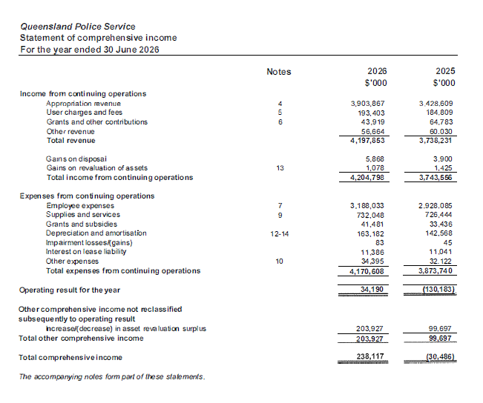

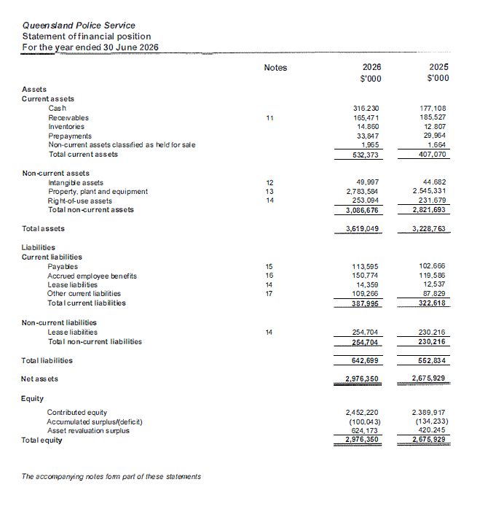

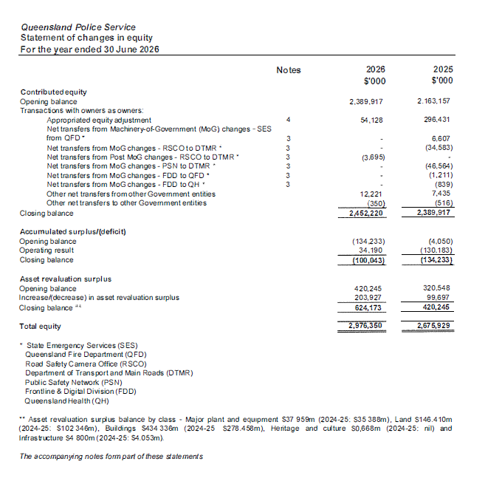

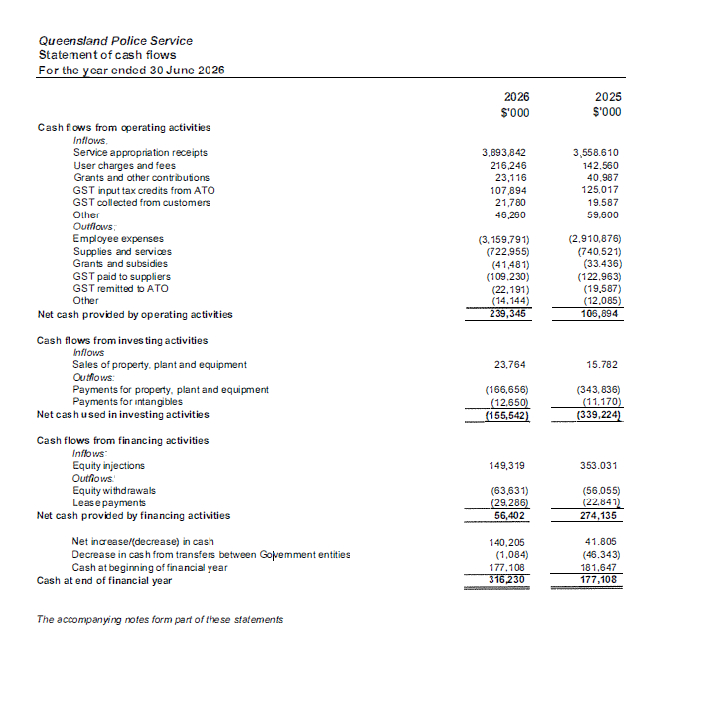

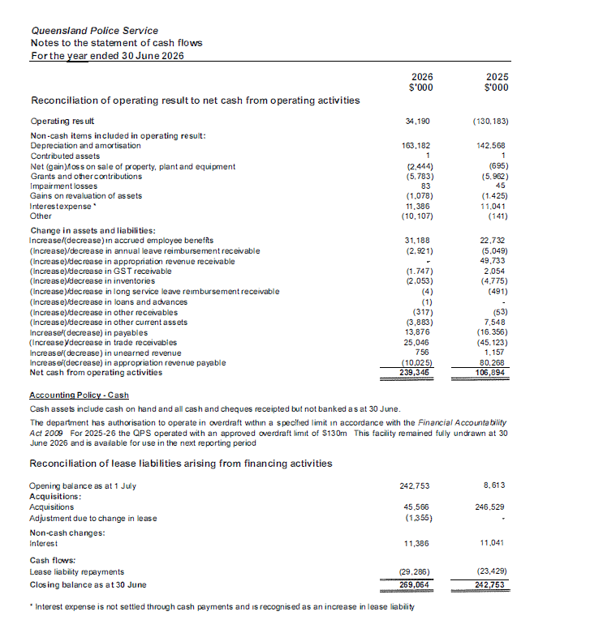

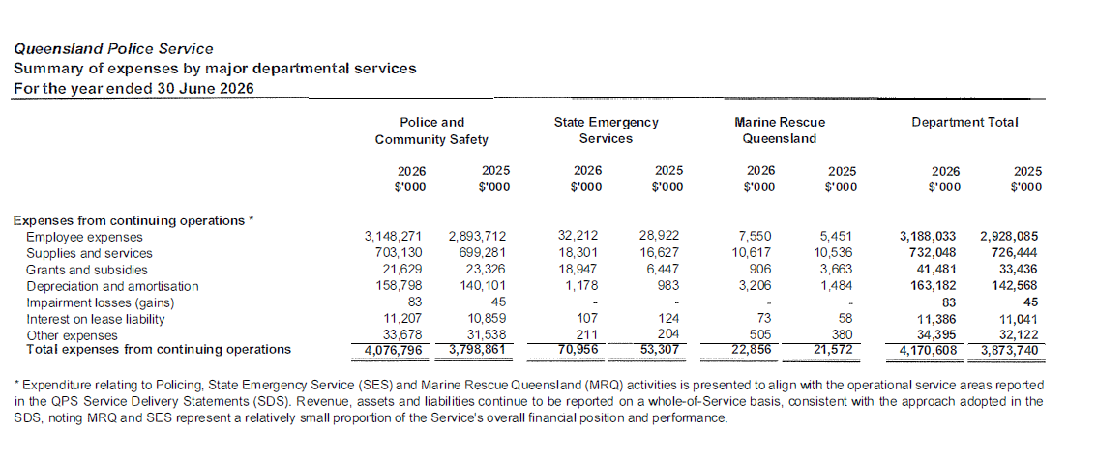

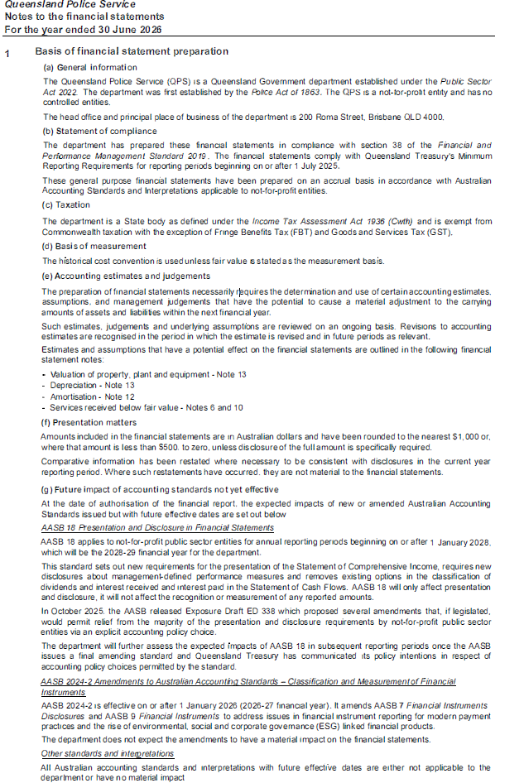
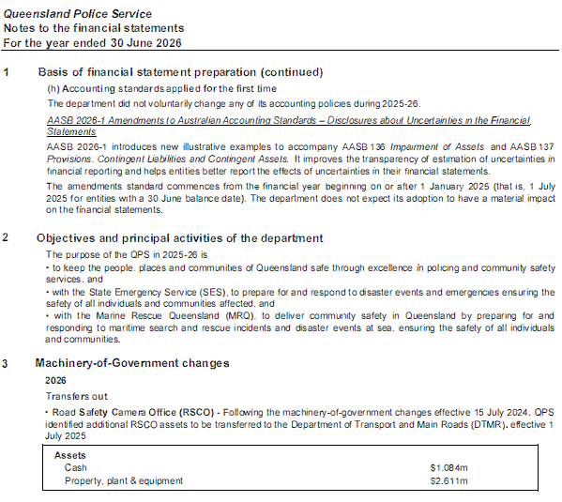

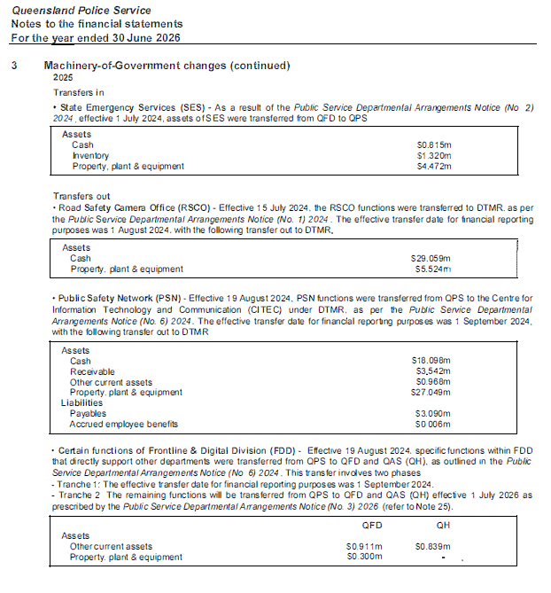

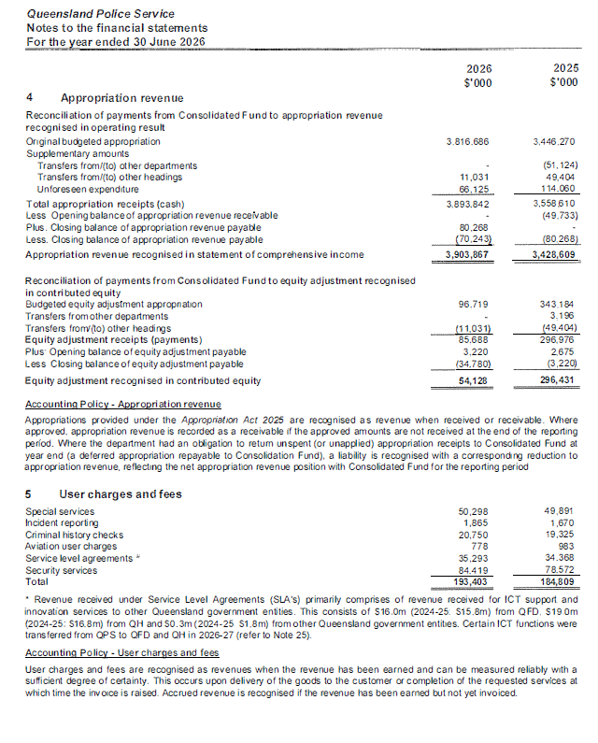

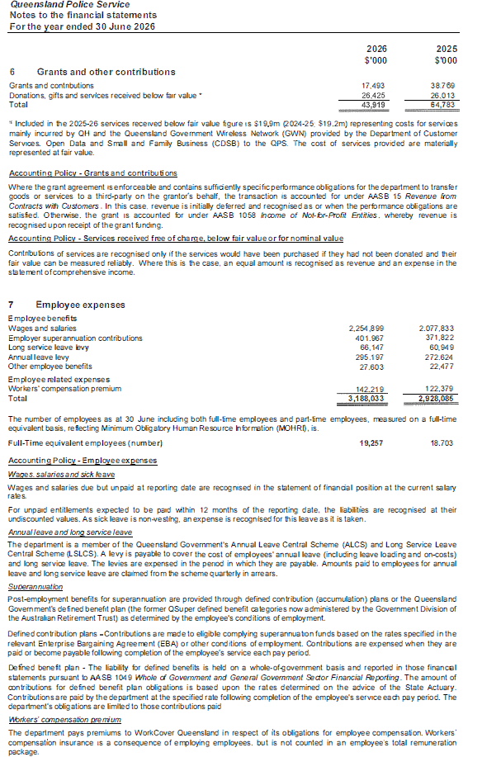

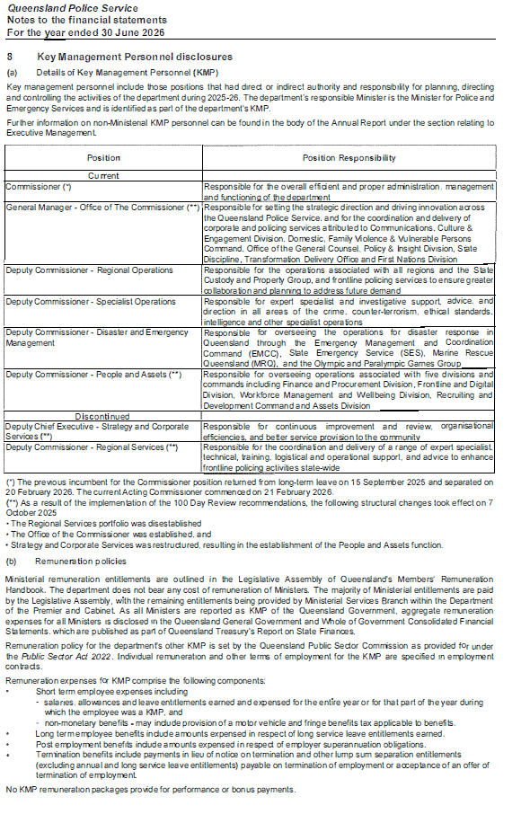

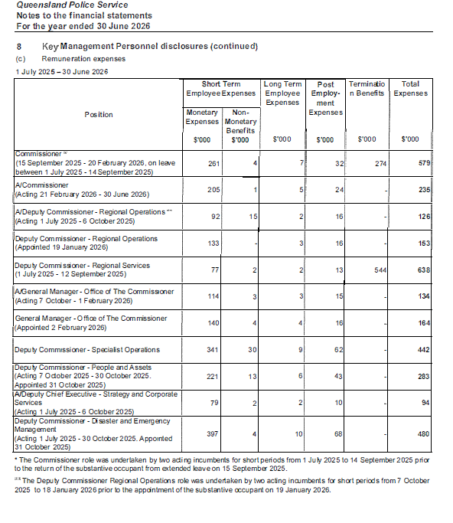

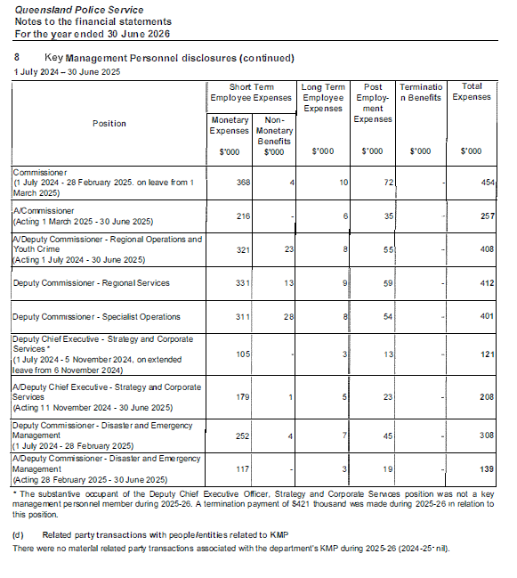

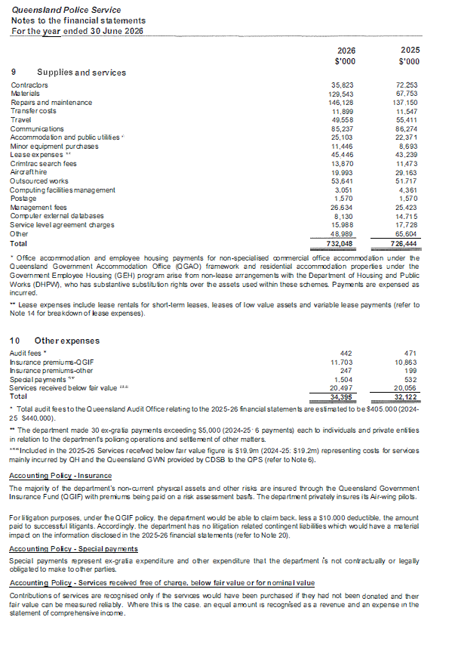

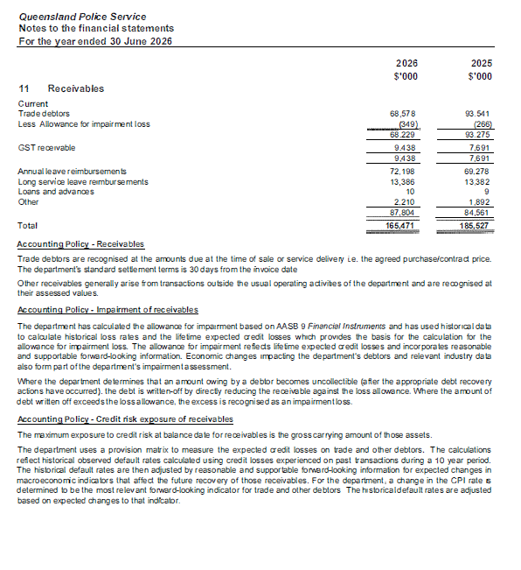

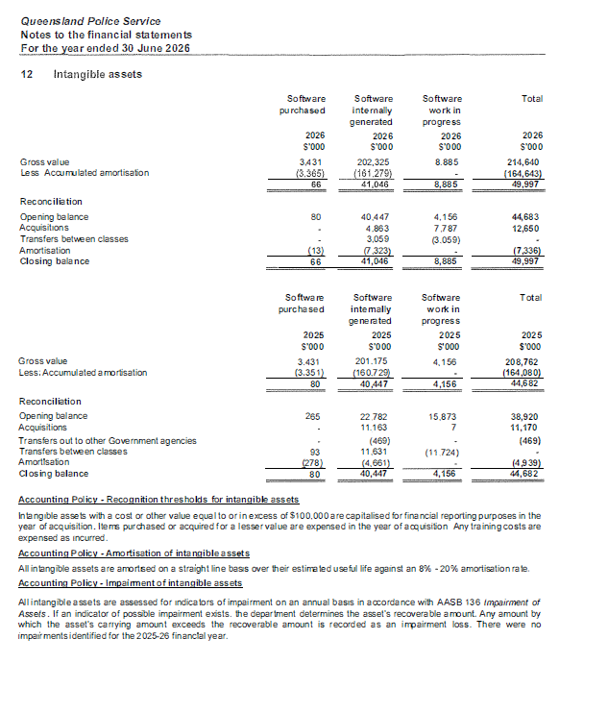

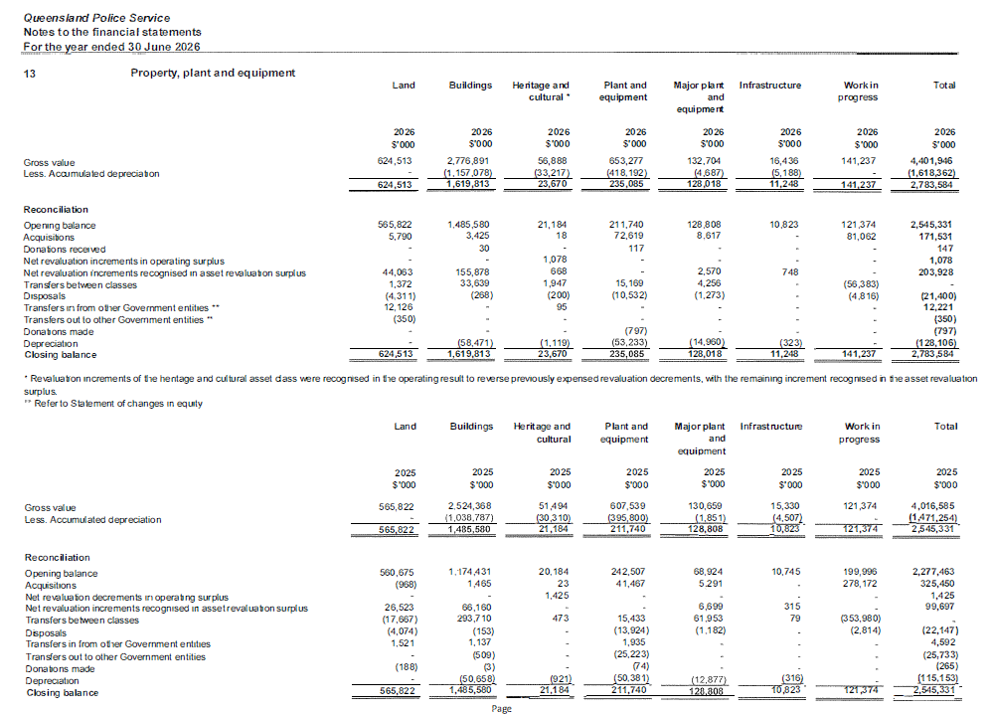

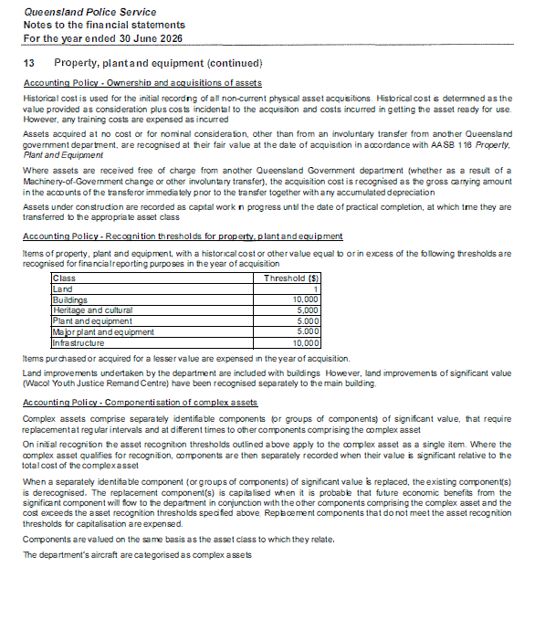

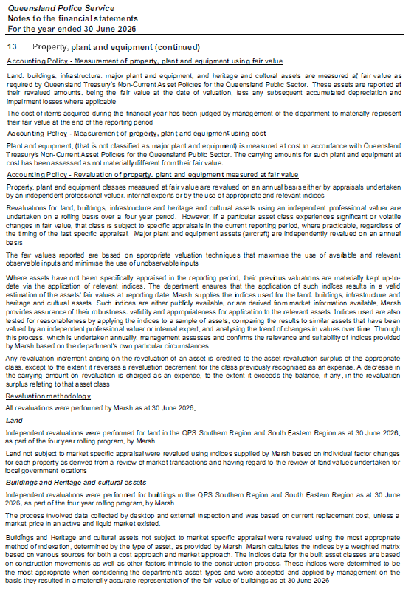

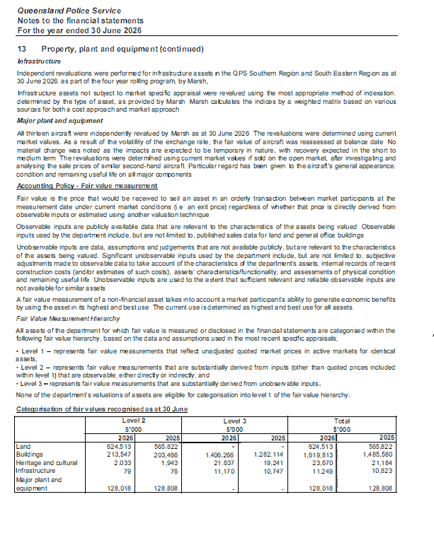

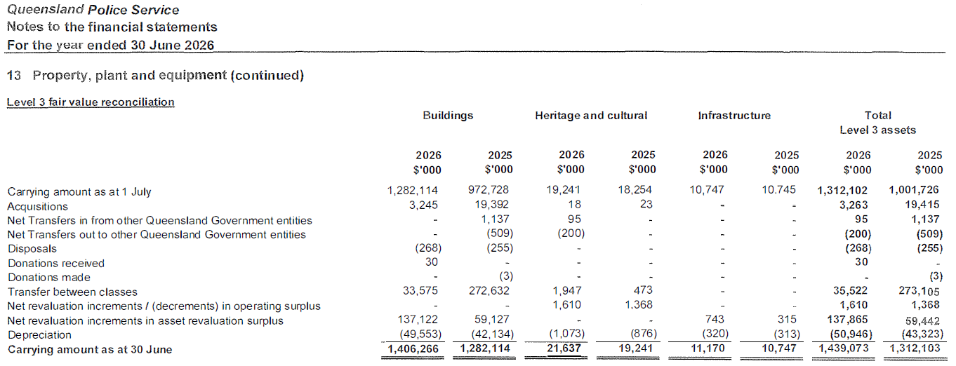

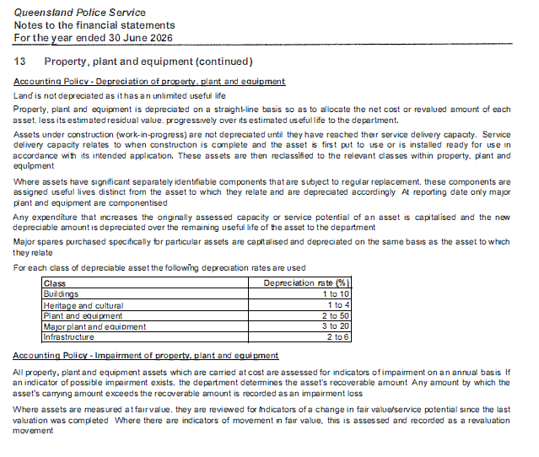

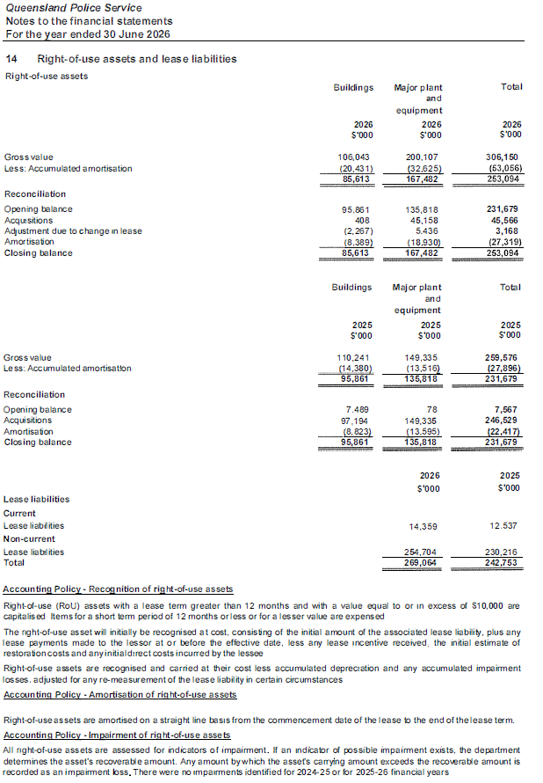

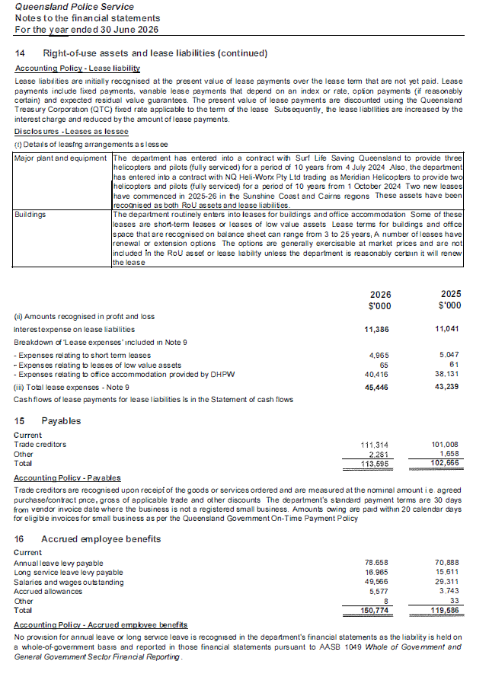

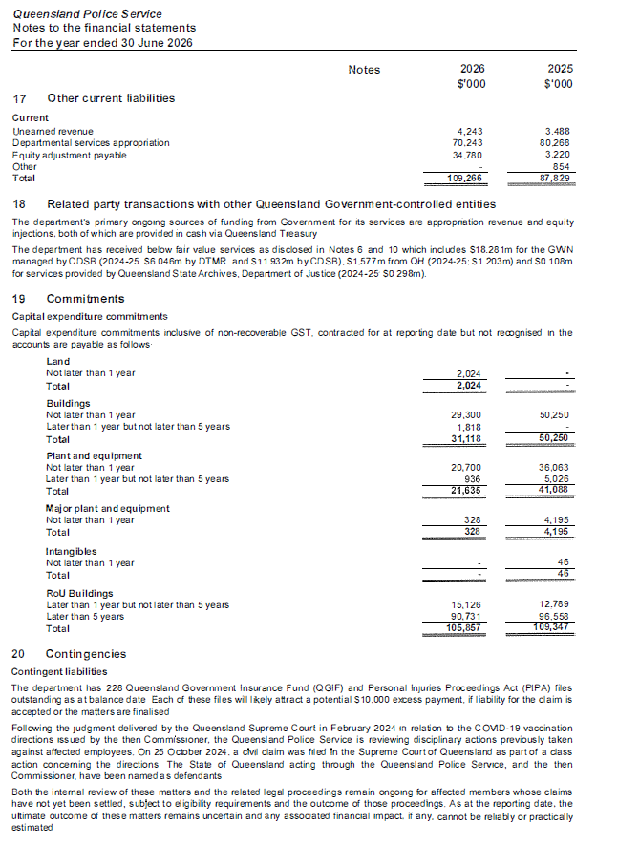

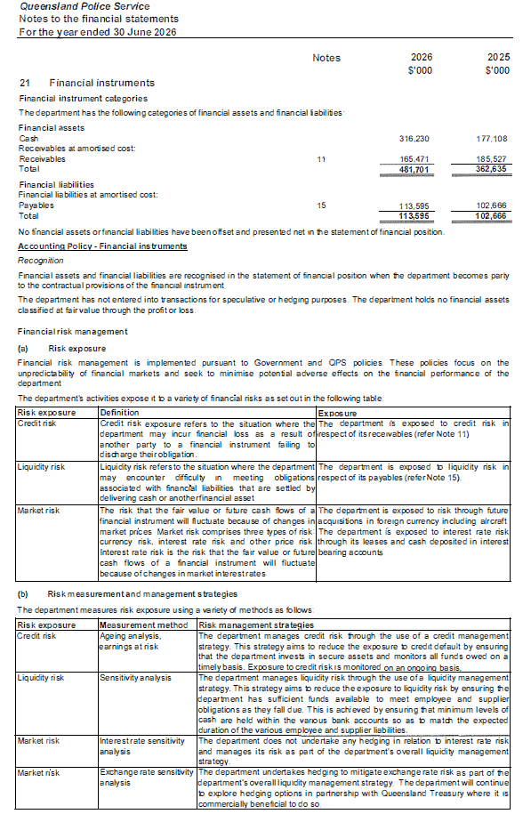

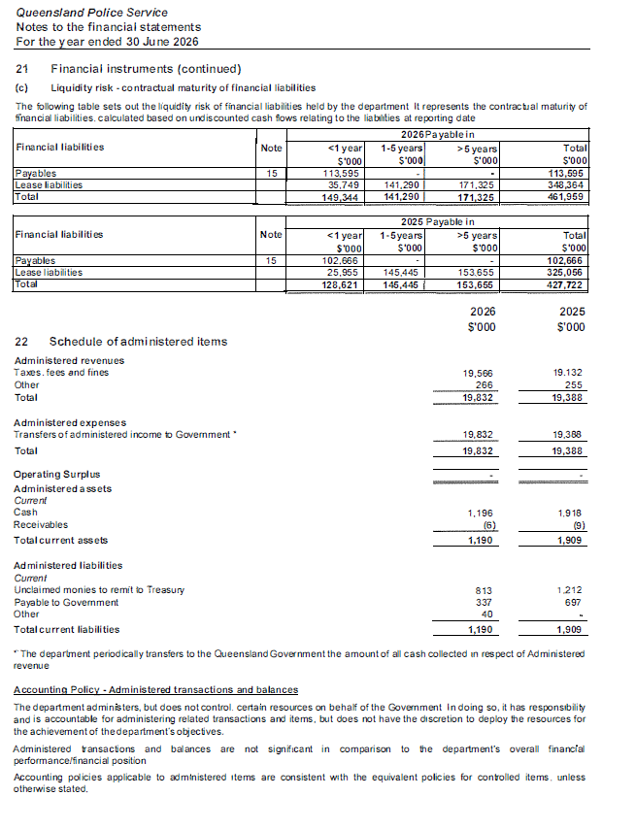

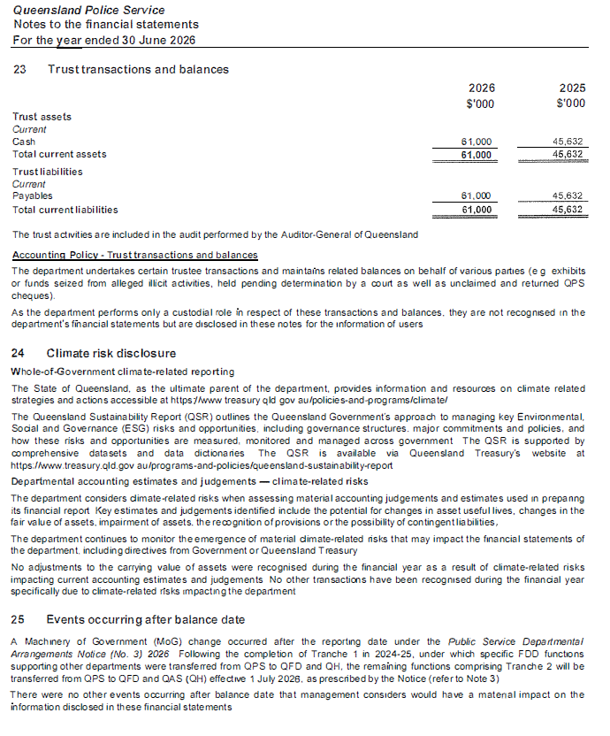

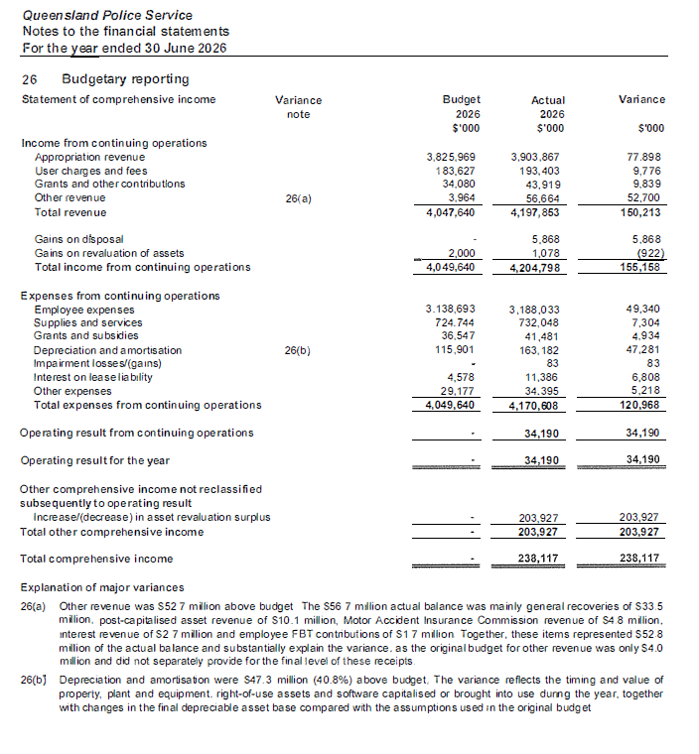

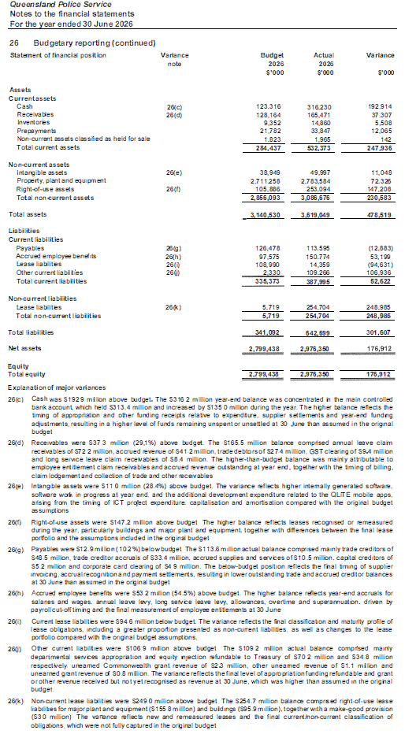
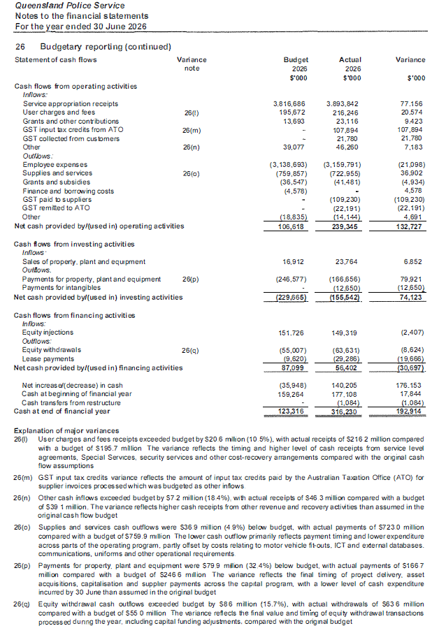

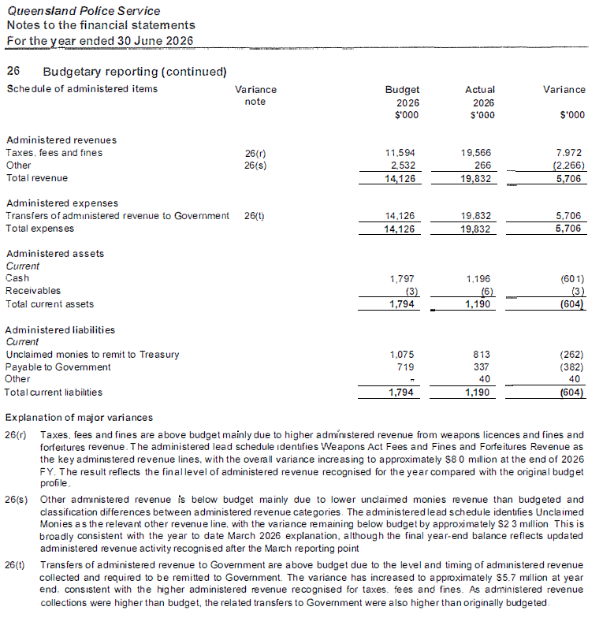

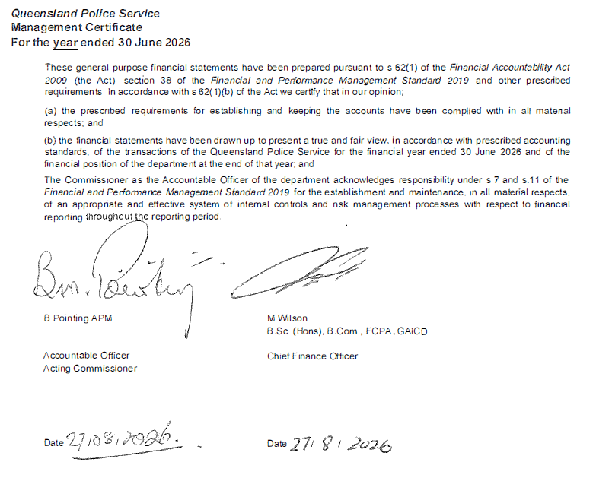

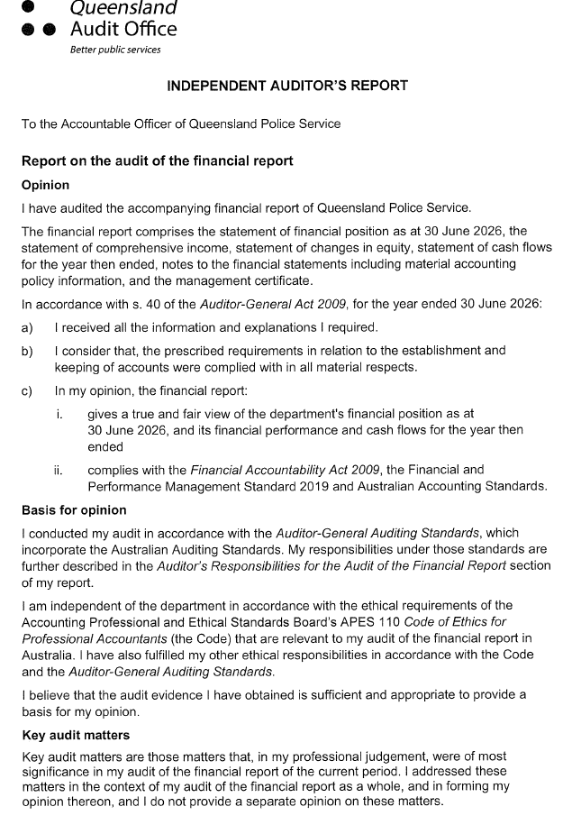

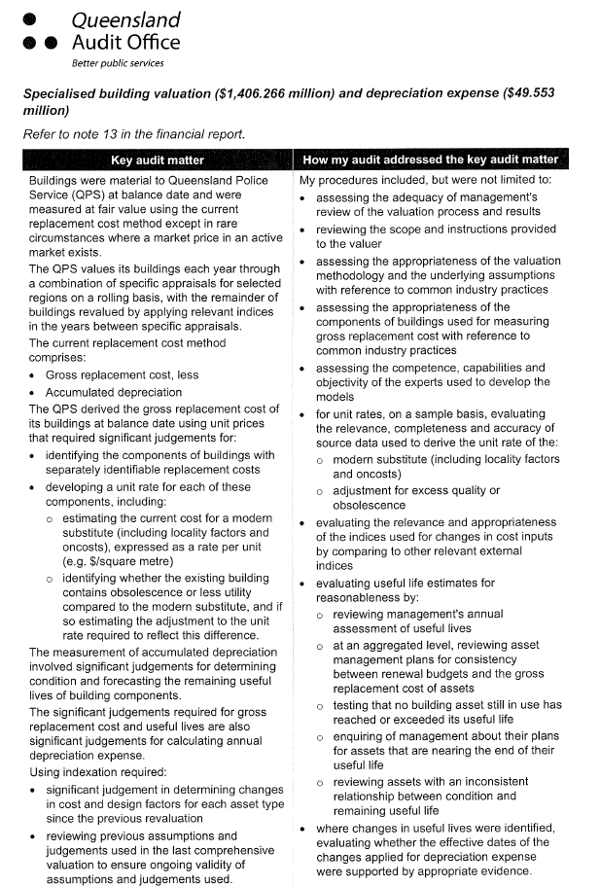

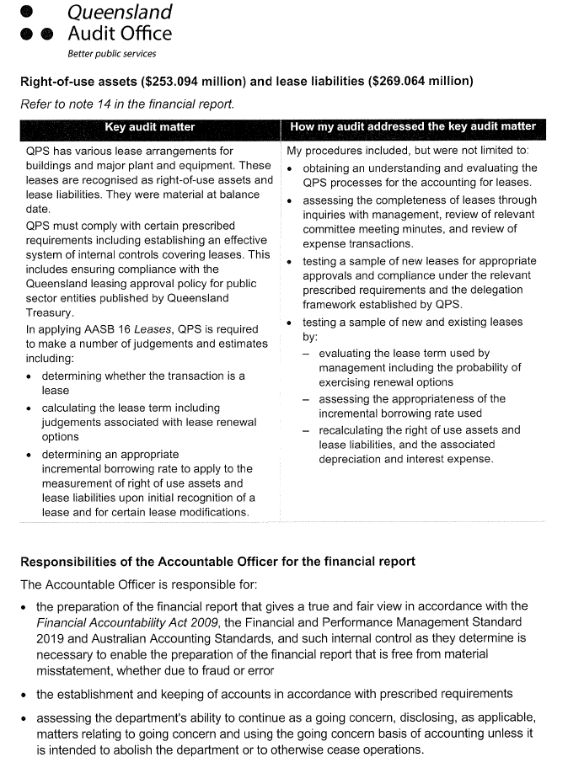

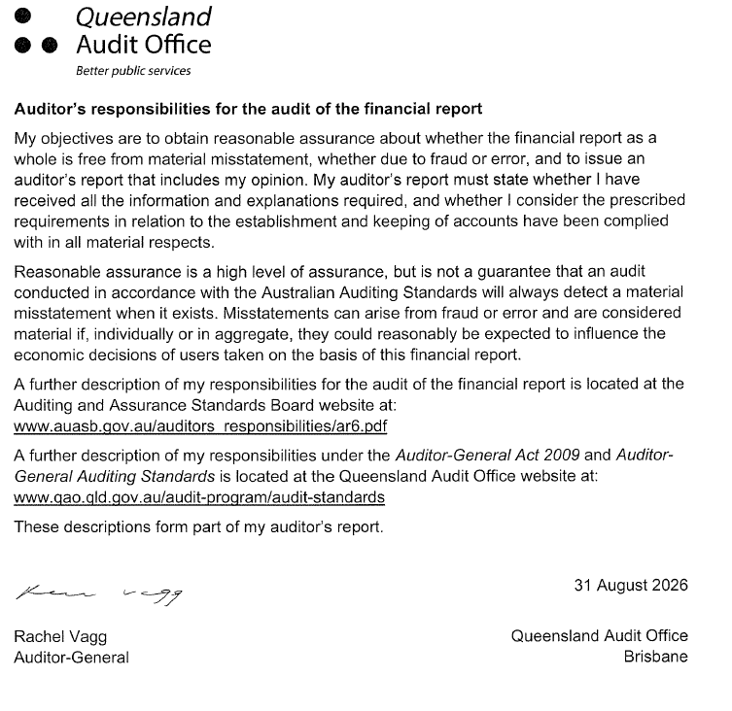

Appendices
Government bodies
Controlled Operations Committee
Act | The Controlled Operations Committee is established under the Police Powers and Responsibilities Act 2000.
Functions | The Controlled Operations Committee is responsible for considering and making recommendations about applications for an authority, or variation to an authority, to conduct a controlled operation under Chapter 11 of the Police Powers and Responsibilities Act 2000.
Achievements | The committee provides its own annual report after 30 June each year, detailing the work and activities of the QPS under Chapter 11 Controlled Operations of the Act for the preceding 12 months.  The committee’s annual report is available online at www.parliament.qld.gov.au/work-of-assembly/tabled-papers.
Financial reporting | Records are inspected by the Chairperson of the Controlled Operations Committee. Transactions of the entity are accounted for in the QPS financial statements which are certified by the Auditor-General of Queensland.
Remuneration
Position | Name | Meetings | Approved fee | Approved sub-committee fees | Actual fees received
Independent Member and Chairperson | The Honourable Roslyn Atkinson AO | 17 (Includes annual inspection) | $520 | n/a | $8,840.00
Member (QPS Commissioner’s nominee) | Acting Detective Chief Superintendent  Troy Pukallus | 4 | n/a | n/a | n/a
Member (QPS Commissioner’s nominee) | Acting Detective Chief Superintendent Colin Briggs | 1 | n/a | n/a | n/a
Member (QPS Commissioner’s nominee) | Acting Detective Chief  Superintendent Craig McGrath | 8 | n/a | n/a | n/a
Member (QPS Commissioner’s nominee) | Acting Detective Chief Superintendent Vince Byrnes | 1 | n/a | n/a | n/a
Member (QPS Commissioner’s nominee) | Acting Detective Chief Superintendent Denzil Clark | 2 | n/a | n/a | n/a
Member (CCC Chairperson) | Bruce Barbour | 15 | n/a | n/a | n/a
Member (A/CCC Chairperson) | Jen O’Farrell | 1 | n/a | n/a | n/a
No. of scheduled meetings | 17 (Includes annual inspection)
Total out of pocket expenses | $8,840.00

Public Interest Monitor
Act | The Public Interest Monitor is appointed under the Police Powers and Responsibilities Act 2000 and the Crime and Corruption Act 2001.
Functions | The Public Interest Monitor has the following functions for surveillance device warrants, retrieval warrants, approvals of the use of surveillance devices under emergency authorisations, and covert search warrants:  - to monitor compliance by police officers with Chapter 9 of the Police Powers and Responsibilities Act 2000 (the Act) in relation to matters concerning applications for covert search warrants  - to monitor compliance by law enforcement officers with Chapter 13 of the Act in relation to matters concerning applications for surveillance device warrants, retrieval warrants and approvals of the use of surveillance devices under emergency authorisations  - to appear at any hearing of an application to a Supreme Court judge for a warrant or approval mentioned in paragraph a) or b), or to a magistrate for a warrant mentioned in paragraph b), to test the validity of the application, and for that purpose at the hearing, to–  - present questions for the applicant to answer and examine or cross-examine any witness; and  - make submissions on the appropriateness of granting the application;  - to appear at a consideration of a report made to a Supreme Court judge or a magistrate or given to the monitor and referred to a judge or magistrate under section 357 of the Act;  - to gather statistical information about the use and effectiveness of covert search warrants, surveillance device warrants;  - to report as required by the Act on any matter about which the Act expressly requires the Public Interest Monitor to report;  - whenever the Public Interest Monitor considers it appropriate  - to give to the Commissioner a report on noncompliance by police officers with Chapter 9 of the Act; or  - to give to the chief executive officer of a law enforcement agency a report on noncompliance by law enforcement officers of the law enforcement agency with Chapter 13 of the Act.  The Public Interest Monitor also has the following functions:  - under the Criminal Code 1995 (Cth), to exercise the power conferred on the monitor under the following sections –  - section 104.12 (Service, explanation and notification of an interim control order)  - section 104.12A (Election to confirm control order)  - section 104.14 (Confirming an interim control order)  - section 104.18 (Application by the person for a revocation or variation of a control order)  - section 104.17 (Service of a declaration, or a revocation, variation or confirmation of a control order)  - section 104.19 (Application by the Australian Federal Police Commissioner for a revocation or variation of a control order)  - section 104.23 (Application by the Australian Federal Police Commissioner for addition of obligations, prohibitions or restrictions)  - under the Terrorism (Preventative Detention) Act 2005, to exercise the power conferred on the monitor under the following sections –  - section 14 (General provisions that apply if the Public Interest Monitor must be notified about an application to the issuing authority)  - section 73 (Supreme Court hearing and decision).  - to gather statistical information about the use and effectiveness of control orders and preventative detention orders under the Acts mentioned in paragraphs a) and b)  - whenever the Public Interest Monitor considers it appropriate – to give to the Commissioner a report on noncompliance by police officers with the Terrorism (Preventative Detention) Act 2005  - to gather statistical information about the use and effectiveness of official warnings for consorting;  - to gather statistical information about the use and effectiveness of public safety orders made by commissioned officers under the Peace and Good Behaviour Act 1982;  - to gather statistical information about the use and effectiveness of firearm prohibition orders made under the Weapons Act 1990, Part 5A;  - to monitor compliance by police officers with the Weapons Act 1990, Part 5A, Division 4;  - whenever the Public Interest Monitor considers it appropriate – to give the commission a report on noncompliance by police officers with the Weapons Act 1990, Part 5A, Division 4.  The Public Interest Monitor must also report in relation to:  - the use of covert search warrants under the Act;  - orders made under the Terrorism (Preventative Detention) Act 2005;  - control orders under the Criminal Code 1995 (Cth), Division 104;  - official warnings for consorting (“OWFC”) issued by QPS officers;  - public safety orders made by QPS commissioned officers under the Peace and Good Behaviour Act 1982  - firearm prohibition orders (FPO) made by the Commissioner under the Weapons Act 1990, Part 5A.  The Public Interest Monitor is required to report on the following matters:  - under the Terrorism (Preventative Detention) Act 2005:  - the number of initial orders made during the year;  - the number of final orders made during the year:  - whether a person was taken into custody under each of those orders and, if so, how long the person was detained for;  - particulars of any complaints about the detention of a person under a preventative detention order made or referred during the year to the ombudsman or the CCC;  - the number of prohibited contact orders made during the year;  - the use of preventative detention orders and prohibited contact orders generally.  - under the Criminal Code 1995 (Cth), Division 104:  - the number of control orders confirmed, declared void, revoked or varied during the year;  - the use of control orders generally.  - Under the Act:  - the number of OWFC given during the year;  - the number of times the giving of an OWFC led to a person committing an offence against:  - section 790 PPRA (assault or obstruct police officer); or  - section 791 PPRA (contravene direction or requirement of police officer);  - the extent of compliance by the QPS with Chapter 2, Part 6A of the Act; and  - the use of OWFC generally.  - under the Peace and Good Behaviour Act 1982:  - the number of public safety orders made during the year;  - the extent of compliance by the police service with the Peace and Good Behaviour Act 1982, Part 3, Division 2; and  - the use of public safety orders generally.  e) under the Weapons Act 1990 (WA), Part 5A:  - the number of FPOs:  - made by the Commissioner during the year (141G);  - made by the Court during the year (141H);  - revoked by the Commissioner during the year (141G(5))  - Revoked by the Court during the year (141H(7));  - the number of appeals stated under Part 5A, Division 6 during the year against the making of an FPO by the Commissioner;  - the number of appeals stated under Part 5A, Division 6 during the year against the making of an FPO by the Court;  - the number of charges made during the year for offences if the charge arises from a search under Part 5A, Division 4 –  - An offence under the WA;  - An offence under another law.  - the number of firearms and firearm related items seized under Part 5A, Division 4 in the year;  - the number of firearms and firearm related items given to or seized by a police officer under section 141W in the year;  - the extent of compliance by the police service with Part 5A, Division 4 in the year;  - the use of FPOs generally.  The Public Interest Monitor is responsible for the recording, reporting and inspection regime for telecommunications interception in accordance with the Telecommunications Interception Act 2009 which enables the use by the QPS and the Crime and Corruption Commission of Commonwealth telecommunications interception powers as a tool for the investigation of serious offences.  The Public Interest Monitor is entitled to appear at the hearing of the application for a telecommunications interception warrant to test the validity of the application and, for that purpose at the hearing, to –  - ask questions of any person giving information to the eligible Judge or nominated Administrative Review Tribunal member; and  - make submissions to the eligible Judge or nominated Administrative Review Tribunal member about the following maters –  - in relation to an application for a warrant in relation to a telecommunications service  - in relation to an application for a warrant in relation to a person.  In addition, the Public Interest Monitor has record-keeping oversight to ensure eligible authorities keep documents connected with the issue of warrants in accordance with the Telecommunications Interception Act 2009.  As the inspecting entity for the QPS, the Public Interest Monitor:  - must inspect the eligible authority’s records as required under section 23 of the legislation to ascertain the extent of compliance by the authority’s officers  - must report in writing to the Minister about the results of the inspections  - may do anything necessary or convenient for the performance of the functions mentioned in (a) and (b).
Achievements | The annual report of the Public Interest Monitor is available at www.parliament.qld.gov.au/work-of-assembly/tabled-papers.
Financial reporting | Financial transactions made with the Public Interest Monitor are accounted for in the QPS financial statements which are certified by the Auditor-General of Queensland.
Remuneration
Position | Meetings* | Approved fee | Approved sub-committee fees | Actual fees received**
Public Interest Monitor  David Adsett | 61 | A service fee of $450.00 per hour to a maximum of $2,250.00 per day | n/a | $205,724.50
Deputy Public Interest Monitor  Gavin Rebetzke  (Finished 08/06/2026) | 41 | A service fee of $450.00 per hour to a maximum of $2,250.00 per day | n/a | $86,814.75
Deputy Public Interest Monitor  Peter McDermott  (Commenced 08/08/2025) | 41 | A service fee of $450.00 per hour to a maximum of $2,250.00 per day | n/a | $107,373.00
Deputy Public Interest Monitor  Jason Ward (Commenced 09/06/2026) | 2 | A service fee of $450.00 per hour to a maximum of $2,250.00 per day | n/a | $18,356.25
No. of scheduled meetings | 145
Total out of pocket expenses | $418,268.50

* Number of meetings refers to the number of court/tribunal appearances (where there may be one or multiple applications) and excludes inspections and incidental meetings.
** Actual fees received includes all fees related to the Public Interest Monitor functions including applications, inspections, incidental meetings, administration, and report preparation incurred during the 2025-26 period. Some fees included in this total have been paid outside of the 2025-26 reporting period.

Acronyms
ADP | Abbreviated Disciplinary Proceeding | PDS | Professional Development Strategies
AI | Artificial Intelligence | PPRA | Police Powers and Responsibilities Act 2000
ARC | Australian Retail Council | PSA | Public Sector Act 2002
ARCC | Audit, Risk and Compliance Committee | PSAA | Police Service Administration Act 1990
ARNI | Airbridge Resilient Network Infrastructure | PSO | Peer Support Officer
BoM | Board of Management | QBLAI | Queensland Blue Light Association Incorporated
BSF | Balin Stewart Foundation | QH | Queensland Health
CCC | Crime and Corruption Commission | QHVSG | Queensland Homicide Victims Support Group
CSQ | Crime Stoppers Queensland | QPCYWA | Queensland Police-Citizens Youth Welfare Association
DYJVS | Department of Youth Justice and Victim Support | QPP&D | Queensland Police Pipes and Drums
eDRMS | Electronic Document and Records Management System | QPS | Queensland Police Service
ELT | Executive Leadership Team | QSAC | Queensland Sentencing Advisory Council
ESC | Ethical Standards Command | RLSSQ | Royal Life Saving Society Queensland
FTE | Full Time Equivalent | RoGS | Report on Government Services
IGEM | Inspector-General Emergency Management | SDS | Service Delivery Statement
LCP | Leadership Capability Program | SES | State Emergency Service
LGBTQIA+ | Lesbian, Gay, Bisexual, Transgender, Queer/Questioning, Intersex and Asexual | SFS | State Flying Squad
LWN | Leading Women Network | SHSO | Senior Human Services Officer
MOHRI | Minimum Obligatory Human Resource Information | SLSQ | Surf Life Saving Queensland
MRQ | Marine Rescue Queensland | SMT | Support Management Team
NAIDOC | National Aboriginal and Islanders Day Observance Committee | SWD | Safety and Wellbeing Division
NHWQ | Neighbourhood Watch Queensland | TMR | Transport and Main Roads
NSCSP | National Survey of Community Satisfaction with Policing | VFQ | Volunteering for Queensland
OCGG | Organised Crime Gangs Group | VREC | Video Recorded Evidence-in-Chief
OLP | Online Learning Product | WFQ | Working for Queensland
OPGG | Olympic and Paralympic Games Group | WOW | Wear Orange Wednesday
OWFC | Official Warnings for Consorting | WSEG | Workforce Support and Engagement Group
PCYC | Police-Citizens Youth Club | YCG | Youth Crime Group

Compliance checklist
Summary of requirement |  | Basis for requirement | Annual report reference
Letter of compliance | - A letter of compliance from the accountable officer or statutory body to the relevant Minister/s | ARRs – section 7 | 2
Accessibility | - Table of contents  - Glossary | ARRs – section 9.1 | 4, 115-116
Accessibility | - Public availability | ARRs – section 9.2 | 1
Accessibility | - Interpreter service statement | Queensland Government Language Services Policy  ARRs – section 9.3 | 1
Accessibility | - Copyright notice | Copyright Act 1968  ARRs – section 9.4 | 1
Accessibility | - Information Licensing | QGEA – Information Licensing  ARRs – section 9.5 | 1
General information | - Introductory Information | ARRs – section 10 | 1, 7-10, 12-18
Non-financial performance | - Government’s objectives for the community and whole-of-government plans/specific actions | ARRs – section 11.1 | 7-8
Non-financial performance | - Agency objectives and performance indicators | ARRs – section 11.2 | 7-9, 23-29
Non-financial performance | - Agency service areas and service standards | ARRs – section 11.3 | 23-29
Financial performance | - Summary of financial performance | ARRs – section 12.1 | 19-22
Governance – management and structure | - Organisational structure | ARRs – section 13.1 | 15
Governance – management and structure | - Executive management | ARRs – section 13.2 | 43-44
Governance – management and structure | - Government bodies (statutory bodies and other entities) | ARRs – section 13.3 | 57, 109-114
Governance – management and structure | - Public Sector Ethics | Public Sector Ethics Act 1994  ARRs – section 13.4 | 51
Governance – management and structure | - Human Rights | Human Rights Act 2019  ARRs – section 13.5 | 11
Governance – management and structure | - Queensland public service values | ARRs – section 13.6 | 7-8
Governance – risk management and accountability | - Risk management | ARRs – section 14.1 | 59
Governance – risk management and accountability | - Audit committee | ARRs – section 14.2 | 47-48
Governance – risk management and accountability | - Internal audit | ARRs – section 14.3 | 59
Governance – risk management and accountability | - External scrutiny | ARRs – section 14.4 | 57-58
Governance – risk management and accountability | - Information systems and recordkeeping | ARRs – section 14.5 | 60
Governance – risk management and accountability | - Information Security attestation | ARRs – section 14.6 | 11
Governance – human resources | - Strategic workforce planning and performance | ARRs – section 15.1 | 61-69
Governance – human resources | - Early retirement, redundancy and retrenchment | Directive No.04/18 Early Retirement, Redundancy and Retrenchment  ARRs – section 15.2 | 69
Open Data | - Statement advising publication of information | ARRs – section 16 | 4
Open Data | - Consultancies | ARRs – section 31.1 | www.data.qld.gov.au
Open Data | - Overseas travel | ARRs – section 31.2 | www.data.qld.gov.au
Open Data | - Queensland Language Services Policy | ARRs – section 31.3 | www.data.qld.gov.au
Open Data | - Charter of Victims’ Rights | VCSVRB Act 2024  ARRs – section 31.4 | www.data.qld.gov.au
Financial statements | - Certification of financial statements | FAA – section 62  FPMS – sections 38, 39 and 46  ARRs – section 17.1 | 104
Financial statements | - Independent Auditor’s Report | FAA – section 62  FPMS – section 46  ARRs – section 17.2 | 105-108

Annual Report 2025-2026
Queensland Police Service
www.police.qld.gov.au

